Student name: Andrew Ross Pullin
Student ID: 0851963
Course Title: Computing (Data and Information Systems)
Assignment 2: Professional Development Plan (PDP)
Module: ACCA4025 Learning in the Digital Era

Table of Contents
Task 1 – Self-evaluation 2
Task 2 – PDP 3
Task 3 – Unit 4 topic summary 4
Task 4 – Video presentation 5

Task 1 – Self-evaluation

A screenshot of the task answer from the PowerPoint presentation:
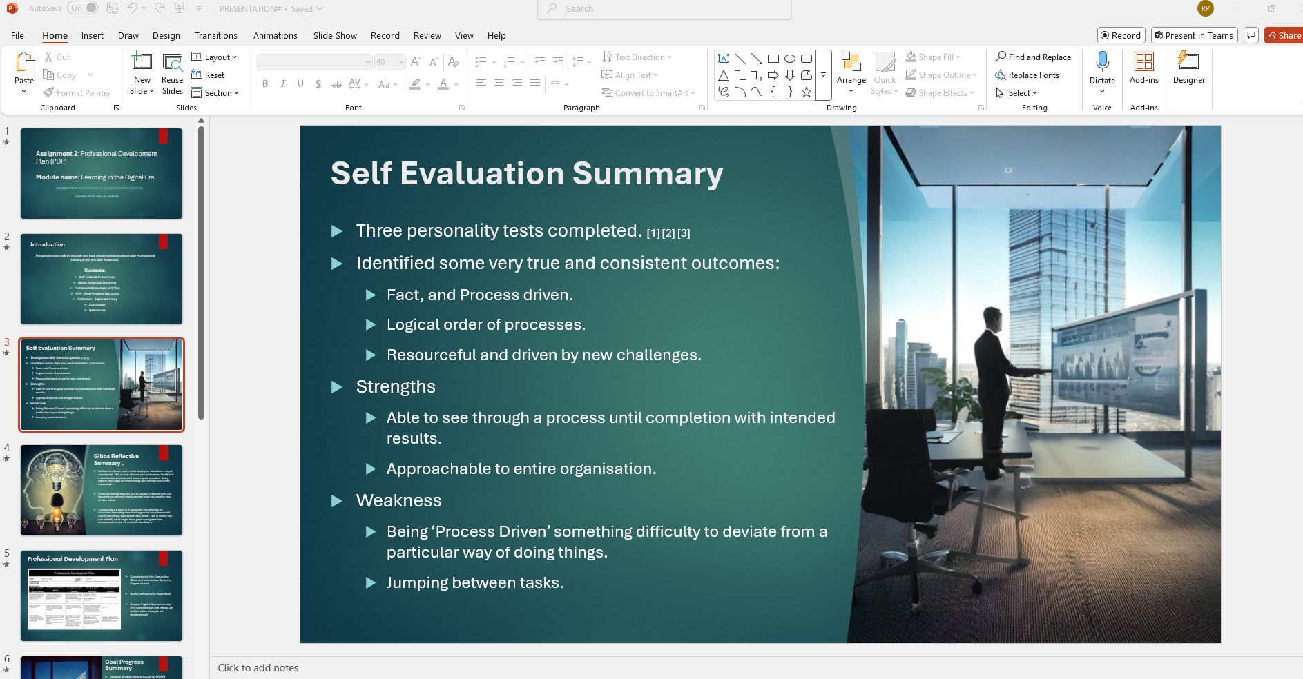

Task 2 – PDP

A link to view and download the Professional Development Plan from OneDrive:
https://uowtsd-my.sharepoint.com/:w:/r/personal/0851963_student_uwtsd_ac_uk/Documents/1.%20Level%204/ACCA4025%20Learning%20in%20Digital%20Era%20-%20SUBMITTED%20ASS1,%20ASS%202%20TODO/Task%202/Task%202/ACCA4025%20Ross%20Pullin%20-%20Task%202%20-%20PDP.docx?d=w5c5071ee2c1c4eec8c399228736c0b46&csf=1&web=1&e=prwbA3

A screenshot of the Professional Development Plan slide from the PowerPoint presentation:
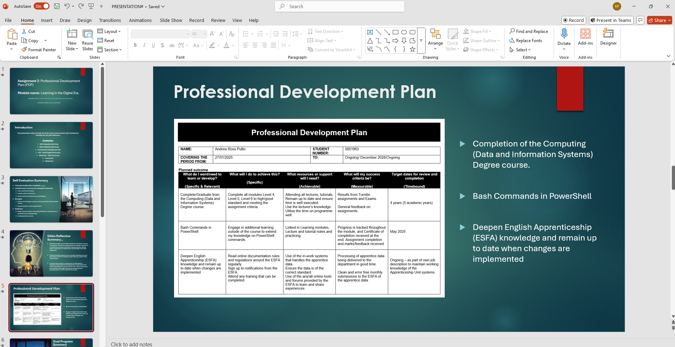

Task 3 – Unit 4 topic summary
A screenshot of the Reflection topic summary from the PowerPoint presentation:
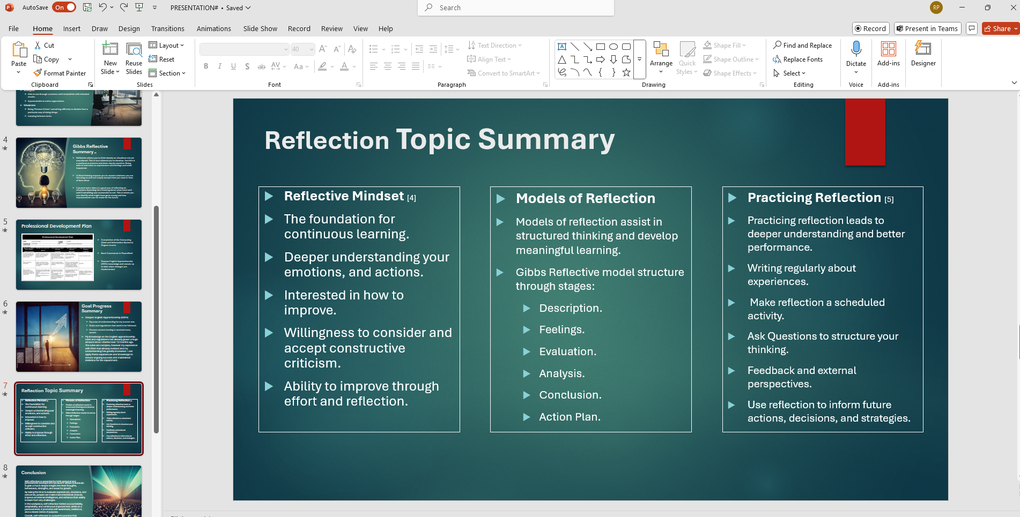

Task 4 – Video presentation

A link to the Video in its cloud platform (e.g. YouTube).

https://youtu.be/22KQzNe6h9A

Screenshots of the video from YouTube:
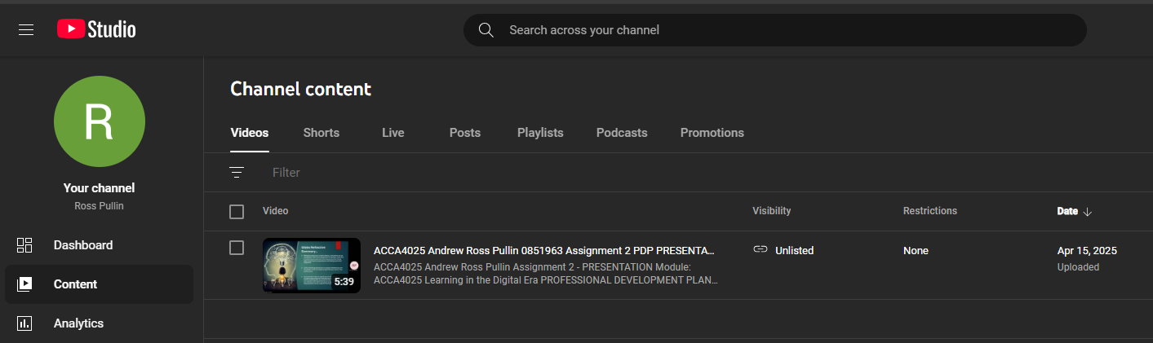

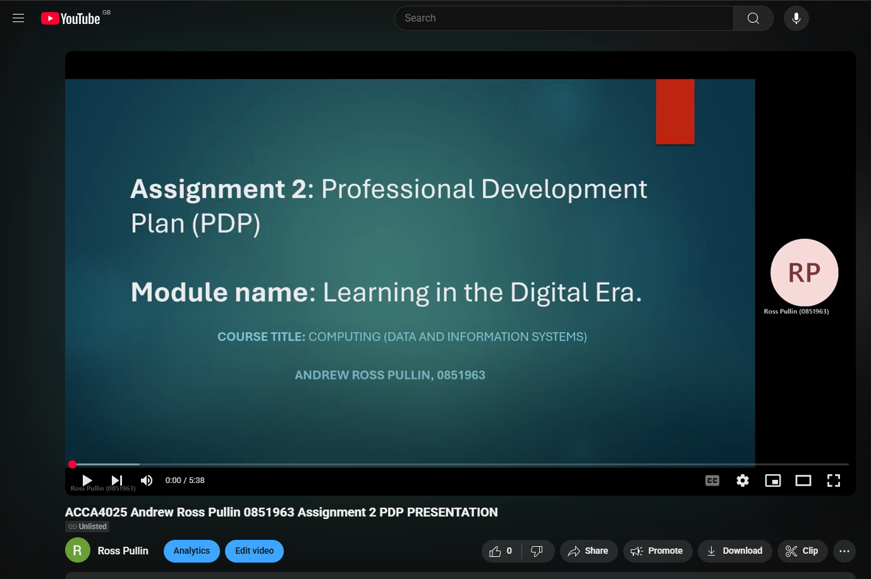

A link to view the PowerPoint Presentation from OneDrive:

https://uowtsd-my.sharepoint.com/:p:/r/personal/0851963_student_uwtsd_ac_uk/Documents/1.%20Level%204/ACCA4025%20Learning%20in%20Digital%20Era%20-%20SUBMITTED%20ASS1,%20ASS%202%20TODO/Task%202/ACCA4025%20Ross%20Pullin%20Assignment%202%20-%20PRESENTATION.pptx?d=w8ee9db9357ba4287a2b6bb6c2332ba56&csf=1&web=1&e=PDa81B

