Major Project (1) Research Essay - Conor Haslem

Overview

The production will have a 2-minute maximum duration and will be primarily live-action with computer-generated elements which will take the form of the antagonist characters of the film and environmental effects.
The film itself will be a fantasy/sci-fi action short with elements of espionage set in a near-apocalyptic world caused by the over-consumption of the planets resources and subsequent poisoning of the planet that has rendered it hostile to the common population who have now succumbed to slum-like conditions. Despite the harsh negative effect on the planet, the consumption of the planet continues through huge extractors that extract the raw energy of the planet itself, representative of real-world fossil fuel extraction with the world reflecting the dependency we have with the energy source in our own society. In the world of the short, this is pushed to the extreme, having a full corporatist society in which private corporations exist as their own governments, with their own jurisdictions and militaristic police force. With the planet now in ruin from this over-consumption, various groups of eco-terrorist characters have taken it upon themselves to try and stop the further destruction of the planet by sabotaging the remaining active extractors. The film will take place during one of these missions with the protagonist sneaking into a site to destroy a major extractor.

A major focus of the project is a reflection on the impact of humanity on nature, specifically through the fossil fuel extraction, represented through the location setting of an extraction reactor draining the life from the planet, resulting in the deterioration of the planet and gradual decay of the environment.

Story and World Building

This story has been heavily inspired by Final Fantasy VII, where an antagonistic corporation produces energy through extraction of the Planet’s ‘Lifestream’ and the protagonists taking on the role of ‘eco-terrorists’. Introducing the story with a sabotage mission in one of the corporation's reactors with intent to plant a bomb in the reactor to save the planet. For the story of the production, it will be looking at the scenario if the this had not been done and the extraction of the Lifestream had been allowed to continue, linking with the potential real-world scenario of fossil fuel use being allowed without objection to its continuation.

With the world-building of the short, specifically, the world before it’s the current state, the society that existed is heavily inspired by cyberpunk fiction, which often portrays a corporatist society where all aspects of modern society have been privatized and owned by a select few megacorporations, including law enforcement. As governments in these works have essentially dissolved in favor of the corporations, they are free to continue to exploit the world and its inhabitants for their own personal gain. In the world of Collapse, following the growth of the power of a single megacorporation due to the discovery of a new energy source; the raw life energy of the planet itself (reflecting the discovery of oil, gas, and similar fossil fuels).

- Cyberpunk 2020

https://www.pcgamesn.com/cyberpunk-2077/cyberpunk-2077-factions-classes-characters-story-setting-lore

Cyberpunk 2020 is a tabletop role playing game set in a fictional 2020 in the US, or 2077 in the CD Projekt Red videogame adoption. In the world of cyberpunk following massive socio-economic collapse, as is the case in most of the world in this universe, governments had to rely on several megacorporations in order to avoid complete economic downfall, giving them Full Powers in order to operate as they will. In this world, this resulted in the operation of various megacorporations acting as a pseudo government in America and, in the push for further power and profit, resulted in huge wealth inequality despite massive technological advancement with this ‘low-life, high-tech’ outcome.

- Final Fantasy VII

https://uk.ign.com/faqs/2003/final-fantasy-vii-plot-analysis-454384

Final Fantasy VII is a 1997 Japanese role playing videogame set in a fictional, unnamed planet in which a single corporation, the Shinra corporation, acts as the government for their own city of Midgard. A major element of the corporation, and of the plot of the game, is that they discovered a way to use the ‘Lifestream’ (the physical life force of the planet) to develop an energy source in the form of Mako energy. In the game, a group known as Avalanche belief this use of the lifestream, while advancing the lives of most of the people in the city, is taking away from the planets life and so revolt against the Shinra by attacking their various Mako reactors which extract the lifestream.

With the new energy source, they have been able to cement themselves as the most powerful entity in the world, providing huge advancements to human life although at the cost of draining the planet of its life, subsequently causing the complete collapse of civilization. This collapse coming due to the killing of plant life, and therefore everything that relies on it, and polluting the atmosphere to a toxic level from the extraction and processing of the planets life energy.

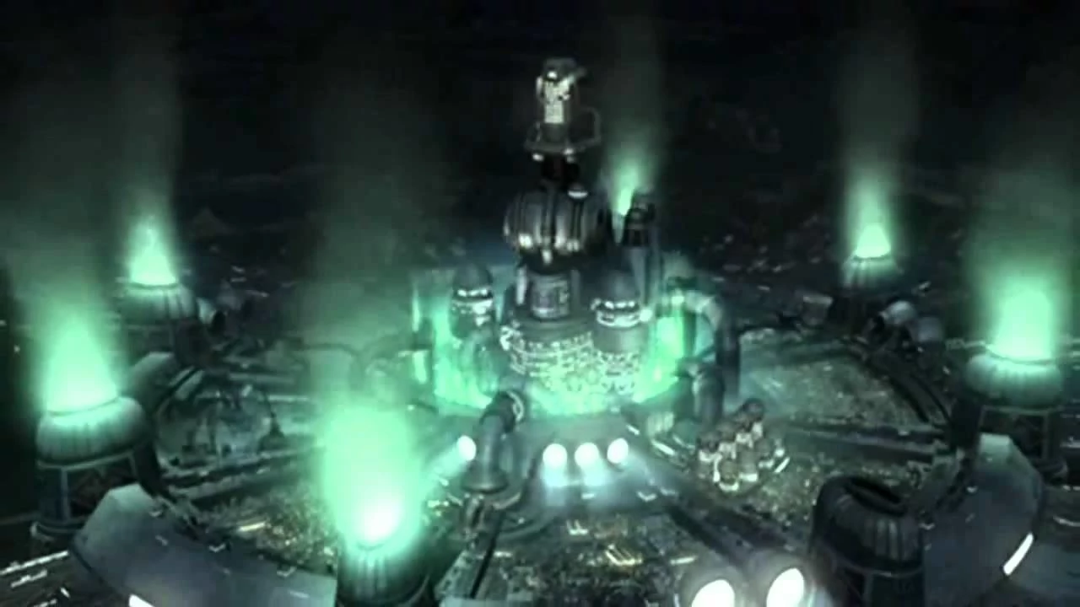
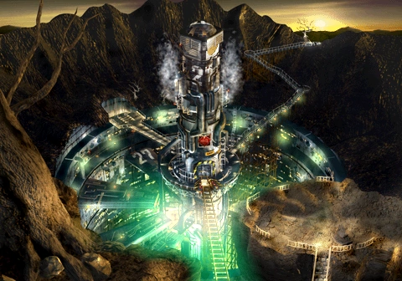

- The Last of Us

https://www.youtube.com/watch?v=VKaX7GQyWm0

This new toxin has the added effect of mutating those who inhale it in high concentrations, similarly to fungal spores, as inspired by the videogame ‘The Last of Us’ in which the mutated zombies have found themselves in that state due to a fungal infection. Those infected in the world of the short would passively act as a carrier, emitting the same spore-like substance and resulting in the setting of the short being filled with these polluting spores, taking the form of black particles in the air.

An early scene in The Last of Us shows one of the zombies, known as cordyceps, whose mutation has progressed to a point it had died although with the fungus still in its body, it acts as a passive catalyst of the infection, releasing the spores of the fungus into the air and contaminating environment. This concept will be used in the short with the mutated soldier characters who would exhaling the particles of the pollution into the setting.

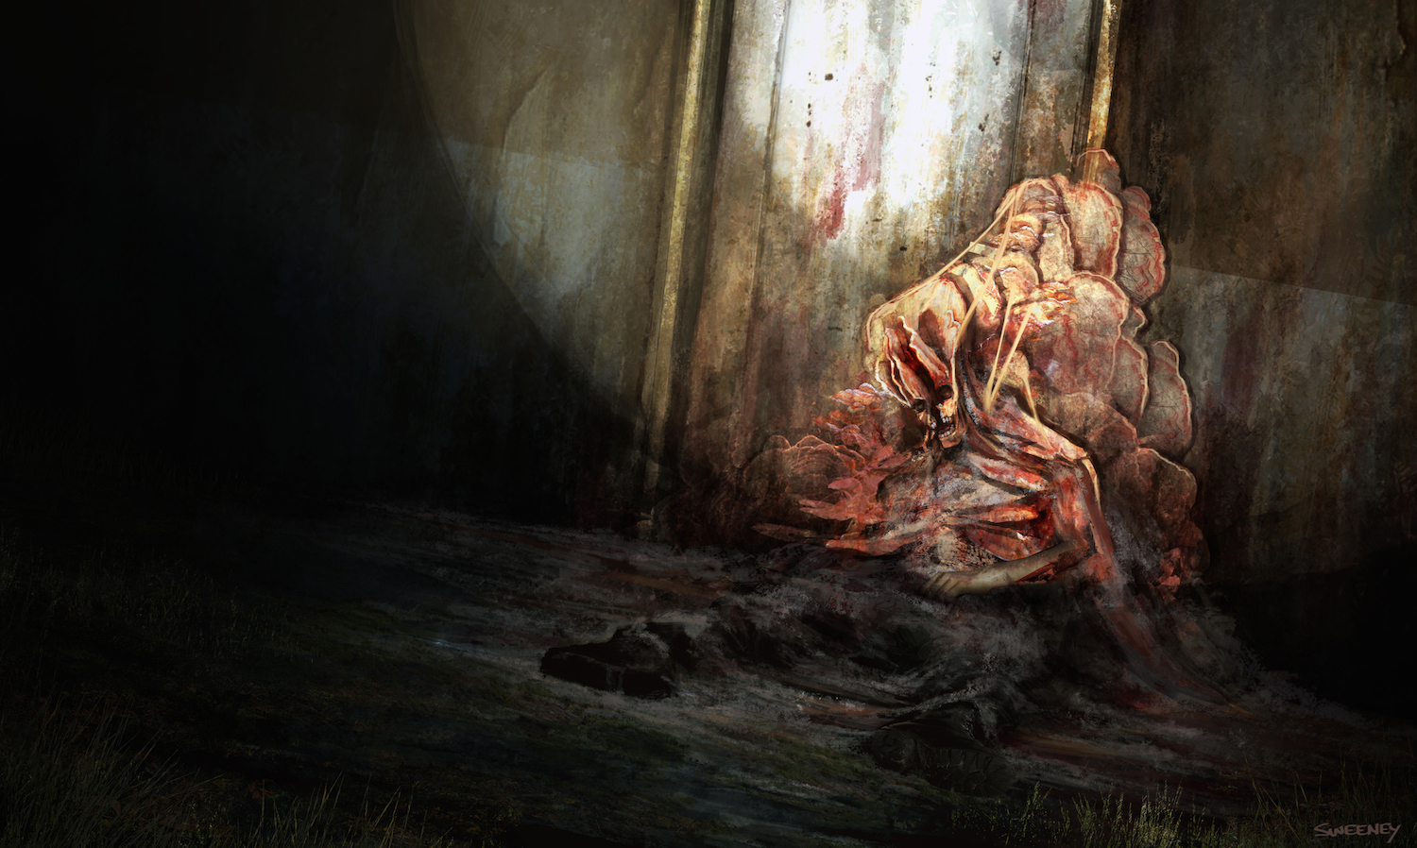
Cordycep fanart detailing a dead zombie in the game that continues to release spore in the environment.

- Stranger Things

https://www.youtube.com/watch?v=gpoUGJaIMK4&t=24s

Stranger things is a supernatural science-fiction horror series produced by netflix featuring a groups encounter with a telepathic girl and a parallel world. The parallel world in question, known as the ‘Upside Down’ will inspire some of this contamination featured in the short. The world in the series is identical to the real-world although appears corrupted and mutated by a supernatural presence, one of its features is the presence of snow or ash-like particles in the air. These particle are a central component of the Upside Down, being an early indicator in the second series where the parallel world is intruding and infecting the real-world, with these particles appearing in this affected areas.

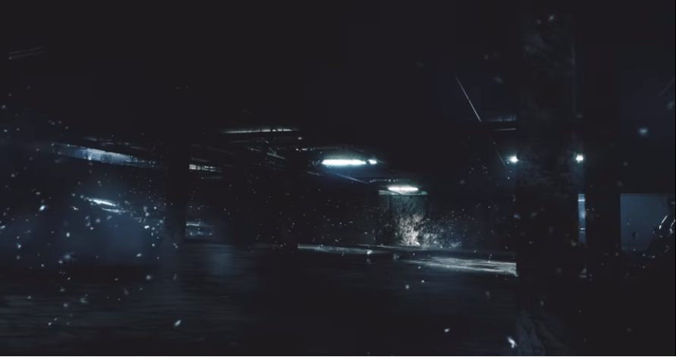
Stranger Things Upside Down world effect created in After Effects

Genre

The short film will be within the fantasy genre at its core however these elements are to exists as a symbolism of aspects of the real world, for example, the factories that are draining the life of the planet, which will be presented in a literal sense, is representative of the fossil fuel industry. With this, the short itself will focus on realism in its visuals and in the mechanics of the characters without notable elements traditionally associated with fantasy, being closer to the low-fantasy subgenre in which a magical element, in this case the magical element is the raw life energy of the planet, intrudes on an otherwise real-world environment. Additionally the short will take elements from espionage and action-horror genres, the former in its introduction with the antagonists featuring some horror elements taking the form of their movements and presentation.

Visual Elements

Camera Movement and Editing

Considering the implementation of animated computer-generated elements to the short film, camera movements will be kept to a minimum as this will eliminate the need to replicate the movements when rendering the animations, greatly saving time in the production, instead still or slow moving shots will be primarily used in the production, this also being sufficient in portraying the narrative.

This use of still or slow moving shots is also intended to lend itself to development of suspense leading up to the second act in following the lead character through the setting and avoiding the soldier characters, which is to be presented in more of a horror-like tone, in this case over use of camera movements may be distracting for the slower pace of this portion of the short.

- Fake camera movements

https://www.youtube.com/watch?v=a0rLrR0TgkQ

While focusing on primarily still of slow moving shot, with the technical benefit of this making it much easier to implement computer generated elements, the whole short won’t only be still, with some slow moving shots primarily used during where cg elements are not present. To expand on the shots with cg element, fake camera shot can be created in post-production, either in the editing of the footage in premier as this tutorial shows, or continuing this in the composition where the video can be manipulated to track the live action footage over the cg elements rather than the other way around, this will be particularly useful in the later stages of the short which will focus on green screen shooting.

Keeping with this tone, the short will make use of close to mid shots in the earlier scenes, revealing just enough of the decaying conditions of the setting, hinting towards the larger depictions of an apocalyptic world such as composting shots from the ‘point of view’ of elements that reveal this, for example the damaged environment or dead bodies, while creating an element of claustrophobia in the tight corridors the lead will be navigating, along with keeping focus on their expressions and body language as a method to develop them early in the short without this requiring a dialogue explanation.

Character Design

In keeping with the realism of the short, the designs of the lead character will focus on the use of common real-world clothing, avoiding designs typically associated with post-apocalyptic films like that of Mad Max, for example. With the lead character specifically, she is intended to follow more of the ‘everyman’ archetype, not particularly skilled or professional in the actions she is to take in the short, with that her design is intended to reflect her common status, her outfit featuring common clothing for the likes of harsh winter-like weathers. However as the environment is intended to be hostile especially with an almost toxic atmosphere, aspects of her design are intended to reflect low-quality gear, indicating they are self-made such as her gas mask.

- Silent Hill

Silent Hill is a supernatural horror videogame series centered around a town that has been affected by an ultimately unknown supernatural force although each game has this being influenced by some element of the town such as a cult or the inner fears or guilts of the central characters. A notable aspect of the protagonist in these games is that they each follow the ‘everyman’ archetype, a character made to feel like any common person, not necessarily trained in combat or other skill that would offer them an advantage to the situation their in. With the short this will be reflected in the protagonist as they are intended to be a survivor of the post-apocalyptic world although attacking the location of the setting on necessity rather than because they have the skill to do so. Similarly to Silent Hill, their ability with a gun will be severely limited as will any sort of combat they undertake.

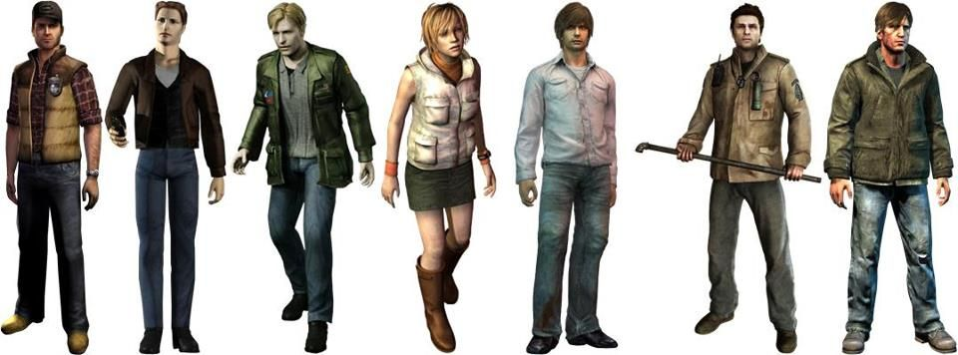
Silent Hill Protagonists

- The Road

https://www.youtube.com/watch?v=94KcI0gLq1A

The Road is a 2009 post-apocalyptic drama focusing on the journey of a man and his son in hopes to find any remnants of civilisation after a major, global catastrophe. Like with Silent Hill, the main character is not particularly skill for the apocalypse although with the situation demanding, he is able to press on. The designs of the characters here will have an influence in the protagonist of the short film as they feature everyday clothes that are generally common in the real-world with basic practicality such as thick coats for warms or walking/hiking boots that would be more hardy and comfortable for the journey of the characters. This also reflects on the commonality of the character in the short as they don’t have access to any advanced gear that would give them an advantage in the world.

In contrast to this, the antagonists of the short, namely the zombie-like soldiers, will have a slightly more sci-fi design highlighting the advancement of the world that would have been provided by the extracted energy source prior to this leading to the world's decay. Although once again in keeping the realism aspect of the design of everything, this sci-fi inspired design is intended to remain subtle, taking cues from cyberpunk fiction and namely the Metal Gear Solid videogame series in giving them their desired look of advancement but still realistic rather than futurism.
Another major focus of their design is of a military aesthetic, this intended to hint towards to the corporatist society that existed before the apocalypse with the corporation responsible for the extractor and other like it becoming the governing body of the planet, as such the guards of their facilities would also have the duel role of a militaristic police force, answering only to the corporation, providing them with their military grade gear and design.

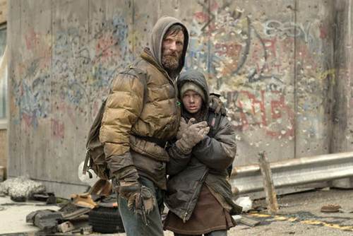

- Final Fantasy VII (Shinra Soldiers)

Another aspect of Final Fantasy VII is the soldiers that are private security/military of Shinra. As the Shinra corporation acts as the government, the soldiers act as the law enforcement of the city of Midgard in the game, as well as the military force.

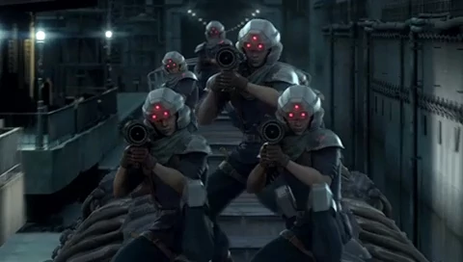

- Mirror's Edge Catalyst (Kruger Security)

http://mirrorsedge.wikia.com/wiki/Kruger_Security

Mirror’s Edge Catalyst is another game with heavy cyberpunk influences, although there is no information detailing the relationship between the government and the corporations of the game, the central conglomerate featured, the Kruger Holding firm, owns a private security sector known as Kruger Security which appears to act as the law enforcement of the city setting, much like the intent of the soldier characters of the short.

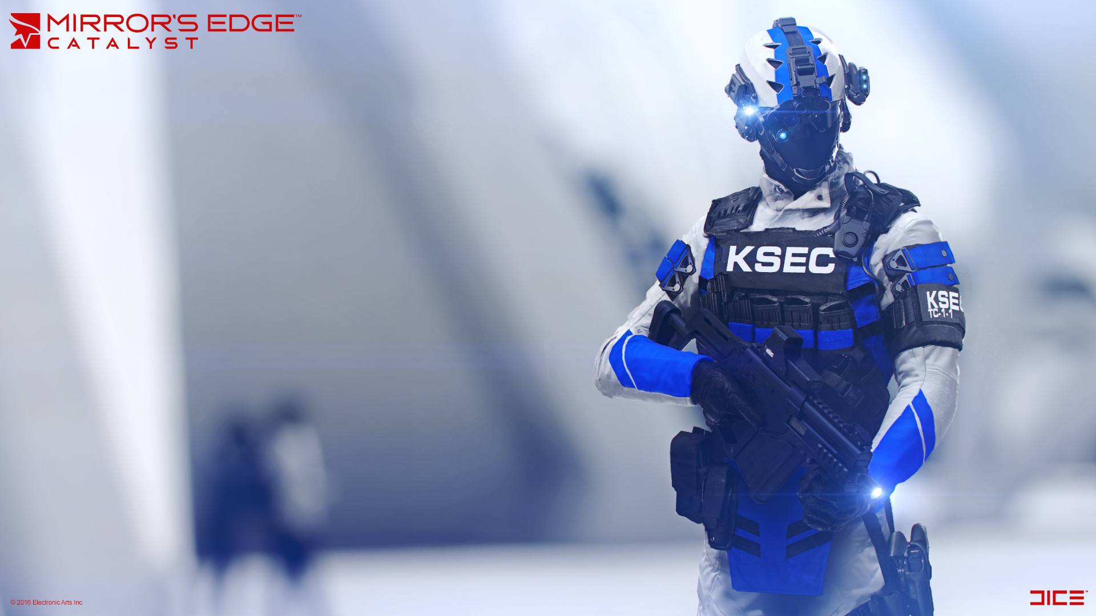

- I Am Legend

https://www.youtube.com/watch?v=aK1r7tBWnro

In the 2007 post apocalyptic film I Am Legend, the world has been destroyed due to a plague that has mutated all the humans in the world into extremely feral mutants, their movements being very animalist and aggressive. In the short film, the soldier characters will enter into a similarly aggressive feral state when pursuing the protagonist, transitioning from they’re standard stiff zombie-like movements.



Set Design

The set design of the short will focus heavily on the post apocalyptic concept. The setting itself will be an abandoned factory to represent the extractor which will offer the apocalyptic aesthetic desired for the short with minimal adjustment, however this extractor setting, while abandoned and decaying, is still supposed to be functional to a degree, continuing to extract the essence of the planet for energy through automation.

This external environment will be a major focus for establishing the condition of the world. In these shots, the scene will be presented in an almost barren desert, save for the factory itself, minimal vegetation, and surrounding ruins, these being a mix of industrial and residential which, in the story, would have been enjoyed the development of energy from the extractor. This show of the collapse of the planet will be explored further through fissures to the physical planet life energy with piping from the factory will feed into.

The particle effects to be used throughout will also see a lot of use here in the atmosphere where it will provide the effect of blocking out the sun, once again heavily linking to real world climate issues.

- Fallout (Series)

The Fallout role-playing videogame series is features a post-apocalyptic setting brought on through world nuclear war, leaving the planet in an irradiated, wasteland state, many major areas now becoming desert-like. However a major focus of the world design of these games is the transition from the pre-war world to its current state, various elements of the design linking back to this, such as pre-war technology still in some degree of function and now used by the various communities and bandit gangs that exist. While not display a world destroyed by war, this will be a great influence for the short in how it blends the pre and post war state of the world, particularly with visuals of the condition of the pre-war elements that continue to function.



