LCBB 4001 – Accounting fundamentals
Lecturer: David Jenkins
Student: Florin Daniel Baleanu 2109714

ESSAY ON ACCOUNTING FUNDAMENTALS
Table of Contents
Introduction 3
Question 1: Financial transactions of Sandrolia Limited 3
Question 2: Critical analysis of relevance using of financial statement 8
Question 3: Financial transactions of Ricardo’s Limited 9
Question 4: Comparison and contrasting with the liquidity and profitability 13
Conclusion 14
References 15
Bibliography 16

Introduction
The fundamental objective of financial accounting is to help the business maintain a complete record of all the books accurately. It is also helpful for the management to record daily transactions such as purchases, income, sales, and even other expenses. This assessment has shed light on the concept of fundamentals of accounting. The importance of financial statements, accounting standards, liquidity, and profitability has been analyzed. Furthermore, financial transactions such as income statements, the balance sheet have also been prepared

Question 1: Financial transactions of Sandrolia Limited
Financial accounting provides the management to compare their current financial transaction with historical performance (Phillips et al. 2019, p.25). Furthermore, it also helps stakeholders to understand the financial position during a year. Financial accounting consists of summarizing and recording financial transactions in accordance with their date of occurrence. According to Stone, (2020, p.25), It provides brief information about the organizational performance and helps the management in recording the transactions accurately.
The financial statement has been prepared for the business of Sandrolia Limited for the year ended 31st December 2019. There are different types of accounting that have been prepared such as journal entries, updated trial balances, and also the financial statement for that period. The list of accounts along with their performance and explanation has been mentioned underneath.
a.) Journal entries
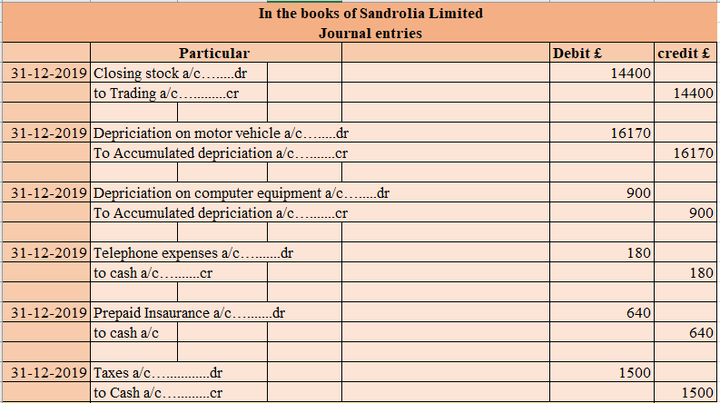
Figure 1: Journal entry
(Source: self-developed)
Journal entries have been prepared for the business of Sandrolia Limited for the following additional information. There is certainly additional information that is important for the business to consider while preparing the financial statement. This additional information is part of final accounts which will be adjusted in their respective accounts. From the above figure, the company is having a closing stock value of £14400. This balance will be adjusted in both the closing stock account and trading account of the business. There are certain other additional adjustments such as depreciation which has been calculated at £16170 and £900 respectively for both motor vehicle and computer equipment. The telephone expenses have not been recorded previously which has been recorded and adjusted.
b.) Updated Trial balance
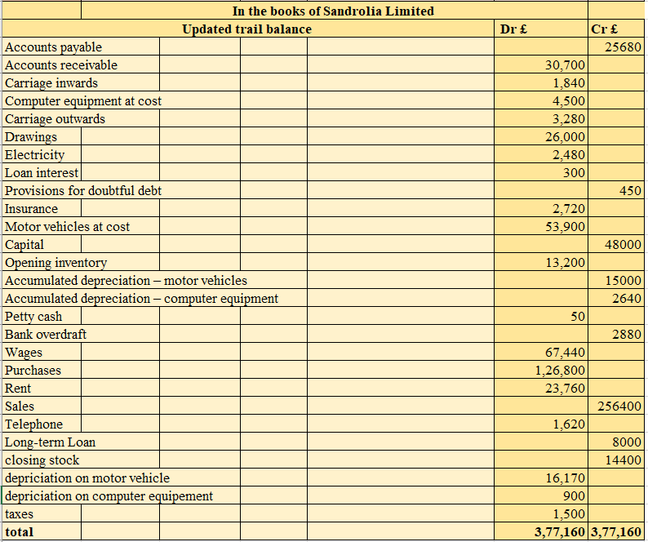
Figure 2: Trial balance
(Source: self-developed)
Trial balance is helpful for the companies to adjust their final entries at the end of the year in the respective books. The importance of preparing the trial balance is to make sure that all the entries are mentioned from the general ledger (Monte‐Mor et al. 2018, p.175). The trial balance has been prepared for the business of Sandrolia limited and from which it can be identified that the total balance is calculated at £377160.
c.) Financial statement and positions
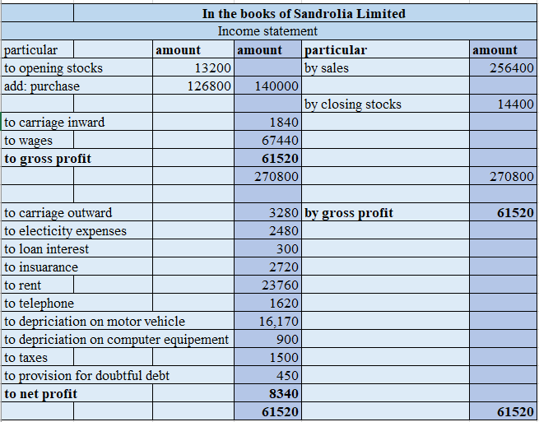
Figure 3: Income statement
(Source: self-developed)
The trading account has been developed for the company of Sandrolia Limited for the year ended 31st December 2019. From the conducted trading statement, the firm is having an opening stock of £13200 and a purchase of £126800 on the opening date. Furthermore, they have made a sale of £256400. This calculation has basically focused on the historical values that can be effective in computing the financial transactions. The gross profit of the business has been calculated at £61520. There are certain expenses that have been recorded in the income statement such as carriage outward, electricity bill, loan interest, rent, telephone, and many more. The net profit of the business has been calculated at £8340 at the end of the year. Therefore, it can be said that the business is having a good position of profit in the end of the year. However, it will be helpful for the company to find some ways to reduce their expenses and that will help them to uplift the position of net profit easily.

Balance sheet
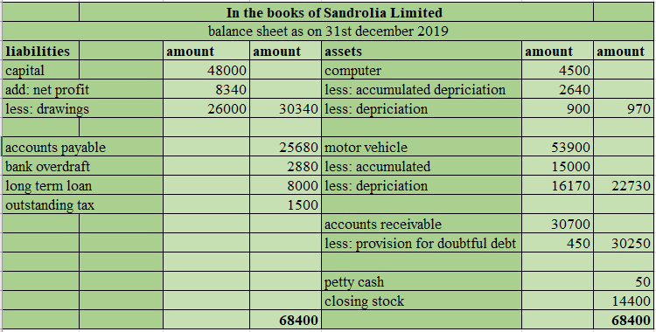
Figure 4: Balance sheet
(Source: self-developed)
The business of Sandrolia limited on the year ended 31st December 2019 has been analyzed from the final position. Similarly, the value of drawings has been deducted from the capital balance. The total balance in the capital account of the business has been evaluated at £30340 at the end of the year. The management also has certain liabilities such as accounts payable of £25680, bank overdraft of £2880, long term loan of £8000, and outstanding tax of £1500. On the other hand, the assets side of the balance sheet includes a computer of £970, a motor vehicle of £22730 at the end of the year. This balance has been adjusted after considering the accumulated depreciation, and also the yearly depreciation of the assets. The final position of both Assets and liabilities in the balance sheet is reflecting a figure of £68400.

Question 2: Critical analysis of relevance using of financial statement
The financial statement is considered as a formal record that mainly develops the financial activity in an organization. In preparation for the financial calculation, it mainly produces different types of statements for computing the financial position. In this measurement, the evaluation of the financial statement is mainly included for projecting the financial position of a firm. The measurement mainly highlighted the result of the business operation, financial position and cash flow for a firm. The financial statement is useful for computing the decision regarding the financial allocation for an organization (Dewi et al. 2019, p.1373). As per measurement, it has highlighted financial allocation for an organization. The measurement is generally prepared the financial position, statement of income, and cash flow statement. The users generally compute the financial position for estimating organization strength. The users analyze the asset with the liability to evaluate financial strength. The measurement has basically highlighted financial relevance for performing the analysis. The statement is prepared for the purpose of computing financial value and business decisions. It is also useful in determining the reduction of the key obligations that a business requires to pay. Users basically get a positive impact in taking the business decision by making an investment. The taxation decisions are also made using the statement that can be conducted using the financial value.
Using the financial statement, users mainly evaluate the financial factor by performing an analysis. Certain limitations are also associated with the financial value that can be useful for conducting the financial evaluation. Statement mainly records the financial aspects of an organization. Users get confused about the internal and external influences of the organization that cannot be measured using the financial statement. This calculation basically highlighted the historical values that can be effective in computing the financial evaluation. Users of the financial statement have failed to control the cost value. In contrast with the opinion of Hajek and Henriques (2017, p.139), Information that is provided by the statement is insufficient to analyse the current situation of an organization. The data can be manipulated while calculating the financial statement. The statement is beneficial for estimating the financial factor that is basically compared with the previous value for estimation of the growth. In order to contradict the opinion of Kim et al. (2020, p.62), users collect data about the actual expenses of the organization from statements but usually fail to get the total value of the firm. The analysis is basically used for computing the actual result regarding the financial data. The financial statement is useful for computing the decision regarding the financial allocation for an organization. The Users can only analyse the financial performance and fail to analyze the influences for an organization. For estimating the financial factor, it is also relevant for estimation of financial strength. As per analysis, it has conducted an analysis over the financial factor that does not consider the future prediction. The inflation rate is not adjusted with the financial statement. As per computing the actual value, it possesses lower compatibility with the other data.

Question 3: Financial transactions of Ricardo’s Limited
d.) Journal entries for the additional information
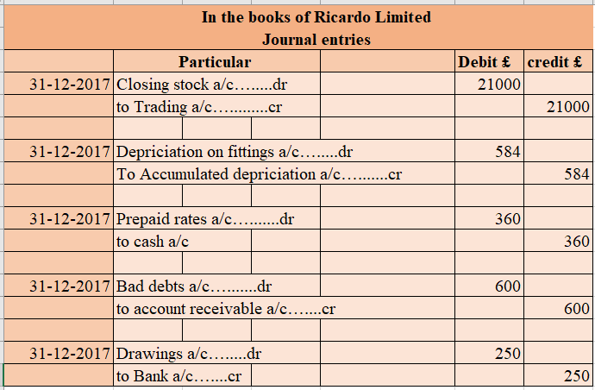
Figure 5: Journal entry
(Source: self-developed)
The journal entries have been prepared for the business of Ricardo Limited in order to analyze the additional information. There is certainly additional information that has been recorded in the books of accounts. The closing stocks of the business have been recorded at £21000 at the end of the year. Furthermore, the value for depreciation has been recorded at £584 which has been deducted from the accumulated depreciation of the fittings. The management has expected that a bad debt of £600 will occur in the books of accounts during the year. They have also made a provision of 3% against the remaining receivables. The owner of the business has taken £250 from the bank for personal use which has been treated as a drawing in the book of accounts.
e.) Updated trial balance
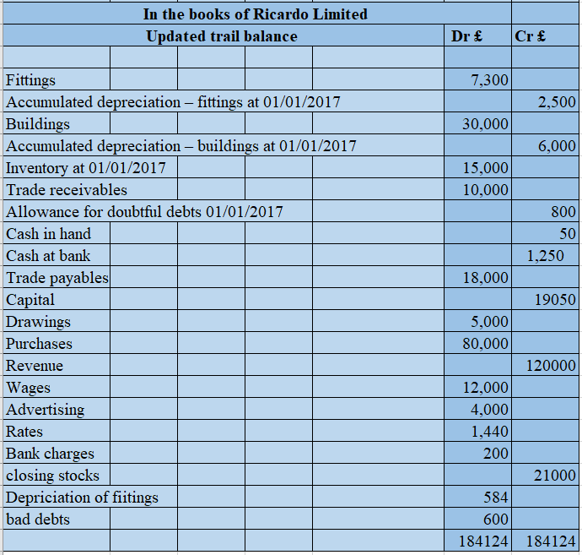
Figure 6: Trial balance
(Source: self-developed)
The updated trial balance has been conducted for the company for analyzing the final position of both the debit and credit sides of the books of accounts. The business is observed to be having a final position of £184124 on both sides of the trial balance at the end of the year. Trial balance provides brief information about the organizational performance and helps the management in recording the transactions accurately in the respective account. The final position indicates a good position of Ricardo limited at the end of the year.
f.) Income statement and final position
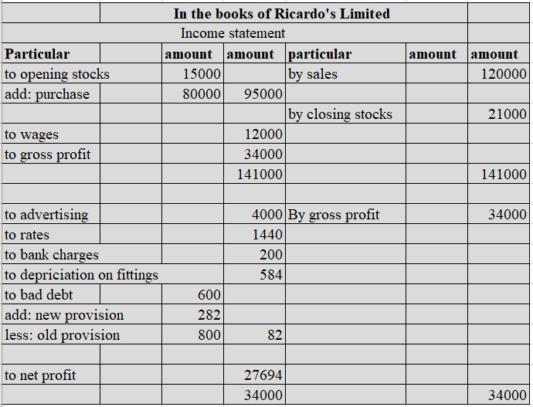
Figure 7: Income statement
(Source: self-developed)
The trading books has been developed for Ricardo Limited in order to analyze the revenue and expenditure made by the business during the year. The company is having an opening stock of £15000. They have also made a purchase of £80000 during the year which has been added to the opening stock. The revenue generated by the business during the year is £120000. The closing stock of the business has been recorded at £21000. There are certain direct expenses that have been paid by the business such as wages of £12000. On the other hand, the business has also made certain indirect expenses such as advertisement, rates, bank charges, depreciation, and even a lot more. The net profit of the business has been calculated at £27694 at the end of the year.
The financial statement of the business is indicating a positive sign as the net profit has been calculated at £27694. It will be helpful for the management to reduce certain expenses such as advertisements that will help them to uplift the position of net profit during the year.
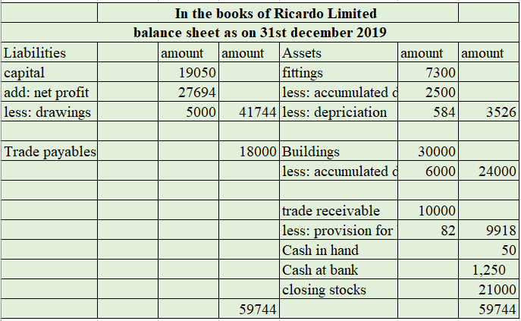
Figure 8: Balance sheet
(Source: self-developed)
The financial position has been developed for the business of Ricardo Limited for analyzing the final position of both the sides. From the above figure, it can be identified that the capital position of the business is £19050. Furthermore, a net profit of £27694 has been added and the value of drawings of £5000 has been deducted. The final position of capital has been calculated at £41744 in the financial position. The value of trade payables in the books of account has been recorded at £18000. On the other hand, the business is having certain assets such as buildings, fittings, trade receivable, and cash balance. The value of fittings and fixtures has been recorded at £3526 after deducting the accumulated and yearly depreciation from it. Similarly, the closing balance of the building has been recorded after deducting the accumulated depreciation of £6,000. The balance of building at the end of the year is £24000 and trade receivable are £9918.

Question 4: Comparison and contrasting with the liquidity and profitability
Liquidity is defined as the ability of the organization to convert the asset value into cash. It mainly evaluates the position by raising its cash when the cash is needed. It usually highlights the ability to liquidate the cash value using the asset to reduce the short debt (Chen et al. 2018, p.164). The liquidity of an organization is usually measured by computing the cash value and also the portion of the current asset. The projection of current assets mainly measures the ability to minimize its debt margin.
It is the amount of money that is generated by making investments or selling products. Profitability is measured with the help of income and expenses generated during a year. Profitability is important as it describes the increase or decrease in the equity position of a business (Sari and Sedana, 2020, p.116). Moreover, the management can easily make growth opportunities, market trends with the help of profitability.
The comparison of liquidity and also profitability is mainly measured by the earnings and also the expenses of an organization. Liquidity basically highlights the strength of mitigating the short loan in a firm. It is also useful in determining the reduction of the key obligations that a business requires to pay. It is basically a parameter of how fast the company is able to liquidate its asset margin. As per measurement, the profit of an organization is considered as the liquid value that is basically useful for computing the financial projection. Insufficient liquidity can bankrupt a short-term organization. Profitability is used for estimating the business success that is considered as an indication of the financial measurement. On the other hand, estimating the cash position usually computes the cash balance of the cash flow. The profitability is considered as a parameter of business performance that is mainly indicated using the income statement and also the other reports (Zuhroh, 2019, p.203). Liquidity is basically estimated as the ratio and also the cash flow for evaluating the cash position of a firm. The balance value is used for the estimation of the strength of the business.
The measurement has basically highlighted the financial data that positively computes the strength of an enterprise. In order to compute the liquidity, it basically computes the cash flow to project the ability of the working capital. The financial statement projects the profit and also the value of cash in different ways. The statement is prepared for the purpose of computing financial value and also business decisions. As per comparison, profit value is basically estimated earnings that are effective in the evaluation of profitability. On the other hand, companies compute the cash balance in different ways for estimating the financial factor that is measured the actual value. In this process, it has basically included cash projection that has evaluated the liquid strength for mitigation of debt. Furthermore, it has also reflected the financial value that is determined over the financial statement. The statement basically separates the profitability and also liquidity to project the earnings and liquid cash in a different way.

Conclusion
This assessment can be ended by the concept of fundamentals of accounting that have been used to prepare the accounting statements. There are different types of financial statements that have been prepared such as journal entries, trading accounts, and many more. Accounting fundamentals is an operational strategy that is used by the business for managing financial activities. The assessment also includes the primary objectives of financial reporting and the importance of liquidity and profitability of the business. It is helpful for the management in maintaining the business in accordance with the rules and regulations easily. Therefore, it can be said that the fundamentals of accounting are helpful in analyzing the books of accounts and making financial reports accurately.

References
Chen, C.W., Collins, D.W., Kravet, T.D. and Mergenthaler, R.D., 2018. Financial statement comparability and the efficiency of acquisition decisions. Contemporary Accounting Research, 35(1), pp.164-202.
Dewi, N., Azam, S. and Yusoff, S., 2019. Factors influencing the information quality of local government financial statement and financial accountability. Management Science Letters, 9(9), pp.1373-1384.
Hajek, P. and Henriques, R., 2017. Mining corporate annual reports for intelligent detection of financial statement fraud–A comparative study of machine learning methods. Knowledge-Based Systems, 128, pp.139-152.
Kim, J., Kim, R. and Kim, S., 2020. Does financial statement comparability mitigate delayed trading volume before earnings announcements?. Journal of Business Research, 107, pp.62-75.
Monte‐Mor, D.S., Galdi, F.C. and Costa, C.M., 2018. The role of accounting fundamentals and other information in analyst forecast errors. International Finance, 21(2), pp.175-194.
Phillips, F., Libby, R. and Libby, P., 2019. Fundamentals of Financial Accounting, 6e.
Sari, I.A.G.D.M. and Sedana, I.B.P., 2020. Profitability and liquidity on firm value and capital structure as intervening variable. International research journal of management, IT and Social Sciences, 7(1), pp.116-127.
Stone, E.J., 2020. An Analysis of the Fundamentals and Professional Applications of Financial Accounting.
Zuhroh, I., 2019. The Effects of Liquidity, Firm Size, and Profitability on the Firm Value with Mediating Leverage. KnE Social Sciences, pp.203-230.

Bibliography
Beerbaum, D., 2020. Benchmarking and best-practice analysis in Financial Accounting–the case of Related Party Disclosures. Journal of Applied Research in the Digital Economy (JADE).
Demerjian, P.R., 2017. Calculating efficiency with financial accounting data: Data envelopment analysis for accounting researchers. Available at SSRN 2993687.
Dunn, L.N., 2018. The Fundamentals of GAAP: Case Studies of Accounting Principles.
Garbowski, M., Drobyazko, S., Matveeva, V., Kyiashko, O. and Dmytrovska, V., 2019. Financial accounting of E-business enterprises. Academy of Accounting and Financial Studies Journal, 23, pp.1-5.
Gomez, S.M., 2019. ACCT 115-003: Fundamentals of Financial Accounting.
Inuwa, U., Abdullah, Z. and Hassan, H., 2018. A Mixed-Method Study of the Effect of the Demonstration Method on Students' Achievement in Financial Accounting. International Journal of Instruction, 11(4), pp.577-592.
Kachelmeier, S.J., 2020. Financial Accounting and Auditing Experiments in the Journal of Accounting Research: Historical Background and Recent Advances. Journal of Accounting Research.
VILLARREAL, J.L. and CÓRDOBA MARTÍNEZ, J.X., 2017. FUNDAMENTALS FOR THE STUDY OF RESEARCH FLOWS IN ACCOUNTING. Tendencias, 18(2), pp.139-151.

