Matthew Jones
Student Number 1501100:
Wordcount:1478
How technology has accelerated the growth, expansion and replacement of traditional businesses

Goals and objectives:
- How and why has technology affected the traditional business
- What business benefited greatly from a surge or technology
- Has technology affected the was business tech a skill
- What has this growth, expansion and replacement done to the global and local economy
In order to achieve my goals and objectives I will be conducting a literature review, Looking at many different theory’s by different authors on the effects of technology on the traditional business as a whole. Then expanding on those findings and understanding has it changed the business environment for the better or worse. I would also like to use first hand research by interviewing smaller businesses to get their take on the technology aspect and how they dealt with or rose above the struggle to stay ahead in an ever growing market.
After collecting all this data and first had experience I will have a great deal of understanding for the topic and this will hopefully allow me to achieve all of my goals and objectives. With all this knowledge this in the end will allow me to answer the definitive question “How technology has accelerated the growth, expansion and replacement of traditional businesses”.
Introduction:
Has technology changed the business environment for the better or worse that is the basis for my dissertation with the question being “How technology has accelerated the growth, expansion and replacement of traditional businesses” the reason for this is that I have an interest in how technology has changed the traditional business by this I mean has I bettered it has it made it worse has technology been the downfall of the high street these are things that are going to be covered. The main focus points are going to be has the internet had an effect on traditional businesses in the high street, Has it changed the way people learn new skills making classes redundant, How much did the internet expand the revenue generated by a business who transferred from traditional business methods to an online store.
I would also like to talk about things such as how has things like websites and video sharing platforms such as YouTube changed the conventional way of learning and how they have affected businesses that sell a skill learning workshop.
Some personal research objectives I would like to achieve are:
- Better my understanding of the technological world and how it has changed the traditional business for the better or worse.
- What percentage of small businesses go under within the first year if they do not utilise things such as social media and marketing.
- Understand each angle and don’t be blindsided with an opinion going into the research.
Review of relevant literature:
Many authors have stated that technology has benefited the entire business environment and others talk about the struggle it has put upon systems that where struggling before the advancements these advancements have brought upon changes that may not have been needed if technology did not advance. Technology has changed every aspect of business from marketing to the legal side below is an extract from Schess, Esq., Nancy B. (2013) and it talks about how the business environment has changed legally due to the advancements in technology.
“As technological advances have come into the workplace and become commonly used, they have challenged existing legal principles requiring the re-examination of traditional rules regulating workplace behavior.”
There are businesses that operate globally that would not have the option if technology was not so readily available businesses such as Facebook these businesses would not have been created without the technological advancement there will be a much more advance detail of the effect of technology on internet business and social media as a business and how these social media sites operate as a business.
“The rise of social networking has figuratively shrunk the world and now users can connect without regard to geographical obstacle, financial background, or even social status.”
Extract above from Scott Olson (2016)
One point to touch on very lightly as there will be a lot more detail in the dissertation is how the internet and technology advancements have affected the local high street an extract from ukbusinessinsider (2017): “The decline of the High Street means local shops and local jobs disappearing. The number of people working in retail shop floors across Britain fell by 2.4% in the first quarter of 2017. For many people, the decline is also a blow to local communities.” This shows the impact that online selling has had on local communities in terms of locally generated income and also local jobs.
The research strategy and methodology:
Due to the fact that I am going to be dealing with a lot of figures and statements there will be a quantitative and qualitative study the reason for this is that for an in-depth look at how this has actually benefited or worsened the traditional business I would like to get a plethora of data and first hand interviewing to understand what peoples outlook is on the topic. “The research design refers to the overall strategy that you choose to integrate the different components of the study in a coherent and logical way, thereby, ensuring you will effectively address the research problem; it constitutes the blueprint for the collection, measurement, and analysis of data.” De Vaus, D (2006)
For the quantitative study there will be a questionnaire of three or more options consisting of 30 to 40 questions with a minimum of 50 people to answer the questionnaire the purpose of this is to get a blanket opinion of a decent amount of people this I would like to create into a visual representation using excel or a programme like that. Some sample questions I would like to ask would be:
- Has the advancement in technology and the internet effected your business
- What has been the biggest change for you since technology has advanced

Ethical consideration:
Ethical consideration is going to be vital when it comes to doing my primary research using interviews and also questionnaires the reason for there being a big push on these interviews and questionnaires being ethical is so that the people doing them can feel more comfortable knowing they are being treated correctly thus allowing them to speak more openly allowing me to gather a database of knowledge that is more accurate and also that will be more beneficial to my research.
The interviewees will have the option to have their interview be anonymous but for my research I would prefer to have a name and a business to put them with but they do have the option to be anonymous the interviews will also be taped the participant will be informed before the interview the purpose for this is so they do not feel they have been misled. The questionnaires are going to be anonymous but the participant can put their name on it if they so wish the reason for this not being gravely important is due to the fact that questionnaires are being done to just get a great deal of information back and then that can be studied and made into charts for easier understanding.

Planned timetable:
Below is a timetable of my proposed structure for the research and writing of my dissertation like a great Spanish writer once said “To be prepared is half the victory” said by Miquel de Cervantes that quote is something that will help me on my journey with this dissertation because preparation is key with projects and having a planned timetable of the way I shall be preparing for this is going to help keep me driven and motivated also it will keep me on track as I know what I will be doing each week.
The purpose of this timetable is to keep myself on track but not get so caught up that I miss out on ways of bettering the dissertation and also bettering my own knowledge therefore I am going to stay on this as a weekly thing but every other week I would like to step out of the routine and learn something new that will ultimately better the content of my work.

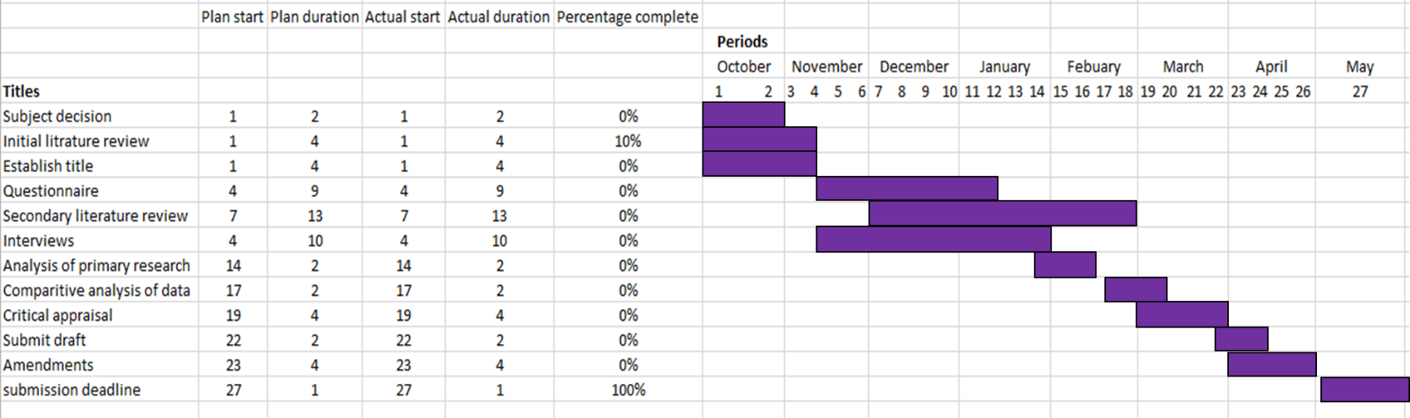

Reference list:
Schess, Esq., Nancy B. (2013) "Then and Now: How Technology has Changed the Workplace,"Hofstra Labor and Employment Law Journal: Vol. 30: Iss. 2, Article 7.
De Vaus, D. A. Research Design in Social Research. London: SAGE, 2001; Trochim, William M.K. Research Methods Knowledge Base. 2006.
Oscar Williams-Grut. (2017). 'What we're seeing is a revolution': How the internet is remaking the British High Street. Available: http://uk.businessinsider.com/future-british-high-street-internet-brexit-retail-2017-8. Last accessed 6th Nov 2017.
Scott Olson. (2016). Eight Ways Technology Is Changing Business. Available: https://appdataroom.com/eight-ways-technology-changing-business/. Last accessed 6th Nov 2017
Wiki. (2017). Miguel De Cervantes. Available: https://en.wikipedia.org/wiki/Miguel_de_Cervantes. Last accessed 6th Nov 2017.

