

ACCA4018

Synthesize A Solution to A Potential Real-Life Scenario

By
Rebecca Ryall
1705433



Table of Contents
Table of Figures 2
Introduction 3
Related work (research aspect/literature review focus) 3
Problem formulation 4
Advantages of using BYOD 4
Disadvantages of using BYOD 4
Implementation 6
Results/findings & discussions 9
Conclusion 9
References 10
Appendix 11
Draft Information Protection Policy 11

Table of Figures
Figure 1 - hyper fork 6
Figure 2 - company Devices 7
Figure 3 - Bring your own devices 8
Figure 4 - three layer 8

Introduction
In this document there is information to do with BYOD (bring your own devices) and BYOT (bring your own technology) and what is it all about, why is it used? also, how it is changing companies, if introducing BYOD is a good idea for various companies and is it the future. Is it safe or does it possibly present a serious security risk, by allowing the employee to access client’s personal files and even clients be able to access the company’s information that is held about the client on their own devices? what policies should be put in place to protect the employee and the clients? As well as protecting the company on its rights to withhold information.

Related work (research aspect/literature review focus)
Bring your own device is quickly becoming a new trend in work places, employees wanting to use their own devices at work because they feel more comfortable using their own computers, technology keeps improving so much so that smart phones are no long used to only make phone calls. but are now capable of much more and are nearly as advanced as a computer, More and more companies are supplying their employees with smart phones to be used for business. Most companies are introducing BYOD where employees used their own personal smart phone to make business calls and to send emails[1], while other companies are introducing BYOD where their employees bring their own personal devices like laptops, notebooks, and tablets to work allowing employees to be more efficient. Due to the employees being able to work anywhere at any time[2], another reason for companies adopting this idea is that it can lower the cost of training as the employees already have knowledge using their own device. it can even lower the cost of maintenance and the expense of upgrading old hardware[2]and software licensing.
There is a lot of benefits to BYOD but one of the more important risks that it raises is the potential to be a major security risk, making it likely that sensitive files maybe to do with either an employee’s personal data or the company’s restricted files could be revealed[1].
Because the information company’s hold is so valuable and confidential making it a very important asset [2], every company thinking about implementing BYOD should always apply high-security standers and make sure they are being executed correctly. to help protect against any threats possibly even malware, accidental loss and criminal intend like ransomware and theft.

Problem formulation
The BYOD policy will only be supporting mobile devices on android and windows 10 the reason for this choice is android is more compatibly with windows then apple devices. The reason all laptops and tablets need to be running Windows 10 is because any devices running on an older system, will not be able to run the advanced antimalware software correctly by not being able to support the updates that are needed to be running the software effectively. The main priority is to ensure that all devices connected to the network are compatible as well as screened for any viruses, so the reasoning for my decision is supported by the possible risk rising with the use of older or non-compatible phones. The choice of not use Apple phones, apple laptop or apple tablets it due to the knowledge that well most viruses are not compatible with Apple software, can still be held on the device and when the device is connected to the network could then infect many other windows devices.

Advantages of using BYOD
- Employee content being able to be adaptable with their work.[3]
- Familiarity with there own device
- Low cost due to less hardware maintenance and software licensing
- Flexible work times
- Work location no longer limited

Disadvantages of using BYOD
- The risk of losing confidential files
- Disgruntled employee misusing company files
- Location limited to internet connection

What type of data is retained by the mobile devices connecting to Hyper-fort network?
When it comes to BYOD scheme there are many things to think about, as well as what must be considered like what kind of information could be retained on the employee’s personal mobiles, that are used under the BYOD scheme. mobile phones are no longer just used to make phone calls but can be used for many things in the business world. Mobile phones are now smartphones making them much more like computers. They can do just as much and sometimes used a lot more frequently than computers because of their small size, communicating to others as never been so easy or so fast. Because how advanced smartphones are these days they can hold a lot more sensitive data like client account numbers as well as client files with all there details also contact information.

What is the potential for data when the participating devices leaves the office environment?
When it comes to the BYOD scheme there is many benefits but also a large security risk of data being leaked[1]. Because even though employees being able to take there work home on their own devices can help with productivity. It may also higher the chances of the devices being lost or stolen, therefore once the devices are lost or stolen the data stored on the device is irretrievable. It’s more likely to be stolen when the device is out of the office because the lack of security well employs travel between work and home. Or from the employee’s home which then can damage the company with data being lost or misused tarnishing their reputation and resulting in a loss of business.
How to address the blending of personal and business usage when devices are in office.
To help prevent employees using the devices under the BYOD scheme for personal use other than work, each laptop will be set up with to account personal account and work account. the personal account will not be able to be connected to the company’s network so will not have any internet access, to help employees stay focused as well as to keep them from any temptation to miss use their laptop in the workplace.

What strategy to deploy to deal with different brands of devices.

The type of manufacturing bands name is not set to any particular bands, but the devices must abide by the BYOD policy. The devices cannot be an apple product because their operating system is not compatible windows 10 or android, so any devices not running Windows 10 or Android will be in confliction with the BYOD policy.

What strategy to deploy to deal with different Operating System platforms.
What strategy to deploy to deal with different application on user devices.

the reason for only using windows 10 and Android is to prevent any future issues with different operating systems platforms such as company-based applications not being compatible with employee’s personal devices. By limiting which operating systems are acceptable on the BYOD scheme to two main platforms lowers any risks of file errors caused by conflicting programs such as e.g. word, pages and Smartsheet not being able to be opened on a different device.
What mitigating strategy will be deployed when the owner of a participating device leaves their employment, or the device is lost, stolen, or fails.
If for any reason any employee under the BYOD scheme terminates there employment for either retirement, chooses to change their job or if they are fired/ let go, the employee must bring in all devices used under the BYOD scheme to have all company files to do with client files removed and to have the work account to be deactivated, to also have all there logins details for the company to be removed from the network.

Implementation
Cisco Packet Tracer Executable 7.1 used
The switch and router passwords is cisco and secret is class.
The reason for the uses of a packet sniffer was through researching and finding that packet sniffers can help diagnose network issues[4] which can allow the company to stay on top of any problems with their own network and fix them internally.
To help strengthen the security there are two ASA firewalls to help prevent against any cyber-attacks, as well as all switches and routers being password encrypted with a warning if anyone attempts to access them from outside the company. The message shows the following (Unauthorized access is strictly prohibited and prosecuted to the full extent of the law) to be used as a deterrent to cyber criminals. The visual network plan for the company is shown in figure 1 the section shown in figure 2 is the company’s assets such as company owned computers and printers and phones, and the section shown in figure 3 is the network set up for the bring your own devices to work scheme. Set up for either laptops and smart phones to help keep the company connected, but to also keep the company secure and protected all devices owned by the company or under the BYOD scheme are connected to the internet through two firewalls shown in figure 4.
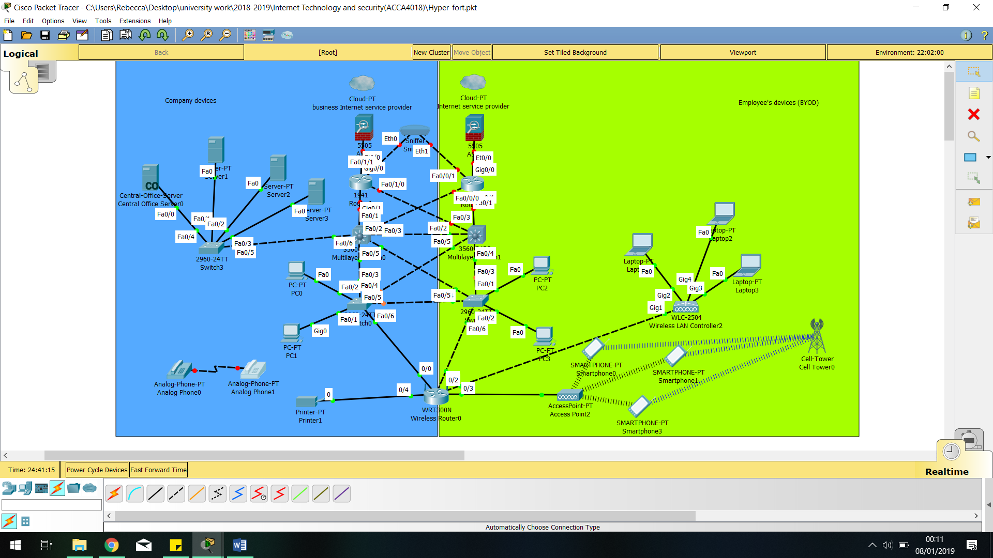
Figure 1 - hyper fork
What is also displayed in figure 2 is the server section which is comprised of individual servers to handle all the company’s data as well as the company’s internal emails and there DNS servers. A web server to help with the company’s social interaction as well as the company handbook, they are housed in a separate department and maintained by the IT support. To help keep them protected against viruses brought in to the company from any non-company computers or devices, that maybe being used by employees or clients under the bring your own devices scheme.
Figure 2 - company Devices
The employee must login to their work account on their devices and once connected to the network, can then attempt to access the servers but before they can start downloading or opening files the network needs to be sent a request. The request must be specific asking for a particular file number or account details using the client reference number and only once the request has passed through two firewalls successfully can they access company files.
When it comes to clients wanting to access their account under the BYOD scheme the client cannot access the network without going through some security measures. The client must have their own private login details, as well as if the client login in from outside the company they will need to be granted access by a member of staff. If the client needs any help managing their account a member of staff can help explain to the client by monitoring their actions as well as remote access on the client’s devices to help assist the client.
The company owned devices all also protected with a firewall to help avoid against the servers getting infected with any malware as well as having multiple backups off site to protect company files, the whole network is connected to a sniffer shown in figure 4 to help diagnose any issues to do with the company’s network. each switch is setup to only be accessed by the IT support department by being password encrypted and to show a warning if attempted to be accessed by anyone other then the IT support department. all routers are setup and configured with the same security level, each computer is connected to the network and can communicate to one another using the company’s internal email. The telephones are setup to a communications system allowing multiple incoming and outgoing calls, also being able to handle internal calls making it easier to connect to different departments within the company.

Figure 3 - Bring your own devices
When it comes to the bring your own devices scheme with all laptops and tablets all being connected to the network in the same way. Using wireless connection on all the devices instead of wires will help to lower costs by not needing to setup wire installation in the offices using the BYOD scheme. While with the smartphones they are needed to have a different setup to connect to the phone line, because they need to be close to a cell tower to connect to their particular network to then receive a strong enough signal to be able to make calls. The smartphones are connected to a switch to access the network to allow the employer to download files needed to contact any clients.
Figure 4 - three layer
In figure 4 the network is connected using the three layer system the top layer being the Core well the middle layer being the Distribution and the bottom layer being the Access

Results/findings & discussions
Through researching the risks of cyber attacks in businesses the findings were that businesses be it larger or small are frequently defending against cybercriminals whom are trying to gain access to the files and confidential documents. company’s hold many different types of sensitive information on their numerous clients making them a target, these finding showing how important it is to prevent against any attacks as well as having multiple backups on site and off site to help protect company information from hackers. Hackers aim to destroy data that would be irretrievable without copy’s [5] when it comes to the BYOD scheme is an idea that seems to be growing in popularity[6][3]. BYOD is not only able to be implemented by small companies but is also designed with large companies in mind [2].

Conclusion
Looking through the positives and negatives of the bring your own devices scheme and found there are many positives to introducing BYOD in to the company, for instance the lowering of cost of upgrading hardware and maintaining devices as well reducing the amount of payed licencing for software. Even though there are much more advantages then Disadvantages about having employees bring their own devices in to the work place, but there is still a large risk of data being lost or the potential of files being stolen because of the employees being able to take confidential files of client’s home on their personal devices. With that being the most problematic risk to the company there are strategies that can be put in place to lower the risk by having a more strengthened security put in place and maintained, with that in mind through the findings would suggest that by implementing BYOD scheme would be beneficial to the company by improving productivity. Due to the factor the company’s network is 95% wireless based and by the company also using cloud services to distribute IT services to clients and employees means by applying the BYOD scheme would be make easier because the staff are already trained to download the files, they need on to what devices there using if the company chose to implementing parts of the policy in Appendix. the company would not be responsible for any cost of any replacement for any of the employees devices, but would reserve the right to gain access to their devices to install advanced anti-malware software before they can connect to the company network. The idea of how the network would support the BYOD scheme is shown in figure 1 and shown in figure 4 is the three layer systems which is design to support the added follow of users such as staff and clients.

References

[1] S. Tanimoto, S. Yamada, M. Iwashita, T. Kobayashi, H. Sato, and A. Kanai, ‘Risk assessment of BYOD: Bring your own device’, in 2016 IEEE 5th Global Conference on Consumer Electronics, 2016, pp. 1–4.
[2] N. Fani, R. von Solms, and M. Gerber, ‘A framework towards governing “Bring Your Own Device in SMMEs”’, in 2016 Information Security for South Africa (ISSA), 2016, pp. 1–8.
[3] D. Evans, ‘What is BYOD and why is it important?’, 2013.
[4] ‘What is a Packet Sniffer? | Kaspersky Lab US’. [Online]. Available: https://usa.kaspersky.com/resource-center/definitions/what-is-a-packet-sniffer. [Accessed: 10-Dec-2018].
[5] R. E. Crossler, ‘Protection Motivation Theory: Understanding Determinants to Backing Up Personal Data’, in 2010 43rd Hawaii International Conference on System Sciences, 2010, pp. 1–10.
[6] J. Bratthall Tideman and J. Lindström, ‘Key components when utilising BYOD within organisations - A framework for developing the BYOD policy’, 2018.
[7] T Wake CISSP CISM CEH, ‘Information Protection Policy – Template’, 2011. [Online]. Available: https://www.halkynconsulting.co.uk/security-resources/downloads/information_protection_security_policy_template.doc. [Accessed: 15-Nov-2018].

Appendix

Draft Information Protection Policy [7]
Policy statement
This document is to be reviewed every 12 months the purpose of this policy is to protect the companies interests when introducing BYOD scheme as well as helping employees understand what is covered in this scheme
Definition
BYOD scheme
Risks
- Possible leak of data either company files or client or employee’s personal data
- Disgruntled employee misusing company confidential files
- Corrupt files and infect company server with malware

Applying the policy
Management
Policy compliance
Employees wanting to use the BYOD scheme will bring in the devices they wish to use to be check for viruses to have anti-malware software installed.
Then have their devices set up with two users accounts one account used for personal use and second account used for company business, all files stored on the business account are encrypted and the business account password protected.
The files downloaded on to the business account cannot be transferred or copied to any other devices or flash drives other than uploaded to the company server.
if the employee leaves the company for any reason be it retirement, made redundant or fired the employee must bring in all devices under the BYOD scheme to have the business account deactivated.
The IT department will maintain employee’s devices but are only responsible for the up keep of the anti-malware updates and password protection and encryption on the business account.
Any hardware problems with the device will not be covered nor will there be replacements of employee’s personal devices.
Review and revision
- Policy discussed and checked for any changes every year

marking criteria and Student FEEDBACK

This section details the assessment criteria. The extent to which these are demonstrated by you determines your mark. The marks available for each criterion are shown. Lecturers will use the space provided to comment on the achievement of the task(s), including those areas in which you have performed well and areas that would benefit from development/improvement.

Common Assessment Criteria Applied (Assignment 1) | Marks available | Marks  awarded
1. Research-informed Literature
Extent of research and/or own reading, selection of credible sources, application of appropriate referencing conventions.
Evidence of background reading and good critique/analysis of literature. It would be good to see more references from journals/conference proceedings as this would add more credibility to your work. You can access many journals from the online library - https://www.uwtsd.ac.uk/library/online-library/, IEEE and ACM are the main ones for computing (Grade mark: 73.33%) | 15 | 11
2. Knowledge and Understanding of Subject
Extent of knowledge and understanding of concepts and underlying principles associated with the discipline.
You have demonstrated knowledge of the underlying concepts and principles (Grade mark: 73.33%) | 15 | 11
3. Analysis
Analysis, evaluation and synthesis; logic, argument and judgement; analytical reflection; organisation of ideas and evidence
Your report discussed most of the required criteria for this work. You have not done a written policy and a DFD. (Grade mark: 70.00%) | 40 | 28
4. Practical Application and Deployment
Deployment of methods, materials, tools and techniques; application of concepts; formulation of innovative and creative solutions to solve problems.
A very detailed and designed implementation. However your layer 3 switches do not have countermeasures implemented. (Grade mark: 85.00%) | 20 | 17
5. Skills for Professional Practice
Attributes in professional practice: individual and collaborative working; deployment of appropriate media; presentation and organisation.
A well written work but some areas need formatting. (Grade mark: 70.00%) | 10 | 7

Assignment Mark (Assessment marks are subject to ratification at the Exam Board. These comments and marks are to give feedback on module work and are for guidance only until they are confirmed. ) | Late Submission Penalties (tick if appropriate) |  | 74%
 | Up to four weeks late |  | 74%
 | First Attempt? |  | 74%

