A Guidance Handbook for Early Years
keyworkers during childhood
transitions.



Transition Images, (2021)

Contents Page No

- Introduction: Transitions in the Early Years 3
- The Role of the Adult 4-5
- The Needs of the Child 6-7
- Environment 8
- Partnership Working 9
- Interventions 10-11
- Proposed Outcomes 12
- Reference List 13-15

Introduction

Aim
The aim of this handbook is to give valuable information about early years transitions to early years practitioners. In this handbook it will give information about the role of the adult, the needs of a child, the learning environment, partnership working, interventions and proposed outcomes. This handbook will also be looking at the meaning of transitions. This will help to make children’s transitions go as smoothly as possible.

Transitions
What is a transition? “The word ‘transition’ is regularly used in human services to refer to the general process of someone growing up or moving from one set of services to another”, Multiple System Navigator (2020). The purpose of this handbook is to provide information about transitions looking specifically at the transition from nursery to reception as this transition is a noticeably big step for children.
When a transition is taking place, everyone needs to be involved, the parents of the child, the carers of the child, the teachers, and the practitioners. According to Gunning. (2020) it helps to have conversations and good communication with the parents, carers, children, any additional agencies involved, future and current teachers, keyworkers and practitioners. Carrying out these actions requires for the adults to be organised and to have a clear plan and agreement policy.
For children change is an important thing and they can find transitions challenging in many ways. It is incredibly important that early year’s practitioners are aware of their role to support these transitions. According to Walker. (2019) practitioners must develop polices and procedures to ensure that the children are happy and to ensure that the child’s transition is going smoothly. The following checklist includes the key areas in which they need to consider when the child’s transition is happening which includes the policies and the procedures.

The Role of the Adult.
Parents
The role of the parent is essential in transitions. The place the child is having the transition in, and the parent need to have honest communication. The parent should get informed by the setting the child is in on how the child’s transition is going. Therefore, if the communication is correct between the parent and the setting it will help for the child’s transition to run smoothly. “Strong, respectful relationships between parents and practitioners lay the foundation for positive transition. For the practitioner, a genuine dialogue with parents provides information, affording opportunities to extend ideas and educational experiences within the setting” Patel (2021).
Keyworkers
According to Walker (2019) during transitions developing a secure attachment with a keyworker is essential. Early Years practitioners have an important role with supporting the children when they are struggling and feeling different kinds of emotions. A way of helping to make the transition easier is to keep familiar routines for the children as this can help reduce anxiety.
The children rely on us adults as childcare practitioners to help make the transition as trouble free and as smoothly as possible. As a keyworker you would be observing the child to find out what the child’s likes, dislikes and interests are. The keyworker must have good communication with the parents or carers as they both would be spending the most time with the child, therefore they can help each other to provide what is best for the child. Keyworkers are more likely to be able to pick up on any disabilities and be able to read their body language more as they are trained in that specific area. The child needs consistency, and the child needs to feel safe around these people and have familiar faces around them for the child to learn and develop successfully. The key worker is an essential role in which they are helping to develop a positive relationship with the children’s parents to help make sure the child feels comfortable in the school setting and confident during their transition.

Role Model
Children tend to pick up on a lot of things, therefore you must be a good role model by showing them what is right and what is wrong. By being a good role model, you must ensure you are showing kindness towards people, using the correct language around children, and by showing respect. According to Michigan State University (2015), through the process of modelling children can learn aggressive behaviours just by observing the behaviour, if it is through live models or even by watching television. If this aggressive behaviour is shown often the child is likely to pick up on it and imitate them. Therefore, whatever you are doing you have to consider what the child would be thinking and what the child would be picking up on.

Setting Manager
The responsibility of the setting manager is to ensure that everything is in place correctly with clear policies and the correct procedures in place. The role of the setting manager must ensure that all the children are getting treated right and that no child is at a disadvantage. They are also in charge of all health and safety and making sure it is a safe environment for the child to learn in. The setting manager has responsibility for safeguarding of the child and must report to the appropriate authorities if necessary. According to Early Years Alliance (2018) safeguarding includes- protecting children from maltreatment to always keep the children safe, ensuring children are healthy and their development is going correctly, ensuring children grow up with consistent care, love and safety and taking action to enable all of the children to have the best possible transition and outcome.

The Needs of the Child.
To be able to meet a child’s needs you must understand that every child is different, and every child has different needs. For practitioners to be able to do this, they must get to know the child to know what the child enjoys doing and know what the child’s interests are. All children learn at different rates therefore some children may struggle with counting whereas some children may already be able to do this. According to GOV, “this is part of normal childhood development and may just indicate that, with minor adjustments to the teaching methods, or the provision of small amounts of support, encouragement and additional help, good progress can be made”.
Therefore, the keyworker must have a good relationship with the child to know if the child needs that additional support. It is important that the keyworker picks up on any additional needs at a young age so that the child can get the attention and help they need. To have a good relationship communication is essential. Sometimes communication can be very difficult with a child. This can be due to many different reasons, for example, with early years children some children may have no speech, they could be feeling very anxious or overwhelmed when they are meeting new people. Therefore, as early years practitioners we should be able to pick up on when a child is feeling like this and know how to adapt to help the child feel more comfortable.
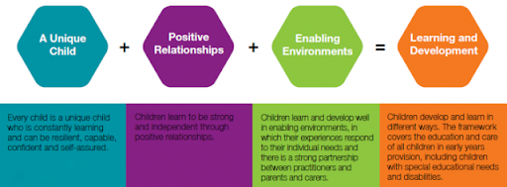
According to the University of Colorado, (2021) children need these eight key things from an adult to be able to thrive and succeed. Security- Children need to feel security around them and protection from harm, they should feel safe in their house and in their learning setting. Stability- children need constant love and affection from their carers. Consistency- parents should synchronize their parenting and make sure the important values stay consistent, it is so important for a child to constantly feel loved. Emotional support- parent’s words and actions should encourage children’s trust, respect, self-esteem and independence. Love- saying and showing you love your children is important. Showing your children even when they have disobeyed and angered you that you will always love them. Education- Making sure that your children get the best possible education and help. Making sure that your children feel safe during their education studies. Positive role models- To a child their parents are their first and most important role model. Instil your values and teach your children to be kind. Structure- Rules, boundaries, and limits. Without these rules children are forces to be adults before they are ready.
According to Bruner (1996) children’s overall development is fundamentally affected by their relationships with their parents/keyworkers and on how the child is feeling. There has been a revolution in recent thinking about children’s development and now we know that there is a close link between children’s emotions and cognition.
Brain development at a young age as a child is very important as it will have an impact on their future life. According to Bruce (1997) when you are a child and at a young age the brain is at its most malleable point in the first few weeks of the child’s life and stimulation is critical at this point. From brain research it shows that during the first few weeks of a child’s life the brain has immense plasticity and at this point of the child’s life it is a critical time for shaping the architecture of the child’s brain and the term term capacity to learn. Therefore, the brain is at its most impressionable, fragile time whilst you are at a young age. Both going out and touching new things, seeing different things and being social as a child is hugely important as it profoundly shapes a child’s potential.

Environment
Children playing outside in the environment is an essential role when children are growing up and going through transitions because it is extending children’s development and their learning. Children need fresh air and to be able to run free, children have a lot of energy, and it is essential for them to get fresh air on a regular basis to keep healthy. This also impacts on their psychological and physical well-being both short- term and long- term. Children tend to feel more relaxed when they are playing outside.” Enabling environments encourage babies and young children to play because they feel relaxed, comfortable and ‘at home’ in them” Early Years Matters (2021). When children feel safe, they feel comfortable to explore what is around them. Therefore, when they are outside, they feel comfortable to explore new things, as well as enjoying and playing they are learning new surroundings. According to Early Years (2021) there are three terms to describe the environment which are the emotional environment, the outdoor environment and the indoor environment. Which every child needs all three to be able to learn and play correctly. Vygotsky (2020) concentrated more on children's immediate social and cultural environment and their interactions with adults and peers. He argued that cognitive development occurred first through children's immediate social interactions, and then moved to the individual level as they began to internalise their learning. Play is important for children as they learn through play. Vygotsky’s theory (1962) he believed that children are born with a set of abilities, but the children could not reach these and be fully developed unless they experienced social interaction, Vygotsky also believed that children’s speech and language has a massive impact on the child’s cognitive development. Vygotsky and Piaget believed that children learn from exploring the environment around them and learn from being active. Dowling (2014) believed that children will ‘play out’ their own life experiences therefore, this enables us practitioners to see and understand the child’s perspectives.
The Early Years Foundation Stage (EYFS) Curriculum, which covers children aged birth to the end of the reception year, became statutory in September 2008 and places strong emphasis on the importance and value of daily outdoor experiences for children’s learning and development.

Partnership Working
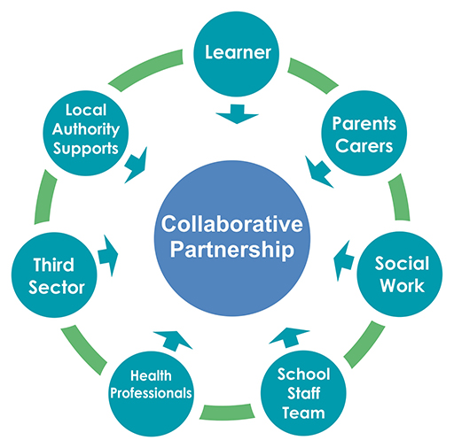
Partnership during transitions is essential. There needs to be a clear plan in place for the child’s transition. As the keyworker, parent and the other roles working together is essential for the child’s transition to run clearly and smoothly. There needs to be strong links between the adults to provide a positive transition. The communication between the parent and the keyworker needs to be honest and accurate to provide the best outcome for the child, the parent needs to be aware of how the child behaves when the child is not with them.
According to the Early Years Foundation Stage (2021) , a partnership includes “parents, families and practitioners working together to benefit children. For a partnership to work well, it must be built on trust, transparency and responsibility from all parties involved”.
Participants in any partnership should have clearly articulated roles and responsibilities, and an understanding of and respect for the roles of other professionals with whom they work (Lumsden, 2005; King et al., 2009).

Interventions
To help support children whilst they are going through transitions there have been many different interventions put in place to help provide children the best possible transition. These have been put into place to aim to build strong links between the parents and the children before they begin school.
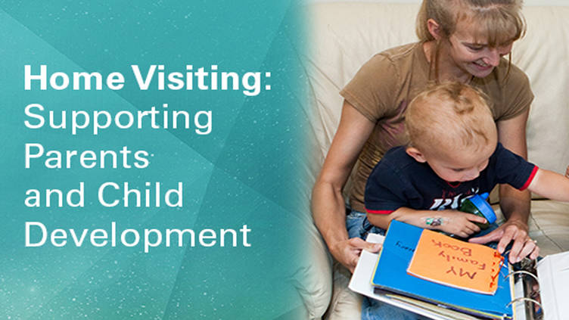
Before a child begins school the child’s keyworker and a teacher, who is going to be in the child’s class, will arrange a home visit. This is put into place to see what the child is like at home and to get to know the child a little bit before they start nursery. It is also good that this is put into place so the child is kind of familiar with their faces, so that when they start nursery this should ease their nerves a little bit. Bronfenbrenner believed that it was better to observe a child in their own home, and in an environment, they are used to. It is good to have a home visit as the child knows that environment and therefore the child would know what is surrounding them. This shows the keyworker and the nursery teacher what the child’s likes, and dislikes are, by seeing what the child likes to play with. This could help to make the child feel less anxious. Home visiting gives the provider license to observe and interact with the family in its natural setting. According to family process theory, understanding relationships between family members and between the family and the environment are essential to understanding family health (Broderick, 1993).
Whilst the home visit is taking place the keyworker and the teacher will provide the parents with a welcome pack. The welcome pack includes forms for the parents to fill in about the children. This gives the parents the opportunity to provide the teacher and the keyworker with essential information about the child. Therefore, this will help the teacher and keyworker to get an understanding of what the child is like, this will also provide the teacher with any additional needs, dietary needs, or health problems the child may have therefore they can put additional help in place before the child begins nursery.
Before the child begins nursery, they will have an opportunity to go to the setting and have some settling in sessions. The first session the parent tends to stay with the child therefore the child feels that security of their parent being around them. After the first session has taken place depending on how it goes, the next session the parent is advised to stay with the child for an hour and then let the child explore individually. The amount of settling in sessions the child will have depends on how the child is settling in, every child is different therefore every child needs a different number of sessions. Settling in sessions are a time for information sharing about the child and the most important people in that child’s life (Collins, 2010).
At the end of each session the parent and the worker will have a conversation which gives the parent and the worker the opportunity to discuss any concerns. The information they discuss is essential as they both need to know what is happening and how the child is behaving therefore, they can both help the child and put any additional help in place. Once all the children are settled into the nursery there is an opportunity for the parents to come into the school for informal play sessions.

Proposed outcomes.
The keyworker in the nursery will know that the child’s transition has been successful and has run smoothly once the child has clearly settled and is happy in their new setting. The keyworker will see this by seeing the child playing, smiling and being independent. The child should be showing that they have a good relationship with the practitioners/keyworkers and will the children around them. Therefore, the keyworker would know if the transition has run smoothly as the child would be showing that they are confident, happy and secure in their setting.

Reference List

Bruner. (1996) Early Childhood. 1st Ed. London: Sage Publication.

Bruce, T. (2006) Early Childhood. 1st Ed. London: Sage Publication.

Broderick. (1993) A Meta-analysis of Home Visiting Programs for At-risk Families. Available
at: https://files.eric.ed.gov/fulltext/ED499307.pdf (Accessed: 23rd November)

Collins, S. (2010) Thinking through the uses of observation and documentation. 1st Ed. Berkshire: Open University Press.

Dowling, M. (2014) Young Children’s Personal, Social and Emotional Development. 4th Ed. London: Sage.

Early Years Matters. (2021) Enabling Environment. Available at: https://www.earlyyearsmatters.co.uk/our-services/school-and-nursery-improvement-partner/enabling-environments/ (Accessed: 23rd November)

Early Years Matters. (2021) Enabling Environment. Available at: https://www.earlyyearsmatters.co.uk/our-services/school-and-nursery-improvement-partner/enabling-environments/ (Accessed: 23rd November)

Early Years Foundation Stage. (2021) Partnership with parents. Available at https://www.starschildcaregroup.co.uk/blog/4-reasons-every-nursery-should-have-a-partnership-with-parents (Accessed: 23rd November)

Early Years Alliance. (2018) Safeguarding in the Early Years. Available at: https://www.eyalliance.org.uk/safeguarding-early-years (Accessed: 24th November)

Gov.UK. (No date found) Meeting the needs of all children. Available at: https://help-for-early-years-providers.education.gov.uk/get-help-to-improve-your-practice/meeting-the-needs-of-all-children (Accessed: 22nd November)

Google pictures. Available at: http://www.newsilksworthacademy.co.uk/school/early-years-foundation-stage/ (Accessed: 22nd November)

Gunning, C. (2020) Early Education. Available at: https://www.early-education.org.uk/transitions (Accessed: 18th November)

Lumsden, King et al. (2005, 2009) Practice Principle 2: Partnerships with professionals. Available at: https://www.education.vic.gov.au/Documents/childhood/providers/edcare/pracpartner.pdf (Accessed: 23rd November)

No name found. (2020) Multiple Systems Navigator. Available at: https://www.msnavigator.org/transition-to-adulthood/transitions-big-picture/what-does-transition-mean (Accessed: 18th November)

Patel, A. (2021) Supporting Transitions in Early Years. Available at: https://www.teachearlyyears.com/a-unique-child/view/supporting-transitions-in-the-early-years (Accessed: 18th November)

Rymanowicz, K. (2015) Model behaviour in early childhood. Available at: https://www.canr.msu.edu/news/monkey_see_monkey_do_model_behavior_in_early_childhood (Accessed: 22nd November)

The Early Years Foundation Stage. (2009) Benefits for Early Years of Learning Outside the Classroom. Available at: https://www.lotc.org.uk/wp-content/uploads/2010/12/Benefits-for-Early-Years-LOtC-Final-5AUG09.pdf (Accessed: 23rd November)

Transition Images. (2021) Available at: https://www.shutterstock.com/search/transition

University of Colorado. (2021) What every child needs. Available at: https://www.childrenscolorado.org/conditions-and-advice/parenting/parenting-articles/what-children-need/ (Accessed: 22nd November)

Vygotsky. (2020) Development is determined by environmental factors. Available at: https://www.open.edu/openlearn/education-development/childhood-youth/introduction-child-psychology/content-section-2.2 (Accessed: 23rd November)

Walker, E. (2018) Managing Transitions in Early Years Provisions. Available at: https://app.croneri.co.uk/feature-articles/managing-transitions-early-years-provisions (Accessed: 18th November)

Walker, E. (2019) Managing Transitions in Early Years Provisions. Available at: https://app.croneri.co.uk/feature-articles/managing-transitions-early-years-provisions (Accessed: 18th November)

