1.Executive summary

1.1 Remit of the report
The main goal achieved in this report is four points. The first point is to use the strategic theory of learning to determine the strategy used by Adidas. The second point is to conduct a critical assessment based on Adidas' strategy. The third point is to draw some reasonable suggestions based on the conclusions drawn after the end of the assessment.

1.2 Brief background of adidas
Adidas was founded in 1949 and is a member of the German sportswear manufacturer Adidas AG. Named after its founder, Adolf Adi Dassler. It has two core brands, Adidas and reebok. Adidas has a successful corporate culture 3C, which includes Confidence, Collaboration and Creativity. Adidas is very focused on the development of talent and ROLE MODEL LEADERSHIP.

1.3 Summary of conclusion
Adidas uses its rich resources to design and develop sustainable materials to design a wide range of sports products. Adidas develops children's apparel design and personalization services to meet customer service needs. The logo design of different brands of Adidas is also very good. Adidas' commitment to employee care and social responsibility will enhance Adidas' reputation. However, propaganda and design products will be a burden for Adidas, and pressure from competitors will reduce the profitability of Adidas' differentiated strategy.

1.4 Advantages and disadvantages of the strategy
The advantages are differentiation strategy improve the company's sales performance and increase profits, increase customer loyalty
The disadvantages are it difficult for companies to achieve true differentiation and making differentiation needs huge investment.

1.5 Summary of recommendations
1. Adidas should continue to implement the differentiation strategy
2. to increase investment in research continually to expand the gap with competitors.
3. Adidas can develop into a diverse range of companies.
4. to continue invest in the corporate social responsibility

2.Introduction
This report investigates the strategy adopted by adidas. The researches include a set of strategies methods. Firstly, the background of adidas and strategies of major concepts could be introduced. And then, the main body includes the implemented strategies of organization and evaluate the strengths and weaknesses of strategies. The final part is conclusion and recommendations.

2.1Background of the organization
Adidas was founded in 1949 and is a member of the German sportswear manufacturer Adidas AG. Named after its founder, Adolf Adi Dassler. It has two core brands, Adidas and reebok. Adidas has a successful corporate culture 3C, which includes Confidence, Collaboration and Creativity. Adidas is very focused on the development of talent and ROLE MODEL LEADERSHIP. In the 2018 Fortune Global 500 list, adidas ranked 480. Adidas mission is to be the best sport company in the wold. And it has approximately 56,888 employees and has seven locations in the world. (adidas, 2015)
More details in the Appendix 1
(sources from adidas group website)
https://www.adidas-group.com/en/group/culture/

2.1Definition of major concepts

2.2.1 Strategy
Porter (1980, P35) defines strategy as a broad formula for how companies compete, what their goals should be, and what strategies are needed to achieve them. The company is working hard and its strategy to achieve its goals. And Rumelt and Richard (2011, P37) also stated the strategy usually involves the formulation and implementation of these two main components. Formulation a strategy involves analyzing the environment or situation, making a diagnosis, and then making a guiding policy that includes activities such as strategic planning and strategic thinking. Implementation refers to the action plan taken to achieve the goals set by the guiding policy.

Strategy is a series of methods and plans that companies take to achieve some long-term goals or gain benefits. The formulation and implementation of the company's strategy has a rigorous analysis and investigation to adapt to the company's future funding and the expected results.

2.2.2 Business level strategy
Business level strategy is the way strategy managers design a set of actions to use one company resources and unique competencies to obtain a competitive advantage outperforming other competitors in the market (Karami,2007). The business layer strategy focuses on how to achieve sustainable competitive advantage within a given scope and under defined resource allocation. It plays a key role in consolidating and enhancing the competitive position and competitive advantage of enterprises. （Wang Qiliang, 2007,P26)
Through these theories, this can be summarized as a business layer strategy is a strategy in which companies use their own resources to gain a competitive advantage in a market segment or a single industry sector

2.2.3 Competitive advantage
Porter's competitive advantage in 1985 was the key to ensuring that a company leads other competitors and gets higher benefits. There is a another explains. Competitive advantage refers to the ability gained through attributes and resources to perform at a higher level than others in the same industry or market. (Chacarbaghi; Lynch, 1999). And Powell and Thomas in 2001 declared resources held by a firm and the business strategy will have a profound impact on generating competitive advantage. In addition, Superior performance outcomes and superiority in production resources reflect competitive advantage. (Lau, 2002)
Competitive advantage is the key to a company's use of its resources and strategies to get ahead of other competitors and get more benefits. Therefore, a company's competitive advantage can be reflected in the company's performance and productivity and the strategies adopted.

2.2.4 Porter Generic Strategies
Porter wrote (1980, PP46) that strategy targets either cost leadership, differentiation, or focus. These are known as Porter's three generic strategies and can be applied to any size or form of business.
Dess and Davis (1984, P27) made the definition for the three strategies.
Cost leadership is a business' ability to produce a product or service that will be at a lower cost than other competitors. The strategy involves gaining market share by attracting cost-conscious or price-sensitive customers. When the company wants to achieve a leading position in the competition, this strategy can minimize the company's investment and achieve its goals.
A differential advantage is when a business' products or services are different to its competitors. Companies generally gain a competitive advantage through differentiation strategies. Because customers can experience different experiences from the differentiation of company products and services, this will help them make the right decisions.
Focus strategy ideally tries to get businesses to aim at a few target markets rather than trying to target everyone. The focus strategy reflects the company's ability to adjust and plan for market segments. This requires a thorough study of the market, which allows the company to take targeted measures.

The figure 1 the chart of Porter Generic Strategies
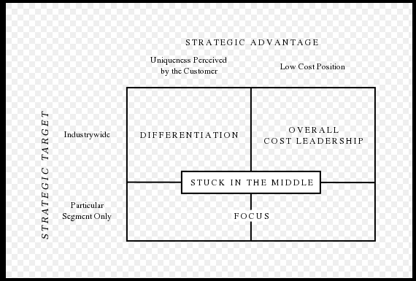
(sources from Porter (1980). Competitive Strategy )
Through Porter Generic Strategies, if a company belongs to the stuck in the middle, company can choose one or two strategies to develop according to their own situation. These theories are all conducive to the company to gain its own competitive advantage.

3.main body
This section mainly analyse some of the strategic approaches adopted by Adidas and the evaluation of these strategies.

Differentiation strategies are not suitable for small companies. It is more suitable for large companies. Because the company needs to provide one or several differentiations in the market, products, services, transportation, etc. to gain a competitive advantage. (Wright, 2004)
Adidas is a large international company with sufficient capital to develop and design its own differentiation.
Adidas focuses more on the broad differentiation strategy. The corporate level strategy of Adidas focuses on innovation, trying to produce new products, services and processes in order to cope up with the competition.
(Mahdi, Abbas, Mazar, & George, 2015)

3.1 Implementation of the strategy

3.1.1 Differentiation strategy
Differentiation is a strategy about the differentiation the product and service meeting customers demand and charging for the premium price (Pizam, 2010).

3.1.1.1 Products differentiation
Edward (1933, P33) thought product differentiation is the process of distinguishing a product or service from others, to make it more attractive to a particular target market.

Regarding the differentiation of Adidas products, its products can be divided into three main categories according to gender, including men, women and children. The first two are the original series of Adidas. On December 9, 2009, Adidas and Disney jointly announced that the two parties will jointly launch a new baby and children's wear series. Since then, Adidas' products have been adapted to people of all ages. On the other hand, its products can also be divided into footwear, apparel and jewelry. These classifications reflect the clarity of Adidas' market segmentation. But the most prominent aspect of Adidas is the other two aspects. One of them is that Adidas designs products for customers that adapt to these sports, depending on the type of exercise. The design of these products includes almost all sports held at the Olympics. It also designed products for cycling. The diversity and differentiation of these products will allow Adidas to meet a wide range of customer needs and increase their sports experience. On the other hand, in order to win the loyalty of high consumption, Adidas began to implement a private customized strategy in October 2017 or named custom-design service. This strategy allows consumers to design the shoes they want based on their hobbies. These product strategies reflect Adidas' significant investment in product differentiation. More detail information will be shown in Appendix 2.

http://www.qdaily.com/articles/45857.html
https://www.adidas.com.cn/campaign/keyfranchise
https://www.adidas.co.uk/
Adidas also uses product differentiation strategies to promote various products to promote sales. For example, Adidas released the first sports fragrance in 1990 to make athletes more attractive and spirited. Adidas perfumes are now very popular with many athletes, which makes consumers pay more attention to Adidas products. Its fragrance is now produced by the famous French perfume company COTY. When consumers experience the combined effects of perfume and other products, Adidas will attract more consumers to buy and increase consumer loyalty and satisfaction.
https://site.douban.com/137239/widget/notes/6177161/note/190037681/

3.1.1.2 Services differentiation
Customer service is the provision of service to customers before, during and after a purchase. The perception of success of such interactions is dependent on employees "who can adjust themselves to the personality of the guest"
(Buchanan and Leigh, 2011)
Regarding Adidas' services, it can be divided into two aspects. One is the service to the company target customer. One is the service to society.

In terms of customer service for the company, due to advances in technology, Adidas mainly focuses on establishing online network services. In 2000, Adidas partnered with Sports, the world's leading Internet sports media company, to market the ADIDAS brand and its products through their websites cbs.sportsline.com and sports.com. This strategy has allowed Adidas to lead other companies to promote their products worldwide. Adidas has now established a comprehensive customer service center. The customer service center provides many ways to accept customer complaints and timely feedback. These include WhatsApp, Facebook, Twitter and mobile phones. Specific information will be shown in Appendix 3. On the other hand, Adidas' official website also provides auto-reply features and customer receipts for some common issues. Customers can log in to their own accounts to find their own order information and after-sales service information on the website. Certainly, Adidas has a good privacy statement. These features allow Adidas to achieve better customer satisfaction and increase customer loyalty. And these make Adidas have a good reputation around the world.

In terms of logistics, in 2001, ADIDAS rebuilt the original warehouse and established a modern large-scale distribution center in Germany to provide distribution services for sales in Europe and the Middle East and improve the efficiency of logistics distribution. This allows Adidas products to be shipped to European countries faster and to gain greater market share.

Brand logo differentiation
Branding is a set of marketing and communication methods that help to distinguish a company or products from competitors, aiming to create a lasting impression in the minds of customers.（Ghodeswar, Bhimrao M ，2008)

Regarding the brand logo of Adidas, in its history, Adidas brand logo is divided into three series, namely sports performance series (three-striped logo), sports traditional series (shamrock logo) and sports fashion series (spheroidal three-stripes) Sign). The specific logo image will be shown in Appendix 4. The sports performance series is dedicated to the mass sports industry. Its positioning is a popular sports trend. It adopts the Adi three-strip logo and the price is more acceptable to the public. The sports tradition series is the classic series of Adidas. Its positioning is a retro classic trend, which is more fashionable and high-end than the sports performance series. The sports fashion collection reflects Adidas' latest fashion style and is loved by young people.

These three different logos represent Adidas' different styles of products, which allows customers to more clearly distinguish Adidas products and quickly find the products they need. On the other hand, because Adidas has different logos, the company's research and development is more targeted, which further makes Adidas more widely available market.

CSR
Corporate social responsibility (CSR, also called corporate sustainability, sustainable business, corporate conscience, corporate citizenship or responsible business) is a type of international private business self-regulation. (Wood, Donna J. 1991)
While once it was possible to describe CSR as an internal organizational policy or a corporate ethic strategy。(Sheehy and Benedict ,2015)

In 2015, the Adidas Group developed a fair labor compensation strategy. This is also an attempt by Adidas to achieve fair labor compensation. In order to protect the welfare of workers, in 2010 Adidas began working with Hong Kong's Labor Education and Service Network to train workers representatives to understand how to ensure worker welfare.
https://www.adidas.com.cn/CSR/home?locale=zh_CN

Adidas provides accident insurance, medical insurance, travel insurance, and term life insurance for full-time employees. For part-time personnel and contractors, the company also provides accident insurance and other medical insurance. In order to better train employees, in July 2014, Adidas established a corporate university called “adidas Group Learning Campus” in China. In 2015, Adidas invested more than RMB 1.2 million to protect the health and safety of Chinese employees, including basic safety equipment and 100% annual medical check-ups.

To protect the environment, Adidas continues to increase the use of environmentally friendly materials in the manufacture of apparel and accessories, including high quality cotton, renewable polyester, recycled rubber and bio-based thermoplastic polyurethane. As of the end of 2015, all Adidas footwear products were manufactured using environmentally friendly materials. In 2014, after the successful phase-out of all long-chain fluorochemicals, Adidas made significant progress on the phase-out of PFC-free. Adidas achieved 99% non-fluorination of the product by December 31, 2017.

After the Wenchuan earthquake in 2008, Adidas immediately donated RMB 3 million through the Shanghai Red Cross. At the same time, employees of the Adidas Group in China donated RMB 173,000. Adidas Hong Kong and Taiwan donated a total of RMB 399,000. paragraph.

3.2 Advantages and disadvantages of the strategy

3.2.1 Advantages
When the company implements the differentiation strategy most directly, it will help to improve the company's sales performance and increase profits. The differentiation of products and services helps to increase customer loyalty. （Mu Wei, Wang Yuchen, & Li Leiming. 2005, P25)
Sales performance is the sum of the benefits that a company or an individual gain over a period. To a certain extent, sales performance can assess how well a company or individual operates during this time. A company's loyal customers are customers who have high trust or dependence on the company's products or services. Customer loyalty can be increased and lost.

When Adidas began selling children's products in 2009, it began to acquire the new market for children's apparel and the profits it brought. And from 2010 to 2015, Adidas' worldwide sales continued to increase. And in 2015 exceeded 2.5 billion euros. In addition, if Adidas customers accept the custom-made service and are satisfied with the products they design, they will become Adidas loyal customers or increase their loyalty to Adidas. These will help Adidas get a better reputation and increase its market share.
Mu Wei, Wang Yuchen, & Li Leiming. (2005). Research on Environmental Management and Enterprise Competitiveness Based on Differentiated Strategies. Systems Engineering Theory and Practice, 25(3), 26-31

3.2.2 Disadvantages
The company's differentiation strategy means that the company needs to invest a lot of capital to investigate and research new products and markets. （Wang Hong,2007)
The implementation of the differentiation strategy is easily borrowed by competitors, which makes it difficult for companies to achieve true differentiation. （Zhang Song, & Wu Xianfeng. 2006)
The company's investment in any new products and services will be huge, which requires the company to have enough funds to support. And the company's differentiation strategy will be easily imitated by the opponent, which makes it difficult for the company to open the gap with competitors.

For Adidas' product diversification, Adidas spent a lot of time and resources to design and analyze the functionality and utility of various sports products. The use and design of some environmentally friendly materials also requires the company to invest a large amount of capital. Especially for private custom and perfume products, the employment fees of some famous designers and perfume adjusters. Products also need to have the cost of a well-known actor and star to promote. These will make the company cost a lot of money.

After Adidas achieved all products in 2015 with eco-friendly materials. Nike also used and produced renewable materials. As of FY2017, NIKE has transformed more than 4.6 billion plastic bottles into recycled polyester footwear and apparel. Adidas also achieved 99% non-fluorination in 2017.
{The nike of sustainable business report,
https://sbi-stg-s3-media-bucket.s3.amazonaws.com/wp-content/uploads/2018/05/18175102/NIKE-FY1617-Sustainable-Business-Report_FINAL.pdf}

4.Conclusion
Adidas has used its vast resources to design and develop sustainable materials to design a wide range of sports products, which gives Adidas a huge competitive advantage. And in order to enter new markets and get good customer loyalty, Adidas conducts the design of children's apparel and personally customized services for customer service. Of course, these strategies have also made Adidas profitable. on the other hand. Adidas started designing and selling some affiliated fragrances. This has earned Adidas a greater reputation and advocacy. The design of the logos of different brands of Adidas is also very good. Each logo represents a different product type and corresponding target customer, which can improve the company's customer satisfaction and loyalty. Adidas' commitment to employee care and social responsibility will further enhance Adidas' reputation.

However, propaganda and design products will become a burden for Adidas, and pressure from competitors will reduce the profits of the Adidas differentiation strategy.
Adidas requires significant investments in the implementation of its product and service differentiation strategy, which increases the company's financial burden and risk. On the other hand, Adidas has the same level of competitor Nike, and the differentiation strategy is easily imitated or surpassed by competitors, which will make Adidas's differentiated profits be taken away.

5. Recommendations
1. Adidas should continue to implement the differentiation strategy, and the market survey should be more detailed to meet the deeper needs of customers.
2. The investment in research can continue to increase, and more talented technical talents can be introduced to further expand the gap with competitors.
3. Adidas can develop into a diverse range of companies to invest in related products and services such as the Adidas Stadium, the Adidas Sports Center and the adidas hotel to special athlete
4.to continue invest in the corporate social responsibility and concentrate on the serious social issues.

Words approximately: 2700

6.Reference list
[Porter, Michael E. (1980). Competitive Strategy. Free Press. ISBN 0-684-84148-7.]
【Mintzberg, Henry and, Quinn, James Brian (1996). The Strategy Process: Concepts, Contexts, Cases. Prentice Hall. ISBN 978-0-132-340304.】
【Rumelt, Richard P. (2011). Good Strategy/Bad Strategy - The Difference and Why it Matters. Crown Business. ISBN 978-0-307-88623-1.】
Wang Qiliang. (2007). Business layer strategy: basic connotation, characteristics and future research direction. Industrial Technology Economy, 26(6), 133-134.

【Porter, M. E. (1985). Competitive advantage: creating and sustaining superior performance. 1985. New York: FreePress, 43, 214.】

[Chacarbaghi; Lynch (1999), Competitive Advantage: Creating and Sustaining Superior Performance by Michael E. Porter 1980, p. 45]

Powell, Thomas C. (1 September 2001). "Competitive advantage: logical and philosophical considerations". Strategic Management Journal. 22 (9): 875–888. doi:10.1002/smj.173

Lau, Ronald S (1 January 2002). "Competitive factors and their relative importance in the US electronics and computer industries". International Journal of Operations & Production Management. 22 (1): 125–135.
【Porter, Michael E. (1980). Competitive Strategy. Free Press. ISBN 0-684-84148-7】
【Dess, G. G., & Davis, P. S. (1984). Porter's (1980) generic strategies as determinants of strategic group membership and organizational performance. Academy of Management journal, 27(3), 467-488.】
Wright, P, "A refinement of Porter's strategies."

[Mahdi, H. A. A., Abbas, M., Mazar, T. I., & George, S. (2015). A Comparative Analysis of Strategies and Business Models of Nike, Inc. and Adidas Group with special reference to Competitive Advantage in the context of a Dynamic and Competitive Environment. International Journal of Business Management and Economic Research, 6(3), 167-177.]

[Chamberlin, Edward. The Theory of Monopolistic Competition: A Re-orientation of the Theory of Value. Harvard University Press. ISBN 978-0674881259.]

[Ghodeswar, Bhimrao M (2008). "Building brand identity in competitive markets: A conceptual model". Journal of Product & Brand Management. 17: 4. doi:10.1108/10610420810856468.]
【Buchanan, Leigh (1 March 2011). "A Customer Service Makeover". Inc. magazine. Retrieved 29 Oct 2012.】
【Wood, Donna J. (1991). "Corporate Social Performance Revisited". The Academy of Management Review. 16 (4): 691–718. doi:10.2307/258977. JSTOR 258977】
【Sheehy, Benedict (2015-10-01). "Defining CSR: Problems and Solutions". Journal of Business Ethics. 131(3): 625–648. doi:10.1007/s10551-014-2281-x. ISSN 0167-4544.】
Jiang Ruochen, & Chen Hongjun. (2011). Empirical Research on the Influencing Factors of Sales Performance. Business Economics and Management, 1(2), 21-29.

Zhang Zhiping, & Chen Huichun. (2002). Cultivation model of corporate loyal customers. Economic Management (9), 40-43.

Mu Wei, Wang Yuchen, & Li Leiming. (2005). Research on Environmental Management and Enterprise Competitiveness Based on Differentiated Strategies. Systems Engineering Theory and Practice, 25(3), 26-31

Wang Hong. (2007). Research on Enterprise Implementation Differentiation Strategy. Productivity Research, (1), 111-112.

Zhang Song, & Wu Xianfeng. (2006). Theoretical analysis and practical application of China Mobile's differentiated competition strategy. Jiangxi Communication Technology, (3), 45-48.

7.Appendix
Appendix 1 (sources from adidas official website, https://www.adidas-group.com/en/group/strategy-overview/)
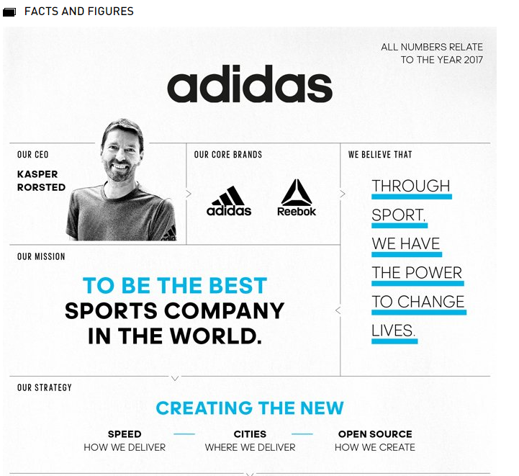
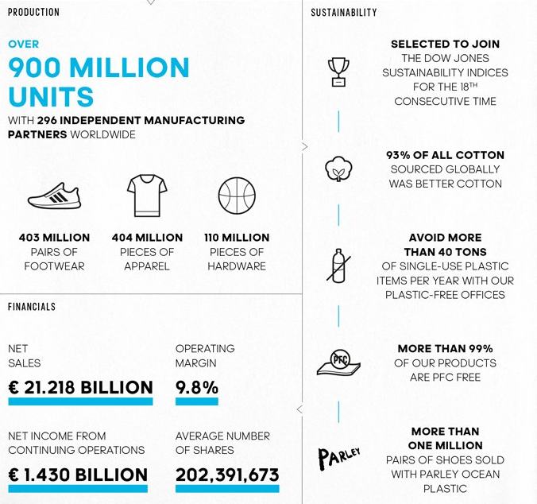
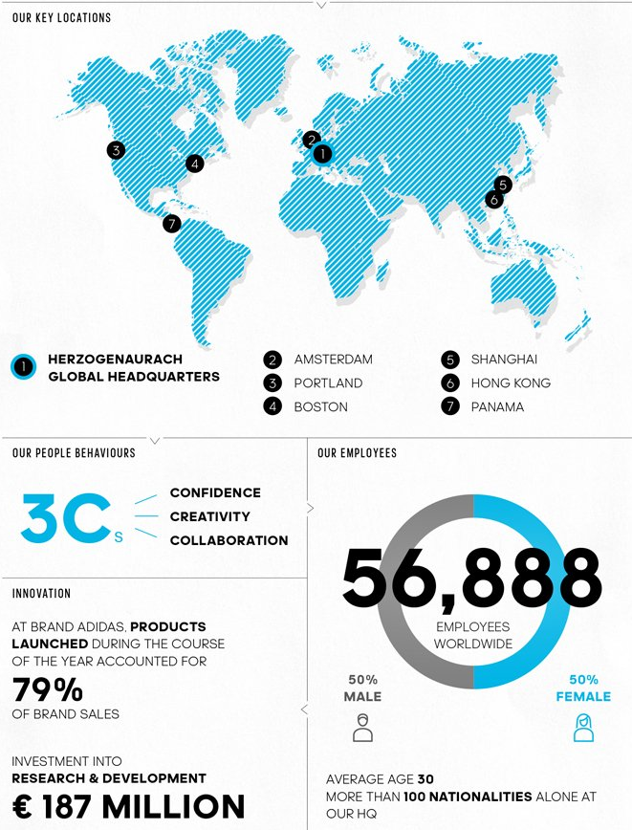
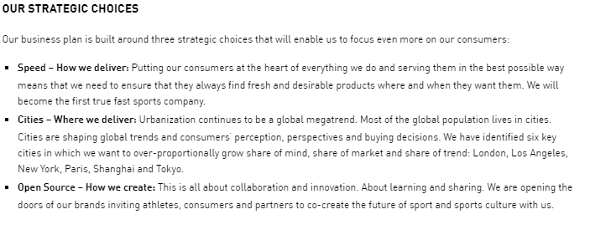
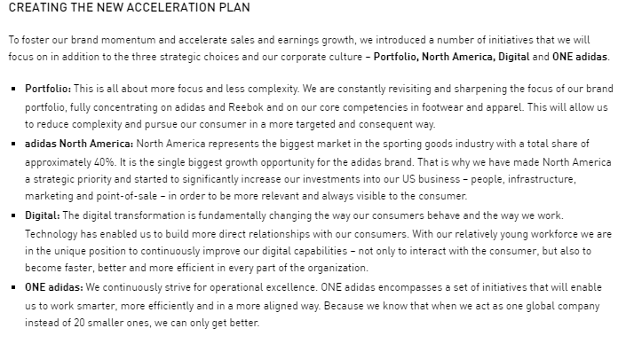

Appendix 2(sources from adidas official website, https://www.adidas.co.uk//)


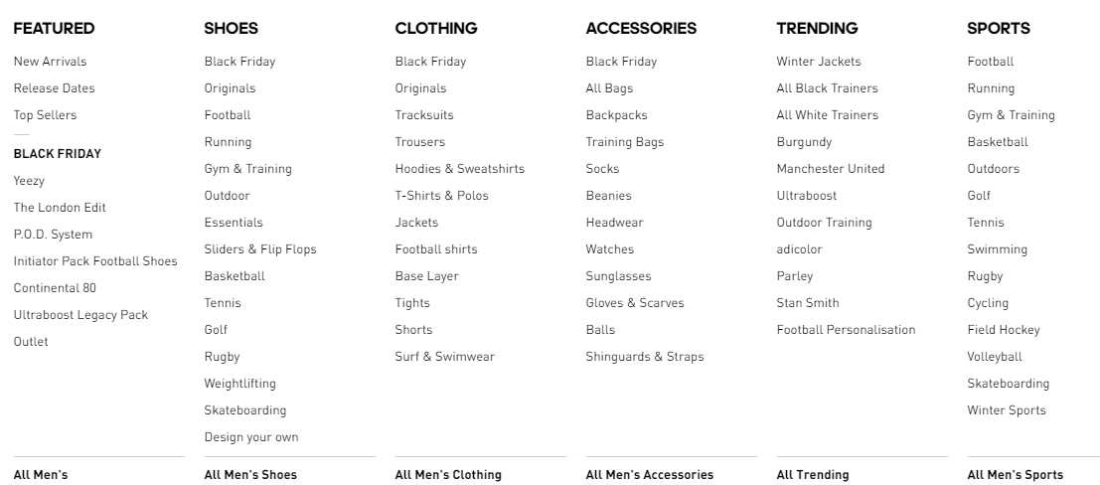

Appendix 3(sources from adidas official website, https://www.adidas.co.uk/help)
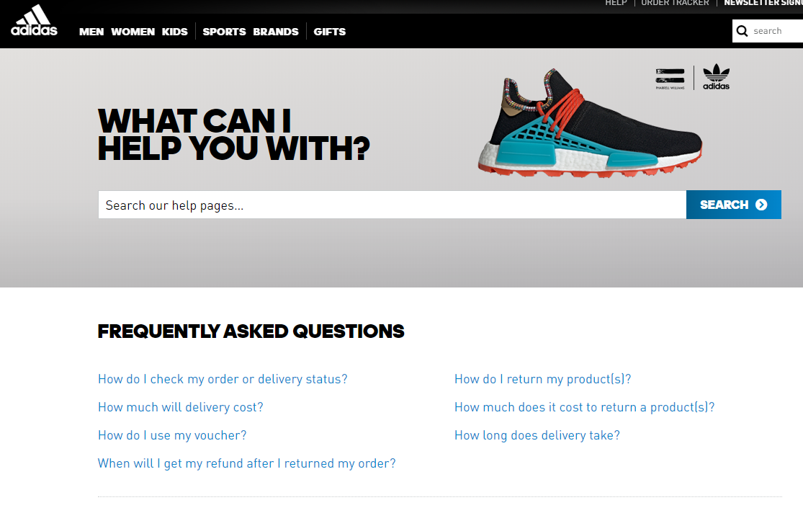
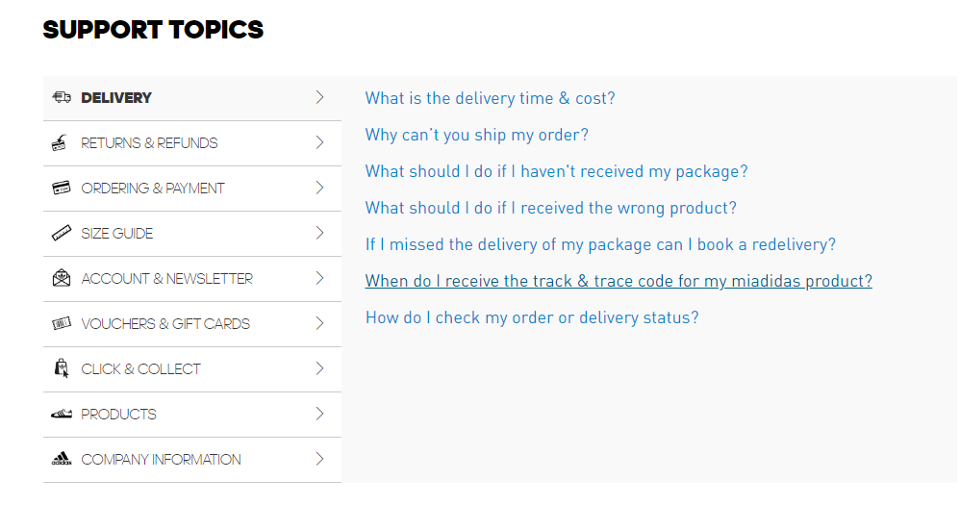
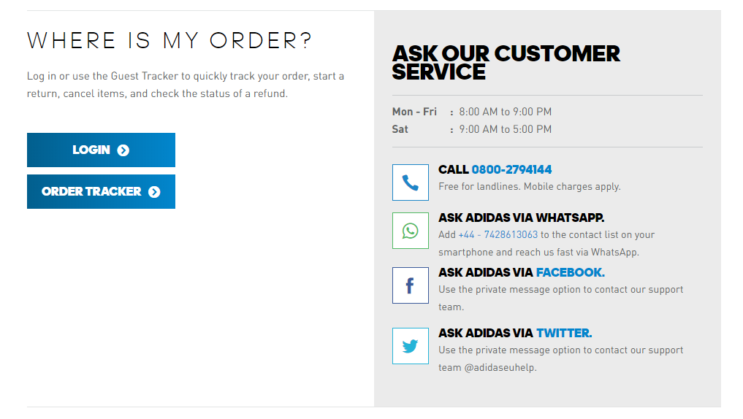
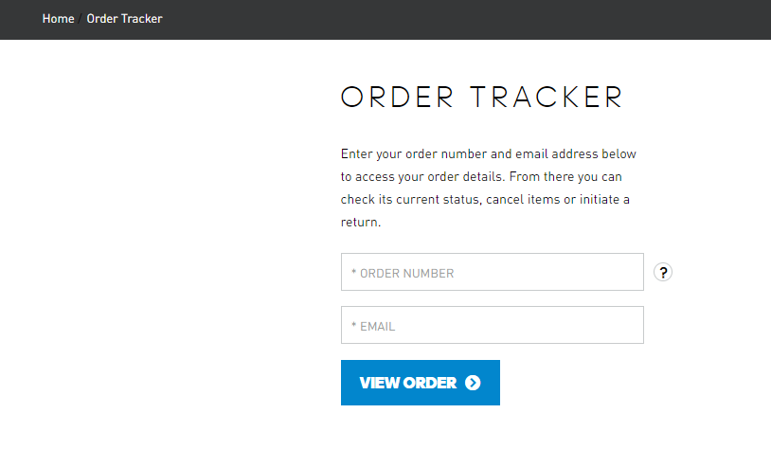
Appendix 4(sources from https://www.douban.com/group/topic/75758100/)


