RESEARCH AND CASE SCENARIO IN DATA SECURITY AND COMPLIANcE
Jacob John Hopkins
Student University of Wales Trinity St David, Swansea, Wales
2003836@student.uwtsd.ac.uk

Task 1 3
Abstract 3
I. Introduction 3
II. Research in Data Security and Compliance 3
1) Physical Security 3
III. Conclusion 6
Task 2 7
Abstract 7
IV. Introduction 7
V. Case Scenario 7
2) Risk Management 7
3) Protection Mechanisms 8
4) Compliance 9
5) Policies 10
6) Contingency Planning 10
VI. Conclusion 11
VII. References 12
VIII. Appendices 13

Task 1
Abstract
In recent years, data has become what could be argued as one of the most valuable items out in the world. Viewed by many as a resource, data is used and often exploited for financial gain by both industries and individuals, with and without your permission. Additionally, loss of data can be damaging on a host of accounts, affecting both those who own the data and those who lose it. Because of this, it is critical that data is kept as secure as possible by utilising a multitude of safeguarding techniques and systems that can help both identify and mitigate potential threats to our data. Helping not only preserve valuable data, but hopefully prevent negative press and collapse of organisations. Throughout this research paper, extensive analysis and evaluation of physical security will help identify not only its benefits but also the drawbacks that can follow as a result of implementation strategies.
Keywords – Physical Security, Security Structure.
- Introduction
As a way of ensuring standards and security measures across numerous industries, various laws, and policies such as the EU’s General Data Protection Regulations (GDPR) and UK’s Data Protection Act (DPA) have come into force as of 2018 to build a solid foundation of data security and appease public demand. Ensuring heavy penalties are distributed when data protection is breached, both the DPA and GDPR protect what is important to consumers. A detailed breakdown into what the DPA is and what it covers can be found in Appendix A, with further information on GDPRs penalties in Appendix H. Organisations could face up to a devastating €20 million fine in the case of failing to comply with the GDPR. As stated by John Flucke in his article on The Importance of Data Security, “it was estimated that $15 billion was stolen from 13.1 million U.S. consumers in 2015. Nowadays, hacking and stealing confidential data is very big business.” ^{[1]}. This information shows how valuable data truly is and can be an indicator towards the dangers that can occur if no action is taken towards securing ourselves. As a result of instances such as the one mentioned above, extensive research into data security and compliance has never been more important.
- Research in Data Security and Compliance
- Physical Security
To help safeguard and protect valuable items such as networking equipment from unauthorised access or misuse, we use what is called physical security. According to P.R. Baker and D.J. Benny, physical security was “often described as the forgotten side of security” ^{[3]}, yet it is vitally essential in the overall security and protection strategy of data.
Praised as one of the top five “Info security Pioneers” ^{[4]} by the Information Security Magazine in 1998, Donn B. Parker is a prestigious researcher and is recognised and respected for his extensive work in the info security field. Within his book titled Fighting Computer Crime, Mr Parker curated a list of what he deemed the “Seven Major Sources of Physical Loss”, this included…
- Extreme temperature: heat, cold
- Gases: war gasses, commercial vapours, humid or dry air, suspended particles
- Liquids: water, chemicals
- Living organisms: viruses, bacteria, people, animals, insects
- Projectiles: tangible objects in motion, powered objects
- Movement: collapse, shearing, shaking, vibration, liquefaction, flow waves, separation, slide
- Energy anomalies: electrical surge or failure, magnetism, static electricity, aging circuitry; radiation: sound, light, radio, microwave, electromagnetic, atomic ^{[5]}
There are various controls that fall under physical security that can be used in many settings where important items are stored. These controls include the use of external and internal walls, fencing and gates to keep intruders out. Constructing large and difficult to scale walls or fences act as great deterrents. However, it is important that the placement of any wall, fence or gate are expertly thought-out to ensure that they not only fulfil their security goals but are also structurally sound to withstand potential unavoidable environmental factors, something mentioned in the sixth major sources of physical loss from Donn B. Parker. While many computing systems and networks can help keep unauthorised users out through the use of various intricate layers of logical code, without the appropriate physical security in place these logical layers of security can be easily circumvented, resulting in potential data breaches.
Having guards, both human and canine, monitor locations with the intent of removing unauthorised visitors can help further deter and intercept unauthorised individuals from accessing sensitive information. Helping make reasoned responses to situations based of prior evaluations and teachings, guards offer a less hard-coded approach to handle potential threats than many automated security systems. This of course however comes at a cost, with insourcing security teams requiring extensive training, screening, and appropriate equipment, all of which can cost a company valuable time and resources. Not to mention the responsibilities and potential issues of managing such a team. In a 2005 study by The ASIS Foundation, it was found that around “30.3%” ^{[6]} of companies were outsourcing guard services among many other services.
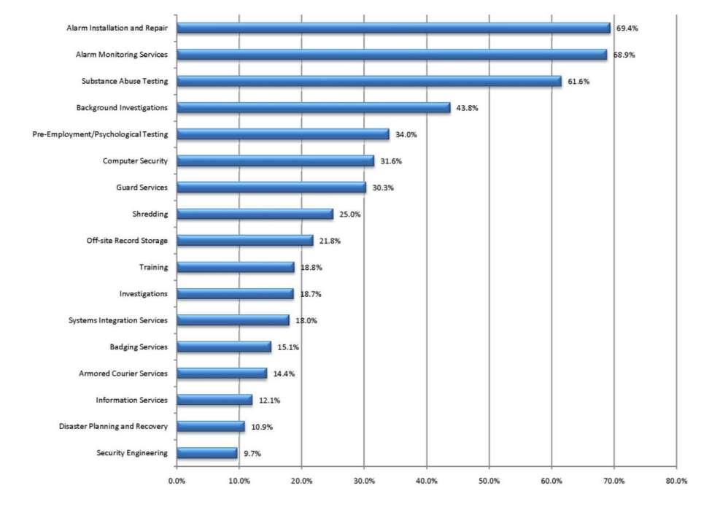
This action is often taken by companies to offset the responsibilities surrounding employing guards to third parties, this does however also come at a cost. Entrusting those outside of your own business with handling data could lead to potential leaks of information, this relates back to Donn B. Parker’s fourth major source of physical loss. Mentioned by Kelly Stewart, an experienced physical security designer and practitioner for over 25 years, in his article on managing security services, “[There is] potential for unscrupulous subcontractors to provide confidential information to competitors or steal business” ^{[7]}. While it could be argued that similar threats could arise from in-house staff, businesses are more in control in the level of review that goes into a potential employee. As stated within industry leading Google’s whitepaper document on security, their security guards “have undergone rigorous background checks and training” ^{[8]} assuming to help reduce the potential of theft and disloyalty among staff. Google highlighting this in their whitepaper exhibits just how important it is that key areas such as this are thought-out when building a team.
Within these companies there can be various identifiable community roles such as the general management of a facilities security. Further examples could include IT management which may cover environmental and access security, and information security management that may handle important risk assessments and implementation reviews. Having dedicated teams to manage and direct key units within an organisation can aid greatly in the overall performance and quality of work produced, this is very useful when developing safeguarding structures. Much like guards, these community roles can also be outsourced rather than handled and managed inhouse, helping free up valuable time for organisations to focus on primary objectives rather than juggling additional support operations. It can be seen in the previous figure [6], areas such as information services and disaster planning and recovery were outsourced by “12.1%” and “10.9%” of companies respectively. Regardless of the approach to team building, a company must ensure that it takes the appropriate steps to help reduce the potential of data breaches amongst its staff. In some instances however, even the best of employees can fall victim to a dangerous and ever-growing attack that will in turn often compromise data, that attack is social engineering. Described by the governments National Cyber Security Centre as “manipulating people into carrying out specific actions, or divulging information, that’s of use to an attacker.” ^{[9]}. Social engineering attacks stole over a reported “$5 billion worldwide from 2013-2016” ^{[10]} according to website SysGroup, indicating just how prevalent these types of attacks are and what they can achieve. Michael Erbschloe is an experienced author and educator; he discusses social engineering in great detail in his book ‘Social Engineering: Hacking Systems, Nations, and Societies’. A clipping from the book can be found in Appendix B. Additionally, a short slideshow presentation published by the UKs National Cyber Security Centre briefly covers social engineering and how easy such an attack can occur can be found in Appendix C, offering an approved governing source. Ensuring areas such as a candidates ethics or morals are discussed during interviews and screenings can aid in building a picture on the kind of individual that is being dealt with, helping employers identify potential inhouse threats before they may arise.
For traversing through secure facilities, many organisations opt for the use of ID cards and/or badges to help identify individuals and provide levels of security clearance to specially trained and qualified personnel while also allowing for controlled accesses to areas and equipment. This is done through the use of what are called electromechanical locks, taking advantage of the convenient magnetic strips, radio signals, and at times biometric data from employees to activate electronic powered locking mechanisms. Not only can these advanced locking systems be used to enhance a facility’s security, but they can also integrate within specialised alarm systems to allow for automatic or manual switch control in the case of an emergency. Furthermore, these locking systems can track and manage the usage of doors with crucial information such as times accessed and by whom. While the convenience and layered security of these methods can prove useful to an organisation, there are various threats that can plague these magnetic/RFID systems. Duplication of smart ID cards or badges arguably stands as the biggest threat, with plenty of tutorials and equipment readily available online for anyone to pick up and execute through a simple internet search. Due to many RFID chips employing vulnerable technology through the use of unencrypted protocols, these devices could potentially cause damaging effects towards unsuspected organisations. It is stated in Broadcom’s thread on Endpoint Protection that in 2013 up to 80% ^{[13]} of US companies deployed vulnerable technology in their RFID systems. In a fantastic case study of the University of Maryland, authors D. Ramsbrock, S. Moskovchenko, and C. Conroy investigate magnetic swipe card systems, how they work, and the security designed to protect its users. Highlighting the various attacks that can be executed through many different approaches and detailing appropriate ways of mitigating such threats from arising. Please refer to Appendix D for a short abstract from the case study. Tailgating is another prevalent threat that can be brought on by the use of technology such as ID cards and advanced locking systems. Tailgating is the act of closely following an authorised individual into a building or door after they have gained access. There are technologies such as the familiar turnstiles you may find at train stations, or mantraps which act almost as an airlock, to discourage and limit the potential of tailgating. Refer to Appendix E for a detailed figure outlining a mantrap in use.
Fire security and safety is imperative, with fires accounting for “more property damage, personal injury, and death than any other threat.” ^{[16]}, resulting in a strong desideratum towards fire safety structures and systems in the hope to limit the damage and threat of potential fires. The implementation of said structures often result in the creation of fire suppression systems. These systems, built on fire detection and fire suppression, are designed to help identify possible fires and deploy a list of countermeasures to deny the hazardous area of one of three things, oxygen, fuel, or temperature, to eliminate the threat. While in most instances, water-based systems such as mist sprinklers are used to extinguish the flames, however when dealing with class C electrical fires it can be very dangerous to use conductive elements to tackle flames. Instead, gaseous emission systems are utilised, releasing carbon dioxide or alternate gases such as Novec 1230TM from pressurised storage containers into the affected area. The choice between the use of CO2 or other gases like Novec 1230TM is based on the likelihood of people or animals present in the systems vicinity. Being reliant on oxygen to survive means the exposure to significant amounts of CO2 can be lethal, suffocating those within the area of emission. Because of this, CO2 is often avoided in office environments. Unlike CO2, something like Novec 1230TM is able to remove the heat from a fire rather than its oxygen source. Because of this, it does not pose a suffocation risk to people or animals and therefore is safe to be used within occupied spaces. Novec 1230TM does however come with a couple disadvantages over other gaseous systems such as CO2, with the compound itself “not [being] as common as other fire suppression chemicals” ^{[17]}. This issue leads to emission systems built on Novec 1230TM being more expensive, not only to install but to upkeep overtime in comparison to other gaseous emission systems. An illustration detailing on how such a system is installed can be found in Appendix F.
One threat that is yet to be discussed within this research paper is the very thing fuelling our data storage and management, and that is electricity. Recognised as the seventh major source of physical loss by Donn B. Parker, electrical devices can experience both current surges and interruptions, both of which can be damaging to not only the devices connected, but also the data that is stored and transferred between them. Implementing something called an Uninterruptible Power Supply, or UPS for short, into a security structure can help alleviate the stress of such a damaging occurrence from happening. These electrifying tools assure the delivery of power to devices in the event of an outage, ensuring no downtime for the system while also helping prevent damage or data loss. Measured using volt-amperes, UPS’ typically offer up to 1,000 VA with the ability to surpass 10,000 VA, providing enough power to enable important systems to continue their operations even in the event of a power outage. In the case of there being no UPS devices configured during an outage, it has been mentioned that devices such as PCs and servers could suffer from damage or even data loss as a result. In a well-executed and presented study from students in the Sharif University of Technology, Iran, rigorous tests on solid-state drives storage devices were ran to test the potential effects a power outage could have and how such an event could affect the devices reliability. At the end of the study it was concluded that “the failure ratio in SSDs due to power outage is significantly affected by the parameters of the running workloads in the application layer” ^{[19]}. Using the supporting graphs found within this study, organisations can evaluate the potential damage that could be caused to their systems in the event of an interference of power without a UPS, evaluating their options based on parameters such as the data type used within their running workloads and come to a decision on how this could play into their data security management structure. Please refer to Appendix G for a further information on the study, including more specific details surrounding the test conducted and their results.
- Conclusion
Ensuring aspects of data security, such as physical security, is properly adhered to can have great benefits on an organisation. Using extensive evaluation reports and risk assessments, organisations can develop and build effective and reliant security structures that can help in mitigating potential future dangers. However, while physical security is as important to protecting our data as any logical system, it is also recognised that many implementations of security, such as those discussed throughout this research paper, can experience difficulty and occasionally result in undesired outcomes. This realisation highlights the importance of planning ahead and assessing the most ideal approach for an organisation, and without it shows the many ways in which security flaws can be exploited, potentially leading to irreversible damage to both a business and its reputation.

Task 2

Abstract
As a well-established threat intelligence and consultancy company, FlowTech offer a plethora of services ranging from business continuity to data recovery and risk management. Now that the organisation is breaking into a wider market, they believe a new information security unit would be beneficial to prepare themselves for any possible threats the organisation could face. In this case scenario, an initial approach toward a strong and relevant security structure will be designed and discussed for the new information security unit. This proposal will identify, evaluate, and justify numerous factors that is believed to be of upmost importance to FlowTech and their growing portfolio.
- Introduction
While research and analysing the many concepts of information security can help in building an understanding towards the topic, implementing such knowledge is not as straight forward. Each situation dealt by information security teams may differ from the rest, resulting in the development of alternate approaches. This all comes down to both the quality and quantity of planning from the information security teams, ensuring extensive structuring and development is conducted. This can be done through the identification of a company’s requirements in relation to its services, in this case how FlowTech operate. Using our knowledge of its online presence we can develop the ideal approach to information security that will in turn help protect both FlowTech and its consumers.
- Case Scenario
- Risk Management
Risk management is a fundamental and effective way of mitigating potential threats to an organisation through identifying, assessing, and controlling risks highlighted by a team within said organisation. Risk management is often dictated by a set of predetermined actions within a specialised process specially designed with the organisation in mind, such as the one below found below:
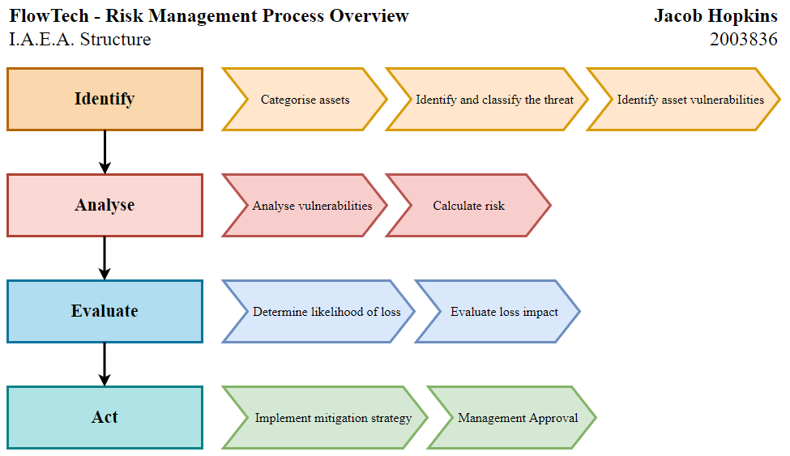
The I.A.E.A. Structure is a risk management approach created by myself with FlowTech in mind. Taking various aspects of the organisation into careful consideration, this risk management process was developed to help mitigate potential threats through identifying, analysing, evaluating, and acting upon each of them brought to light. Additionally, using a risk management structure, FlowTech can hope to avoid potential competitive disadvantage brought on by dangerous risks that have damaged the organisation due to lack of planning. If unsuccessful, FlowTech could be led to falling behind its competitors within the industry, greatly impacting key areas of the organisation such as its reputation and client footfall. Because of this, I believe it is vital that FlowTech is to implement a relevant and suitable risk management structure such as the I.A.E.A. to manage and guide appropriate and effective solutions to potential risks.
- Protection Mechanisms
With the help of factors such as risk management, the development and implementation of protection mechanisms can benefit the likes of FlowTech, enabling the organisation to readily counteract potential dangers and attacks it may face. Such protection mechanisms can help detect, react, and deter would be attacks and protect confidential and valuable client data withheld by FlowTech and their partners.
Task 1 thoroughly covered an extensive number of protection mechanisms available to FlowTech in the form of physical security. Systems such as those utilising ID cards and badges allows for the monitoring of personnel and management of access within FlowTech’s physical secure data and cloud facilities. With this technology, FlowTech can confidently manage the security clearance of employees whilst utilising their tools to retrace footsteps of individuals to potentially identify inside threats. Additionally, the use of mechanisms such as mantraps can create tightly sealed airlocks within FlowTech’s physical locations. Using its multiple door system, mantraps could help FlowTech in reducing the likelihood of attacks utilising tailgating to gain access to their devices by carefully controlling the footfall within secure areas and enabling authorised individuals to become aware of those around them in a cost-effective way.
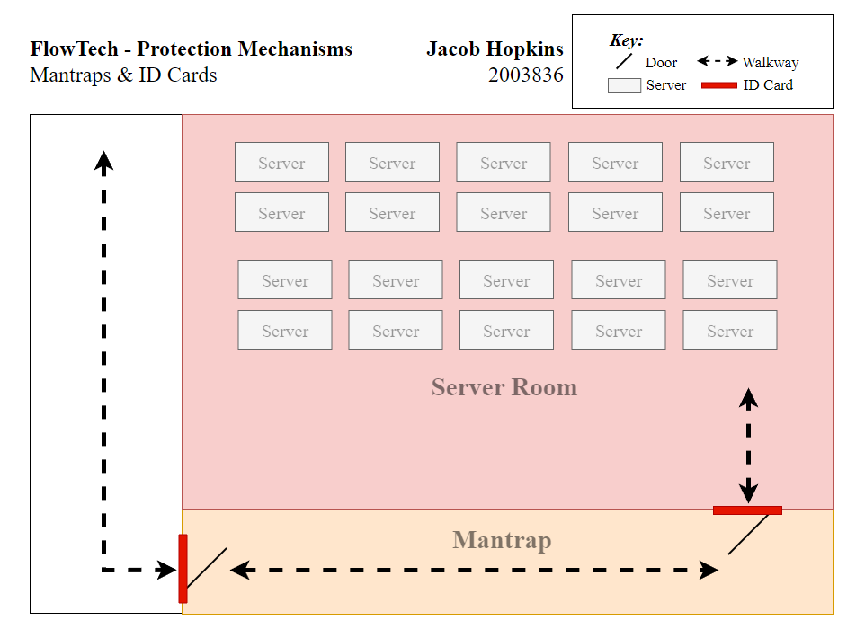
The proposed diagram above showcases an example mantrap system utilising locked doors requiring ID cards to gain access. As previously covered, these mechanisms can greatly limit access to secure areas within FlowTech’s facilities, enforcing those attempting to gain entry to provide identification to continue, whilst also helping reduce the potential of tailgating, in turn helping protect and preserve the confidentiality of client data.
As a means of identifying and deterring logical and network-based attacks, FlowTech could look towards the implementation of an Intrusion Detection and Prevention System, otherwise known as IDPS. These network devices could effectively identify and report possible intrusions within the FlowTech network by actively scanning traffic forwarded through networks, comparing data with known malicious patterns and activity such as door knocking, and flagging suspicious packets. This enables the organisations information security team to act quickly towards possible external threats and help mitigate them before damage can be dealt. Ideally, an IDPS would be installed beyond FlowTech’s network firewall, positioning itself as a backup protection mechanism to the firewall, to identify and terminate malicious content plaguing the network by dropping the packet if the firewall is to fail. If an attack is successful, the IDPS would enable FlowTech to analyse collected data from the network device and examine how such an attack played out. Using the information gathered, FlowTech can make effective and appropriate alterations to both their network and security to help combat future attacks following a similar approach. The diagram below depicts this implementation.
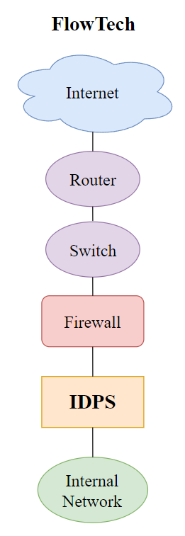
In addition to monitoring network traffic from external sources, an IDPS can also be configured to monitor and analyse internal network traffic amongst the likes of employees. Using specially configured parameters based on asset data handled across the FlowTech network, an IDPS can flag suspicious packets such as large data transfers. This tool can be useful for identifying both dangerous and disloyal employees looking to exploit the organisations data. Furthermore, the installation of an IDPS can act as a deterrent towards would-be attackers due to it increasing the potential of detection when infiltrating FlowTech’s network, further supporting the proposal of implementing such a system.
- Compliance
It is important that laws are carefully considered within an organisation and its structure, ensuring that operations comply with the laws relative to where they are conducted. As covered within task 1, the UKs Data Protection Act (DPA) and the EUs General Data Protection Regulation (GDPR) are prime examples of these kinds of regionalised jurisdictions. As a business providing a service to an extensive number of clients, FlowTech have a responsibility to ensure that the data withheld for the use of their services is kept safe. Through their consultancy services, FlowTech handle areas such as business continuity, data recovery and risk management through what is believed to be cloud storage service. These areas could hold sensitive data such as large backups of client databases’ for data recovery. In addition to this, sensitive data such as building plans and equipment, could also be stored in relation to their risk management and business continuity services. If FlowTech are not to abide by these rules set out by these governing bodies, the organisation could suffer greatly in the very possible event of a data breach or loss of data. This is covered in detail within task 1, highlighting the potential fines and penalties that can be faced by those refusing to follow the rules set out by the European Union or UK government, including up to a €20 million fine. Because of this, it is critical that creating a safe environment for data to be stored is of upmost importance and ensures that the compliance of both DPA and GDPR are achieved, limiting the damaging effects of said events.

- Policies
Policies function as laws within an organisation, acting as a strong foundation for planning information security and dictating what actions and behaviour is deemed acceptable. Comprised of a set of standards, it is important that policies are understood amongst organisation members as a mean of improving effectiveness. This can be achieved through guidelines and practises set out by organisational managers.
When assessing both FlowTech’s position and organisational requirements I would suggest the implementation of an Issue-Specific Security Policy, often referred to as an ISSP. These policy structures provide guidance in the proper use of a resource, including assets and technologies such as FlowTech’s cloud storage and services, in an attempt to prevent the misuse of such assets. An ISSP could act as a great way of articulating FlowTech’s expectations on their resources for their employees, whilst also documenting resources. In addition to this, the use of an ISSP would indemnify FlowTech against liability in the case of an employees inappropriate or illegal use of the organisations resources, standing as a massive means of protection against legal action potentially taken by clients. As a way of showcasing FlowTech’s effort to ensure resources, such as its client data, will not be used inappropriately, the organisation can have an ISSP stand as a binding agreement between itself and its employees. This can help reflect FlowTech’s trustworthiness and professionalism to both its current and future clients, in an attempt to draw in more business and thus boost the company. There is a large selection of topics an ISSP can be deployed towards within FlowTech, such as the use of company equipment including data storage devices, use of personal equipment on company networks, and the management of data, just to name a few examples. To ensure these policies remain viable, FlowTech must carefully manage and update what they produce, this can be done through scheduled reviews, revision dates, and the formation of management teams to monitor policy validity.
- Contingency Planning
In adverse events that threaten data and asset security, many organisations turn to contingency plans to help guide them through the appropriate response and recovery procedures. These procedures are often set out by qualified individuals within the information security team, closely working alongside community management across the organisation to ensure a level of understanding and preparedness in the event of an attack. As FlowTech is very much still a developing organisation, it would be appropriate to follow a single integrated contingency plan, drawing together areas such as incident response, disaster recovery, and business continuity.
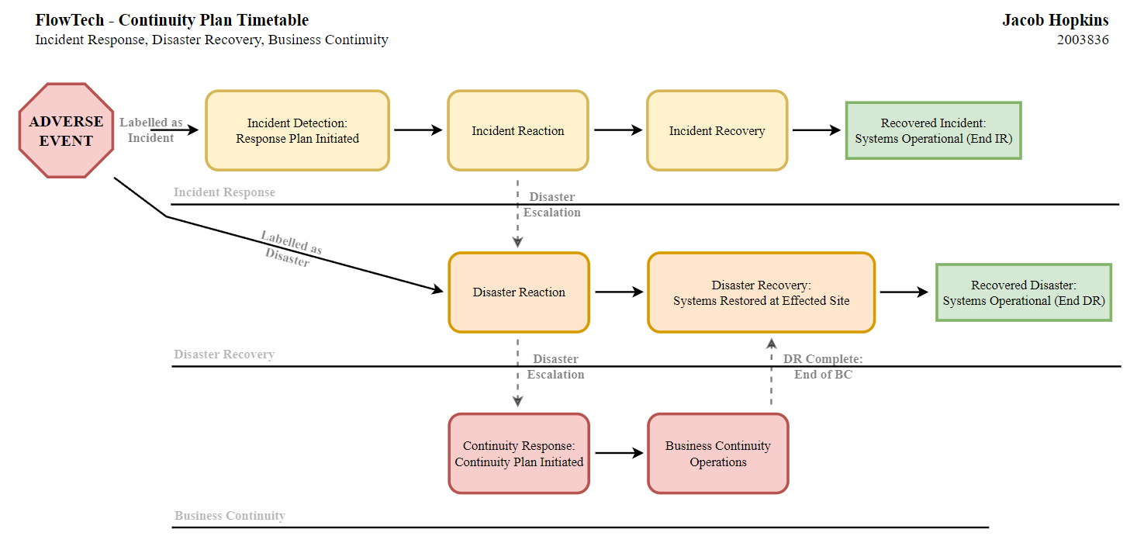
This continuity plan would involve suitable backups of sensitive client data from across FlowTech’s consultancy services in addition to their cloud servers and storage. With immediate action plans prepared in the event of an attack, and long-term support measures available for deployment if necessary. The use of said plan would enable FlowTech to tackle future attacks in an effective and organised manner, ensuring that the appropriate actions are taken handling organisation resources, and prolonging the security of sensitive data during reaction and recovery.

- Conclusion
With every growing business comes a multitude of ever-growing threats, each striving for the same outcome. Because of this, it is vastly important for an organisation such as FlowTech to have a strong and reliable information security unit to help manage and guide colleagues when it comes to threats. The purpose of this case scenario report was to help guide FlowTech through the development of their information security unit, and to discuss the importance of building a strong and reliable team to help protect organisation resources and data. The responsibilities of these teams are significant, and without a proper understanding of this could be detrimental to FlowTech as an organisation. Each of the factors covered throughout this report helps breakdown key areas handled by an information security unit, detailing their importance and the sheer impact an alternate approach can make to an organisation. While the content covered stands as a justified and valid approach to an information security unit, it is still only a set of recommendations based on my own research and beliefs. Because of this I still urge FlowTech to continue to evaluate their morals and position within the industry to come to a solution they deem is best suited for their organisation to handle this dilemma.

- References
[1] J. Flucke, "THE IMPORTANCE OF DATA SECURITY," Dental Products Report, vol. 50, (9), pp. 1-83, 2016. Available: https://www.proquest.com/trade-journals/importance-data-security/docview/1818045402/se-2?accountid=130472 Accessed Nov. 17, 2021.
[2] UK Government, “Data Protection,” gov.uk, Nov. 15, 2018. Available: https://www.gov.uk/data-protection. Accessed Nov. 18, 2021.
[3] P. R. Baker and D. J. Benny, The Complete Guide to Physical Security. CRC Press, 2012, p. 2. Available: https://books.google.co.uk/books?hl=en&lr=&id=U7U6Lc2ZYaYC&oi=fnd&pg=PP1&dq=physical+security+importance&ots=bU8Fckizxe&sig=XFCxt--JBl3WqA4yOYjj3690jQI#v=onepage&q&f=true. Accessed Nov. 18, 2021.
[4] R. Gezelter, Computer Security Handbook, 2002. Available: http://computersecurityhandbook.com/author-parker.html Accessed Nov. 19, 2021.
[5] M. E. Whitman and H. J. Mattord, Principles of information security, 6th ed. Boston, Mass.: Cengage Learning, p. 503, 2018.
[6] K. Strom, M. Berzofsky. B. Shook-Sa. K. Barrick, C. Daye, N. Horstmann, S. Kinsey. The Private Security Industry: A Review of the Definitions, Available Data Sources, and Paths Moving Forward. RTI International, 2010, p.37. Available: https://www.ojp.gov/pdffiles1/bjs/grants/232781.pdf
[7] K. Stewart, “Managing Security Services”, Facility Executive, Oct. 20, 2014. Available: https://facilityexecutive.com/2014/10/managing-security-services/ Accessed Nov. 20, 2021.
[8] Google, “Google security whitepaper”, Google Cloud, Sep. 8, 2021. Available: https://cloud.google.com/security/overview/whitepaper Accessed: Nov. 20, 2021.
[9] National Cyber Security Centre, “NCSC glossary”, NCSC, Nov. 23, 2018. Available: https://www.ncsc.gov.uk/information/ncsc-glossary Accessed: Nov. 23, 2021.
[10] SysGroup Marketing, “Statistics You Need to Know About Social Engineering”, SysGroup. Available: https://www.sysgroup.com/resources/blog/statistics-need-to-know-social-engineering Accessed: Nov. 23, 2021.
[11] M. Erbschloe, “Social Engineering Hacking Systems, Nations, and Societies”. Boca Raton: CRC Press LLC, 2019. Available: https://www.taylorfrancis.com/books/mono/10.1201/9780429322143/social-engineering-michael-erbschloe Accessed: Nov. 23, 2021.
[12] C. Cranny, “Cyber Security”, Home Office Digital, Data and Technology. NCSC. Available: https://www.ncsc.gov.uk/static-assets/documents/ECW-HODDT-Social-Engineering-ppt.pdf Accessed: Nov. 23, 2021.
[13] J. Power, “RFID Information Can Be Stolen from Three Feet Away”. Broadcom, Jul. 24, 2013. Available: https://community.broadcom.com/symantecenterprise/communities/community-home/librarydocuments/viewdocument?DocumentKey=cca590a2-b1c8-4618-bdd2-e9cc8aafbe46&CommunityKey=1ecf5f55-9545-44d6-b0f4-4e4a7f5f5e68&tab=librarydocuments Accessed: Nov. 23, 2021.
[14] D. Ramsbrock, S. Moskovchenko, and C. Conroy, 2021. Magnetic Swipe Card System Security: A case study of the University of Maryland, College Park. [online] pp.10-11. Available at: http://honors.cs.umd.edu/reports/Conroy-Magnetic%20Swipe%20Card%20System%20Security.pdf Accessed: Nov. 23, 2021.
[15] M. E. Whitman and H. J. Mattord, Principles of information security, 6th ed. Boston, Mass.: Cengage Learning, p. 511, 2018.
[16] M. E. Whitman and H. J. Mattord, Principles of information security, 6th ed. Boston, Mass.: Cengage Learning, p. 514, 2018.
[17] Fire Trace International, “Fire Suppression Systems with 3M Novec 1230”, Fire Trace International. Available: https://www.firetrace.com/en/3m-novec-1230 Accessed: Nov. 23, 2021.
[18] M. E. Whitman and H. J. Mattord, Principles of information security, 6th ed. Boston, Mass.: Cengage Learning, p. 519, 2018
[19] S. Ahmadian, F. Taheri, M. Lotfi, M. Karimi and H. Asadi, "Investigating power outage effects on reliability of solid-state drives", Automation & Test in Europe Conference & Exhibition, 2018. Available: https://arxiv.org/pdf/1805.00140.pdf Accessed: Nov. 23, 2021.
[20] Intersoft Consulting, “GDPR Fines/Penalties”, Intersoft Consulting. Available: https://gdpr-info.eu/issues/fines-penalties/ Accessed: Dec. 4, 2021.

- Appendices
Any appendices can be found within the document titled “Assignment Appendix” submitted separately via alternate Moodle link.

marking criteria and Student FEEDBACK

This section details the assessment criteria. The extent to which these are demonstrated by you determines your mark. The marks available for each criterion are shown. Lecturers will use the space provided to comment on the achievement of the task(s), including those areas in which you have performed well and areas that would benefit from development/improvement.

Common Assessment Criteria Applied (Assignment 1) | Marks available | Marks  awarded
1. Engagement with Literature Skills
Extent of research and/or own reading, selection of credible sources, application of appropriate referencing conventions.
Your work has demonstrated that you have done your own research which supported with relevant and appropriate up to date sources. The recommended referencing techniques used, however, avoid using superscript intext citation. (Grade mark: 95.00%) | 20 | 19
2. Knowledge and Understanding Skills
Extent of knowledge and understanding of concepts and underlying principles associated with the discipline.
You have critical appraise your research work demonstrating knowledge of the well-established concepts and principles. You have shown application of skills and research in the assignment. (Grade mark: 90.00%) | 10 | 9
3. Cognitive and Intellectual Skills
Analysis, evaluation and synthesis; logic, argument and judgement; analytical reflection; organisation of ideas and evidence
You have discussed all tasks and reference to additional information in your appendices. Task 1; you research section, your paragraphs are too long, aim to start new ideas in a new paragraph. Task 2 discussion interrelate the case study (Grade mark: 92.00%) | 25 | 23
4. Practical Application Skills
Deployment of methods, materials, tools and techniques; application of concepts; formulation of innovative and creative solutions to solve problems.
Diagrams provided to discuss your own approach. You must number and name all figures used. (Grade mark: 92.00%) | 25 | 23
5. Transferable Skills for Life and Professional Practice
Attributes in professional practice: individual and collaborative working; deployment of appropriate media; presentation and organisation.
Your work was written, formatted and flow excellently. Avoid using first person tense. (Grade mark: 95.00%) | 20 | 19

Assignment Mark (Assessment marks are subject to ratification at the Exam Board. These comments and marks are to give feedback on module work and are for guidance only until they are confirmed. ) | Late Submission Penalties (tick if appropriate) |  | 93%
 | Up to four weeks late |  | 93%
 | First Attempt? |  | 93%

