Therapy Assistant Practitioner:
Demonstrating Practice Logbook



This logbook was completed by:

Mentor’s name: …jessica simms… Mentor’s signature:  Date: …13/02/2026…

Learner’s name: ……Darren evans ………. Learners’ signature: Date: …13/02/2026….

The content page includes a list of evidence to be collected as part of your portfolio:

- Log of supporting documents: | Details to include (including criteria): | Date of completion: | Mentors signature: | Appendix / page
- An observation of your practice | A supporting document from your mentor of your compliance with person centred practice (1.2 & 4.3). | 13/02/2026 |  | Appendix 1 / Page 3
- Evidence of reading and learning related to role | A minimum of 2 examples of your engagement with researching and learning on topics related to your role (8.4). | 03/02/2026 |  | Appendix 2 / pages 4/5
- Log of a wide range of assessments. | A minimum of three anonymised assessments completed by you, demonstrating a range of skills and tools (1.2). | 1.29/12/2025  2.6/11/2025  3. 26/11/2025 |  | Appendix 3 / pages 6/7/8
- Copy of a recent Personal Development Appraisal Review (PDAR). | A copy of the most recent PDAR document completed with supervisor / mentor (8.1 & 8.3). | 01/04/2025 |  | Appendix 4 / page 9
- Copies of your recent supervision records. | A minimum of two supervision records, demonstrating attendance and contribution to supervision and agreement to actions (4.2). | 1.12/11/2025  2.10/02/2026 |  | Appendix 5 / page 10/11
- A copy of a risk assessments you have undertaken | A formal or informal risk assessment that you have completed. This can be a case note entry, DATIX, incident report or an assessment completed due to risks (such as a falls risk assessment) (4.3) | 23/01/2026 |  | Appendix 6 / page 12
- Examples of any training you have participated in or delivered | A minimum of five examples of evidence that you attended or delivered training within the last 12 months (8.4). | 1. 12/02/2026  2. 12/02/2026  3. 07/11/2025  4. 07.01.2025  5. 09/01/2026 |  | Appendix 7 / page 13/14/15/16/17
- Evidence of your compliance with mandatory training | A minimum of 5 examples of your mandatory training compliance over the past 12 month (4.1). | 2025 |  | Appendix 8 / page 18
***The following pages are where you can start to include your evidence:
Appendix 1 (to be completed by your mentor) - Supporting document:
Give a brief description of your relationship with the learner and a typical activity that you have overseen the learner complete:
I am Darrens team leader. My role is to over see the day to day running’s of the service that Darren works in, supervise him clinically and non-clinically and monitor ongoing professional standards.

Does the learner demonstrate the following performance in their day to day practice: | - Yes | - No | - N/A | Signature
- Person-Centred Practice
- Actively listens to patients/carers to understand goals and concerns | yes
- Adapts communication style to meet patient needs (such as cognitive, language, sensory) | yes
- Respects patient dignity, respect, and personal preferences | yes
- Involves patients in decision making and provides clear explanations | yes
2. Professionalism & Accountability
- Arrives prepared, punctual, and appropriately presented for the clinical task. | yes
- Follows organisational policies, procedures, and scope of practice | yes
- Accurately reports and escalates clinical concerns to qualified therapists | yes
- Accepts responsibility for actions and learns from feedback | yes
- Maintains appropriate boundaries and therapeutic relationships | yes
3. Safe & Competent Clinical Practice
- Delivers treatment sessions as prescribed by supervising clinicians | yes
- Demonstrates safe handling, mobility, and equipment use | yes
- Uses standardized assessments correctly and ethically | yes
- Identifies and reports risks (falls, safeguarding, deterioration, environmental hazards) | yes
- Documents interventions and outcomes accurately and timely | yes
Appendix 2 evidence 1.
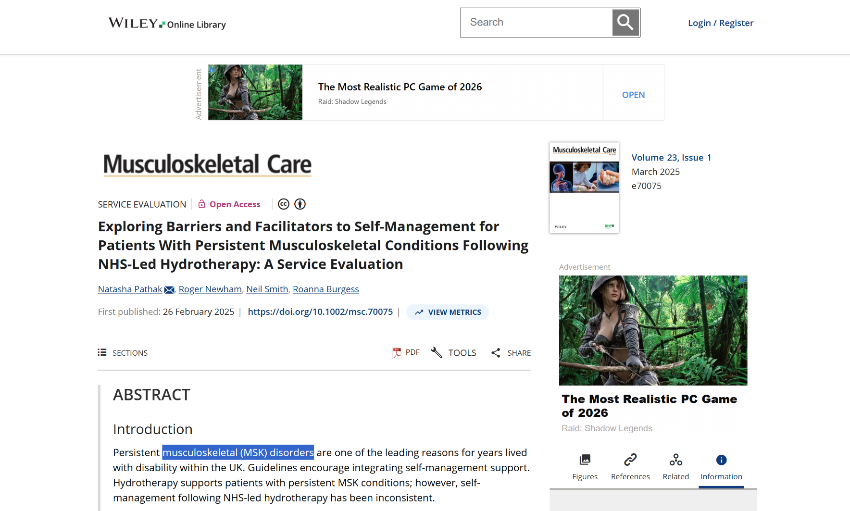

One of a long list of Articles I looked at when setting up hydrotherapy for my work place. Pathak, N., Newham, R., Smith, N. & Burgess, R. (2025) Exploring barriers and facilitators to self-management for patients with persistent musculoskeletal conditions following NHS-led hydrotherapy: a service evaluation. Musculoskeletal Care. Available at: https://onlinelibrary.wiley.com/doi/10.1002/msc.70075 (Accessed: 3rd February 2026).
Appendix 2 evidence 2


NHS Wales (2023) Health and Care Quality Standards 2023. Used for researching and keeping up to date with nhs standards for my role.
Welsh Government (2023) Using the People’s Experience Framework: Guidance for NHS Wales.
Available at: https://nwssp.nhs.wales/a-wp/governance-e-manual/putting-the-citizen-first/health-and-care-quality-standards-2023/
(Accessed: 3 February 2026).

Appendix 3 evidence 1
s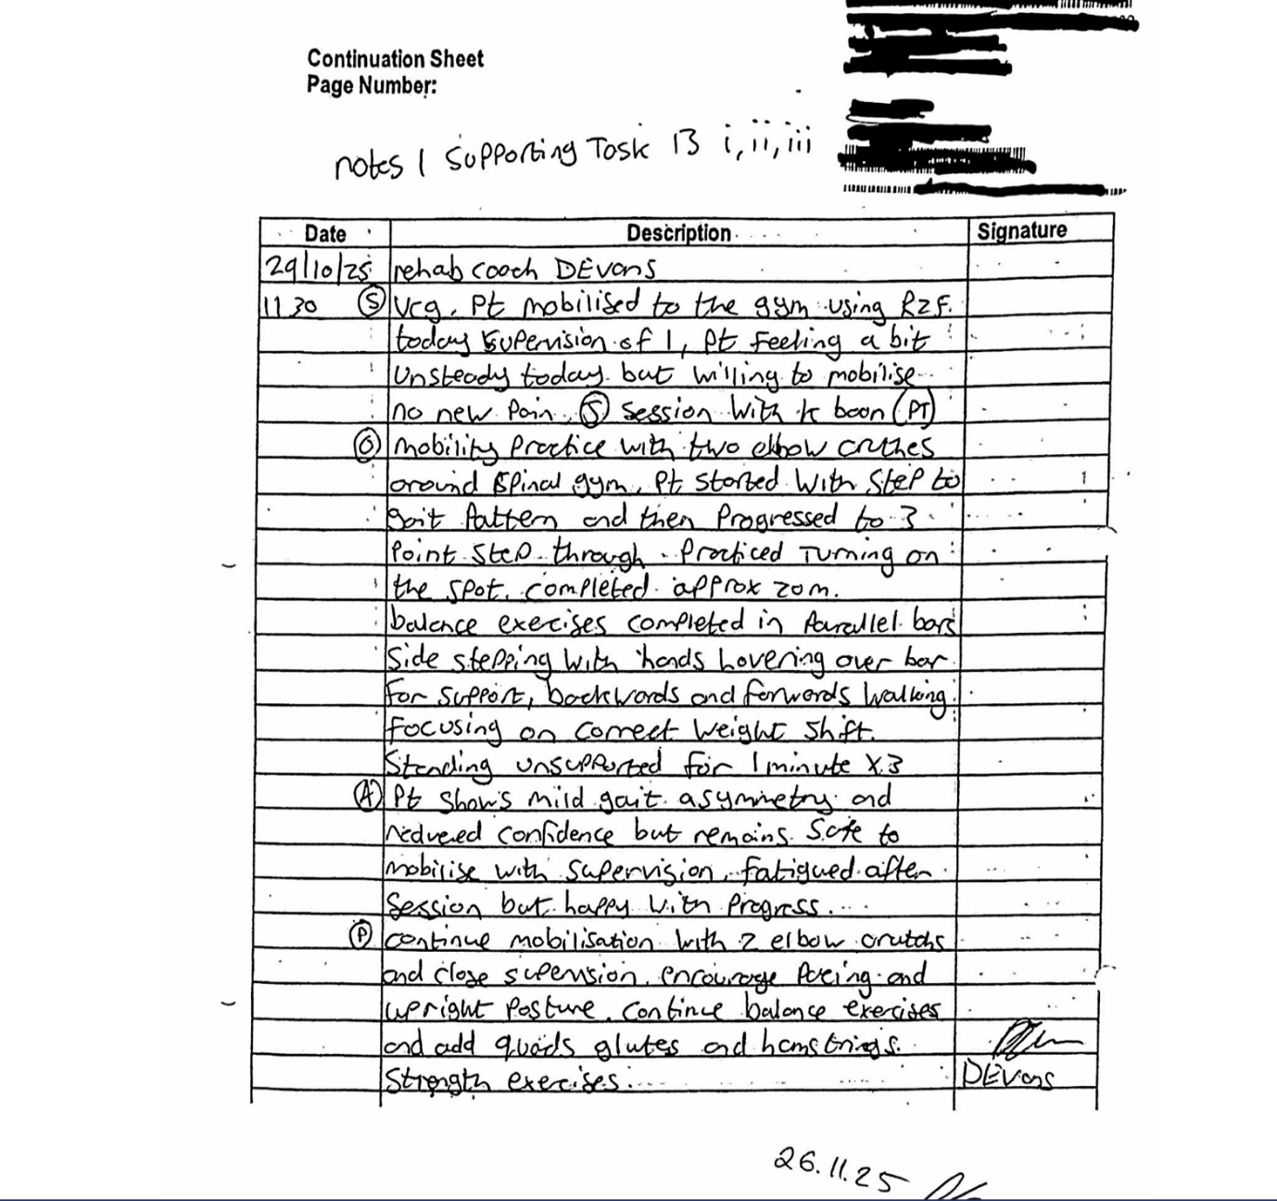Soap note written after treatment with a patient.
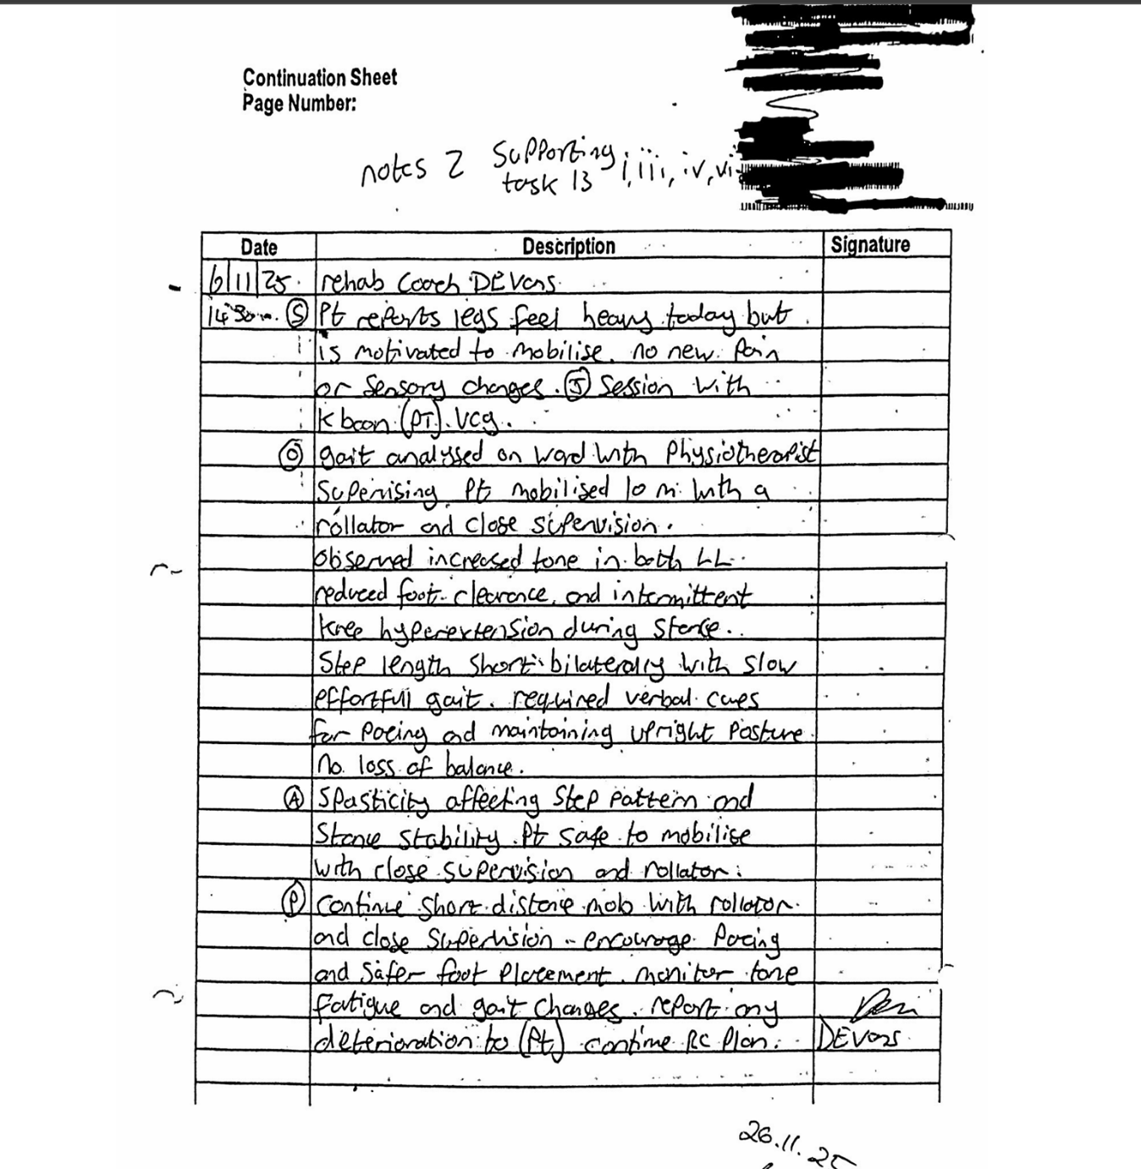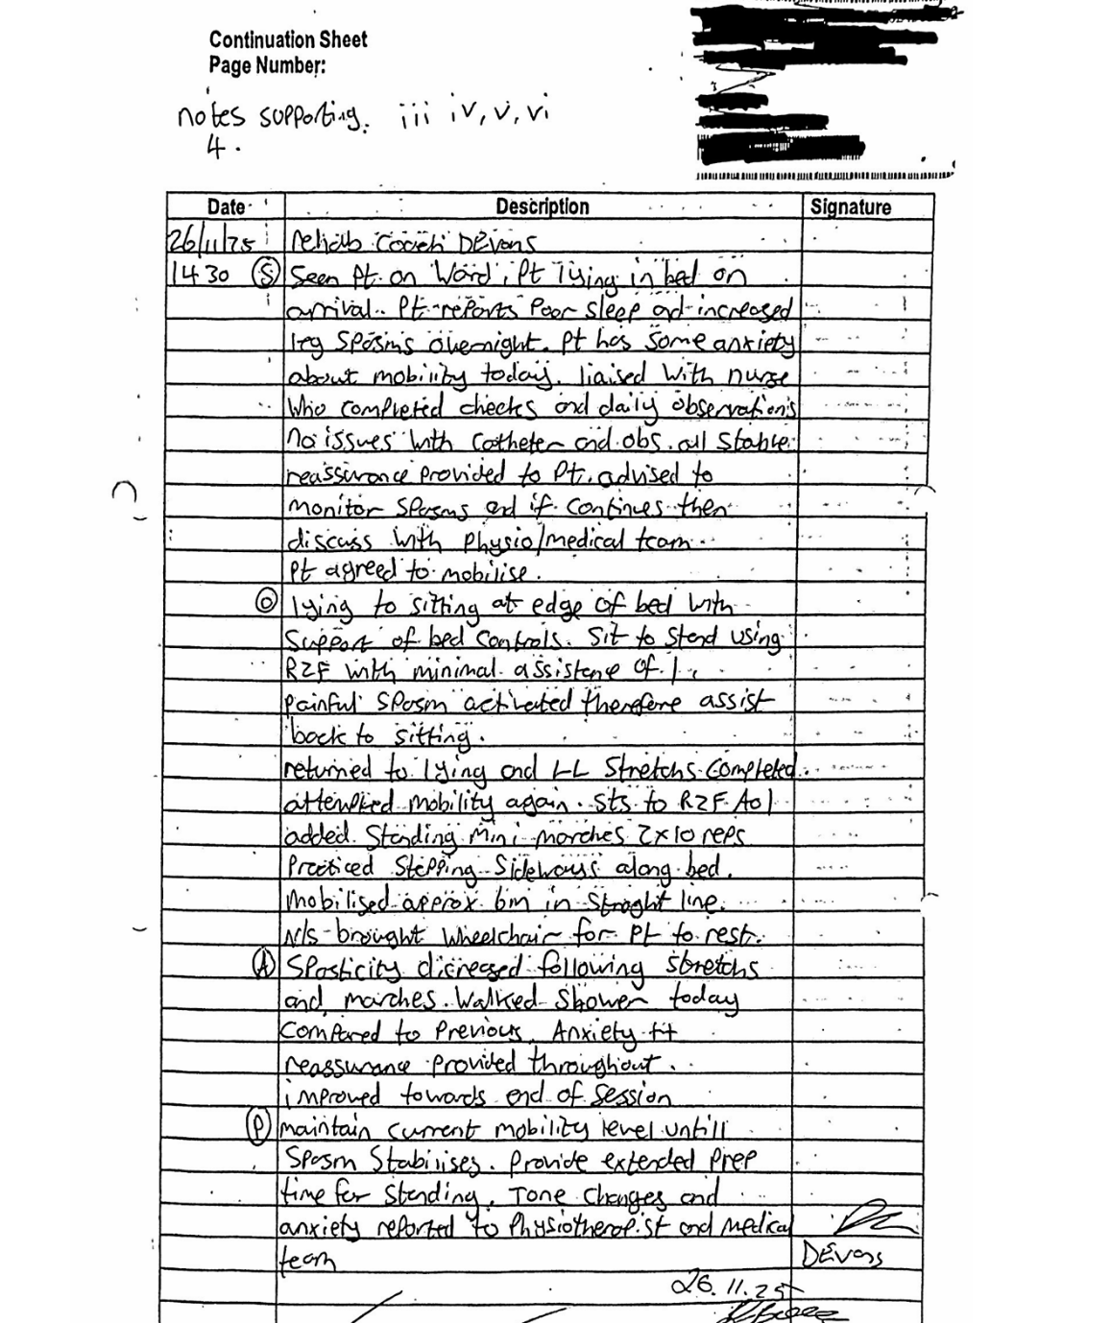
Appendix 3 evidence 2
Soap notes written after treatment with patient.
Appendix 3 evidence 3
Soap notes written after treatment with patient.

Appendix 4 evidence 1
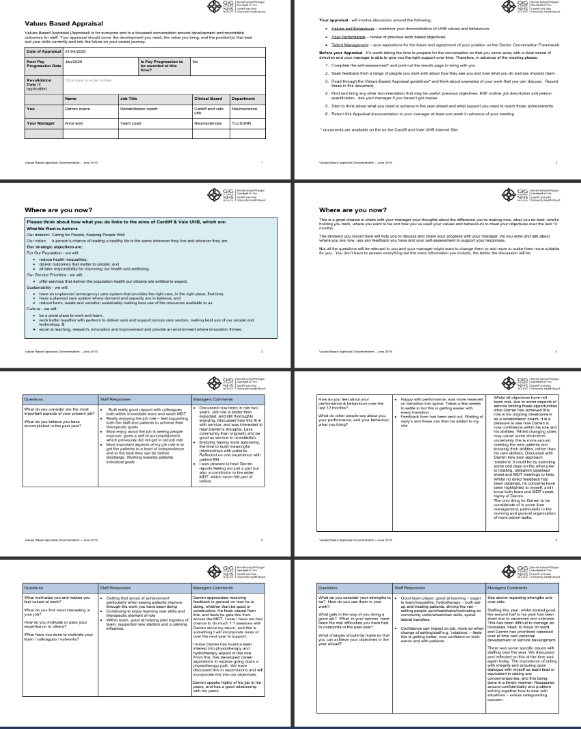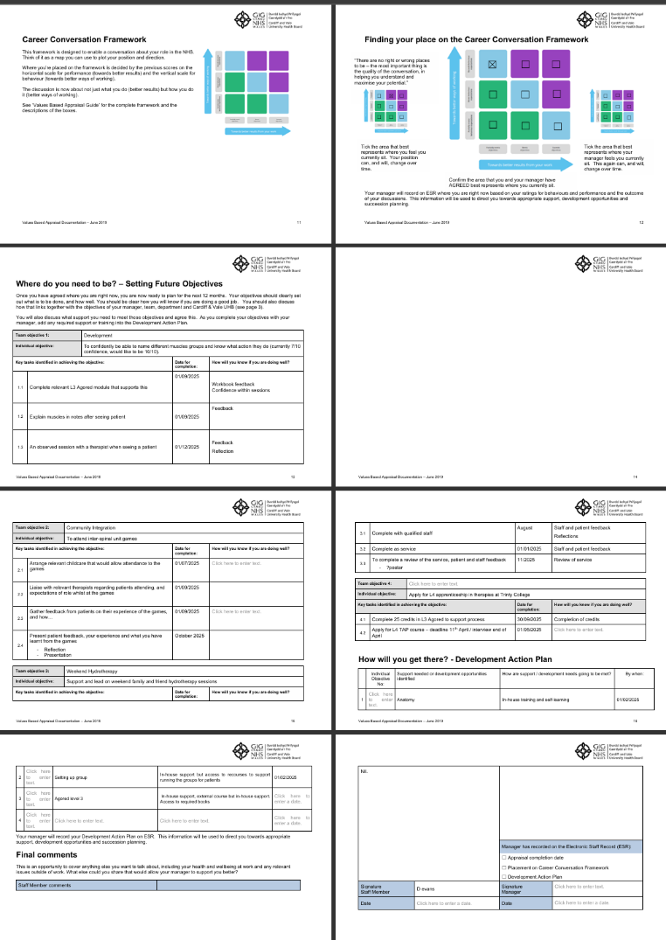
This is a most recent PDAR (VBA). It was completed with my old manager. Vba is due again so will have a updated vba very soon
Appendix 5 evidence 1
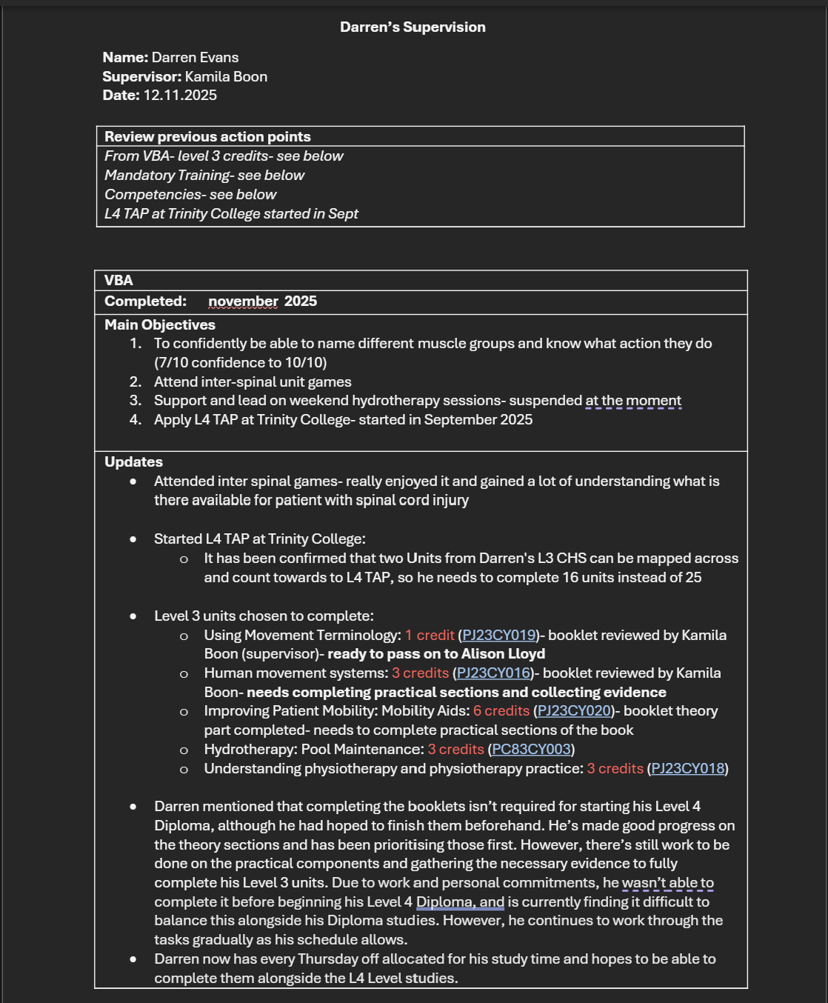
supervision done at the end of 2025 with my last mentor.
appendix 5 evidence 2

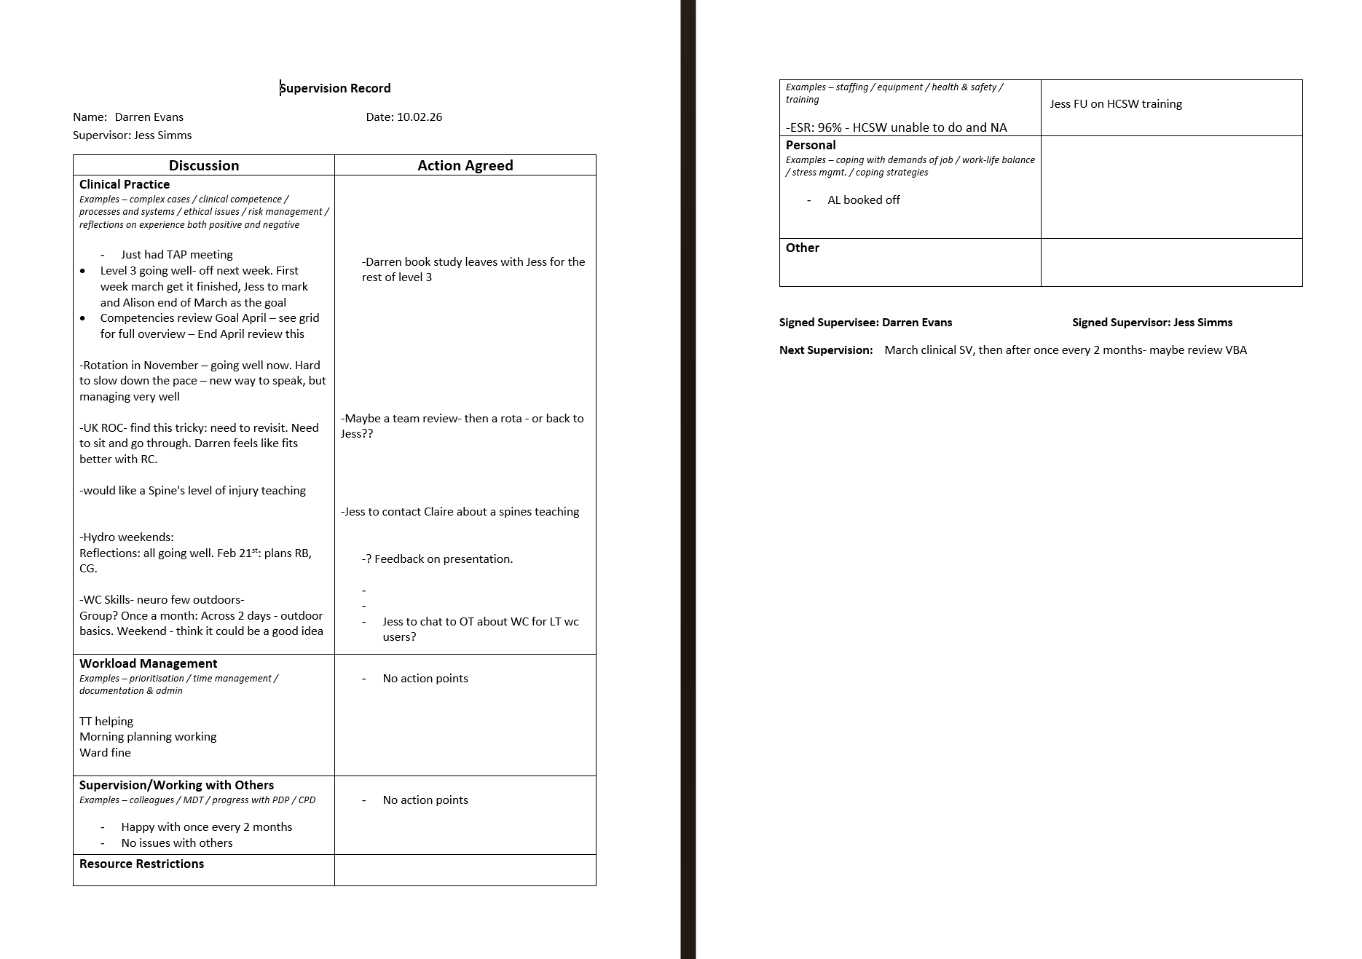
copy of a most recent supervision done with newest manager

appendix 6 evidence 1

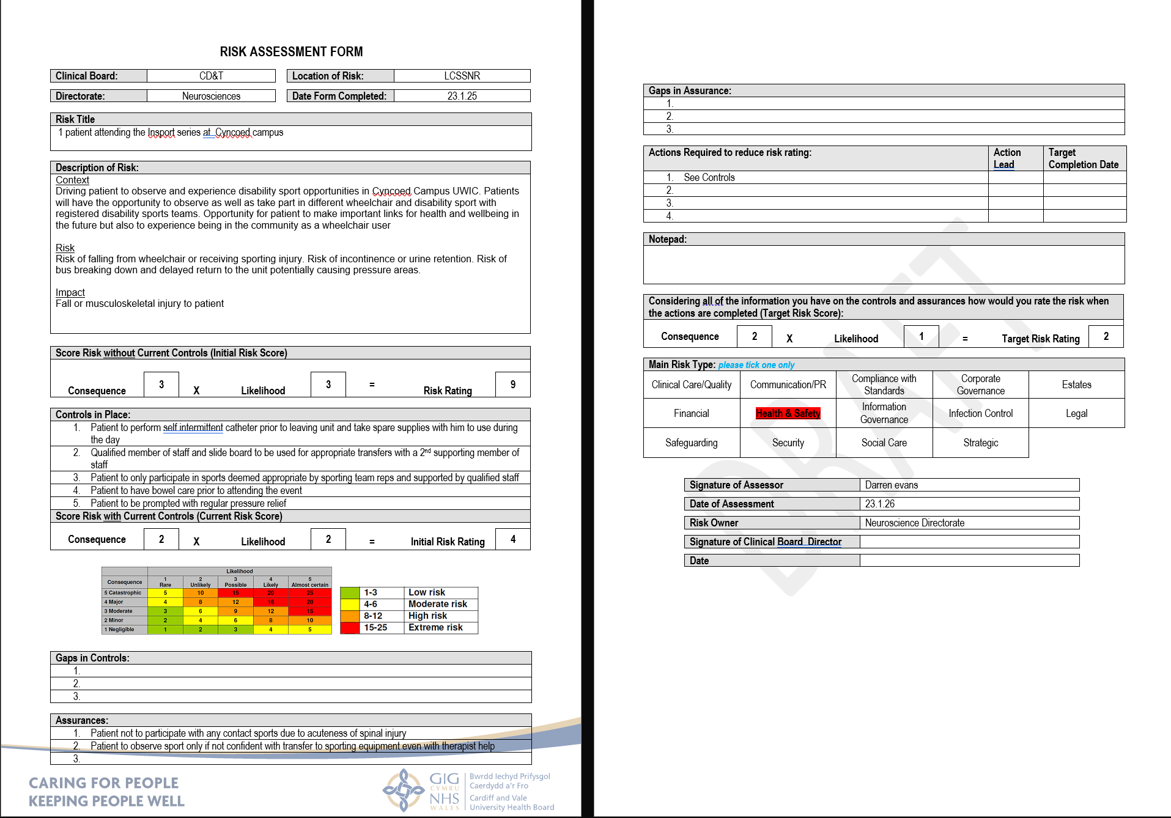

copy of risk assessment done for a community visit to inter sport wales
Appendix 7 evidence 1
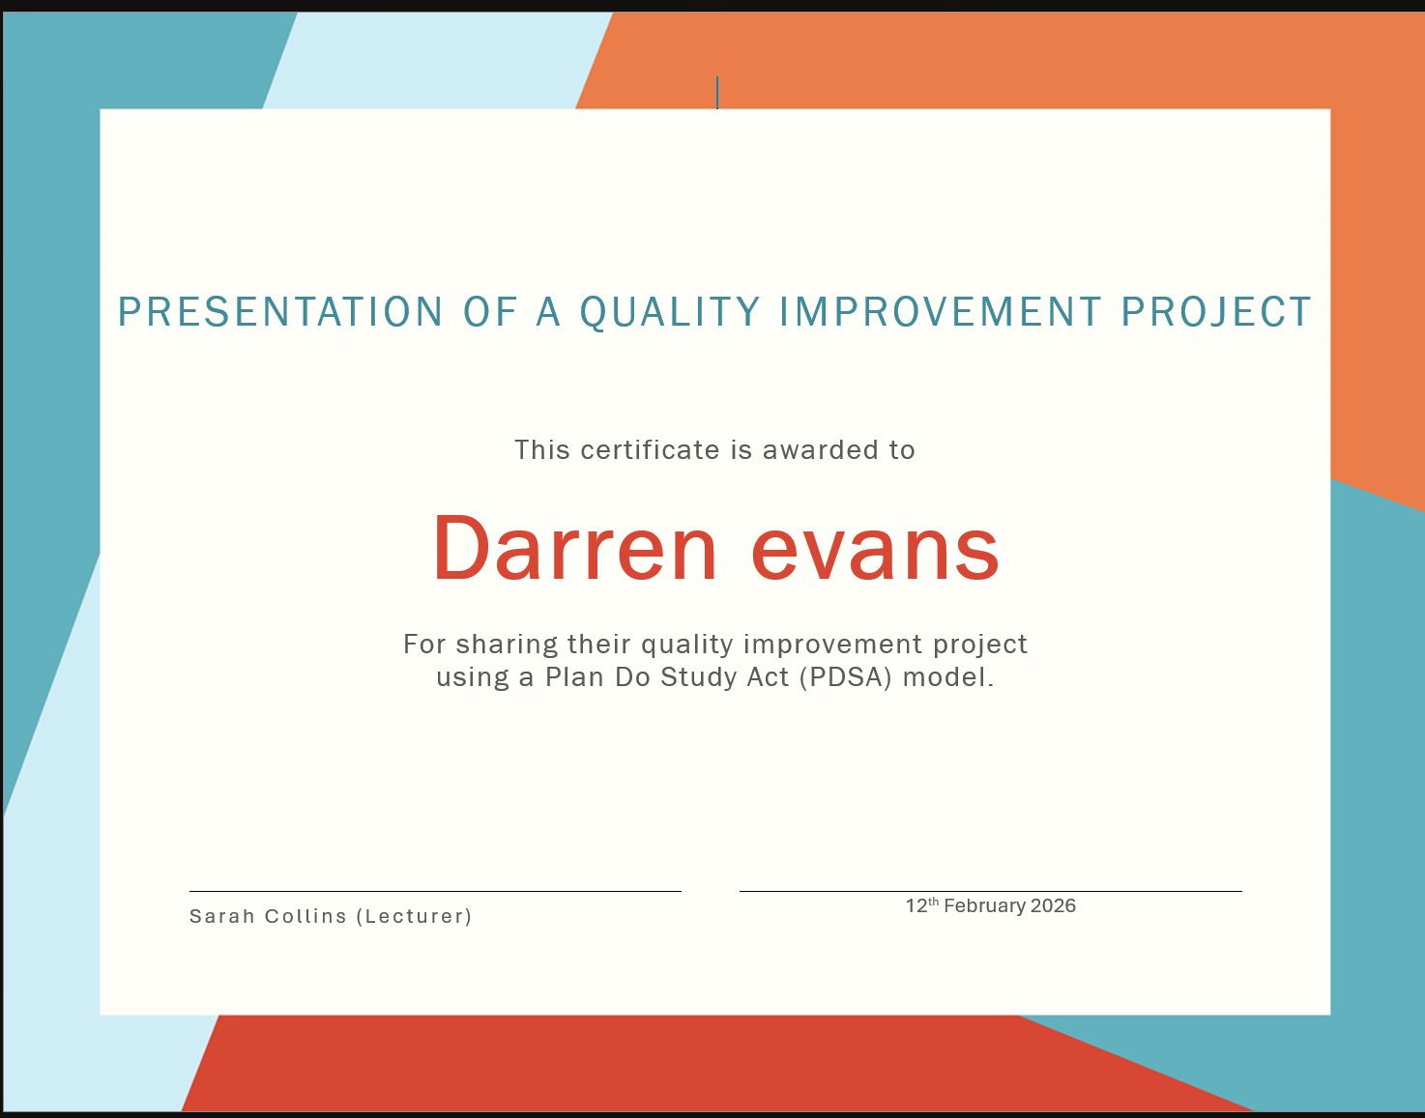

Certificate of presentation completed

Appendix 7 evidence 2
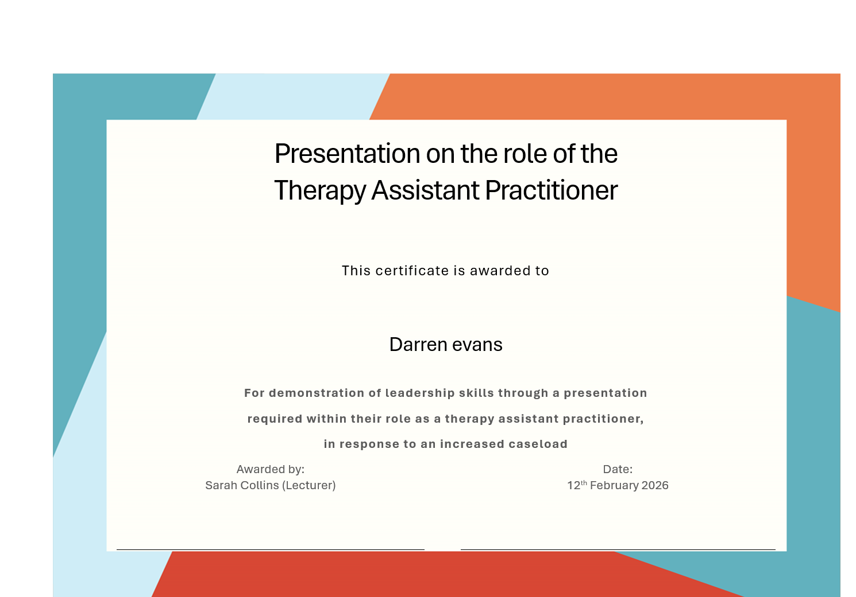

Certificate of presentation completed

Appendix 7 evidence 3
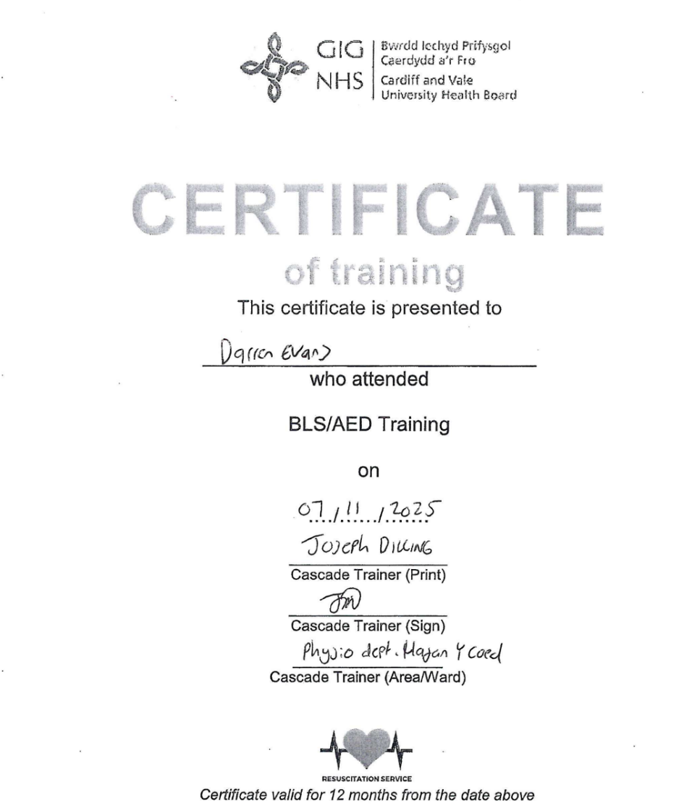 certificate of resus training completed

Appendix 7 evidence 4
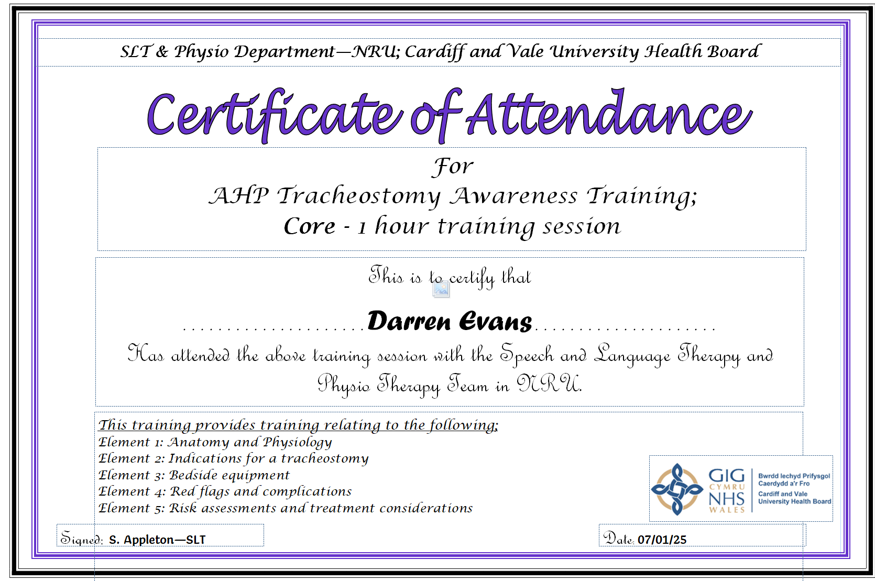

Certificate of tracheostomy training completed

Appendix 7 evidence 5

Appendix 7 evidence 5
A letter of passing agored community food and nutrition course level 2. Course was deliver of a number of weeks

Appendix 8 evidence
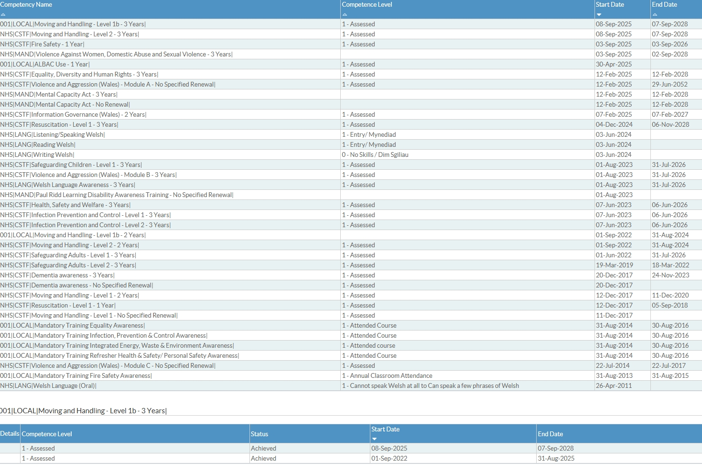
Screenshot of my esr folder. A lot have been completed within this last 12 months.

