

Student Name: - Psalmist George Nana Kwasi KING.

Student No. : - 1606028

Module Name: - Developing Workplace Critical Thinking BMSK5001

Module Tutor: - Moly Jack

Word Count: - 4360

TABLE OF CONTENT

Introduction------------------------------------------------------------------------------------3
Organisational description------------------------------------------------------------------3
Critical thinking? ------------------------------------------------------------------------------4
Importance of critical thinking at workplace -------------------------------------------4
Own organisation: ----------------------------------------------------------------------------5
Difference between beliefs, attitude and values --------------------------------------5
The importance of values in workplace --------------------------------------------------7
The importance of attitude in workplace: (negativity and positivity) -------------8
The importance of beliefs in workplace --------------------------------------------------9
Management theories ----------------------------------------------------------------------10
The scientific management of Frederick Taylor ---------------------------------------10
Bureaucratic management theories of max weber -----------------------------------11
Managerial functions ------------------------------------------------------------------------12
Change Mamagement -----------------------------------------------------------------------13
Recommendation and Conclusion --------------------------------------------------------14
Reference ---------------------------------------------------------------------------------------15

INTRODUCTION:
This assignment is required to have an indebt understanding of how to apply critical thinking to a definite organisational perspective, and outline the processes involved in order to generate a desired outcome in an organisational workplace environment. The report also highlights the beliefs, attitude and value systems and its importance. A touch on management theory and functions is also detailed below.

ORGANISATIONAL DESCRIPTION:
The challenges were clearly defined and therefore warranted the appointment of a new manager over a relatively small company who had the challenge of employing incompetent professional employees. The new manager’s assignment was to analyse and evaluate and draw conclusion to a situation with the aim to enhance the quality of their employees using different techniques, also, input measures in other to sustain the organisation. The scenario required the necessity to apply good critical thinking because it entailed dealing with both unprofessional and professional employees.
Bearing in mind that every manager is also a role model and is expected to exhibit great managerial excellence, and that their thinking style and methods of analysing a problem as a leader must motivate the employees as a whole, and must spend quality time with the employees and know much about their challenges, must have demonstrate a positive attitude at all times (Mimeo 2016).
In this scenario, most of the unprofessional workers who had no good qualification were the most enthusiastic and hard workers and punctual as opposed to the incompetent professionals who wanted salary increment but were always late to work and are also ready to give instructions. The urgency of this matter needed an experience leader and manager who could meticulously apply vivid critical thinking skills, who can analyse the situation objectively, and in other to reach a logical conclusion, must be able to consider all the facts. A scientific management style of application was needed and then to dissolve their old ways and habits of using common sense of managing the company.

In other to achieve this, management have to bear in mind the very importance of:
- Keeping the goal in focus and
- Regularly asking any questions without being bias.
- Gathering all data and available resources and evaluating them accordingly.
- You must consider people who have different ideas which may not be the same as your and be ready to collect feedback.
- At this point, you should be in the state of engendering solutions bearing in mind the long and short term consequences whiles you implement each solution

CRITICAL THINKING?
In my quest to research the very meaning of critical thinking, I have uncounted numerous definitions. It is obvious that very one thinks when making major or minor decision and not necessarily knowing what to expect at the end. Critical thinking helps us to discover, research and process the data we collect. It is also important to critically think in other to make informed decisions. (Informed decisions are based on evidence that we can trust or can be explained to others and have a good chance of achieving the effects we want).
In the simplest of term, a critical thinker is one who can demonstrate and put forward philosophies that are very innovative, must be able to relate logic and reasoning to solving multifaceted problems and also being able to evaluate various options and techniques in ascertaining ones beliefs and values, and finally, improve and apply their knowledge gained through the acquisitions (DXC, 2019). In other words, a critical thinker must seek more amplification with regards to new ideas, he must also be sceptical and not believe anything they hear and must admit and accept convincing evidence which are contrary to their ideas.
According to Austin, (2018), the actual variance between critical and logical thinking is that, logic is a science while critical thinking is a process. What is means is that, process is step by step in other to achieve a desired end. A critical thinker rethinks what has been thought about and reviews it. The traits of a critical thinker is that he or she listens is open to more opinions, he is not bias and also defines the problems without emotions.
The ultimate goal for every employer is to find a candidate who has the ability to generate the best results in every situation. Persons with critical thinking abilities or skills are the most sought after in every organisation because companies face different challenges at different times and need candidates who can think for themselves and make informed decisions on their own (Alison, 2019).

IMPORTANCE OF CRITICAL THINKING AT WORKPLACE:
If you are a manager or a leader who manages several staff, you must be a good thinker. This is because individual members of your team may have different beliefs, attitudes and values. The same applies to how employee should address their employers or managers. A scenario where bad workers are being managed by a good manager, the results of their project will be disappointment unless the manager thinks critically with a different style and skill. In the case of CoAEN, the company deals with businesses locally and internationally and therefore must have the technical abilities of rethinking and apply critical thinking to every decisions they make. The importance of critical thinking at the workplace is essential because it helps to:
- Save time when undertaking a project because you will have outlined the pros and cons before the initiation of the project.
- There is clear and improved communication channel which helps the work flow (Alice 2016)
- Unseen ideas. While gathering and critically accessing evidence, it will interest you to know how you can come up with new ideas for new business within the sae organisation.
- Helps in conflict resolutions at workplace. Often rather than not, misunderstanding at the workplace can cause lots on damage to the reputation of the organisation.
- Promoting creativity. Workers easily look for inventive ways of embarking on their work.
- It promotes team performance. This can be achieved where team members are also well vested in the knowledge of critically carrying out their duties (Career & Education, 2015).

OWN ORGANISATION:
The company which was known to be the best producer and leading exporter of Cocoa of Africa Europe Network (CoAEN), was now heading down the drain. The company has suffered many crisis in time past and this was due to the novice structure of its organisational culture and structure and beliefs. The behaviour of its employees at the very commencement was foreseeable because, the selections was focussed on whom you know and not centred on the quality of the individual. It was a selection of family members and friends who had comparatively very little idea on Cocoa production.
In this situation, some of the techniques used to combat the bad behaviours of the employees at CoAEN was to deal with the situation as soon as possible, to evaluate the position of the employee’s job, also to continually keep an eye on the situation and lead as example. The leader must be able to document every situation he encounters and remember to stay cool (Thuy and Milo 2016). All though the CEO of the CoAEN had a vision and a clear plan, his methodology and level of abour force however in the early stages nearly collapsed the company until there was a drastic U-turn. The employment of a manager who had the scientific management theory with critical thinking skills was very necessary for the uplift of the company.

DIFFERENCE BETWEEN BELIEFS, ATTITUDE AND VALUES:
Life is full of the demonstrations of beliefs, values, attitudes and behaviour that emulates who we are. These characters will either make or unmake you as a person or as an organisation. We should notice that the diagram below clearly reviles the very root cause of who we really are and also demonstrates how our beliefs, values and our attitude affects the behaviour of an organisation or a person.

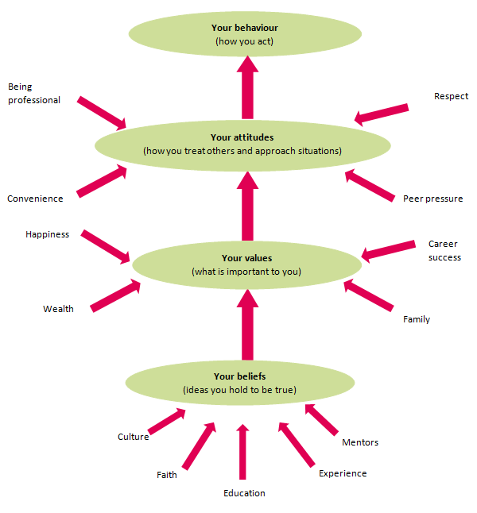

Figure 1: Personal beliefs, values, attitudes and behaviour.

Figure 1 above is the symbolism of a person or an organisation. Our beliefs, values and attitudes are who we really are. We are justified by the reactions of any of the three mentioned above and they can generate negative or positive results or behaviour. So for this Cocoa of Africa Europe Network (CoAEN) company to achieve excellence, potential skilled candidate or employee with good knowledge must be identified and employed.
The figure above further explain that:
- Your beliefs is your thoughts pattern and your personal ideas and vision, and sometimes your experience in life or your assumptions. Whatever you accept to be true becomes a pattern of your belief system even though one can’t understand it. It certainly cannot be proven but ones it is accepted, it forms part of you. This is quiet important for this Cocoa of Africa Europe Network (CoAEN) because, the manager should have had a clear plan and a vision and how to execute it.
- Your values are based on your beliefs which you have gained over the years and are very dear and important to you. It is your worth and positive attitude which drives your confidence. In other to be respected or responsible or to make clear decision your values must be well articulated. Commitment to Cocoa of Africa Europe Network (CoAEN) becomes your worth because it is what will drives your ambition. Your beliefs and attitudes can affect your friends and families, religious leaders around you, and also, the knowledge you acquire can highly influence you greatly (Mahan, 2018).
- A well accentuated values and beliefs form your attitude. The way people will relate or react to you is reliant on the beliefs and values you embrace. In other words, your behaviour or expressions to others and how they respond to you must be influenced by your beliefs and values gained. It has also got to do with our feelings and behaviour towards others and to ourselves.
A manager must have good values and beliefs to be able to demonstrate it to his workers. Which means, the ideas you hold to be true and the importance you attach to it will determine how you approach situations. Which can also mean that, bad leadership values and beliefs will result in bad organisational structure and that will determine the outcome of your organisation.

THE IMPORTANCE OF VALUES IN WORKPLACE:
Your value is your brand. To every individual, your values are who you really are and this was the situation of the CoANE Company. Where there is no value there is either no progression or less progression to the life of an individual or an organisation. Values are also the fundamental for the organisation’s culture and that is what drives the organisation’s vision. Team members will be accountable for what they do and they will strive to make a great difference if there is a clear core value for the organisation. It is also important for a company to have values as this helps employees to build a good team and also helps to them to respect the organisation’s policy.
Some of the importance of workplace values are that team members are more reliable and positive in their approach to work, the deliver quickly and quality. The fact is that strong values are the governing body and is the principal approach which makes a company (Mindtool, 2019).

Some of the benefits are:
- It attracts good employees and promotes unity at workplace. The employee is almost an ambassador of every organisation. Good values identifies good employees and clients and therefore a company’s value is what will destroy or make it.
- It also protects company’s assets. Employees will not misuse company cars and make unnecessary telephone calls. This also protects personal and company’s integrity.
- Ethical-decision making. Company face challengers and so it is vital that when managers what to make decisions at these times, they should base and guide their decisions on the strong ethical values that governs the company (Larry, 2015)

According to Penny, L. (2019) Work values that every employers would want to look out for in an employee are:
- Employee who can easily adapt quickly to change and can also maintain flexibility when it comes to completing a task.
- Who have a sense of honesty and good relationships
- Confidence within themselves. Persons who are not afraid ask for help in the areas where they are less equipped or less informed.
- If they can also demonstrate professional behaviour and are able to complete highly quality jobs at all times.

THE IMPORTANCE OF ATTITUDE IN WORKPLACE: (Negativity and Positivity).
Your attitude towards others may encourage them to come to work the next day just as yours may also have an impact on them. Working with people can be very frustrating sometimes, however, a positive attitude creates a conducive atmosphere at workplace. A positive attitude helps promotes peace and releases stress at the workplace. People will begin to fight and back bit others at the workplace when negative attitude is demonstrated. On the other hand a positive attitude promotes good competitions and help productivity.
The desire of any company or organisation is to employ people with good moral attitude to work. The advantages are that:
- Interpersonal affiliation is well established. There is much respect among team members at all times which creates trust.
- Teamwork is always improved because team members cover each other.
- Goals are achieved quickly due to good and clear communication links.
- Leaders fill free to operate
- Rix is reduction or minimised at the workplace.
- It creates an atmosphere of positivity which makes the environment becomes conducive for the team as a whole (Beverley, 2016).

People’s perceptions towards you may certainly change as you change. Attitude can be demonstrated not only through words but even through your silent action. That means, not saying anything can frustrate or break up a team.
Some of the effects of demonstrating negative attitude at workplace are:
- Good customer deterrent. Customers make up an important part of every business success. They can easily identify issues and give feedback to the appropriate authority. For instance, when an employee speaks to a customer in a very bad way and the issue is not solved amicably.
- Unhappy employees: Low pay or over high work expectations could also make workers unhappy. Unfair treatment is also an issue which causes employees not to return to work (Agnes, 2014)

THE IMPORTANCE OF BELIEFS IN WORKPLACE:
Beliefs mainly represents the assumptions anyone makes about your organisation. They are internal feeling about you believe is true, although not proven. For instance, a company can predict that in ten years’ time they will be the best in their marketing sector, or a mother may say she child will become the president in the future. Decisions are based on assumptions. People will follow your ideas or invest in your organisation if you believe what you are doing is right.
Good employers or leaders with any of the managerial or leadership style listed below can influence the team positively if they have strong beliefs. According to TEC, 2018, all leadership style are not the same and that there are different methods to approaching different companies.
TEC further explains that:-
- Autocratic, where the leader have all the power. This kind of leadership can lead to high absenteeism because of its strictness and the control of the leaders.
- Bureaucratic, where leaders set examples for the staff to do likewise. In this style of leadership tasks are carried by the rule of the book and so risk is minimised.
- They can also be Charismatic, where the leaders inspires their team members with the advantage of great transformation taking place in the organisation.
- Or Democratic, these kind of leaders like to involve employees or team members in making decision, however, they have the ultimate say. This is very important because it helps creativity in the organisation (TEC, 2018).
There are many more types of leadership style, however, the Cocoa Company had to employ a democratic manager who has a strong belief in other to enhance their company standards.

MANAGEMENT THEORIES:
In other to understand the term Management Theories I will like to define management and theories on its own. According to Cambridge Dictionary (2019), Management is simply when a business or something is are being controlled and organised or the activity of being in charge of employees or department. Theory is defined as set of rules or principles or a realistic descriptive facts which management can use to control.
Therefore, in conclusion, management theories is a set of principles or rules that managers use to manage an organisation. For an organisation to attain success, a theory relating to that organisation must be used to assist managers to manage the affairs that company. The application of a theory will depend on the employee or the workforce. Although there are many theories, management may have to combine different styles or theories for the productivity of their organisation and over the years, the working practice has changed dramatically because of these theories.

THE SCIENTIFIC MANAGEMENT OF FREDERICK TAYLOR:
Many theorist have introduced different theories way back in the 20th century even though there were many businesses before that time. Taylor is said to be the father of scientific management movement emerging from that century because he was one of the first theorist to study management as a problem (Taylor, 1911). He further established that, every employer and workers ultimate aim is to have a secured place of working environment. Therefore, it is important for management to ensure and assure a maximum prosperity for both parties (Taylor, 1911). It is therefore necessary for any establishment to enforce the appropriate management theories based on the structure of the organisation.
Mind Tools, (2019) also explains that, although lots of people are motivated to work because of money, it contributed to the failure of many companies because their selecting procedures was not based on quality but quantity. Hence, selecting the right person for the right job was the fundamental to every company’s success. Based on these challengers, taking onto account these experiences at workplace, Taylor developed a systematic scientific management approach which was also known as Taylorism.

Below are his four scientific management principles:
- To demolish the common sense habit and apply the techniques to selection by a scientific means.
- People work differently, so you must choose the correct person who can carry the task to the core and if possible, train them in other for the job.
- To measure performance by monitoring and supervising the workers. This will help workers to use the right tools for the right job.
- To engage managers to plan and train workers by way of sharing the work between managers.

BUREAUCRATIC MANAGEMENT THEORIES OF MAX WEBER:
According to Toolshero, (2019), the Max Weber’s bureaucratic theory is also a powerful theory which is intended to help an organisation to set up effectively and in a practical way. No organisation intends to set up and fail or is designed to have an ineffective system, but to have power and to focus on the internal and external factors that will enhance the success of the organisation. This is why the bureaucratic management structure focuses on a systematic way of structuring to ensure success. The powerful 6 bureaucratic management principles of Max Weber described below is designed to govern the administration of an organisation.
- Task specialisation principle gives everyone the responsibility and power to do his /her own task, however, you cannot help to do another person’s job in this bureaucratic setup.
- The fundamental characteristic of the Hierarchical principles of authority means that employees are allocated to specifically leader or management.
- With the Formal selection principle, employee get paid centred on the proficiency and your technical know-how and also, based on your position.
- Rules and requirements is a very firm principle which help to warrant standardisation making employees stick to their own task.
- The principle of Impersonal does not allow you to work with your feelings but according to the rational factors. In other words, you work according to the books principles rather than personal factor.
- This Career Oriented principle of a bureaucratic setup allows an organisation to select employee based on their experience. This helps allocate the right jobs to the right people.
However, the problem of this kind of bureaucratic theory does not give their employees the opportunities to voice out their opinions in any decisions that governs the organisation, and it also does not motivate employees. I am not quite sure if this kind of bureaucratic theory is accepted in this modern day establishment. This is why Frederick Taylor Scientific Management theories best suits the Cocoa Company.
MANAGERIAL FUNCTIONS:
These are the four basic functions of a manager in any organisation. A manager must have a plan, and be able to organise and direct people while having full control over any or all activities of the company. A daily structure must be put forward and these structures must be well communicated to the employees (Enote, 2008).
To make a good decision for your organisation you must have certain functions or concepts that can handle any challenging technicalities that the company may face and that these functions help an organisation to maximise resources and to minimise risk. This is however very important to employ a critical thinker who has the abilities of planning, organising, leading or direction and controlling as illustrated in the figure 2 blow.
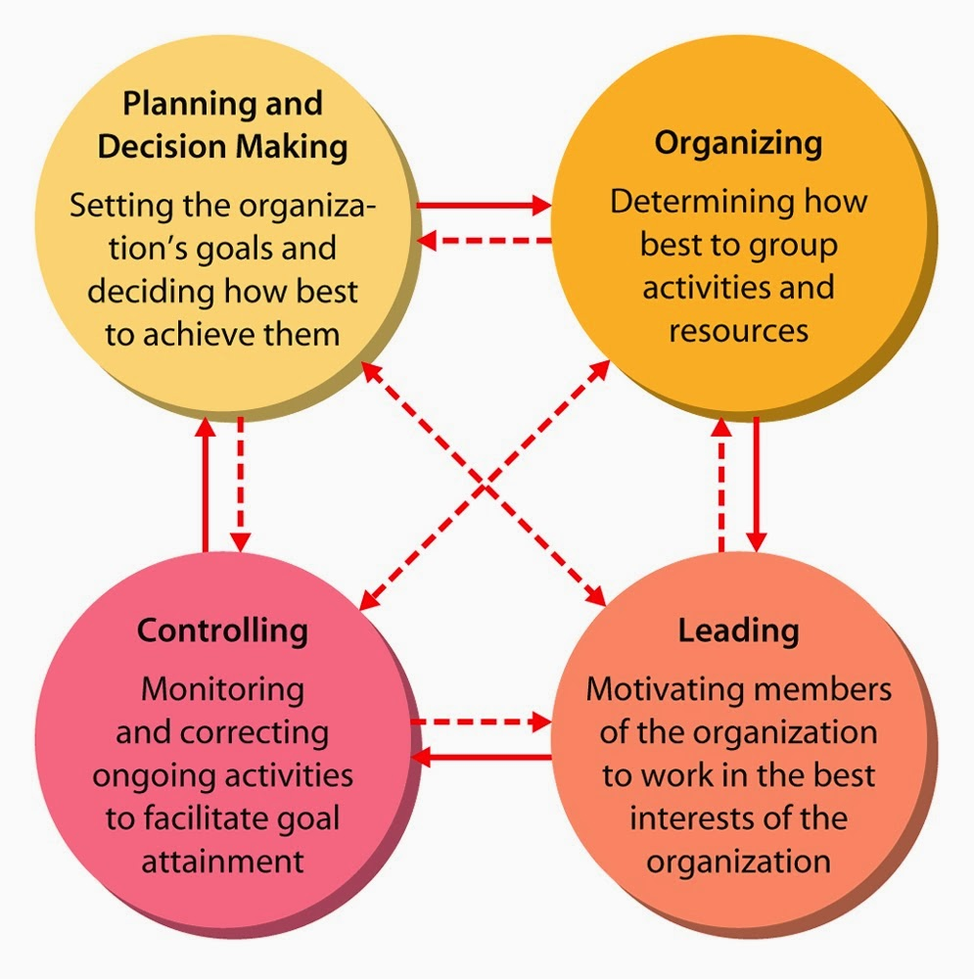

Figure 2: Principles of Management.
Houghton, H. (2016) explains the diagram figure 2 above that:
- Good planning helps you to foresee the future from now and make decisions that will negate any problems. You should be able to map out at this stage all the strategies that will involve in the process to achieve the goal.
- In this stage of Organising, a good manager will make sure that every resources needed are well organised and made available for action to be taken. A manager must properly allocate the right worker to the right task.
- Leading or Directing your plan is of a great necessity because it is the action time. At this time leaders must motivate and communicate throughout as you implement. It is when you actually put the energy of your workers or employees to action and if well supervised you will attain great results.
- Controlling is the stage of ensuring that all your action plans and activities are carried out to the standard of the organisation. The results must be checked and compared to goal so that corrections can be made on other to maintain proper area plan and to remain on track.
Additionally to the functions named above, there are other very important skills that management or leaders should be able to exhibit in other to effectively carry out their work. According to Gabriel, A. (2019), continues to explain that:
- Having a technical ability of interpreting a specific task assigned to a supervisor.
- An interpersonal skills of communicating and interacting with workers in and outside his surroundings.
- To think conceptually or to have skill of thinking abstractly.
- Diagnostically analyse and solving a problems by trying to find into details the symptoms and the root cause of it.
- Good communicating skills. An accurate way of transmitting and receiving information from and to other colleagues to know exactly what is expected to do.
- Decision making ability. When a company faces an unusual challenge, you need a manager who will effectively take an appropriate action that can solve the problem.
- And finally, time management skill of a manager helps to prioritize work make good delegation.

CHANGE MAMAGEMENT:
Change has a great impact on any organisation’s systems, structure and processes, which also affects the employee job roles. Therefore, it is important to apply the right approaches in other to ultimately improve the organisation. When an organisation faces a problem, the only and best way to achieve success is to make changes. According to an article by Prosci, accessed on 16/08/2019, change is a transition from the current state of position through the transitional state and finally to the future. Therefore, it is vital to understand the techniques involved. Change can affect an individual negatively and therefore there must be a systematic approach in structure put in place in other to help that individual and giving them the necessary support needed by giving them the right information and knowledge to implement the change.
RECOMMENDATION AND CONCLUSION:
It is never too late to make a U-turn if you realise you organisation is diving down for destruction. As discussed in this report, good management should not hesitate to make changes which will help the organisation looking in the long and short term. For best results, the embodiment of a critical thinker coupled with one with an excellent managerial skills, who also has a strong beliefs needed for that particular organisation are the key factors to look out for. There are many websites that can enhance and equip any organisation work force if need be, also, books are available online or in book shops. Organisations should not think that all their workers have all the knowledge they need to embark on a project or are able to critically think through when they are faced with challenges.

Reference:
Alice Jones, 2016, The Importance And Benefits Of Critical Thinking and Reflection In The Workplace, accessed on 03/08/2019.
https://www.careermetis.com/benefits-critical-thinking-workplace/

Alison Doyle 2019, the balance careers, Critical Thinking Definition, Skills, and Examples, accessed on 20/06/2019
https://www.thebalancecareers.com/critical-thinking-definition-with-examples-2063745

Agnes Oluoch 2014, CareerAddict, Why Does Your Attitude Affect Your Workplace? Accessed on 30/06/2019.
https://www.careeraddict.com/why-does-your-attitude-affect-your-workplace

Anup Shrestha, 2013, principles of Management. Accessed on 29/06/2019
http://bcispom.blogspot.com/2013/

Austin Cline 2018, Learning Religions, What Is Logic? What Is Critical Thinking? Accessed on 31/06/2019
https://www.learnreligions.com/what-is-logic-what-is-critical-thinking-249764

Beverley Clark 2016, The Benefits of a Positive Attitude in the Workplace, accessed on
20/06/2019
https://www.quillgroup.com.au/blog/benefits-positive-attitude-workplace/

Career & Education, 2015). Benefits of Critical thinking in the workplace, accessed on 03/08/2019.
https://careerandeducation.expertscolumn.com/benefits-critical-thinking-workplace

Cambridge Dictionary (2019, management, accessed on 30/06/2019.
https://dictionary.cambridge.org/dictionary/english/management

DXC.technology 2019, Critical thinking: An essential skill in the modern workplace, accessed on
31/06/2019.
https://blogs.dxc.technology/2018/05/04/critical-thinking-an-essential-skill-in-the-modern-workplace/

Enote 2008, "What are the main functions of managers in business?" eNotes Editorial, 1 Dec. 2008, Accessed 26 July 2019.
https://www.enotes.com/homework-help/main-function-managers-50499

Gabriel Anderson, SliePlayer, Management Functions, accessed on 26/06/2019.
https://slideplayer.com/slide/6841804/

Houghton Mifflin Harcourt, 2016, Cliffs Notes, functions of Managers, accessed on 26/06/2019.
https://www.cliffsnotes.com/study-guides/principles-of-management/the-nature-of-management/functions-of-managers

IMMIGRATION ADVISERS AUTHORITY 2019, Personal beliefs, values, attitudes and behaviour, accessed on 02/06/2019.
https://www.iaa.govt.nz/for-advisers/adviser-tools/ethics-toolkit/personal-beliefs-values-attitudes-and-behaviour/

Larry Ventimiglio 2015, The Benefits & Importance of Ethics in the Workplace, accessed on 31/06/2019.
https://www.linkedin.com/pulse/benefits-importance-ethics-workplace-larry-ventimiglio

Mimeo 2016, Leadership: 7 Ways to Become a Role Model Manager, accessed on 02/07/2019
https://www.mimeo.com/blog/leadership-role-models/

MindTools 2019, Understanding Workplace Values, accessed on 20/06/2019.
https://www.mindtools.com/pages/article/understanding-workplace-values.htm

MindTools 2019, Frederick Taylor and Scientific Management, accessed on 25/06/2019.
https://www.mindtools.com/pages/article/newTMM_Taylor.htm

Mohan Kumar 2018, What Are Beliefs, Values and Attitudes? Accessed on 15/06/2019.
https://owlcation.com/social-sciences/Teaching-and-Assessing-Attitudes

Penny Loretto 2019, the balanced careers, Top 10 Work Values Employers Look For, accessed on 01/07/2019.
https://www.thebalancecareers.com/top-work-values-employers-look-for-1986763

Prosci, Definition of Change Management. Accessed on 16/08/2019.
https://www.prosci.com/resources/articles/change-management-definition

Taylor 1911, The principles of scientific management, accessed on 25/06/2019.
https://archive.org/stream/principlesofscie00taylrich?ref=ol#page/8/mode/2up

TEC 2018, The Executive Connection, 9 common leadership styles: which types of leader are you? Accessed on 10/06/2019.
https://tec.com.au/resource/9-common-leadership-styles-which-type-of-leader-are-you/

Toolshero, (2019, Bureaucratic Theory by Max Weber, accessed on 10/06/2019.
https://www.toolshero.com/management/bureaucratic-theory-weber/

Thuy Sindell and Milo Sindell, 2016, Entrepreneur, 4 Ways Effective Leaders Deal With Incompetent People, accessed on 05/07/2019.
https://www.entrepreneur.com/article/283996

