Name
Student number
E-portfolio report
Learning in the Digital Era – BMPL4007/BMPS4009

Table of Contents

Introduction 2
Task 1 – Written summary 2
Task 2 – Mind map 4
Task 3 – Presentation 5
Task 4 – Reflection 6
Conclusion 6
Reference list 7

Introduction
Every student's college years are important, memorable, and exciting. Professional professors teach pupils in depth during their higher studies. College preparatory programs teach students how to take notes, study, write, test, manage time, think critically, and more. Extracurricular activities help students acquire vital abilities for college. Digital learning can be visualized by Mind maps as it is flexible and gives concrete knowledge (Grand-Clement, 2017). Workshops, lectures, and seminars benefit digital learners too as they spark creativity through idea exchange. By learning from digital sources and the effective usage of it students can excel. In this report the participation of higher education, personal identity, mind map for E-learning and reflection of university life and digital learning was emphasized.

Task 1 – Written summary
Higher education, is any of several forms of postsecondary education that leads to a degree, diploma, or certificate. Every student's college years are important, memorable, and exciting. Because professional professors teach pupils in depth during their higher studies. In higher education, students meet peers from other towns and states and learn about numerous societal concerns (Ahmad, 2015). Higher education in universities contains skilled professors, research, demanding application for various works (such as dentistry and medical schools), and social services activities. Graduate and postgraduate education are available to students. Investing in education beyond high school increases the odds of employment success and a distinctive career path. They also have a greater chance of learning critical thinking and reasoning abilities for life. Education benefits include Planning Your Profession, Paid more progressively, enhanced sense of well-being, Evolution as a person and Intuitive Connections. To achieve aspirations, students must prepare for higher education (Gigliotti and Ruben, 2017). Preparing for college requires these measures.
Course selection
AP, IB, Dual Enrolments, and Honours classes are beneficial (Downes, 2015). College preparatory programs teach students how to take notes, study, write, test, manage time, think critically, and more. These skills prepare pupils for college.
Extracurricular
Participating in extracurricular activities makes high school more fun. These extracurricular activities also teach skills that textbooks and assessments can't. Extracurricular activities help students acquire vital abilities like teamwork, public speaking, creativity, leadership, and self-awareness for college.
Counselling
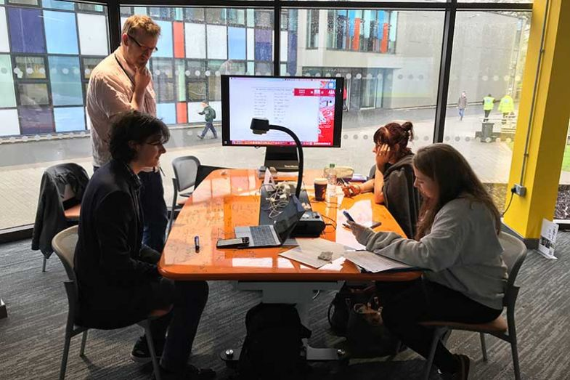
Figure 1: Student counselling (Google Images, 2022)

Most schools provide college counselling. Appointments with him or her help students understand higher education's prerequisites and benefits. Starting in freshman year, guidance counselling is essential.
Exercising skills
It's also crucial to acquire new abilities that will be useful in the workplace and, later, in academic pursuits. It consists of things like the ability to multitask, manage one's own time, and lead others effectively (Chowdry et al., 2013). Students' struggles in higher education will be lessened if they have these.
Preparing for entry exams or requirements
College entrance tests are crucial to new student admissions. Learn about college entrance exams and what colleges require. Many colleges require IELTS or Toefl. Some colleges require or recommend the optional writing section. Higher education students must also prepare for these exams.

Task 2 – Mind map
Digitization has disrupted every sector by accelerating previous advancements. Like doctors and bankers, students may access course materials online and submit their work via email. Technology has simplified teaching, but it has also imposed constraints and forced awkward settings. Mind maps improve eLearning, understanding, and memorizing (Ale Ebrahim, 2013). Digital learning can be visualized by Mind maps as it is flexible and gives concrete knowledge. Mind maps in online education will be examined next. Digital learning mind map below.
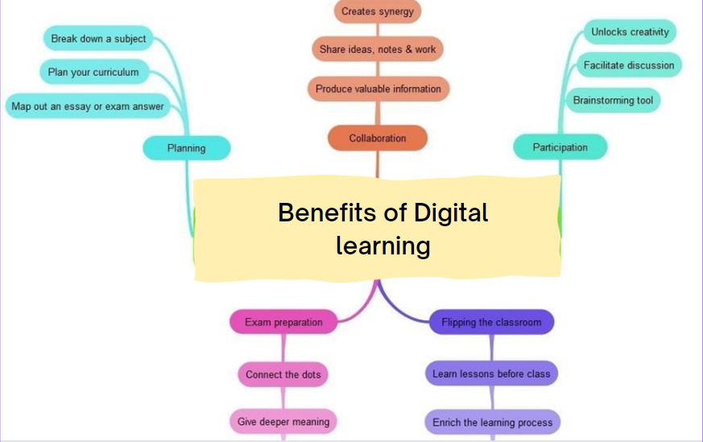
Figure 2: Mind map of digital learning (Self Designed)

Planning
A learning plan, which can range from a course outline to a single assignment plan, is essential for digital students. Visual learners will appreciate the information structure and portability (Lin and Chen, 2017). Digital education is great for career preparation because the internet is full of information about higher education, career counselling, and other vital skills.
Collaboration
To improve learning, collaborate with new software, companies, or schools. A comprehensive resource collection is best created by people studying the same or related topics. Together, you can learn more and faster (Peters, 2010). This reduces stress and work load and encourages collaborative ideation.

Participation
Workshops, lectures, and seminars benefit digital learners too. These seminars will help you use your digital learning platform's many features (Derouin et al., 2015). As mentioned, such seminars and workshops can spark creativity through idea exchange. Students have a unique tool to quickly and intuitively express their ideas, which improves online learning.
Studying for Tests
Digital learning could improve education and test scores due to the wealth of online resources. Digital learning is the best way to find these connections and improve knowledge. (Hong et al., 2007). The dots do not need to stay the same for the learner to succeed.
Flipped learning
"Flipping the classroom" encourages creative, technology-based learning. Flipped classroom students have already learned the material from videos, social media, or other online sources and only do hands-on activities. Educational technology in formal and informal settings opens many new learning paths (Buzan and Buzan, 2012). Students use online resources to prepare lesson notes and engage in class discussion in a flipped classroom.

Task 3 – Presentation
Please follow this link to view my presentation:

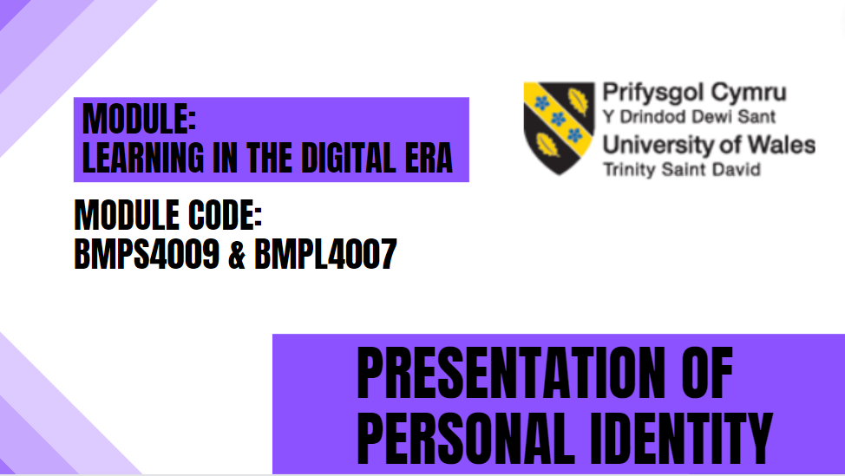
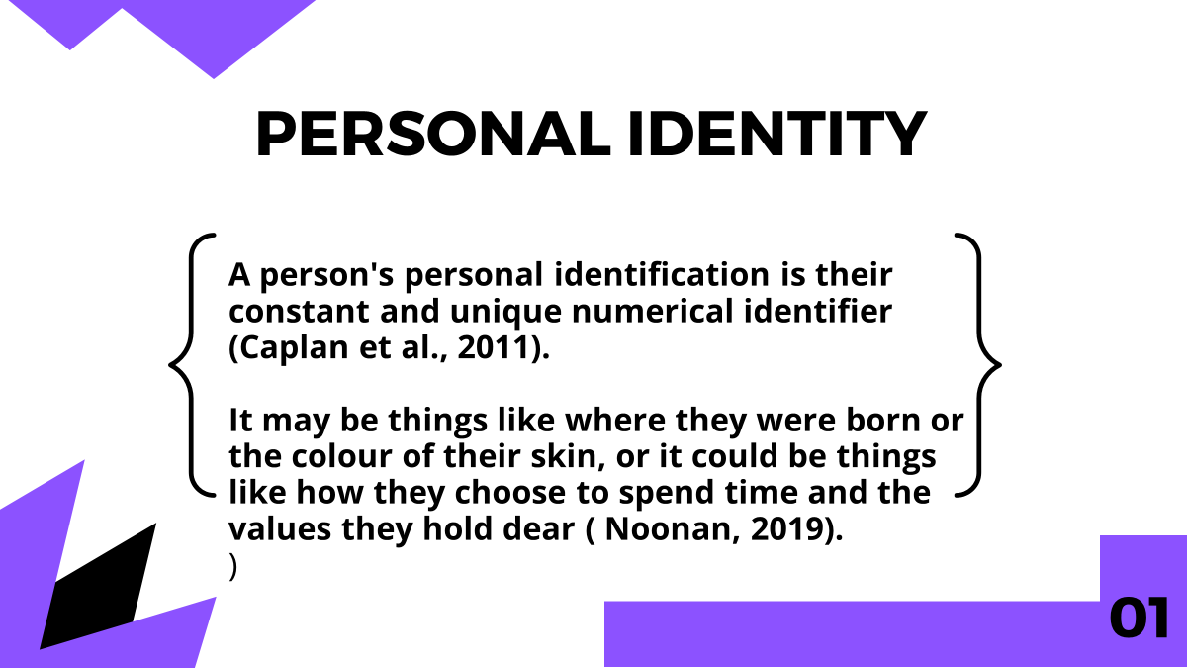
A person's personal identification is their constant and unique numerical identifier. It may be things like where they were born or the colour of their skin, or it could be things like how they choose to spend time and the values they hold dear (Noonan, 2019).

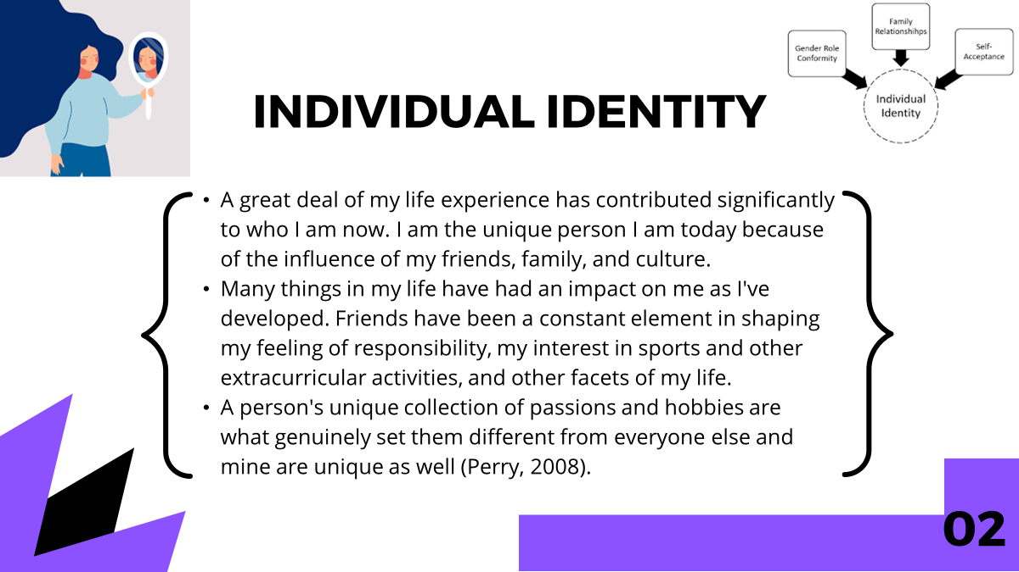
A great deal of my life experience has contributed significantly to who I am now. I am the unique person I am today because of the influence of my friends, family, and culture. Many things in my life have had an impact on me as I've developed. Friends have been a constant element in shaping my feeling of responsibility, my interest in sports and other extracurricular activities, and other facets of my life. A person's unique collection of passions and hobbies are what genuinely set them different from everyone else.

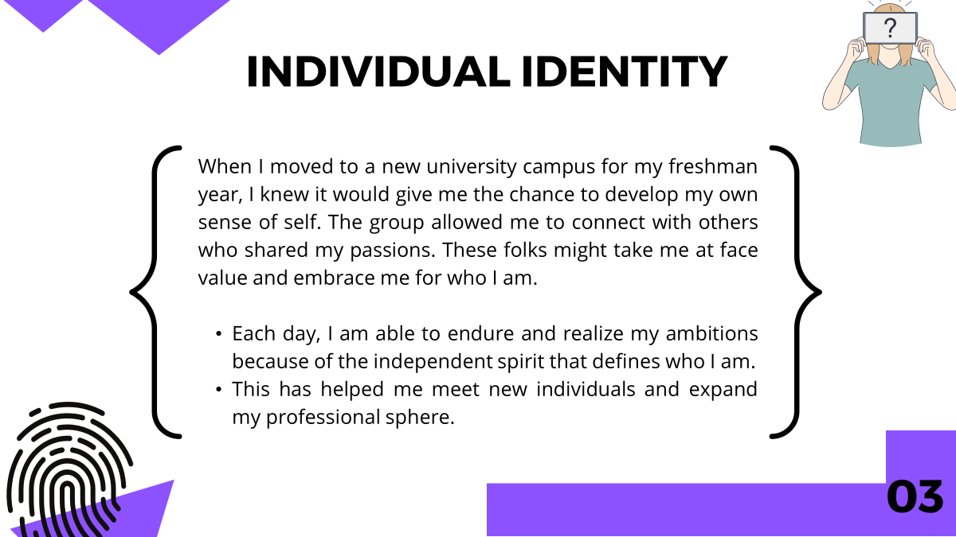
Each day, I am able to endure and realize my ambitions because of the independent spirit that defines who I am. When I moved to a new high school campus for my freshman year, I knew it would give me the chance to develop my own sense of self. The group allowed me to connect with others who shared my passions. These folks might take me at face value and embrace me for who I am. This has helped me meet new individuals and expand my professional sphere.

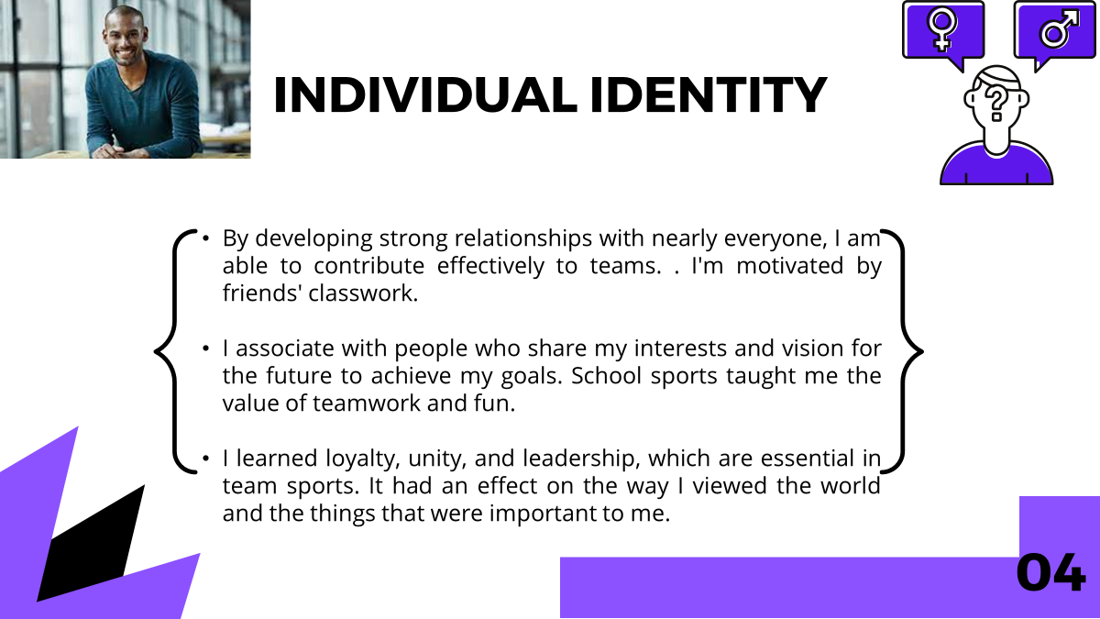

By developing strong relationships with nearly everyone, I am able to contribute effectively to teams. . I'm motivated by friends' classwork. I associate with people who share my interests and vision for the future to achieve my goals. School sports taught me the value of teamwork and fun. I learned loyalty, unity, and leadership, which are essential in team sports. It had an effect on the way I viewed the world and the things that were important to me.
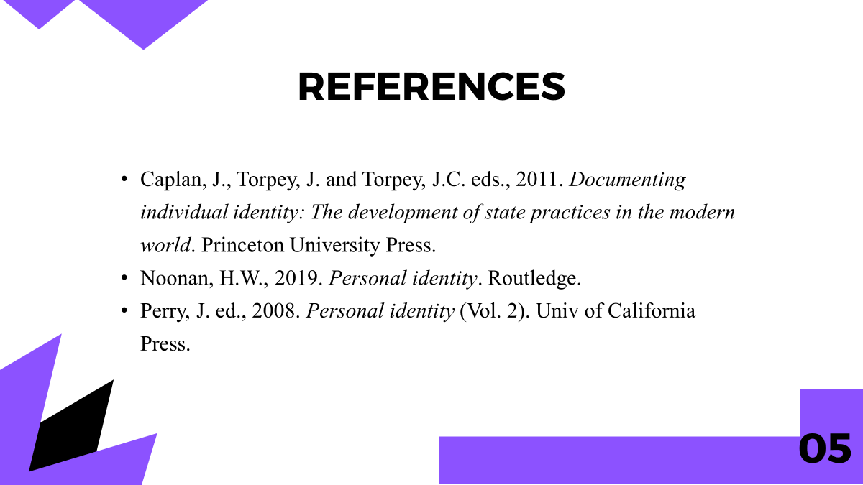

Task 4 – Reflection
Borton's reflection model gives a framework for thinking about reflection. . Borton's approach is basic and may be used to many scenarios without training. Free thought is fostered through laxity (Harsh et al., 2018). In this part the reflection of starting university, getting known to online learning and how it helped in my first assignment will be discussed. I entered college with huge aspirations for success. My situation startled me. I had unexpected opportunities after finishing high school. After much soul-searching, I decided nothing had changed. . I took advantage of my university's many options to have life-changing experiences. I started organizing my winter break vacation to New York City with students and a teacher as soon as I arrived on college. We met weekly for three months, discussing the city's history as an empire's capital and its contemporary function as a human trafficking hub. Due to the small environment, the discourse often took unexpected turns and covered a wide range of issues, with each speaker building on the previous one. I had to learn to use the internet to produce an academic report on a topic I had never researched.
College students like me need online education to expand our horizons and adapt to the world. I'm using the university's digital library more to prepare for future queries. My understanding improved as I used the internet for research and education. This allowed me to finish all my class assignments. Even this report was improved by the utilization of a variety of web resources for this task. Along with digital learning, these internet tools were invaluable to me as I completed my first ever academic writing project. Many people don't realize how useful E-learning can be in the context of university life and coursework, but this response makes it very apparent (Lucas, 2012).

Conclusion
Finally it can be concluded the importance of digital learning in modern day education is vast and in this report it was seen from aspiring for higher studies to personal identity digital learning is very essential. Digital learning could improve education and test scores due to the wealth of online resources

Reference list
Ale Ebrahim, N., 2013. Introduction to the Research Tools mind map. Research World, 10(4), pp.1-3.
Ahmad, T., 2015. Preparing for the future of higher education. On the Horizon.
Buzan, T. and Buzan, B., 2012. How to mind map. London: Thorsons.
Chowdry, H., Crawford, C., Dearden, L., Goodman, A. and Vignoles, A., 2013. Widening participation in higher education: analysis using linked administrative data. Journal of the Royal Statistical Society: Series A (Statistics in Society), 176(2), pp.431-457.
Derouin, R.E., Fritzsche, B.A. and Salas, E., 2015. E-learning in organizations. Journal of management, 31(6), pp.920-940.
Downes, S., 2015. E-learning 2.0. ELearn, 2005(10), p.1.
Gigliotti, R.A. and Ruben, B.D., 2017. Preparing higher education leaders: A conceptual, strategic, and operational approach. Journal of Leadership Education, 16(1), pp.96-114.
Grand-Clement, S., 2017. Digital Learning: Education and Skills in the Digital Age. RAND Europe.
Harsh, P.S.B., Lloyd, D.J.W. and Borton, L.R., 2018, August. Models as an aid to decision making. In International Symposium on Models for Plant Growth, Environmental Control and Farm Management in Protected Cultivation 248 (pp. 27-48).
Hong, B.S., Ivy, W.F., Gonzalez, H.R. and Ehrensberger, W., 2007. Preparing students for postsecondary education. Teaching Exceptional Children, 40(1), pp.32-38.
Lucas, P., 2012, October. Critical reflection. What do we really mean. In 2012 Australian Collaborative Education Network National Conference (p. 163).
Lin, M.H. and Chen, H.G., 2017. A study of the effects of digital learning on learning motivation and learning outcome. Eurasia Journal of Mathematics, Science and Technology Education, 13(7), pp.3553-3564.
Noonan, H.W., 2019. Personal identity. Routledge.
Peters, O., 2010. Digital learning environments: New possibilities and opportunities. International Review of Research in Open and Distributed Learning, 1(1), pp.1-19.
Warschauer, M., 2007. The paradoxical future of digital learning. Learning Inquiry, 1(1), pp.41-49.

