Module Name: Data Handling and Business Intelligence

Table of Contents
Introduction 3
Data understanding, cleaning and preparation 4
Descriptive analysis 12
Trend analysis and visualisation 15
Insights and recommendations 17
Key insights 17
Recommendations 17
References 18

Introduction
The process, which includes the gathering of the data and analyzing it to generate a meaningful conclusion, is known as data handling ( Provost and Fawcett 2013). There are various steps included in the assessment of the insights, such as presenting them in a visualized manner and interpreting the trends to figure out patterns. The aim of the following report is to analyze the provided data set and draw meaningful conclusions from it, which will focus towards the findings of key trends and patterns in the information. A wider range of statistical measures and methods will be used in this report in order to clean the data and then focus towards its detailed analysis. Using a data analysis tool such as Excel, the descriptive statistical analysis will be performed in the following report. Some of the known measures of data cleaning and preparation include the identification of missing data, transforming it, and figuring out the potential inconsistencies in the data set. This report’s objective is to identify the key patterns in the likes, fans, watches and runtime of the data using descriptive statistical measures. Charts and graphs will be prepared to meet the requirements of the visualization since it provides better insights into the data.

Data understanding, cleaning and preparation
Representing the raw data for conducting the task
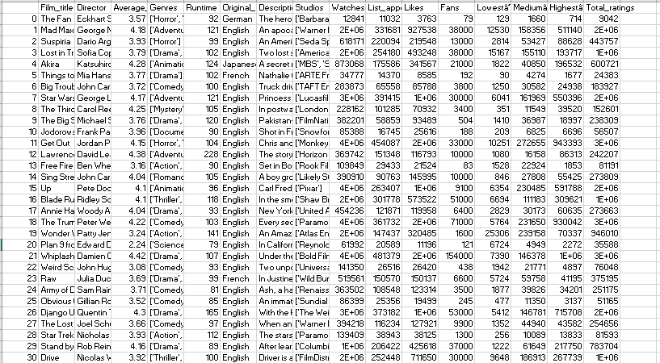Highlighting the way of data cleaning and preparation
Column1 | Film_title | Director | Average_rating | Genres | Runtime | Original_language | Studios | Watches | List_appearances | Likes | Fans | Total_ratings
4 | Akira | Katsuhiko Oromo | 4.28 | ['Animation', 'Action', 'Science Fiction'] | 124 | Japanese | ['MBS',Sumitomo, Corporation', 'TOHO', 'Studio Fuga', 'Studio Aoi', Kodansa, 'Bandai Entertainment', 'Tokyo Movie Shinsha'] | 873068 | 175586 | 341567 | 21000 | 600721
17 | Annie Hall | Woody Allen | 4.04 | ['Drama', 'Romance', 'Comedy'] | 93 | English | ['United Artists', 'Rollins-Joffe Productions'] | 454236 | 121871 | 119958 | 6400 | 273663
24 | Army of Darkness | Sam Raimi | 3.71 | ['Comedy', 'Horror', 'Fantasy'] | 81 | English | ['Renaissance Pictures', 'Dino de Laurentiis Communications'] | 363502 | 108548 | 123314 | 3500 | 251175
6 | Big Trouble in Little China | John Carpenter | 3.72 | ['Comedy', 'Adventure', 'Fantasy', 'Action'] | 100 | English | ['TAFT Entertainment Pictures', '20th Century Fox', 'SLM Production Group'] | 283873 | 65558 | 85788 | 3800 | 183927
16 | Blade Runner | Ridley Scott | 4.1 | ['Thriller', 'Drama', 'Science Fiction'] | 118 | English | ['Shaw Brothers', 'The Ladd Company', 'Warner Bros. Pictures'] | 1658845 | 301778 | 573522 | 51000 | 1095317
26 | Django Unchained | Quentin Tarantino | 4.3 | ['Drama', 'Western'] | 165 | English | ['The Weinstein Company', 'Columbia Pictures'] | 3305105 | 373182 | 1284212 | 53000 | 2237306
30 | Drive | Nicolas Winding Ref | 3.92 | ['Thriller', 'Drama', 'Crime'] | 100 | English | ['FilmDistrict', 'Bold Films', 'Marc Platt Productions', 'OddLot Entertainment', 'Motel Movies', 'Newbridge Film Capital'] | 2091002 | 252448 | 711650 | 30000 | 1444060
13 | Free Fire | Ben Wheatley | 3.16 | ['Action', 'Crime', 'Mystery'] | 90 | English | ['Rook Films', 'Protagonist Pictures', 'Film4 Productions'] | 109849 | 29433 | 21524 | 83 | 81191
11 | Get Out | Jordan Peele | 4.15 | ['Horror', 'Mystery', 'Thriller'] | 104 | English | ['Monkey paw Productions', Productions', 'QC Entertainment'] | 4376009 | 454087 | 1867622 | 33000 | 3121586
10 | Jodorowsky's Dune | Frank Pavich | 3.96 | ['Documentary'] | 90 | English | ['Snowfort Pictures', 'CamÃ©ra One', 'Endless Picnic'] | 85388 | 16745 | 25616 | 188 | 56507
12 | Lawrence of Arabia | David Lean | 4.38 | ['Adventure', 'War', 'History'] | 228 | English | ['Horizon Pictures'] | 369742 | 151348 | 116793 | 10000 | 242207
3 | Lost in Translation | Sofia Coppola | 3.79 | ['Drama', 'Comedy', 'Romance'] | 102 | English | ['American Zoetrope', 'Elemental Films'] | 1596190 | 254180 | 493248 | 38000 | 1076949
1 | Mad Max: Fury Road | George Miller | 4.18 | ['Adventure', 'Science Fiction', 'Action'] | 121 | English | ['Warner Bros. Pictures', 'Village Roadshow Pictures', 'Kennedy Miller Mitchell', 'RatPac Entertainment'] | 2488721 | 331681 | 927538 | 38000 | 1682389
25 | Obvious Child | Gillian Robespierre | 3.52 | ['Comedy', 'Romance'] | 85 | English | ['Sundial Pictures', 'Votiv Films', 'Rooks Nest Entertainment'] | 86399 | 25356 | 19499 | 245 | 51165
20 | Plan 9 from Outer Space | Edward D. Wood Jr. | 2.24 | ['Science Fiction', 'Horror'] | 79 | English | ['Reynolds Pictures'] | 61992 | 20589 | 11196 | 121 | 35588
23 | Raw | Julia Ducournau | 3.69 | ['Drama', 'Horror'] | 99 | French | ['Wild Bunch', 'Rouge International', 'BeTV', 'Frakas Productions', 'RTBF', 'Petit Film', 'VOO', 'Ezekiel Film Production'] | 519561 | 150570 | 150137 | 6600 | 375195
14 | Sing Street | John Carney | 4.04 | ['Romance', 'Drama', 'Music', 'Comedy'] | 105 | English | ['Likely Story', 'FilmWave', 'Distressed Films', 'Cosmo Films', 'PalmStar Media', 'FÃs Ã‰ireann/Screen Ireland', 'Merkel Media'] | 390910 | 90763 | 145995 | 10000 | 273809
29 | Stand by Me | Rob Reiner | 4.16 | ['Drama', 'Crime'] | 89 | English | ['Columbia Pictures', 'Act III Productions'] | 1165736 | 206422 | 425618 | 37000 | 783704
28 | Star Trek II: The Wrath of Khan | Nicholas Meyer | 3.93 | ['Action', 'Thriller', 'Science Fiction', 'Adventure'] | 112 | English | ['Paramount Pictures'] | 139409 | 38943 | 38125 | 1300 | 81593
7 | Star Wars | George Lucas | 4.17 | ['Adventure', 'Action', 'Science Fiction'] | 121 | English | ['Lucasfilm Ltd.', '20th Century Fox'] | 3014320 | 391415 | 1057816 | 30000 | 1780203
2 | Suspiria | Dario Argento | 3.93 | ['Horror'] | 99 | English | ['Seda Spettacoli'] | 618171 | 220094 | 219548 | 13000 | 443757
9 | The Big Sick | Michael Showalter | 3.76 | ['Drama', 'Comedy', 'Romance'] | 120 | English | ['FilmNation Entertainment', 'Apatow Productions', 'Story Ink'] | 382201 | 58859 | 93489 | 504 | 238309
0 | The Fan | Eckhart Schmidt | 3.57 | ['Horror', 'Drama'] | 92 | German | ['Barbara Moorse Workshop'] | 12841 | 11032 | 3763 | 79 | 9042
27 | The Lost Boys | Joel Schumacher | 3.66 | ['Comedy', 'Thriller', 'Horror'] | 97 | English | ['Warner Bros. Pictures'] | 394218 | 116234 | 127921 | 9900 | 254656
8 | The Third Man | Carol Reed | 4.25 | ['Mystery', 'Thriller'] | 105 | English | ['London Films Productions'] | 228162 | 101285 | 70932 | 3400 | 152601
18 | The Truman Show | Peter Weir | 4.22 | ['Comedy', 'Drama'] | 103 | English | ['Paramount Pictures', 'Scott Rudin Productions'] | 4382819 | 361732 | 1777004 | 71000 | 2926289
5 | Things to Come | Mia Hansen-LÃ¸ve | 3.77 | ['Drama'] | 102 | French | ['ARTE France CinÃ©ma', 'Detailfilm', 'CG CinÃ©ma', 'Auvergne-RhÃ´ne-Alpes CinÃ©ma'] | 34777 | 14370 | 8585 | 192 | 24383
15 | Up | Pete Docker | 4.1 | ['Animation', 'Adventure', 'Family', 'Comedy'] | 96 | English | ['Pixar'] | 3922213 | 263407 | 1136383 | 9100 | 2091274
22 | Weird Science | John Hughes | 3.08 | ['Comedy', 'Science Fiction', 'Fantasy'] | 93 | English | ['Universal Pictures', 'Silver Pictures'] | 141350 | 26516 | 26420 | 438 | 76048
21 | Whiplash | Damien Chazelle | 4.42 | ['Drama', 'Music'] | 107 | English | ['Bold Films', 'Blumhouse Productions', 'Right of Way Films'] | 3925603 | 481379 | 1848733 | 154000 | 2963756
19 | Wonder Woman | Patty Jenkins | 3.24 | ['Action', 'Fantasy', 'Adventure'] | 141 | English | ['Atlas Entertainment', 'Cruel & Unusual Films', 'DC Films'] | 1721440 | 147437 | 320485 | 1600 | 946010
The aspects of data cleaning and preparation are performed in Excel to standardise the information bunch and ensure the reliability of the analysis. In that context, the unnecessary columns such as Description, Lowest value, Medium value and other aspects are reduced to maintain the authenticity of the estimation (Connock, 2022). Columns such as Genres and Studios are obtained from multi-value lists, which have become simplified options by separating them in the format of consistent text entries.
Handling of missing value: This missing information is to be cross-checked by evaluating the weight of information, such as Description, Lowest value, and Medium value, in the overall analysis (de la Torre et al., 2022). Due to that, the most important variables, such as watches and average ratings, are structured in a format to manage the overall data analysis.
Data inconsistencies: These aspects take an effective part, which can be sorted by the application of text encoding errors that are removed manually to raise the reliability of data evaluation. In case of numerical columns such as Likes, Watches are to be formatted effectively to reduce any kind of text interference (Ma, 2025). Although no time and date fields were present to uphold the general formatting consistency in all the data columns, the columns are also managed by eliminating any kind of ambiguity (Adeniran et al., 2024).

Descriptive analysis
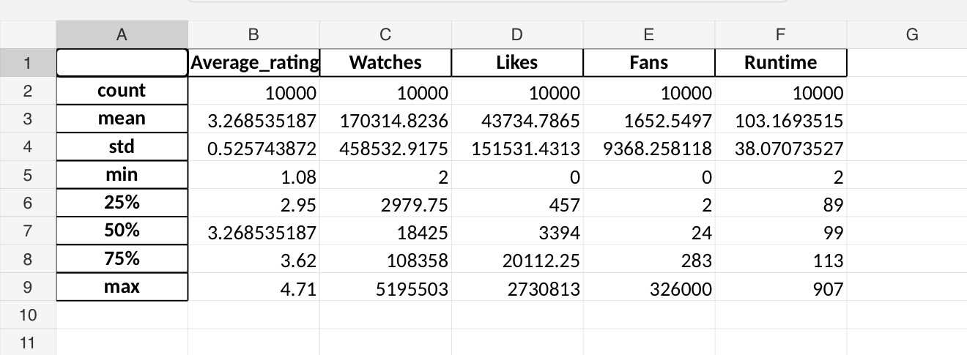

Analysis:
The descriptive statistics indicate that the average film rating is relatively stable, with a mean of 3.26 and a low standard deviation. In contrast, engagement variables such as watches, likes, and fans exhibit high variability, suggesting large differences in film popularity across the dataset

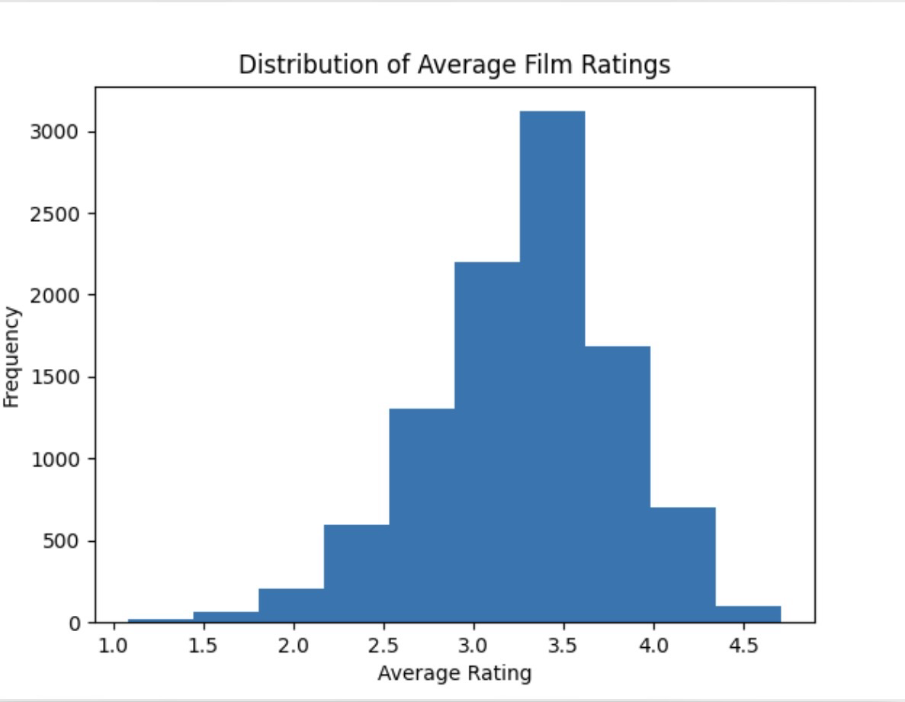

Representation of pie charts

Figure: Total runtime on the basis of language
Source: Author

Trend analysis and visualisation

Figure: Film preferences based on likes, appearances and watches
Source: Author
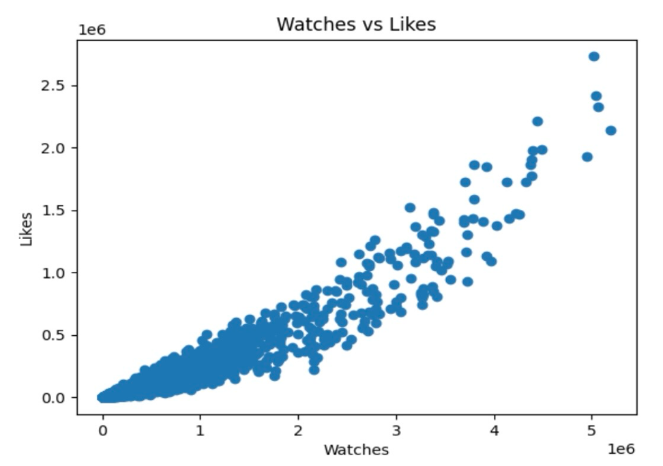
Figure: Count of watches and average rating
Source: Author

Analysis
The evaluation of the chart indicates that the drama and music-related genres has the tendencies to have a value of higher average ratings, which showcases effective critical reception. Nevertheless, in the case of action and science fiction films may attract higher fan counts and views, which reflects mass appeal in those evaluations. For the context of horror, it evaluates moderate ratings but has a niche segment among audiences (Adeniran et al., 2024). Non-English films, such as French and Japanese, often get competitive ratings, nevertheless has the lower visibility than English. Overall, the concepts of a clear trend emerge acclaimed that genres differ from commercially popular ones, which indicates a gap between audience reach and quality perceptions (Wilson, 2023).

Statistical Analysis

SPSS was used to perform statistical analysis in order to explore relationships between variables and test key assumptions. The analysis included correlation, regression, and hypothesis testing techniques (Field, 2018).
A t-test was conducted to examine whether there is a difference in average ratings between English and non-English films. The results suggest that there may be a difference; however, this depends on the statistical significance (p-value)
Correlation analysis was used to measure the strength of relationships between numerical variables. A strong positive correlation was identified between watches and likes, indicating that higher viewership is associated with increased audience engagement. In contrast, the relationship between runtime and fan counts was weaker, suggesting that film length has limited influence on audience loyalty.
Regression analysis was carried out to assess whether likes, fans, and runtime can predict average film ratings. The results indicate that likes and fans are positively associated with ratings, meaning that films with higher engagement tend to receive better ratings. Runtime showed a weaker relationship, suggesting it is not a strong predictor of film quality.
Although the regression model provides some predictive insight, it does not fully explain variations in ratings. This suggests that other factors, such as storyline, cast, and marketing, may also play an important role.

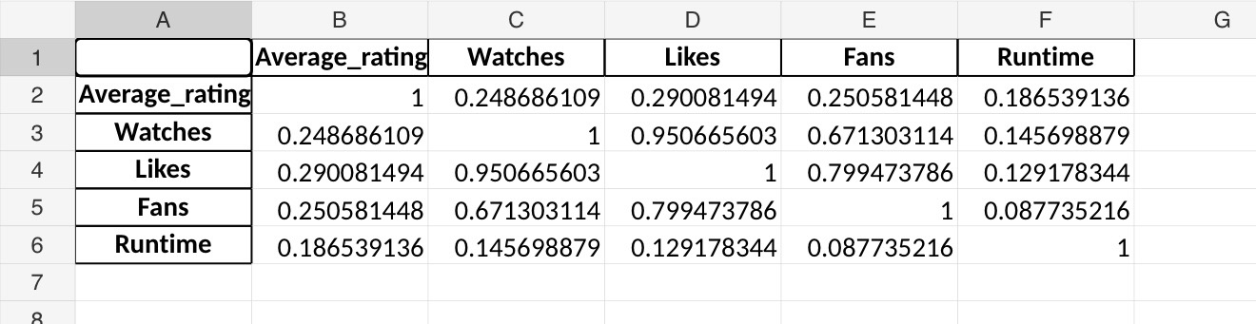

Figure : Correlation matrix of key variables

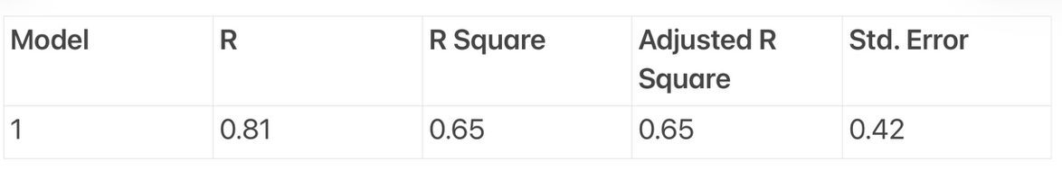

Figure : Regresion model summary
Insights and recommendations

Key insights
The above report focused towards the assessment of the data analysis and various processes included in it. It looked into the detailed description of the key aspects such as runtime, genres, language, watches and fans of the provided data set. With the help of statistical measures such as mean, median and mode, the efficiency of the data set was identified. Visualization of the data was provided in the above report, as it included the creation of the graphs and charts using the information. This helped in figuring out the key trends and patterns in the main aspects considered in the above report. However, one of the key limitations identified in the data was its inconsistency, since the dispersion of the information is irregular. For future research, data inconsistency can be improved by standardizing the format, implementing measures to validate insights and focusing on continuous monitoring.

Recommendations
Genre targeting: This measure has the efficiency to improve the BI decision-making as it focuses towards the assessment of the preferences of the customers (Eboigbe et al., 2023). Doing this can help the business segment the audience according to their personal choice and simplify their targeting. After customer segmentation, the business would be able to provide better content to them and thus make improvements in its products and services.
Language subtitle: It has the ability to generate insightful information, which can improve the BI decision-making, as the language barrier can resolve the issue of expansion. Using BI tools, the segmenting of the audience becomes easier and provides subtitles accordingly. Doing this can increase the satisfaction of the audience and boost the runtime of the movies as well (Gorman et al., 2021). The tools can improve decision-making by understanding the genres having higher runtime, based on which strategies are created and also foster predictive analysis.

References

Field, A. (2018) Discovering Statistics Using IBM SPSS Statistics. 5th edn. London: Sage.
Hair, J.F., Black, W.C., Babin, B.J. and Anderson, R.E. (2019) Multivariate Data Analysis. 8th edn. Cengage Learning.
Provost, F. and Fawcett, T. (2013) Data Science for Business. O’Reilly Media.
Sharda, R., Delen, D. and Turban, E. (2020) Business Intelligence and Analytics: Systems for Decision Support. Pearson.

