Task 3 – Source Evaluation Template
Student Details
Name and student ID: Amar Ishaque and 2535725
Topic chosen: The importance of customer service for business success
Title of source: Customer experience management: Toward implementing an evolving marketing concept
Author(s): Homburg, C., Jozić, D. and Kuehnl, C.
Year published: 2017
How did you find this source?
This source was obtained by searching on Google Scholar via the university library resources. I used the terms: customer service and business success, customer experience management and customer satisfaction impact on business performance. I chose this article after looking at various sources as it talks about how managing customer experience contributes to better customer relations and business performance.

Why did you choose this source?
This source is highly relevant to my topic, as it relates to an issue of great concern to me, the importance of customer service for business success. The article covers the role of customer experience management in driving customer satisfaction, loyalty, and business performance.
The source is useful because it gives academic proof of the value of business being customer-centric, and having good service experiences. It assists to illustrate the significance of service and how it is not just about addressing customer needs, but also establishing solid relationships that can contribute to company development.
Yes, this is an academic source as it comes from a peer-reviewed academic journal, the Journal of the Academy of Marketing Science.

When was it published? Is it recent enough? Why?
This article was originally published in 2017. The book isn't a recent publication, but it's still relevant as it addresses the basic concepts in customer experience and customer relationship management, which are still relevant in today's world of business. Additionally, the article has been referenced frequently, demonstrating its impact on research within the realm of customer service and marketing.
Author Credibility
Who is the author? What are their qualifications or expertise?
The authors are academics who specialize in marketing, customer experience management and business relationships. Christian Homburg is an internationally recognised Marketing Researcher with extensive publications in the fields of Customer Management, Service Quality and Marketing Strategy. The authors are experts in this field due to their academic backgrounds and their publications in research.

Reliability
Is the source reliable? Why?
It is a reliable source because it has been published in the Journal of the Academy of Marketing Science, a respected peer-reviewed academic journal. The article is peer-reviewed and thus has a high credibility. Moreover, the article refers to previous academic research, utilizes research evidence and is authored by seasoned researchers. These make it an excellent resource for gaining insights into the role of customer service and customer experience in business success.

5-Minute Presentation Structure
- Introduce topic and source
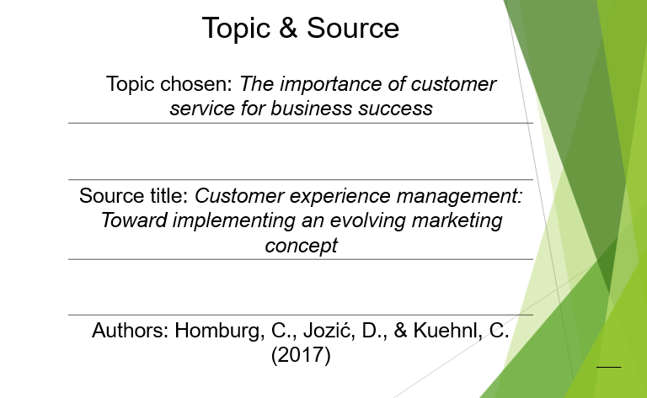
Good morning everyone, I am going to talk about my source evaluation for the topic “The importance of customer service for business success.” I chose the academic article titled Customer experience management: Toward implementing an evolving marketing concept by Homburg, Jozić and Kuehnl (2017) for this task. I chose this topic because customer service is a critical factor in the development of customer satisfaction, customer loyalty and business success in the long term. Positive customer experience is likely to keep businesses in a good relationship with customers.
- Explain how you found the source
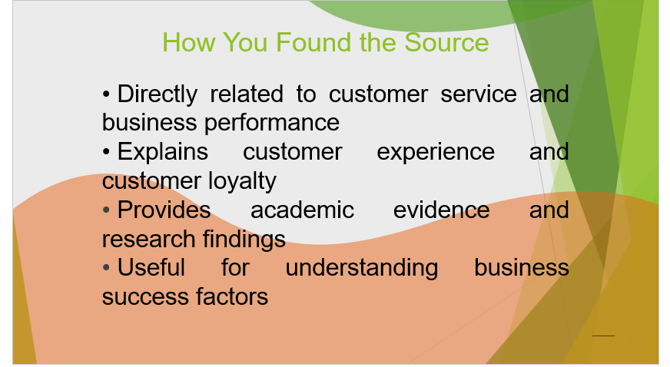
I have selected this source as it is easily related to the topic I have selected. The article elaborates on the impact of customer experience management on customer satisfaction and loyalty, critical aspects in the success of businesses. The source is helpful as it offers evidence-based discussion, not just personal opinions. It outlines how companies should be concerned about customer relationships and service quality for long-term success. This makes the article relevant for understanding that why customer service is an important business strategy.

- Evaluate credibility (author, date, reliability) - To do so, you will need to respond to the above questions.
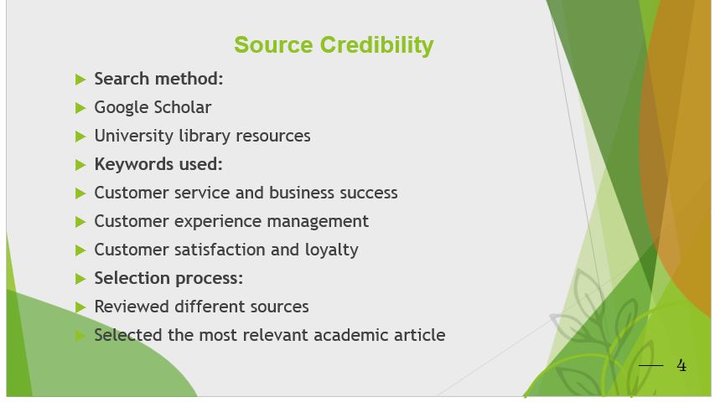
I used Google Scholar and Library resources at the University to find this source. I used the following terms to search: “customer service and business success”, “customer experience management”, and “customer satisfaction and loyalty”. At first, I ended up with a couple of articles but I rated them according to their academic quality and reliability. This article was chosen because it specifically mentioned the effect of customer experiences on business outcomes.

- Short reflection – What did you find difficult about this task?
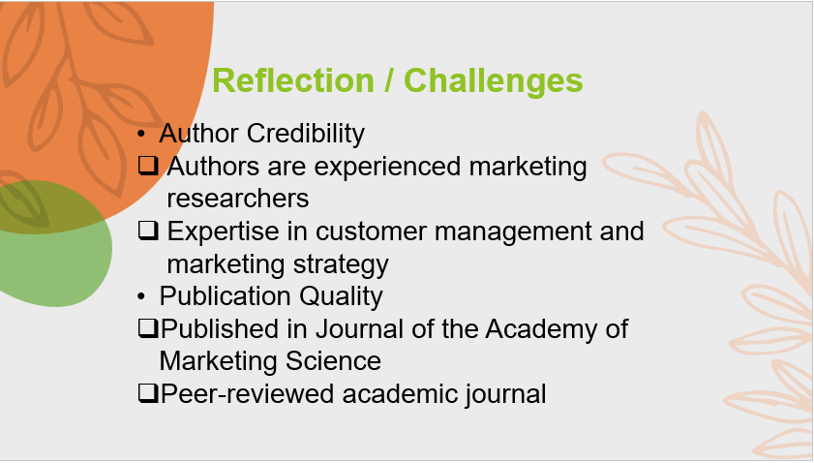
The authors' academic background adds to the credibility of this source. Homburg, Jozić and Kuehnl are researchers on the topic of marketing, customer relationships and customer experience management. It was published in a well-respected peer-reviewed journal, the Journal of the Academy of Marketing Science. This guarantees the reliability of the article as it is viewed by experts before being published.

- What did you learn from this task?
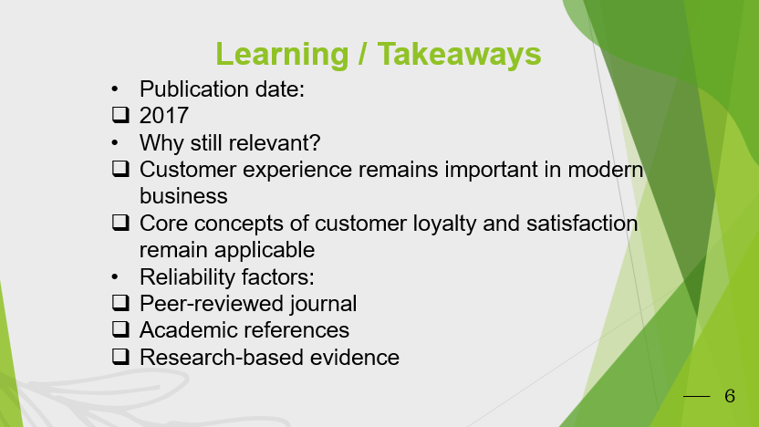
This article was first published in 2017. It's not the latest book out there, but it's still applicable since customer satisfaction, loyalty and customer experience are still relevant business priorities. The source is reliable because it contains references to other research that have been peer-reviewed and it is published in a peer-reviewed journal rather than being based on opinion.

