Er Côf Annwyl
Confirmative Praxis Report
Eleri Wynne Richards MA Textiles (0152015)
ADDA7002c

Word count:5504

List of images

Image 1: Richards, E.W. (2024): Pererindod i’r Bedd [Tecstiliau]. Mynwent Tynycoed, (11.08.24)
Image 2: Richards, E.W. (2025): Cyraedd Adre [Tecstiliau]. Melin Llech, (22.05.25).
Image 3: Richards, E.W. (2025): Gyda’i Gilydd Mewn Brethyn [Tecstiliau]. Mynwent Tynycoed, (19.04.25).
Image 4: Richards, E.W. (2025): Cyraedd Adre [Tecstiliau]. Melin Llech, (22.05.25).
Image 5: Amgueddfa Genedlaethol Cymru (n.d): Capel Celyn [Llun}. Caerdydd, (17.01.25)
Image 6: Porch, L. (n.d): Gweithdy [Tecstiliau}. Caerdydd, (17.01.25).

Index

Page
Introduction 4
Chapter 1 5
Chapter 2 8
Chapter 3 9
Chapter 4 15
Chapter 5 18
Conclusion 20
Bibliography 22

Introduction

History can be illuminated by looking back at one’s own family’s story generation by generation[…..] houses, […..] class and religious fluctations, the role of women [….] …all the things that connect us to each other and to a community, which can be a place or a feeling. […..]. However, the degree to which the past is key to the present is debateable; too much made of the past fosters a determinism that limits the future. (Lippard, 1997, p. 23).

Yet according to David Gross (2000, p.36):
people return to their past because the time contained meaningful opportunities in the persons life. Furthermore, forms of melancholia amongst artists can be considered as a sign of genius with exceptional ability.

This body of work is drawn around the historical narrative of my family, the place where they lived and the ‘cottage’ industry that they built. Melin Llech is set in a valley near the village of Pen y Cae, Breckonshire. In the 1800’s Thomas and Gwenllian Roderick originally of Llanddeusant, Carmarthenshire, settled there. With Thomas’ family background in weaving, the devoted young couple built a woollen mill and home at the side of the river. Their married life was short. Yet, they had achieved so much in the 10 years together. Six children had been born and the mill was up and running (family records). After Gwenllian’s passing, Thomas remarried, a wife was neeeded to raise the children and help with daily life. Yet, family records confirm that after the loss of his wife, Thomas lost interest in the mill. It was his son, Evan, that resurrected the busines and made the mill what it became known as- Llech Factory. According to Davies (2003) in Upper Dulais and Swansea Valleys, it employed several people to carry out tasks involved in processing wool and manufacturing cloth. Davies also states that the mill is ‘’listed in Brycheiniog (XIV) as one of the most important mills in Breckonshire between 1830-1914. It’s said to have ceased operating c1920” (Davies, 2003, p. 156). Furthermore, the family name of Roderick became established in the area (Davies, 2003), with a row of houses in the parish being named Roderick Villas. Enquiries for additional information on the mill have been made with former curator, Gareth Beech, at the Woollen Museum, Drefach , who confirmed that they had no record of it. Enquiries have been made to obtain more information on the factory with The Mills Archive, unfortunately they hold no records. Nevertheless, the factory site is documented on Coflein, an online database for the National Monuments Records of Wales (NMRW), the name derived from the Welsh term for memory, côf, and line, lein. It appears that there is some ‘côf’ of it. For this reason, Millie hendricks, a distant descendant relative of Roderick, now in her senior years, residing in Pensylvania, was contacted. Hendricks has kindly provided copies of photographs of Evan & Margaret Roderick, their children and factory workers that have been used for this enquiry.

As a Textie artist, learning more about ancestors and their skills in textiles has become a priority as there are no children to pass the tradition on to. The former factory and home is now a ruin. These places were central to community life in providing work to locals. With their demise, communities have been lost with inhabitants migrating and skills lost.

Due to personal interest on family’s textile practices with wool, further reasearch has been sourced into the symbolic meanings of wool, spinning and fleece across Europen Cultures. Themes on psychogeography, hauntology, space/ place, memory and identity run through this praxis with cathartic textile responses created around ethnographic research as aforementioned.

Chapter 1: Preserving History & Sustainability

According to the United Nations (2024), the textile industry is responsible for providing products, jobs and for generating a significant amount of revenue. Textiles are entrenched into the lives of humankind. Yet, the industry has a major impact on climate change. As Veronika Hunt Šafránková, Head of the UN Environment, postulates ‘’Each year, the textile sector is estimated to be responsible for up to 8% of the global greenhouse gas emissions […].’’ As well as this issue, the industry is being challenged for being known for having poorly paid workers that work in conditions that are inadequate. Further to this, in an article on The Environmental Impact on Fashion, Explained, Maiti Rashmila (2025) posits that due to the increase of textile waste in landfill sites, fabrics like polyester and nylon take longer to decompose and become fragments of plastic that are non-biodegradable. The microplastics found in the soil at these sites, and in waterways from the laundering of clothes, work their way into the food chain through water to non-contaminated areas, where crops grow and animals graze.

‘’Textiles are central to tackling the triple planetary crises of climate change, biodiversity loss, and pollution” (UNESCO, 2023). Due to this ongoing issue, people are becoming more waste conscious, up-cycling more, thus contributing towards a circular economy. In addition to being mindful around textile waste, the natural method of colouring cloth is also less harmful to the planet and the eco systems. Dyes produced from plants are less toxic (Jamieson, 2012). Furthermore, according to Katelyn Toth-Fejel (2015, p.10)” Natural dyes open up possibilities for a more diverse and locally derived colour palette for design practice and one which is not dependant on petroleum -derived materials.”

This method of dyeing was practiced by textile makers in early centuries. Nevertheless, at one time in the fashion industry, it became stigmatised with the tie-dyeing generation (Jamieson, 2012). Yet, spinners and weavers have continued to practice it with the colouring of yarn, a skill that late family members practiced throughout their lives with an aim to passing it down to younger generations. A dye chart has been preserved in their honour and has been a source of inspiration for this praxis.

Further to being mindful about textile waste, preserving history is equally as important. According to Director General of UNESCO (Azoulay, 2023), ‘’Archives are essential for the collective memory of humanity and preparing for the future.’’ Archives allow the viewer to imagine what existed previously and can help shape a more informed better future. They are records from which knowledge, untold stories and new beliefs can be composed and transmitted. As well as museums playing a key role in preserving history for future generations, the National Trust too are the biggest conservation charity in the UK. They also work towards tackling climate change, look after nature and protect historic sites for all to enjoy (National Trust, n.d). The National Trust currently manage the site of the former Llech Factory. Consequently, Arts Council Wales (ACW) are committed to preserving the history and culture of crafts and the arts in Wales.

According to ACW (2025) creative skills from past generations are being rediscovered and celebrated in a contemporary way by emerging artists, with weaving included. The resurgence of this traditional skill offers an insight into cultural traditions proving its relevance in the present fast-paced world. The skill reflects on making use of local and natural resources that tell stories of local traditions through farming, manufacture, retailing and its final use. Woven goods, particularly woollen blankets are deep rooted in Wales’ pastoral heritage. The ‘carthenni’ (Welsh for blankets) are known for their warmth, colours, patterns and for their durability, often with them passed down through generations.

With the revival of these skills in being not just to preserve them, it is also about bolstering cultural identity and connecting to the past and the natural environment from which they have derived. In promoting and supporting the traditional crafts, Welsh culture can be continued. Furthermore, with the continuation of making these traditional crafts from locally sourced materials, they contribute towards a sense of pride and community spirit that connects people and their environment (ACW, 2025). Furthermore, a goal of The Well-being of Future generations Act 2015 is for Wales to become a country of vibrant culture that thrives in its language, “a society that promotes and protects culture, heritage and the Welsh Language and which encourages people to participate in the arts and sport and recreation’’ (Walker, 2020). In report written by Derek Walker, Future Generations Commissioner for Wales, in the 2030 strategy, he states that it is the mission of the public bodies to make urgent changes to promote culture and creativity to improve well-being and enhance the ‘fabric’ of Welsh communities. He further states that:

Cultural wealth is often the glue that holds our communities together and once it is lost it is very difficult to recreate.
Harnessing the power of creativity, and bringing people together to co-imagine a better future, will be key to addressing some of the big challenges we face, such as climate change, social isolation, and economic inequality. Culture brings hope, positivity, and optimism to thinking about the long-term. (Walker, 2023)

Moreover, John Dewey (1927, cited by Lippard,1997, p. 23) stating that:

Whatever the future may have in store, one thing is certain; unless local communal life can be restored, the public cannot adequately solve its most urgent problems- to find and identify itself.

Chapter 2: Research

The work entitled ‘Er Côf Annwyl’ is a textile response to research surrounding European Folklore encompassing wool, weaving, thread, yarn, and a personal interest in the former Llech Woollen Factory. Further to this, themes on hauntology, psychogeography, space and place, memory and identity are at the heart of this work. The artworks of Welsh artists Cefyn Burgess, Gideon Kopell, Lisa Porch and Bethan M Hughes for the way that they have captured Welsh Culture in their work. Cindy Steiler’s work Vestige (2018) has been a source of inspiration for her use of old photographs of people unknown and artefacts in her work to prove that the subjects existed. Textile artist, Burgess, is known for capturing his personal recollections of attending Welsh Chapels, the decline in congregation, the demolition of the buildings, and the migration of the Welsh in cloth. Through textiles and weaving and stitch, Burgess creates beautiful blankets that depict imagery of these places that no longer exist. Secondly, Koppel for his film Sleep Furiously (2007) based on community Welsh Life and the closure of a local school, with dramatic scenes of his mother’s pilgrimage to his father’s grave. Thirdly, the work of Welsh artist Bethan M. Hughes’ mini quilts for the eisteddfod. And moreover, a research paper Connecting Threads written by Mirjam Mencej (2011) has been instrumental in creating responses for this praxis. The paper discusses European Folklore that surrounds wool, thread, fleece, spinning, the supernatural. From looking at Burgess’ and Hughes’ work, research into ‘Carthenni,’ the name given to Welsh Blankets that are passed down through generations has been undertaken. Further to secondary research, visits to Mission Gallery, July 2025, to view Burgess’ exhibition; Drefach Woollen Museum, Jan 2025, to understand the the processing method applied to creating yarn and the manufacturing of blankets; Jen Jones quilt museum, June 24, to learn more about the construction methods of quilting; St Fagans to view the exhibition on sustainable, circular fashion using old blankets, and Lisa Porch’s workshop exhibit on Welsh Culture, Jan 25.

During the whole project, there has been traumatic moments; illness of close family members and the loss of my mother. For this reason, the aim of this project is to create work that will mark a vestige of a place and the people of it through connecting with history, natural environment, and materiality. The site of the Llech Factory has a powerful sense of longing, grand forebears often spoke of it. The history of it has been discussed by my late grandmother in filmed documentary interviews (journal). Several descendant Roderick, women, and men have continued with textile work. This place has been a form of tabernacle that generations have always paid appreciation for their creative skills to with a sense of longing, as Lucy Lippard (1997, p.4) in The Lure of the Local postulates, it remains ‘’THE LOCUS OF DESIRE’’ to the few that know of it. Yet, what was an industrious place and home has become a “horrible inside-outside” (Bachelard, 1969, p. 217), with passers by not knowing its history.

Chapter 3- Methodology

This body of work has involved re-visiting the site of the mill and the cemetery, as well textile processes in stitch, quilting, feltmaking, embellishing, transfer and digital printing. Some newly acquired perfomative skills embarking on a pilgrimage wearing Welsh dress between the ruin and cemetery of Capel Tynycoed, where pieces of textile work have been curated, photographed and filmed. This was performed to convey the experience of forebears who traversed the pathways in the past and in keeping the memory alive. The map of the pathway between both sites can be seen in in one textile piece. The curation of work at the cemeterery was done with a spiritual nature in connecting past and present family members. Thread, wool, fleece were used in the making of each piece, with the fleece, according to Mencej (2011) left in its raw state and cut thread to symbolise end of life . Thread as defined by the Cambridge Dictionary (n.d) is “ (a length of) a very thin fibre. “Yet, the word has so many uses in binding things together [..] as a material to mend or stitch,” in this case, it binds the past with the present through a dialogue between maker and materials. Hitherto, fleece as defined by the Cambridge Dictionary (n.d) is the “thick covering of wool on an animal, especially a sheep, or this covering used to make a piece of clothing.” Conversely, in this praxis, the symbolic use of un-spun wool relates to other-world.

Further practical skills in stitch, dyeing, printing, weaving have also been explored around the research aforementioned. The symbolic meaning of these materials with processes applied has brought together a series of imagery of a haunting nature. They mark the existence of a place, at one time was noteworthy in its community.

Psychogeography/ Hauntology

Through being inspired by Kopells scenes of his mother’s pilgrimage to his fathers grave in the film Sleep Furiously (2007), the series of visits to the ruin and ‘family’ chapel have been documented through film and photography wearing Welsh Dress, reflecting the clothing worn by a late family member in an old photograph. It is not known whether this photo is the last photo taken of her, as the upright pose and blank expression suggests that she may have been photographed dead, as practiced during that era and known as post mortem photography (Bell, 2016). Yet, she holds a book, presumably a hymn book and is wearing a hat and shawl that suggest that she is going to chapel.

The photos/videos of the journeys are made with a wool basket of yarn carried, the basket symbolic of a womb (Mencej, 2011). According to Mencej (2011), some European cultures place fleece/yarn on graves of the departed instead of flowers. The belief is that the wool captures the souls of the dead and is transferred to the living through textile making, the inbetween world- liminal.

Yet, according to Merlin Coverley (2020) who comments on Fisher and Derrida’s conceptions on hauntology, that for Derrida the return from the past in the present is in a form of an animated figure or spirit that whenever it returns to haunt the living, is as if it is the first. This figure can be “unchanging and insistent, demanding a reckoning for a message that went unheard or was ignored” (2020, p.10-11). Nonetheless, for Fisher

[…….] there are two opposing temporal currents intrinsic to hauntology: the no longer and the not yet. The former haunts the present from the past, an event, idea or entity whose moment is past, but which continues to make its presence felt.

There is reference in French culture to “revenants too return at night in search of a thread or in order to work on spinning wheels […]” Sébillot (1981,p. 142-143, cited by Mencej, 2011, p.63).

With consideration given to these concepts, further exploration was undertaken to establish where the burial sites of where generations 1 and 2. In looking through bequeathed family archives, there were numbers recorded next to some of the names. With this information, a re-visit to the cemetery, counting rows of graves from known sites was done; the grave of generation 2 was found. There was a carved headstone with names and year of death. The area of generation 1 was located, an exact site was difficult to pinpoint in the oldest area of the cemetery.

At the grave of Evan and Margaret Roderick, the blankets made by them at their woolen mill were curated in their memory, a way of reuiniting them, image 1. Balls of my late grandmother’s hand spun and naturally dyed wool were also placed on the grave, as paracticed in Bulgarian cultures that “ throw( balls of wool onto places where someone has died” (Mencej, 2011, p.81). Paying visits to the graveside in memoriam has been a custom to those in ‘the in-between’ world “[..] for long stretches of time in in early human history, this rough equation seems to have been operative: memory equals life, forgetting equals death” (Gross, 2000, p.1). Gross further adds that “remembering was important in the distant past because it made available information needed for survival” (2000, p.1).
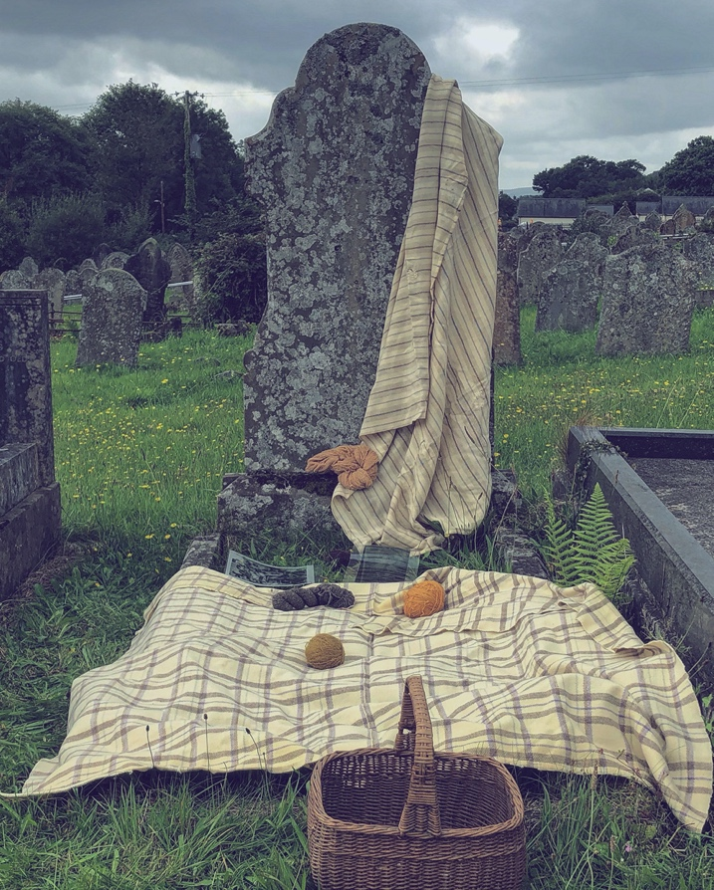
Image 1

Ethnography
Mencej’s paper (2011) has been a major influence to the practical work that continued. Attention was drawn towards the naturally dyed samples of woollen cloth, old family photographs and the pillows made for the WIP Exhibition, year 2. With deliberation, a decision was made to needle felt the dyed samples of cloth together and experiment with aperture sizes to be used as frames for the faces in the photographs. Following this, raw fleece would be needle punched into each image to represent hair of the subject, as Mencej (2011) mentions in Greek folklore, hair has the same function as thread in connecting to otherworld. Further experimentation continued with the needlefelting using industrial and domestic machines at the university, also a ‘hobby’ kit was used at home. This small portable device along with a single felting needle produced results equally as good, despite being more time consuming. Having created samples using the different coloured waste, it was felt that they detracted from the image. Re-consideration was needed, as time was passing; thoughts on final pieces of work had to be in place as the work in progress (WIP) symposium was approaching. This did not hinder the making in any way, as LeFevre (2010) states “If at first you don’t suceed, celebtate failiure.” With this in mind, re-visiting primary sources of research was implemented.

The exhibition titled A Bespoke Welsh Woollen Coat (2025), brought back the incentive to move forward with the project. There were coats on display made from old blankets constructed from mills that no longer exist. Another exhibit in stitch on Welsh Culture by Porch was inspirational too. This visit, along with re-visiting explorative work, and primary research visitis to museums and galleries, were sufficient to think creatively in combining elements previously explored together. Transfer printing with eucalyptus oil on wool produced shadowy, haunting effects on cloth, an appropriate way to capture subjects in old photographs, particularly as the subjects were involved in the woollen industry. The pillows stuffed with raw fleece previosly made, were interesting, yet ways of exhibiting these were limited. Consideration was then given to create mini quilts following a visit to the Quilt Museum, and viewing Hughes’ installations in the past. Hughes produces three-layer quilts that are stitched to create texture (Hughes, 2024). To proceed, eucalyptus prints on wool were made and outline quilted by hand, using a quilting method customary to Wales, 3 layers of fabric stitched together with thread (Quilters Guild, 2024); yet, the batting used were oddments of interlining left over from a previous project. Consideration was given to using materials available, instead of new throughout. These mini quilts were bound with the cloth, dyed from natural sources, bringing the ‘’wild to domestic space” (Plas, 2004, p.265-266, cited by Mencej, 2011, p. 72)). Wild Colour by Jenny Dean (2010) has been an invaluable resource with this. Each quilt has embellished elements. The quilt that depicts the image of the factory has a more contemporary element to it that text in the form of graffiti has been stitched into the facing wall of the processing shed, image 2.

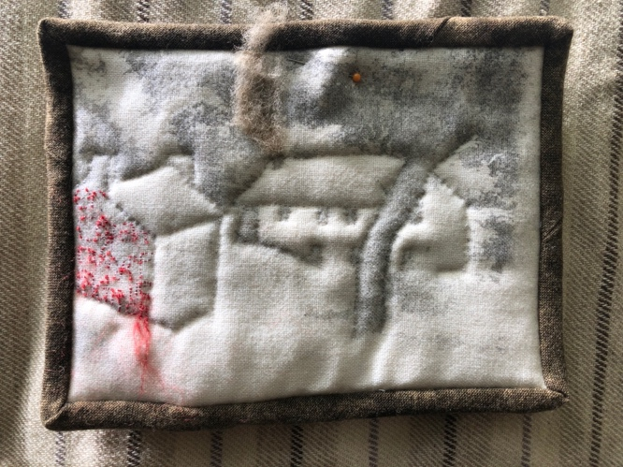
Image 2
In modern culture a disused building may be vanadalised and marked by its perpetrator. In this case, the vanadalism has been caused by natural sources and neglect over time. Red silk thread has been used to stich features in images. Again, according to European Folklore, cut thread resembles blood and death (Mencej, 2011). And, according to Gwen Beynon in a BBC video Coch (2012), red used in quilts in Welsh Culture, represents something special. Nevertheles, Welsh Quilts blogspot (2010) suggests that the colour red was meant to have healing properties and was favoured with children. Furthermore, with the embellishing of the mini quilts, raw fleece has also been worked into each piece, again the fleece representing the dead (Mencej, 2011). In Welsh culture, wool/ fleece would have been used as the inner layer for added warmth and comfort (Moss, 2010). With this in mind, a quilt ‘in the making’ depicting the eldest son of the ‘factory,’ the ‘tailor of Glasgow House’ was created, using carded raw fleece as the inner layer. This unfinished piece without the binding that anchors the layers together has a different quality to it from the others, as Catherine Dormor (2020, p.93) postulates “In the absence of the structuring scaffold of the cloth, its material presence becomes revealed.’’ This piece is left at an ambiguous stage, the basting stitches visible, the packing raw, suggesting that the maker is no longer ‘in the present’ to complete it or that it may have been left this way for someone to finish it. The prayer handwritten by my late grandmother, is left in the same way, with some words stitched in cut, red, thread that symbolises blood “[…] as soon as the thread was cut it melted into blood [….]” Cardigos (2008, p.113, cited by Mencej, 2011,p 60). There is an element of beauty to these pieces, as there are with worn quilts that reveal their layers. The materials that are custom to quilt making have been used, however, in a new way with the inner stratum being used at the top. In addition to the mini quilts, a patchwork piece ‘in the making’ using the dyed cloth has also been made as a means to include names of family taken from the family tree. This is not intended to be a finished piece, as the family is growing indirectly, and it may be in time, that someone will continue with it. Photocopies of the papers used for transfer printing have been used to make the templates, another way of including subjects of the past into this work. It was also felt that weave should be included in this body of work as it was practiced at the ‘ffactri.’ A length of linen was woven to experience the skill. Accorrding to A Kilbourne Matossian (1973, p.331, cited by Mencej, 2011, p.69) to weave “in the primitive symbolism of Western Civilisation, to [..] weave is to create body tissue.” A poem “Stitcher’s Prayer’ has been worked into this piece with thread. The cut length of thread representing blood running from this ‘flesh.’ The words being appropriate to each female and some male family members, as they continued to use threads in textile making until their dying day.

Further to the processes applied, the method of digital printing has been explored. The image of the grave being focal to this study needed printing. A slot was booked for this, and a test piece on wool was printed. This was successful with the colours and detail. Nevertheless, a digital image on wool did not feel appropriate to this project. A discussion with a senior lecturer around printing the photograph life size on to paper or vinyl was had. This felt more inkeeping with the overall exhibit.

Whilst working on these pieces, thoughts and questions came to mind about methods of display.

Chapter 4- Exhibition Planning
With the venue of the exhibition confirmed at the university, and areas to exhibit the final pieces of work, careful consideration is needed to the suitability of space to accommodate the final pieces for Er Côf Annwyl. The building is light and airy and has may wonderful rooms and corridors to showcase an end of year art show. However, after showcasing at the Work In Progress (WIP) Mash Up exhibition May 2024, the work exhibitied at the top floor, became damaged from sunlight that filtered through the roof lanterns for the duration of the show. For this reason, the printed and dyed cloth produced for the pieces made for this exhibition will have to be away from natural/sun light. The ghostly subjects in the cloth will be more visible in a shaded position. Furthermore, a space will also be needed for the life size photograph of the grave. Ideally, the round reading room presents as being an atmospheric site to accommodate the exhibit. This space, much to the disappointment to some of the cohort, has been allocated to the film students. Consequently, another site was allocated being the Makers Studio. The room has a chapel-like quality to it with high ceiling and elongated arched windows, similar to Capel Tynycoed where family are buried.

The space for Er Côf Annwyl has been allocated for the Makers Room at the university. Ways of curating the pieces needs to be considered. With this in mind, Steiler’s work Vestige (2018) is inspiring. The textile/photographs suspended with thread is motivating. At home, there were many lengths of crochet that were made by my great aunt/ grandmother- subjects captured in the photographs-that were still waiting to be used. In continuing to be mindfull around sustainability with textiles, consideration towards including them to suspend the quilts has been given, and to incorporate them as part of the work. It felt that the textiles created by many female members of the family were being brought together, and that this body of work is a way of celabrating their skills and their lives. The quilts together with the crochet lengths have been placed on the headstone and photographed, paying tribute to the factory, its owners, workers and family, image 3. Furthermore, the crochet and quilts depicting images of generation 3 and 4 have been arranged on the grave of daughter and grandaughters of the Ffactri as an ongoing pilgrimage to preserve their memory.
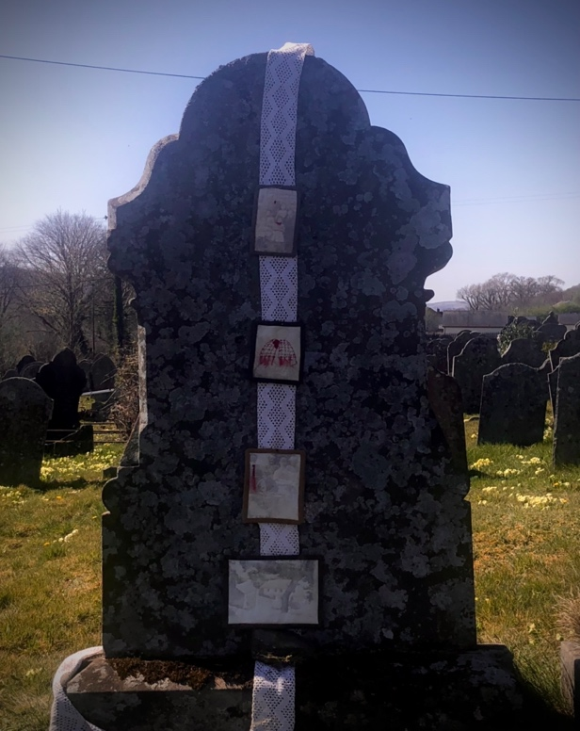
Image 3

Public ‘Solo’ Exhibition!

Prior to the final showcase at the university, the textile work has been curated at the at the ruin of the mill. The mini quilts were pinned to the blankets that originated there and were draped over window openings. In addition to displaying the textile pieces, a woollen shirt that Evan Roderick would have worn, along with a nightgown that the grandmother would have worn, were positioned alongside. Walking sticks passed down through generations were used for curating. According to Arts Wales (2025) “Public art installations and cultural projects often reflect local traditions, history, and landmarks, creating a sense of continuity and connection to the past. “Indeed, this work had strong connections with its environment here!

The display was photographed and videoed, image 4. Passers by walked through, and photographed the work asking questions. The video was circulated on instagram, there was a response, ‘where may we see this?’ In reply, the date and venue of the final show was given. The intention with this project from the start has been fulfilled. Yet the final exhibition is drawing nearer.

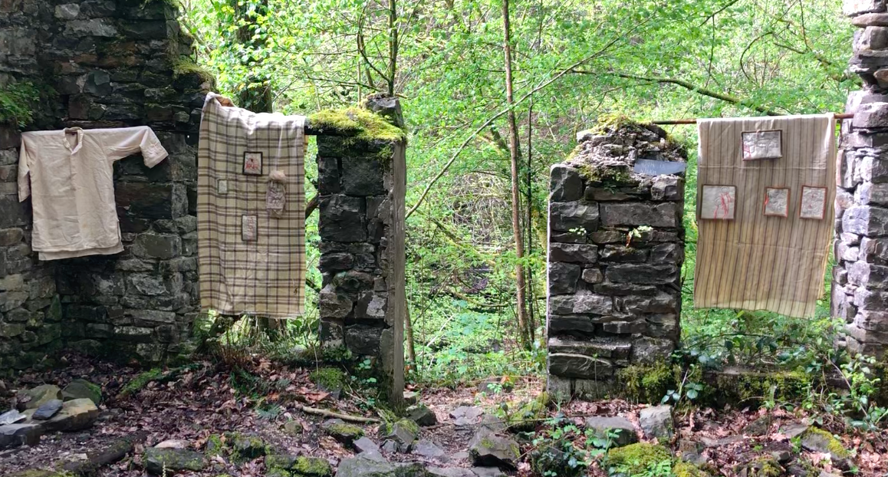
Image 4

Chapter 5: The intention

The photo taken of the grave adorned with woven blankets and balls of yarn has become the epicentre of this project. Therefore, it must have a prominent position in the exhibit of Er Côf Annwyl at the Goleuo/ illumine 2025 exhibition. A recent visit to the National Museum of Wales provided inspiration for showcasing this work. The interactive exhibit Capel Celyn depicting a life size photo of a family of the said village leaving their home for the last time with final belongings, created a strong sense of emotion with the history attached, image 5.
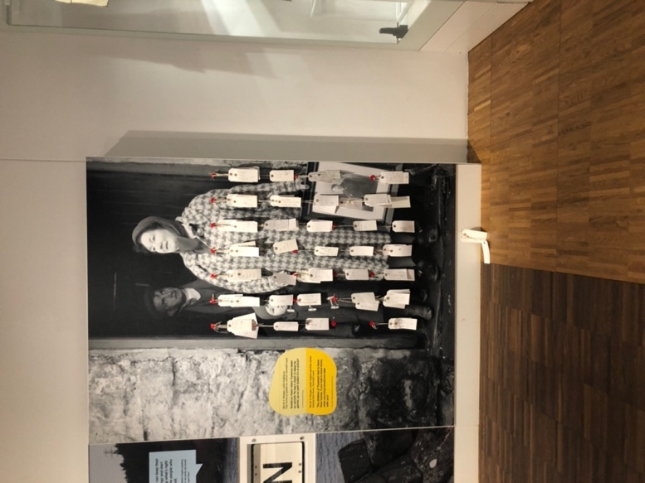

Image 5:

The village was flooded to create a dam to supply water to Liverpool in 1965 (Edwards, 2015). The whole community were rehoused elsewhere, despite many angry protests at the time. This exhibit, inviting the viewer to respond to the work in writing their responses on luggage tags provided inspiration to create labels for my textile pieces. Research into labelling the deceased was looked into and ‘toetags’ were made from oddments of woven gauze , fleece, thread, stained paper prined with nettle. Moreover, another textile exhibit of a workshop led by Porch on the same subject that incorporated names of characters from Mihangel Morgan’s book Pantglas provided further inspiration to use the walking sticks to suspend the textile pieces made, image 6.

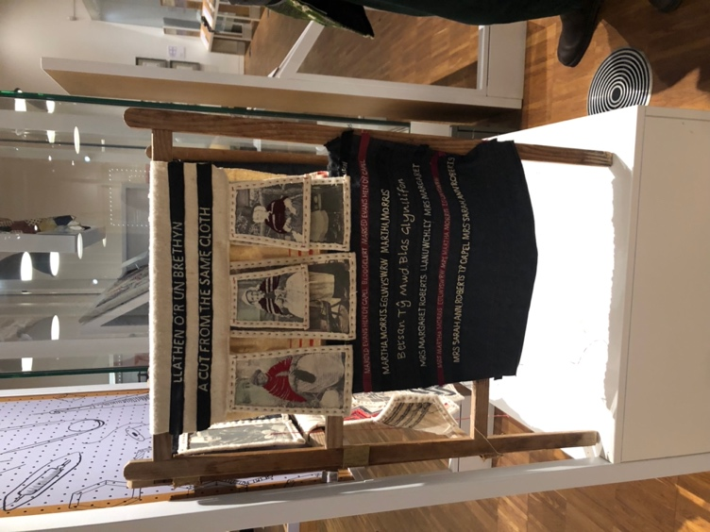
Image 6
The image of the grave will be life size, with the headstone measuring approximately 6’ in height and 3’ wide, the length of the kerb stone being 8’. The image will be fixed to an even backboard, a focal point to the work, almost as if it needs to be worshiped. The stitched quilts are envisaged by being suspended from the walking sticks and secured to the crochet lengths, either side of the headstone, however this may change. Below the headstone on the plinth, the intention is to place the basket of yarn/ fleece , as practiced in some cultures to capture souls to pass on to life in the making/ womb. The woven length and and some stitched work along with the stone rubbings will be positioned in front of the headstone, so that the viewer can make a connection with the work. The nightgown and flannel shirt may also be included in being suspended above the horizontal plinth, as revenants of Roderick looking over.

Conclusion

This praxis has been challenging in many ways. Not only has it challeneged my thinking as a Textile practitioner, the project itself has challeneged me emotionally, due to the loss of my mother. However, despite this it felt right to continue with it as my mother knew of it. She contributed to the project in passing down family records and materials that has aided in this enquiry. Further to the loss of mum, other close family members are experiencing health issues and are needing my support. Whatever challenges that life may bring, they often change a persons perspective, as John C. Maxwell (n.d) states “Success is due to our stretching to the challenges of life. Failure comes when we shrink from them.”

Working on the textile pieces for this project has helped with the acceptance of the confrontations that life has brought. Through imagery and making in utilising some materials and tools that belonged to the subjects depicted, a connection to them , using thread, has been felt, as well as marking a vestige of their existence in ‘my time,’ similar to Burgess through capturing memories on cloth and Steiler’s (2019) use of photos:
Through the process of envisioning and executing this work, I remind myself to be and do all I desire in the time I have been given. I remind myself to shape my legacy with intent as well as prepare for the unexpected ways my personage may echo after I am gone. The interplay of photography and memory is undeniably powerful, but also incomplete and fallible. I hope to balance what might seem a bleak reality in this regard by incorporating handcrafted textiles, which speak to me of comfort, family, love, connection.

To conclude, the work created for Er Côf Annwyl responds to research, through materials and processes used, as well as inspiration from the artists mentioned. The subjects in the mini quilts, over time will eventually fade, all that will remain being fragments of cloth that may survive a length of time. Wool being sustainable and if cared for, is a material ‘for life.’ The exhibition at St Fagan’s is testament to this, so too are the blankets made by the Llech factory that have survived for over 100 years. As a nation, Wales needs to continue promoting and preserving its cultural history and in making good use of its natural resources. As Guy Debord (1988, cited by Gross, 2000, p.132) posits:
[….] nothing gets remembered if the media wants it forgotten, a good case can yet be made that some important memories barely acknowledged by popular culture or the mass media have nonetheless persisted, […].

Bibliography
Anon., 2017. Ellen MacArthur Foundation, A new textiles economy: Redesigning fashion’s future. [Online].
Anon., 2023. Woven Histories of Welsh Wool and Slavery. s.l.:Common Threads Press and Charlotte Hammond.
Anon., 2025. Arts Wales. [Online]
Available at: https://www.artswales.org.uk
[Accessed 16th April 2025].
Aspin, C., 1982. The Woollen Industry. Aylesbury: Shire Publications Limited.
Azoulay, A., 2023. Unesco. [Online]
Available at: https://www.google.com/url?sa=t&source=web&rct=j&opi=89978449&url=https://www.unesco.org/en/articles/unesco-archives-preserving-our-heritage-future-generations&ved=2ahUKEwiSh868-bGLAxU2YEEAHUixFisQFnoECC8QAQ&usg=AOvVaw2rB-5ro_Rso8R2DFYHyhs6
[Accessed 7th February 2025].
Bachelard, G., 1969. the Poetics of Space. Toronto: Beacon Paperback.
Bell, B., 2016. BBC News. [Online]
Available at: bbc.com
[Accessed 13th April 2025].
Beynon, G., 2012. Gwenllian Beynon-Coch [Interview] (26 January 2012).
Bousfield, A., 2025. The Cardiffian. [Online]
Available at: https://cardiffjournalism.co.uk/thecardiffian/2025/02/25/therea-a-real-magic-to-it-tailor-celebrates-the-heritage-of-wool-in-wales/
[Accessed 23rd April 2025].
Cambridge, D., n.d. Cambridge Dictionary. [Online]
Available at: https://dictionary.cambridge.org/dictionary/english
[Accessed 7th April 2025].
Coverley, M., 2020. Hauntology: Ghosts of Futures Past. Harpenden: Old Castle Books.
Davies, W., 2003. NOW & THEN. Carmarthenshire: Derwen Press.
Dean, J., 2010. Wild Colour. 2nd ed. New York: Watson-Guptil Publications.
Derrida, J., 2002. Acts of Religion. New York: Routledge.
Dormor, C., 2020. A Philosophy of Textile. 1st ed. London: Bloomsbury Publishing.
Edwards, T., 2015. BBC. [Online]
Available at: https://www.bbc.co.uk/cymrufyw/34518186
[Accessed 23rd April 2025].
Fejel, K., 2015. KATELYN TOTH FEJEL. [Online]
Available at: https://www.katelyntothfejel.com/edgeways
[Accessed 23rd April 2025].
Gross, D., 200. Lost Time On Remembering and Forgetting in Late Modern Culture. Massachusetts: University of Massachusetts Press.
Guild, Q., 2024. Quilters Guild. [Online]
Available at: https://www.quiltersguild.org.uk/pages/quilt-making-faq/layering-your-quilt
[Accessed 18th Dec 2024].
Holroyd, D. G. &. A. T., 2014. On making, sustainability and the importance of small steps: A conversation. Conjunctions, 1(1), pp. 1-27.
Hughes, B., 2024. Ruthin Crafts. [Online]
Available at: https://ruthincraftcentre.org.uk/resedencies-information/bethan-m-hughes/
[Accessed 23rd April 2025].
Hughes, B. M., n.d. Bethan M. Hughes. [Online]
Available at: https://bethanmhughes.wordpress.com/arddangosfeydd-exhibitions/
[Accessed 18th Dec 2024].
Jamieson, R., 2012. Natural Dyes: plant a permacoture garden. The Guardian, 20th August, pp. 10-11.
LeFeuvre, L., 2010. Tate. [Online]
Available at: https://www.tate.org.uk/tate-etc/issue-18-spring-2010/if-first-you-dont-suceed-celebrate
[Accessed 12th March 2025].
Lippard, L. R., 1997. The Lure of the Local. New York: The New Press.
Maxwell, J., n.d.. Brainy Quote. [Online]
Available at: https://www.brainyquote.com/quotes/john_c_maxwell_600864
[Accessed 18th April 2025].
Mencej, M., 2011. Connecting Threads. Electronic Journal of Folklore, Volume 48, pp. 54-84.
Morgan, M., 2011. Pantglas. 1st ed. Ceredigion: Y Lolfa.
Moss, P., 2010. welsh-quilts.blogspot. [Online]
Available at: https://welsh-quilts.blogspot.com
[Accessed 31st March 2025].
Nations, U., 2024. Textile Industry: how can we make it more sustainable?. [Online]
Available at: https://unric.org/en/textile-industry-how-can-we-make-it-more-sustainable/
[Accessed 7th February 2025].
Nations, U., 2024. Threads of Change: Systemic Transformation of the Textile Sector. [Online]
Available at: https://unric.org/unbt-threads-of-change-systemic-transformation-of-the-textile-sector/
[Accessed 7th February 2025].
Rashmila, M., 2025. Earth.org. [Online]
Available at: https://earth.org/
[Accessed 19th April 2025].
Steiler, C., 2019. Cindy Steiler. [Online]
Available at: https://www.artfieldssc.org/galleries/art/2018/vestige/816635
[Accessed 7th February 2025].
Sutton, D., 2021. David Sutton's poetry website. [Online]
Available at: https://www.davidsutton'spoetrywebsite.com
[Accessed 30 April 2025].
Thomas, A., 2009. Design and sustainable development:what is the contribution that design can make? A case study of the Welsh Woollen Industry, Sheffield: Sheffield University.
Trust, N., n.d. National Trust. [Online]
Available at: https://www.nationaltrust.org.uk/our-cause
[Accessed 7th April 2025].
unkown, 2023. UNESCO. [Online]
Available at: https://www.unesco.org/en/articles/unesco-archives-preserving-our-heritage-future-generations
[Accessed 7th April 2025].
Walker, D., 2020. Future generations Commissioner for Wales. [Online]
Available at: https://futuregenerations.wales/wp-content/upload
[Accessed 18th April 2025].
Walker, D., 2023. Cymru Can, Cardiff: Anon..
Watkins, A., 1983. South Wales Coalfield Collection [Interview] 1983.
Weighton, H., n.d. Haf Weighton, Artist. [Online]
Available at: https://hafanhaf.com
[Accessed 18th Dec 2024].

