

MODULE CODE: Digital Skills for Personal Development and Business Growth BMSW4008

ASSESSMENT COMPONENT: PORTFOLIO

STUDENT NAME: Donna watkins

STUDENT NUMBER: 2508071

LECTURER: Aqsa Shabir

DATE: Friday 12th December 23:59
Contents
Task 1 3
Assessment of Digital Skills 3
References 3
Task 2 4
LinkedIn Learning Certificates for Office365 4
Task 3 5
Essay on Relevance of Excel in professional and personal life. 5
References 5
Task 4 6
7 Minute Reflective Presentation 6
References 6

AI Acknowledgement
I confirm that I have not presented any AI generated materials as my own work.
I confirm that I have copies of my drafts, notes, and other resources I used, which I may be asked to provide in evidence.

ASSESSMENT OF DIGITAL SKILLS
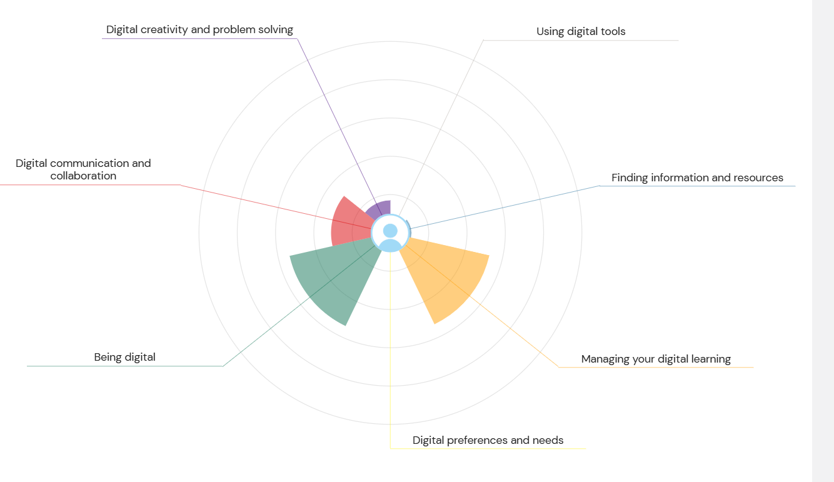

- Today, digital skills are no longer just useful—they are essential. Most of our learning, communication, and everyday activities now involve technology in one way or another. Digital skills help us study more effectively, work more efficiently, and stay connected in both personal and professional situations (Scheel, Vladova & Ullrich, 2022). Because technology continues to grow and change, it is important for students like me to understand our strengths and weaknesses so we can develop the skills needed for success. In this reflection, I will explain my results from the JISC digital capability assessment, describe two strengths and two weaknesses, and create a SMART action plan to help me continue improving.

- The JISC digital capability framework looks at six areas: digital well-being, communication, creation, working with data, learning, and identity (JISC, 2017). My results show that I am confident in digital communication and managing my digital learning, but I need to work on digital creativity and problem-solving, as well as using a more formal tone in professional online settings.

- Digital Capabilities: Strengths and Weaknesses

- Strength 1: Digital Communication
- One of my main strengths is digital communication. I feel comfortable using different online tools such as messaging apps, email and social media. I can communicate clearly, share information, and stay connected with people easily. This confidence helps me when working with classmates and taking part in group tasks. Research shows that strong digital communication skills are important for studying, building relationships, and working well with others in online spaces (Scheel, Vladova & Ullrich, 2022). Being able to communicate well online also supports networking, which is helpful for future career opportunities (European Commission, 2018).

- Strength 2: Managing Digital Learning
- I am also good at organising my digital learning. I keep my apps in order, store files where I can easily find them, and use digital tools to help me manage my workload. These habits make my studying smoother and help me stay focused. According to the European Commission (2018), being able to organise digital resources is an important part of digital competence. I also plan to keep improving by using platforms such as LinkedIn Learning or YouTube tutorials to help me learn new digital skills. This shows I’m committed to improving and keeping up with new technology.

- Weakness 1: Digital Creativity and Problem-Solving
- A weaker area for me is digital creativity and problem-solving. Even though I enjoy being creative, I lack confidence when using more advanced digital tools or trying new apps. I also sometimes struggle to fix problems when technology doesn’t work as expected. Developing this skill means learning how to create digital content, experiment with tools, and solve technical issues calmly and independently (European Commission, 2018). I want to become more comfortable trying new things, even if I make mistakes along the way.

- Weakness 2: Using a Formal Digital Tone
- Another weakness is writing in a formal tone when needed. While I’m confident communicating informally, I sometimes find it hard to switch to a more professional tone in emails or messages to tutors, employers or organisations. Research explains that tone can easily be misunderstood online, so it is important to communicate clearly and politely, especially in formal situations (Scheel, Vladova & Ullrich, 2022). Improving this skill will help me communicate more effectively in academic and career settings.

- Action Plan for Improvement (SMART Goals)

- To improve my digital creativity and problem-solving, my SMART goal is to complete an introductory online module, such as a beginner Canva course or a basic coding class. After finishing the module, I aim to create three pieces of digital content that I can use for academic work or future projects. This goal is measurable because I will know I have completed it once the three items are produced. It is achievable because there are many free online tools available. It is relevant because being more creative and confident with digital tools will help me in university assignments and in job roles that require innovation. I aim to complete this goal within the next 10 weeks.

- To improve my formal digital tone and etiquette, my SMART goal is to take a short online course or tutorial on professional email etiquette and formal communication. I will know I have achieved this when I pass the end-of-course quiz and begin using a more formal tone consistently in my emails and messages to tutors for one academic term. This is achievable through platforms such as LinkedIn Learning or other free tutorials. It is highly relevant because good communication is essential for academic success and making a good impression in professional environments. I will begin this training immediately and put these skills into practice throughout the term.

- Conclusion: Reflecting on Growth

- Improving my digital skills will help me a lot in my studies and future career. By becoming more confident with digital creativity, I’ll be able to present assignments in more interesting and visually engaging ways, which is now a common expectation in education (Beetham & Sharpe, 2020). Learning to use a formal tone online will help me communicate more professionally with tutors, which can lead to better support and stronger academic relationships. In the workplace, employers value digital problem-solving skills because they show resilience, adaptability and independence (van Deursen & van Dijk, 2019). Improving these weaker areas will help me become a stronger digital learner and a more employable person overall. By following my SMART goals, I can continue growing and feel confident that my digital skills will support me in both academic and professional environments.

References.
Beetham, H. and Sharpe, R. (2020) Rethinking pedagogy for a digital age: Designing and developing for digital and blended learning. 3rd edn. Abingdon: Routledge.
European Commission (2018) DigComp 2.2: The digital competence framework for citizens. Luxembourg: Publications Office of the European Union.
JISC (2017) Building digital capabilities: The six elements defined. Available at: https://www.jisc.ac.uk/guides/building-digital-capability (Accessed: 1 December 2025).
Livingstone, S. (2014) ‘Developing social media literacy: How children learn to interpret risky opportunities on social network sites’, Communications, 39(3), pp. 283–303.
Ng, W. (2012) ‘Can we teach digital natives digital literacy?’, Computers & Education, 59(3), pp. 1065–1078.
Scheel, K.L., Vladova, G. and Ullrich, A. (2022) ‘The structure of digital competence in higher education: A systematic review’, International Journal of Educational Technology in Higher Education, 19(1), pp. 1–28.
van Deursen, A.J. and van Dijk, J.A. (2019) ‘The first decade of internet skills research: Achievements and challenges’, New Media & Society, 21(5), pp. 1144–1161.

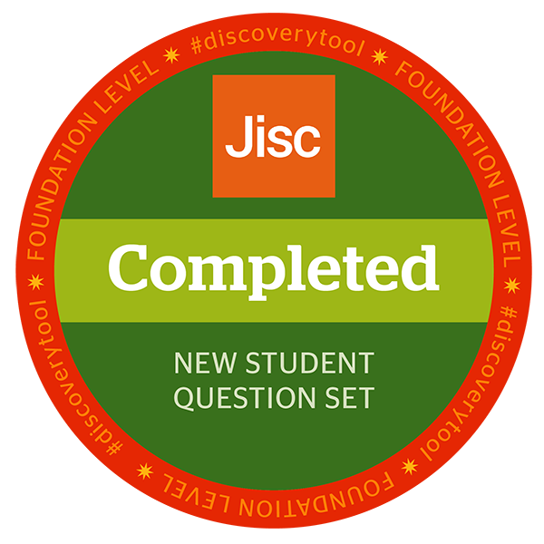

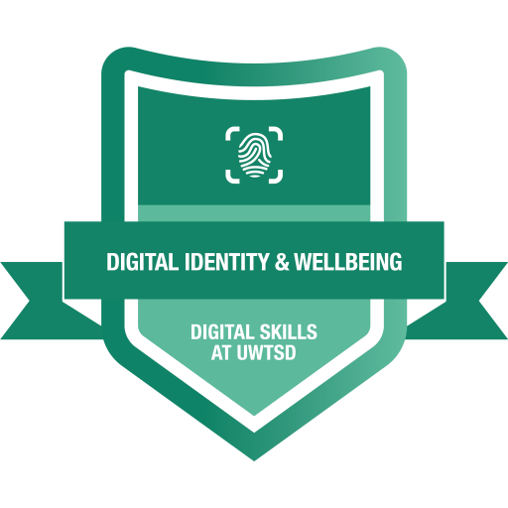

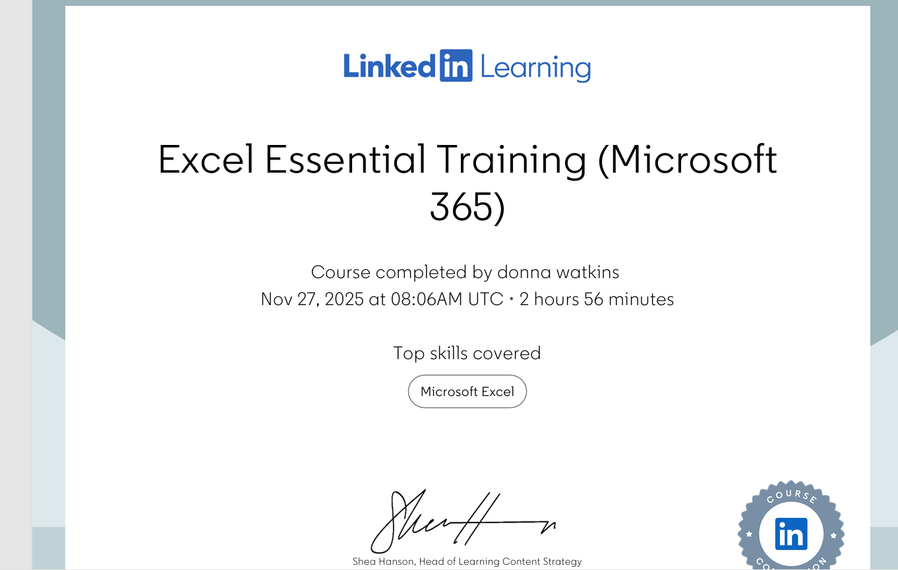

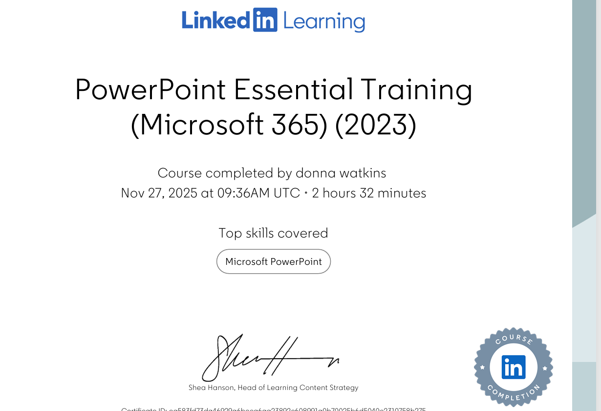

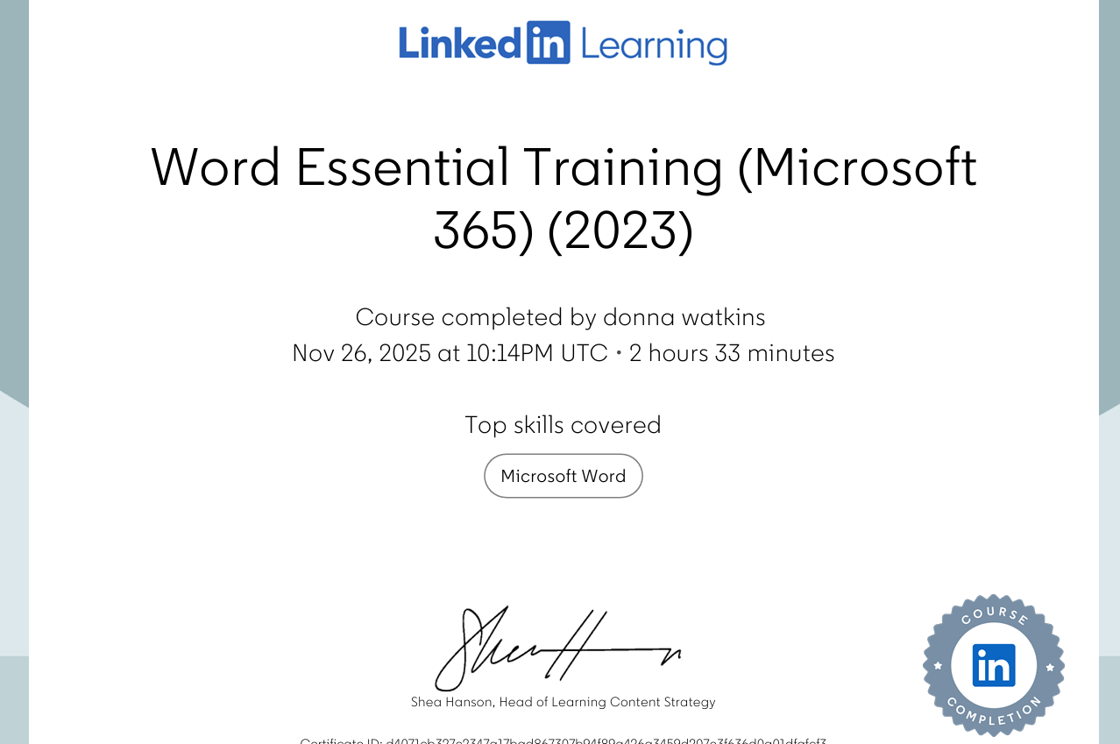

Discussing the relevance and importance of Microsoft excel (1000 words)

The following essay will look at the relevance and importance of Microsoft Excel in the new digital era. It will look at its role in tasks such as data analysis, budgeting, reporting and decision making. It will discuss its functions and uses and where these positions excel in terms of it being a useful tool in everyday and professional life.

Microsoft Excel is a program that was created in 1982 (MAX, 2024) and was designed to make graphs, complete statistical analysis and financial functions. It was initially particularly useful in professional settings such as the financial sector (The Wall Street School, 2013). It enabled companies and institutions to complete tasks such as investment analysis, loan and mortgage calculations, accounting and tax planning with more ease and efficiency. Over time, it has become used in other sectors such as with students (Formby et al, 2013) researchers, academics and healthcare (Lapolla, 2020). It is now a more widely used and accessible tool that has been incorporated into modern life and the new digital era (Charlesworth, 2024).

Excel has hundreds of functions, but some are particularly important for data analysis. It helps calculate data quickly for example, the ‘IF’ function allows for automated decision making, SUMIF’s allow for creating sums based on specific criteria, VLOOKUP helps combine data and look for certain values in a data set (Murray, 2025). Excel makes tasks that would be time consuming and difficult for the human brain to complete, a lot easier and quicker. The filtering and organizing aspect allow the user to also select criteria and find answers at the click of a button, for example, if one was to create a monthly home cleaning schedule, a spreadsheet could include tasks that needed to be completed monthly, weekly and daily. By filtering, the user would be able to select the ‘daily’ option and find easily what would need to be completed that day. This would be a lot quicker than paper-based methods. Furthermore, if any amendments needed to be made this could be done quickly and efficiently, without the need to complete a whole new schedule. In the professional world, analysing data is key - whether this be reviewing how well a quarter has done and evaluating profits or loss or used in forecasts to predict different scenarios and project sales on various growth rates. These tasks are fundamental to a business’s survival, so having a tool like excel is crucial in the business world.

Excel further supports businesses in terms of developing a budget such as creating spreadsheets for time keeping, clocking in and out and payroll. It also helps with managing and logging expenses. Many industries benefit from using excel such as retail where spreadsheets can be kept keeping track of stock and the average sales or profit margin of stock. Excel can help with budgeting at home with things like creating lists to keep track of food and bill budgets or to keep track of savings to help create a savings plan. It can also be used to create shopping lists where prices can be included to ensure there is no overspending on the grocery budget, tracking spending habits (GyanSetu, 2025)

Excel helps with reporting findings and presenting them in a more efficient and timely way. Within excel you can create graphs and charts easily, which are more visually appealing and easier to understand. Graphs and charts can be used in situations such as budgeting for example, creating a pie chart to represent home expenditures and analysing incoming and outgoing finances. This is also helpful in education settings such as schools where budgets need to be created to keep track of the financial year and submitted to the local authorities, graphs can be created with the data set and sent for easier reviewing and planning. When looking at students, excel can be used to keep track of grades and assignments or track study time. It can be incorporated into part of the research planning phase for projects such as creating a timeline to visualize how long is needed to complete an assignment.

Using excel for the things mentioned above, then helps inform decisions for example; if a pie chart was created using income and outgoings of a home, if one part of the pie chart was dedicated to a particular area such as bills, it would be easily identifiable and then excel could be used to breakdown each bill and decisions could be made in regards to reducing a certain bill such as energy, switching to a different supplier or making more economic decisions, therefore using excel has real life positive implications which span both professional and home settings.

In conclusion, excel has become a really important tool in both professional and home life. It has hundreds of functions and tools which can make tasks more efficient and understandable. Using excel can help with making financial decisions, keeping track of income and expenses and calculating savings automatically. For this reason, it is highly relevant that students learn how to use excel as it has become a tool that businesses also use to monitor their progress, make financial decisions and forecasts and report to shareholders and investors. This is also relevant across various sectors and career paths, therefore a student having knowledge and understanding of excel is vital for career development and progression. Research has shown its implementation and use in areas such as academia, healthcare, retail, finance, home and hospitality can have positive outcomes; therefore, it would not be wrong to conclude that excel is a highly relevant and important tool in today's digital era.

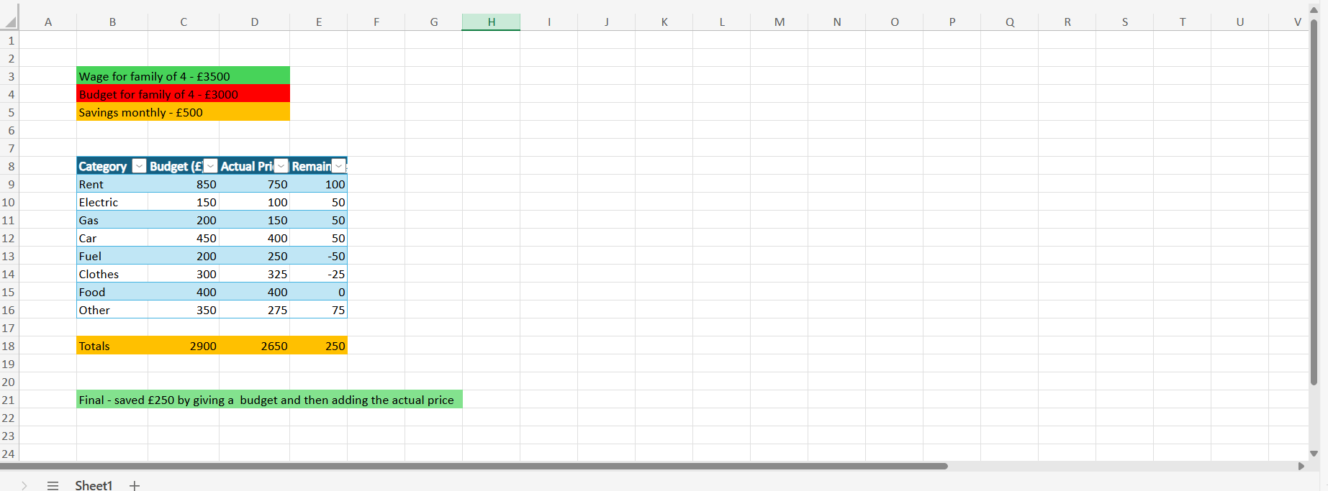

References
Charlesworth, A. (2024) Is Microsoft Excel still relevant? Kaplan. Available at: https://kaplan.co.uk/blog/features/is-microsoft-excel-still-relevant (Accessed: 12 December 2025).
Formby, S.K., Medlin, B.D. and Ellington, V.B. (2013) ‘Microsoft Excel®: Is it an important job skill for college graduates?’, Journal of Learning in Higher Education, 9(1). Available at: https://eric.ed.gov/?id=EJ1140801 (Accessed: 12 December 2025).
Gyansetu (2025) 10 best uses of MS Excel in daily life. Available at: https://www.gyansetu.in/blog/best-10-uses-of-ms-excel-in-daily-life/ (Accessed: 12 December 2025).
LaPolla, F.W. (2020) ‘Using Excel for data management in clinical research’, Journal of Community Hospital Internal Medicine Perspectives, 10(1). Available at: https://pmc.ncbi.nlm.nih.gov/articles/PMC6919992/ (Accessed: 12 December 2025).
Max (2024) When was Excel created? Max Training. Available at: https://maxtrain.com/2024/02/19/when-was-excel-created/ (Accessed: 12 December 2025).
Murray, S. (2025) Most useful Excel functions for data analysis. GoSkills. Available at: https://www.goskills.com/Excel/Resources/Most-useful-Excel-functions-for-data-analysis (Accessed: 12 December 2025).
The Wall Street School (2013) Why is Excel important in finance? Available at: https://www.thewallstreetschool.com/blog/why-is-excel-important-in-finance/ (Accessed: 12 December 2025.



