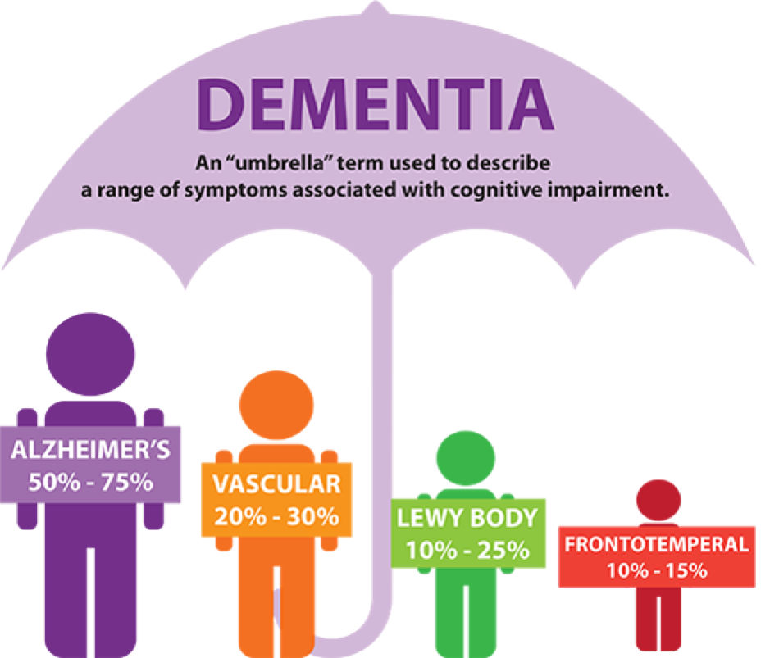
What support is offered to people suffering dementia?

Page 1
Contents

Front Cover ………………………………………………………………………………………………………………. Page 1
Contents ……………………………………………………………………………………………………………………. Page 2
Abstract ……………………………………………………………………………………………………………………… Page 3
Introduction ………………………………………………………………………………………………………………. Page 3
What is dementia and the Prevalence of dementia …………………………………………………… Page 4
Nhs Framework ………………………………………………………………………………………………………… Page 5
Community based support ………………………………………………………………………….……………. Page 6
VIPS framework ……………………………………………………………………………………………………….. Page 7
Conclusion ………………………………………………………………………………………………………………. Page 8
Recommendations …………………………………………………………………………………………………. Page 8
Appendix ………………………………………………………………………………………………………………… Page 9 & 10
References ……………………………………………………………………………………………………………. Page 11 & 12

Page 2
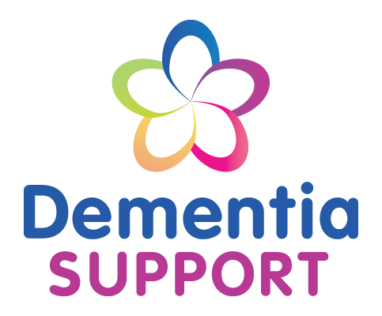
Introduction
The purpose of this report is to demonstrate frameworks that are I place to help support those who are living with dementia. It will evaluate the frameworks and draw conclusions on what recent studies have found. It will evaluate figures and how the frameworks have been adapted overtime throughout the NHS and communities. It will show the reader the prevalence of dementia within the UK and highlight the importance of early diagnosis. Appendices will be added to show the online support that people in communities can access.
Abstract
Research will be undertaken in order to find out what support services are available to those who are living with dementia. Not only those who are living with dementia but the people who are caring for them including, family, friends and paid or volunteer carers. It will pick services that are both NHS funded and charity’s and focus on what their main aim and goal is in order to provide effective care within communities, day centres and in the NHS hospitals throughout the UK. Evaluations with be drawn and it will show what these organisations have in common and whether or not their services are working, this will be highlighted in the recommendations section once research has been undertaken.

Page 3
Dementia is a disorder which is progressive and can affect how the brain works. In particular it affects the ability to remember, reason and think (AgeUK, 2018).
Alzheimers UK (2018) continues and describes dementia as not a disease in itself but that of a group of symptoms that accompany a number of diseases which can affect the brain.
Dementia is not a symptom of growing old but the risk of having dementia can increase with age.
Studies show that most people affected by dementia are over 65, however, there are many people within the UK who are below 65 suffering.
The prevelance of dementia in the UK is rapidly increasing and Jopling (2017) believes that we need to act now in order to reduce the risks, he includes that working on finding a cure and imporving the rate in which dementia is diagnosed which will in turn help increase the impact of the current treatments that are being provided.
In the next 10 years Dementia Statistics (2018) reveal that diagnosis’s for dementia will be expected to rise to almost 400,000 and to nearly 1 million in the next 30 years.

What is dementia and the prevalence within the United Kingdom (UK)

Dementia in the UK
600,000-800,000... people have dementia in the UK.
One in six... people over 80 have dementia.
Only 43%...of people with dementia have actually been diagnosed
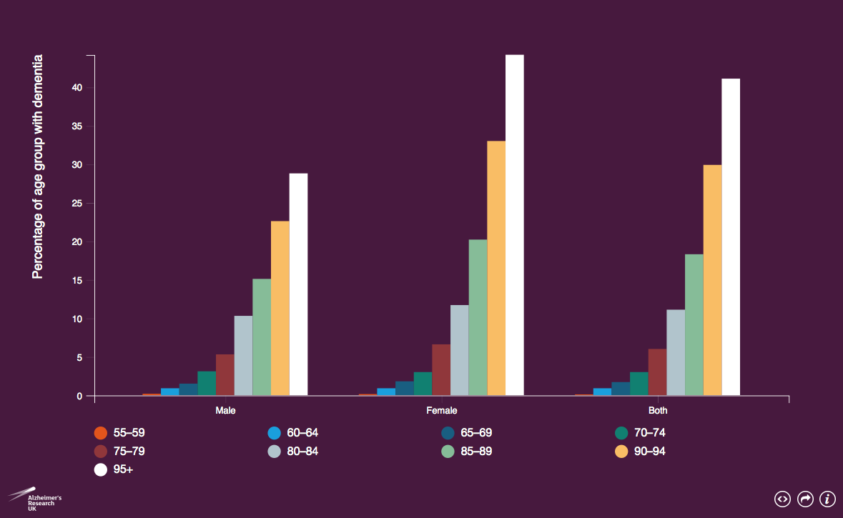
Dementia statistics (2018) provide research which shows the prevalence by groups.
The provided this research in a graph (see below).
This graph shows us the estimated percentage of people that are living with dementia within different age groups in the UK, it demonstrates which age are at more risk of developing dementia and how many more woman are living with dementia than men in older ages,
Page 4
Dementia assessment and improvement framework amongst NHS employees within a Hospital setting.
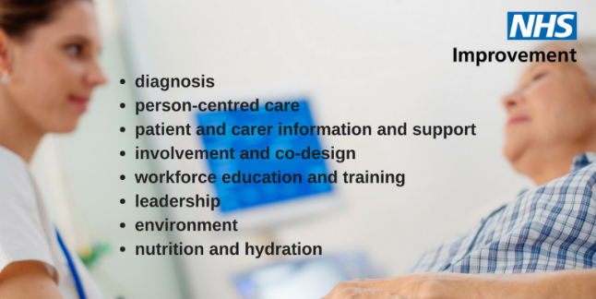
Within the UK, the NHS have set out an evidence based framework in order to help and support the directors of nursing and medical directors to achieve ‘outstanding’ care to those that are living with dementia during their stay at a hospital.
The Framework that has set out consists of eight standards.
- Diagnosis
- Person Centred care
- Patient and carer information and support
- Involvement and co-design
- Workforce education and training
- Leadership
- Environment
- Nutrition and hydration
This frame work was launched in October 2017 and was designed by Antonia Lynch, she aimed to draw on the national policy and wants to achieve outstanding rating from the Care Quality Commissions (CQC) as well as the views of the patients and their careers that are being supported with dementia. Within the UK hospitals, the framework is directed and aims to help support ‘organisational leaders’ such as senior sisters and charge nurses.
Using the framework checklist they should evaluate their care and make any necessary improvements (NHS England, 2018).
The Framework list includes leadership as one of the eight standard focuses is on leadership and highlights the important role that the senior nurses need to take in order to ensure that there is a high quality dementia care across all organisations.
These will be inspected by the CQC (Nursing Times (2017).
NHS UK (2019) reported that the new role of leaderships within the new dementia framework rated as outstanding by consultants. The consultants also highlighted that nursing directors have taken a visible leadership and has a positive impact on the culture and the organisation in general.
Whilst this framework has good feedback within the NHS, it is still relatively new and therefore
hasn’t been evaluated and conclusion made whether or not it is working. NHS, UK aim to review the framework in 2020. (NHS UK, 2018).
The NHS, also provide social service support for individuals with dementia, they can provide carers to help wash and dress, laundry services, meals on wheels, help with aids and adaptions and can provide you with access to day centres within the communities, all this is funded by the NHS in order to help improve the lives of those living with dementia and to keep them as independent as possible. As well and NHS funded services there are many charities who can provide similar services such as Alzheimers Society and Age UK. (NHS UK (2019).
Page 5
Community based care for dementia
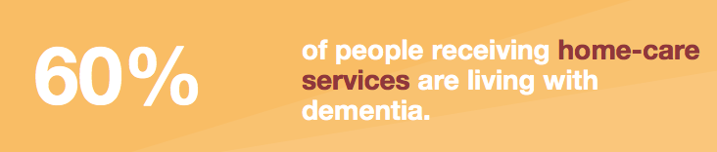
Community based Admiral Nurses
2000 a practice was put in place to bring in Admiral Nurses in order to make a difference in peoples lives (DementiaUK, 2018). There are many compentencies an admiral nurse have to adhere to including practicing person-centred care, theraputetic skills aswell as sharing knowledge and information through the promotion of the admiral nurse (DementiaUK, 2018).
Admiral Nurses are specialist nurses who are experts in clinical, emotional and practical support and provide their expertise to families that are living with dementia.
British Leigion (2018) continue and state that admiral nurses provide support not just to the individual with dementia but to their family and friends too.
They work to help families when there are communication break downs between themselves and the individual suffering with dementia, they offer skills and techniques to help them stay connected to their loved ones.
They offer support by showing the family best ways in preventing or managing fear or distress the individual with dementia may be showing.
They also help in guiding the family to cope by getting additional care for their loved one with dementia and lastly they are a ear to listen to, they will answer all your questions and will take time to ensure the family really understand the answers to their questions. A blog written in 2017 on the dementia UK official website showed how much admiral nurses are valued and are important to the dementia society, Ann Joan (2017) states that an important factor is that families who care for loved ones suffering dementia all need help in understanding dementia and how a person will change their emotional ability, cognitive functions and how changes in behaviour are linked to dementia.
Simon Bell (2017) also states that he finds the most valuable tools is to help the families or carers understand what I is like to live with dementia and help them understand and accept that the individual suffering with dementia can’t help what is happening to them.

Page 6
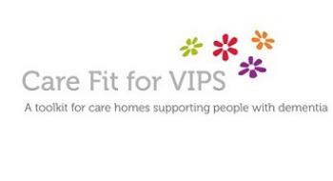
Vips framework of Dementia Care
This approach was originally developed by Thomas Kitwood in the 1980’s, however it was known as the person centred care for dementia not VIPS. He believed that there was more to a person than just their diagnosis. He believed that by leading person-centred care approach was essential. Person centred approach was introduced by Carl Rogers in 1940’s. (Heerma, 2018). Person centred care aims to focus on the needs of the individual and what they want, desire and goals are, and this makes them central to the care and nursing process (Goodfrey, 2018). Acgnelli (2014) states that whilst various person centred theories have been developed, Thomas Kitwoods theory is the most widely referred to within dementia care. Thomas Kitwood believed that positive person work, enabled nurses to develop competencies in delivery the best person-centred care to individuals with dementia in a clinical practice (Kitwood, 1997).
The Vips framework has since been re-developed by Dawn Brooker In 2004, she aimed to sum up the elements within person centred care for all individuals with dementia, the ‘Vips’ abbreviation stands for Valuing people, Individual needs, Perspective of service user and Supportive social psychology. This frame work aims to promote the rights of the person suffering with dementia, provide individualised care to meet each individual’s needs, understand care from the perspective of the person receiving the support and allowing a person to remain in relationships by keeping them in social environments.
This framework primarily work within care home settings and is aimed at domiciliary carers, care homes and day centres and it decides how well a care home is delivery care at present and to identify priorities for improvement, it helps to find useful information and resources on person cantered dementia care and help record, plan and test ideas for improvement. The main focus and goal is to always make improvements so that they are delivery the highest stand of care they possible can (Mcleod, 2018).
The VIPS offer a toolkit which is a free online resource for people to access and it provides a questionnaire. This is aimed at again improving the services through a Likert scale where when answering the selection of questions it gives options of 1-5, with 1 being poor and 5 being very good.
In 2017 the National institute of care (NICE) excellence adapted this framework and highlighted the importance of person centred care which is based on four main principles. These principles are to prevent ill health, promote and protect good health, improve the quality of care and services and to adapt and provide health and social care services. Not only do NICE promote the wellbeing of individuals who have dementia but they emphasise that they also consider the importance of the paid care workers, friends and families that help support those living with dementia.
Page 7

Recommendations
The VIPS toolkit has proven to be very successful and therefore it has been adapted many times in order to continue providing the best services. However as a researcher, it was not always easy to access the toolkit online and an individual would need to sign up in order to take the test. It was found that no summary of these questions or what to expect when taking the questionnaire and therefore this may look to some as too much work and they wouldn’t be willing to take the test as it could prove time consuming, this could lead to the impact of not helping to improve the services. The NHS framework is yet to be evaluated so therefore no recommendations can be made. The admiral nurses are continuing to improve and from feedback that can be seen on the dementia UK website, they are an essential part of the dementia society and really help the families of those with loved ones living with dementia, therefore at this time there are no recommendations to be given for admiral nurses.
Conclusions
Whilst dementia continues to grow amongst the people in the UK, we can see that each organisation and support system all have one goal in mind. Early diagnosis is often key to help slow the process of dementia. However these organisations thrive of continuing to research and improve their services at every opportunity in order to change the way society portrays people with dementia and help individuals live their life in the best possible way they can. Having support for carers, family and friends are something that these organisations can provide and believe it is something that’s important to help them keep improving the way everyone cares for individuals with dementia.

Page 8
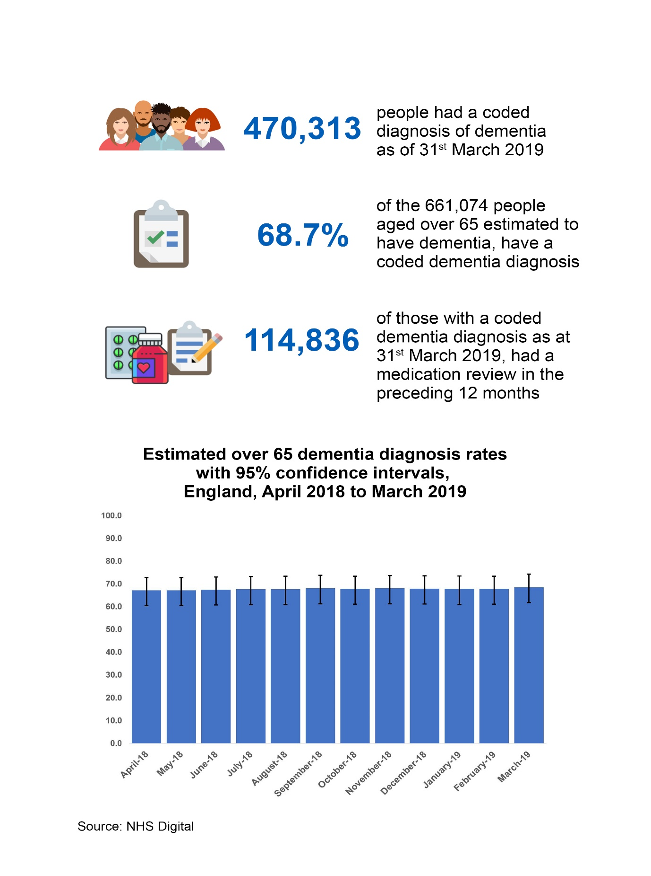
Appendix
Page 9
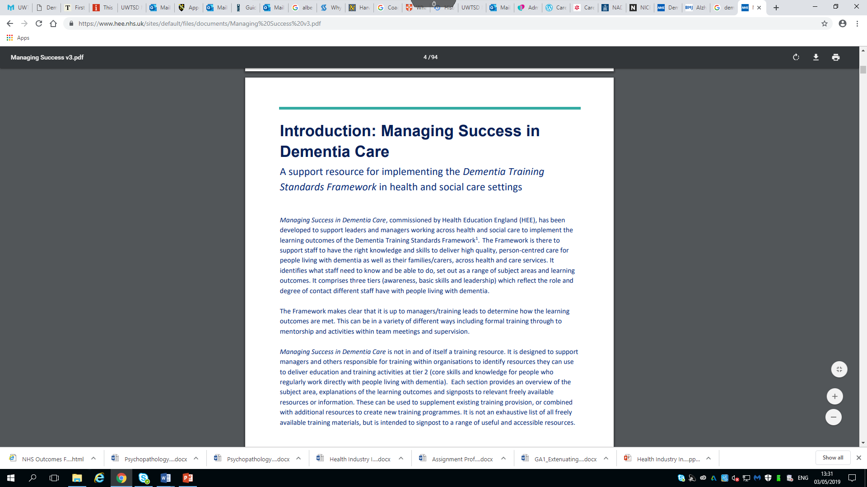

Page 10
References
Age UK (2019). Dementia, Age UK. Last accessed 23/04/2019
Alzheimers Society (2019). Alzehimers UK. https://www.alzehimers.co.uk. Last accessed 23/04/2019.
Alzheimer’s Disease International. (2015). World Alzheimer Report 2015: The global impact of dementia. London, United Kingdom: Alzheimer’s Disease International.
Brooker, Dawn. Person-centred dementia care: making services better. Jessica Kingsley Publishers, 2007.
British Leigion (2018) Dementia Care. https://www.dementiacare.org/Dementia-care-community/
Last accessed 21/04/2019.
Dementia UK (2019). https://www.dementiauk.org/get-support/admiral-nursing/. Last accessed 22/04/2019.
Dementia Statistics (2018) Prevelance by age in the UK. https://www.dementiastatistics.org/statistics/prevelance-by-age-in-the-uk . Last accessed 25/04/2019
Godfrey et al (2018) The person, interactions and environment programme to improve care of people with dementia in hospital, Southampton. Chapter 4. Page 77.
Heerma (2019) Thomas Kitwood’s person centred care for Dementia. Very Well Health. ED 2. VOL 1.
Jopling (2017) Promising approaches to living well with dementia, London. Page 45-47
Kitwood, T. (2007). Dementia reconsidered: The person comes first: Open University Press Buckingham, UK.
Kitwood T. (1997) Dementia Reconsidered: The Person Comes First. Open University Press, Milton Keynes. Page 105-108
Mitchell G, Agnelli J (2015) Person-centred care for people with dementia: Kitwood reconsidered. Nursing Standard. 30, 7, 46-50. Date of submission: August 28 2014; date of acceptance: September 4 2014
NHS Englad (2018) Dementia statistics. https://www.NHSEngland.co.uk . Last accessed 23/04/2019
Page 11
References continued
NHS UK (2019) NHS dementia Guide. Htttps://www.nhs.uk/conditions/dementia/diagnosis-plan/. Last accessed 23/04/2019.
Prince et al (2014). Dementia UK. London. Page 4-5
Rosvik et al (2013) A model for using the VIPS framework for person centred care for persons with dementia in nursing homes. 10 (6) Page 227-230.
World press (2012). Dementia and Eldery Care News. http://dementianews.worldpress.com/framework-of-dementia-care. Last accessed 24/04/2019

Page 12

