Group Project
  - Computer systems and electronics / Electrical and Electronic Engineering

Student: Adam McGowan

Lectures: Gareth Jones and Gary Jones

Contents
Introduction 4
The team members of group 4
Background research 4
Sketches of battery monitor 5
Proteus battery monitor 7
Screenshots of codes 9
Breadboard battery monitor 11
Conclusions 16
References 18

Figure 1 - Old Sketch 4
Figure 2 - New Sketch 5
Figure 3 - Proetus circuit diagram 6
Figure 4 - code of 14 volts 8
Figure 5 - Voltage Discharge curve of Li-ion [2] 9
Figure 6 - Battery Monitor on breadboard 10
Figure 7 - battery monitor 100% display seen 11
Figure 8battery monitor without battery connected 12
Figure 9 - 14volt 12
Figure 10 - 100% charged 12
Figure 11 - 13.5 volts 13
Figure 12 - 68.3% charged 13
Figure 13 - 13.3 volts 14
Figure 14 - 41.6% charged 14
Figure 15 - 13.1 votls 14
Figure 16 - 20% charged 14
Figure 17 - 12.9 volts 15
Figure 18 - 0% charged 15

Introduction
The introduction is about a project on designing and creating individual as part of a team but working alone. In this project is about a battery monitor that will help a bicycle user who owns an electric bicycle that would like to monitor the battery life that is left before it becomes empty or when it charged to full. This will help the user to able to plan to use the battery for another time or in an emergency if it close to empty. The battery will switch off when it’s empty or warn the user it coming to empty. To save time to build the circuit on a breadboard than building on a real circuit board as time consuming and could be expensive to build as this could take months of work to wait for the circuit board to ship back.
Instead of using battery, the black box (Power supply) would be used instead as this would make it cheaper and easier than using loads of lithium cells.

The team members of group
The project team members were split into three different groups. There a group AAA-Bike who had three members, each worked on an individual project but as a team to work and help each other’s in anything that could be useful. There a motor, light and battery monitor.
The other group members all worked on a GPS, Lights, sensors, light jacket and indicators.

Background research
Background research on battery monitor is all about how the battery is charging or discharging. The battery monitor is all about giving a user who is using this device a way to keep an eye on the battery power and how long the battery going to last before the battery becomes empty.
Some background research is based on the battery to understand how the battery works and how to do the calculations to find the right numeric and equations for the voltage and resistance. To understand how a battery monitor works, there has to be research done into looking at other sources that other researchers has done.
Lithium Ion batteries were invented in the 1970s by a British Chemist Stanley Whittingham. “The co -founding fathers of Lithium Ion Battery’s”. This was the first breakthrough of understanding the batteries reactions by intercalation [1]. Lithium Ion is named after chemicals of active materials.

Sketches of battery monitor
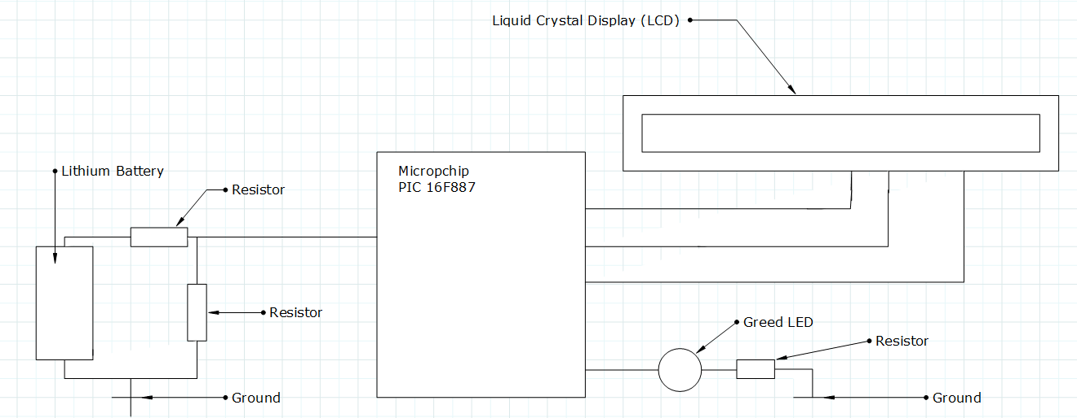
Figure 1 - Old Sketch
The top sketch is the older version of being the first to use and to make on Proteus. This was created to make the battery monitor an easy built design for a user to understand how to use it. The Green LED was added to give the user the attention when the battery is running low on power. This was just a quick scratch at first to make the circuit plain and fast, the components on the sketch showing are Lithium Battery, two resistors, microchip PIC and a liquid crystal display. These were to be used to design a battery monitor. The resistors act as a potential divider this is to stop the high voltage that coming from the lithium battery from destroying the microchip PIC. The microchip PIC itself is the main part that works the whole battery monitor that takes the readings and does the calculations that is coded to do and display them to the LCD.
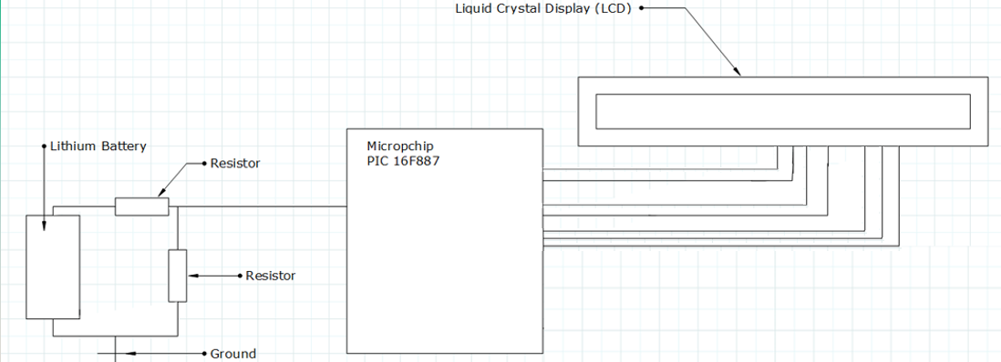
Figure 2 - New Sketch
On the second sketch showing above this is the new sketch that is the similar version of the old sketch but the Green LED was taken out, because there was no use to it and that it didn’t work. All the components are the same and hasn’t change, but there has been a voltage regulator added into the circuit, the voltage regulator helps to prevent the lithium battery from overloading the microchip and damage or destroying it. The regulator is reducing the high voltage from the lithium battery to a minimum of 5 volts, this is then used to power the microchip itself.

Proteus battery monitor
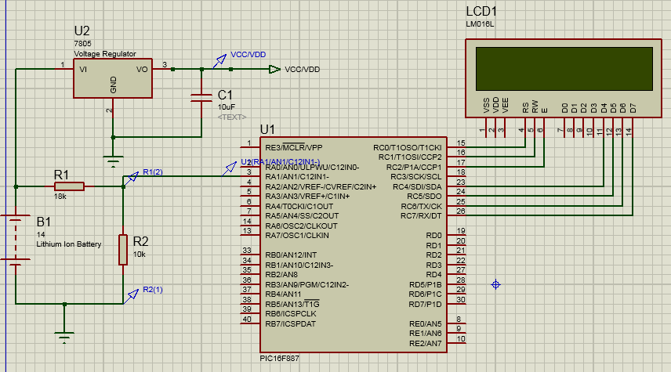
Figure 3 - Proetus circuit diagram
Here is the circuit diagram that from Proteus 8 which is where the circuit is built first and test and coded before it comes anywhere near building the circuit on a breadboard. The 14 volt lithium battery on the left hand side is the input from the battery that would be connected from the e-bicycle. The resistors are acting as a Potential divider and brings the voltage from 14 down to 5 volts to stop the 14V battery from melting the microchip or exploding it.
As this is connected directly to the chip, this is how the input from the battery will give it readings to the liquid crystal display (LCD). The voltage regulator which is connected directly to the battery helps to prevent the battery from overloading the circuit and bring the voltage down to 5 volts for a safe causes for the microchip to be powered up properly without getting into trouble. The capacitor is acting as a charge and discharge to shorten the voltage that is coming through the voltage regulator, this helps by reducing the stress to the regulator and the microchip.

The LCD will gives readings on what is shown from the battery output that is connected to the input, this will tell the user the charge percentage and voltage “X’s” this is show a battery monitor works. Each of the wires connected from the LCD to the microchip is given different jobs to work, as for Rs is to select register and Rw is to read and write onto the LCD so that it displayed, this is being told what to do by the microchip. E is enabling the pins that are set to high or low so it acts as a logic pin. VSS/VDD is the voltage to power up the LCD so that it can work to be seen by users to read the LCD, but some LCD has too much positive running through it that causes it hard to be see and so a negative voltage is needed to make the display visible to the users.

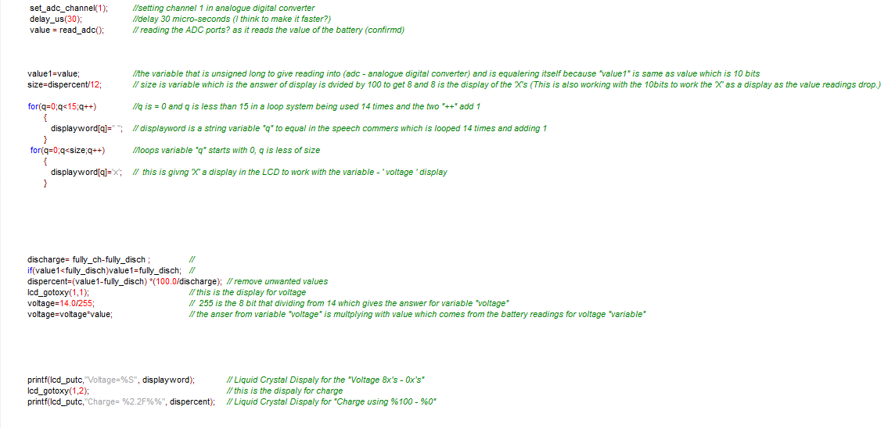
Screenshots of codes
Figure 4 - code of 14 volts
The code here that tells how the battery monitor works, where the code itself tells any user who viewing it on what it does in order to take the readings of a lithium battery. The set_adc_channel (1) is to set channel 1 in analogue to digital converter. The delay of 30 micro seconds is to ensure the microchip has time to work fast. The loop system in the code is to keep the code active and mustn’t end until either the user switch off the device or that the battery is empty. The code mentions how the voltage “X’s” works and displays to the LCD The charge percentage that discharge at 100 and every time the it also shows on LCD the 100% and when 14 dividing by 255 which is 8 bits, it does the calculations on the each time the from 14 to 13.9, 13.5 all the way until the percentage reaches 0 and it stops.

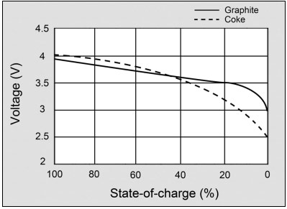
Figure 5 - Voltage Discharge curve of Li-ion [2]
Here is showing what voltage does in the state of charge. To measure lithium batteries is a tricky way as lithium batteries cannot be measured by voltage because voltage is doesn’t move until the charge to discharge is gone and then the voltage down dead point. When the voltage hits down dead point, that will tell the Lithium Battery to turn off and stop what is was doing to save itself from getting damage. “A battery should have a flat voltage curve in the usable discharge range. The modern graphite anode does this better than the early coke version” [2].

Breadboard battery monitor
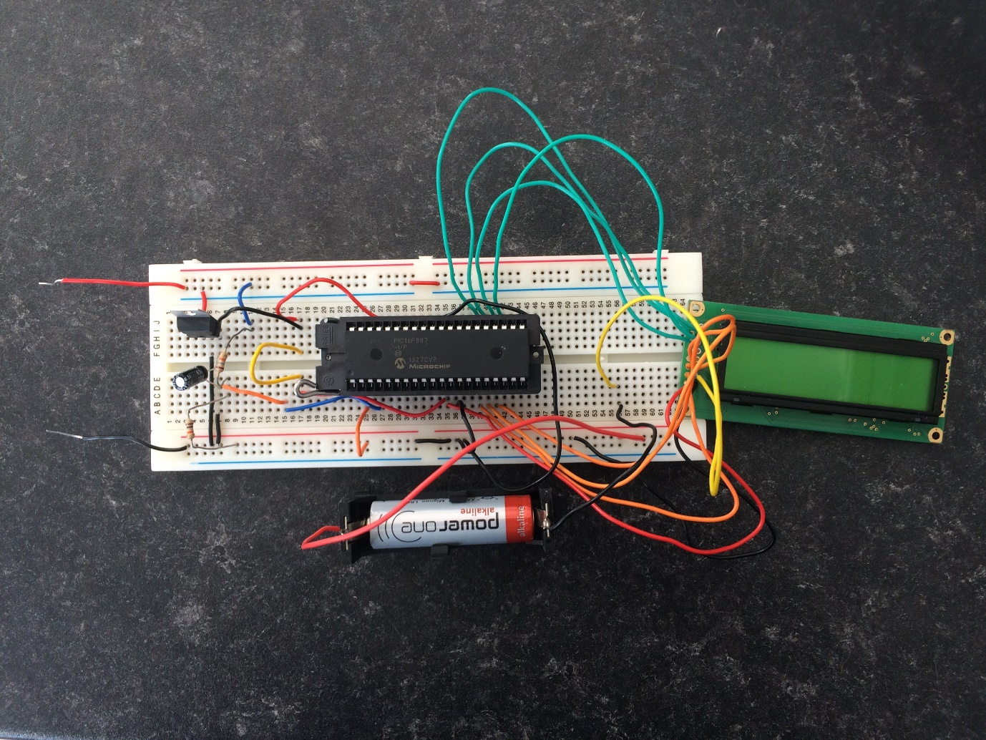
Figure 6 - Battery Monitor on breadboard
This is the battery monitor on a breadboard, this shows how it is designed. The two wires that are sticking out (red and black) are where the input battery is fixed to it. This battery monitor is Lithium ion only, which means that other type of batteries might not work on this battery monitor as this is designed for electric bicycle only. The red input wire is the positive and the black wire is the negative, when it is connected to a lithium battery it will give a display reading that has to be at the right voltage of 14 volts at max. If it goes over 14 volts, this might cause the microchip to melt or explode and this will damage the battery monitor.
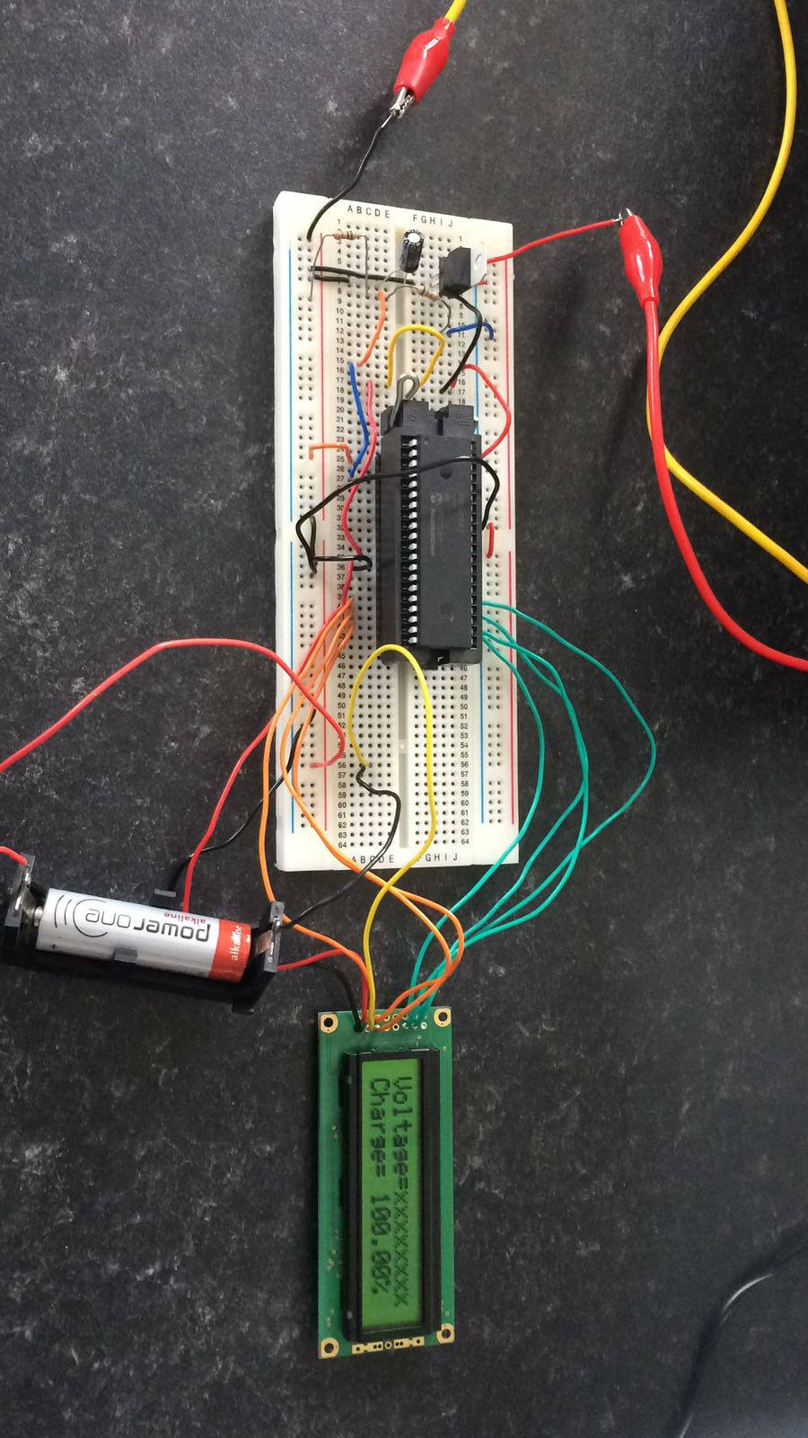
Figure 7 - battery monitor 100% display seen
This battery monitor has another battery of 1.5V, but the battery is doing the opposite as it can be see clearly the positive is connected to the negative and the negative is connected where the yellow wire is connected, this is to make the Liquid Crystal Display (LCD) work, as the LCD needs a negative voltage to work its display, this is because the intake of the other wires that are connected to the microchip must be inferring with some voltage to the LCD that could be already powered that way, so this is why another battery fix the problem of the display.
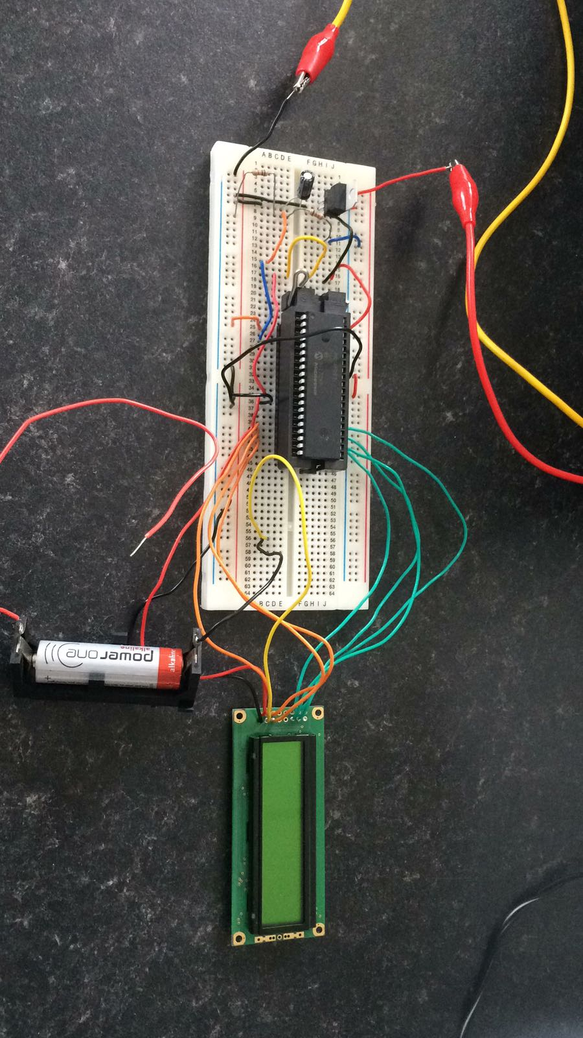
Figure 8battery monitor without battery connected
As the display isn’t working, because the other battery is disconnected from the breadboard and that the LCD has too much positive input that takes over the display.
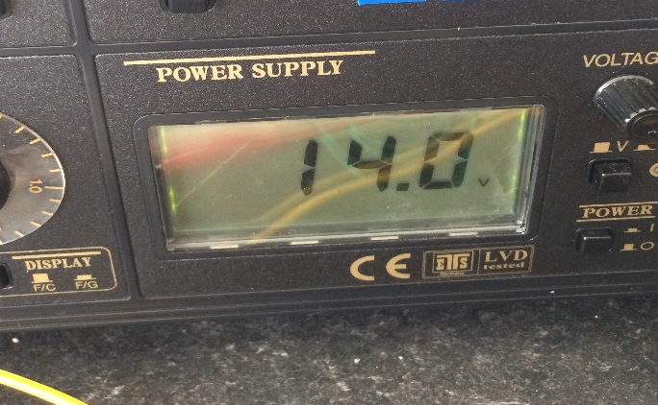
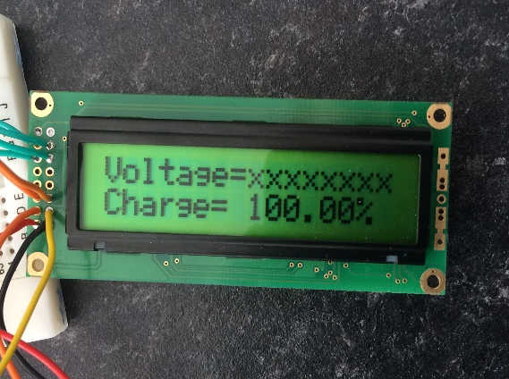
Figure 9 - 14volt
Figure 10 - 100% charged
Here is what showing the battery at 100% where the maximum voltage is 14 volts. Charge is what displays the 100% of the battery has and the voltage is the number of “X’s” 8/8 that display to tell the user the “X’s” is left before the battery discharges empty.

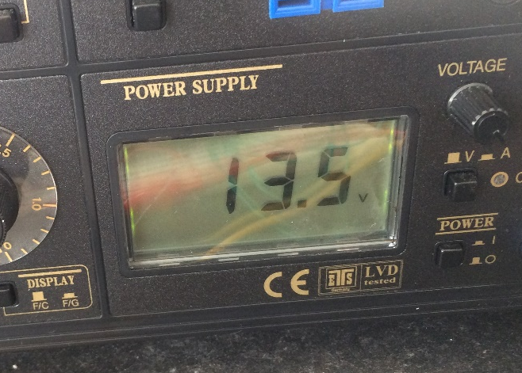
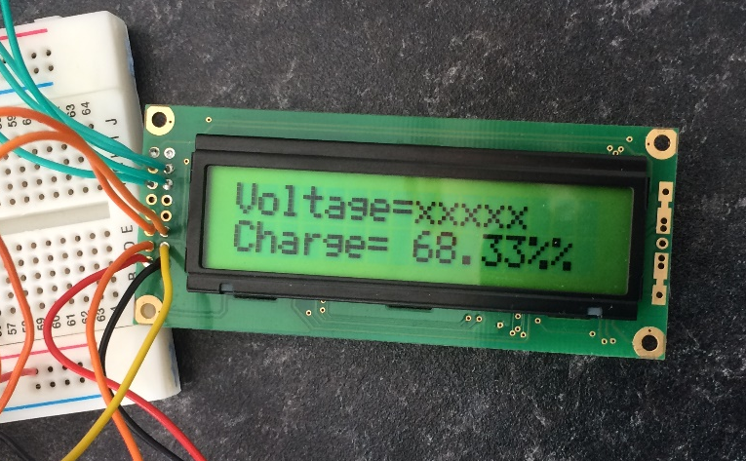
Figure 11 - 13.5 volts
Figure 12 - 68.3% charged

When the battery is discharging the “X’s” disappear and the charge tells the user what power source is left in the battery. Here in the photo above is showing the battery is at 68.3% and number of “X’s” 5/8. In the other photo from the side is showing that the voltage is now at 13.5V and that it has lost 0.5 volts when it discharging.
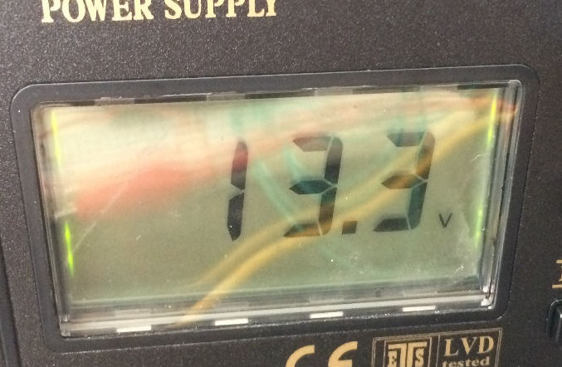
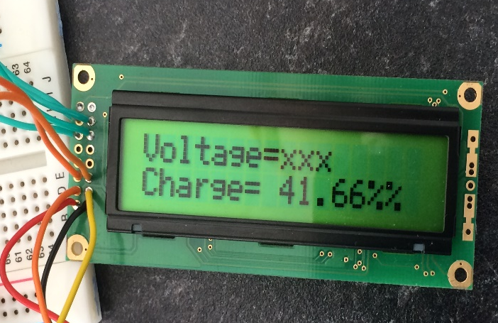
Figure 13 - 13.3 volts
Figure 14 - 41.6% charged
The photo here is showing almost half of battery life is left. The charge is at 41.6% and there are only 3/8 voltage “X’s” left. The voltage is now at 13.3V, this is no difference from the 68.3% one as the voltage is only 0.7v discharged, this is telling the user that there only half of battery before it becomes flat.

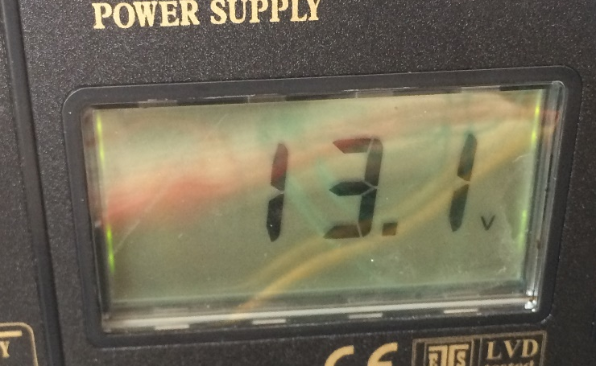
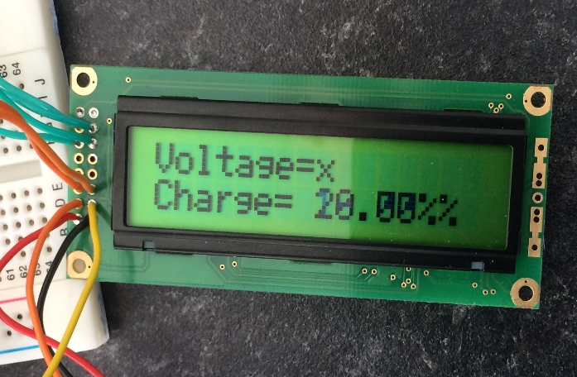
Figure 15 - 13.1 votls
Figure 16 - 20% charged
The charge is now at 20% and only one X remains. The voltage is now at 13.1V, this will tell the user that the battery is almost empty and that there will be not a lot of time left before it flat.

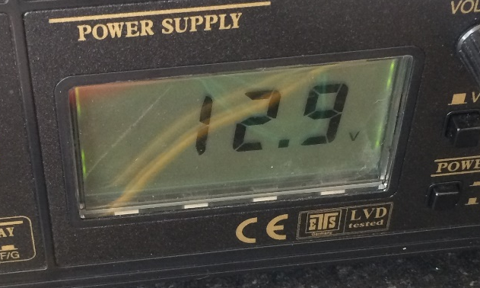
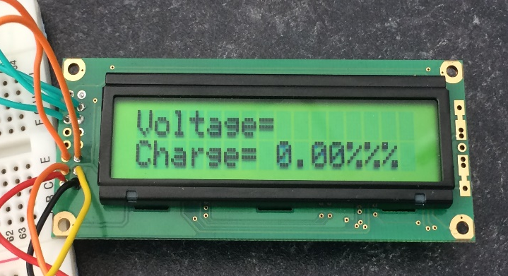
Figure 17 - 12.9 volts
Figure 18 - 0% charged
The battery is now empty and there are no “X’s” displaying, the charge is now 0% and the voltage in the battery it flat. On the other where showing the 12.9V remain on what is showing is little remain in what will be of the lithium ion battery. This is to protect the battery from ending up dead. Lithium doesn’t like losing all its voltage completely as it could damage the life time in the battery.

Conclusions
In the project of the battery monitor, has been a tough nut to work on as there was a lot of effort and research that had to be done to understand not just the battery monitor but the battery itself. The battery had to be researched to understand how the battery work and how the battery is calculated to get the right equations from it. This is when used to design the battery monitor and be able to design and program the battery monitor on Proteus, this is done by learning all about how Lithium Ion battery and how they work with monitors. To do that it has to be done by reading the currents that comes from the source, voltage wasn’t any use as in lithium it doesn’t drop the voltage as it does in a lead acid battery. The voltage only drops in a lithium is when the charge is discharged from 100% to 0%. Researching a way around this wasn’t easy and that trying to code this as well into Proteus was very hard and that help was needed by the lectures to get the code done. Then to build on a breadboard from the designed on Proteus this was the easy task to build and that it had to be checked with the lectures before it can be plugged into a live voltage to avoid damaging the black box or any harm to anyone using it. The whole project worked well and that the battery monitor worked and when changing the voltage down the charge showed it was working and when changing the voltage again the charge showed a different reading and that all went good. If there was more time, there would have been other components added to the source and to make it look better and more intelligent and smarter, also the Green LED would have been added back into the circuit to act as a light to get the users attention to warn that the battery is coming to empty or to warn the user that the battery is full.

References

[1] | “BATTERY PIONEERS: STANLEY WHITTINGHAM,” Batteries International, 22 September 2016. [Online]. Available: http://www.batteriesinternational.com/battery-pioneers-stanley-whittingham/. [Accessed 16 May 2018].
[2] | “BU-204: How do Lithium Batteries Work?,” Battery University, 31 July 2017. [Online]. Available: http://batteryuniversity.com/learn/article/lithium_based_batteries. [Accessed 16 May 2018].

