Dan Griffiths
P148119 (dgriffiths.148119@student.uwtsd.ac.uk)

University of Wales Trinity Saint David
School of Engineering

Beng. Mechanical and Manufacturing Engineering

Major Project REport (Year 2018)
Investigation into Reliability of Fluid Power Driven Process Cooling Fin Fans at Pembroke Refinery and Potential Improvements
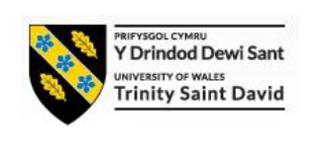

Declaration of Authenticity
This project report is the result of the author’s original research it has been composed by the author and has not been previously submitted for examination.

Signed: Date:

Acknowledgement
The author would like to thank Dan Rochester (Valero Rotating Equipment Superintendent) and Andrew Byrne (Valero Rotating Equipment Asset Technician) for providing access to the warranty reports and oil analysis data used in this report, and to James White (Utilities Operations Superintendent) for providing the predicted energy costings for the financial year 2017/2018.

Abstract
Over the last 5 years a perceived lack of reliability in the hydraulic driven fin fan systems at Pembroke Refinery in comparison with their electric driven counterparts has been noted. Investigation into this issue has proven not only is this perception is accurate, the hydraulic system costs twice as much in direct maintenance costs, and two and a half time as much in production losses, as the comparable electric system for the same period of time.
The most significant failure modes affecting the reliability of the hydraulic system are attributable to the hydraulic motors and relate to seizure of the hydraulic motors and failure of the hydraulic motor shaft seals.
The most likely root cause of these failures is poor hydraulic oil hygiene due to insufficient filtration in the system and an unsuitable maintenance regimen for replacing the existing filters.
It is recommended that additional filtration systems be fitted in the hydraulic circuit on the individual hydraulic motor case return lines and that an interval based planned maintenance activity be utilised to change filter cartridges rather than the run to failure regime currently implemented.

BEng Major Project: Investigation into Reliability of Fluid Power Driven Process Cooling Fin Fans at Pembroke Refinery and Potential Improvements
Contents
Declaration of Authenticity 1
Acknowledgement 1
Abstract 2
List of Figures 5
List of Tables 7
Introduction 8
Aims 8
Objectives 8
Considerations 8
Industrial Partners 8
Timescales 9
Collation of historical work order data 9
Calculation of maintenance costs including outage costs 9
Identification of most common failure modes 9
Calculation of running costs of fluid power and electric power fin fans 9
Comparison of maintenance costs and reliability of fin fan systems 9
Investigate potential reliability improvements for selected system 9
Compilation of Project Report 10
Project Gantt Chart 10
Pembroke Refinery 11
Butane Isomerisation Unit 11
Fin Fans 12
O6-EA-101 Fin Fans 12
Literature Review 15
Maintenance and Maintenance Systems 15
Reliability Centred Maintenance 16
RCM at Pembroke Refinery 18
Failure Modes Effects Analysis 19
Measures of Equipment Reliability 21
Energy Consumption/Running Costs 22
Utilities Costings 22
Hydraulic System Running Costs 22
Electric System Running Costs 23
Comparison of Hydraulic and Electric Fin Fan Running Costs 24
Historical Work Order Data 25
Hydraulic System Work Order Data 25
Electric System Work Order Data 25
Comparison of Hydraulic and Electric System Maintenance Requirements 26
Analysis of Hydraulic System Failures 27
Hydraulic System Components Ranked by Production Loss Time 27
Hydraulic System Components Ranked by Production Loss Value 28
Mean Time Between Failures (MTBF) and Mean Time To Repair (MTTR) for Hydraulic System Components 29
Failure Modes Effect Analysis (FMEA) on Hydraulic Driven Fin Fan System 31
Identification of System Components and Component Function 31
Identification of Failure Modes and Effects 32
Assigning Occurrence Ranking 33
Assigning Severity Ranking 33
Assigning Detection Ranking 34
FMEA Results and Analysis of Failure Modes Based on RPN 34
Alternative Identification of Worst Actors in Hydraulic System 35
FMEA Analysis with Modified RPN 35
MTBF, MTTR and Outage Cost Matrix 36
Discussion of Historical Failure Analyses 36
Investigation of Hydraulic Motor Reliability Problems 37
Most Common Historical Failure Mode 37
Hydraulic Motor Seizures 38
Hydraulic Oil Leaks 39
Summary of KPM Warranty Reports on Hydraulic Motor Seizures 40
Summary of Warranty Report QRS8158-1: 06-EAHM-101-23B Hydraulic Motor Seizure (08/12/14) 40
Summary of Warranty Report: 06-EAHM-101-24B Hydraulic Motor Seizure (22/09/15) 41
Summary of Warranty Report: 06-EAHM-101-26B Hydraulic Motor Seizure (05/01/16) 42
Hydraulic Motor Seizure Failures: Root Cause Analysis (RCA) Using Fault Tree/Cause Mapping 43
Background Information for Analysis 43
Further Information on System Operating Temperature 43
Fault Tree/Cause Map for Problem of Hydraulic Oil Overheating 44
Relationship Between Overheating of Hydraulic Oil and Seizures 45
Motor Seal Failures 45
Identification of Potential Remedial Actions 46
Limitations of Current System Design and Practices 46
Limitations of System Design 46
Limitations of Current Maintenance Practices 47
Potential for Installation of Case Drain Filtration 48
Common Case Drain Filtration versus Individual Case Drain Filtration 48
Specifications for Case Drain Filtration 49
Identification of Hydraulic Pipe Work Size 49
Identification of Case Leakage/Volumetric Flow Rate 49
Identification of Filter Grade Based on Particulate Size 51
Estimated Costs for Case Drain Filtration System 52
Potential for Interval Based Replacement of Hydraulic Filters 54
Conclusion 55
References 57
Reference List 57
Bibliography 57
Annex 1: SAP Historical Work Order Data 59
Annex 1a: Combined Electric And Hydraulic SAP Work Order Data 59
Annex 1b: Filtered SAP Work Order Data (Hydraulic) 60
Annex 1c: Filtered SAP Work Order Data (Hydraulic Drive System Only) 61
Annex 1e: Mean Time Between Failures and Mean Time to Repair for Hydraulic System 63
Annex 1f: Filtered SAP Work Order Data (Electric ) 64
Annex 1g: Filtered SAP Work Order Data (Electric Drive System Only) 65
Annex 1h: Mean Time Between Failures and Mean Time to Repair for Electric System 67
Annex 2: Hydraulic System FMEA Data 68
Annex 2a: FMEA Table for Hydraulic System 68
Annex 2b: FMEA Table for Hydraulic System with Combined RPN Number 69
Annex 3: Hydraulic Motor Warranty Reports 70
Annex 3a: KPM Warranty Report QRS 8158-1 70
Annex 3b: KPM Warranty Report QRS 8158-2 72
Annex 3c: KPM Warranty Report QRS 8175 74
Annex 4: Hydraulic Oil Analysis (ALcontrol Laboratories Report 1787563) 76
Annex 5: Dingbro Industrial Filtration Division Quotation 77

List of Figures
Figure 1 Project Timeline Gantt Chart 10
Figure 2 Bath-Tub Curve Model of Time Dependent Failure Frequency. 16
Figure 3 Application of FMEA within RCM Process. 19
Figure 4 Pareto Chart for Hydraulic System Production Loss Time 27
Figure 5 Pareto Chart for Hydraulic System Outage Costs 28
Figure 6 Surface Break-down of Rear Bearing Rollers. 40
Figure 7 No.3 Piston/Con-Rod Ball Assembly Wear. 40
Figure 8 Motor Casing with Carbon Deposits Resulting from Excessive Hydraulic Oil Temperature. 41
Figure 9 No.4 Piston/Con-Rod Ball Assembly Wear. 41
Figure 10 Stripped Down Piston/Con-Rod (Piston No. 2) Assembly Demonstrating Wear and Carbon Deposits. 42
Figure 11 Fault Tree/Cause Map for Overheating of Hydraulic Oil 44
Figure 12 Simplified P&ID Diagram of Hydraulic Circuit 46
Figure 13 Test Properties of RANDO HD Hydraulic Oils. 49
Figure 14 Hydraulic Motor Volumetric Efficiency Constants. 50
Figure 15 Motor Torque Curve for KPM HMB 045 Hydraulic Motor. 50
Figure 16 06-EAHM-101-24B with Potential Filter Location Highlighted. (Authors own image) 52

List of Tables
Table 1 Single Stage Steam Turbine Technical Data 13
Table 2 Reduction Gearbox Technical Data 13
Table 3 Hydraulic Pump Technical Data 13
Table 4 Hydraulic Motor Technical Data 13
Table 5 Electric Motor Technical Data 14
Table 6 Examples of Maintenance Activities Employed for Various Equipment Types at Pembroke Refinery 18
Table 7 Occurrence, Severity and Detection Rankings Scale. 20
Table 8 Utility Costs for 2017/18 Financial Year 22
Table 9 Percentage of Total Production Loss Time by Equipment Type 27
Table 10 Percentage of Total Production Loss Value/Outage Costs by Equipment Type 28
Table 11 Hydraulic Fin Fan System Equipment Ranked by MTBF (Low to High) 29
Table 12 Hydraulic Fin Fan System Equipment Ranked by MTTR (High to Low) 29
Table 13 Identification of System Components and Associated Functions 31
Table 14 Identification of Associated Failure Modes and Potential Causes for System Component Failure 32
Table 15 FMEA Occurrence Ranking Scale 33
Table 16 Severity Ranking Factor According to MTTR 33
Table 17 Severity Ranking Factor According to Potential Harm 33
Table 18 Detection Ranking Based on Earliest Warning Detection Method 34
Table 19 Ranking of System Components by Sum of RPN Values 35
Table 20 Ranking of Components by Cumulative Work Order Costs 36
Table 21 Breakdown of SAP Work Orders for Hydraulic Motors by Failure Type 37
Table 22 Hydraulic Motor Failure Modes Ranked by Percentage of Total Failures and Total Work Order Costs 37
Table 23 Wear Particle Size Distribution in Hydraulic Oil Sample Based on ALcontrol Report 51
Table 24 Details of Dingbro Quote (Dingbro Reference 22963-1) 52
Table 25 Estimated Purchase and Installation Costs of Each Filter System 53

Introduction

Aims
The aim of the proposed project will be to investigate the perception, within the Pembroke Refinery Maintenance Organisation, of a lack of reliability of fluid power driven process cooling fin fans at Valero Pembroke Refinery, and identify any potential reliability improvements that could be implemented.

Objectives
The project will require execution of the following phases:
- Calculation of annual running costs of selected fin fan systems and comparison of results.
- Collation of historical work order data pertaining to selected fin fan systems.
- Calculation of maintenance costs of selected fin fan systems based on analysis of historical work order data, identification of Mean Time Between Failures and Mean Time To Repair for various components within hydraulic and electric fin fan systems.
- Comparison of maintenance costs and reliability of fluid power driven and motor driven fin fan systems to identify poorest performing system
- Identification of main failure modes of the system with the worst reliability (electric or hydraulic) and conduct Failure Modes Effects Analysis and other suitable analysis methods to identify system component with greatest effect on system reliability.
- Investigate failure modes for component with greatest effect on system reliability and carry out root cause analysis by means of fault mapping.
- Investigate potential reliability improvements for poorest performing system, based on most common failure modes of that system, including projected costs of implementing identified improvements.
- Evaluate and recommend most suitable reliability improvements.
- Compilation of project report.

Considerations
A significant consideration in the execution of this project was the limited availability of detailed historical work order data. This may require that some analysis methods are conducted based only on information contained in the Valero SAP CMMS work orders (post-2012), since access to the predecessor CMMS system (ORBIT) is largely restricted for licensing reasons.

Industrial Partners
As a contractor employee at Pembroke Refinery, obtaining the required data for the execution of the proposed project required assistance from Valero Energy Corporation, specifically the Rotating Equipment Department, the Butane Isomerisation Area of the Operations Department, and the Utilities Area of the Operations Department.

Timescales

Collation of historical work order data
It was necessary to investigate and compare the maintenance work order histories of four fluid power driven fin fan banks with their sister electric motor driven fin fan banks.
This required every relevant work order be identified from the computerised maintenance management system (CMMS) and classified as to whether it related to planned maintenance or reactive maintenance and whether the work related to any part of the drive systems or to the fan itself.
The fin fan banks to be investigated and compared were selected and the historical work orders relating to these systems identified using the Pembroke Refinery CMMS (SAP) and took approximately two weeks to complete.

Calculation of maintenance costs including outage costs
The outage length and associated costs, along with the direct costs of the maintenance activities (labour, parts, services) had to be identified from the historical work orders. This data was then used to compare the reliability and maintenance costs of the fluid power driven and electric motor driven fin fan banks.
Once data from all historical work order had been collated, the calculation of maintenance costs was carried out, this took four weeks.

Identification of most common failure modes
The historical work order data was then used to identify the most common failure modes of the selected equipment by analysis of remedial work conducted under each work order.
Once data from the historical work orders had collated the identification of the most common failure modes was carried out, this took two weeks.

Calculation of running costs of fluid power and electric power fin fans
In addition to the relative reliability of the two systems and the maintenance costs and outage costs, it was also necessary to calculate the running costs of the two systems.
By utilising the steam and electricity costing values for Pembroke Refinery and identifying the steam consumption of the fluid power driven system and the electricity consumption of the electric motor system respectively, it was possible to calculate the annual energy costs to run each fin fan bank.
The energy cost data for Pembroke Refinery has been obtained from the Utilities Department Superintendent. Calculation of the annual energy costs for the two power driven systems took one week.

Comparison of maintenance costs and reliability of fin fan systems
It was necessary to compare the calculated running costs, maintenance costs and the relative reliability of the fluid power-driven and electric power-driven fin fan systems selected, in order to identify which type of system most requires reliability improvements.
Once the reliability data, maintenance costs and running costs had been calculated, this was executed, taking two weeks to complete.

Investigate potential reliability improvements for selected system
Once the least reliable of the two fin fan systems had identified it was be necessary to investigate potential reliability improvements based on the most common failure modes of the least reliable drive system.
This included providing cost estimates for the implementation of the identified reliability improvements.
This stage of the project took take eight weeks to execute, commencing on completion of the comparison of running and maintenance costs and the relative reliabilities of the two systems.

Compilation of Project Report
Based on the projected timings for the execution of the previous steps, a period of nine weeks should be available for the compilation of the project report.

Project Gantt Chart
A Gantt Chart for the expected project timeline is illustrated below:
Figure 1 Project Timeline Gantt Chart

Pembroke Refinery
Pembroke Refinery is a large refinery in Western Europe with a complexity of 11.2 on the Nelson Index and the capability to refine heavy, sour crudes which are typically the most difficult to process [Leffler, 2008], and which allows the refinery to remain competitive in the European market.
The refinery first opened in 1964 as a simple crude distillation unit and has expanded to add additional capacity and complexity, with a Fluid Catalytic Cracking Unit and associated Olefins complex added in the early 1980’s.
The refinery process units have been engineered to favour gasoline production but also produce significant quantities of other streams such as diesel, kerosene, jet fuel, fuel oils and liquefied petroleum gas, with a nominal production capacity of 270,000 barrels per day.
The refinery was originally built by Regent Oil before being sold to Texaco in the late 1970’s and remained in Texaco-Chevron ownership until it was acquired by Valero Energy Corporation, the world’s largest independent refining company, in 2011.

Butane Isomerisation Unit
The Butane Isomerisation Unit, also known as the Butamer Unit, is designed to isomerise normal butane, referred to as n-butane or in refining shorthand as C4, to create isobutane, referred to as iC4, in order to provide feedstock for use in the Hydrofluoric Acid (HF) Alkylation Unit.
The butane isomerisation process heats n-butane and injects methyl-chloride promoter before it is fed into a reactor, containing platinum-based catalyst and a hydrogen rich atmosphere, to change the straight chain normal butane into branched-chain isobutane.
The feedstock of field butane, a stream of mixed n-butane, isobutane, and other light ends such as propane and pentane, is separated into three streams using the De-Isobutane (DIB) column. The n-butane stream is removed from the side draw and sent to the Butamer Reactor where the isomerisation process converts it to isobutane, before it is sent back to the DIB column to separate the generated isobutane from any remaining n-butane.
The DIB column bottoms product consists of a mixture of n-butane and pentane which are routed to storage for use as gasoline blending stock.
The isobutane stream is removed from the DIB column as the overhead product, passing through the DIB Overhead Condenser Section (Fin Fan Cooled Exchangers) before the condensed stream is sent to storage for use as feedstock for the HF Alkylation Unit.
The HF Alkylation Unit reacts isobutane with olefins (butylene and propylene) to produce alkylate (isoparaffins), a high-octane gasoline blending stream, which is a valuable product [Leffler, 2008], requiring import at high cost, if not produced on-site.
The need for alkylate for gasoline blending stems from the banning of tetra-ethyl lead (TEL), which once served to improve the octane number of gasoline blends but was discovered to be a significant pollutant [Leffler, 2008] and the increasing compression levels of modern gasoline engines have led to continued demand for high octane gasoline in order to prevent premature ignition or knocking during use [Leffler, 2008}.

Fin Fans
Fin fans are used to cool process fluids in the oil, gas and chemical process industries and a fin fan cooling system comprises tube bundles with fins to increase the heat transfer surface area and a fan, mounted either above or below the fan, which is used to create a cooling air draught through the tube bundles.

O6-EA-101 Fin Fans
The 06-EA-101 Fin Fan System is part of the DIB Overhead Condenser system and is utilised to cool the iC4 overhead stream from the DIB Column before it is routed to the DIB Overhead Accumulator Drum (06-F-107) from which the isobutane is pumped to storage for use as iC4 feedstock.
The 06-EA-101 Fin Fan System comprises 24 fin fans, 20 of which are hydraulically driven by 5 separate Fluid Power Generators (FPGs), while 4 fans are driven by individual electric motors.
The utilisation of hydraulic fin fans is due to the lack of electrical supply reliability in the 1980’s when the Cracking and Olefins (C&O) Complex was designed and built. The Hazards and Operability (HAZOPS) studies conducted during the process design identified a need to cool the DIB overhead stream in order to prevent over-pressurising the C&O flare headers in the event of an emergency shutdown.
The use of steam turbine driven hydraulic fin fans allowing for approximately 20 minutes running in such an event, based upon reserve steam capacity, was identified as a suitable protective measure.

Hydraulically Driven Fin Fans
The hydraulically driven fin fan systems are driven by individual hydraulic motors, with four hydraulic motors supplied by each FPG, with each FPG system comprising a steam turbine driving a hydraulic pump via a reduction gearbox.
The hydraulic pump pressurises hydraulic fluid which is used to power the hydraulic motors. The hydraulic oil is distributed to the hydraulic motors via a distribution circuit comprising a common high-pressure feed line, distributed to each individual motor circuit via a flow divider, and a high pressure return line, fed from each motor circuit via a common manifold, which returns the hydraulic oil back to the hydraulic pump suction port. The high pressure return line is equipped with a duplex cartridge filtration system with differential pressure indicators.
The hydraulic oil also serves to cool and lubricate the hydraulic motors by means of crank case leakage, which is returned to the pressurised hydraulic oil reservoir via a common case drain manifold. This hydraulic oil is cooled via a shell and tube heat exchanger before it returns to the reservoir.
A charge pump takes hydraulic oil from the reservoir and pumps it into the suction side of the main hydraulic pump to make up the losses from the circuit due to the motor crank case leakage. The suction line from the reservoir to the charge pump is equipped with a duplex cartridge filtration system with differential pressure indicators.

O6-PH-101F Driven Fin Fans
The 06-PH-101F hydraulic system and its driven fin fans (06-EAHM-23A/24A/25A/26A) have been selected for this reliability investigation since this bank has a directly equivalent electric motor driven fin fan bank, allowing direct comparability of the energy and maintenance costs of two power systems supplying identical equipment.
The bank comprises 4 fin fans (2 x Fans with Standard Moore Blades, and 2 x Fans with 14’ Hudson Upgrade Blades). Each fan is driven by individual Kawasaki Hydraulic Motors supplied by flow divider from a single hydraulic pump. This pump is, in turn, driven via a reducing gearbox, by a single stage steam turbine. The equipment particulars for this system are highlighted in the tables below:
Table 1 Single Stage Steam Turbine Technical Data
Single Stage Steam Turbine (06-PHT-101F)
Manufacturer: Worthington | Model: SST 503
Rotation: Clockwise from Drive End | Governor: Woodward TG10
Minimum Running Speed: 3600 rpm | Maximum Running Speed: 5000 rpm
Design Running Speed: 4760 rpm | Trip Speed: 5750 rpm
Inlet Steam Pressure: 31.65 kg/cm²  (450 psig) | Exhaust Steam Pressure: 2.8 kg/cm²  (40 psig)
Power: 128 kW (171 hp)

Table 2 Reduction Gearbox Technical Data
Reduction Gearbox (06-PHG-101F)
Manufacturer: Falk | Ratio: 119:45
Input Speed: 4760 rpm | Output Speed: 1800 rpm

Table 3 Hydraulic Pump Technical Data
Hydraulic Pump (06-PH-101F)
Manufacturer: Danfoss | Model: 27PV
Type: Variable Displacement with Charge Pump | Controller: P-70 Pneumatic
Outlet Pressure: 2500 psig

Table 4 Hydraulic Motor Technical Data
Hydraulic Motors (06-EAHM-23A/24A/25A/26A)
Manufacturer: Kawasaki Precision Machinery (KPM) | Model: F3/HMB045/PV/F3/70/PL1210
Type: Fixed Displacement | Inlet Pressure: 2500 psig
Quantity: 4 (1 each per Fin Fan)

Electric Driven Fin Fans (06-EAM-23B/24B/25B/26B)
The electric driven fin fan bank comprising fin fans 06-EAM-23B, 06-EAM-24B, 06-EAM-25B and 06-EAM-26B have been selected for this reliability investigation since this bank is directly equivalent to the 06-PH-101F driven hydraulic bank and comprises 4 fin fans (2 x Fans with Standard Moore Blades, and 2 x Fans with 14’ Hudson Upgrade Blades). This system drives identical equipment to the 06-PHT-101F driven system, allowing direct comparison of the maintenance and running costs.
These fins are driven by individual induction motors supplied via individual Motor Control Centres (MCCs) situated in the Olefins Sub-Station (Sub-Station 11). The equipment particulars for the drive motors are highlighted in the table below:
Table 5 Electric Motor Technical Data
Electric Motors (06-EAM-23B/24B/25B/26B)
Manufacturer: Brooke-Crompton | Type: Induction
Voltage: 415V 3 Phase | Power: 30 kW
Quantity: 4 (1 each per Fin Fan)

Literature Review
The project, being aimed at investigating and improving the reliability of a mechanical system in the Oil and Gas Industry, is concerned with improving the systems themselves and the ways in which they the systems are maintained. On this basis a review of maintenance practices, systems and philosophies has been conducted along with a review of widely used reliability analysis metrics and investigative tools.

Maintenance and Maintenance Systems
Maintenance is an important operational activity in industry and within the process industries maintenance activities typically represent around 4% of capital expenditure [Braaksma et al., 2012, page 1055]
Mobley [2004] identifies that there are two main maintenance philosophies typically employed in industry, namely run to failure (RTF) and preventative maintenance, and within preventative maintenance there are a number of sub-groups, including time-interval planned maintenance and predictive or condition-based maintenance, while improvement maintenance can also be implemented to design out identified failure mechanisms.
RTF describes a maintenance philosophy where all maintenance activities are carried out reactively to repair equipment once failure has occurred and to return it to usable condition, whereas preventative maintenance philosophies involve activities that correspond to the true definition of maintenance, which Moubray [2000, page 6] defines as “ensuring that physical assets continue to do what their users want them to do”.
RTF is the most basic of maintenance philosophies and is essentially a “no maintenance approach” to asset management, stemming from the belief that “maintenance is a necessary evil”, which was historically a common attitude among corporate management and operations/production personnel [Mobley, 2004, pp. 1 – 2].
RTF is utilised under the false belief that carrying out maintenance on a reactive basis only is cheaper than implementing preventative maintenance activities, but it is actually the most expensive philosophy to adopt. RTF results in high production losses, and requires a large inventory of spares to be carried and high overtime labour costs in order to minimise equipment downtime [Mobley, 2004, pp. 3 – 4], and is essentially a corrective maintenance only approach to asset management.
Preventative maintenance philosophies encompass all maintenance management systems which proactively seek to maintain assets in a usable state and the earliest forms were based solely on carrying out maintenance on a set time-interval.
This time-interval approach was set by the expected life-expectancy of system components, based on the ‘bath-tub’ curve model which predicts a high frequency of failures for new components, due primarily to installation error, reducing to a lower steady state failure frequency after the initial period of operation, before failure frequency rises as components “wear out”. This is illustrated in Figure 2, overleaf.
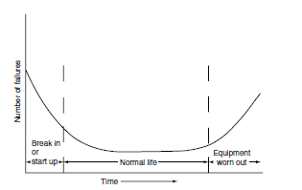
Figure 2 Bath-Tub Curve Model of Time Dependent Failure Frequency.
Reproduced from: Mobley, R K, (2004); Maintenance Fundamentals, 2nd Edition, Oxford: Elsevier, page 3.
The planned maintenance interval is based on the ‘bath-tub’ curve, and initially for new plant and equipment this is informed by reliability testing conducted by the original equipment manufacturer (OEM) or by previous experience with similar equipment. This is generally adjusted as historical data regarding real-world reliability is built up with operational experience of the equipment [Mobley, 2004, page 14].
More recently, preventative maintenance has begun to move away from rigid, interval-based maintenance tasks, introducing condition-based maintenance tasks or predictive maintenance tasks driven by data obtained by various condition monitoring techniques.
There now exist several maintenance methodologies for delivering preventative maintenance which, to a greater or lesser extent, include corrective maintenance, planned interval-based maintenance, condition-based maintenance and improvement maintenance tasks. Such philosophies include Total Productive Maintenance (TPM), frequently employed in high volume manufacturing industries, and Reliability Centred Maintenance (RCM), commonly used in high risk industries [Wang et al., 2012].

Reliability Centred Maintenance
Reliability, from a maintenance and engineering perspective has been defined by O’Connor and Kleyner [2012, page 1] as “the probability that an item will perform a required function without failure under stated conditions for a stated period of time”. The improvement of equipment reliability is one of the driving purposes of implementing maintenance systems in any industry, since unreliability leads to production losses, but it is of particular importance in the safe operation of process equipment in safety critical industries.
Reliability Centred Maintenance (RCM) is a maintenance philosophy developed in 1978 by United Airlines, in partnership with the United States Department of Defense, and was widely adopted by the international civil aviation industry soon after [Moubray, 2000].
Moubray [2000, page 6] identifies that it has since become “one of the cornerstones of third generation maintenance practice” and defines the purpose of RCM as “seeking to determine what must be done to ensure that any physical asset continues to do whatever its users want it to do in its present operating context” [2000, page 7].
Moubray [2000, page 7] further defines RCM by identifying the process of implementation, which in its most basic form, requires the following seven steps be completed and the corresponding questions answered:
- Function identification - What are the functions and performance standards of the physical asset?
- Functional failure identification - How does the physical asset fail to fulfil its functions?
- Failure mode identification - How are functional failures caused?
- Failure effects identification - What happens when functional failures occur?
- Failure consequence identification - How does each failure matter?
- Protective task identification - How can failures be predicted or prevented?
- Default task identification - What can be done if no predictive or preventative measures can be identified?
In implementing the RCM steps, in order to optimise maintenance for various types of equipment within a system, it is important that the various factors are clearly defined.
The function of an asset is basically what action the user requires the asset to perform, while a performance standard is how well an asset is required to perform an action, which can be related to factors such as energy efficiency, time taken to perform a function, or quality of output. The function and performance standards may be defined for an entire system or for the individual assets within a system [Moubray, 2000, pp. 7 – 8].
Functional failures are best described as occurrences in which an asset fails to meet the performance standards associated with its function and like the function, it may apply to the system as a whole or its individual components [Moubray, 2000, pp. 46 – 47].
The failure modes can be defined as “all events that are reasonably likely to cause each failed state” [Moubray, 2000, page 9]. Failure modes may be divided into three distinct categories: when the asset capability deteriorates below the performance standard, when the performance standard rises above the asset capability, and when the asset capability is below the performance standard from the outset [Braaksma et al., 2013, page 1058].
The failure effects are any effects that result from functional failure of an asset and should be fully investigated. The difference between failure effects and the failure consequences, which are closely related but distinct factors, should be understood. The failure effects should be considered as what happens when functional failures occur, while the failure consequences should be regarded as why the effects matter [Moubray, 2000].

RCM at Pembroke Refinery
This process is utilised at Pembroke Refinery to ensure the most appropriate maintenance tasks are used for the various equipment used on site. This allows the function of each component to be defined, the various failures which effect the component to be determined, and the effects of the failure to be considered based on the impact on production, safety and the environment.
This information is then used to determine whether there should be planned maintenance tasks implemented, whether condition monitoring is required to give early warning of failure, or whether a run to failure philosophy may be adopted. This is illustrated in the table below, which highlights the different maintenance approaches employed for various types of equipment used on site:
Table 6 Examples of Maintenance Activities Employed for Various Equipment Types at Pembroke Refinery
Equipment Type | Equipment Criticality |  |  | Maintenance Tasks Applied
Equipment Type | Production | Safety | Environmental | Maintenance Tasks Applied
Centrifugal Pump | Low (Moderate without Redundancy) | Moderate | Moderate | Periodic condition monitoring (Vibration Analysis) with sampling intervals decreased where redundancy reduced by failures.
Fin Fan Assembly | Low (Moderate without Redundancy) | Moderate | Low (Moderate without Redundancy) | Periodic re-greasing and opportunistic blade inspection. Re-belting on RTF basis.
Pressure Safety Valve | Moderate (High without Redundancy) | High | Moderate (High without Redundancy) | Planned inspection and testing governed by Risk Based Inspection.
Reciprocating Process Compressor | High | High | High | Continuous vibration and temperature monitoring.  Planned maintenance overhauls based on hours run.  Planned interim inspections.

Failure Modes Effects Analysis
Failure Modes Effects Analysis (FMEA) is a tool used to identify how systems or components can fail and the likelihood and severity of such failures and is essentially a form of risk assessment, that unlike many other process improvement tools, “does not require complicated statistics” [McDermott et al., 2009, page ix].
FMEA is often applied to evaluate the safety and reliability of a new product in the form of a product/design FMEA but can also be applied to evaluate the safety and reliability of a process in the form of a process/system FMEA [McDermott et al., 2009, page 20].
As such FMEA is a commonly utilised tool in the design of an RCM maintenance system, Braaksma et al. state that “FMEA is an important part of reliability-centred maintenance”, and that it is used “for defining preventative maintenance programmes”, [2012, page 1055]. The application of FMEA within the RCM process is highlighted in the diagram below:
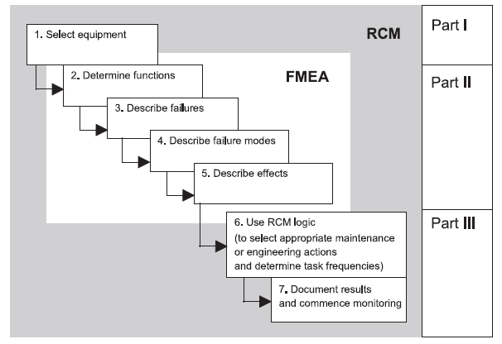
Figure 3 Application of FMEA within RCM Process.
Reproduced from: Braaksma, A, Klingenberg, W, and Veldman, J, (2013); ‘Failure mode and effect analysis in asset maintenance: a multiple case study in the process industry’, International Journal of Production Research, Volume 51, Number 4, page 1056.
The FMEA tool is particularly suited to use in the RCM process since it seeks to answer the first five of the seven RCM questions and uses compatible terminology to the RCM process.
McDermott et al. [2009] describe a ten-step process for executing an FMEA study, the similarities between these steps and those prescribed by Moubray [2000, page 7] for the RCM process are evident. The ten steps identified by McDermott et al. [2009, page 23] are as follows:
- Step 1 - Review the process.
- Step 2 - Brainstorm potential failure modes.
- Step 3 - List potential effects of each failure mode.
- Step 4 - Assign a severity ranking for each effect.
- Step 5 - Assign an occurrence ranking for each failure mode.
- Step 6 - Assign a detection ranking for each failure mode.
- Step 7 - Calculate a risk priority number (RPN) for each effect.
- Step 8 - Prioritise the failure modes for action.
- Step 9 - Take action to eliminate or reduce the high-risk failure modes.
- Step 10 - Calculate the resulting RPN as failure modes are reduced or eliminated.
For the FMEA to perform the desired function of assessing risk in a system or process for the purposes of “defining preventative maintenance programmes” [Braaksma et al., 2012, page 1055] the assignment of risk priority numbers for the failure modes identified is of greatest importance.
There are many methods of calculating the severity, occurrence, detection rankings and the resulting risk priority numbers which are the product of the severity, occurrence and detection rankings. McDermott et al. [2009] describe ranking methods for these factors for both design and process FMEAs, although the process FMEA described are biased toward traditional manufacturing processes and the quality output of those processes.
Sharma and Sharma [2010] describe a means of ranking these factors which is better suited to carrying out an FMEA for the purposes of informing the RCM process and defining maintenance improvements.
Within the system they describe the occurrence ranking as being related to the Mean Time Between Failures (MTBF) for the system or components based on historical data [Sharma and Sharma, 2010, page 73].
The severity described in this system is based on the mean time to repair the component or system and the effect of the downtime on production. Sharma and Sharma do not discuss the safety effect of failure in determining severity so it is assumed this is based on a non-hazardous process where there is no risk to life associated with the failure [Sharma and Sharma, 2010, page 74]. This would need to be modified to consider safety and environmental effects in order to be used in a safety critical industry such as oil and gas.
Sharma and Sharma discuss the detectability ranking in terms of non-detection of failure by operators and maintainers using physical senses and by periodic inspection, both “with and without the assistance of diagnostic aids” [Sharma and Sharma, 2010, page 74].
The scale for assigning the occurrence, severity and detection rankings in the system described by Sharma and Sharma is, with suitable modifications, suitable for use in this project. The original scale is illustrated in the table below:
Table 7 Occurrence, Severity and Detection Rankings Scale.
Reproduced from: Sharma, R, and Sharma, P, (2010); ‘System failure behaviour and maintenance decision making using RCA, FMEA and FM’, Journal of Quality in Maintenance Engineering, Volume 16, Number 1, page 74.
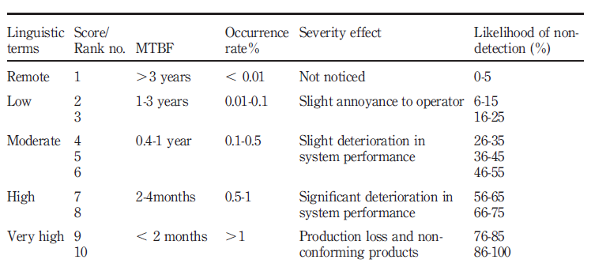

Measures of Equipment Reliability
Equipment reliability metrics are used to identify the effectiveness of the operation and maintenance of equipment and can help identify components with poor reliability. This is an important function, which allows remedial activities to be directed at improving the reliability of these items.
One metric frequently used in manufacturing industries is Overall Equipment Effectiveness (OEE) which is a measure of equipment availability, performance efficiency and quality.
For the purposes of OEE, availability is defined as the ratio of actual operating time to planned operating time, performance efficiency is the ratio of parts produced to operating time divided by the planned run rate, and quality is the ratio of good parts made to the total number of pieces made [Gehloff, 2015, page 14].
The OEE may then be calculated as the product of equipment availability, performance efficiency and quality as follows:
Overall Equipment Efficiency (OEE) = Equipment Availability x Performance Efficiency x Quality
OEE is an effective measure of reliability for industries which can be classed as discrete manufacturing, which describes processes which produce distinct items, such as the automotive industry and electronics industry, where a measurable number of items are produced by a process in a given time.
Gehloff, identifies that the OEE metric is not suitable for process industries, such as the oil and gas and power generation industries, where distinct items are not produced due to the continuous nature of the process, since performance efficiency and quality cannot be determined [2015, page 15]. For such industries it is identified that the Mean Time Between Failures (MTBF) is a more suitable metric.
MTBF is the mean of all failure intervals for a system or its sub components where those components are repairable. O’Connor and Kleyner [2012, page 7] identify that a similar term, Mean Time To Failure (MTTF) exists which describes the failure interval for items which are not repairable and are simply replaced upon failure. For the purposes of this project the term MTBF will be utilised for both repairable and non-repairable components.
Similarly, the term Mean Time To Repair (MTTR) which is the mean of all maintenance downtime intervals for a system or its components is a useful metric to identify those items with the greatest potential for production losses resulting from failure.
Both MTBF and MTTR will be utilised as metrics when analysing the historical work order data for the hydraulic and electric fin fan systems and will be used as part of the analysis of failures modes and the assignment of their risk priority numbers for the purposes of the FMEA.

Energy Consumption/Running Costs

Utilities Costings
The utilities costs at Pembroke Refinery includes the cost of natural gas used in the Steam Plan Boilers and the Process Unit Heaters, the cost of raw and potable water and the cost of electricity used for various applications from lighting to supplying electric motors. The various utilities costs, based on the financial year 2017/18, are identified below:
Table 8 Utility Costs for 2017/18 Financial Year
Utility | Unit Cost
Natural Gas | 36.4 pence per Therm
Natural Gas | £14.44 per GCal
Natural Gas | £12.42 per MWh
Municipal Water | 31.19 pence per m³ (Raw)
Municipal Water | 87.77 pence per m³ (Potable)
Electricity | 7.68 pence per kWh (Forecast Annual Average)
31.65 kg/cm² HP Steam (450 psig) | £12.16 per tonne
17.6 kg/cm² MP Steam (250 psig) | £10.92 per tonne
2.8 kg/cm² LP Steam (40 psig) | £8.09 per tonne (As Steam Turbine Let-Down, with power recovered)
2.8 kg/cm² LP Steam (40 psig) | £10.92 per tonne (As MP Let-Down, with no power recovered)
Boiler Feed Water | £1.49 per m³

Hydraulic System Running Costs
The hydraulic system running costs can be determined based on the steam consumption of the Worthington steam turbine which drives the hydraulic pump. Since the turbine has a metered consumption at full power of 10 tonne per hour, the annual consumption can be determined as follows:
Annual Consumption Rate = Hourly Consumption Rate x 24 Hours x 365 Days
= 10 tonne per hour x 24 Hours x 365 Days
= 87,600 tonne per annum
As the cost of 31.65 kg/cm² HP steam used to power steam turbines, is £12.16 per tonne, the annual running cost of the steam turbine driven hydraulic system can be calculated as follows:
Annual Running Cost, Turbine = Cost HP Steam x Annual Consumption Rate
= £12.16 per tonne x 87,600 tonne per annum
= £1,065,216 per annum
Since the HP turbine let-down (exhaust) steam has a value as 2.8 kg/cm² LP utility steam of £8.09 per tonne, the annual running cost of the turbine may be adjusted as follows:
Recovered Steam Value = Cost LP Steam x Annual Consumption Rate
= £8.09 per tonne x 87,600 tonne per annum
= £708,684 per annum

$∴$ Adjusted Annual Running Cost, Turbine = Annual Running Cost – Recovered Steam Value
= £1,065,216 - £708,684
= £356,532 per annum
The adjusted annual running cost may be used to determine the cost per kWh of running the steam turbine, based on the turbine nominal power of 128 kW:
Annual Power Output, Turbine = Nominal Power x 24 Hours x 365 Days
= 1,121,280 kWh per annum
$∴$ Cost per kWh, Turbine = $\frac{Adjusted Annual Running Cost, Turbine}{Annual Power Output, Turbine}$
= $\frac{£356,532}{1,121,280 kWh}$
= £0.32 per kWh

Electric System Running Costs
The electric system running costs can be determined based on the 30kW nominal power rating of each electric motor and the fact the electric fin fan system uses four individual motors, as follows:
Annual Power Consumption, Electric = Nominal Power x No. Units x 24 Hours x 365 Days
= 30 kW x 4 Units x 24 Hours x 365 Days
= 1,051,200 kWh per annum
Since the forecast annual average electricity unit costing is 7.68 pence per kWh, the electric fin fan running costs can be calculated as follows:
Annual Running Cost, Electric = Annual Power Consumption, Electric x Forecast Electric Unit Costing
= 1,051,200 kWh per annum x £0.0768 per kWh
= £80,732 per annum

Comparison of Hydraulic and Electric Fin Fan Running Costs
Since the cost per kWh of running both the hydraulic fin fan system and the electric fin fan system have been determined, the difference in running cost per kWh may be determined as follows:
Difference in Running Cost per kWh = Running Cost/kWh, Turbine – Running Cost/kWh, Electric
= £0.32 per kWh – 0.0768 per kWh
= £0.2432 per kWh
From this it can be seen that the turbine driven hydraulic fin fans cost 24.32 pence per kWh more to run than the electric motor driven fin fans, resulting in the turbine costing four times as much, per kWh, to run than the four electric motors. This equates to a significant difference in annual running cost, which has been calculated as follows:
Difference in Annual Running Costs = Annual Running Cost, Turbine – Annual Running Cost, Electric
= £356,532 per annum - £80,732 per annum
= £275,800 per annum
This identifies that the turbine driven hydraulic fin fan system costs £275,800 per annum more to run than the electric motor driven fin fan system. The electric motor driven fin fan system annual running costs may be expressed as a percentage of the turbine driven hydraulic fin fan system annual costs, as follows:
Annual Running Costs, Electric as % of Annual Running Costs, Turbine =
$\left(\frac{Annual Running Cost, Electric}{Adjusted Annual Running Cost, Turbine}\right)$ x 100
= ($\frac{£80,732}{£356,532})$ x 100
= 22.64%

Historical Work Order Data
Fifty-two historical work orders have been identified relating to the two directly comparably hydraulic and electric fin fan banks. These historical work orders cover the period since the introduction of SAP as the Pembroke Refinery CMMS (1st May 2012 Go Live Date). Thirty-two pertain to the hydraulic fin fan bank and associated drivers while twenty pertain to the electric fin fan bank.
A further seventy work orders have been identified from the predecessor CMMS system, Orbit, dating back to 1999. Forty-one of these work orders pertain to the hydraulic fin fan bank while twenty-nine pertain to the electric fin fan bank.
Orbit access is limited and interrogation of this system currently only allows the work order creation and completion dates to be identified and the equipment failure type. No repair costs can be identified for these work orders.

Hydraulic System Work Order Data
The hydraulic system work order data has been reduced from thirty-two SAP work orders to thirty by excluding two work orders which pertain solely to fin fan blade failures and fin fan bearing block failures. This decision is due to the fact that the fin fan blades and bearing block assemblies are identical to those used on electric driven fin fans and this project is concerned with the comparable reliabilities of the drive systems alone.
The remaining work orders have been classified based on the equipment type. This classification has resulted in the following equipment groupings:
- Hydraulic Motors.
- Hydraulic Pump.
- Hydraulic Hoses, Piping and Valves.
- Charge Pump.
- Filters/Hydraulic Oil.
- Gearbox.
- Steam Turbine.
- Heat Exchanger/Oil Cooler.
The thirty work orders for the hydraulic system since 2012, for which there is detailed information in the SAP CMMS, show that the total maintenance costs, in terms of parts, labour and services, are £53,279.19, while the total production loss or outage costs attributable to this system for the same period are £2,570,000. Therefore, the total cost of maintenance on this system since 2012 is £2,623,279.19.

Electric System Work Order Data
The electric motor driven system work orders have been reduced from twenty work orders to twelve by excluding fin fan bearing block and fin fan blade failures, since as has previously been identified, these items are identical to those fitted to the hydraulic system and these failures are not pertinent to the comparable reliability of the two drive systems.
The electric motor driven system work orders identified in the SAP CMMS have, like the hydraulic system work orders, been classified into equipment types, but since the electric motor system is simpler, only two equipment groups have been used:
- Electric Motors.
- Drive Belts.
The twelve work orders for the electric motor system since 2012, for which there is detailed information in the SAP CMMS, show that the total maintenance costs, in terms of parts, labour and services, are £25,357.40, while the total production loss or outage costs attributable to this system for the same period are £1,070,000. Therefore, the total cost of maintenance on this system since 2012 is £1,095,357.40.

Comparison of Hydraulic and Electric System Maintenance Requirements
Comparison of the historical work order data for the hydraulic driven fin fan bank and the electric motor driven fin fan bank reveals that there have been significantly more maintenance activities required for the hydraulic system than for the electric system since 2012, with the hydraulic system having thirty work orders generated over this period compared with only twelve work orders for the electric system.
The hydraulic system has also cost more than the electric system to maintain, with the direct maintenance costs in terms of parts, labour and services being more than double than the direct maintenance costs of the electric system, as demonstrated:
Ratio of Direct Maintenance Costs, Hydraulic: Electric = $\frac{Direct Maintenance Cost, Hydraulic}{Direct Maintenance Cost, Electric}$
= $\frac{£53,279.19}{£25,357.40}$ = 2.1
In terms of production loss values/outage costs, the difference is even larger, with outages due to maintenance on the hydraulic driven fin fan system costing £2,570,000, while outages due to maintenance on the electric motor driven system, for the same period, are far lower at £1,070,000. This gives an outage cost ratio between the hydraulic system and the electric system as follows:
Ratio of Production Loss Values, Hydraulic: Electric = $\frac{Production Loss Value, Hydraulic}{Production Loss Value, Electric}$
= $\frac{£2,570,000}{£1,070,000}$ = 2.4
The difference in the ratios, for the hydraulic system compared to the electric system, for direct maintenance costs and for the production loss values, may be explained by the fact that failure of some components within the hydraulic system will result in the outage of all four fans, whereas within the electric system any single failure will only result in the outage of one fan.
With the hydraulic system requiring more maintenance intervention, and with direct maintenance costs and production losses for this system being more than double those associated with the electric system, it is necessary to investigate the reliability of the hydraulic system further and identify the worst actors and any potential improvements.

Analysis of Hydraulic System Failures
Since the hydraulic driven fin fan system maintenance costs, in terms of both direct costs and production loss values, are more than double those of the electric motor driven fin fan system, it is necessary to further investigate the hydraulic system reliability.

Hydraulic System Components Ranked by Production Loss Time
The grouping of work orders by equipment type has allowed the identification of hydraulic system components responsible for the largest production losses.
The table and chart below identify the various equipment/component groups with the production loss time ranked from highest to lowest:
Table 9 Percentage of Total Production Loss Time by Equipment Type
Equipment Type | Percentage of Total Production Loss Time | Cumulative Percentage of Total Lost Time
Hydraulic Motor | 58.82352941 | 58.82352941
Hydraulic Pump | 17.64705882 | 76.47058824
Hydraulic Hose/Piping/Valves | 8.403361345 | 84.87394958
Gearbox | 4.621848739 | 89.49579832
Cooler | 3.361344538 | 92.85714286
Charge Pump | 2.521008403 | 95.37815126
Filters/Oil Change | 2.521008403 | 97.89915966
Turbine | 2.100840336 | 100

Figure 4 Pareto Chart for Hydraulic System Production Loss Time
This clearly illustrates that hydraulic motor failures account for the greatest production loss time, with a little under 60% of production loss due to hydraulic fin fan failure being directly attributable to hydraulic motor failure. It must be noted that despite this, hydraulic motor failure does not necessarily result in the greatest production loss values.

Hydraulic System Components Ranked by Production Loss Value
Due to the fact that failure of some components results in only one fin fan being out of service and failure of other components will result in all four fin fans being out of service, the greatest production loss times do not necessarily mean the greatest production loss value.
The following table and chart rank the component groups based on production loss values, from greatest to lowest. This has required that, where a component is responsible for the loss of four fin fans, the basic production loss value has been multiplied by a factor of four.
The basic production loss per day of a fan outage is £5,000, and where four fans are out of service this rises to £20,000 per day. This value is based on typical production rate cuts during summer where ambient temperatures are high. During winter or where significant numbers of alternative are available during an outage fans (there are twenty hydraulic driven fin fans on the overhead condenser system), lower or no production loss values have been recorded.
Table 10 Percentage of Total Production Loss Value/Outage Costs by Equipment Type
Equipment Type | Percentage of Total Production Loss Value | Cumulative Percentage of Total Production Loss Value
Hydraulic Pump | 32.6848249 | 32.6848249
Hydraulic Motor | 27.23735409 | 59.92217899
Hydraulic Hose/Piping/Valves | 12.06225681 | 71.9844358
Gearbox | 8.560311284 | 80.54474708
Cooler | 6.225680934 | 86.77042802
Charge Pump | 4.6692607 | 91.43968872
Filters/Oil Change | 4.6692607 | 96.10894942
Turbine | 3.891050584 | 100

Figure 5 Pareto Chart for Hydraulic System Outage Costs
This data identifies that hydraulic pump failures account for 32% of outage costs, the greatest proportion of production loss values/outage costs, with the hydraulic motors, which it has been shown, account for the greatest proportion of production loss time, accounting for the second greatest production loss value at 27% of total production losses/outage costs.

Mean Time Between Failures (MTBF) and Mean Time To Repair (MTTR) for Hydraulic System Components
The mean time between failure (MTBF) and the mean time to repair (MTTR) for the various hydraulic system components have been determined using the SAP CMMS work order data (post 2012) and the predecessor ORBIT CMMS work order data (1999 -2012).
The MTBF and MTTR for the hydraulic system components are identified in the following tables:
Table 11 Hydraulic Fin Fan System Equipment Ranked by MTBF (Low to High)
Rank | Equipment Type | Mean Time Between Failures  (Days)
10 | Vertical Filters | 116.3
9 | Horizontal Filters | 277
8 | Hydraulic Motors | 854.5
7 | Hydraulic Pump | 976.7
6 | Hoses/Pipework/Valves | 1042.6
5 | Flow Divider | 1111
4 | Charge Pump | 1997.5
3 | Reduction Gearbox | 4514
2 | Heat Exchanger/Oil Cooler | 4889
1 | Steam Turbine | No Failures only PM

Table 12 Hydraulic Fin Fan System Equipment Ranked by MTTR (High to Low)
Rank | Equipment Type | Mean Time To Repair  (Days)
10 | Reduction Gearbox | 85
9 | Heat Exchanger/Oil Cooler | 54.5
8 | Vertical Filters | 39.4
7 | Flow Divider | 29
6 | Hydraulic Motors | 26.3
5 | Horizontal Filters | 23
4 | Hydraulic Pump | 16.7
3 | Charge Pump | 14.7
2 | Hoses/Pipework/Valves | 5
1 | Steam Turbine | No Failures, only PM

From this data it can be seen that the component with the greatest reliability, in terms of MTBF, is the heat exchanger/oil cooler, but it does have the second highest MTTR, meaning that any failure does lead to significant production losses.
The components with the worst reliability, in terms of MTBF, are the vertical filters which filter hydraulic oil as it is taken from the hydraulic oil tank prior to entering the suction side of the charge pump. The MTBF of these components are less than 117 days. The MTTR of these components is the third longest at just under 40 days.
The components with the second worst reliability, based on MTBF, are the horizontal filters which filter the high pressure return prior to the suction side of the hydraulic pump. The MTBF of these components is 277 days, while the MTTR for these components is the sixth longest at 23 days.
It should be noted that both the vertical and horizontal filter systems are duplex systems utilising replaceable cartridges and the failure point used is when the differential pressure across the online filter increases. This triggers the bypass valve to open and a visible indicator which warns of the filter blockage. At this point the Operations Department switch over the flow to the spare filter and raise a work order to change the filter cartridges.
This means that both filter cartridges are typically changed well within the serviceable life of the second filter and that no system outage occurs and the actual maintenance time is significantly shorter than the MTTR suggests, the MTTR being elevated by delays in scheduling the maintenance action (filter replacement).
Excluding the filters, the component/components with the next worst reliability are the hydraulic motors, with a MTBF of 854.5 days, and also have the fifth longest repair time with a MTTR of 26.3 days. These are the components with the lowest reliability that will cause a true failure resulting in outage.
The component with the worst reliability, in terms of MTBF, the failure of which will cause all four fin fans to be out of service, is the hydraulic pump, with a MTBF of 976.7 days. The MTTR of the component is 16.7 days, the third lowest repair time of all component types in the system.

Failure Modes Effect Analysis (FMEA) on Hydraulic Driven Fin Fan System

Identification of System Components and Component Function
For the purposes of the FMEA study the hydraulic fin fan system has been separated into its constituent components and the function of these components, in the context of the operation of the system, have been defined.
The identified components and their functions are illustrated in the table below:
Table 13 Identification of System Components and Associated Functions
Component | Function
Steam Turbine | Provides Motive Power
Turbine – Gearbox Coupling | Transmits Motion from Turbine to Gearbox
Reduction Gearbox | Reduces Rotational Speed
Gearbox – Hydraulic Pump Coupling | Transmits Motion from Gearbox to Hydraulic Pump
Hydraulic Pump | Imparts Pressure to Hydraulic Fluid by Converting Rotary Motion
Charge Pump | Primes Hydraulic Pump/Replaces Losses Due to Case Drain Return
Heat Exchanger | Cools Hydraulic Oil on Case Drain Return
Hydraulic Oil | Acts as Power Transmission Fluid
Hydraulic Hoses/Pipes | Conduit for Distributing Hydraulic Oil
Hydraulic Filters | Remove Wear Particles and Foreign Debris from Hydraulic Oil
Gear Type Flow Divider | Distributes Hydraulic Oil Flow Evenly Across Four Hydraulic Motor Circuits
Isolation Valves | Provide Isolation of Sub-Circuits from Main Circuit
Hydraulic Motors | Convert Pressure/Flow into Rotary Motion

Identification of Failure Modes and Effects
The next step of the FMEA process required that each component be analysed to identify all failure modes associated with their function. The failure modes are any occurrences which could prevent the component from fulfilling their required function.
The identified failure modes are illustrated in the table below:
Table 14 Identification of Associated Failure Modes and Potential Causes for System Component Failure
Component | Potential Failure Modes
Steam Turbine | Insufficient Steam Feed  Tripping Light  Governor Failure  Bearing Failure  T&T Failure  Throttle/Trip Linkages Seized  Gland Steam Leak  Split Case Steam Leak  Flange Steam Leak
Turbine – Gearbox Coupling | Sheared Membranes
Reduction Gearbox | Bearing Failure  Gear Failure
Gearbox – Hydraulic Pump Coupling | Sheared Membranes
Hydraulic Pump | Swash Controller Failure  Swash Plate Failure  Bearing Failure  Seal/O-ring Failures
Charge Pump | Bearing Failure  Seal Failure
Heat Exchanger | Insufficient Cooling Water Feed  Insufficient Hydraulic Oil Flow  Shell/Tube Internal Leak  External Leakage
Hydraulic Oil | Wear Particle Build Up  Thermal Degradation  Water Contamination  External Debris Contamination
Hydraulic Hoses/Pipes | Joint Leak  Hose Leak
Hydraulic Filters | Filters Blocked
Gear Type Flow Divider | O-ring Failure/Leakage  Gear Wear/Failure  Bearing Failure
Isolation Valves | Valve Stuck Open/Passing  Valve Stuck Closed/Blocking Flow  Gland Leak
Hydraulic Motors | Seal Failure  Bearing Failure  Con-Rod Sheared  Piston Seized  Valve Spool Seized

Assigning Occurrence Ranking
The occurrence ranking assigned to the failure modes has been based on the calculated MTBF for the various component types. The scale utilised is illustrated in the table below:
Table 15 FMEA Occurrence Ranking Scale
Occurrence Ranking | Equivalent MTBF
1 | >3000 days
2 | >2500 days, <3000 days
3 | >2000 days, <2500 days
4 | >1500 days, <2000 days
5 | >1000 days, <1500 days
6 | >800 days, <1000 days
7 | >600 days, <800 days
8 | >400 days, <600 days
9 | >200 days, <400 days
10 | <200 days

Assigning Severity Ranking
The severity ranking assigned to the failure modes has been based on the calculated MTTR for the various component types and also takes into account the potential number of fans affected by the failure and whether there is any potential for harm resulting from the failure mode. The MTTR has been ranked on a scale of one to five and the potential for harm ranked on a scale of one to two, with the severity ranking being the product of the two scales. This is illustrated in the tables below:
Table 16 Severity Ranking Factor According to MTTR
Ranking | Equivalent MTTR
0.5 | <10 days
1 | >10 days, <20 days
1.5 | >20 days, <30 days
2 | >30 days, <40 days
2.5 | >40 days, <50 days
3 | >50 days, <60 days
3.5 | >60 days, <70 days
4 | >70 days, <80 days
4.5 | >80 days, <90 days
5 | >90 days

Table 17 Severity Ranking Factor According to Potential Harm
Ranking | Potential for Harm
1 | Low
2 | High

Assigning Detection Ranking
The detection ranking assigned to the failure modes is based on the amount of warning the detection method provides. Methods include detection by human senses, by use of specialised condition monitoring equipment and by any indication mechanism built into the system or component and the assignment of rankings is based on qualitative rather than quantitative values, according to recognised hierarchy for earliest effective detection methods. This scale is illustrated in the table below:
Table 18 Detection Ranking Based on Earliest Warning Detection Method
Ranking | Detection
1 | Detection by Vibration Analysis
2 - 3 | Detection by Oil Analysis with Identification of Failing Component
4 | Detection by Thermography
5 - 6 | Detection by Oil Analysis without Identification of Failing Component
7 | Visual Detection by Indication Mechanism
8 | Visual or Audible Detection
9 | Detection by Internal Inspection
10 | No Warning of Failure

FMEA Results and Analysis of Failure Modes Based on RPN
From the FMEA study conducted for the hydraulic system, it has been identified that three of the identified failure modes for the hydraulic motors, each has the highest RPN value of 180. These failure modes are hydraulic motor seal failure, connecting rod failure and seized piston.
The next highest failure mode relates to blockage of the hydraulic filters, which has an RPN of 140. This is unexpected, although the filters are highly likely to ‘fail’ at regular intervals, these are consumable items performing a sacrificial function and the failure of which does not result in any fans being taken offline and there are no production losses associated with this failure mode.
Another unexpected high RPN failure mode is the external leakage failure mode for the oil cooler/heat exchanger. This failure mode has an RPN of 60, but historically the item has the highest reliability of all system components, with a mean time between failures of 4889 days.
Some discrepancies in the FMEA results from what might be expected could be accounted for by the fact that the MTBF and MTTR data obtained from historical work orders are general for a component, the equipment history with SAP and within the predecessor CMMS system is not detailed enough to differentiate between failure modes for a given component, and therefore, within the FMEA it has been necessary to apply the same MTBF and MTTR values for all failure modes relating to a given component.

Alternative Identification of Worst Actors in Hydraulic System
Due to the identified issues relating to the validity of the FMEA study, influenced by the limitations of the historical work order data, two alternative methods of analysing the historical work order data have been utilised to identify the worst actors in the hydraulic system; FMEA Analysis with a Modified (Cumulative RPN), and an MTBF, MTTR and Outage Cost Matrix.

FMEA Analysis with Modified RPN
The first method is a simple additional analysis of the RPN values determined during the FMEA analysis in which the sum of all RPN values for a given component have been calculated. Based on this additional step the rankings, from lowest to highest, have been determined for the hydraulic system components, as identified in the table below:
Table 19 Ranking of System Components by Sum of RPN Values
Ranking | Equipment/Component Type | Sum of RPN Values for All Failure Modes Associated with Equipment Type
1 | Gearbox | 8
2 | Steam Turbine | 98.5
3 | Hydraulic Hoses/Pipework | 100
4 | Charge Pump | 112
5 | Heat Exchanger | 114
6 | Hydraulic Oil | 120
7 | Hydraulic Filters (Vertical and Horizontal Combined) | 140
8 | Isolation Valves | 200
9 | Hydraulic Pump | 234
10 | Flow Divider | 240
11 | Hydraulic Motors | 660

This method improves the FMEA resolution for the equipment type with the worst effect on system reliability but does not provide the detailed analysis of the actual failure mode, which is less reliable in the original analysis due to lack of detail in the historical work orders.
Analysis of results from this method identifies that the hydraulic motors have the highest cumulative Risk Priority Number, with the flow divider having the second highest RPN and the hydraulic pump the third highest RPN.

MTBF, MTTR and Outage Cost Matrix
This matrix utilises the component rankings for MTBF, MTTR, which have previously been determined and the rankings of components based on associated total work order costs (including downtime/production losses) identified within the SAP work order data. The total work order costs are ranked in the table below:
Table 20 Ranking of Components by Cumulative Work Order Costs
Ranking | Equipment/Component Type | Cumulative SAP Work Order Costs (incl. Outage Costs)
1 | Flow Divider | No Failures in SAP
2 | Steam Turbine | £102,783.12
3 | Charge Pump | £120,171.09
4 | Hydraulic Filters (Combined) | £125,030.80
5 | Oil Cooler/Heat Exchanger | £170,866.69
6 | Gearbox | £222,027.17
7 | Hoses, Pipe Work and Valves (Combined) | £313,368.50
8 | Hydraulic Motor | £716,382.00
9 | Hydraulic Pump | £852,649.82

The overall ranking will be the product of these rankings, the higher the ranking the worse the reliability performance of the component type. This decision matrix is illustrated below:
Equipment/Component Type | MTBF Ranking | MTTR Ranking | Work Order Cost Ranking | Product of Rankings
Vertical Filters | 10 | 8 | 3 | 240
Horizontal Filters | 9 | 5 | 3 | 135
Hydraulic Motors | 8 | 6 | 7 | 336
Hydraulic Pump | 7 | 4 | 8 | 224
Hoses/Pipework/Valves | 6 | 2 | 6 | 72
Flow Divider | 5 | 7 | 1 | 35
Charge Pump | 4 | 3 | 3 | 36
Reduction Gearbox | 3 | 10 | 6 | 180
Oil Cooler/Heat Exchanger | 2 | 9 | 5 | 90
Steam Turbine | 1 | 1 | 2 | 2

This method also highlights the hydraulic motors as having the highest ranking based on the product of MTBF, MTTR and historical work order costs including production losses.

Discussion of Historical Failure Analyses
The various methods utilised for analysing historical failures (FMEA, FMEA with Cumulative RPN, and the MTBF, MTTR and Work Order Cost Ranking Method) on the hydraulic fin fan system have all identified the hydraulic motors as having the greatest effect on system reliability, and for this reason the historical failures for the hydraulic motors have been investigated further in order to identify suitable remedial actions as part of the RCM process.

Investigation of Hydraulic Motor Reliability Problems
As identified by the analysis of historical failures by FMEA, FMEA with cumulative RPN, and by analysis of MTBF, MTTR and Work Order Cost, the hydraulic motors have been identified as the system components with the greatest influence on system reliability.
On this basis it was necessary to further investigate the causes of the historical hydraulic motor failures and to identify potential remedial actions to reduce the likelihood of the identified failure mechanisms.
To assist this investigation, historical work order data has been utilised, along with Warranty Reports for failed motors provided by Kawasaki Precision Machinery (KPM), and lube oil analysis reports.

Most Common Historical Failure Mode
The historical failures of hydraulic motors 06-EAHM-101-23B/24B/25B and 26B have been identified from the SAP CMMS data. As has been previously identified, the Orbit data is limited to the work order creation and completion dates and does not identify the failure type or the work order costs. The relevant SAP work orders have been tabulated below:
Table 21 Breakdown of SAP Work Orders for Hydraulic Motors by Failure Type
Work Order (W/O) Number | Date W/O Created | Date W/O Completed | Equipment Number | Failure Description | Total Cost (including Production Losses)
4218022 | 08/12/2014 | 09/01/2015 | 06-EA-101-23B | Motor Seized | £165,939.77
4242013 | 05/01/2015 | 09/01/2015 | 06-EA-101-24B | Motor Seized | £20,589.83
4346178 | 01/05/2015 | 02/07/2015 | 06-EA-101-25B | Hydraulic Oil Leak | £200,968.60
4393495 | 25/06/2015 | 07/07/2015 | 06-EA-101-26B | Hydraulic Oil Leak | £61,128.19
4469036 | 22/09/2015 | 22/10/2015 | 06-EA-101-24B | Motor Seized | £101,313.87
4562555 | 05/01/2016 | 20/02/2016 | 06-EA-101-26B | Motor Seized | £101,194.14
4579790 | 25/01/2016 | 17/03/2016 | 06-EA-101-23B | Hydraulic Oil Leak | £65,247.60

Table 22 Hydraulic Motor Failure Modes Ranked by Percentage of Total Failures and Total Work Order Costs
Failure Type | Number of SAP Work Orders | Percentage of Total Hydraulic Motor SAP Work Orders | Total Cost (including Production Losses) | Percentage of Hydraulic Motor SAP Work Order Costs
Motor Seized | 4 | 57.14285714 % | £389,037.61 | 54.30588848 %
Hydraulic Oil Leak | 3 | 42.85714286 % | £327,344.39 | 45.69411152 %
Total | 7 |  | £716,382.00

It has been identified from the SAP Work Order data, seven hydraulic motor failures have occurred since June 2012, and that these failures are attributable to two separate failure modes: seizure of the motor and hydraulic oil leaks. Motor seizure is accountable for fifty-seven per cent of the SAP Work Orders, while hydraulic oil leaks account for forty-three per cent of the SAP Work Orders.
Motor seizures also account for fifty-four per cent of hydraulic motor work order costs while hydraulic oil leaks account for the remaining forty-six per cent of the associated work order costs.

Hydraulic Motor Seizures
Nilsson and Prakash [2010, page 92] define a seizure as ‘very severe damage to sliding surfaces in which the driving force is unable to overcome the friction force and there is complete cessation of relative movement’.
Hydraulic motor seizure is not a single failure mode but a symptom of several failure modes which have been identified in the System FMEA study as:
- Bearing Failure.
- Sheared Connecting Rod.
- Seized Piston.
- Valve Spool Seized.
The potential causes of each failure mode resulting in motor seizure have also been identified in the System FMEA study. The potential causes are common to all four identified failure modes and have been identified as follows:
- Age related wear.
- Incorrect assembly.
- Wear debris and foreign particles in hydraulic oil.
- Insufficient lubrication attributable to reduced/insufficient flow, incorrect lubrication grade, thermal degradation of oil, and water contamination of oil.
It should be noted that the failure mode may be caused by any of the potential causes acting alone, but often the failure mode could be as a result of two or more causes acting in unison [Geitner and Bloch, 2012].
During the period covered since the introduction of the SAP CMMS, there have been three incidences of hydraulic motors seizing on the 06-PH-101F driven fin fan system. Each of the failed motors was sent to KPM for repair and or investigation of the failure cause.

Hydraulic Oil Leaks
Hydraulic oil leaks associated with the hydraulic motors could result from case joint leaks caused by incorrect assembly of the motor, from leaking hose connections and from motor shaft seal leaks.
Hydraulic oil leaks caused by leaking hose connections would be classified as hose/piping failures not as hydraulic motor failures, while case joint leaks would result in infant mortality of the hydraulic motor and no such failures have been recorded during the period covered by detailed SAP CMMS work orders.
The potential causes of hydraulic motor shaft seal failures have been identified as follows:
- Age related wear.
- Incorrect assembly.
- Wear debris and foreign particles in hydraulic oil.
- Excessive motor case oil pressure.
During the period covered since the introduction of the SAP CMMS, there have been three incidences of hydraulic motor shaft seals leaking on the 06-PH-101F driven fin fan system.

Summary of KPM Warranty Reports on Hydraulic Motor Seizures

Summary of Warranty Report QRS8158-1: 06-EAHM-101-23B Hydraulic Motor Seizure (08/12/14)
KPM Warranty Report QRS8158-1 corresponds to the post failure inspection of a Model F3/HMB045/PV/F3/70/PL1210 Radial Piston Staffa Motor (Serial No. 00381459), used in service at Pembroke Refinery as 06-EAHM-101-23B. This motor suffered a failure due to motor seizure on the 08/12/14 (SAP Work Order: 4218022).
The findings of the investigation, as presented by the report, indicate that failure occurred due to heavy contact at both the front and rear bearings, resulting in the bearing roller surface failing, releasing wear debris into the case leakage channels, from where the debris was distributed to the cylinders causing accelerated wear of the piston and con-rod ball assembly.
Figure 6 Surface Break-down of Rear Bearing Rollers.
Image reproduced from: KPM Warranty Report QRS8158-1, page 1.
Due to the failure of the rear bearing, the valve spool has been end-loaded in service, releasing additional wear particles into case leakage channels. The combination of bearing failure, accelerated wear to the piston/con-rod assemblies, and end-loading of the valve spool have resulted in internal friction overcoming the motive force of the pressurised hydraulic oil supply and the hydraulic motor has seized.
Figure 7 No.3 Piston/Con-Rod Ball Assembly Wear.
Reproduced from: KPM Warranty Report QRS8158-1, page 2.
The internal condition of the failed hydraulic motor was determined to be uneconomical to repair.

Summary of Warranty Report: 06-EAHM-101-24B Hydraulic Motor Seizure (22/09/15)
KPM Warranty Report QRS8158-2 corresponds to the post failure inspection of a Model F3/HMB045/PV/F3/70/PL1210 Radial Piston Staffa Motor (Serial No. 00381462), used in service at Pembroke Refinery as 06-EAHM-101-24B. This motor suffered a failure due to motor seizure on the 22/09/15 (SAP Work Order: 4469036).
The findings of the investigation, as presented by the report, indicate that failure occurred due to excessive back-pressure in the case leakage channels coupled with overheating of the hydraulic oil. This is evidenced by widespread carbon deposits within the failed motor casing.
Figure 8 Motor Casing with Carbon Deposits Resulting from Excessive Hydraulic Oil Temperature.
Reproduced from: KPM Warranty Report QRS8158-2, page 1.
The resultant thinning of the oil film, due to high operating temperature reducing the viscosity of the oil, has led to heavy contact between the bearing rollers and the bearing races, resulting in accelerated wear and an increase in wear particles within the case leakage channels.
The increased wear particle concentration, along with the reduction in lubricity of the hydraulic oil due to overheating, has also lead to accelerated wear of the piston/con-rod ball assemblies in all cylinders.
Figure 9 No.4 Piston/Con-Rod Ball Assembly Wear.
Reproduced from: KPM Warranty Report QRS8158-2, page 2.
The cumulative effect of friction caused by the heavy contact at the worn bearings and piston/con-rod assemblies has resulted in the motor seizure.
The internal condition of the failed hydraulic motor was determined to be uneconomical to repair.

Summary of Warranty Report: 06-EAHM-101-26B Hydraulic Motor Seizure (05/01/16)
KPM Warranty Report QRS8175 corresponds to the post failure inspection of a Model F3/HMB045/PV/F3/70/PL1117 Radial Piston Staffa Motor (Serial No. 297361), used in service at Pembroke Refinery as 06-EAHM-101-26B. This motor suffered a failure due to motor seizure on the 05/01/16 (SAP Work Order: 4562555).
The findings of the investigation, as presented by the report, are identical to those of KPM Report QRS8158-2, pertaining to 06-EAHM-101-24B, where failure is attributable to high back pressure on the case leakage system coupled with excessively high operating oil temperature.
Again, this has led to reduction in the viscosity of the hydraulic oil, the hydraulic oil subsequently failing to prevent contact of the bearing surfaces, leading to accelerated wear to both the front and rear bearings, and the increase in wear debris in the system resulting from this causing accelerated wear of the piston/con-rod ball assembly.
Figure 10 Stripped Down Piston/Con-Rod (Piston No. 2) Assembly Demonstrating Wear and Carbon Deposits.
Reproduced from: KPM Warranty Report QRS8175, page 2.
Ultimately, the increase in internal friction has resulted in the seizure of the hydraulic motor. The internal condition of the failed hydraulic motor was determined to be uneconomical to repair.

Hydraulic Motor Seizure Failures: Root Cause Analysis (RCA) Using Fault Tree/Cause Mapping

Background Information for Analysis
Cause mapping is a form of fault tree for root cause analysis which is utilised to investigate equipment failure at Pembroke Refinery. This has been applied to the hydraulic motor seizures, utilising evidence from the KPM Warranty Reports, and other sources.
The three warranty reports indicate advanced wear of the front and rear bearings, along with wear of the piston/con-rod ball assemblies on all cylinders of the failed motors. Additionally, two of the failure reports identify the presence of carbon deposits indicating that the operating oil temperature was excessive.

Further Information on System Operating Temperature
The oil temperature is regularly sampled as part of the current CBM system utilised, which also includes oil sampling/tribology analysis, and vibration analysis. The hydraulic oil temperature has not been recorded in excess of 63˚C, with the typical operating temperature ranging between 47˚C and 60˚C, these temperatures are well within the operating limits of the RANDO HD 46 hydraulic oil used for the application [Chevron, 2017, page 2] and the 80˚C maximum continuous operating temperature of the hydraulic motor when using fully synthetic hydraulic oil [KPM, 2017, page 36]. This indicates that the overheating is a localised problem, not system wide.
The potential causes of localised overheating within the hydraulic motor are all related to excess back pressure due to restrictions in the motor case leakage ports or in the case drain line which returns hydraulic oil from case leakage back to the hydraulic tank.
Excess back pressure, leading to restricted flow rates, may be the result of an isolation valve on the cased drain line being closed or not fully opened, by incorrect design or assembly of the hydraulic motor with undersized case leakage ports in the casing or incorrect clearances, or it may be the result of time dependent deterioration where wear debris is deposited in the ports which could build up and cause restrictions.
During commissioning of hydraulic motors, the high-pressure inlet and return block valves and the case drain return block valves are opened and locked in the open position as per the operations department commissioning procedure, so it is extremely unlikely that the motor would be run with the case drain return line isolated from the motor.
No infant mortalities, which for hydraulic motors could be classes as any failures within 60 days of commissioning, have been identified in either the SAP or ORBIT CMMS work order histories. This indicates that localised overheating due to design faults or incorrect assembly is unlikely.
Therefore, the most likely cause of localised overheating of hydraulic oil within the hydraulic motor is excessive heat soak, caused by inadequate flow rates through the motor case resulting from fouling of the case leakage channels with wear debris, creating back-pressure which reduces the normal flow rate of the hydraulic oil. The fault tree/cause map for this failure mechanism is illustrated overleaf.

Fault Tree/Cause Map for Problem of Hydraulic Oil Overheating
Figure 11 Fault Tree/Cause Map for Overheating of Hydraulic Oil

Relationship Between Overheating of Hydraulic Oil and Seizures
The cause-effect relationship of the overheating of the hydraulic oil and the subsequent seizure of the hydraulic motors may be explained as follows:
- Wear debris from hydraulic motors recirculates through system as no filtration present on case drain return lines and debris is returned to hydraulic tank.
- Debris can also be deposited in hydraulic motor case leakage pathways.
- Hydraulic oil containing wear debris is drawn from hydraulic tank and reintroduced to high pressure circuit by charge pump. Wear debris is captured by vertical and horizontal filters.
- Continued recirculation of hydraulic oil with entrained wear debris blocks filters, recirculation of oil continues via filter bypass until duplex filters swapped over or filters changed. During this period wear debris is recirculated to hydraulic motors, accelerating wear and producing further wear particles.
- Further wear debris accumulates in case leakage pathways, back pressure increases reducing flow and increasing heat soak of hydraulic oil.
- Viscosity of hydraulic oil reduces with elevated temperature, reducing lubricity and further accelerating wear of hydraulic motor parts.
- This process continues until age related wear and reduced lubrication leads to excessive internal resistance causing hydraulic motor seizure failure.

Motor Seal Failures
The damage mechanism above is closely related to the motor seal failure mechanism as excess back-pressure can lead to over-pressurisation of the hydraulic motor case and would be the most likely potential cause of the hydraulic motor shaft seal failure. KPM state that crankcase pressure must not exceed 3.5 bar on standard shaft seals or 10 bar for improved shaft seals as fitted to Model HMB 045 Hydraulic Motors used at Pembroke Refinery [KPM, 2017, page 9].
Hydraulic motor shaft seal failures may also be cause by the presence of particulates in the hydraulic oil acting as an abrasive that wears the surface of the seal and the corresponding shaft landing.
The presence of wear debris is likely to produce seal failures by a combination of these mechanisms, where abrasive wear weakens the seal and back pressure resulting from wear debris deposits causes the weakened seal to fail.
Therefore, it is feasible that failure of hydraulic motors by both seal failure and seizure failure modes are symptomatic of hydraulic oil hygiene levels.

Identification of Potential Remedial Actions
The identified hydraulic motor failures are most likely the result of poor hydraulic oil hygiene within the PH motor hydraulic circuit. In order to identify suitable remedial action, it is necessary to consider any weaknesses in the current system design and maintenance practices.

Limitations of Current System Design and Practices

Limitations of System Design
As previously identified, the hydraulic system features two sets of duplex filters, fitted on the main hydraulic pump suction line and the charge pump suction line, as highlighted on the hydraulic circuit P&ID diagram, below:
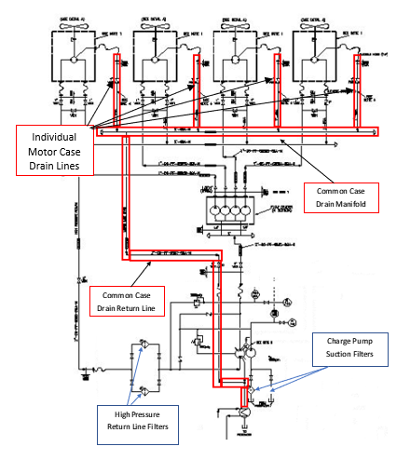
Figure 12 Simplified P&ID Diagram of Hydraulic Circuit
The filtration system on the main hydraulic pump suction line serves to filter the high pressure return in order to prevent the reintroduction of wear particles to the circuit and prevent damage to the main hydraulic pump and the four hydraulic motors. The high-pressure return contains hydraulic oil that has provided motive force to the motors and as such is likely to have a lower concentration of wear particles than the case drain return.
The filtration on the charge pump suction line serves to filter hydraulic oil that is drawn from the hydraulic tank. This hydraulic oil, containing oil that has returned unfiltered via the case drain return line can have a high concentration of wear particles. The charge pump suction line filters serve to remove these particles, protecting the charge pump, and subsequently the main hydraulic pump and hydraulic motors from damage.
Both of these filter systems, when blocked, are bypassed by means of a spring-loaded bypass valve. The increased differential pressure due to filter blockage overcomes the seating pressure of the spring and opens the bypass valve, providing a visual indication to the operator that the online filter is blocked, but also allows unfiltered flow to the hydraulic circuit until the operator switches over to the clean filter or, if both filters in the duplex system are blocked, until the filters are changed out.
During periods where the filter systems are operating on bypass, any wear debris in the high-pressure return, and more importantly case drain wear debris entrained in the hydraulic tank, may be recirculated to the system, potentially causing damage to the charge pump, main hydraulic pump and hydraulic motors [Parr, 2009].
As identified from the Hydraulic System P&ID, the case drain return line (highlighted in red) is not fitted with any form of filtration, either on the individual case drain returns or the common return line after the manifold. This allows wear debris generated within the motor crank case, where the highest amounts of wear are likely to occur, to return to the hydraulic tank and as such this is the main weakness in the design of the system with regard to oil hygiene.

Limitations of Current Maintenance Practices
Currently, hydraulic oil filters are changed as they are reported as being blocked, which is identified when the high differential pressure causes the bypass valve to open and the visual indicator activates. As identified, this occurrence means that unfiltered wear debris is allowed to recirculate, potentially casing accelerated wear in the charge pump, main hydraulic pump and hydraulic motors.
No attempt has currently been made to carry out a planned maintenance activity to change the filters prior to failure and therefore prevent bypass events.
Another current maintenance practice relating to hydraulic oil hygiene within the system is the routine sampling of hydraulic oil. The samples are sent to ALcontrol Laboratories for tribology analysis which include fluid condition checks such as viscosity and acid number tests, and wear debris analysis.
These test results are used to determine the point at which the hydraulic oil in the system must be changed due to deteriorating condition and contamination.
Wear debris analysis also indicates the level of wear in the moving components in the system, such as the hydraulic pump and the hydraulic motor but the fact that the metallurgy of the components in the system is very similar, and the fact that the only practicable sampling point on the hydraulic tank is common to all components means that the analysis cannot differentiate and identify the exact component suffering deterioration.

Potential for Installation of Case Drain Filtration
The identified deficiency in the system design with regard to lack of filtration of hydraulic oil returning to the tank via the case drain line should be addressed in order to improve system wide oil hygiene and protect the system components.
This will benefit not only the reliability of the hydraulic motors but will also serve to improve the reliability of the main hydraulic pump and the charge pump, reducing the amount of wear debris recirculating through the system during operation, especially during filter bypass events.
Based on industry best practices, the filtration system should be of a duplex cartridge type, to allow for the filter elements to be changed out with the system operating and should include a high differential pressure bypass in order to prevent excess back pressure causing hydraulic motor shaft seal failures and/or hydraulic oil over temperature events [Parr, 2009].

Common Case Drain Filtration versus Individual Case Drain Filtration
Case drain line filtration may be fitted either as a single system on the common leg of the case drain return line after the manifold or as four individual systems on each motor case drain lines before the common manifold.
The main advantage of installing a single system on the common leg of the case drain return would be related to the cost of installation being less than for installing four separate systems.
There are several foreseeable advantages associated with installing four individual filtration systems, one on each hydraulic motor case drain lines. The advantages are:
- Failure of the filter bypass valve to open in the event of filter blockage and the resulting excess back pressure would affect only one hydraulic motor, meaning any resultant seal failure would be limited to one motor not four motors.
- Additionally, in the event of filter blockage and a bypass event occurring, the amount of wear debris passing back to the hydraulic tank is limited to the amount produced by a single hydraulic motor instead of the amount produced by four hydraulic motors.
- Decreasing filter blockage intervals would allow the deteriorating condition of a particular motor to be identified, allowing for preparations to replace the motor to begin, such as erecting access/scaffold, thereby reducing the repair time. Utilising a common filtration system would not allow the differentiation and identification of the deteriorating motor.
From these points it can be seen that the advantages of individual filtration systems on each hydraulic motor case drain outweigh those of a single common filtration system.
The likelihood of allowing earlier detection of the deterioration of specific hydraulic motors is a particular advantage since it allows early warning of impending failure and allows time saving measures such as obtaining spares and putting access in place which allows for the reduction of down time and resulting production losses, which have a significant effect on the overall cost of maintenance.
This principle of identifying potential failures, which Moubray [2000, page 348] defines as “an identifiable physical condition which indicates that a functional failure is either about to occur or is in the process of occurring”, is a key principle of condition monitoring and the implementation of RCM as a whole.
Therefore, it is recommended that individual filtration systems be installed on each hydraulic motor case drain line.

Specifications for Case Drain Filtration
In order to identify the correct filter specification for installation it is necessary to identify a number of important factors. These factors are:
- Hydraulic pipe work size.
- Case leakage rate/volumetric flow rate.
- Particulate size.

Identification of Hydraulic Pipe Work Size
The selected filtration system must be suitable for connection to either 1” SAE 3000# or 1 ¼” SAE 3000# in order to be compatible with the existing hydraulic system.

Identification of Case Leakage/Volumetric Flow Rate
The case leakage/volumetric flow rate for the HMB 045 series hydraulic motor may be identified by the following expressions, as identified by KPM (2017, page 29]:
Total Leakage (Qt) = (k₁ + n/k₂) x $∆$P x k_{V} x 0.005
where, k₁ = Zero Speed Constant
k₂ = Speed Constant
k_{V} = Viscosity Factor
n = Motor Shaft Speed (rpm)
$∆$P = Differential Pressure
The Zero Speed Constant and Speed Constant for the HMB 045 Model Motor and the Viscosity Factor, based on the kinematic viscosity of RANDO HD 46 at 40˚C, can be identified from the following tables:
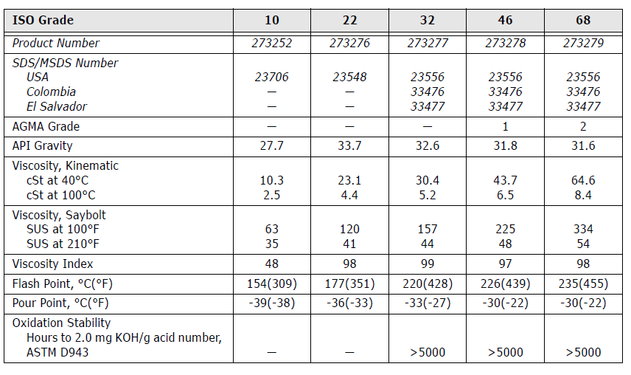
Figure 13 Test Properties of RANDO HD Hydraulic Oils.
Reproduced from: Chevron, (2016); RANDO HD Hydraulic Oil Product Data Sheet, Chevron Corporation. Available from: https://cglapps.chevron.com/msdspds/PDSDetailPage.aspx?docDataId=323786&docFormat=PDF, page 2.
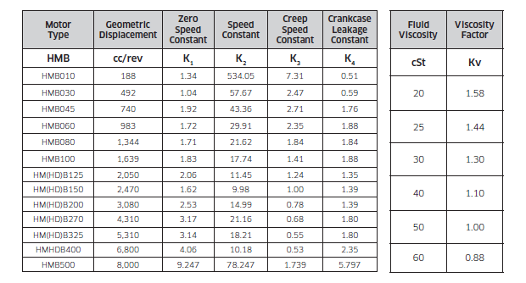
Figure 14 Hydraulic Motor Volumetric Efficiency Constants.
Reproduced from: Kawasaki Precision Machinery, (2017); HMB Series Fixed Displacement Radial Piston Staffa Motor Manual, Kawasaki Precision Machinery UK Ltd. Available from: http://www.kpm-eu.com/files/Datasheets/HMB-M-200109-14.aspx, page 29.
It can be seen from these tables that, for the HMB 045 Model Motor, the Zero Speed Constant (k₁) is 1.92, and the Speed Constant (k₂) is 43.36, while for RANDO HD 46 with a kinematic viscosity of 43.7 centistokes at 40˚C, the Viscosity Factor may be estimated at 1.05.
The Differential Pressure ($∆$P) for the HMB 045 Model Motor, based on a rated shaft power of 30 kW and motor shaft speed of 140 rpm may be estimated at 172 bar, by interpretation of the Motor Output Torque Curve, below:
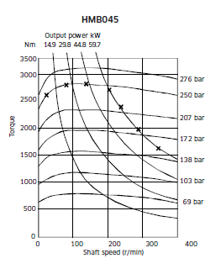
Figure 15 Motor Torque Curve for KPM HMB 045 Hydraulic Motor.
Reproduced from: Kawasaki Precision Machinery, (2017); HMB Series Fixed Displacement Radial Piston Staffa Motor Manual, Kawasaki Precision Machinery UK Ltd. Available from: http://www.kpm-eu.com/files/Datasheets/HMB-M-200109-14.aspx , page 25.

Therefore, based on the values identified, the total leakage rate (Qt) may be determined as follows:
Total Leakage (Qt) = (k₁ + n/k₂) x $∆$P x k_{V} x 0.005
Qt = (1.92 + 140/43.36) x 172 x 1.05 x 0.005
Qt = 4.649 litres per minute
The selected filtration system must have a volumetric flow rate capacity exceeding 5 litres per minute in order to ensure no excess back pressure occurs which could lead to over-pressurisation of the hydraulic motor case and could cause motor shaft seal failure.

Identification of Filter Grade Based on Particulate Size
Based on the historical oil analysis report produced by ALcontrol Laboratories, the distribution of particulate sizes has been identified and is illustrated in the table below:
Table 23 Wear Particle Size Distribution in Hydraulic Oil Sample Based on ALcontrol Report
Particle Size | Sample Test Date
Particle Size | 13/09/17 | 08/06/17 | 23/05/17 | 19/04/17
>4µm, <6µm | 14913 particles/ml | 30233 particles/ml | 33745 particles/ml | 16346 particles/ml
>6µm, <14µm | 2931 particles/ml | 6938 particles/ml | 6028 particles/ml | 3678 particles/ml
>14µm | 122 particles/ml | 218 particles/ml | 163 particles/ml | 162 particles/ml

This identifies that the greatest number of wear particles fall within the range of 4µm to 6µm, therefore the filter element selected for use in the proposed system should be a 3µm mesh size.

Estimated Costs for Case Drain Filtration System
Based on the identified specifications for a duplex filtration system with differential pressure bypass valve and indictor, with minimum volumetric flow rate capacity of 5 litres per minute and a filter mesh of 3 microns, Dingbro Ltd. Industrial Filtration Division have quoted as follows:
Table 24 Details of Dingbro Quote (Dingbro Reference 22963-1)
Details of Dingbro Quote for Filter Element Housing
Part Number: 4599AF-B3CL Filter Housing | Rating: 150 bar
Volumetric Flow Rate: 10 GPM (45 l/min) | Housing Material: Aluminium
Connections: 1 ¼” SAE 3000 | Filter Element: 3 Micron ABS Glass Fibre
Price (Net): £3756.00 | Delivery Time: 2 Weeks

Based on this, the cost of filter systems for all four hydraulic motors is £15,024, excluding installation costs.
Since installation would require a system outage on all four fans, it is suggested that the installation be carried out during the next planned Cracking and Olefins Turnaround in 2020.
This would require the fabrication of a suitable stand/bracket for each filtration system, which ideally would be located on the fin fan deck for ease of access and could be incorporated into the hand rail upright, as identified in the image of 06-EAHM-101-24B, below. This would also require some parts of the existing pipe work/hoses be changed out or modified.
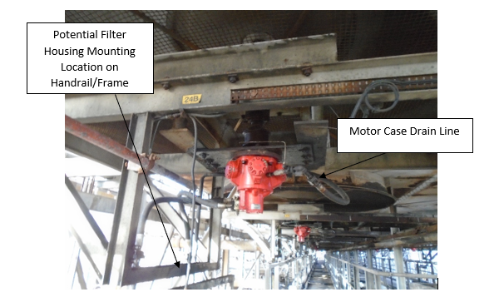
Figure 16 06-EAHM-101-24B with Potential Filter Location Highlighted. (Authors own image)

Installation costs, including the quoted cost of the filter system have been estimated as identified in the following table:
Table 25 Estimated Purchase and Installation Costs of Each Filter System
Work Activity | Parts Required | Estimated Part/Material Costs per Filter System (including Purchase Cost of Filter Housing) | Labour Hours | Estimated Labour Costs per Filter System  (Based on Labour Rate of £50 per Hour)
Fabricate/Install Filter Housing Stand | Miscellaneous Steel Angle Sections | £200 | 4 | £200
Fit Housing to Stand | Filter System and Miscellaneous Fixings | £3756 | 3 | £150
Modify and Connect Drain Lines to Filter Housing | Hoses, Pipe Fittings and Clamps | £400 | 3 | £150
 | Sub-Total: £4356 |  | Sub-Total: £500
 | Total: £4856

Therefore, the total cost of installing the specified filtration systems each of the motor case drain lines on the hydraulic system is estimated at £19,424.
Given that the cost of hydraulic motor seizures on the 06-PH-101F system during the period covered by the SAP CMMS is £389,037.61, if the installation of case drain filtration reduced the number of failures by twenty per cent, the proportion of the total costs saved would be £77,807.52, which would far outweigh the estimated installation costs.
Even with a twenty per cent reduction in failures, the cost savings could be higher, given that there would also potentially be cost savings on the failures which did occur, due to the identified advantage of the individual filtration systems providing warning of failure by means of reducing filter blockage intervals, which would allow for reduced repair time/outage costs due to the ability to plan the repair in advance.
Given that the outage costs associated with hydraulic motor seizures are £700,000 for the period covered by the SAP CMMS data, a fifty per cent reduction in repair time and the associated savings in production losses could result in a £350,000 saving over an equivalent time period.
This does not take into account the potential improvements to the main hydraulic pump reliability, which itself is accountable for the greatest production losses within the hydraulic system.
By reducing the particulates within the system the likelihood of wear debris damaging the main hydraulic pump and charge pump is expected to significantly reduce.

Potential for Interval Based Replacement of Hydraulic Filters
In addition to installing filtration systems on the individual case drain lines from each hydraulic motor it is also suggested that the existing vertical and horizontal filters, fitted to the charge pump suction and main hydraulic pump suction lines, be changed out as a planned (PM) task based on a service interval, rather than as a reactive task as is the current practice.
As identified during the evaluation of the limitations of current maintenance practices, the current run to failure philosophy utilised for filter replacement guarantees that filter bypass events occur on a regular basis.
Given that the filters may be checked by the plant operator only once during a shift, it is not unreasonable to expect such bypass events to last up to 12 hours before the next shift check, when the blockage may be detected and the alternative filter placed on line. As identified, such bypass events can result in significant quantities of wear debris being allowed to recirculate through the hydraulic system.
Since the MTBF of both the horizontal and vertical filters have been identified, it is feasible to introduce filter changes as a planned maintenance activity based on the identified intervals.
A suggested PM interval could be based on 90% of the calculated MTBF values, which would provide the following time-frames: for the vertical filters, with a MTBF of 116 days, a suitable PM interval would be 104 days, while for the horizontal filters, with a MTBF of 277 days, a suitable PM interval would be 250 days.
Carrying out filter changes as PM activities using these intervals would not greatly increase the direct maintenance costs in terms of greatly increasing numbers of replacement filters, but would potentially increase the reliability of rotating equipment within the system by eliminating the majority of filter bypass events.
Finally, if the proposal to install filtration on the case drain return lines was to be implemented, it would be beneficial to carry out filter changes on these items as an interval based PM activity, once sufficient data was obtained on failure intervals to determine the MTBF.

Conclusion
As identified in this report, the hydraulic system performs significantly worse than the electric system, both in terms of energy/running costs and also in terms of maintenance costs and reliability.
In fact, maintenance expenditure for the hydraulic system has been identified as twice that of the electric system, in terms of direct costs (parts, labour, services) during the period since the SAP CMMS has been used. Production down-time losses attributable to the hydraulic system are two and a half times greater than those associated with the electric system, for the same period.
The failure of the hydraulic motors has been identified, by several analysis methods, as having the greatest impact on system reliability, although the main hydraulic pump has the greatest attributable production down-time losses, due to the fact all four hydraulic fans are out of service when the pump fails.
Investigation of the historical work orders relating to hydraulic motor failure has identified the most significant hydraulic motor failure modes as being motor seizure and motor shaft seal leaks.
The limitations of the depth of detail in the historical work order data has led to some difficulties and it has been recognised that the FMEA analysis had to be conducted based on incomplete failure data.
Further analysis by means of RCA using Cause Mapping, utilising supplementary evidence from Warranty Reports, has identified that poor hydraulic oil hygiene is likely to be the root cause of both of these failure modes. Poor oil hygiene has also been acknowledged as having a significant effect on the life-span of other components, such as the main hydraulic pump and charge pump.
Based on this, two suitable remedial actions have been recommended which could potentially reduce the wear debris levels within the system and reduce the likelihood of wear debris being recirculated around the system.
These remedial actions are the installation of filtration on the currently unfiltered hydraulic motor case drain lines and the interval based change out of existing filters, which are currently maintained/changed on a run to failure basis.
These actions could significantly reduce the amount of wear debris returning to the hydraulic tank from the hydraulic motors, and also reduce the likelihood that any debris that does return to tank is then recirculated through the system.
The use of filtration on the individual hydraulic motor case drain lines also has the expected benefit of giving warning, due to decreasing filter life, of deteriorating condition of a specific motor, therefore allowing pre-planning of maintenance activities, leading to a reduction in MTTR.
These combined benefits could result in significant savings, reducing number of hydraulic motor failures by twenty per cent could save £70,000+ over a five year period, while reducing MTTR by fifty per cent could save £350,000+ over the same period.
Further scope exists to investigate the failure modes of less significant components within the hydraulic system to further improve reliability within the system. Additionally, a proposed Combined Steam and Electricity (CoGen) Plant at Pembroke Refinery could improve redundancy in electrical supply. This could allow for the replacement of hydraulic fin fan drives with electrical systems, the feasibility of which could also be suitable for further research.
Finally, due to difficulties encountered in obtaining relevant information from historical work order data during this study, it must be suggested that Pembroke Refinery examines the methods used and procedures for recording failure data. This could provide a further avenue of investigation into the most suitable means of historical record keeping for historical reliability data analysis.

References

Reference List
Braaksma, A, Klingenberg, W, and Veldman, J, (2013); ‘Failure mode and effect analysis in asset maintenance: a multiple case study in the process industry’, International Journal of Production Research, Volume 51, Number 4, pp. 1055 – 1071.
Chevron, (2016); RANDO HD Hydraulic Oil Product Data Sheet, Chevron Corporation. Available from: https://cglapps.chevron.com/msdspds/PDSDetailPage.aspx?docDataId=323786&docFormat=PDF (Last accessed: 18/02/18).
Gehloff, M, (2015); ‘OEE vs. MTBF: Which is the right metric?’, Plant Engineering, Volume 69, Issue 9, pp. 14 - 16.
Geitner, F, and Bloch, H, (2012); Machinery Failure Analysis and Troubleshooting: Practical Machinery Management for Process Plants, 4th Edition, Oxford: Butterworth-Heinemann.
Kawasaki Precision Machinery, (2017); HMB Series Fixed Displacement Radial Piston Staffa Motor Manual, Kawasaki Precision Machinery UK Ltd. Available from: http://www.kpm-eu.com/files/Datasheets/HMB-M-200109-14.aspx (Last accessed: 20/02/18).
Leffler, W, (2008); Petroleum Refining in Non-Technical Language, 4th Edition, Oklahoma: Penn Well Corporation.
McDermott, R, Mikulak, R, and Beauregard, M, (2009); The Basics of FMEA, 2nd Edition, New York: CRC Press.
Mobley, R K, (2004); Maintenance Fundamentals, 2nd Edition, Oxford: Elsevier.
Moubray, J, (2000); RCM II: Reliability Centred Maintenance 2.2, 2nd Edition, Oxford: Butterworth-Heinemann.
Nilsson, D, and Prakash, B, (2010); ‘Investigation into the seizure of hydraulic motors’, Tribology International, Volume 43, pp. 92 – 99.
O’Connor, P, and Kleyner, A, (2012); Practical Reliability Engineering, 5th Edition, Chichester: Wiley.
Parr, A, (2009); Hydraulics and Pneumatics: A Technician’s and Engineer’s Guide, 2nd Edition, Oxford: Butterworth-Heinemann.
Sharma, R, and Sharma, P, (2010); ‘System failure behaviour and maintenance decision making using RCA, FMEA and FM’, Journal of Quality in Maintenance Engineering, Volume 16, Number 1, pp. 64 – 88.
Wang, Y, Cheng, G, Hu, H, and Wu, W, (2012); ‘Development of a risk-based maintenance strategy using FMEA for a continuous catalytic reforming plant’, Journal of Loss Prevention in the Process Industries, Volume 25, pp. 958 – 965.

Bibliography
Alia, V, (2006); ‘Don’t mistake power-supply MTBF for life expectancy’, Plant Engineering, Volume 60, Issue 1, page 33.
Barron, R, (1996); Engineering Condition Monitoring: Practice, Methods and Applications, Harlow: Addison Wesley Longman.
Coetzee, J, and Claasen, S, (2002); ‘Reliability Centred Maintenance for Industrial Use: Significant Advances for the New Millenium’ South African Journal of Industrial Engineering, Volume 13, Number 2, pp. 97 – 129.
Danfoss Hydraulic Pumps, (2017); PV Series Variable Displacement Pump Manual, Danfoss Hydraulic Pumps Ltd. Available from: http://files.danfoss.com/documents/series%2020%20variable%20pump%20and%20fixed%20motor%20service%20manual/bln-9630.pdf (Last accessed: 18/02/18).
Duchowski, J, and Mannebach, H, (2006); ‘A Novel Approach to Predictive Maintenance: A portable Multi-Component MEMS Sensor for On-Line Monitoring of Fluid Condition in Hydraulic and Lubricating Systems’, Tribology Transactions, Volume 49, Number 4, pp. 545 – 553.
Hauptmanns, U, (2011); ‘Reliability data acquisition and evaluation in process plants’, Journal of Loss Prevention in the Process Industries, Volume 24, pp. 266 – 273.
Kumar, U, Knezevic, J, and Crocker, J, (1999); ‘Maintenance free operating period – an alternative measure to MTBF and failure rate for specifying reliability?’, Reliability Engineering and System Safety, Volume 64, pp. 127 – 131.
MacDonald, D, (2004); Practical HAZOPS, Trips and Alarms, 1st Edition, Oxford: Newnes.
Matthews, C, (2012); Engineers’ Data Book, 4th Edition, Chichester: Wiley.
Samat, H, Kamaruddin, S, and Azid, I, (2012); ‘Integration of Overall Equipment Effectiveness (OEE) and Reliability Method for Measuring Machine Effectiveness’, South African Journal of Industrial Engineering, Volume 23, Number 1, pp. 92 – 113.
Timings, R, (2010); Mechanical Engineers Pocket Book, 3rd Edition, Oxford: Newnes.
Wassan, R, and Majid, M, (2015); ‘Risk Screening as an Input for Risk Assessment of Rotating Equipment’, Applied Mechanics and Materials, Volume 761, pp 333 – 338.

Annex 1: SAP Historical Work Order Data

Annex 1a: Combined Electric And Hydraulic SAP Work Order Data

Annex 1b: Filtered SAP Work Order Data (Hydraulic)

Annex 1c: Filtered SAP Work Order Data (Hydraulic Drive System Only)

Annex 1e: Mean Time Between Failures and Mean Time to Repair for Hydraulic System

Annex 1f: Filtered SAP Work Order Data (Electric )

Annex 1g: Filtered SAP Work Order Data (Electric Drive System Only)

Annex 1h: Mean Time Between Failures and Mean Time to Repair for Electric System

Annex 2: Hydraulic System FMEA Data

Annex 2a: FMEA Table for Hydraulic System

Annex 2b: FMEA Table for Hydraulic System with Combined RPN Number

Annex 3: Hydraulic Motor Warranty Reports

Annex 3a: KPM Warranty Report QRS 8158-1
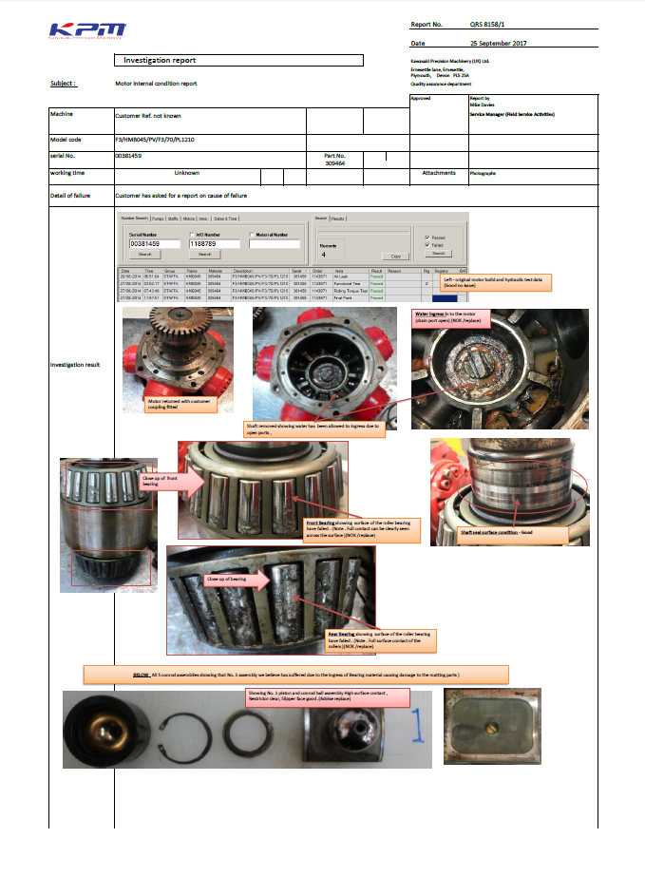

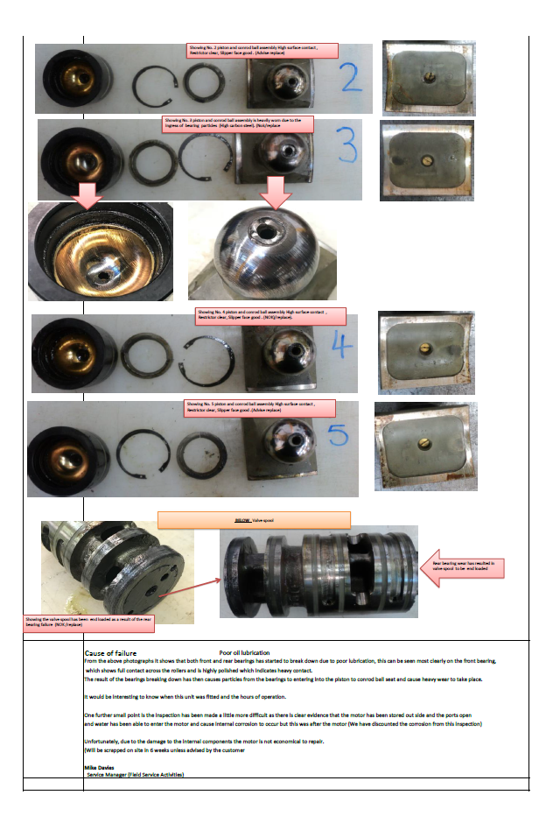

Annex 3b: KPM Warranty Report QRS 8158-2
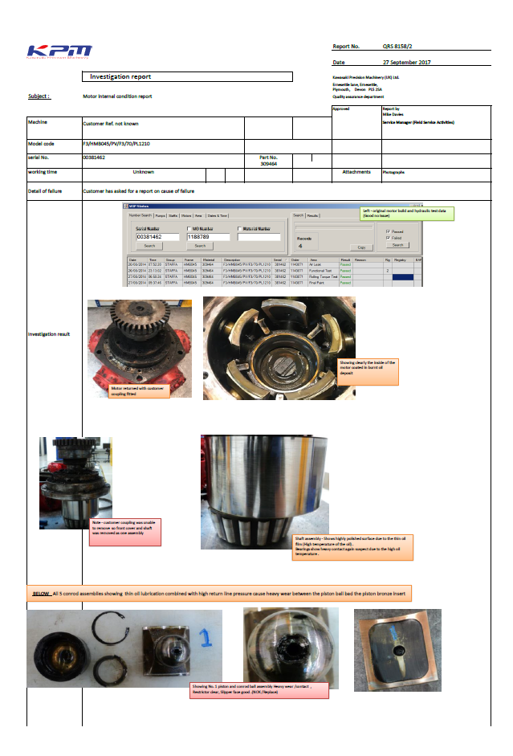
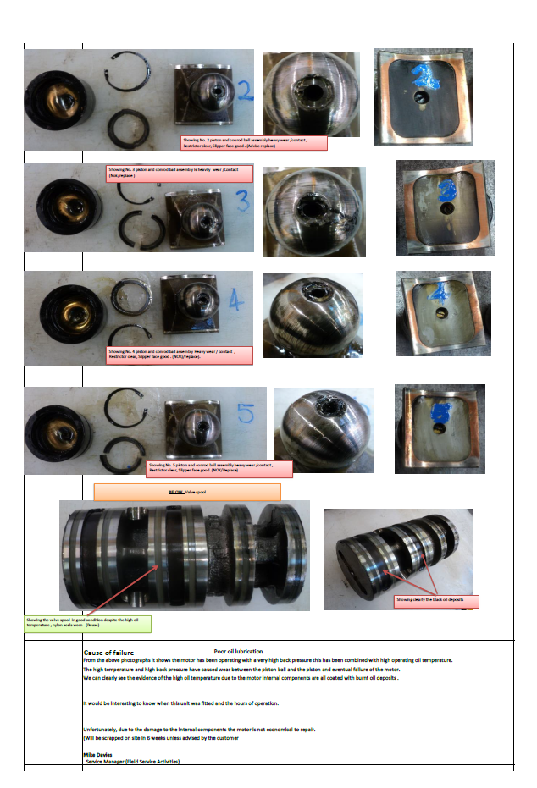

Annex 3c: KPM Warranty Report QRS 8175
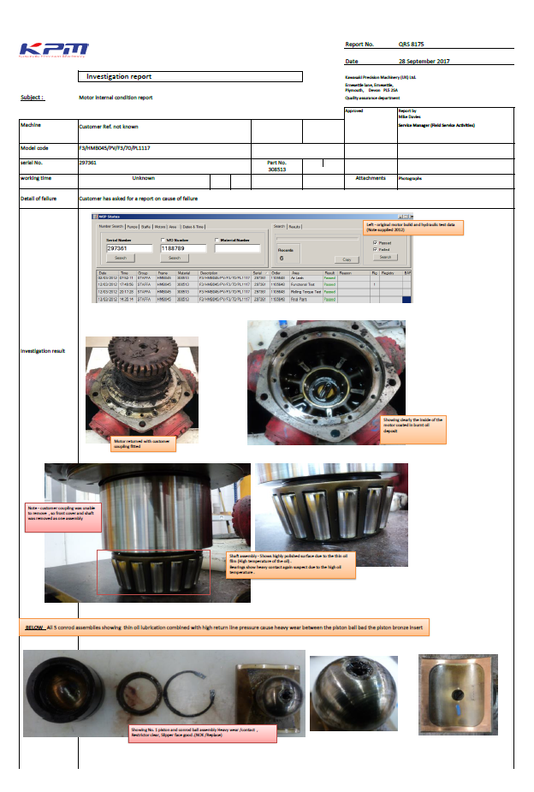
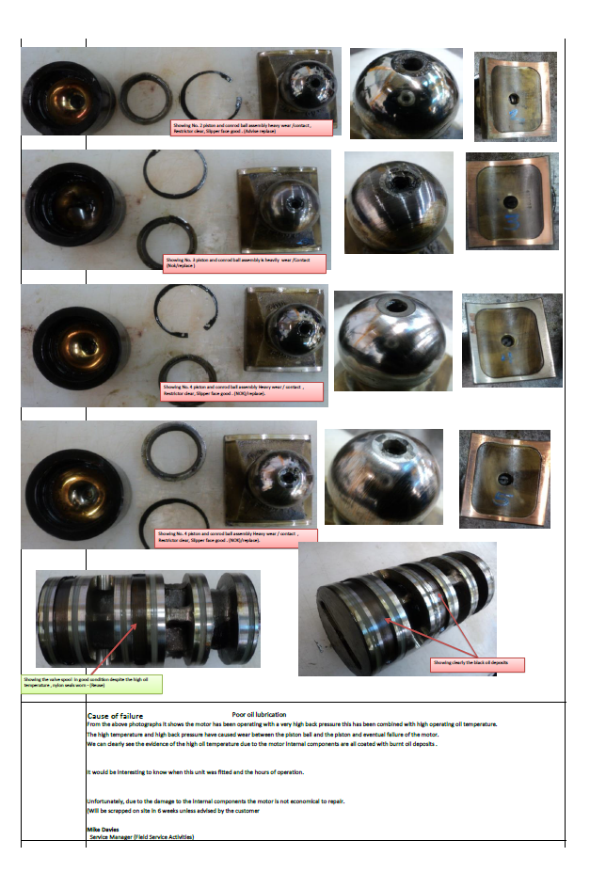

Annex 4: Hydraulic Oil Analysis (ALcontrol Laboratories Report 1787563)
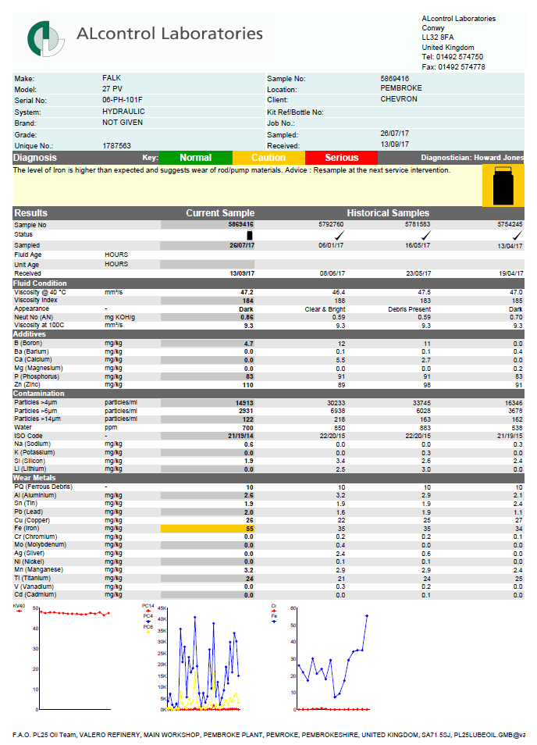

Annex 5: Dingbro Industrial Filtration Division Quotation


