
Student Name: Maria Angeles Hurtado Funes
Student Number: 2013026
Lecture Name: Tushara Belendran
Word count: 4.296
Date Submission: 5/ 01/2021

marketing management lcmb7001
assigment – 2
Report on Mcdonald’s
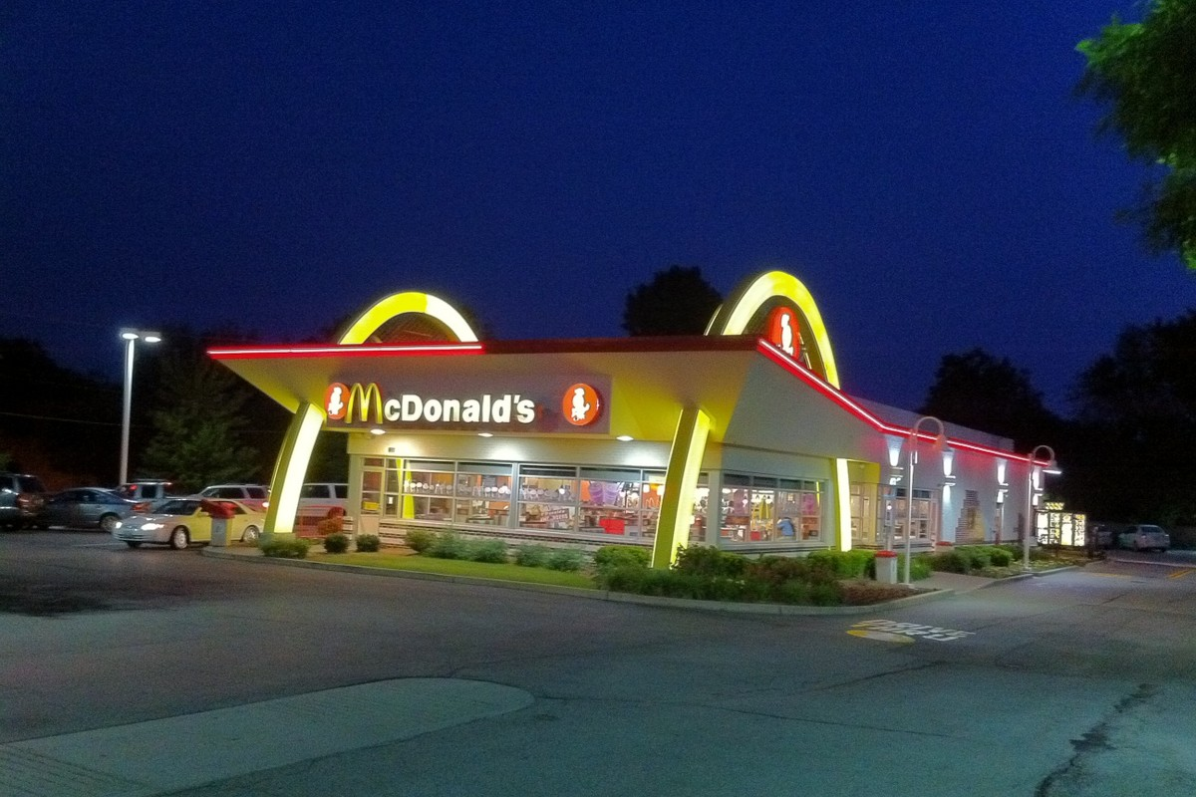

Table of contents
1- INTRODUCCION 1
2- COMMUNICATION 2
3- COMMUNICATION MODEL OF MCDONALD’S 2
4- THE SHANNON AND WEAVER MACRO-MODEL OF THE COMMUNICATION PROCESS. 3
5- INTEGRATED MARKETING COMMUNICATION (IMC) 4
6- CURRENT PROMOTIONAL CONCEPTS OF MCDONALD’S 4
7- RECOMMENDATION OF PROMOTIONAL STRATEGIES FOR MCDONALD’S 6
Online promotional strategies 6
Offline promotional strategies 7
8- BRANDING STRATEGIES AND BRAND EQUILTY OF MCDONALD’S 7
9- KELLER’S BRAND EQUILTY MODEL 8
10- ADAVANTAGE AND DISVANTAGE OR KELLER’S BRAND EQUITY MODEL 9
11- CUSTOMER TOUCHPOINT AND CUSTOMER JOURNEY 9
12- CUSTOMER JOURNEY MCDONALD’S 9
13- ADVANTANGE AND DISVANTANGE OF MCDONALD’S CUSTOMER JOURNEY 12
14- CONCLUSION 12
REFERENCE 13

INTRODUCCION

Exist a variety of ways to link communication between company and customer.
This report assesses the communication and how companies should use it in marketing strategies, with Integrated marketing communication model.
A successful marketing strategy is necessary for any company. The companies need to make customer satisfaction in every step from the beginning until the end, for this reason, the companies need to analyses customer touchpoint and analysis the customer journey.
Companies study customer journey due that the satisfaction level of the customer is essential, companies know every touchpoint of the journey, excellent services are the most important as the company want to make customer loyalty.
MacDonald’s is a worldwide company with many years of experience. McDonald’s use different marketing strategies and promotion in all of the step of the customer journey. In this report is analyses the last promotion of McDonald’s.
McDonald’s start to include technology and digital customer experience, like the app and self-order kiosk. Technology es a critical element of velocity growth plan retail and excellent customer experiences. (acquisition, 2019)

COMMUNICATION

Communication is the act of transferring information from one place to another. Every communication involver a message. Companies tools are customer communication, It means any communication between services provider and customer by any method call, email, correspondences, it makes possible the relationship between a company and the customer, to keep a customer and the effective communication.
The communication is not only for customer who buys product and services, also it is for future costumer and organisations who will able to influence them. (Fill, 2009)

MacDonald’s marketing focus on value, quality, food taste, menu choice, nutrition and customer experiences as well. MacDonald’s use Marketing communication mix include media advertising, sales promotion, customer experiences, public relations and direct marketing. (Dudovskiy, 2016)

COMMUNICATION MODEL OF MCDONALD’S

McDonald’s use integrated marketing communication methods it is multi- canal and is use due that the company want make sure that the commercial information arrives everywhere.
The marketing communication involves advertising on Tv, internet and radio even Spotify played in the rush morning hour to force customer come to McDonald’s and grab the breakfast.
Children are the strength in the brand, happy meal is one of the best seller product in MacDonald’s due that, they launch special promotion in a short time, for example, the gift inside the happy meal invites to the children to come back soon before the promotion end.
Other the communication tool integrated is Public relations through, public appearance news and event sponsorship that help to trust the company.
Direct marketing is promoted by coupons discount online and magazines when the new product is launched. (Dudovskiy, 2016)
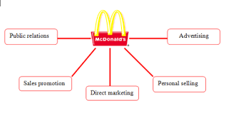

Fig – 1: Communication model of McDonald’s (School, 2016)

THE SHANNON AND WEAVER MACRO-MODEL OF THE COMMUNICATION PROCESS.

This model of communication is considerate model of signal processing, it was developed in 1949 by Shannon and Weave. It is a linear model that explains a transmission communication between sender and destination, there is an important factor which affects the communication ‘Noise’

Fig - 2: Shannon- Weaver’s model

There are six elements to explain this process, the first element and the most important is the information source, it is the origin of massage, the encoder is transmitter the message, the channel is where the message is adapt for transition, it is travel to a decoder where the message is reconstructed from the signal and the last step is the receiver is a destination, where the message arrives. One of the problem in this model is
the noise factor or dysfunctional factor, which may lead to the signal received being different from that sent. (Fedaghi, 2012)
Due to the noise normally the messages sent when they reach the receiver are different or part of the message information is lost regardless of the channel on which it is sent.

INTEGRATED MARKETING COMMUNICATION (IMC)

The competition between companies has increased, many of the markets is rapidly becoming saturated and customers are searching for more than a single benefit, in then moment that they want to do a transaction of services or good.

Integrated marketing communications has emerged around 1990, the brand tries to align, coordinate message though of communication disciplines to provide clarity and move the customer toward a sale and maintains customer loyalty, for this reason, the companies through IMC, to make the greatest maximum communication impact.

Integrated Marketing Communication was recommended as a vital and operational approach for marketing correspondence since it gives opportunities for small and medium-sized enterprises to incorporate communication apparatuses and channels to gain admittance to their group of spectators with a specific end goal. (Muhammad Sabbir, 2019)

IMC help to pull all of the brand message points together into are cohesive whole to ensure the message is not confusing.

The companies have to identify different marketing communication method. The company should consider your target audience and how they like to receive information, gather facts, and perform research on the problem they are trying to solve.
After chose the market channel need to a target audience and have a focus in customer value that they want to capture attention. Chose the customer more profitable and transmit the promotional information.

The company should study and understand what makes customers decide to buy a product or service by one brand or another and why they did it. The significant is understanding the problem you are solving and how to help them in that decision journey. Depends on the price of the product the customer decision-making process can be short or extended. It is important to have a good relationship with the customer.

Every marketing plan is different because they have different objective although most of them have an integrated marketing communication plan.

CURRENT PROMOTIONAL CONCEPTS OF MCDONALD’S

McDonald's use the Integra marketing communication in every promotion and campaign in this year they mix them value, food, integrity and affinity.

On November 2020 McDonald’s launch new growth strategy. The strategy includes many different changes included refreshed purpose to feed and foster the communities and update company values and behaviors. (McDonald's, 2020)

"In countries around the world, we have seen customer behaviors change at an unprecedented pace over the last several months. We believe this presents an opportunity to do something special as we write the next great chapter of McDonald's," said McDonald's President and Chief Executive Officer Chris Kempczinski. " (McDonald's, 2020)

The three keys of promotional growth are, maximize our marketing, commit to the core, double down on the 3 D’s (Digital, Delivery and drive-thru)

McDonald’s will have focusing on four areas that matter most like ingredient quality, communities equity, they will support farming communities, driving climate action to protect the planet, for this reason, they will change packaging from renewable and recycled by 2025 and focus on equity by providing an opportunity for restaurant crew to complete this they will reduce barriers to employment for over 2 million people worldwide.

The new campaign of McDonald’s ‘Serving Here’ demonstrates the company’s values and illustrates its commitments to the customer, communities, crew, farmers, franchisees and suppliers.

McDonald’s want to elevate focus moving beyond brand engagement people and how the costumers feel, about visiting McDonald’s the encourage others to join them.

To show how McDonald’s continue listening to the customer and finding opportunities to create a cultural moment they promote the famous orders so far with Travis Scott and J Balving. ‘ Iconic Brand, Iconic Talent’

This campaign broke the internet each drop sold out in a few hours. Thousands of items sold, they reached 2,2 billion people in just 9 hours, 22b impressions, 667k total mentions and 95% por/nev sentiment. (McDonald's, 2020)

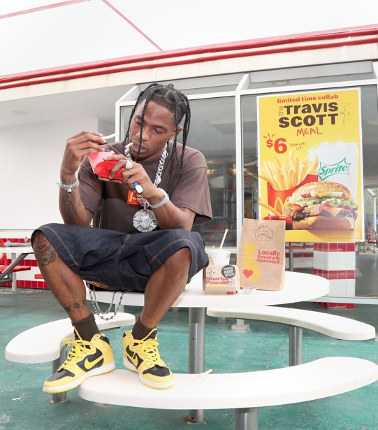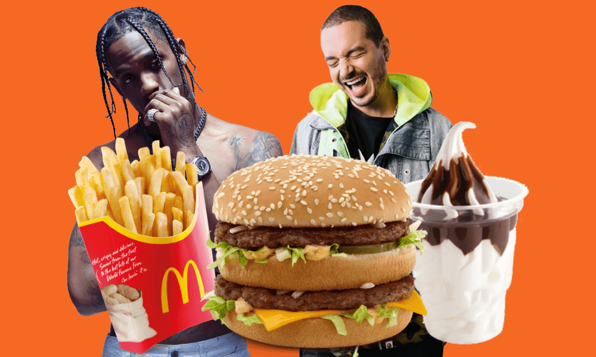
Fig – 3: McDonald’s promotion 2020.

The current situation in the world with the Covi-19 changed the situation and the marketing strategies of the companies, McDonald's is adapting by improving digital offering across drive-thru, takeaway, delivery, curbside pick-up and dine-in, its app to place orders faster and easy experience to love and in addition to improving the home service by hiring different external companies to that orders reach customers as soon as possible, although there is always a McDonald's within 3 miles. The drive-thru service has also improved so that customers can pick up their orders more quickly. Orders are already made by machines and not by people.

The new strategic of McDonald’s from November 2020 the focus is in McCafe, students and promote the app, for this reason, they made a campaign discount for student, after 6 coffee get one for free , also if you download the app you get some discount in the menu.
You can have always a delicious meal that meets the need for an incredible price.
McDonald’s use always IMC with a combination.

RECOMMENDATION OF PROMOTIONAL STRATEGIES FOR MCDONALD’S

McDonald’s maintains online and offline marketing strategic that promote its clear, brand-centric messaging to broad audiences also use other channels such as its mobile app to reach and retain loyal customer. Offline and online marketing techniques support each other and it can create a unified strategy.
An idea that they can use is when they do online promotion, if the picture get a lot like then the company can use this picture for offline promotion,

Online promotional strategies
McDonalds investment lot money in marketing, actually they start to use more social media and a lot technologic advances,
Currently problem in McDonald’s is that has been criticism of the quality of their food due that the actitud of the culture has change, people speak just about healthy food.
McDonald’s change many thing now as well they put image of farmers in advantage but they citizen care every day more about bad food even the government make high tax for them. I think that McDonald need to promote more healthy food and change menu for vegan people and create more event with sporting famous people.

Offline promotional strategies
MacDonald’s print publication in the underground, bus stop and they are collaboration with association in every community.
Offline, McDonald’s’ owned channels were also utilized - including self-ordering kiosks to Digital Menu Boards, tent cards and traymats.

McDonald’s have more power in online promotional strategies but need to improve offline promotional. (Kasi, 2018)

BRANDING STRATEGIES AND BRAND EQUILTY OF MCDONALD’S

The importance of creating a brand is because this leads to a positive customer experience. (Brown, 2016) The McDonald’s Brand is the two yellow arche. An equilty brand means brand awareness, image, trust and reputation, all built up over the years, are the guarantee of future earnings. (Kapferer, 2008)

Brand Awarenes
Actually, McDonald’s ranked on the 6th position as world’s most important brand and most visited fast food chain restaurant. All the new products are test in America after that McDonald’s.
Also MacDonald’s is a big fast food chain worldwide and introduce different product depend of the culture and country.

Brand association
The heavily association is the products of McDonald’s like burger and fries the product is associated a them names like Big Mac and French fries as well there is a strategic product for children which offering a toys and the name is Happy Meal.
The new strategy launch for McDonald’s is to make his coffe more famous and the name is McCafe.
This product makes the customer think about McDonald’s when they hear the names of this products.

Brand Loyalty
McDonald's customer is a strong brand loyalty it’s fries and kid meal are famous as the Big Mac burger.
In the new strategic, Mcdonald’s introduce more chicken because the customer demand chicken in the menu and for the next year they will have food with plan base it can provide more new customer loyalty.

Brand Asset
Mcdonald’s is one of the powerful brands worldwide. They have secret recipes of the sauces and burger patties.

Brand Element
The statue is one of major focus in Mcdonald’s strategic because, there are so many competitive advantages and many rivals in the industry. Mcdonald’s make the advertising in every country according to customer and culture.(Kasi, 2018)
Brand equity is when the company have high value as the name and product is recognizable. If the company has a positive brand quality the customer will pay a high price for the same product even if they get the same thing for the other competitor.
McDonald’s has a brand quality because actually has a loyalty customer. (Hayes, 2020)

KELLER’S BRAND EQUILTY MODEL

Build strong brand is the end of every company and to build a strong brand you must shape how customers think and feel about your product. so that customers have specific, positive thoughts, feelings, beliefs, opinions, and perceptions about it you brand can grow rapidly.
When you have strong brand equity, your customers will buy more from you, they'll recommend you to other people, they're more loyal, and you're less likely to lose them to competitors.

Fig – 4: Keller’s brand equality McDonald’s
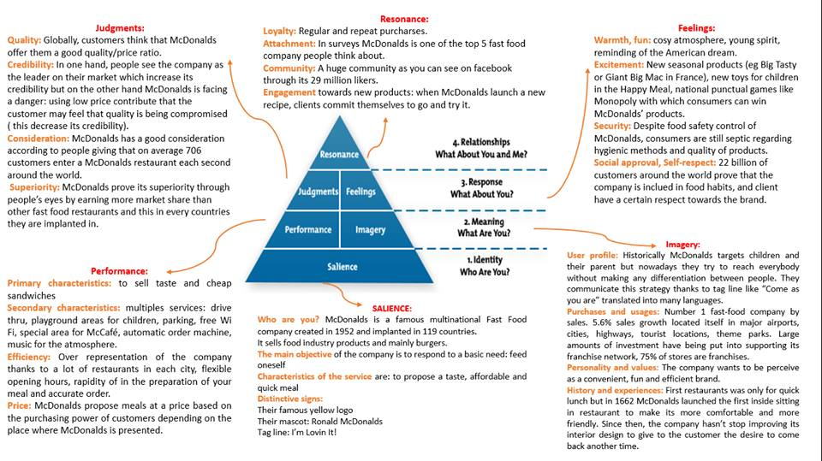

Every step show how we need to create the brand and to make the framework.
It is the first step where you need to explain who are you and how you will be your distinctive sign. In the graphic you can see the description of the company and which is the focus in the business model.
In this step you can understand how the customer see your brand and why they choose you instead that your competitor, the brand have to follow the client decision, is important to know what your customer perceive the bran and if you need to improve in same point.
Next step the focus is in identify and communicate what your brand means and what it stands for. Performance define how your product fit your client needs like characteristics of the product, durability, price, efficiency.
Imagery referent how the bran meets your customer need on psychological level.
Normally the customer respond you brand according to how they feeling and judgments the result of your products. McDonald’s has 22 million customers around the world, it approves the company consolidation.
The last step is how the company engage the customer and keep then with a loyalty attachment.

ADAVANTAGE AND DISVANTAGE OR KELLER’S BRAND EQUITY MODEL

The Ketler’s equity model the function is to make a strong brand imagine and ideal brand experience. (Keller's, 2019)
The logic of the model is simple and help companies to develop and reach high understanding your customer and implementing strategies accordingly.
The brand resonance pyramid is reviewed as a means to track how marketing communications can create intense, active loyalty relationships and affect brand equity. (Keller, 2003)

The limitation of this model is in Business to Business (B2B) branding doesn’t exist.
Implement Keller’s brand equity model effect on the B2B market model need modification. (Kerri-Ann, 2001) The model is based on customer-based brands and not so much focus on business- business (B2B).

CUSTOMER TOUCHPOINT AND CUSTOMER JOURNEY

The customer touchpoint means any interaction between customer and company, a customer touchpoint can be everything that transfers some type of information from the supplies to the client includes visiting the website, social media page, send an email, watching tv is few examples.
Every company gets touchpoint customer in different ways, all the customer touchpoint can lead a positive or negative experience, for this reason, is so important every touchpoint. (Aichner, 2017)
To have high customer satisfaction the company need to work about product/ services quality and interaction quality, if the company created positive feedback from the client it increasing positive word of mouth (WOM)
Touchpoint should reinforce what your company stands for and provide a clutter-free way for your customer to connect with your vision.

CUSTOMER JOURNEY MCDONALD’S

McDonal’s guarantee that every customer who walks through their restaurant door is welcomed, has everything they need and leaves feeling special. You’ll spot and quickly fix any problems that may affect the customer experience. You also know what makes people happy and will go out of your way to make feel good moments they won't forget. (McDonald's, 2020)

Happy customer drive growth, they transact more often, spend more and promote your organization to others. Customer journey is relative to the whole process the customer touchpoint, and how the company can improve the interaction and experiences in the journey. The digital transformation is a change in the customer journey and helps the company to have more information about the customer. (Karrar, 2018)

Aware
In this step is when McDonald’s start to work in the brand 46 years ago, when the customer starts to try and trust the food and the company.
This is the first step to the marketing and communication plan, where the company work to help customer to find out the products and service that the brand have.
They need to make sure that the advantage shows the benefits and strengths of the products.
McDonald’s found that the customer at that time need to be served quickly because they need to safe tome and they start to make the service good and quickly.
In the current situation McDonald’s change products and practice because of the Covid situation they improve service as never before. Now the marketing and communication is most of them in social media is how they start to show new app services and how they improve delivery.

Acquisition
Interaction and engagement is the most important concept in this step. The company need to make contact to the client by right frequency time because you need to hold the attention until they became a potential buyers.
In that stage McDonal’s use so many way to created the need to the client for example in morning time you can hear in the radio or spotify how they make his advantage for the breakfast and McCafe, it help to client are in rush go thru to the restaurant in that time many customer go for drive-thru service.
McDonald’s slogan is known all over the world, if you listen to his phrase you will know perfectly well what brand is being promoted.‘i’m lovin’it’

Evaluation and Consideration
In that stage is when the customer decides if they wasn’t to buy or not the product and service, in that moment we need to find out why they make that

Retention or Assimilation
It is one of the most important step because the customer very easy can change and walk out your back door never return. In that stage we need to review the satisfaction of the client and the real experience with your product and with the company, it will influence the satisfaction level customer lifecycle. One the customer begun using your product, it’s critical that you keep the lines of communication open for 90 days.
Actually the customer start to use the app for they order and it is help to follow the customer lifecycle and even for engage them. In the app the company can see the favorite product for the clients and they can make feedback for the service and explain the experience that can help for future clients too.

Advocacy
If you have done everything right you can use loyalty retention mesures as churn rate and renewal. In this stage you customer. The loyalty customer change a brand ambassador because they have the power of social proof that is the amaziglyn powerful.
In that case we can see how the children one of the best customer of McDonald’s are ambassador of them beca

. Customer journey app restaurant is one of the most used now with the pandemic that we are experiencing, all the restaurants remain closed and only have the opportunity to take the order to home. In the first stage, we can see how the client is planning what he is going to eat the next day, when the next day arrives he looks at the food options that are proposed and discovers that this McDonald's is one of the fastest and serves you breakfast, lunch and dinner also most likely you know the menu and if you have downloaded the application you can benefit from the discounts. McDonald's works to guarantee the speed of the order so that it arrives as soon as possible, the client will enjoy it and a satisfied client will be good feedback on the web in addition to a brand ambassador.

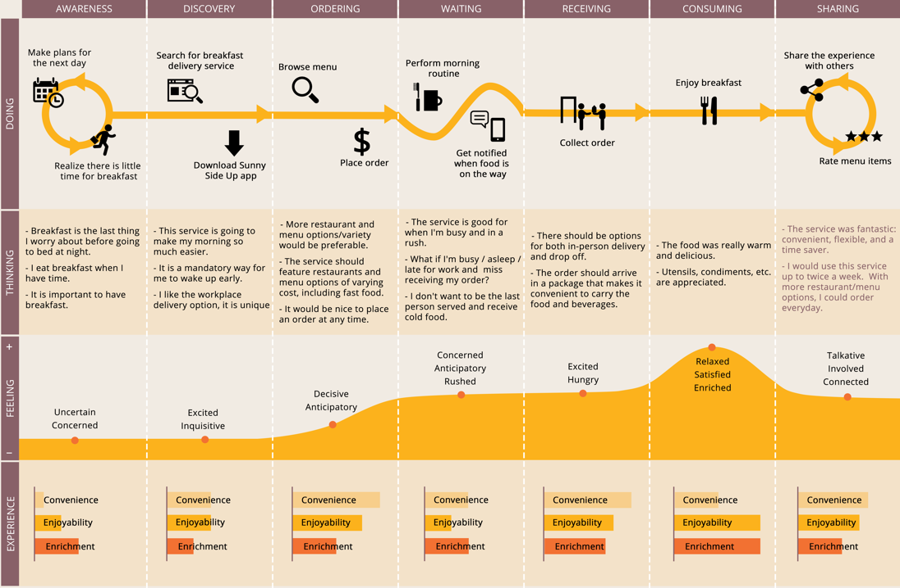

Fig – 5- : Customer Journey app restaurant.

The biggest customer McDonald's has right now are children. In this map you can see how they enter the restaurant with their parents, mainly they get bored for this reason McDonald's is working to improve their delivery times in restaurant and they have more kisks to order your menu and just pick up in the desk , normally children are easily influenced by other children in turn these in some way help to his parents going to McDonald’s. The impulse that McDonald’s gives to the children along with its facilities as a playground in restaurants for them and special menu for children with the promotion of the exclusive gift. The children are eating their menu at the table and them play in the playground. When the children leave the restaurant, they upset which leads their parents to return to the restaurant in the short term.
Goes from building excitement, to queue boredom and ends in the climax of the playground. (Labee, 2020)

Fig – 6 : The child’s journey

ADVANTANGE AND DISVANTANGE OF MCDONALD’S CUSTOMER JOURNEY

McDonald's has always been one of the most effective marketing companies internationally.
One of its main objectives was to serve the customer quickly with good quality of food and service that is how it became this great brand since it knew how to find differentiation and understand the needs of the customer at that time.
The customer journey should be excellent experience for the customer, from the first step of the journey until the last.
The advantages of the customer journey are many since McDonald's invests a lot in marketing and is continually studying the needs of its customers.
With the current problem and seeing that their customers could not go to the restaurant because they remain closed due to the pandemic, they are improving digital applications, deliveries home being faster and they are also improving the service of pick-up by car at McDonald's.
The fact social media right now is the major touchpoint of the McDonald’s., facebook and instagram is the biggest touchpoint of the company, also in that situation the people stay at home and have more time to check social media.
Because currently the customer use more app McDonald’s have easier to help customer request and get more support data about the customer experience and customer reference.

On of the stage in the engagement model is make unique and relevant “promises” and strongly engage your staff to deliver or exceed expectations against these promises. This is the fundamental model to build trust, summarised in the total engagement model diagram. (Alpert, 2010)
McDonald's disadvantage is in the engagement model, where employees are an important part of the company. Currently McDonalds employees are not really happy with the company since McDonald's pays one of the lowest salaries so their employees are not the happiest this can present a problem when it comes to job performance. A happy employee will always convey happiness to customers, for that reason McDonald's has a lot of staff turnover, which culminates in that it has to give more trainer to new employees and the company's philosophy does not impregnate most of its employees because of that they leave the company.

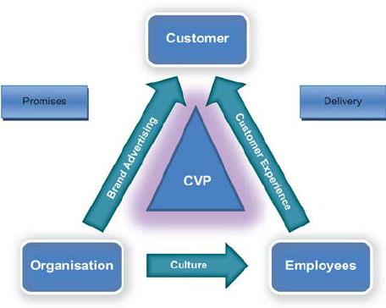

Fig – 8 : Total Engagement Model ( Roberts and Alpert, 2010)

CONCLUSION

To conclude McDonald's is currently one of the most important chains of fast food companies in worldwide. It is at the forefront of technological advances to provide better service to its customers, also its comprehensive marketing makes the brand is present through many channels, this being the way to reach the customer frequently and For short periods, there is one McDonald's for every 3 miles, so even drivers find it easier to see the yellow arches in their path.
McDonald's is fighting now is to combat the image of unhealthy that its products have because all health organizations that make bad campaigns. In November 2020 McDonald's launch that they will improve the quality of meats and menus in addition to this in 2021 McDonald's plans to introduce vegetarian products in its menus.

REFERENCE

Acquisition, M. a. t. d. m. p. c. e. w. t., 2019. retail costumer experience. [En línea]
Available at: https://www.retailcustomerexperience.com/news/mcdonalds-aims-to-drive-more-personal-customer-experience-with-tech-acquistion/

Aichner, t., 2017. Managing Customer Touchpoints and Customer satisfaccion.. International Journal of Industrial Engineering and Management..

Brown, S., 2016. Brand & Branding. london: s.n.

Dudovskiy, J., 2016. BRM. [En línea]
Available at: https://research-methodology.net/mcdonalds-marketing-communication-mix/

Fedaghi, S. A.-., 2012. Researchgate. [En línea]
Available at: https://www.researchgate.net/publication/272964534_A_Conceptual_Foundation_for_the_Shannon-Weaver_Model_of_Communication

Fill, C., 2009. Marketing communication, interactivit- communities and content. s.l.:s.n.

Kapferer, J. N., 2008. The new Strategic Brand Management. s.l.:s.n.

Kasi, 2018. Marketingmixx. [En línea]
Available at: https://marketingmixx.com/brand-equity-of-mcdonalds/

Keller's, 2019. Keaton Hawker. [En línea]
Available at: https://medium.com/@keatonhawker/kellers-brand-equity-model-what-it-is-how-to-use-it-84e42d562299

Kerri-Ann, 2001. Application of Keller's brand equity model in a B2B context, s.l.: s.n.

McDonald's, 2020. Corporate McDonal's. [En línea]
Available at: https://corporate.mcdonalds.com/corpmcd/investors/events-and-presentations.html

Muhammad Sabbir, N. H. a. M. A., 2019. Service Marketing strategic for small and medium enterprise. En: s.l.:s.n.

