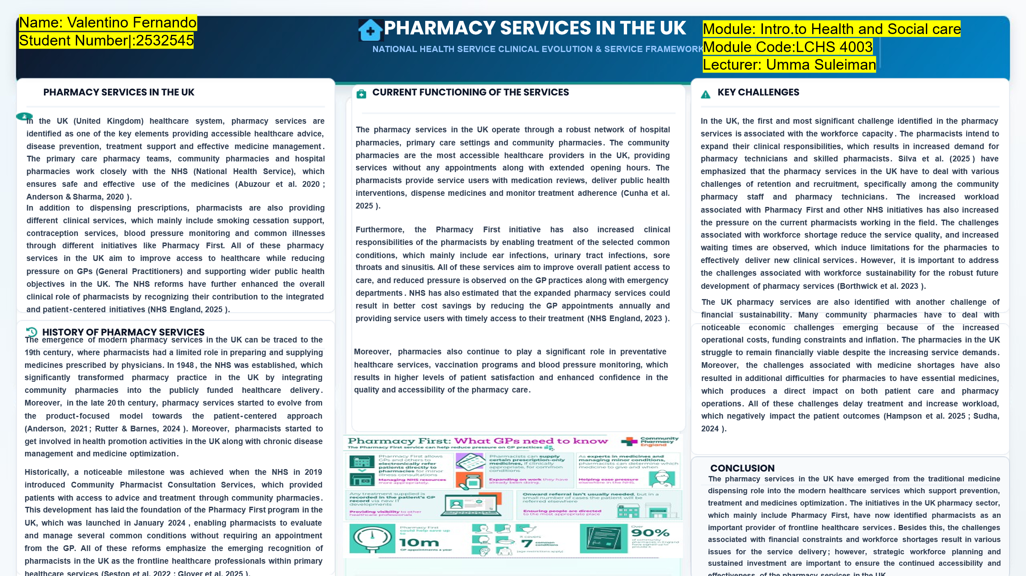

REFERENCES:

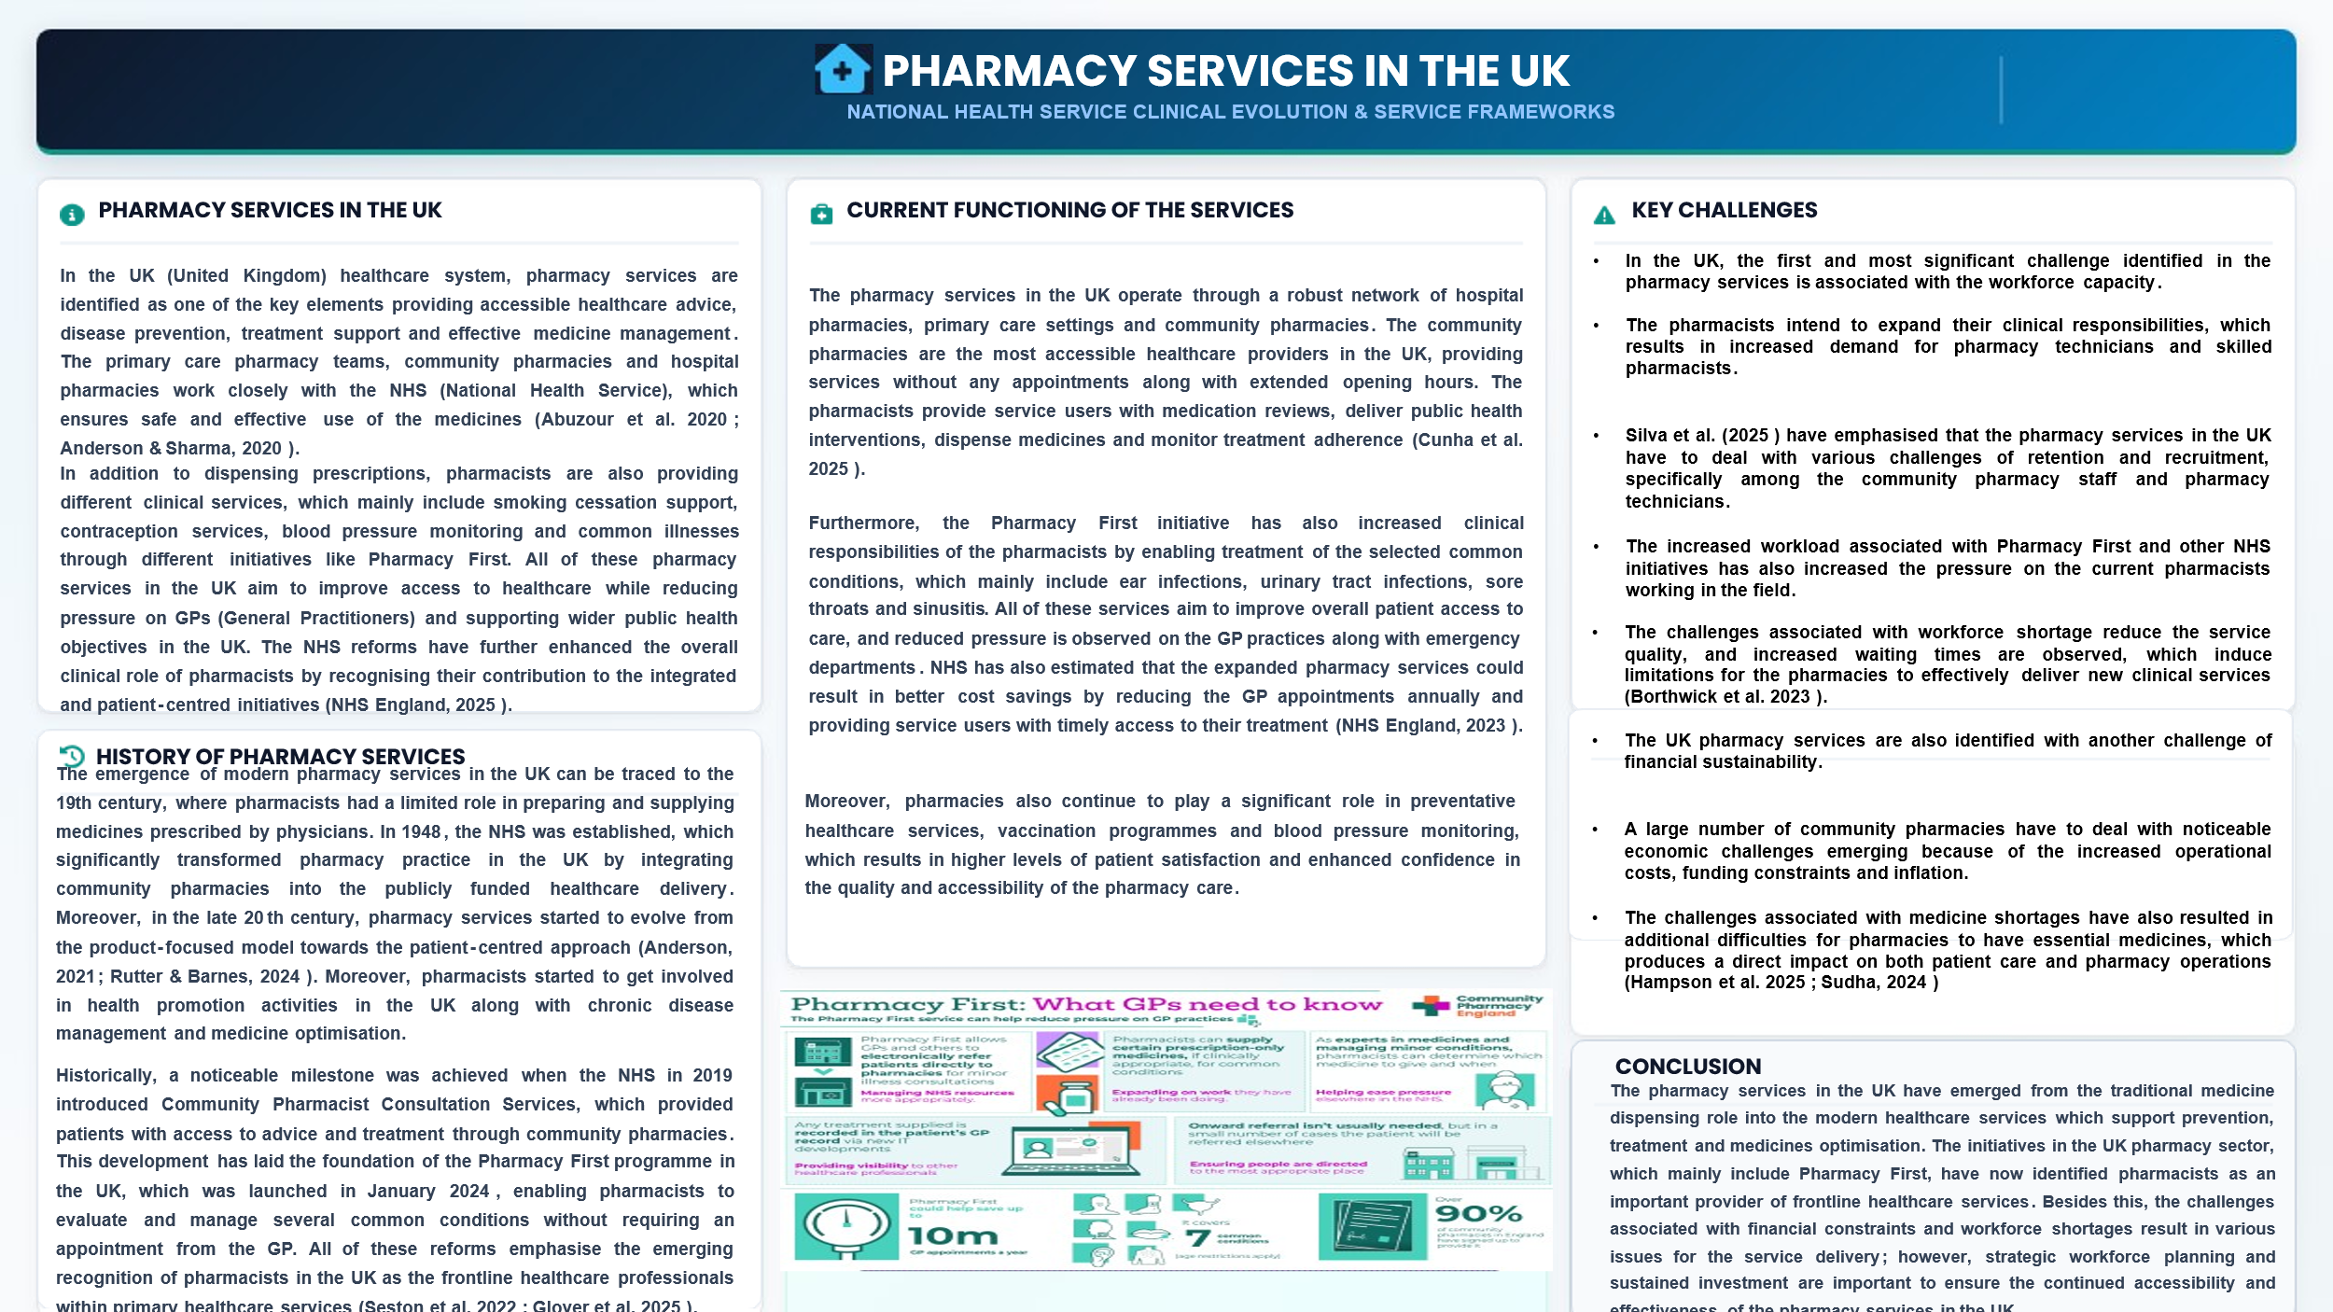Abuzour, A. S., Hoad-Reddick, G., Shahid, M., Steinke, D. T., Tully, M. P., Williams, S. D., & Lewis, P. J. (2020). Patient prioritisation for hospital pharmacy services: current approaches in the UK. European Journal of Hospital Pharmacy, 28(e1), ejhpharm-2020-002365. https://doi.org/10.1136/ejhpharm-2020-002365
Anderson, C., & Sharma, R. (2020). Primary health care policy and vision for community pharmacy and pharmacists in England. Pharmacy Practice, 18(1), 1870. https://doi.org/10.18549/pharmpract.2020.1.1870derson, C., & Sharma, R. (2020). Primary health care policy and vision for community pharmacy and pharmacists in England. Pharmacy Practice, 18(1), 1870. https://doi.org/10.18549/pharmpract.2020.1.1870
Anderson, S. (2021). Pharmacy and Professionalization in the British Empire, 1780–1970. Springer International Publishing. https://doi.org/10.1007/978-3-030-78980-0
Borthwick, M., Barton, G., Ioannides, C. P., Forrest, R., Graham-Clarke, E., Hanks, F., James, C., Kean, D., Sapsford, D., Timmins, A., Tomlin, M., Warburton, J., & Bourne, R. S. (2023). Critical care pharmacy workforce: a 2020 re-evaluation of the UK deployment and characteristics. Human Resources for Health, 21(1). https://doi.org/10.1186/s12960-023-00810-y
Cunha, G., Rodrigues, A. R., Bell, V., & Forrester, M. (2025). Exploring the Evolving Role of Pharmaceutical Services in Community Pharmacies: Insights from the USA, England, and Portugal. Healthcare, 13(15), 1786–1786. https://doi.org/10.3390/healthcare13151786
Glover, R. E., Lalani, M., Sonnex, K., Allen, T., Anderson, C., Ashiru-Oredope, D., Avery, A., Coupland, C., Elliott, R., Goulding, J., Higgins, H., Johnson, S., Mackenna, B., Muller-Pebody, B., O’Neill, S., Pacho, A., Taylor, A., Thornley, T., & Mays, N. (2025). A mixed methods protocol for an impact and implementation evaluation of the Pharmacy First Services for management of common conditions in England. International Journal of Pharmacy Practice, 33(2). https://doi.org/10.1093/ijpp/riaf004
Hampson, N., Fitzpatrick, L. M., & Eii, M. N. (2025). Pharmacy education for sustainable healthcare: a UK progress update and call to action. International Journal of Pharmacy Practice, 34(1). https://doi.org/10.1093/ijpp/riaf067
NHS England. (2023, May 9). NHS England» Delivery plan for recovering access to primary care. Www.england.nhs.uk. https://www.england.nhs.uk/long-read/delivery-plan-for-recovering-access-to-primary-care-2/
in Pharmacy Practice, 1(1). https:// NHS England. (2025). NHS England» Clinical Pharmacists. Www.england.nhs.uk. https://www.england.nhs.uk/gp/expanding-our-workforce/cp-gp/
Rutter, P., & Barnes, N. (2024). Facilitating self-care through community pharmacy in England. Exploratory Research in Clinical and Social Pharmacy, 13, 100404. https://doi.org/10.1016/j.rcsop.2023.100404
Seston, E. M., Anoliefo, C. J., Guo, J., Lane, J., Okoro Aroh, C., White, S., & Schafheutle, E. I. (2022). Community Pharmacist Consultation Service: A Survey Exploring Factors Facilitating or Hindering Community Pharmacists’ Ability to Apply Learnt Skills in Practice. Pharmacy, 10(5), 117. https://doi.org/10.3390/pharmacy10050117
Silva, V., Joaquim, J. J., Desselle, S., Quaye, S., & Matos, C. (2025). Safe Staffing Standards for Pharmacy Technicians in Hospital Settings. Journal of Market Access & Health Policy, 13(3), 45–45. https://doi.org/10.3390/jmahp13030045
Sudha, T. (2024). Strategic Financial Management for Pharmacies and Best Practices and Case Studies. IJRIPP-International Journal of Research and Innovations jagunifiedinternational.in/wp-content/uploads/2024/09/IJRIPP-Vol.11-4-June-2024.pdf

“COMMUNITY DISABILITY SERVICES IN THE UK”
Name: Valentino Fernando
Student Number:2532545
Module: Introduction to Health and Social Care
Module code: LCHS 4003
Lecturer: Umma Suleiman

Introduction
This essay is based on the evaluation of the Community Disability Services in the UK (United Kingdom). This essay has critically analysed its historical origins and policy development, influencing their development, and how these services are performing in modern practices, while discussing their contribution to improve the overall quality of life for individuals suffering from any disability. This essay has further emphasised both achievements and continuing challenges within service provision.

Main Body
In the UK, the development of community disability services is highly shaped by the noticeable changes in societal attitudes towards disability. Historically, individuals suffering from any disability were placed in institutional settings in which care was limited to medical treatment and supervision only (Macdonald, 2020). Furthermore, Zaks (2023) has emphasised that historically, disability in the UK was mainly understood through the medical model in which it is recognised as an individual issue which requires intervention. However, in the latter half of the 20th century, emerging criticism was observed towards institutional care, which led to a shift and an enhanced focus on community-based support. The disability rights movement in the UK advocated for social participation, independence and equality for individuals suffering from any disability. Moreover, legislative developments were also observed, which mainly include "National Health Service and Community Care Act 1990” and “Care Act 2014", which reinforced the principle that individuals are required to receive support within their communities (UK General Public Acts, 2010).
In the UK, the community disability services in the modern era play their role through strong collaboration between local authorities, voluntary organisations, healthcare services and social care providers. Shakespeare et al. (2021) have emphasised that in the UK, the community disability services provide individuals with a wide range of support, which mainly includes occupational therapy, employment support, personal care, rehabilitation, speech & language therapy, and housing assistance. The major strength of this current provision is its person-centred approach, which aims to involve the service users in the decision-making processes designed for their care and support plans. Alzughaibi (2024) has further highlighted that the integrated and multidisciplinary services significantly improve overall coordination among service providers and service users, thereby reducing the issues associated with service fragmentation and enhancing the overall user experience. Besides this, various challenges are also observed in the community disability services in the UK. These challenges mainly include the financial pressures on the local authorities and NHS (National Health Service), which noticeably contribute towards resource shortages, along with enhanced demands for services. On the other hand, issues associated with long waiting times, geographical inequalities and workforce shortages also deteriorate the efficiency of the community disability services in the UK because of the barriers observed in accessing timely support (Woolnough, 2024).
Lastly, community disability services in the UK play an important role in enhancing the overall quality of life of the service users. These services allow individuals to remain engaged within their communities while fostering dignity, social inclusion and independence. On the other hand, community disability services also provide personalised support to these individuals, through which disabled individuals can ensure effective participation in employment, community activities and education. Furthermore, the community-based interventions are also directly associated with enhanced psychological well-being, which results in stronger social relationships and increased self-confidence (Lee et al. 2021; Baskin et al. 2021). However, the community disability services play their role as a fundamental mechanism to support empowerment and participation among disabled individuals, which results in improved life outcomes.

Conclusion
Community disability services in the UK have emerged from institutional care models to person-centred and community-based systems that promote both independence and inclusion among disabled individuals. The current services in the UK are mainly focused on a multidisciplinary support aiming to enhance overall quality of life; however, various challenges are still persistently associated with service accessibility, funding and workforce capacity. By ensuring continued investment, sustained policy commitment and effective integration, all these challenges can be mitigated, and a high quality of life can be ensured for all service users.

References

Alzughaibi, M. (2024). THE IMPORTANCE OF INTEGRATING HEALTHCARE SERVICES IN THE SUCCESS OF THE TREATMENT PLAN. Gland Surgery, 9(2), 450–456. https://www.glandsurgery.net/index.php/GS/article/view/122
Baskin, C., Zijlstra, G., McGrath, M., Lee, C., Duncan, F. H., Oliver, E. J., Osborn, D., Dykxhoorn, J., Kaner, E. F. S., LaFortune, L., Walters, K. R., Kirkbride, J., & Gnani, S. (2021). Community-centred interventions for improving public mental health among adults from ethnic minority populations in the UK: A scoping review. BMJ Open, 11(4), e041102. https://doi.org/10.1136/bmjopen-2020-041102
Lee, C., Kuhn, I., McGrath, M., Remes, O., Cowan, A., Duncan, F., Baskin, C., Oliver, E. J., Osborn, D. P. J., Dykxhoorn, J., Kaner, E., Walters, K., Kirkbride, J., Gnani, S., & Lafortune, L. (2021). A Systematic Scoping Review of Community‐based Interventions for the Prevention of Mental Ill‐health and the Promotion of Mental Health in Older Adults in https://doi.org/10.1111/hsc.13413narratives of mental health service users/survivors accessing long term “treatment” in England. Journal of Criminological Research, Policy and Practice, 7(2), 179–194. https://doi.org/10.1108/jcrpp-02-2020-0027
Shakespeare the UK. Health & Social Care in the Community, 30(1), 27–57., T., Watson, N., Brunner, R., Cullingworth, J., Hameed, S., Scherer, N., Pearson, C., & Reichenberger, V. (2021). Disabled people in Britain and the impact of the COVID ‐19 pandemic. Social Policy & Administration, 56(1). https://doi.org/10.1111/spol.12758
UK General Public Acts. (2010). National Health Service and Community Care Act 1990. Legislation.gov.uk. https://www.legislation.gov.uk/ukpga/1990/19
Woolnough, S. (2024, January 10). Challenge And Change: What Does 2024 Hold For The Health And Care System? The King’s Fund. https://www.kingsfund.org.uk/insight-and-analysis/blogs/challenge-change-what-does-2024-hold-for-the-health-and-care-system
Zaks, Z. (2023). Changing the Medical Model of Disability to the Normalization Model of disability: Clarifying the past to Create a New Future Direction. Disability & Society, 39(12), 1–28. https://doi.org/10.1080/09687599.2023.2255926

