
Title: Understanding and Engaging in the Customer Experience
Module Code: BMSK5003
Tutor Name: Yajesh Kumar
Name of the Student: Nadira Akther
Student ID: 1605769

Introduction 1
Critical analysis of the factors that influence Zara’s ability to maximise customer value 2
1. Quality modules & standards 2
2. Customer Services 3
3. Customer value 4
4. Customer-centric focus 5
Ethical Considerations of Zara 7
Critical understanding of Zara’s quality processes and its effectiveness in meeting customer requirements. 9
Appreciation of quality control by Zara and its importance: 9
Evaluating the benefits & challenges of developing and maintaining good customer relationships. 11
Value & purpose of CRM for Zara 11
Buyer-seller relationship 12
Analysing the customer experience of Zara 13
Conclusion 16
References 17

Introduction
Due to fierce competition in the business world, organisations in all areas are embracing a customer-centric strategy to satisfy customers and optimise the customer experience (Webb, 2011). Customer experience requires a holistic approach including. Quality standards of an organisation; buyer-seller relationship, its customer centricity & services; value & purpose of CRM manage the customer expectations of a firm (Goodman, 2011). Zara has been selected as the company for analysing the factors that have an impact on the organisation's ability to enhance customer value and gain critical understanding of the effectiveness of organisations quality processes in meeting customer requirements. It is a Spanish fashion retailer founded in 1975 under the parent company, Inditex group. Having more than 2200 locations worldwide in 2017, Zara introduces at most 20 clothing collections per year (Zara.com, 2018).

Critical analysis of the factors that influence Zara’s ability to maximise customer value
Quality modules & standards, customer service, value and customer-centric focus help a firm to make sure good customer value (Gibbert, Woodside and Golfetto, 2011). According to DOLIGALSKI (2016), customer value can be defined as the receipt of getting the expected product quality at a competitive price. Scholars divided customer values into two types. The first one is perceived customer value and the other is desired customer value. The desired value is mainly based on what customer exactly want from a product and the perceived value is the customer reliance that they can be benefited by the product they had been received. If a company can maintain the quality of the products according to customer expectation, customer value can be highly perceived on a positive note (Mello, 2012). Zara has been selected as the firm to apply the analysis of the influential factors in enhancing customer value. Although Zara focuses on its product quality & services in maximizing customer value, there are other factors too in which the firm gives importance. They are analysed below.
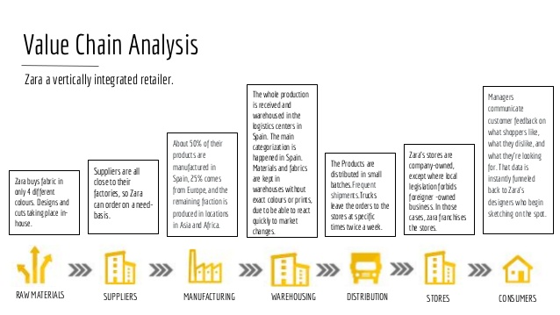
Figure 1: Quality control through a vertically integrated Value Chain (Michelli, 2012).
- Quality modules & standards
Standards and regulation are one of the most crucial parts of a business. To maintain and improve the existing quality, an organisation needs to update their business idea, plan and techniques based on the standards. For example, Zara monitors its business plans and asses the the developing process of its products through quality modules and standards (Michelli, 2012). This factor helps Zara to produce top class quality product and focus on the management of sustainability. Zara believes that it is only possible to maintain a top class quality when there is an appropriate control, maintenance of quality standards and an ideal environment available for producing a product. The firm believes that the quality of products can be maintained excellent consistently by following sustainable models and standards. The firm control & improves its value chain process and works on it in every detail from the very beginning to the end of a product life by following the quality standards. It also makes sure the product quality by choosing good ingredients for the products (Static.inditex.com, 2018). These initiatives reduce the manufacturing faults, helps the firm to execute plans properly and ensure the product quality effectively (McDonald, 2013).
- Customer Services
Quality customer service of Zara makes its customer value stronger by appreciating the product quality and the culture of the firm (Nickels, McHugh and McHugh, 2013). Even though it is neglected most of the time by many fashion retailer, nonetheless Zara considers customer services as the most basic element of its business. Under this factor, Zara tries to maximise the customer value by online inquiries, call centres to in-store staff, exchange of faulty dress and after sales services of its products (Shaw, 2013). The company tries to follow the basic criteria of customer value in providing customer services and the criteria are shown below.

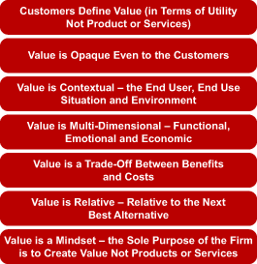
Figure 2: Fundamentals of customer value (Webb, 2011)
From the graph it can be said that customer value can be thought and perceived from different angle and perspectives. Zara focuses on understanding these perspectives and use them in providing services to the customers. Thus, the customer services of Zara are focused on the value based perspectives rather than just products or services.
- Customer value
Zara focuses on the fundamental components of customer value graph to identify what a customer expects from it (DOLIGALSKI, 2016). Generally, not all the time customer needs and expectation are visible. For that reason, Zara reads the customer mind by following the idea of customer vicinity. It also tries to understand the customer mind is through the delivery man or service staffs who are physically interacting with the customer. Zara also emphasizes on the customer value framework on understanding the customer value and it is analysed below.

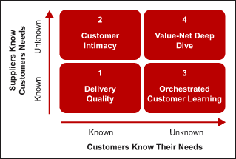
Figure 3: Customer Value Framework (Shaw, 2013).
The two dimensions discussed earlier can create the following four scenarios:
- Delivery quality: Providing good quality is the most fundamental requirement of apparel sector. For getting a better result on that, Zara has executed Radio Frequency Identification (RFID) technology that helped the firm to operate the store and manage products in a better way. This method enhances the customer services greatly. Not only that, by using the pilot project levels, customers also get to know about the company’s manufacturing process more details than before (Rajagopal and Castano, 2015). Through this process, the company-customer relation can be better. This mostly applicable to Zara’s men’s were such as Zara special Flowy Floral shirt, pants and Blazers.

- Customer intimacy: In this dimension, Zara's need to know their customers need properly. For this, they should apply the customer vicinity path which can be helpful to discover consumer mind. Zara already did a lot of things to identify the customer need. They launching a training programme where their employee can train themselves. This process basically based on believe and self-confidence where the trainee goes through a deep observing process to examine and identify the customer mind. Zara also gives extra importance and attention to this group of products. These products group are mainly for women such as Smocked Checked dresses, Asymmetric ruffled dresses etc.

- Orchestrated Customer learning: Here, the organisation needs to allow the customer to know the system through an organised customer learning process. To discover the hidden needs of a customer this process can be very much helpful. Zara taking some wonderful initiative and diplomatic tactics which is the basic elements of the strategy to go through their customer by this learning process. Mentioning the name of Henly T-shirt is the finest example for this dimension.
- Value-not deep dive: Circumstances is not always offered you a familiar situation. This is a situation where both the company and the consumer don't know exact demand, actual value and the consideration. For that, there is some lacking on balance relationship of consumer and the organisation. Zara and its consumer accept the fact that it may possible to don't know always customer value that provided by the organisation. Both of them believe is other capabilities help to run the process. Thus, the essential approach might be taken if there is a creation of any kind of need. Technical Fabric Sneakers, White Embossed Sneakers is a great example of this dimensions (Paluch and Blut, 2013).
Zara operates their business idea by centralized their customer. Zara tries to listen to their customer demand, desire and understand their expectation. After that, they delivered those message to the design team as soon as possible so that they can provide the ideal product according to their customer expectation. This is how Zara making their business policy effective by emphasised on customer service policy (Dukes and Zhu, 2016).

Customer-centric focus
Focusing on the good services according to the customer demands is the key goal of customer-centric strategy. Customer centricity influence a business to understand the needs, wants & demands of the customers while making decision from the starting point-point to after sales services within the organisation. A firm like Zara focus on offering positive experience during purchase, after sale services, latest trends customer loyalty & profits. Customer centricity influence Zara’s ability continuously to enhance customer value by offering what customers like and prefer. According to a recent survey, 58% of people think that being customer-centric is the most important characteristic for a business to establish a good customer experience (Jerger and Wirtz, 2017).
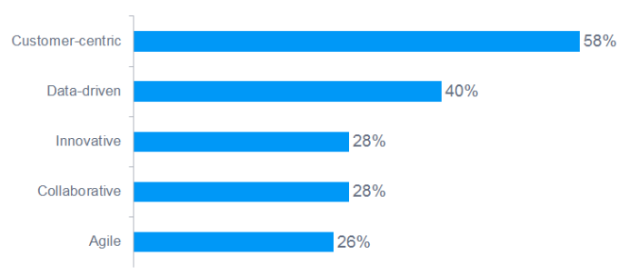
Figure 4: Result of the survey on what characteristics a business must contain for establishing a good customer experience (DOLIGALSKI, 2016).
Zara has made a great example for the fashion retailers on regarding keeping the customers in control & infuse them into the culture through understanding their needs and building seamless communication with them. The firm has made it possible by keeping the customers at the centre of company’s operational & marketing strategies. This is done by Zara through investing time and resources in understanding the real demands and preferences of the customers rather than predictinf traditional & seasonal trends. To do this Zara has invested heavily on attracting customers to their shops through promoting beauty, historical appeal & retail shops rather than investing huge amounts of money in the advertisements. Zara has created a brand image where customers perceive the firm as a combination of quality products, interactive & good stores full of convenience (Paluch and Blut, 2013).
Zara monitor the customer reaction, feedback and complaints carefully and seriously which is a great example of its customer-centric strategy. Through technology, employees and other ways, Zara makes notes of its customer interactions, activities and choices regarding their purchases. The report regarding the customer complaints and feedback are communicated to the staff & the headquarters (Paluch and Blut, 2013). These are used by the top management while devising the strategies for the offerings and customer services.

Ethical Considerations of Zara
As Zara is one of the most renowned and successful fast fashion retailers in the world, it does compromise to its ethical issues. Thus, the firm is identifying and addressing the ethical issues the fashion retilaers face in their operations. Through using these ethical issues, Zara has planned to solve them in its more than 2000 stores all over the world. As part of the strategy, the firm has developed a firm and transparent supply chain management. The firm has been able to ensure positive ethical conditions due to having 50% of its production plants closer to the headquarter in Spain. Thus, the firm has given its interested stakeholders opportunities to monitor the ethics issues and the implementation of total transperant SCM policies according to the adherence to the code of conduct (Paluch and Blut, 2013).
One of the most important characteristics of Zara as a fast-fashion apparel brand is its continued adherence to the sustainable apparel coalition. This particular alliance greatly requires the business organisation to greatly decrease the possible negative environmental and social impacts of the fast-fashion industry. This coalition requires Zara to reduce as much as possible the use of energy in the process of production and stores. Zara is also looking towards publishing sustainability goals, which has its aim that within 2020, the greenhouse gas emission will be reduced to 20% (Paluch and Blut, 2013).
Zara has boycotted Uzbek cotton and this decision has made Zara a positively oriented organisation (Jones, 2018). Zara has boycotted this organisation as there has been complaints about the company of having problems with child & adult forced labour. The promotion of sustainability through joining the Better Cotton Initiative is another example of the ethical consideration of Zara. Zara has strong policies regarding the health, safety and good practices for the workers in the production plant and cotton industry.
Under its ethical considerations, Zara has given environmental impact as its most important ethical priority. For this reason, the firm has taken initiatives to recycle the wastages and use them in the production process. This strategy is called “Closing the Loop” in Zara under which the firm focuses on repairing & reusing the old cloths and wastage (Jones, 2018). Zara encourages its customers to drop off their clothing & apparels to its stores for giving second life to their clothes. Zara has a vision of implementing strategy that will send nothing to the landfills from its plants, stores, head offices & logistics. Zara has targeted to reduce its carbon emissions to 15 percent within 2020 through strict guidance, measurement & reporting of the carbon emissions to support the Greenhouse Gas protocol(Aune, 2015).
The code of conducts of Zara regarding labour, manufacturing and supply conditions are considered good by the apparel industry. For this reason, Zara got A+ category in the ethical fashion report of 2018 in term of auditing, good relations with the suppliers and environmental policies (Martínez Barreiro, 2014). Under its strict ethical standards, Zara’s parent organisation, Inditext has implemented a strong control system to trace the exact sourcing of materials, production of the products and sourcing of other offerings. Child labour is banned in Zara and the firm takes strict action due to the negligence of this policy (Martínez Barreiro, 2014).

Critical understanding of Zara’s quality processes and its effectiveness in meeting customer requirements.
Inditex, which is a parent company of Zara is constantly making sure that its offerings must meet have a good quality and meet the stringent health & safety standards (Aune, 2015). According to a retail analyst CLSA, Zara has been able to succeed in the market long run of due to the quick response of its brand to the latest customer preferences by offering new and creative products to the store. The stringent testing of the products of different brands by Zara has helped the firm to offer high-quality products under its brands (Strategic quality management and quality costs, 2011).

Appreciation of quality control by Zara and its importance:
The success of the Apparel industry depends on controlling quality, as it is one of the crucial and important factors in choosing offerings by the customers. The apparel market is getting fierce and competitive with the passage of time with the addition of more small companies and Chinese brands. Thus, companies like Zara are putting emphasis on quality control and maintenance to create competitive advantage and differentiation of its offerings. Through quality control, Zara is making its business strategy successful by tailoring dresses and other products according to the needs & wants of its customers and current market trends. Exceeding the customer’s expectations is the main goal of quality process and control. Zara uses quality control assurance to reduce waste and, low-cost operation of the business and facilitate high levels of productivity.
Through implementing ISO 9001: 2015 in its quality control system, Zara has been able to provide a greater foundation to its business. The firm has achieved certification that it has used as a marketing tool. The quality control is providing the firm with numerous operational benefits. Zara always focuses on the quality of its products along with their designs. The improvements in quality are the main focus through using two ways. Zara uses quality control and quality assurance to maintain and improve its product quality (Gibbert, Woodside and Golfetto, 2011). Through these two techniques, Zara makes sure quality requirements & standards of the offerings. Under quality control, Zara makes sure the effective implementation of the operation to maintain quality standards. And in quality assurance, the firm checks and evaluate the implementation to check whether the products meet the quality requirements. These standard practices make sure quality standards and superiority of the end offerings of Zara. The operational management of Zara of controlling quality is given in the following.
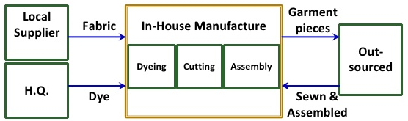
Figure 5: New operational management process to ensure quality by Zara (Zara.com, 2018)
Before assembling each component, methods and techniques are tested by Zara in the pre-production stage to avoid any form of errors quality faults in assembling. In its operational management, Zara checks, tests and find the quality situation of interlining, closures, sewing threads & other necessary design elements before construction. This operational process is followed to saves time & money, ensure the quality of the fabric and maintain quality control of the products. The business strategy of Zara has a rule that customers will not accept or appreciate the products if the fabric quality is not according to the customer’s demands. This situation prevails event it’d the products are well designed & constructed.
In addition, Zara maintains the availability of the most demand products in the stores throughout putting emphasis on the shorter lead times more. Customers find the needed clothes & apparels of same quality all the time due to this strategy of Zara. Instead of putting emphasis on the future demands of the apparels and clothes, Zara gives priority on the current demands and sales. Through this strategy, Zara differentiates itself as most of the companies spend considerable time in forecasting future demand of the customers (Strategic quality management and quality costs, 2011).
Moreover, Zara is using lower quantities strategy through maintaining scarce supply and reducing the quantity manufactured for the most demanding product. Zara uses this lower quantity strategy to reduce exposure of single product & artificial create scarcity. Under this strategy, the firm believes the products will be more desirable if the availability is lower. Loss of high inventory of an item due to lesser sales can be avoided by lower quantity strategy and it is another advantage of this strategy.
Zara offers ranges of styles under its quality control strategy. The firm produces ranges of styles instead of more quantities per styles. The number of styles produced amounts 12,000 a year. Zara has created a competitive advantage through this strategy. Through using this distinctive strategy, Zara can use new styles to fill up the self and increase sales if a style sells out quickly. Thus, Zara makes a good combination of quality, style and quantity strategy in its quality process to make sure healthy sales and customer satisfaction. This requires Zara to reach out to the customers with the right strategy at the right time (Martínez Barreiro, 2014).

Evaluating the benefits & challenges of developing and maintaining good customer relationships.
As Zara collects information of customers through CRM software, it has helped the firm to gain success by incorporating its CRM strategy. This strategy has helped Zara to understand the popular products & designers. The information is used to identify the latest trends, customer preferences and produce products quickly based on them.

Value & purpose of CRM for Zara
Providing the company with a good return on investment is the key value of CRM in Zara. The purpose of CRM of Zara is to capitalise the potential of the organisation fully, keep increasing clients, attract more leads & reduce costs. Penetrating the existing customer base is also the key purpose of Zara due to high costs of attracting the new customers (Gummesson, 2015).
Zara uses IDIC model in its CRM system to integrate the business functions, engage with the customer and generate value. Apart from this, making operations more distinctive and facilitating the familiarity of product & service to the customers are also crucial for Zara in maintaining a relationship with the customers under the implementation of the IDIC model. Zara follows four basic steps in the model and they are described below.
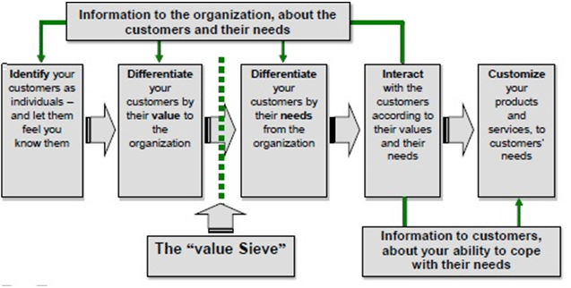
Figure 6: IDIC model of Zara (Michelli, 2012).
In the first stage, Zara identifies its core customers by considering each customer as an individual & gaining a detailed knowledge about them. Through doing this Zara has developed a database of its customers by segregating customer based on the differentiation of their tastes & visiting time. In the second stage, Zara has differentiated customers based on their future values for it. For example, the firm has few categories under the differentiation strategy such as super-growth, low maintenance, most growable and most valuable customers. Based on the categories, the firm has grown customers by offering price bundles for the “Most Growable Customers", special discounts for "Supergrowth customers" and after-sales services for low maintenance customers (Goodman, 2011).
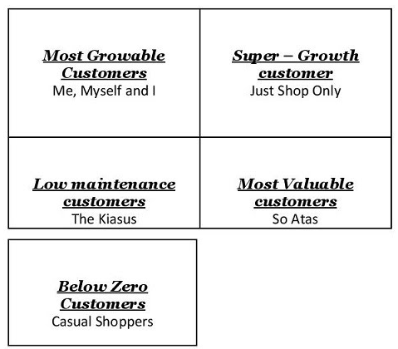
Figure 7: Numerous customer categories of Zara (Static.inditex.com, 2018)

Buyer-seller relationship
A good buyer-seller relationship is a prerequisite of developing good customer relationship management. Zara follows cos leadership strategy to provide quality offerings at lower prices (Leppard and Molyneux, 2016). To exploit low-cost structure of different countries Zara sources materials & products from different parts of the world. High turnover of products and Just-in-time (JIT) strategy have helped Zara to build a good seller-buyer relationship by efficient inventory management process. As Zara get big orders from the customers due to its good customer relationship, high sales volume of sales lowers the manufacturing costs. This helps Zara to build a good relationship with the buyers (Assael, 2011).
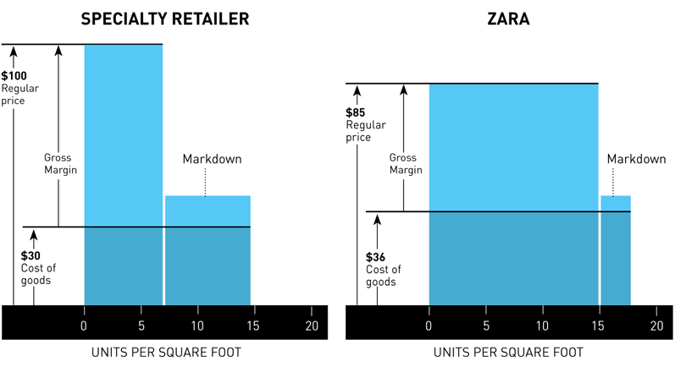
Figure 8: Zara's Competitive Economics
Zara has lower prices and costs per products compared to other rival companies. For this reason, the gross margin of Zara is 55 per cent greater & the sales are 20 per cent more units per square foot than its competitors. A great emphasis on the effective and good communication is also a reason for good seller-buyer relationship of Zara (Bishop, 2012). By keeping informed each other about every issue, Zara has created continuous trust and loyalty with the suppliers. The demand-driven approach of Zara helps the firm to understand the unique needs & wants of the customers by making good use of its unique communication strategy. The information of the customer needs and wants to be used in the design, production process, & distribution of the offerings (Buttle, 2017). Through hearing customers voice, the buyer-seller relationship is improved by Zara.

Analysing the customer experience of Zara
The most exciting opportunity and potential for the apparel firms nowadays is found Customer Experience according to a recent survey. Business firms like Zara working for improving customer experience regularly to enhance customer satisfaction rates, increase sales and reducing customer churn (Turban, 2011).
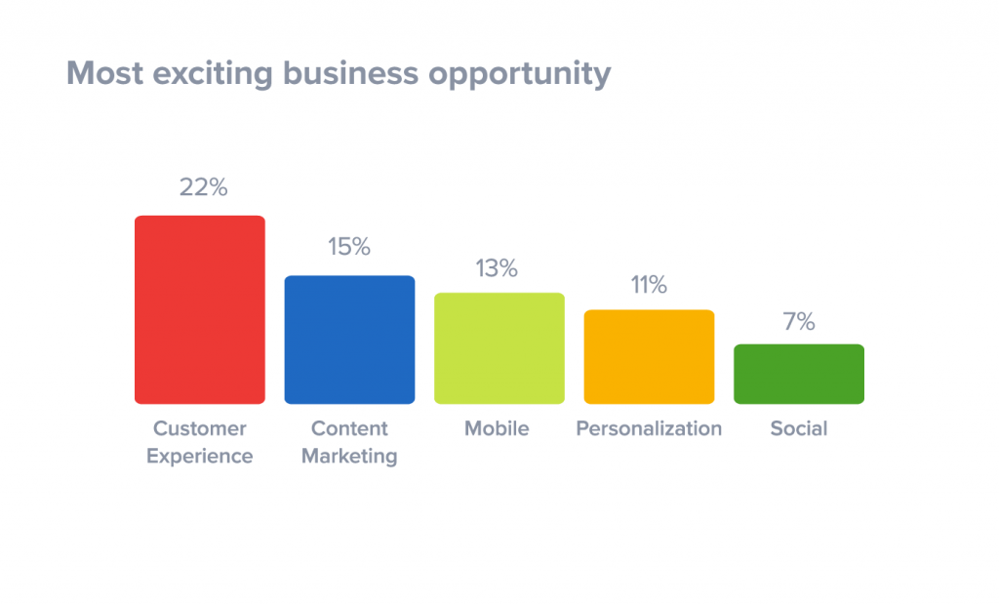
Figure 9: Most exciting business opportunities (Shapiro, 2013).
Zara uses 4Es of marketing to improve the customer experience. They are substituting products for customer experience; a distribution for every market, segment pricing for the products and promotion for evangelism (Zhao and Tao, 2012). By putting customers at the centre of the business strategy, Zara has used this strategy to managed customer’s expectations. Introduction of augmented reality experience in the stores is great example of this strategy where Zara used pull marketing strategy to increase customer curiosity and customer experience with the company. Zara, has been successful to manage the expectation of customers compared to its competitor H&M, which uses the push strategy to improve improve the customer experience. In the age of new retail economy, Zara has been successful to improve experience of the customers by capitalising customer’s priorities and using more radicalised 4E strategy (Trompenaars and Coebergh, 2013).
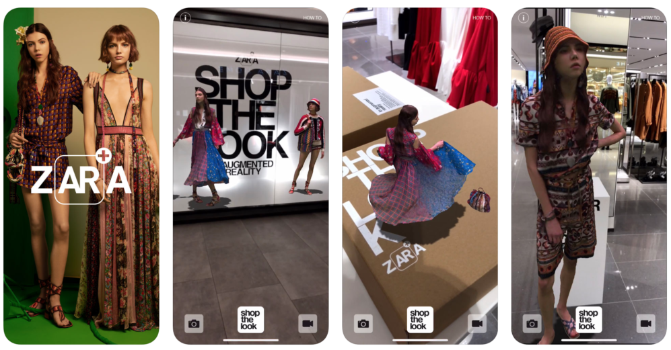
Figure 10: Augmented Reality Experience of Zara (Rajagopal and Castano, 2015).
Provision of great store experience is also one of the reasons that makes Zara one of the best apparel retailers and facilitate customers to visit to the stores & offering the hottest trends at an affordable price. Apart from providing great experience to the customers, Zara offers new offerings with sher creativity and facilitate the enhancement of loyal customer base. For this reason, customers of Zara visit the stores six times a year where customers of the competitors visit their stores two or three times per year. In addition, Zara offers frictionless shopping and new styles at a very highly curated rapidly. These unique strategies of Zara have allowed the firm to manage custoemr’s expectations efficiently and make the experience at store out of the box (Armstrong and Kotler, 2014).
Interactive services such as self-service checkouts and aiding technologies of Zara improve the customers’ experience in store and allowed them to skip the long waiting of in the queue by using do-it-yourself kiosks. Online order, click and collect & fitting room tech of Zara have reduced the lead-time in the ordering, increased the efficiency of the online ordering system, and offered the customers to coordinate & scan items easily in the store. Zara has created a competitive advantage over retail stores through providing uniqe features in the fitting room is through an innovative technology. These are strategies of Zara in its quality process. The goals of these strategies is the improve the quality process constantly and give customers uniqe experience. Althrough it requires high costs, extra sales and brand value covers the extra costs.

Conclusion
While evaluating the factors that influence Zara’s ability to render good services and the quality process of Zara, many strategies, factors and details of the customer experience at Zara have come out. The key finding is the customer centric focus of Zara and the initiatives of the firm to improve the customer experiences through creative products and various technologies. Customer value, services, appreciation, centricity and many other factors influence Zara’s ability to serve the customers and continuous focus on these factors influence the quality process of Zara. Zara maintain good buyer-seller relationship, adopt latest technologies and improve experience of the customers at stores to improve its quality process & it made the firm one of the most successful retailer in the appearel industry.

References
Armstrong, G. and Kotler, P. (2014). Marketing. Upper Saddle River, N.J.: Prentice Hall.
Assael, H. (2011). Consumer Behavior and Marketing Action. 5th ed. Cincinnati, Ohio: South-Western College Pub.
Bishop, T. (2012). Principles of Marketing Management (Online) New Delhi: World Technologies. http://www.tsd.ac.uk/en/lrc/onlineresources/e-books/ [Accessed 15 Dec. 2018].
Buttle, F. (2017). Customer relationship management. Oxford: Elsevier/Butterworth-Heinemann.
DOLIGALSKI, T. (2016). INTERNET-BASED CUSTOMER VALUE MANAGEMENT. [Place of publication not identified]: SPRINGER INTERNATIONAL PU.
Dukes, A. and Zhu, Y. (2016). Why Customer Service Frustrates Consumers: Exploiting Hassle Costs by a Tiered Customer Service Organization. SSRN Electronic Journal.
Goodman, J. (2011). Strategic customer service. New York: AMACOM.
Gibbert, M., Woodside, A. and Golfetto, F. (2011). Creating and managing superior customer value. Bingley: Emerald Group Publishing Limited.
Jerger, C. and Wirtz, J. (2017). Service Employee Responses to Angry Customer Complaints. Journal of Service Research, 20(4), pp.362-378.
Jones, R. (2018). Engineering Cheerful Robots: An Ethical Consideration. Information, 9(7), p.152.
Leppard, J. and Molyneux, L. (2016). Auditing Your Customer Service: The Foundation for Success. London: Routledge.
Longenecker, J. (2015). Small business management. Mason (OH): Thomson/South-Western.
Martínez Barreiro, A. (2014). Towards a New System for the Fashion Industry. The Zara Model. Revista Internacional de Sociología, LXVI(51).
McDonald, K. (2013). Crafting the customer experience for people not like you. Hoboken, N.J.: J. Wiley & Sons.
Mello, S. (2012). Value innovation portfolio management. Boca Raton, Fla.: J. Ross.
Michelli, J. (2012). The new gold standard. New York: McGraw-Hill.
Nickels, W., McHugh, J. and McHugh, S. (2013). Understanding business. New York: McGraw-Hill Irwin.
Paluch, S. and Blut, M. (2013). Service Separation and Customer Satisfaction. Journal of Service Research, 16(3), pp.415-427.
Rajagopal and Castano, R. (2015). Understanding consumer behaviour and consumption experience. Hershey, Pa: Business Science Reference.
Richter, R., Bindseil, U., Haucap, J. and Wey, C. (2016). Institutions in perspective. Tübingen: Mohr Siebeck.
Serafin, P. and Newaz, M. (2013). The Pharmacogenomic Consideration of Lipid Homeostasis: Role of Pharmacist in Ethical and Economic Consideration. Pharmacology &amp; Pharmacy, 04(01), pp.115-120.
Shaw, C. (2013). Revolutionize your customer experience. Houndmills, Basingstoke, Hampshire: Palgrave Macmillan.
Shapiro, B. (2013). Customer value. Stuttgart: Schäffer-Poeschel.
Static.inditex.com. (2018). The quality of our products | Inditex. [online] Available t: http://static.inditex.com/annual_report_2015/en/our-priorities/the-quality-of-our-products/ [Accessed 15 Dec. 2018].
Trompenaars, A. and Coebergh, P. (2013). 100+ management models.
Turban, E. (2011). Information technology for management. Hoboken, NJ: J. Wiley & Sons.
Webb, N. (2011). The digital innovation playbook. Hoboken, N.J.: Wiley.
Zara.com. (2018). ZARA Official Website. [online] Available t: https://www.zara.com/ [Accessed 15 Dec. 2018].
Zhao, B. and Tao, J. (2012). Ke hu guan xi guan li =. Beijing Shi: Jing ji guan li chu ban she.

