

Module : Data Handling and Business Intelligence
Module Code: LCBB5000
Lecturer: Dr Sadeque Shaikh

Student: Daniela Mihaela Visan
Student ID: 2247387

Contents
Introduction Page 3
Dataset Overview and Statistical Examination Page 3
Interpretation of Findings Page 3
SPSS Analysis: Correlation Page 4
Scatterplot Interpretation Page 5
Visualizing Data Using Excel Page 5
Conclusion Page 6
Tools Evaluation Page 7
Data Mining Cycle Page 8
Conclusion Page 9
References Page 10

Introduction
During my tenure at a leading research institution, I was entrusted with examining the "USA Housing Dataset" utilizing Microsoft Excel and SPSS. This dataset encompasses critical details about residential properties, including pricing, number of bedrooms, square footage, and other pertinent features. The primary aim of this analysis is to extract valuable insights that can assist stakeholders in comprehending market trends and property valuations. By harnessing Excel's visualization strengths and SPSS's statistical analysis capabilities, this report strives to deliver a comprehensive evaluation of the housing market.

Dataset Overview and Statistical Examination
The "USA Housing Dataset" offers a broad spectrum of information on residential properties. Below is an in-depth analysis of the dataset's statistical attributes, shedding light on its key variables:
- Mean value for price: The dataset indicates an average property price of $553,062.88. This figure represents the central tendency of property prices, reflecting the typical market value. However, it's important to recognize that the mean can be skewed by high-priced outliers present in this dataset.
- Median value for price: With a median price of $460,000, this metric serves as a more reliable indicator of central tendency. Unlike the mean, the median remains unaffected by extreme values, offering a clearer depiction of the standard property value within the dataset.
- Mode of the price: Notably, the mode, or the most frequently occurring price, is $0. This irregularity suggests potential data entry errors or unrealistic values, highlighting the necessity for data cleaning and preprocessing before conducting detailed analyses.
- Standard deviation for the number of bedrooms: A standard deviation of 0.90 for bedroom counts signifies minimal variability, indicating that most properties have a similar number of bedrooms. This uniformity may reflect standardized housing designs prevalent in the dataset's region.
- Variable with the largest variance: The price variable shows the highest variance, pointing to significant disparities in property values. This variability underscores the diversity in property characteristics and prevailing market conditions.
- Variable with the largest standard deviation: Similarly, the price variable also records the highest standard deviation, reaffirming its wide dispersion and the complex pricing dynamics within the housing market.

Interpretation of Findings
The statistical metrics derived lead to several key observations:
- Price Distribution: Comparing the mean and median prices reveals a positively skewed distribution, with high-priced properties elevating the mean. This pattern is typical in datasets featuring luxury or high-end properties.
- Data Irregularities: The mode value of $0 highlights potential inaccuracies that must be addressed during data cleaning to ensure precise analysis.
- Market Heterogeneity: The substantial variance and standard deviation in property prices reflect a heterogeneous market, where factors such as location, property size, and amenities contribute to price fluctuations.

SPSS Analysis: Correlation
Using SPSS, the correlation coefficient between price and bedrooms was calculated as 0.189. This indicates a weak positive correlation, suggesting that properties with more bedrooms tend to have higher prices, albeit not strongly.
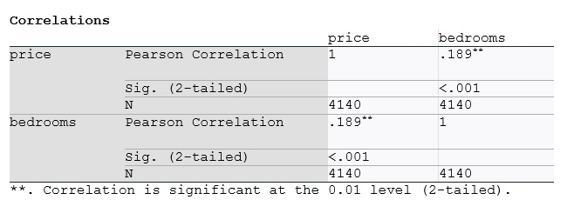
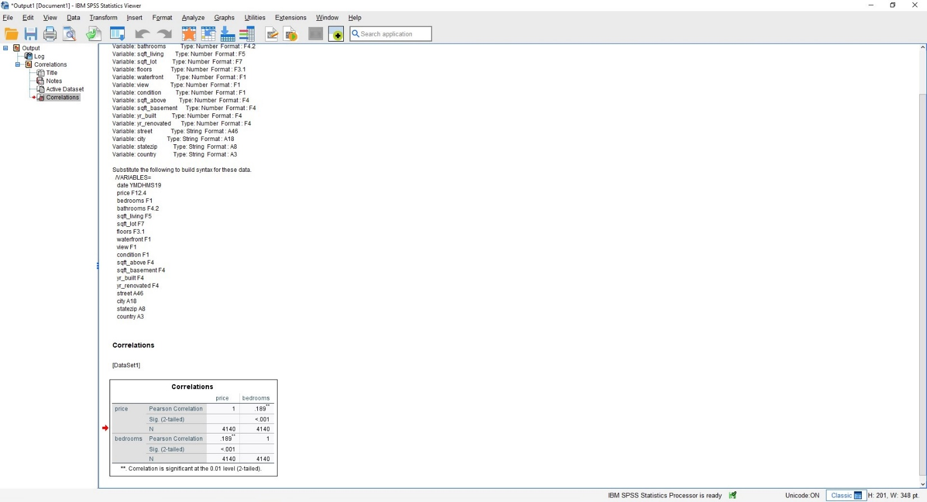
Scatterplot Interpretation:
The scatterplot of price (horizontal axis) versus bedrooms (vertical axis) further highlights the weak positive relationship. Most data points cluster within specific ranges, but a few outliers (e.g., extremely high-priced properties) are evident, reflecting the variability in the dataset.
These findings suggest that while the number of bedrooms slightly influences the price, other factors likely play a more significant role in determining property values.
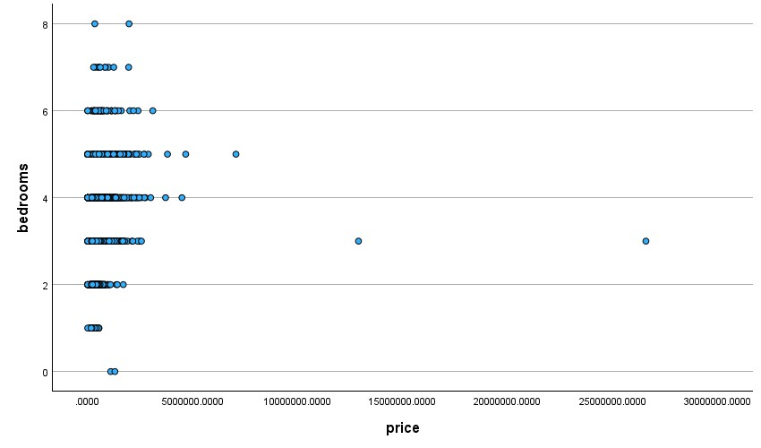
Visualizing Data Using Excel
To effectively communicate the findings, Excel is utilized for data visualization and computation using various features such as pivot tables, charts, and functions. Below is a description of key visuals:
- Bar Chart with Formulas: A bar chart was created to compare the number of bedrooms, average price, and the average price difference. This chart provides insights into how price trends differ with the number of bedrooms. The price difference line emphasizes deviations and patterns in the dataset.
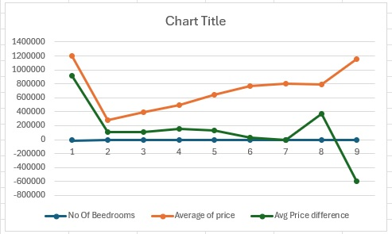

- Pivot Table: A pivot table aggregated average property prices by bedroom count, offering a concise summary of how bedroom numbers influence pricing. This analysis demonstrated that, while bedroom count affects prices, the extent of this effect varies across different property categories.
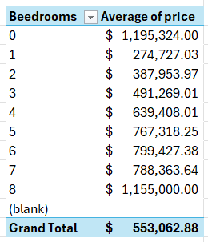

Conclusion
Before conducting any analysis, it's imperative to ensure the dataset's integrity. The presence of a mode value of $0 for property prices indicates potential data entry errors. Such anomalies can significantly skew results, leading to incorrect conclusions. Data cleaning involves identifying and rectifying these errors, handling missing values, and ensuring consistency across the dataset. Preprocessing steps may include normalization or standardization of data, especially when dealing with variables on different scales. For instance, square footage and number of bedrooms are on different scales and normalizing them can improve the accuracy of correlation analyses.
Exploring Additional Variables
Beyond bedrooms, other variables such as square footage, number of bathrooms, age of the property, and location (e.g., zip code) can provide deeper insights into property valuations. Analysing these factors can help determine their individual and combined impact on pricing. For example, larger square footage typically correlates with higher prices, but the rate of increase may vary based on location and property type.

The examination of the "USA Housing Dataset" yields critical insights into property pricing dynamics. While the number of bedrooms shows a weak correlation with price, other factors—such as square footage, location, and amenities—appear to exert a more substantial influence. The integration of Excel's visualization tools with SPSS's statistical analysis facilitated a thorough exploration of the dataset, providing valuable perspectives for stakeholders and decision-makers in the real estate market.

Section 2: Tools Evaluation
Comparison of Excel and SPSS
Reflecting on my journey through data analysis, I've had the opportunity to work extensively with both Microsoft Excel and SPSS. Each tool has its unique strengths and challenges, and navigating them has been both enlightening and, at times, demanding.

Microsoft Excel
Excel has been my go-to for initial data exploration. Its intuitive interface made it straightforward to input data, perform basic calculations, and generate quick visualizations. I recall working on a dataset where I needed to understand sales trends over several quarters. Using Excel's pivot tables, I could swiftly reorganize the data, allowing me to spot patterns that weren't immediately obvious. The ability to create various charts, like bar graphs and line charts, enabled me to present my findings in a visually appealing manner.
However, as I delved deeper into more complex analyses, I began to encounter some of Excel's limitations. For instance, when attempting to perform advanced statistical tests, I found myself constrained by the lack of built-in functions. There was a time when I needed to run a multiple regression analysis to predict future sales based on several variables. While Excel could handle simple regressions, setting up a multiple regression required manual calculations and workarounds, which was both time-consuming and prone to errors. Additionally, managing larger datasets became cumbersome, with the software slowing down and occasionally crashing, leading to frustration and lost work.

SPSS
To overcome these challenges, I turned to SPSS, a software specifically designed for statistical analysis. My initial experience with SPSS was akin to learning a new language. The interface was different from Excel, and the plethora of options was overwhelming. I remember spending hours going through tutorials, trying to grasp the basics of data entry and manipulation.
Once I became more comfortable, the power of SPSS became evident. Conducting complex analyses, such as factor analyses and ANOVAs, was more straightforward. For a research project, I needed to analyze survey data to understand the underlying factors influencing customer satisfaction. SPSS's factor analysis feature allowed me to identify these factors efficiently. Moreover, the software's ability to handle large datasets without significant slowdowns was a significant advantage.
Despite its strengths, SPSS wasn't without its challenges. The learning curve was steep, and I often found myself consulting forums and guides to understand specific functions. Additionally, while SPSS provided a range of statistical outputs, its data visualization capabilities were somewhat limited compared to Excel. There was an instance where I needed to present my findings to a non-technical audience, and I found myself exporting data back to Excel to create more polished and interactive charts.

Integrating Excel and SPSS
Over time, I realized that leveraging both tools in tandem allowed me to capitalize on their respective strengths. My typical workflow began with data cleaning and preliminary analysis in Excel. For example, I would use Excel to remove duplicates, handle missing values, and create initial summaries. Once the data was prepared, I would import it into SPSS for more rigorous statistical testing. This approach streamlined my analysis process and ensured that I utilized the best features of both platforms.

Data Mining Cycle
Engaging in data analysis projects also introduced me to the structured methodology of the data mining process.
Problem Definition: Every project began with a clear understanding of the question at hand. For instance, in one case, I aimed to determine the factors affecting employee productivity in a corporate setting.
Data Collection: Gathering relevant data was crucial. I sourced information from internal databases, employee surveys, and performance reports.
Data Preparation: This stage was often the most time-consuming. I spent considerable time cleaning the data, addressing missing values, and ensuring consistency.
Data Exploration: Using Excel, I would generate descriptive statistics and visualizations to get a sense of the data distribution and identify any anomalies.
Modeling: With the prepared data, I turned to SPSS to build predictive models. For the employee productivity project, I employed regression analysis to identify key predictors.
Evaluation: Assessing the model's performance was essential. I used SPSS to check for accuracy, validity, and any potential biases.
Deployment: Finally, I presented my findings to stakeholders, often using Excel to create comprehensive reports and dashboards that were easy to interpret.
Conclusion on tools evaluation.
Navigating the realms of Excel and SPSS has been a journey of growth and learning. Each tool has taught me valuable lessons about data analysis, from the importance of accurate data entry to the complexities of statistical modeling. While challenges were inevitable, they provided opportunities to develop problem-solving skills and adaptability. Today, I feel more confident in my analytical abilities, knowing that I can leverage the strengths of both Excel and SPSS to derive meaningful insights from data.

References
Pallant, J. (2020). SPSS Survival Manual: A Step by Step Guide to Data Analysis Using IBM SPSS. London: Open University Press.
Walkenbach, J. (2019). Excel 2019 Bible: The Comprehensive Tutorial Resource. Hoboken: Wiley.
Tableau Software. (2024). Tableau User Guide. Available at: Tableau Website.
Provost, F., & Fawcett, T. (2018). Data Science for Business: What You Need to Know about Data Mining and Data-Analytic Thinking. O'Reilly Media.
Camm, J. D., et al. (2019). Business Analytics. Cengage Learning.
Hair, J. F., et al. (2020). Multivariate Data Analysis. Pearson.
Kuhn, M., & Johnson, K. (2019). Applied Predictive Modeling. Springer.
Kelleher, J. D., Mac Namee, B., & D’Arcy, A. (2020). Fundamentals of Machine Learning for Predictive Data Analytics. MIT Press.

