Ozma Shazia Student ID 2438055
Lecturer: Ellie Ristic
Task 3 Reflective Journal
Module: Academic Skills LCLM4001
Date 20 July 2025

Content page

1 Introduction page 1
2 Description of Experiences Page 1 & 2
3 Analysis and Personal Reflection Page 3
4 Conclusion Page 4
5 Reference list Page 5

Introduction

This is a reflective journal in a report format about my feelings and experience as a first-year student on the Business Studies Course. The reflective journal will discuss the major impacts of the module on my learning, highlighting the positives and negatives of my development as a learner. Tarrant (2013, p. 61) states that the benefits of reflective practice are there to aid professional development and self-awareness. Gibbs' (1998) reflective model is used to outline my experiences, challenges and what I would change next time around (University of Cumbria, 2020).

Description of Experiences

Figure 1 University of Cumbria (2020)
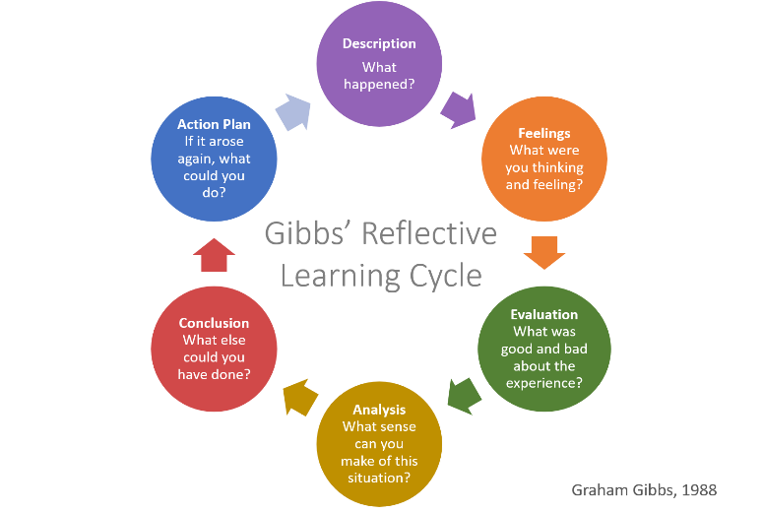

Figure 2 Jasper’s (2013) ERA model reflective Model
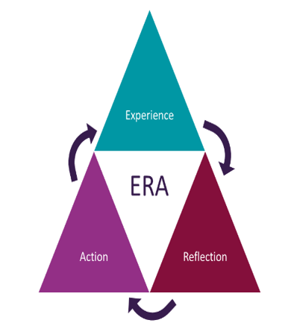
University of Hull (2024)

Figure 3. Driscoll’s What Model (2007)
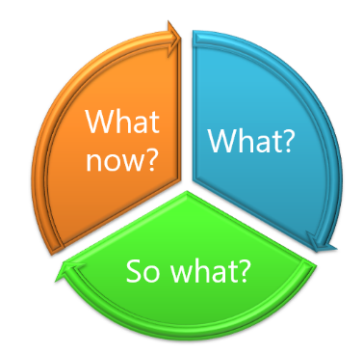
University of Edinburgh (2024)
In week nine, three reflective writing methods were explained that could help me to write my experiences, such as Driscoll's What model (2007), Jasper’s ERA model (2013. I prefer to use Gibbs' (1998) reflective cycle of six stages as shown in Figure 1 to write my report (University of Cumbria, 2020). This is useful for me to write my reflective report, although my writing can be in any order. I completed a task in Week 5's activity, which involved using the Teel and Peel evaluation of a paragraph. When discussing my answers with the teacher, it became confusing as the correct answers were presented haphazardly, which made no sense to me. In the evaluation, I have realised that I need answers in the right order, not in ABCD. I understand that I find it difficult to structure someone else’s work, except for my paragraph. In conclusion, this experience contributed to my understanding of the module by teaching me useful tools that helped me to write better and more effectively.
In Week Eight, I felt that I needed some alternative words in essay writing. I discussed essay structure and joining words with the tutor to help improve my writing skills. I was happy to learn about Thesaurus, as using the same words is reductive. Moreso, according to Elizabeth, Hanratty & Martin (2020), it is essential to plan and write a reflective essay with a concise structure. On evaluation, when I write a paragraph, I use Thesaurus to find alternative words with the same meaning. In conclusion, this can make it easy to read and follow; I can utilize these points in my essay to make for an interesting read.
I assessed my skills using an online tool regarding communication, Digital competence, referencing, research and note-taking. The questionnaire was designed to inform me of my weaknesses and strengths. I learned that my referencing skills are out of practice, the reason being that my last time of study was a year ago. My memory does not retain as much information as it did when I was younger. The analysis demonstrated that I was good at using Microsoft software at an advanced level. It provided a useful evaluation of self-awareness and advisories. Brain training exercises are useful to train my brain to retain the information I find

Analysis and Personal Reflection
Upon my analysis, the ready-made PowerPoint presentations and answers to quizzes could be presented in a user-friendly manner. Using TEEL, the answers should be T was this sentence, not A was this sentence. It threw off my cognitions, so I have learned that I prefer answers to quizzes in the correct sequence. My knowledge about the module increased as I enhanced my study skills, such as structuring academic work and writing, which enables success. One of the strengths of TEEL I was able to improve my written layout. Upon reflection, I could have spent more time putting into practice what I learned so that it stays embedded in memory.
Week one taught me that Time Management strategies are a useful skill to study, especially when I have assignment deadlines (Nancholas, University of Lincoln,2023). I can reduce my stress levels, set myself targets, be more organised, and decrease procrastination. The method is useful because I can go off track as I prioritise playing with my cats. According to Moore et al (2010), there are various methods, such as SMART, which are useful to help me organise myself. These strategies were part of my revision for Task One and Task Two, which I memorised by repeatedly writing down and checking my answers.
Moore et al (2010) outline tools that can be used to make use of your time while you study. To conclude, the recommendations are useful, SMART, 4D’s Strategy and Eisenhower Matrix. They helped me to achieve my study goals and ensure my time is optimised, leaving me less stressed through managing my time effectively.
The critique of Time Management Strategies is that they can work effectively for a student who lives with parents. As for me, who has a household to run, such as paying the mortgage and caring for my son, studying takes second place. Sometimes I could use it in my life, but life has unexpected trials and tribulations that can throw your plans off course. Sometimes things do not go to plan, however, it makes for a great study tool, it helps me to be aware of my obstacles and what I can use to help me (Moore et al, 2010).
The program has been an interesting journey, teaching me tools that I didn’t know existed, such as note-taking, referencing, paraphrasing and summarising. On the flip side, how often can I sit down to implement the time strategy? If I sit down to do my assignment, my dog head-butts my hand off the laptop to stroke her instead. Upon reflection, I can find a room away from my pets or start my assignment when I am given the brief. Furthermore, I could stay behind in class and do a paragraph each week instead of overwhelming myself in one go. I can reflect on my past mistakes and understand what I must do to avoid repeats.

Conclusion
I find that the module has improved my student experience and taught me Time Management Strategies, adjoining words, Teel and Peel. This has given me knowledge and new skills in planning and structuring. It has shifted my learning style to be open to ideas and theories. This module has shown me that there is more to learning and application than I knew. The module helps students to improve their understanding and skill set, especially with great teachers. In the future, I would recommend that PowerPoint presentations be more user-friendly.

Reference

University of Cumbria (2020) ‘Gibbs Reflective Cycle. ‘Available at: https://my.cumbria.ac.uk/media/MyCumbria/Documents/ReflectiveCycleGibbs.pdf (Accessed:01 July 2025).

Moore, S., Colin, N., Murphy, M., and Connolly, C (2010) The Ultimate Study Skills Handbook, Maidenhead: Open University Press.

Nancholas, B. (2023) The power of effective time management, University of Lincoln. The power of effective time management - University of Lincoln (Accessed 11 June 2025)

Tanguay Elizabeth, Hanratty, P. and Martin, B. (2020) Reflective writing for nursing, health and social work. 1st ed. London, England: Red Globe Press.

Tarrant, P. (2013) Reflective practice and professional development. First edition. Los Angeles, [California: Sage.

University of Edinburgh (2024) What? so what? now what? : Reflection Toolkit. Available at: https://reflection.ed.ac.uk/reflectors-toolkit/reflecting-on-experience/what-so-what-now-what (Accessed: 28 July 2025).

University of Hull (2024) Reflective Writing ERA: Available: ERA - Reflective writing - Library at University of Hull (Accessed: 01 July 2025)

