

Problem Solving and Decision Making

Module Code: BMSW4004
Student Name: Mariana Dzharova
Student Number: 2129921
Lecturer’s Name: Balendran Kandasamy

Report Title:
High Employee Turnover Rate in
McDonald’s – Sittingbourne 2

Table of Contents
INTRODUCTION 3
Company Overview 3
The Workplace Problem: High Employee Turnover Rate 4
ANALYSIS OF THE PROBLEM: 4
Fish bone analysis 4
Root Causes of the Problem 5
PESTLE Analysis to Provide Context for Change to Solve the Problem: 7
RANGE OF ALTERNATIVE SOLUTIONS 8
Solution 1: Better Pay 8
Solution 2: Employee Recognition 8
Solution 3: Flexible Working Schedule 8
EVALUATION OF ALTERNATIVE SOLUTIONS 8
IMPLEMENTING THE SOLUTION 9
COMMUNICATE THE PLAN WITH THE STAKEHOLDERS: 10
Influence/Power Matrix and Interest Needs 11
Stakeholder Engagement Plan 11
CONCLUSION 12
REFERENCES 13

INTRODUCTION
Importance of problem-solving skills

Problem-solving is the process of observing what is going on in your environment, identifying the things that can be improved, diagnosing the current state of the environment as well as the factors that may influence it and developing alternatives to influence positive change (Stottler, 2022). Problem-solving is a valuable employability skill because it allows people to organise their time more effectively, to prioritize, plan and execute strategies, to think outside the box, to work under pressure and to resolve problems that disturb the normal working environment. The people that have good problem-solving skills usually have a combination of analytical, creative and critical thinking skills that allow them to identify the most effective solutions.

Company Overview

McDonald’s is an American multinational fast food chain industry that was found in 1940 by Richard and Maurice McDonalds in San Bernardino, California. The business started as a small restaurant that offered cheap yet delicious burgers. Few years later, the business was turned into a franchise and the Golden Arches logo was introduced in 1953. Today, McDonald’s is the world’s largest fast food restaurant chain as it serves almost 70 million customers per day in over 100 countries via more than 40,000 restaurants. McDonald’s is best known for its hamburgers, cheeseburgers and French fries.

The Workplace Problem: High Employee Turnover Rate in McDonald’s Sittingbourne 2

The employee turnover rate measures the total number of workers that leave a company within a certain period of time (Holliday, 2021). The employee turnover rate is a complex problem that is found in Macdonald’s Sittingbourne 2. Despite its huge success story, McDonald’s Sittingbourne 2 is experiencing an alarmingly high employee turnover rate.

High employee turnover rate in McDonald’s Sittingbourne 2 is problematic because it has a direct impact on the company’s revenue and profitability for several different reasons. Firstly, McDonald’s Sittingbourne 2, have higher recruitment costs because they have to hire new employees more often. This also leads to higher training costs because all new employees need to be provided with an induction training that will help them to adjust to their new position. They also experience lower motivation and productivity rates because the employees do not work long enough in order to master the skills needed for their job role. The lower productivity rate has a direct impact on the financial performance of the business and limits its growth potential as well. In addition to this, a low employee turnover rate may also lead to a low workplace morale and to a deteriorating product and service quality (Markovich, 2019).

ANALYSIS OF THE PROBLEM

ROOT CAUSE ANALYSIS (RCA)

The first step to solving a complex problem which is High employee turnover rate in McDonald’s Sittingbourne 2 is to identify the possible causes of the complex problem including possible root causes. This will allow us to design a more specific solutions that will be more effective as well.

Fish bone analysis

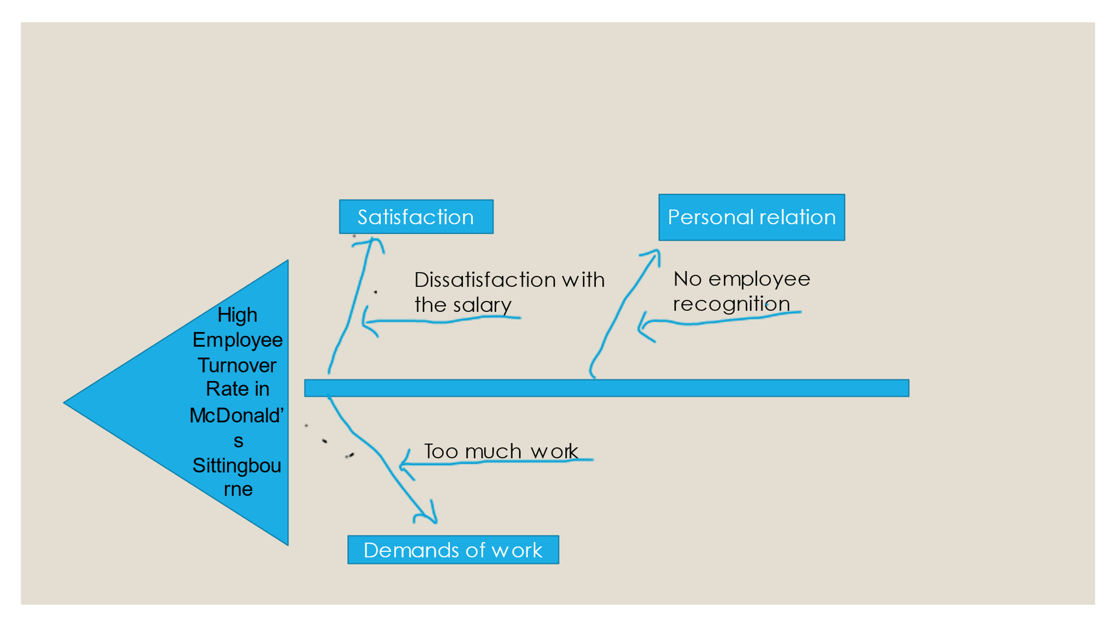
Figure 1: High Employee Turnover Rate in McDonald’s Sittingbourne 2 (by myself)

Root Causes of the Problem

This Fish bone diagram shows three possible causes that may increase the employee turnover rate of a business. They are personal relations, satisfaction, demands of work.
Also, we can identify three possible root causes that may increase the employee turnover rate of a business.
They are:
- Dissatisfaction with salary – low pay is one of the most important root causes why employees decide to leave their jobs.
- No recognition – the lack of recognition schemes such as ‘the employee of the month’ can lead to a higher employee turnover rate because people want to be recognised for their achievements. That is second identified root cause why the lots of employees chose the leave their job in McDonald’s Sittingbourne 2.
- Too much work (being overworked) – burnout happens when the employees are asked to do too many things without being the resources to succeed. This leads to more stress that causes emotional and physical exhaustion. That is another identified rood cause why the employee left their job.

APPLYING SITUATIONAL ANALYSIS MODELS

PESTLE Analysis to Provide Context for Change to Solve the Problem

Political and Legal Factors | - McDonald’s Sittingbourne 2 needs to comply with governmental policies and laws.  - The political of the town Sittingbourne may also affect the business.
Economic Factors | - The high inflation and the raising living costs may require people to look for second jobs in order to be able to support themselves.  - Many businesses did not survive the Covid-19 pandemic, which has increased the unemployment rate in the town.
Socio-Cultural Factors | - People are looking for more flexible jobs.  - The UK is a diverse country so, McDonald’s Sittingbourne 2 must be able to accommodate the needs of people from different backgrounds.
Technological Factors | - New technologies such as social media could made job advertisement easier than ever.  - Technological advancements could also improve the efficiency of recruitment processes as some stages have become automated e.g., CV shortlisting.
Environmental Factors | - Businesses are facing a growing pressure to become more environmentally friendly. If McDonald’s Sittingbourne 2 takes steps to reduce its footprint on the environment, the business will improve its image, which will help it to attract more clients.

RANGE OF ALTERNATIVE SOLUTIONS

Unfortunately, there is not single solution that can solve all the root causes that are identified by the fish bone diagram. So, suggest three alternative solutions that can be made to combat with the root causes.

Solution 1: Better Pay
The better pay is the first solution suggest that the employees in McDonald’s Sittingbourne 2 would prefer to stay on their job despite other root causes (too much work and no recognition) that they want to leave the job. In addition, the better pay is the biggest reason why an employee works for a long period of time in the same company. Although fast-food companies attract workers that have a limited skillset and may leave the company as soon as they graduate, offering them a better pay may motivate them to stay. Offering a better pay may also attract older applicants who are looking for stable long-term job (Brookins, 2011).

Solution 2: Employee Recognition
Implementing a recognition scheme such as ‘the employee of the month’ may be sufficient to motivate some of the employees to stay with the company because such schemes will show them that the company will recognise them for their hard work (Brookins, 2011). Celebrating the accomplishment of workers will also make them more committed to the business because it will make them feel that they are contributing to the overall success of the business on McDonald’s Sittingbourne 2. Also, recognition schemes ‘the employee of the month’ give the employees a reason to stay connected with their respective jobs because the recognition represents the respect that they work hard. This does not only make the employees to feel more valued, but it also encourages them to perform better and to give their best each day for the McDonald’s Sittingbourne 2.

Solution 3: Flexible Working Schedule
By offering a more flexible working schedule the business will improve the work-life balance of McDonald’s current employees, which may be sufficient to motivate them to stay (Brookins, 2011). Moreover, offering a more flexible working schedule may also attract more people who are looking for second jobs or people who struggle to find a job that they can find around their other responsibilities. This people can help to main employees with their work. For example, if McDonald’s Sittingbourne 2 can tailor a working schedule that fits perfectly around school times, the business will attract many mothers who are unable to work other shifts or cannot work full time job due to lack of childcare. Also, the flexible working schedule suggest les working hours per day that is related with more people to do more things and that could avoid being overwork. Offering a more flexible working schedule seems the most appropriate solution to the problem for two main reasons. Firstly, students and younger adults are more likely to stay at jobs that fit around their other responsibilities such as university. Secondly, the PESTLE analysis discovered that the rising cost of living is forcing people to find secondary jobs to support themselves and their families. Therefore, by offering flexible working hours, McDonald’s Sittingbourne 2 will be able to attract applicants from a completely different way such as people who are looking for a second part-time job and mothers who are looking to work while their children are at school. These types of people are likely to apply and stay at the job for a longer period of time despite the lower pay because there are not many employers that are willing to adjust to the lifestyle of the workers.

EVALUATION OF ALTERNATIVE SOLUTIONS

There have suggested three alternative solutions that could solve the complex problem in McDonald’s Sittingbourne 2 which is High Employee Turnover Rate, also, to eliminate the identified the root causes.

FACTORS | SOLUTION 1 | SOLUTION 2 | SOLUTION 3 | WEIGHT
Cost | 4 x 4 = 16 | 4 x 4 = 16 | 5 x 4 = 20 | 4
Dissatisfaction with salary | 5 x 5 = 25 | 5 x 5 = 25 | 4 x 5 = 20 | 5
No recognition | 4 x 3 = 12 | 5 x 3 = 15 | 3 x 3 = 9 | 3
Too much work (being overworked) | 5 x 4 = 20 | 4 x 4 = 16 | 3 x 4 = 12 | 4
TOTAL: | 73 | 72 | 61

Weighted decision-making matrix shows the higher score is the more effective solution. In this case, better pay, the first solution with 73 points has the greatest chance of combating with the complex problem in McDonald’s Sittingbourne 2 because it will provide the employees with better salary. The “more money” will motivate the employee to do the best job every single day and also, they will prefer to stay for long time in the same business McDonald’s Sittingbourne 2.
Then we can see the second solution, employee recognition with 72 points can create competition between the employees to have recognition schemes ‘the employee of the month’. This implies that the workers would like to stay for longer period of employment in the same business. The difference between solution 1 and solution 2 is a very small it is only one point.
And the last solution is this case is Flexible working schedule is low solution with 61 points to allow the complex problem in McDonald’s Sittingbourne 2.

IMPLEMENTING THE SOLUTION

As we see from above Weighted decision-making matrix, the solution with high points is Better pay which will fix the complex problem in McDonald’s Sittingbourne 2. In order to properly implement this solution and make this solution a Gantt Chart will be used. Five activities are planed that will keep all project participant on the right track.

Gantt Chart
TASK | ACTIVITY | PREDECESSOR | DURATION
1 | Introduce the idea to the shareholders/ directors | 1 | 1
2 | Identify the job roles that should offer a better pay | 1 | 2
3 | Inform the current employees of the change | 2 | 1
4 | Design a scheme ‘the employee of the month’ | 3 | 2
5 | Recruit new workers to fulfil empty spots. | 4 | 4

COMMUNICATE THE PLAN WITH THE STAKEHOLDERS

The main stakeholders that may be affected by the solution are:
- Shareholders – high power – high interest.
- Managers – high power – low interest.
- Employees – low power – high interest.
- Supplier – low power – low interest.
- Costumers – low power – low interest

Influence/Power Matrix and Interest Needs

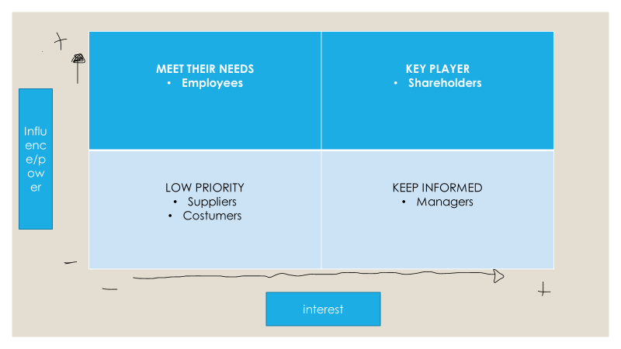

Stakeholder Engagement Plan

Stakeholder | Power | Key Interest & Issues | Communication Vehicle | Frequency | Comments
Shareholders | High | To decrease the employee turnover rate | Meetings | Monthly
Managers | High | To decrease the employee turnover rate | Meetings | Monthly
Employees | Low | To have a better work-life balance | One-To-One with Manager | Monthly
Suppliers | Low | To go through the delivery procedure quicker. | Email | One-Off

CONCLUSION

McDonald’s Sittingbourne 2 high employee turnover rate is problematic because it has a direct impact on the financial performance of the business. The high employee turnover is caused by dissatisfaction with the salary, poor working conditions, luck of employee recognition and long working hours and. It is important to make improvements in an attempt to reduce the employee turnover rate because a lower employee turnover rate can reduce the recruitment, training and operational costs of the business. One of the best solutions to the problem is better pay because it will motivate more of the workers to stay and it will attract applicants from different segments that are looking for additional, long-term jobs.

REFERENCES

Brookins, M. (2011). Ways to Prevent Employee Turnover in Fast Food Restaurants. [online] Chron.com. Available at: https://smallbusiness.chron.com/ways-prevent-employee-turnover-fast-food-restaurants-10277.html [Accessed 13 Apr. 2023].
Corna, H.M. (2021). Is Money the Biggest Motivator for Employees? [online] www.linkedin.com. Available at: https://www.linkedin.com/pulse/money-biggest-motivator-employees-hilary-m-corna [Accessed 13 Apr. 2023].
Holliday, M. (2021a). The What & Why to Employee Turnover. [online] Oracle NetSuite. Available at: https://www.netsuite.com/portal/resource/articles/human-resources/employee-turnover.shtml [Accessed 13 Apr. 2023].
Markovich, M. (2019). The Negative Impacts of a High Turnover Rate. [online] Chron.com. Available at: https://smallbusiness.chron.com/negative-impacts-high-turnover-rate-20269.html [Accessed 13 Apr. 2023].
Stottler, W. (2022). What is problem solving and why is it important. [online] Kepner Tregoe. Available at: https://kepner-tregoe.com/blogs/what-is-problem-solving-and-why-is-it-important/ [Accessed 13 Apr. 2023].
‌

