How Attachment affects emotional development

Attachment can affect a child’s development, relationships and their well-being. Attachment issues can develop in young children. Children who experience attachment issues it can affect their ability to express emotions, trust, confidence, build resilience and enjoy happy relationships with others.
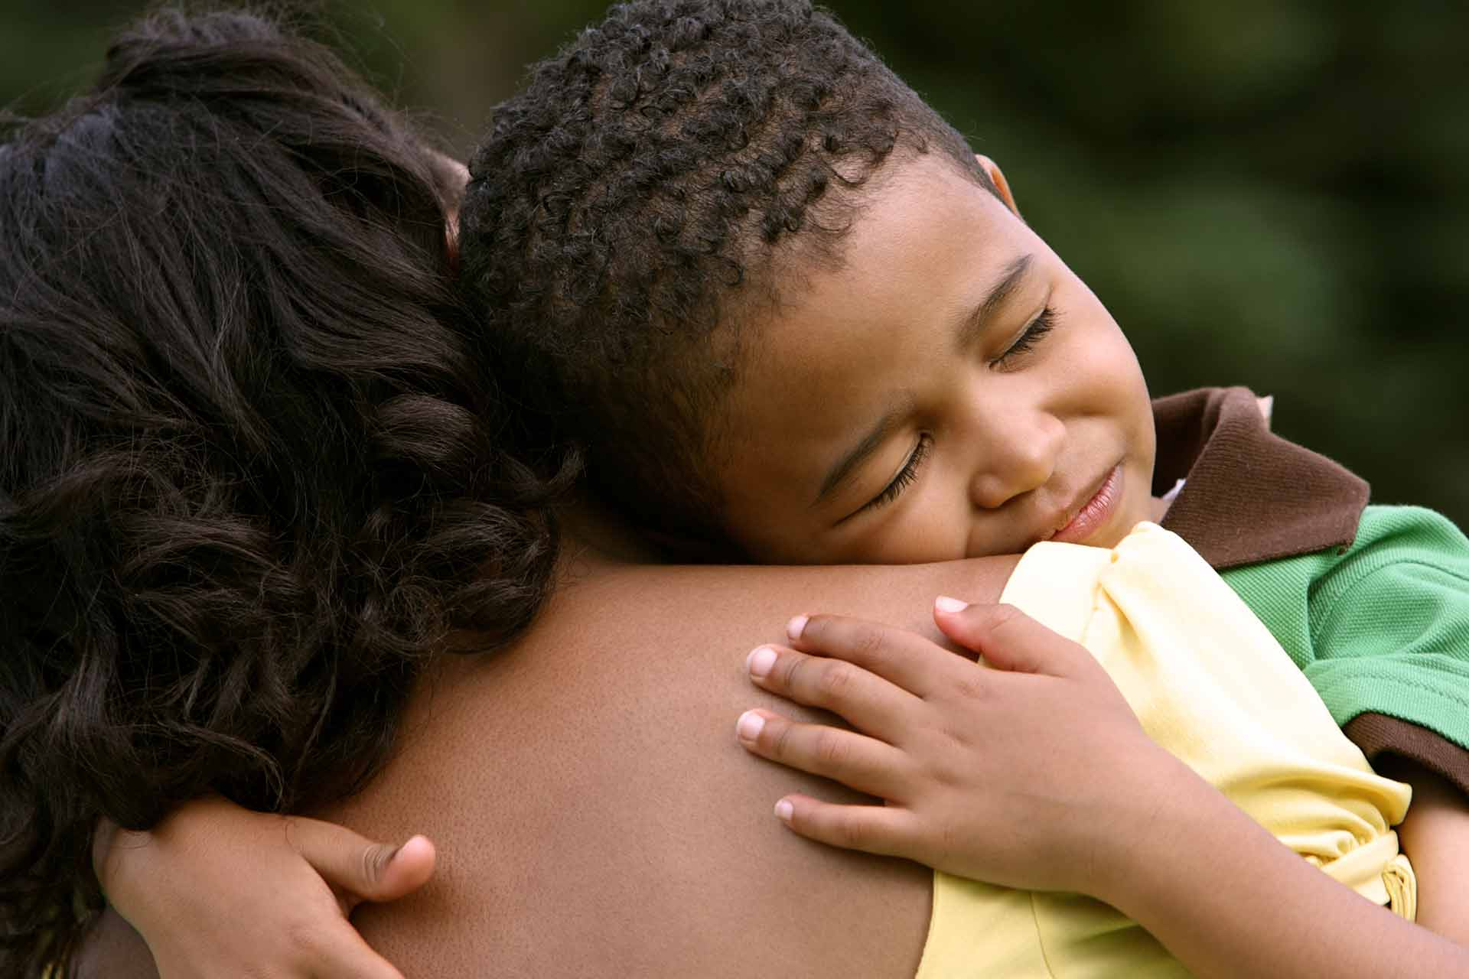
Attachment allows children to explore, learn and relate the wellbeing motivation and opportunity to do so. It is important for safety, stress regulation resilience and adaptability. “Bowlby suggested that early attachment experience creates ‘internal working models’ lifelong templates for preconceptions of the value and reliability of relationships”. (Rees, 2007)

The attachments of both child and parents affect children’s physical, psychological, behavioural and developmental wellbeing. (Rees, 2007). The effects of early attachment with parents or caregivers can trigger the changes socially, physically, cognitively and genetically which can have a positive or negative lifelong consequences. Children can form attachments with more than one caregiver. Due to the disruption or loss of attachment it can affect a child emotionally and psychologically into adulthood and can have an impact on the future relationships.

A first bond can happen after giving birth providing the parents are allowed to have the very early contact with their child. The close relationship between the child and parents starts
very early the reason for this is if a child is born premature then the special baby units will encourage parents to spend time with them who cannot leave the hospital. Attachment can strengthen during the early months of a baby life this is through spending time together in play, communication physical care and personal routines.
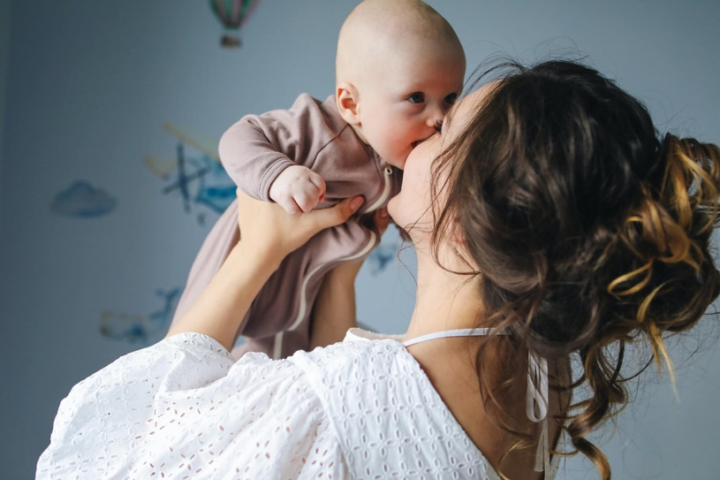
Attachment is a specific aspect of relationship between a child and a parent. Attachment is distinguished from other aspects of parenting such as disciplining, entertaining and teaching.

When forming an attachment, it is something that develops over time for a child but for parents and carers they can start to form an emotional bond with the child before they are born. (NSPCC, 2021)

Some parents or carers may have difficulty forming a bond this could be if they are experiencing mental health issues, been abused or trauma experienced by the parent or child. If a child has been affected by one of these issues, then it may become difficult for the child to form attachments with the practitioner or social worker if the social services are involved and the child may not feel confident in meeting new people.

“Bowlby argued that a child can form many attachments but one of these is qualitatively different. This is what he called primary attachment, monotropy. (McLeod, 2023)

“Bowlby also suggests that there is a critical period for developing attachment which is (2.5 years). If an attachment has not developed during this time period, then it may well not happen at all. Bowlby later then proposed a sensitive period of up to 5 years”. (McLeod, 2023)

The role of the practitioner in attachment is to help the child to feel known, understood, care and are safe and involves a triangle of trust with the child and family. This is to ensure that the family know who they are trusting the child with and how important their role is. The practitioner or key worker helps the child or baby to feel confident and that they are held in their own mind, thought about and loved.

Attachments are formed in different ways during the stage of a child’s development.

Antenatal (before birth)
During this period, parents and carers can form a bond with their child/ children. Any bonds that are formed before birth can have a positive impact on the relationships once the child/children are born. (NSPCC, 2021)

Birth until 6 weeks can be referred as the pre-attachment this is because the baby does not appear to show an attachment to and caregiver. Parents and carers who provide a nurturing environment are responsive to their child’s needs. (NSPCC, 2021)

Babies and young children who may have attachment issues are more likely to develop behavioural problems such as attention deficit hyperactivity disorder also known as (ADHD)or conduct disorder. Children may have issues with attachment can find it difficult forming relationships when they grow up.

“Bowlby was the first attachment theorist. He described attachment as a lasting psychological connectedness between human beings. Bowlby was interested in understanding the anxiety and distress that children can experience when they are separated from their primary caregivers.

“Bowlby was a psychoanalyst like Freud and believed that mental health and behavioural problems could be attributed to early childhood.”

The difference between Bowlby and Freud attachment theory is that Freud addresses psychic conflict and psychological derivatives of conflict whereas Bowlby’s definition of psychoanalytic data is more extensive. (Gullestad, S.E. (2001).

“Bowlby’s theory of attachment suggests that children come into the world biologically pre-programmed to form attachments with other because this will help them to survive. (McLeod, 2023)

Human infants are relatively helpless at birth and for the first few months after being born. They are born with very limited abilities, in the way of physical motor skills and a few cognitive abilities. This means that human infants are vulnerable at birth.

“Bowlby formulated a theory of relationships between the caregiver and the infant which he called attachment relationship drawing largely from work in psychoanalytic theory, ethological theory and work in cognitive and development psychology.”

“Freud’s theory of attachment suggested that infants become attached to the source of pleasure. Infants who are in the oral stage of development become more attached to their mothers. (Cherry, 2023)

Attachment is an emotional bond with another person. Bowlby believed that the earliest bonds could form by children with their caregivers can have a tremendous impact that continues throughout life.

“Although Bowlby did not rule out the possibility of other attachment figures for a child, he did believe that there should be a primary bond which was much more important than any other (usually the mother).” (McLeod, 2023)

Attachment theory focuses on both the processes which can lead to the bonding of children and parents and the impact of this relationship on psychological development.

“Ainsworth was another major contributor to attachment theory that noted that infants use adults as a haven and as a secure base. Infants organize their attachment behaviours that they use the adults as a refuge and source of comfort. (Keenan, T., Evans, S. and Crowley, K. (2016).

“Ainsworth concluded that there were three main styles of attachment which are, secure attachment, anxious- avoidant attachment and anxious resistant attachment. (Cherry 2019)

Reference List

Cherry, K. (2023). How Attachment Theory Works. [online] Verywell Mind. Available at: https://www.verywellmind.com/what-is-attachment-theory-2795337#:~:text=Thinkers%20like%20Freud%20suggested%20that.
Gullestad, S.E. (2001). Attachment theory and psychoanalysis: controversial issues. The Scandinavian Psychoanalytic Review, 24(1), pp.3–16. doi:https://doi.org/10.1080/01062301.2001.10592610.
Keenan, T., Evans, S. and Crowley, K. (2016). Introduction To Child Development. 3rd ed. S.L.: Sage Publications.
McLeod, S. (2018). Mary Ainsworth | Attachment Styles | Simply Psychology. [online] www.simplypsychology.org. Available at: https://www.simplypsychology.org/mary-ainsworth.html#:~:text=Ainsworth%20(1970)%20identified%20three%20main.
McLeod, S. (2023). Bowlby’s Attachment Theory. [online] Simply Psychology. Available at: https://www.simplypsychology.org/bowlby.html.
NSPCC (2021). Attachment and child development. [online] NSPCC Learning. Available at: https://learning.nspcc.org.uk/child-health-development/attachment-early-years.
Rees, C. (2007). Childhood Attachment. British Journal of General Practice, [online] 57(544), pp.920–922. doi:https://doi.org/10.3399/096016407782317955.

The effects of poor nutrition on Physical development

All children need healthy snacks and meals to support their growth and development. A nutrient diet plays an important role in a child’s mental and physical development. (www.rch.org.au, n.d.)

Nutritional deficiencies can occur in children if their diets include an excess of foods which are high in fat, sugar and salt. These are often found in treats such as chips, chocolate, lollies or fizzy drinks or food that has been processed such as take away. Children who do not eat a varied diet which includes enough fresh and whole foods are at risk of long-term health consequences. (www.rch.org.au, n.d.)

The human brain requires all essential nutrients to form and maintain its structure. Children who do not receive sufficient nutrition are at high risk of displaying impaired cognitive skills. (Roberts et al., 2022)

The human brain requires all essential nutrients which include protein, fats, carbohydrates, vitamins, mineral and water to form and maintain the structure. During the first two years of a child’s life children experience rapid growth which increases their iron requirement and places them at a higher risk for iron deficiency anaemia. (Roberts et al., 2022)

Children who have poor eating habits do not get the correct amount of nutrients they need for a healthy growth and development this can lead to being underweight or overweight. Children who are overweight will struggle with their day-to-day life or with simple or daily tasks.

Children who have a poor nutrition tend to have a weaker immune system which will increase their chances of illness. They are more likely to develop long term health problems which can be.

Free school meals encourage a balanced diet, broaden your child's food options, and enhance their social and behavioural development. Free School Meals promote healthy eating, increase the variety of food your child might eat, and can improve their behaviour and social skills.

- Bone thinning which can also be called (osteoporosis) later in life
- Heart and blood vessel disease
- Type 2 diabetes
- Breathing difficulties (asthma)

Being overweight puts children at risk

- Liver problems
- Problems with their hip or bone growth in the legs
- Gallstones
- Early puberty

“In 2020, over 149 million children under 5 were affected by stunting and 45 million affected by wasting depriving them of the opportunity to achieve their full potential before they even reach school age.”

The importance of nutrition is not limited to babies. Eating the correct amount of food is vital for children of all ages. Cognitive development has also been related to nutrition. For example, anaemia which is a condition where a person suffers from low levels of iron in the blood stream has been associated with a slowing of intellectual development. (Keenan, Evans and Crowley, 2016)

“Maslow’s hierarchy of needs in a motivation theory is psychology comprises of fiver tier model of human needs, are often depicted as hierarchical levels within a pyramid.”

Maslow considered physiological needs are the most important as all the other need become secondary until these needs are met. (McLeod, 2018)

A person's ability to promote and maintain their health over the course of their life is influenced by their food. A healthy diet is something that many people find difficult to maintain, even if it is mostly within their power. The purpose of this study is to investigate how kids perceive obstacles to eating a balanced diet. (Magalhães et al., 2022)

“Maslow was more interested in learning about what makes people happy and what they do to achieve that aim.”

Maslow was a humanist who held that everyone has the innate drive to reach their full potential and become self-actualized. However, several more fundamental demands must be satisfied before achieving this goal. This covers the necessities for self-worth, nourishment, safety, and love.

“Erik Erikson was an ego psychologist who developed one of the most popular and influential theories of development. While his theory was impacted by psychoanalyst Sigmund Freud’s work, Erikson's theory centred on psychosocial development rather than psychosexual development.”

Numerous factors can impact children's physical and emotional health when they live in poverty. It is more likely that low-income families cannot afford necessities like food and heating. Poverty prevents parents from giving their kids a good life or engaging in fun activities with them. They must also deal with small living spaces and food instability. Children's mental health is impacted by each of these problems.

Children who live in poverty suffer from a variety of detrimental effects, including poorer physical and mental health and lower academic performance. Poverty-stricken youth could have to start working part-time earlier. Their academic performance would suffer as a result, and they would perform worse academically than their more affluent contemporaries.

“1.6 million children (11% of all children) live in low-income households that struggle to afford basic essentials such as warm winter coats and fresh fruit and vegetables.” (Action For Children, 2023)

“Poverty has been shown to negatively influence child health and development along a few dimensions. For example, poverty–net of a variety of potentially confounding factors—is associated with increased neonatal and post-neonatal mortality rates, greater risk of injuries resulting from accidents or physical abuse/neglect, higher risk for asthma, and lower developmental scores in a range of tests at multiple ages.” (Aber et al., 1997)

Reference List

Aber, J.L., Bennett, N.G., Conley, D.C. and Li, J. (1997). The Effects of Poverty on Child Health and Development. Annual Review of Public Health, [online] 18(1), pp.463–483. doi:https://doi.org/10.1146/annurev.publhealth.18.1.463.
Action For Children (2023). How poverty affects children’s mental health. [online] Action for Children. Available at: https://www.actionforchildren.org.uk/blog/how-poverty-affects-childrens-mental-health/
cherry, K. (2022). How Maslow’s Famous Hierarchy of Needs Explains Human Motivation. [online] Verywell Mind. Available at: https://www.verywellmind.com/what-is-maslows-hierarchy-of-needs-4136760#:~:text=Abraham%20Maslow%27s%20hierarchy%20of%20needs.
Gullestad, S.E. (2001). Attachment theory and psychoanalysis: controversial issues. The Scandinavian Psychoanalytic Review, 24(1), pp.3–16. doi:https://doi.org/10.1080/01062301.2001.10592610.
Keenan, T., Evans, S. and Crowley, K. (2016). Introduction To Child Development. 3rd ed. S.L.: Sage Publications.
Magalhães, P., Vilas, C., Pereira, B., Silva, C., Oliveira, H., Aguiar, C. and Rosário, P. (2022). Children’s Perceived Barriers to a Healthy Diet: The Influence of Child and Community-Related Factors. International Journal of Environmental Research and Public Health, [online] 19(4), p.2069. doi:https://doi.org/10.3390/ijerph19042069.
McLeod, S. (2018). Maslow’s Hierarchy of Needs. [online] Canada College. Simply Psychology. Available at: https://canadacollege.edu/dreamers/docs/Maslows-Hierarchy-of-Needs.pdf.
Roberts, M., Tolar-Peterson, T., Reynolds, A., Wall, C., Reeder, N. and Rico Mendez, G. (2022). The Effects of Nutritional Interventions on the Cognitive Development of Preschool-Age Children: A Systematic Review. Nutrients, [online] 14(3), p.532. doi:https://doi.org/10.3390/nu14030532.
www.rch.org.au. (n.d.). Kids Health Info : Nutrition – school-age to adolescence. [online] Available at: https://www.rch.org.au/kidsinfo/fact_sheets/Nutrition_older_children/#:~:text=In%20some%20children%2C%20poor%20diet.
The Royal Children's Hospital Melbourne (2019). Kids Health Info : Nutrition – school-age to adolescence. [online] Rch.org.au. Available at: https://www.rch.org.au/kidsinfo/fact_sheets/Nutrition_older_children/.
Scaglioni, S., De Cosmi, V., Ciappolino, V., Parazzini, F., Brambilla, P. and Agostoni, C. (2018). Factors Influencing Children’s Eating Behaviours. Nutrients, [online] 10(6), p.706. doi:https://doi.org/10.3390/nu10060706.
www.gov.wales. (n.d.). Get help with school costs | GOV.WALES. [online] Available at: https://www.gov.wales/get-help-school-costs?utm_source=google&utm_medium=cpc&utm_campaign=fsm&gad_source=1&gclid=Cj0KCQiAwbitBhDIARIsABfFYIJfmimdalZY0y125qVlfo3ckda2EkvLEExHRaSQI2p877CHopvJt9EaAmD9EALw_wcB [Accessed 22 Jan. 2024].

How does Cognitive development affect a child’s development

Language development supports cognitive, social, literacy and other aspects of development. Language development starts off with simple sounds and gestures and then includes words and sentences. (Raising Children Network, 2021)

Between the age of 0- 5, language skills develop in children very quickly. During the first twelve months of life, a new-born can indicate their needs through crying and facial gestures. This will enable the parent to understand what the child needs. As children get older their language skills will improve and they will be able to say and understand simple words and sentences.

Early childhood cognitive development starts the minute a child is born and encompasses the development of abilities including reading, language, vocabulary, and numeracy.

Cognitive development refers to the intellectual growth of a child, including their capacity for reasoning, problem-solving, and thought. This can include activities that push a child's boundaries and foster critical thinking, such as reading, puzzles, and educational games.

Memory, focus, logic, perception, imagination, creativity, and problem solving are all aspects of intellectual growth. It is crucial for adults to give kids new experiences that will help in their development, like games, books, toys, outdoor activities, and different forms of play.

Children’s language skills are connected to their overall development and it can predict their educational success. As speaking and listening develops, children build foundations for literacy, for making sense of visual and verbal signs and ultimately for reading and writing.

It's critical that you actively participate in high-quality interactions with your child every day to support their cognitive development. (HelpMeGrow, 2020)
- Exposing your toddler to books and puzzles.
- Expanding on your child's interests in specific learning activities. For example, your toddler might show an early interest in dinosaurs, so you can take him/her on a trip to the natural history museum to learn more about the time that these creatures roamed the earth.
- Answering your child’s “why” questions
As fast as the changes can happen, these processes take time. Different sections of the brain develop at different times, with the part of the brain responsible for abstract thinking, planning, and decision making developing last. If a child has a developmental delay this could affect their cognitive skills as it may take them longer to progress such as learning to hold a pen or pencil, learn to write their name if this occurs then the practitioner will help the child to hold a pencil and provide extra support to the child.

“Cognitive skills include thinking, learning and understanding information. A child with a cognitive delay may have trouble following directions or solving a problem. (Cleveland Clinic, 2023)

Piaget’s theory of cognitive development is the most important to emerge from the study of human development. Piaget believed that development occurred because of predispositions to organize and to adapt to new experiences.

“Skinner argued that children learn language based on behaviourist reinforcement principles by associating words with meanings. Correct utterances are positively reinforced when the child realizes the communicative value of words and phrase.”

“Chomsky argued that children would never acquire the tools needed for processing an infinite number of sentences if the language acquisition mechanism was dependent on language input alone.
Piaget's theory differs in important ways from those of Lev Vygotsky, another influential figure in the field of child development. Vygotsky acknowledged the roles that curiosity and active involvement play in learning but placed greater emphasis on society and culture. (Cherry, 2023)
Piaget felt that development is largely fuelled from within, while Vygotsky believed that external factors (such as culture) and people (such as parents, caregivers, and peers) play a more significant role. (Cherry, 2023)
“Vygotsky's social development theory asserts that a child's cognitive development and learning ability can be guided and mediated by their social interactions. His theory (also called Vygotsky's Sociocultural theory) states that learning is a crucially social process as opposed to an independent journey of discovery.”

Vygotsky thought social and cultural influences had an impact on cognitive development. He placed a strong emphasis on the contribution that social interaction makes to children's mental development, including speech and reasoning.

“Vygotsky argued that higher mental abilities could only develop through interaction with more advanced others.” (Mcleod, 2023)

“Chomsky postulated that people are predisposed to learn language because of an innate biological ability known as the Language Abilities Default Disorder (LAD). Chomsky's theory has its detractors who claim that it is overly innates and undervalues social interaction and other aspects of language learning.”
The difference between Piaget's theory and Vygotsky are Piaget’s differs in important ways from those of Lev Vygotsky another influential figure in the field of child development and Vygotsky acknowledged the roles that curiosity and active involvement play in learning but placed greater emphasis on society and culture. (Cherry, 2023)

When human agents are required or urged to make decisions about unknown isolated events, cognitive obstacles occur. This article contends that obstacles including a dislike of ignorance and the inability to believe prevail over professional knowledge and common sense. (Grinbaum, 2006)

It is predicted that 200 million children globally do not reach their full developmental potential because of unstimulating settings, poor health, and poverty. In adult humans, missing developmental milestones has long-term consequences.

Reference List

Cherry, K. (2023). What Are Piaget’s Four Stages of Development? [online] Verywell Mind. Available at: https://www.verywellmind.com/piagets-stages-of-cognitive-development-2795457#:~:text=Jean%20Piaget%27s%20theory%20of%20cognitive.
Cleveland Clinic (2023). Developmental delays. [online] Cleveland Clinic. Available at: https://my.clevelandclinic.org/health/diseases/14814-developmental-delay-in-children.
Grinbaum, A. (2006). Cognitive Barriers in Perception of Nanotechnology. The Journal of Law, Medicine & Ethics, 34(4), pp.689–694. doi:https://doi.org/10.1111/j.1748-720x.2006.00088.x.
HelpMeGrow (2020). What Is Cognitive Development. [online] Helpmegrowmn.org. Available at: https://helpmegrowmn.org/HMG/HelpfulRes/Articles/WhatCognitiveDev/index.html#:~:text=Cognitive%20development%20means%20how%20children.
Mcleod, S. (2023). Vygotsky’s Sociocultural Theory of Cognitive Development. [online] Simply Psychology. Available at: https://www.simplypsychology.org/vygotsky.html.
Raising Children Network (2021). Language development in children: 0-8 years. [online] Raising Children Network. Available at: https://raisingchildren.net.au/babies/development/language-development/language-development-0-8.
Ford, N.D. and Stein, A.D. (2015). Risk factors affecting child cognitive development: a summary of nutrition, environment, and maternal–child interaction indicators for sub-Saharan Africa. Journal of Developmental Origins of Health and Disease, [online] 7(2), pp.197–217. doi:https://doi.org/10.1017/s2040174415001427.

https://sway.cloud.microsoft/qu0YhE9SnrooIIjv?ref=Link&loc=mysways

