The title: A comparison of the marketing methods of two multinational hotel brands.
Your name: Elena Madalina Vilceanu
Your student ID number: 1815431
The module title: Marketing Essentials BMIH4005
Your lecturer’s name: Luciana Suardi
Word Count: 1.603

Contents
Introduction 2
Moxy Hotels vs Six Senses Hotel 2
SWOT analysis: Moxy Hotel 2
SWOT analysis: Six Senses Hotel 3
PESTLE analysis: Moxy Hotel 4
PESTLE analysis: Six Senses Hotel 5
Marketing Mix 5
Marketing Strategy 6
1. Social Media Marketing 6
2. Experience-driven marketing 6
3. Pop-Up Events 6
I. Social Media Marketing: 7
II. Influencer Marketing 7
III. Referral Marketing 7
IV. Content Marketing 7
Marketing choices and changes 7
Similarities and differences in marketing strategies 8
Recommendations 9
Contemporary concerns 9
Conclusion 10

Introduction
The hotel industry is one of the most competitive industries globally, with many players vying for market share. As a result, hotels have to adopt marketing methods and strategies that are effective in attracting customers. This paper will compare the marketing methods and strategies adopted by two hotel brands, Moxy Hotels and Six Senses Hotels, to attract customers and maintain a competitive edge.

Moxy Hotels vs Six Senses Hotel
Moxy Hotels is a hotel chain which was established in 2014. The brand was launched in Europe and has since expanded globally.
Moxy Hotels is a lifestyle brand that offers affordable and stylish accommodations to young, urban travellers.

On the other hand, Six Senses is a luxury hospitality brand that operates a collection of hotels, resorts, and spas worldwide. The brand is known for offering guests a unique, personalised experience that focuses on wellness, sustainability, and local culture. Six Senses Samui opened in Thailand, in 1997 and set the standard for the company's focus on sustainable tourism and wellness. Over the years, Six Senses has expanded its portfolio to include properties worldwide.
Of course, providing a place to stay is only one aspect of hospitality. We want you to re-establish contact and discover what it means to be psychologically, physically, spiritually, and emotionally happy through our spaces and locations (Jacobs, 2023).

SWOT analysis: Moxy Hotel
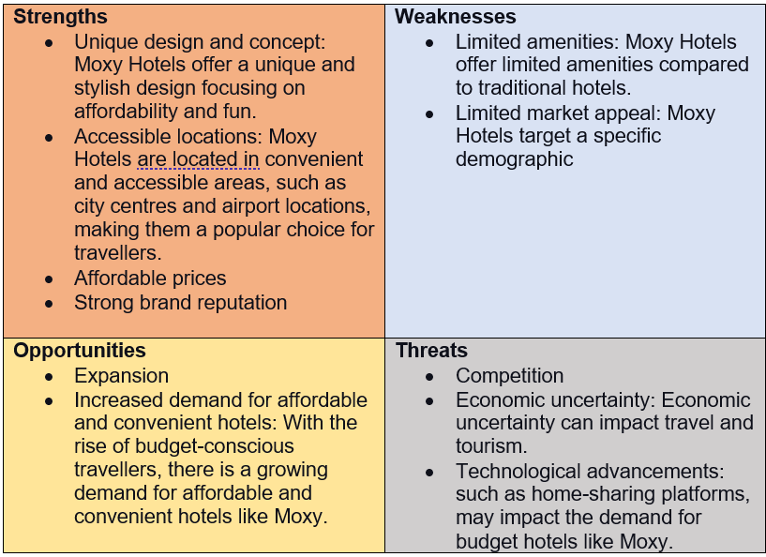
This SWOT analysis will examine the strengths, weaknesses, opportunities, and threats Moxy Hotels faces as it continues to expand and compete in the highly competitive hospitality industry.
(Elena, 2023)

SWOT analysis: Six Senses Hotel
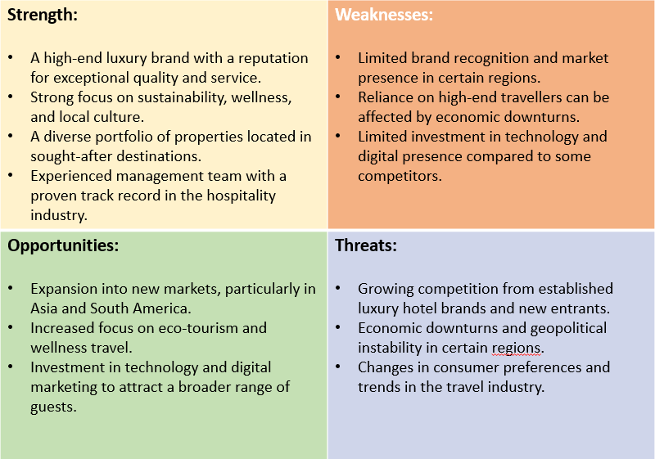
This SWOT analysis will examine the strengths, weaknesses, opportunities and threats Six Senses Hotel faces as it continues to expand.

(Elena, 2023)

PESTLE analysis: Moxy Hotel
PESTLE analysis is a framework used to analyse the macro-environmental factors that affect an organisation.
Applying this framework to the Moxy Hotel, the following factors can be considered:

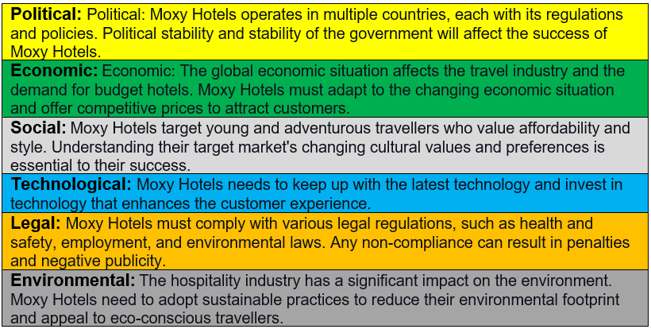
(Elena, 2023)
By considering these factors, Moxy Hotels can identify potential opportunities and challenges and make informed decisions for their future growth and success.

PESTLE analysis: Six Senses Hotel
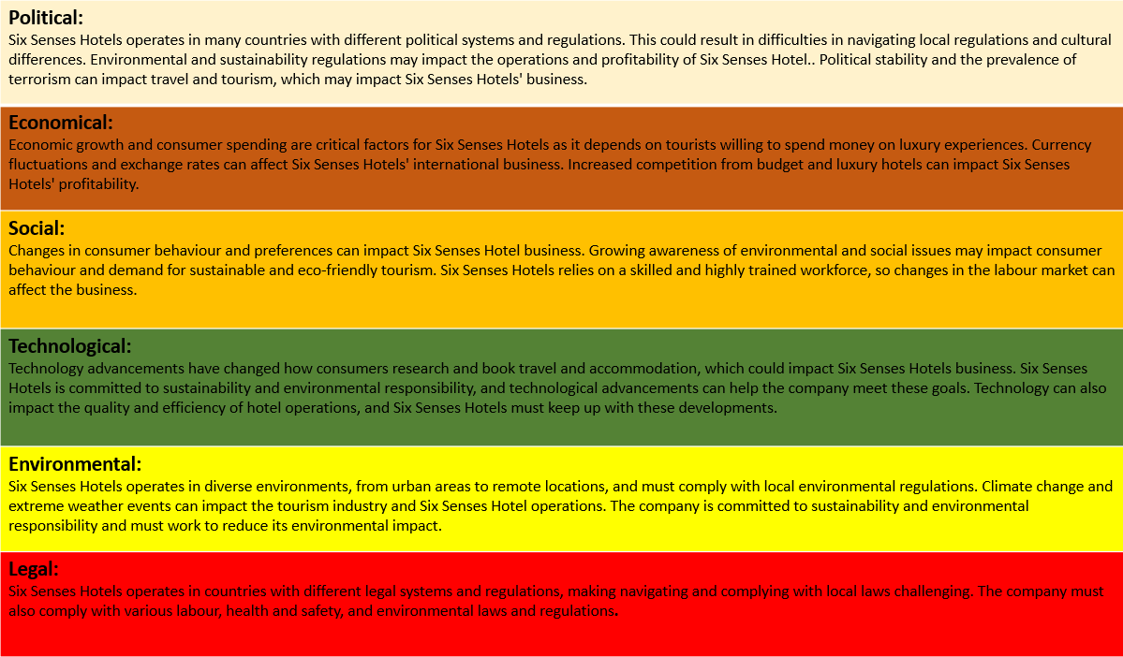
PESTLE analysis is used to analyse the macro-environmental factors. Applying this framework to the Six Senses Hotel, the following factors can be considered:
(Elena, 2023)

Marketing Mix
After analysing marketing methods and strategies, marketing mix can also be defined. Marketing mix refers to actions that companies use to promote their products and services.
This provides an overview of the main elements of marketing that marketers can use to understand how these elements can affect the success of marketing strategies.
In order to have a better understanding, the following table will compare the marketing mix between the two different hotel brands.
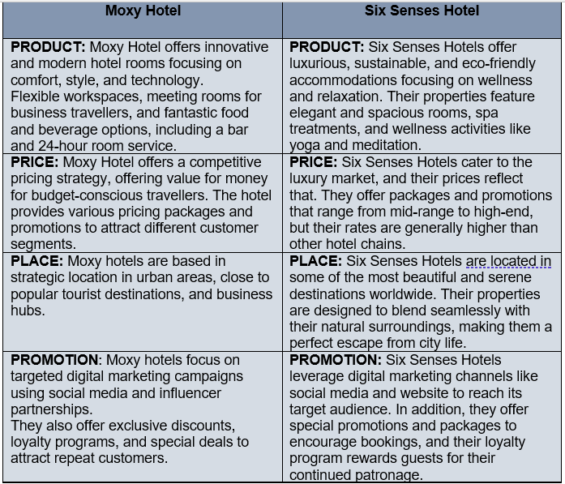
(Elena, 2023)

Marketing Strategy
Moxy Hotel's marketing strategy focuses on reaching out to the younger demographic, who are tech-savvy and are looking for a unique travel experience.

Any successful firm needs marketing. It aids in connecting with and reaching the target market, which is ultimately what will develop the company over time (Sherman, 2022).

The hotel chain uses a variety of marketing strategies to target its desired audience and establish its brand image. Some of these strategies include:
- Social Media Marketing - Moxy hotels heavily relies on social media platforms to reach its target audience.
- Experience-driven marketing - Moxy hotels focus on creating an experience for its guests rather than just offering a place to sleep.
- Pop-Up Events - Moxy hotels often host pop-up events, such as fashion shows, music events, and food festivals, to engage with its target audience and create a buzz around the brand.
In contrast to Moxy Hotel, Six Senses Hotel’s marketing strategies revolve around promoting its unique approach to hospitality, which combines luxury, sustainability, and wellness. Some of their key marketing tactics include:

  - Social Media Marketing: Six Senses Hotels uses social media platforms like Instagram, Facebook, and Twitter to reach out to a broader audience.
  - Influencer Marketing: Six Senses Hotels partners with popular influencers in the travel, wellness, and lifestyle niches to promote their properties and increase brand awareness.
  - Referral Marketing: Six Senses Hotels incentivizes their guests to refer their friends and family to the hotel, offering special perks and discounts to both the referrer and the referred person.
  - Content Marketing: Six Senses Hotels creates and shares high-quality, informative, and visually appealing content.
In the market position, with its presence in over 20 locations worldwide, Six Senses has established a strong reputation for offering world-class, sustainable, and wellness-focused experiences to its guests. In addition, the brand is renowned for its exceptional service, unique design, and commitment to sustainability, contributing to its strong market position.

Marketing choices and changes
In the early stages of its development, Moxy Hotel's marketing approach centred around social media, leveraging influencer partnerships, and utilizing platforms to reach their target audience.
Over the years, Moxy Hotels has made several changes to its marketing approach to keep up with changing consumer preferences and trends. In 2018, the brand launched a new advertising campaign, "Book the Moxy," which encouraged travellers to book directly through their website to receive the best deals and discounts. This move aimed to compete with online travel agencies and increase the brand's direct bookings.
Moxy Hotels has also increased its focus on sustainability and eco-friendliness and has incorporated these values into its marketing messages. The brand has implemented several environmentally-friendly initiatives, such as energy-efficient lighting, reducing food waste, and using eco-friendly cleaning products, which they have highlighted in their marketing materials.
In terms of its market position, Moxy Hotels is well-positioned to meet the growing demand for affordable, stylish, and unique hotel experiences. However, it faces competition from other budget hotel brands, as well as Airbnb and other alternative accommodations.
Understanding the demands of the consumers is the first step to success in the hospitality sector. Before businesses start any marketing initiatives, they should have a clear idea of the type of tourist they want to draw in (Alemar, 2021).
Six Senses Hotel leverages its sustainable and wellness focus to create unique marketing campaigns and promotions that appeal to its environmentally conscious and health-conscious target audience. The brand's marketing choices are designed to build brand awareness, drive bookings, and create a solid emotional connection with guests.
Over the years, the brand has evolved its marketing choices and changes to cater to its target market's changing preferences and expectations. Some of the significant marketing choices and changes of Six Senses over time include: Digital Transformation, Emphasis on Wellness, Sustainable Tourism, Personalized Experiences and Expansion.

Similarities and differences in marketing strategies
Similarities:
- Both Moxy and Six Senses hotels use targeted advertising campaigns to reach specific demographic groups.
- Both hotels strongly emphasise building a brand image and promoting their unique features and services.
- Both hotels use social media platforms to reach a wider audience and engage with customers.
Differences:
- Moxy targets younger generations, such as Gen Z, whereas Six Senses targets older, more affluent travellers. This information can be visualised in the statistics below.

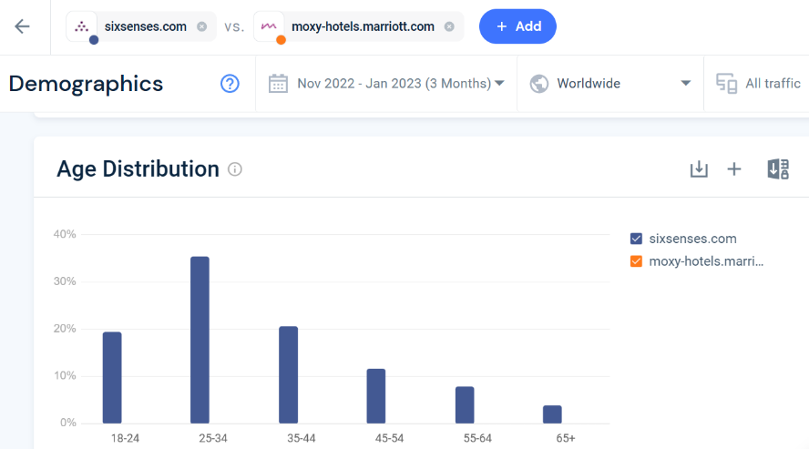
(Similarweb, 2023)
- Moxy strongly focuses on technology and modern design, whereas Six Senses emphasises sustainability and wellness.
- Moxy uses more mass media advertising, such as television and print, whereas Six Senses relies more on online and digital marketing.

Another difference can be identified within the statistics below. It compares the traffic share by country based on websites traffic between the two hotel brands.
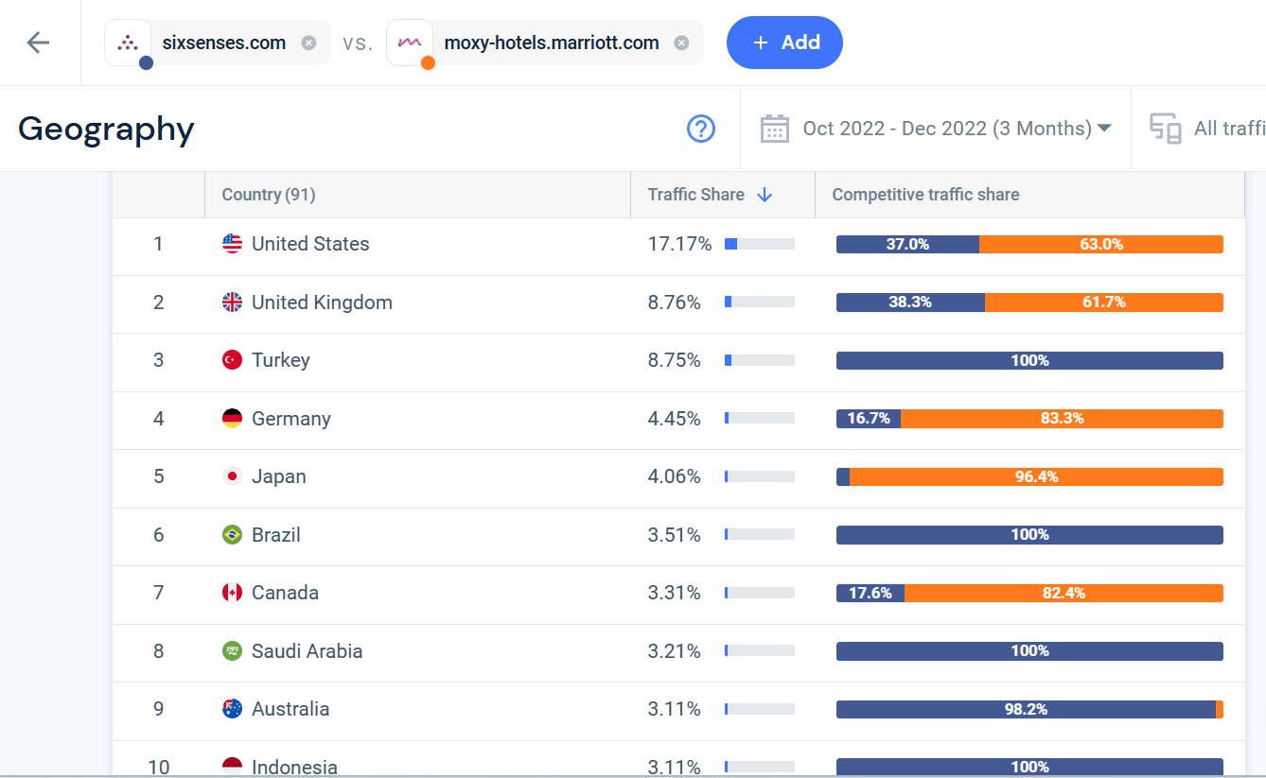
(Similarweb, 2023)

Recommendations
In order to enhance marketing activities for both hotel brands, some recommendations need to be made.
Moxy Hotel should consider introducing interactive marketing to create an interactive marketing campaign that encourages customers to participate and engage with the brand. It can include contests, quizzes, and social media challenges. They should also consider incorporating eco-friendly and sustainable practices into marketing activities, such as promoting the hotel’s efforts to reduce waste and conserve resources.
A focus on environmental sustainability isn’t new, but the degree to which guests expect eco-friendly products and services is (Hollander, 2022).
On the other hand, Six Senses Hotel should promote the hotel’s commitment to environmental sustainability and eco-friendly practices, appealing to environmentally conscious customers but also highlighting the unique local experiences and cultural offerings available to guests, such as local food and drink, cultural events, and outdoor activities.

Contemporary concerns
The contemporary concerns in the hospitality industry are diverse and constantly evolving, but some of the key issues include:
- Labour shortage: Hospitality venues are struggling to fill thousands of job vacancies, according to an industry body (BBC, 2021). The hospitality industry is facing a shortage of skilled workers, particularly in areas such as housekeeping, front desk, and culinary.
- Security and political stability: The ongoing conflict in Ukraine and other regions can impact the tourism industry, decreasing demand for travel and hospitality services in those areas.
- Increased competition: The growth of online booking platforms and alternative accommodation options, such as Airbnb, has increased competition in the hospitality industry.
Overall, the hospitality industry is facing a range of challenges, and businesses must be proactive in addressing these concerns to remain competitive and successful.

Conclusion
In conclusion, both Moxy and Six Senses hotels offer unique experiences to guests with their unique approaches. Moxy is a contemporary hotel chain that prioritises affordability and sustainability and incorporates technology in its operations and guest experience. On the other hand, Six Senses prioritises sustainable luxury, and has a strong commitment to environmental protection and social responsibility, often incorporating local and organic elements into its facilities and offerings. In addition, both hotels effectively target their respective audiences through personalised marketing strategies. Ultimately, the choice between these two hotels depends on personal preferences and priorities, whether affordability and technology or sustainable luxury and local experiences.

References
Alemar, S. (2021) 12 Smart Hotel Marketing Strategies in 2022
Available at: https://www.canarytechnologies.com/post/hotel-marketing-strategies
(Accessed: 05 February 2023)

Athuraliya, A. (2023) The Easy Guide to Performing an Effective Situation Analysis.
Available at: https://creately.com/blog/strategy-and-planning/what-is-a-situation-analysis/#:~:text=Situation%20Analysis%20Tools%201%20SWOT%20Analysis%20The%20SWOT,Five%20Forces%20...%204%205%20C%20Analysis%20
(Accessed: 01 February 2023)
Cvent, (2020) What Is the Hospitality Industry? Your Complete Guide
Available at: https://www.cvent.com/uk/blog/hospitality/what-is-the-hospitality-industry
(Accessed: 03 February 2023)

BBC, (2021) Hospitality 'struggling to fill thousands of jobs'
Available at: https://www.bbc.co.uk/news/business-57285428
(Accessed: 06 February 2023)

Hollander, J. (2022) 100 Hotel Trends You Need to Watch in 2023 & Beyond
Available at: https://hoteltechreport.com/news/100-hotel-trends
(Accessed: 05 February 2023)

Impos, (2021) Major Issues Facing the Hospitality Industry in 2021
Available at: https://impos.com.au/blog/hospitality-issues-2021/#:~:text=Major%20Issues%20Facing%20the%20Hospitality%20Industry%20in%202021,Customers%20Experience%20...%206%206.%20Loyalty%20Programs%20
(Accessed: 04 February 2023)

Jobs, A. (2022) 6 MAJOR HOTEL INDUSTRY CHALLENGES IN 2022
Available at: https://www.soegjobs.com/hotel-industry-challenges/
(Accessed: 04 February 2023)

Jones, R. (2022) What is a Moxy hotel? Everything you need to know about Marriott’s budget brand
Available at: https://www.headforpoints.com/2022/10/02/what-is-a-moxy-hotel-like/
(Accessed: 05 February 2023)

Killen, N. (2021) Six Things to Love About Six Senses Ibiza
Available at: https://www.elegantresorts.co.uk/eleganttraveller/story/six-things-to-love-about-six-senses-ibiza
(Accessed 05 February 2023)

Marriott International, (2023) Moxy Hotels
Available at: https://news.marriott.com/brands/moxy-hotels/
(Accessed: 04 February 2023)

Miceli, C. (2022) Everything You Need To Know About Moxy Hotels: Are They Worth It?
Available at: https://www.pilotplans.com/blog/moxy-hotels-review
(Accessed: 03 February 2023)

Moxi Hotels, (2023) Check us out Moxy Hotels
Available at: https://moxy-hotels.marriott.com/explore/
(Accessed: 05 February 2023)

Sarfleet Research, (2017) 5 Recommendations for Optimizing the Guest Experience
Available at: https://www.hotelnewsresource.com/article94511.html#:~:text=The%20following%20are%20five%20recommendations%3A%201%201.%20Capture,5%20.%20Treat%20each%20quest%20like%20a%20celebrity
(Accessed: 04 February 2023)

Scholz, L (2018) The Moxy Hotels: Creating Experiences as the New Marketing Approach
Available at: https://www.linchikwok.net/2018/04/the-moxy-hotels-creating-experiences-as.html
(Accessed: 06 February 2023)

Sherman, (2022) The Importance of a Marketing Strategy for Businesses Today
Available at: https://www.lyfemarketing.com/blog/importance-of-a-marketing-strategy/
(Accessed: 03 February 2023)

Six Senses, (2023) What's the story of Six Senses?
Available at: https://www.sixsenses.com/en/about-us/history
(Accessed: 06 February 2023)

Six Senses, (2023) Six Senses
Available at: https://www.sixsenses.com/en
(Accessed: 06 February 2023)

Six Senses, (2023) A passion for wellness, community, sustainable design and smiles
Available at: https://www.sixsenses.com/en/about-us/
(Accessed: 06 February 2023)

Swan, S. (2022) How to use the SOSTAC® planning model and the RACE Framework
Available at: https://www.smartinsights.com/digital-marketing-strategy/sostac-plan-example/
(Accessed: 03 February 2023)

Umesi, A. (2022) What Are the 4 Ps of Marketing? A Beginner’s Guide to the Marketing Mix
Available at: https://careerfoundry.com/en/blog/digital-marketing/the-marketing-mix/
(Accessed: 01 February 2023)

