Name student: Mariana Cocos
Student Number: 2024061
Module Title: Assessment 1- Strategic management and sustainability LCBB6004
Lecturer: Mr Riaz Bhatti

Strategic Management and Sustainability
Strategic Report

Volkswagen



Table of Contents
1. Introduction 3
2. Key business strategies of VW over the past five years 3
3. The resources and capabilities 5
4. VW competitive strategies 7
5. Recommendations 9
6. Conclusion 11
7. Bibliography 12

Introduction

Volkswagen is a German, well-known multinational company that operates in the automotive industry. The main area of activity is manufacturing and distributing vehicles and engines. Volkswagen Group along with its subsidiary brands Audi and Porsche was involved in a major sustainability scandal. It has revolved around Volkswagen’s unethical strategy to manipulate emission tests. As reported in the Car Magazine, Volkswagen has intentionally installed a so called “defeat device” software in its diesel-powered vehicles that could supposedly detect when the car was undergoing an emissions test and reduce the emissions to comply with regulatory standards (Car Magazine , 2019).
The purpose of this report is to shed light into the drawbacks of Volkswagen group sustainability strategy. First, with relevant evidence, the key business strategies over the past five years are analysed. Second, I delve into the resources and capabilities of VW and attempt to answer to what extent VW aligned its resources and capabilities with business strategies.
Next, I attempt to analysis how VW has tried to become more competitive using sustainability and environment at the basis of its competitive strategy. With consideration to the devastating limitations of the sustainable strategy applied in previous years, recommendations are provided on how the company can regain clients trust and a competitive advantage by implementing new sustainability practices.

Key business strategies of VW

Over the past years Volkswagen placed a strong emphasis on the Sustainable and Corporate Social Responsibility in response to emissions scandal. The strategies reflect the company's response to industry trends, changing consumer demands, regulatory pressures, and the need to restore its reputation which reflect underlying motivations and factors that influenced VW's strategic decisions in these areas. It is important to acknowledge that both internal and external contexts shaped the VW strategies, despite multiple challenges these are no excuse to resort to unethical practices. While external factors play a crucial role in the design of the strategies in relations to market trends, industry dynamics, internal factors play a crucial role in the execution of these strategies. With a primary focus on strategic management and sustainability the following key strategies are analysed; Ethical Supply Chain Management, Sustainable Manufacturing and Electric Vehicle (EV) Transition where the motivation behind selection and efficiency are evaluated.
Volkswagen implemented Ethical Supply Chain Management which refers to the control over all immediate and eventual environmental effects of products and processes related to the conversion of the raw materials into final products (Beamon, 2005). There is no doubt that to recover from previously used unethical practices, new management recognised the importance of responsible operations in supply chain, application of rigid standards requirements for their suppliers to ensure compliance with labour rights, human rights, environmental protection, and anti-corruption measures (Volkswagen Newsroom, 2019). By creating a transparent and sustainable supply chain, promoting fair and ethical business practices Volkswagen steps into regaining client’s loyalty.
Besides, ethical supply chain management, sustainable manufacturing strategy has been applied by the company. This includes reducing energy and water consumption, optimising waste management, and increasing the use of recycled and sustainable materials in vehicle production. As stated by Rosen and Kishawy (2012) “making development sustainable is in general a challenging and complex undertaking, involving technology and engineering, economics, environmental stewardship, health and welfare of people and the communities”. Despite existing complexities, VW chose to adopt this strategy due to its multiple benefits particularly in term of enhancing company reputation by reducing emissions and improving product quality.
As pointed out previously, multiple challenges could have led to the need to apply extra measures to forecast potential risks associated with its strategies weather these are in term of sustainability, management or any other area, these are crucial to avoid failing into the same traps.
Recognising the importance of restructuring its processes, implementing changes that would support the reduction of the gas emissions, Volkswagen prioritised the development and production of electric cars. They have introduced the dedicated electric vehicle platform called the “Modular Electric Toolkit” to enable the mass production of EVs (Halvorson, 2018). It is no news that electric cars have increased in popularity and demand with Tesla being the market leader, offering innovative design and superior range capabilities and sustainable transportation. The Modular Electric Toolkit strategy was pursued in order to keep up with new developments in the industry and gain a competitive advantage. Despite challenges in term of transferring fully on electric cars. Volkswagen invested billions in EV’s and has a realistic potential to overtake Tesla in the future.

The resources and capabilities

Over the past five years, Volkswagen (VW) has deployed various resources and capabilities to support its business strategies. It has improved the organisational structure to effectively utilise capital, equipment, and supplies including knowledge, reputation, and intellectual property. However, prior to installing defeat device the company's culture including regulatory pressure, costs constraints and competitive pressure could have been among the factors that lead to ethical breach. It has raised multiple questions in term of availability of resources and Volkswagen capabilities to meet sustainability standards including customers wishes.
To analyse the resources and capabilities of (VW) VRIO model (Barney, 1997) is used which stands for value, rarity and organisation (Barney, 1997). The following elements were selected for the analysis, manufacturing capabilities, research and development, brand reputation, customer loyalty and supply chain management capabilities (See: Appendix 1. Volkswagen RIO Analysis).
The Volkswagen's manufacturing capabilities are valuable because they enable production of a wide range of vehicles efficiently and at scale thus, meeting customer demands. The manufacturing capabilities are relatively common in the automotive industry, but Volkswagen's extensive global production network and expertise contribute to a competitive advantage. Additionally, Volkswagen's, built its manufacturing capabilities over many years, and these are not easily imitated. Based on Annual Report (2020) in term of organisation, Volkswagen has effectively organised its manufacturing capabilities by using innovative production techniques including using a simpler, leaner management to strengthen brands.
Volkswagen's R&D capabilities are valuable in driving innovation and technological advancements. The research and development work are essential for sustainably increasing the value of the VW (Annual Report, 2021). The resources allocated for Research and Development are not easily replicated. The company spends billions on research and has highly qualified staff to support the achievements of company objectives. Through their skills, knowledge, and commitment, the employees contribute to various areas including research and development, manufacturing, supply chain management, and customer service.
Volkswagen's brand reputation and customer loyalty are among important contributors to the company's financial performance. The brand is associated with quality, reliability, and a wide range of vehicle offerings. However, it is important to mention that after the scandal, Volkswagen has lost the credibility of its clients, no doubt that the brand was heavily impacted. Nonetheless, it has a long-standing presence and strong market position in Europe and other regions.
Volkswagen's supply chain management capabilities are valuable in ensuring a reliable flow of components and materials to support production and meet customer demand. Volkswagen's global and integrated supply chain, developed over years of operation, contributes to its competitive advantage. Volkswagen's extensive supply chain relationships, logistics expertise, and coordination are difficult to replicate, giving the company a competitive edge. Additionally, the main task for Procurement was to make decisive contributions in costs, supplies, sustainability, quality, and innovation ( Annual Report, 2022). To rectify previous practices Volkswagen has organised more effectively its supply chain. Also, it has implemented stricter standards for suppliers and sustainability criteria.
Even so, Volkswagen costs associated with scandals are very high and as reported by Colvin (2020) damages from the VW emissions cheating are still rolling in. Overall, the resources and capabilities of Volkswagen are efficient however as many other companies Volkswagen faces various contemporary issues in strategic management including but not limited to following corporate social responsibility, keeping a competitive advantage through innovation and sustainable practices and not less important business ethics. As stated by Kapoor (2017), ethical strategic practices can lead to successful business whereas bad ethics can hamper even the best strategic plans.

VW competitive strategies

In the least years automotive industry has been shaped by development and trends that increased the drive to gain a market advantage. As already mentioned previously, high demand for electrical vehicles is among one of them. Not only the demand but also governments stricter emissions regulations, consumers increasing interest in sustainable transportation, thus putting pressure on automotive companies to consider sustainable options and implement them in short period of time.
The drive to achieve results no matter the cost led to devastating outcomes for the VW and poor leadership and strategic management are to blame. Despite existing challenges, leaders failed to consider risks involved in applying unethical strategies which not only provided a false sense of competitive advantage in term of sustainability but also huge loss of money.
The competition Volkswagen (VW) faces in the automotive industry is analysed through Porter's Five Forces framework which helps assess the power of suppliers, buyers, the threat of entry, substitutes, and industry rivalry (See: Appendix 2. Porters five forces analysis. Volkswagen Group). We attempt to shed light into VW efforts to become more competitive while taking into consideration sustainability and the environment.
Starting with the power of suppliers, which addresses the relative strength of suppliers in the industry (Gordon, 2023), VW benefits from a low supplier power due to the high availability of suppliers. This provides VW flexibility in sourcing components and materials and reducing the risk of supply issues. Additionally, the low switching costs for manufacturers enables VW to negotiate favourable terms and prices. By maintaining strong relationships with suppliers, VW can manage better this aspect of competition.
On the other hand, the power of buyers poses a challenge for VW. They have medium to high bargaining power due to low switching costs and an abundance of brand substitutes. By implementing Customers have various options to choose from, and intense competition within the industry puts pressure on VW to meet increasing customer expectations. To maintain market share, VW must deliver high-quality vehicles, innovative features, and competitive pricing, while ensuring a high customer experience. As discussed by (Phillips, 2018) customers are no longer passive they engage in a dialog with a brand, thus their experience and engagement and loyalty contribute to business success.
The threat of entry is relatively low to medium for VW. The automotive industry has high entry costs, substantial investments in manufacturing facilities, and distribution networks. However, VW's ability to reach economies of scale and access established distribution channels provides a competitive advantage. Furthermore, the complexity of the automotive supply chain acts as a deterrent for new players, as it requires extensive coordination and expertise.
The threat of substitutes for VW is medium. The rising gas prices and the environmental concerns have led to exploration of alternative modes of transportation such as public transit, cycling, or car-sharing services. While these substitutes exist, VW's strong brand loyalty, diverse product range, and technological advancements in electric vehicles help mitigate the impact of substitutes (Vokswagen, 2017). By staying ahead of emerging trends and offering superior products and services, Volkswagen can retain its competitive edge in the market.
Lastly, industry rivalry within the automotive sector is high. Multiple competitors, including global auto makers such as Toyota, General Motors, and Ford, as well as luxury brands like BMW and Mercedes-Benz, create a fiercely competitive environment and with legally binding regulations to reduce CO2 (Benz, 2007)VW must continuously differentiate itself and innovate to stand out in this highly competitive landscape but at the same time it must respect emissions standards. Additionally, to maintain a strong market position, VW must effectively manage supplier relationships, meet increasing customer expectations, leverage economies of scale, and differentiate its products through innovation and marketing strategies.

Recommendations

Volkswagen has a high potential to develop competitive advantage by adapting further sustainability practices such as stricter compliance with regulations. These are very important and requires careful monitorisation as potential issue strategy can be devastating for the brand, erasing years of efforts to gain consumers trust and loyalty. This includes ensuring that all vehicles meet or exceed regulatory standards without resorting to any illegal or deceptive practices. By demonstrating a commitment to environmental responsibility, VW can rebuild its reputation and strengthen its competitive position. Also, increasing investments in electric cars and strengthening position in the market could help increase performance, regain customers trust and support environment. Making the switch to electric not only benefits the environment, but it could also help customers save money and discover sustainable way to drive. By focusing on meeting increasing customer expectations by delivering high-quality vehicles with innovative features and competitive pricing, VW can support the enhancement of the overall customer experience. Also, the company must actively engage with customers to understand their needs and preferences and incorporate their feedback into product development and marketing strategies.
It is recommended VW continue to invest in the development of cars, by using technology, innovation with customers’ needs and expectations at the core of processes. As pointed out by (Benz, 2007) taking the customer into consideration not only increases complexity, it also opens the door for strategic advantage. Considering the global necessity to put substantial efforts into CO2 emission reduction, the demand for low emission vehicles will continue to increase. Thus, environmentally friendly practices constitute a valuable selling point in automotive industry. As mentioned earlier strict regulations put a lot of pressure on the company to adapt, change its directions. These challenges must be seen as threats but rather as opportunities to innovate and develop vehicles that would gain competitive advantage, be up to date with new trends on the market and potentially classify as a market leader. Innovation is at the core of the industry thus it must come hand in hand with company objectives as well as business ethics.

Conclusion

In conclusion, the pressure to adhere to emission standards Volkswagen sustainability strategy had major drawbacks, particularly in term of resorting to unethical practices that led to huge financial losses and loss of customer’s trust which are important aspects in generating sales and company growth. In a way it was quite unexpected considering that Volkswagen had a strong market position and possessed valuable resources and capabilities to drive innovation. Despite this Volkswagen still has a strong position in the market, its extensive global production network and expertise contribute to a competitive advantage not easily imitated by other competitors. Volkswagen has the potential to develop a competitive advantage by embracing further sustainability practices and stricter compliance with regulations. Rebuilding trust and reputation requires a genuine commitment to environmental responsibility, ensuring that all vehicles meet or exceed regulatory standards. Adapting to strict regulations should be seen as an opportunity to innovate and differentiate while maintaining strong business ethics. Additionally, Volkswagen has potential to effectively handle the supplier partnerships, fulfil rising customer demands, and distinguish its products through inventive approaches and effective marketing strategies. It is crucial for the company to continuously monitor new strategies, align them with the company goals, and prioritise business ethics to ensure a sustainable progress.

Bibliography

- Annual Report, 2022. Procurement. [Online]
Available at: https://annualreport2022.volkswagenag.com/group-management-report/sustainable-value-enhancement/procurement.html
[Accessed 04 August 2023].
- Anual Report , 2020. Structure and Business Activities. [Online]
Available at: https://annualreport2020.volkswagenag.com/group-management-report/structure-and-business-activities.html
[Accessed 04 August 2023].
- Anual Report , 2021. Research and Development. [Online]
Available at: https://annualreport2021.volkswagenag.com/group-management-report/sustainable-value-enhancement/research-and-development.html
[Accessed 11 August 2023].
- Beamon, B. M., 2005. Environmental and Sustainability Ethics in Supply Chain Management. Science and Engineering Ethics , Volume 11, pp. 221-234 .
- Benz, K., 2007. The automotive industry and climate change. Price Water House Coopers.
- Car Magazine , 2019. VW 'Dieselgate' emissions scandal UK class action. [Online]
Available at: https://www.carmagazine.co.uk/car-news/industry-news/volkswagen/volkswagens-emissions-cheat-software-scandal-an-explainer/#:~:text=Volkswagen's%20'defeat%20device'%20was%20first,to%20nine%20times%20greater%20during
[Accessed 11 August 2023].
- Colvin, G., 2020. 5 years in, damages from the VW emissions cheating scandal are still rolling in. [Online]
Available at: https://fortune.com/2020/10/06/volkswagen-vw-emissions-scandal-damages/
[Accessed 11 August 2023].
- Gordon, J., 2023. Porter's Five Forces - Explained. [Online]
Available at: https://thebusinessprofessor.com/en_US/business-management-amp-operations-strategy-entrepreneurship-amp-innovation/porters-five-forces
[Accessed 15 August 2023].
- Halvorson, B., 2018. Volkswagen details the foundation for 10 million electric vehicles. [Online]
Available at: https://www.greencarreports.com/news/1119032_volkswagen-details-the-foundation-for-10-million-electric-vehicles
[Accessed 15 August 2023].
- Kapoor, S., 2017. Contemporary Issues in Startegic Management. [Online]
Available at: https://epgp.inflibnet.ac.in/epgpdata/uploads/epgp_content/S000023MA/P001397/M022307/ET/1504596793Module-40Quadrant-I.pdf
[Accessed 15 August 2023 ].
- Marc A. Rosen, H. A. K., 2012 . Sustainable Manufacturing and Design: Concepts, Practices and Needs. Sustainability, Volume 4, pp. 154-174.
- Phillips, ., 2018. Contemporary Issues in Strategic Management. United States: Taylor & Francis.
- Vokswagen, 2017. Strategy TRANSFORM 2025+: Volkswagen launches programme for key future technologies. [Online]
Available at: https://www.volkswagen-newsroom.com/en/press-releases/strategy-transform-2025-plus-volkswagen-launches-programme-for-key-future-technologies-1188
[Accessed 17 August 2023].
- Volkswagen Newsroom , 2019. Volkswagen Group commits suppliers to sustainability. [Online]
Available at: https://www.volkswagen-newsroom.com/en/press-releases/volkswagen-group-commits-suppliers-to-sustainability-5122
[Accessed 17 August 2023].

Appendix 1. Volkswagen RIO Analysis

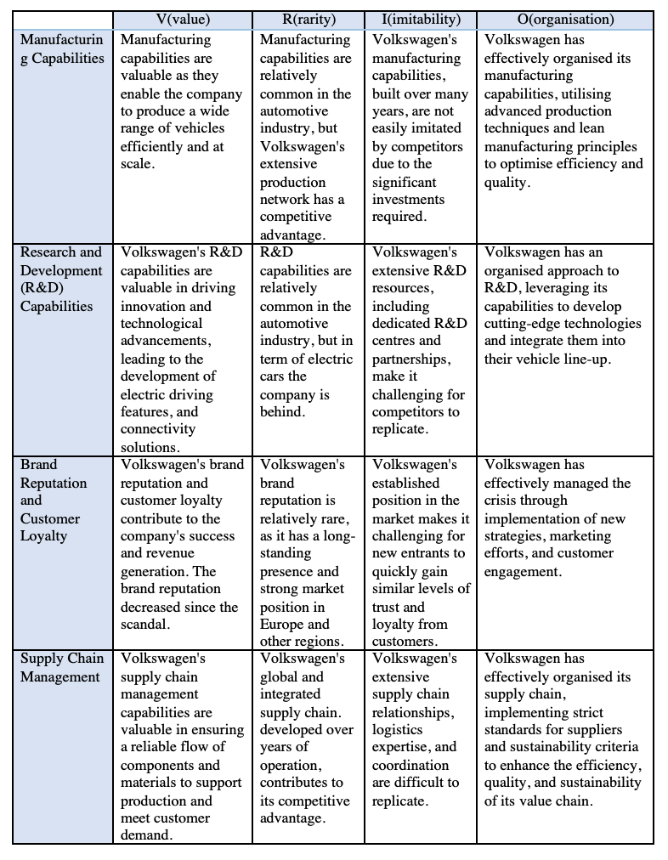

Appendix 2. Porters five forces analysis, Volkswagen Group



