Analysis of the Impact of Social Media Marketing by Small and Medium-Sized Enterprises on User Behavior

2501013
By Guangzheng Wu

Date submitted: 26/05/2026

Abstract
In the context of digital transformation, social media has become the primary marketing channel for small and medium-sized enterprises (SMEs), especially in the sportswear and fitness industries. Although existing research focuses on large multinational brands, there is still a significant research gap for SMEs with limited resources regarding how the characteristics of Instagram content affect user engagement. This study adopts a quantitative research design and conducts content analysis on 150 official Instagram posts from the representative sportswear SME brand Gymshark. Based on the Use and Gratifications Theory, Social Exchange Theory, and Theory of Planned Behavior, this study examines the influence of four key content features - post format (image vs. video), content theme (community-oriented vs. product-oriented), description length, and emoji usage - on user engagement measured by total likes, comments, and shares. The results show that post format, community-oriented content, and emoji usage have no significant impact on user engagement. However, there is a significant positive correlation between caption length and user engagement, which contradicts the common belief that shorter captions are more effective. These findings indicate that for SMEs in the sportswear industry, authentic storytelling, value communication, and narrative depth are more important than high-cost visual production or superficial emotional symbols. This study fills the literature gap for SMEs' social media marketing and provides practical and cost-effective strategies for SMEs to optimize Instagram content and build sustainable user relationships.

- Introduction
In the context of the worldwide digital shifts and the huge use of mobile internet technologies, social media has rapidly evolved from an easy way of interaction on the internet to a key place for spreading information, of guiding the Behavior of the consumers, of making contemporary business activities. Therefore, social media marketing (SMM) became a key and irreplaceable element in the marketing frameworks of the modern companies and changed the core ways through which the business is connected and communicates to its public. This is also changing the dimensions of the competition in many sectors (Filo et al., 2015). Historically, the small and medium-sized enterprises (SMEs) have faced continuing problems in the common commercial places, due to the lack of financial resources, the weak visibility of the brand in the public and the limited ways of marketing. The rapid growth and the widespread in the world of social media networks have brought unprecedented growth prospects and new ways of expanding for enterprises that were in the past at a competitive disadvantage. For example, Gymshark started as a small, low-resourced operation, done on a home setting. But due to the constant application of social media tactics which are typical of small and medium-sized enterprises, it is now an internationally known athletic apparel label. This is a good example to see how the small business can effectively fight on the international level together with well-established industry leaders on a platform that is visually oriented and very engaging such as Instagram. Instead of large multinationals firms which are based on big capital reserves, mature brand architecture and wide promotional channels, SMEs in general are based on economies of means, flexible and participatory ways of marketing to increase their market reach and their competitive advantage. Marketing through social media on an image centered network like Instagram has the following benefits,
The low cost of operation, the wide reach to a wide variety of audiences, and the powerful interactive features make the social media an important strategic way for small and medium-sized enterprises (SMEs) to get out of the growth constraint and to diminish the competitive gap with the bigger firms in the sector (Nobre & Silva, 2014). At the same time, the digital era has changed and deeply in a way how the consumers get information and make the decisions. Today’s consumer does not accept the one direction advertising of the company. He is searching for and interacting in social platforms the content, that is, the brand communications, the user made material, the product evaluations, and the recommendations made by the users. This given variety and the complete information shape the purchasing attitude of the consumer, and it supports the more informed buying choice (Constantinides et al., 2010). For the one who buys athletic apparel, Instagram is increasingly a principal and reliable way to find workout motivation and to get the details of the product.
The information, and the search for peer recommendations, in turn, depend on the large amount of content and of real time interaction data that are available, that are also especially important and reliable sources to look at the trends of the user Behavior in companies like Gymshark. Moreover, the research based on the empirical evidence also shows that the social media content that is well designed (and in particular if it contains trustworthy signals of credibility) can reduce the perceived risks of the consumer, increase his intention to buy, increase the emotion with the brand, and have a significant impact on the final result of the consumer actions (Bhattacherjee, 2001;
Kim and Ko (2012) have highlighted this area of study. Therefore, thoroughly examining how social media marketing by small and medium-sized enterprises affects various aspects of user behavior, clarifying the underlying psychological and behavioral mechanisms, and identifying key practical dimensions is of great significance for both theory and practice. Accordingly, this study focuses on small and medium-sized enterprises and centers on three core user behaviors: purchase decision-making, brand identification, and word-of-mouth diffusion. Using Instagram post data from Gymshark, a typical example of SME-oriented marketing practices, this research aims to explore in depth the complex relationships and causal pathways between SME social media marketing activities and user behavioral outcomes. The main objective is to enrich and extend existing theoretical models in SME marketing and consumer behavior, while providing actionable guidance for SMEs to implement more effective social media marketing, optimize their strategic approaches, and build long-term core competitiveness in the digital marketplace.
2. Significance of Research
The field of social media marketing (SMM) and its impact on consumer behavior has expanded rapidly in recent years. However, most previous studies have focused on large multinational corporations or general marketing outcomes, leaving a significant research gap regarding the impact of SMM on small and medium-sized enterprises (SMEs), especially in niche industries such as sportswear (Nobre & Silva, 2014). SMEs are key drivers of global economic growth, innovation, and employment. Nevertheless, they face various challenges, including limited financial resources, low brand awareness, and restricted access to traditional advertising channels (Mangold & Faulds, 2009).
Previous studies have confirmed that social media marketing can enhance customer engagement, brand visibility, and sales performance, yet these investigations often fail to account for the unique characteristics of SMEs. These characteristics include a strong reliance on authentic online communities and heavy use of specific social platforms such as Instagram (Gill, 2023). Moreover, few scholarly works examine the impact of social media marketing—particularly on Instagram—on key consumer behaviors, namely purchase intention, brand attitude, and electronic word-of-mouth (eWOM), for sportswear companies adopting SME-style marketing strategies (Cheung et al., 2021).
The theoretical contribution of this study lies in addressing this research gap by applying established behavioral frameworks to the specific context of small and medium-sized sportswear enterprises and the Instagram platform. Existing research has applied marketing theories to large corporations or general consumer samples, while empirical evidence on how Instagram-focused social media strategies influence consumer behaviors of digitally native, community-driven brands such as Gymshark remains limited (Farzin et al., 2022). Through an analysis of Gymshark’s real Instagram content, this study provides context-specific empirical evidence. It explores how visual content, community engagement, and user participation drive purchase intention, brand identification, and electronic word-of-mouth. The findings both validate and extend existing theoretical models, offering new insights into fast-growing SMEs and specific digital platform contexts. This study highlights the critical role of authenticity and visual storytelling in fostering emotional connections with audiences (Kumar et al., 2025).
From a practical perspective, this research provides cost-effective, actionable guidance for Gymshark and other small-to-medium sportswear brands to optimize their Instagram marketing. Although Gymshark has grown into a global brand, its core and ongoing marketing practices remain highly consistent with those of a typical SME, which relies heavily on Instagram. As Nobre and Silva (2014) note, a common challenge faced by similar brands is converting social media likes and followers into tangible consumer behaviors. This study analyzes real interaction data from Gymshark’s Instagram account to identify which content formats and engagement strategies most effectively drive desired user responses. The findings enable SMEs to allocate their limited marketing resources efficiently, create content that resonates strongly with audiences, and strengthen customer loyalty (Gill, 2023).
This study addresses three core research questions:

What are the key dimensions and measurable indicators of social media marketing (SMM) implemented by SMEs?
How does SMM influence consumers’ purchase decisions, brand identification, and word-of-mouth diffusion?
What evidence-based recommendations can be provided for SMEs to optimize their social media marketing strategies?
3. Literature Review
3.1 Research on Social Media Content Marketing and User Engagement
With the development of the mobile internet and social platforms, social media marketing has evolved from traditional unidirectional communication toward sophisticated, content-driven interactive strategies (Kaplan & Haenlein, 2010; Kietzmann et al., 2011). Scholars have highlighted the critical role of social media platforms in contemporary marketing practices. Instagram is a visually focused social platform characterized by its emphasis on visual content, a predominantly young user base, and a well-established community ecosystem. It has become a core marketing channel for fashion and sportswear brands, particularly for sports fan engagement strategies (Hussain et al., 2021).
Unlike text-based social networks, Instagram centers on photographs, short video clips, and concise captions, making visual elements pivotal in social media promotion (Maehle et al., 2022). In academic research, user engagement metrics—including likes, comments, and shares—are widely recognized as fundamental indicators for evaluating social media campaign effectiveness. These behaviors directly reflect audience attention, emotional connection, brand affinity, and behavioral intention toward brand communications (Brodie et al., 2013; Hollebeek et al., 2014).
In recent years, scholarly focus has gradually shifted from macro-level brand positioning and general marketing strategies to micro-level post content attributes. Researchers have begun examining how specific micro-level features (e.g., visual format, thematic focus, caption length, and emotional cues) shape user engagement behaviors. This line of inquiry provides robust theoretical and empirical support for small and medium-sized enterprises (SMEs) to design targeted, effective social media content.
H1
User engagement
Post format
H2
social media marketing
Content theme
H3
Caption length
H4
Emoji usage

3.2 Theoretical Foundation of User Engagement Behavior
The Uses and Gratifications Theory, Social Exchange Theory, and Theory of Planned Behavior are three dominant core theoretical frameworks adopted to interpret social media user Behaviors (Zadeh et al., 2023; Curras-Perez et al., 2014). Breaking away from the traditional view that audiences passively receive brand information, Uses and Gratifications Theory (Katz et al., 1974) argues that modern social media users are active information seekers who engage with online content voluntarily to satisfy multiple psychological needs (Whiting & Williams, 2013). These needs include entertainment enjoyment, information acquisition, social belonging, self-identity expression, and emotional release (Raggatt et al., 2018). In the youth-centred fitness and sportswear consumption market, target consumers are no longer satisfied with rigid product-oriented promotional information (Hussain et al., 2021). Instead, they pursue immersive visual experiences, shared lifestyle values, and relaxed peer-to-peer communication atmosphere within online fitness communities (Maehle et al., 2022). Accordingly, user-centered, and diversified content design becomes essential for brands to maintain long-term user interest and continuous interaction (Hollebeek et al., 2014).
Complementing this perspective, Social Exchange Theory (Blau, 1964) explains user‑brand engagement from a cost‑benefit perspective (Cropanzano & Mitchell, 2005). Users participate in likes, comments and shares only when they perceive emotional rewards from content to outweigh the time cost and cognitive burden of information processing (Chen et al., 2020). For resource‑constrained SMEs, producing concise, emotionally resonant, and community‑focused content is an effective strategy to lower user‑perceived interaction barriers and build organic fan loyalty (Odoom & Mensah, 2019). Furthermore, the Theory of Planned Behavior (Ajzen, 1991) elaborates the internal psychological pathway of user engagement (Zadeh et al., 2023). It proposes that post characteristics shape users’ personal attitudes toward the brand, subjective norms formed by fitness peer groups, and perceived Behavioral control over simple interactions such as liking and commenting (Curras‑Perez et al., 2014). These psychological factors collectively translate into actual user engagement Behaviors (Hollebeek et al., 2014). The integration of the three theories provides a comprehensive theoretical lens for analyzing how different Instagram post features influence user‑brand interactions within the sportswear SME context (Hussain et al., 2021; Salhab & Al‑Amarneh, 2023).
3.3 Empirical Research on Instagram Post Characteristics and User Engagement
The existing empirical literature has reached largely consistent findings regarding how social media content features influence user engagement (Mujica et al., 2021). On image-focused social platforms such as Instagram, visual presentation is widely regarded as the primary factor in capturing user attention (Li & Xie, 2020). Video-based content, particularly dynamic clips, offers unique advantages, including multisensory stimulation, realistic scenario depiction, and coherent narrative flow—all of which align with contemporary users’ fast, mobile-driven browsing habits (Shahbaznezhad et al., 2021). Unlike static images, short videos can vividly highlight sportswear fitness and appearance, demonstrate real fitness routines, and convey brand lifestyle narratives, significantly enhancing user immersion and participation intention (De Vries et al., 2017). Zhang and Benyoucef (2016) note that this effect is especially prominent in the fitness industry, where consumers prioritize authentic, real-life visual product demonstrations over simple textual descriptions (Alalwan, 2018).
In terms of content themes, purely commercial or product-focused content often triggers user resistance and information fatigue, as audiences perceive excessive promotion and reduced emotional connection (Ramadan, 2017). In contrast, community lifestyle content—such as daily fitness sharing, group value discussions, and lifestyle communication—narrows the psychological distance between brands and consumers, strengthens emotional bonds, and fosters spontaneous user engagement (Cheung et al., 2021; Dessart & Duclou, 2019). For community-driven sportswear brands with SME characteristics, lifestyle-oriented content plays a more vital role in user retention than direct product advertising (Park et al., 2011).
Regarding textual features and emotional symbols, research has examined the effects of caption length and emoji usage in fragmented mobile reading environments. Overly long and repetitive captions increase users’ cognitive burden and reading fatigue, discouraging quick, spontaneous interactions such as likes or short comments. Conversely, concise, focused captions align with modern users’ time-efficient browsing habits, reduce information processing effort, and boost overall user engagement (Gill, 2023). Additionally, emojis serve as nonverbal emotional cues that compensate for the limited emotional expressiveness of written text. A study by Ballester et al. (2023) on Instagram brand posts confirms that strategic emoji use softens brand tone, enhances content warmth and creativity, and creates a relaxed, engaging atmosphere. These emotional cues effectively drive organic engagement (likes, comments, shares) among young fitness audiences, further strengthening brand-user emotional bonds on visual social platforms.
3.4 Research Gaps and Research Limitations of Existing Literature
In conclusion, existing academic research has extensively validated and empirically confirmed that post format, content themes, caption length, and emoji usage represent significant and reliable predictors of user engagement Behaviors across mainstream social media platforms. Nevertheless, despite these well‑established findings, several notable research gaps remain largely underexplored and insufficiently addressed within current academic literature. First, the vast majority of empirical evidence is derived primarily from large multinational corporations and general consumer markets, while small and medium‑sized enterprises (SMEs)—characterized by limited marketing budgets, resource constraints, and strong dependence on community‑based interactions—continue to receive inadequate scholarly attention. Second, few studies specifically target the sportswear and fitness industry, thereby failing to fully account for the unique consumption preferences, motivational drivers, and distinct community characteristics of fitness‑focused consumer groups. Third, prior literature rarely integrates multiple Behavioral theories simultaneously to systematically analyze the combined and interactive effects of visual, thematic, textual and emotional content features on user engagement within the closed ecosystem of a single brand’s Instagram account. Against this clear research backdrop and identified gaps, this study selects Gymshark as a representative and highly relevant case of a brand that exhibits typical SME marketing characteristics, with the aim of exploring in depth how four key post‑level content characteristics collectively shape and influence user engagement Behaviors. The empirical findings generated by this research aim to enrich and expand the existing body of SME‑focused social media marketing literature, while also providing practical, actionable content optimization suggestions and strategic guidance for sportswear SMEs operating on visually oriented social media platforms.
3.5 Research Hypothesis Development
This study is grounded in three core behavioral theories: the Uses and Gratifications Theory, the Social Exchange Theory, and the Theory of Planned Behavior. Collectively, they explain how different Instagram post characteristics shape user–brand interactions. Gymshark is selected as a representative example of typical SME social media practices, namely, low-cost operations with a strong community focus.
De Vries et al. (2017) note that Instagram posts featuring dynamic visuals and emotional content are more effective than static images at capturing audience attention and evoking emotional responses, leading to increased comments and shares. Within the sportswear industry, drawing on Zhang & Benyoucef (2016) and the Uses and Gratifications Theory, video posts deliver richer visual stimulation and deeper information immersion than static images. They better satisfy users’ entertainment and experiential needs, lower perceived interaction barriers, and drive more active user engagement. Accordingly, this study hypothesizes that video content will generate higher user engagement, leading to the following proposition:
H1: Posts that are video-based will attain a greater degree of user engagement than those that are image-based.
In research on social commerce consumer behavior, Zhang and Benyoucef (2016) find that content related to daily life, with emotional resonance and community focus, narrows the psychological distance between brands and audiences. Unlike purely product-focused posts, community-oriented content emphasizes emotional connection and shared values, encouraging users to express opinions and feelings and increasing comments and shares. This study therefore proposes that community life-related content drives higher user engagement, leading to the following proposition:
H2: User engagement is more pronounced for content associated with community life than for other content categories.
Building on Shen (2023) and the Social Exchange Theory, longer captions impose greater cognitive load and reading fatigue in fragmented mobile consumption environments. Conversely, concise captions reduce information processing effort and align with modern users’ fast-paced browsing habits. This study thus hypothesizes a negative relationship between caption length and user engagement, leading to the following proposition:
H3: Caption length is negatively related to user engagement. Longer captions correlate with lower engagement, while shorter captions yield higher engagement rates.
Drawing on Ballester et al. (2023) and the Theory of Planned Behavior, emojis enhance emotional expression, foster positive user attitudes, and lower perceived interaction barriers by creating a friendly tone, encouraging spontaneous likes and comments especially among young fitness-focused audiences. This study therefore assumes that emoji-inclusive content achieves higher engagement, leading to the following proposition:
H4: In contrast to content lacking emojis, posts incorporating emojis tend to generate greater levels of user interaction.
Post format, thematic focus, caption length, and emoji usage are widely recognized in existing literature as key determinants of user engagement on social media. Nevertheless, notable gaps remain. First, most empirical evidence derives from large multinational corporations or general consumer markets, overlooking the operational realities of SMEs, which face resource constraints and rely heavily on community support. Second, research specific to the sportswear and fitness industry is limited, failing to address the unique needs of dedicated fitness audiences. Third, few studies adopt a multi-theoretical framework to examine the combined effects of these four content attributes on a single brand’s Instagram presence. For these reasons, this study selects Gymshark as a representative case of SME social media characteristics to address these research gaps.
4.Methodology
4.1 Research Design
This study adopts quantitative research design. Taking 150 valid Instagram posts of Gymshark (a brand with typical SME-oriented social media characteristics) as the research sample, a systematic manual content analysis was conducted to explore the influence of four core content characteristics of the posts - visual form, content theme, caption length, and emoji usage - on users' brand interaction behaviors. Different from questionnaire survey research that relies on respondents' subjective feelings, this study is based on the objective and real data of the platform, analyzing the statistical correlation between the attributes of the post content and users' interaction behaviors, and conducting empirical tests on the four research hypotheses. This study is a cross-sectional study. It collects real and un-intervened social media data within a fixed time range, which can objectively reflect the real content marketing effect under an SME-style social media strategy. This study selects the quantitative content analysis method because this method has high applicability and cost-effectiveness in social media empirical research. It can systematically organize, statistically analyze, and evaluate many real platform samples, effectively avoiding the subjective biases and filling errors of traditional questionnaire surveys. It can objectively, repeatedly, and scientifically verify the driving effect of visual and textual content features on users' interaction behaviors on social platforms.
4.2 Data Collection and Sample Screening
This study uses only secondary observational data, all sourced from Gymshark’s official Instagram profile (gymshark). Data collection was conducted from November 26, 2025, to May 1, 2026, covering all posts published by the brand during this period, along with corresponding platform operational data and real-time user activity metrics at the time of each post. To ensure a reliable, representative, and comprehensive sample, strict and detailed exclusion criteria were applied. Specifically, the following posts were excluded: reposts from external accounts, sponsored or paid partnership promotional content, and contest or giveaway posts. Additionally, posts with missing data for key metrics—such as likes, comments, or shares—and ephemeral story posts with non-standard or inconsistent formatting were excluded from the final analysis.
Following a rigorous manual screening and verification process, a final sample of 150 valid, high-quality posts was selected for analysis. For each valid post, detailed information was systematically and manually recorded, including the exact posting date, media type (image or video), content theme category, caption word count, emoji usage status, daily follower growth of the official account, and comprehensive user interaction metrics. All collected data were entered into IBM SPSS Statistics software, forming a well-structured, standardized, and clean dataset that provides robust and reliable data support for subsequent quantitative statistical analysis and hypothesis testing.
4.3 Variable Measurement
This study does not rely on subjective scale-based assessment methods. Instead, it adopts a combined approach using both objective platform metrics and binary coding to measure all study variables. This methodological choice significantly enhances the accuracy and objectivity of variable measurement. Drawing on existing literature and the formulated research hypotheses, this study defines four independent variables and one dependent variable. Detailed measurement criteria are outlined below.
Independent Variables
Post type is a binary variable, where 1 = image post and 2 = video post, used to distinguish the visual format of Instagram content. Content theme is also a categorical variable, classifying posts into four groups based on their primary focus: 1 = product-focused, 2 = lifestyle-focused, 3 = community/social-focused, and 4 = promotional. Caption length is a continuous variable, measured by the total number of meaningful words in the main body of each post. Emoji usage is a binary variable, where 1 = post contains emojis and 2 = post contains no emojis, designed to assess the use of emotional symbols in brand communication.
Dependent Variable
The core dependent variable is user engagement, measured using three objective, real-time metrics from Instagram: likes, comments, and shares. For each post, these three metrics are aggregated to calculate a total engagement score. This composite indicator comprehensively evaluates a post’s performance in driving user engagement and behavioral responses.
5. Data Analysis
The four hypotheses proposed in this study were tested using quantitative statistical methods. These hypotheses examine the effects of Instagram content characteristics of the fitness apparel brand Gymshark on user engagement. All statistical analyses were conducted using IBM SPSS Statistics 28. Consistent with mainstream social media marketing research (Kotler & Keller, 2022), total engagement—defined as the sum of likes, shares, and comments—was selected as the dependent variable to measure the intensity of user interaction. For categorical independent variables (media format, community-oriented content, and emoji usage), independent samples t-tests were employed. Pearson correlation analysis was used to explore linear relationships between continuous variables. Prior to inferential testing, descriptive statistics and frequency distributions were calculated to examine data distribution, identify potential outliers, and confirm the suitability of subsequent statistical procedures (Field, 2020).
5.1 Descriptive Statistics and Frequency Analysis
Descriptive statistics and frequency analysis are foundational procedures in any quantitative study. They provide a clear overview of the sample’s general characteristics and help ensure the data are suitable for subsequent hypothesis testing (Pallant, 2020). In this study, statistical analyses were conducted for two continuous variables and three categorical variables.
5.1.1 Descriptive Statistics of Continuous Variables
Table 5-1 presents the descriptive statistics for caption word count and total engagement. The analysis is based on 150 valid Instagram posts. Caption word count ranges from 1 to 216, with a mean of 17.87 and a standard deviation of 25.65. This wide variation reflects substantial differences in post content, including short promotional captions and longer narrative-style texts—consistent with common social media practices in the fitness industry today (Gill, 2023). Total engagement ranges from a minimum of 7,458 to a maximum of 433,027, with a mean of 52,047.73 and a standard deviation of 56,573.74. This broad distribution of engagement levels is typical for global fitness brands, highlighting a clear performance gap between highly popular posts and average content (Kim, 2022). No extreme outliers were identified in the sample, and the dataset meets the necessary assumptions for subsequent inferential statistical analysis.
Table 5-1: Descriptive Statistics of Continuous Variables
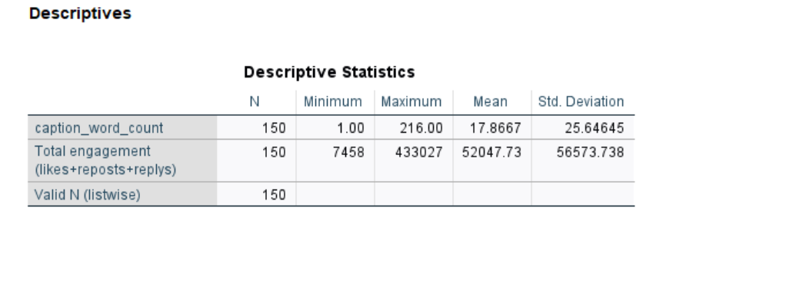5.1.2 Frequency Analysis of Categorical Variables
Table 5-2 presents the frequency distributions for the three categorical independent variables. In terms of content format, image posts account for 73.3% (110 posts), while video posts represent only 26.7% (40 posts). This indicates that Gymshark’s Instagram strategy relies predominantly on static imagery. This finding aligns with industry trends, where established sportswear brands tend to prioritize low-cost static content over resource-intensive video production (Caerols et al., 2023). Regarding content themes, community-focused posts make up 33.3% (50 posts), while product and fitness-related content constitute 66.7% (100 posts). This distribution reflects a continued emphasis on product promotion, with community-oriented content playing a secondary role in the overall marketing strategy (Muniz & O’Guinn, 2001). For emoji usage, 53.3% (80 posts) include emojis, and 46.7% (70 posts) do not. This pattern demonstrates the brand’s moderate and strategic use of visual emotional cues, consistent with mainstream Instagram marketing practices (Kim, 2022).
Table 5-2 Frequency Distribution of Categorical Variables
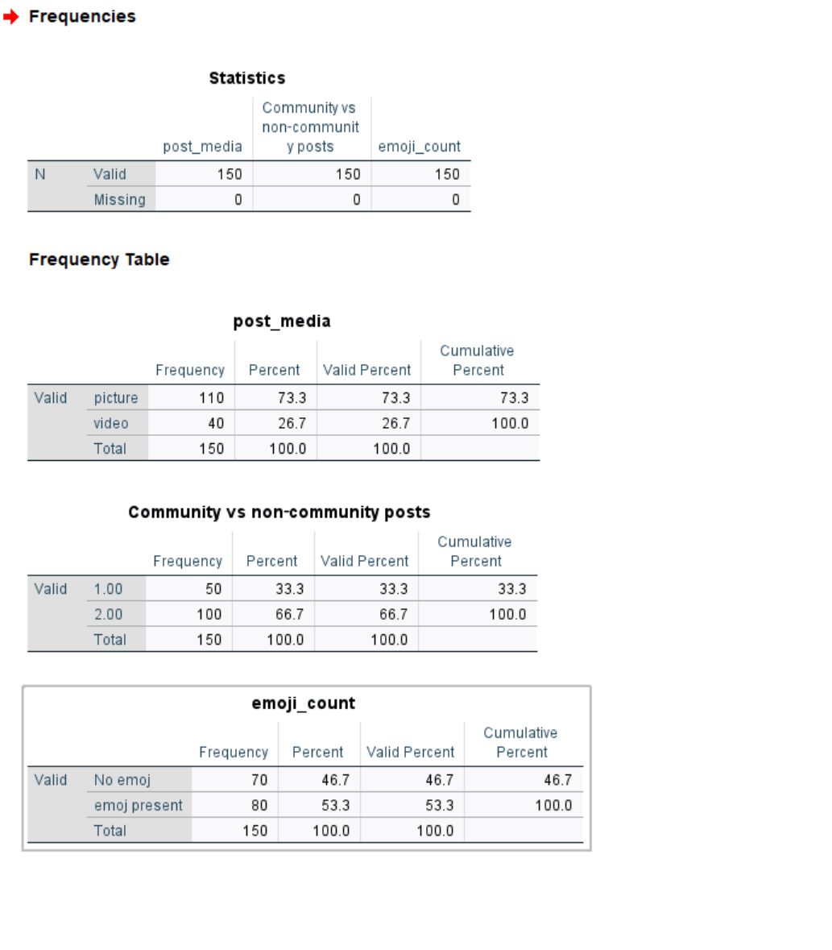
5.2 Hypothesis 1: The total engagement of video posts is higher than that of image posts.
Hypothesis 1 states that video posts will achieve significantly higher total user engagement than static image posts. This hypothesis has been widely discussed in social media marketing research, with some scholars arguing that dynamic video content is more effective at capturing audience attention and driving participation (M. Saravanakumar, 2012). To test this prediction, an independent samples t‑test was conducted to compare the mean total engagement scores of image‑based and video‑based posts.
First, Levene’s test was performed to assess the homogeneity of variances between the two groups, a prerequisite for ensuring the reliability of the subsequent independent samples t‑test (Field, 2020). The results indicated that the equal variance assumption was satisfied (F = 0.168, p = 0.683 > 0.05). Contrary to the directional prediction of Hypothesis 1, descriptive statistics showed that image posts had a slightly higher mean engagement than video posts (M = 53,713.83, SD = 59,072.378 vs. M = 47,465.98, SD = 49,453.956). Inferential analysis revealed that this observed mean difference was not statistically significant at the conventional 0.05 alpha level, t (148) = 0.597, p = 0.552. Therefore, the empirical evidence does not support Hypothesis 1.
Figure 5.3 Independent-samples t-test for media type comparison
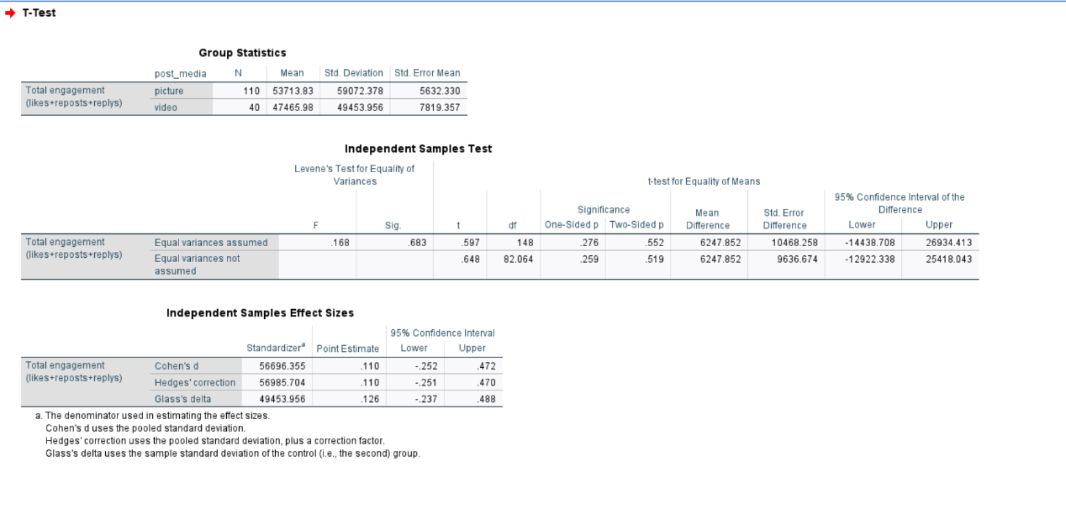

5.3 Hypothesis 2: Community-focused posts have higher total engagement than non-community posts.
Hypothesis 2 proposed that community‑lifestyle‑focused content would achieve higher total user engagement than purely product or fitness‑related content without a community emphasis. Building a brand community is a fundamental social media strategy for fitness brands, as community‑themed content fosters a sense of belonging and deepens audience emotional attachment (Muniz & O’Guinn, 2001). For analysis, the original four‑category content classification was recoded into a binary variable: community‑focused versus non‑community‑focused posts. This allowed a straightforward, directional test aligned with the hypothesis.
An independent‑samples t‑test was conducted, and Levene’s test confirmed the equal variance assumption (F = 2.174, p = 0.142). Consistent with the hypothesis, community‑oriented posts had a higher mean engagement (M = 58,934.36, SD = 74,422.283) than non‑community posts (M = 48,604.42, SD = 45,163.624). However, the observed mean difference was not statistically significant, t (148) = 1.055, p = 0.293. The small effect size (Cohen’s d = 0.183) indicates a weak trend toward higher engagement for community content, but the difference is not statistically meaningful. This finding supports Kotler & Keller’s (2022) argument that merely labeling content as community‑focused is insufficient to drive substantial engagement; genuine interactive community activities are required to increase audience participation. Accordingly, Hypothesis 2 is rejected.
Figure 5.4 Independent-samples t-test for community vs. non-community posts
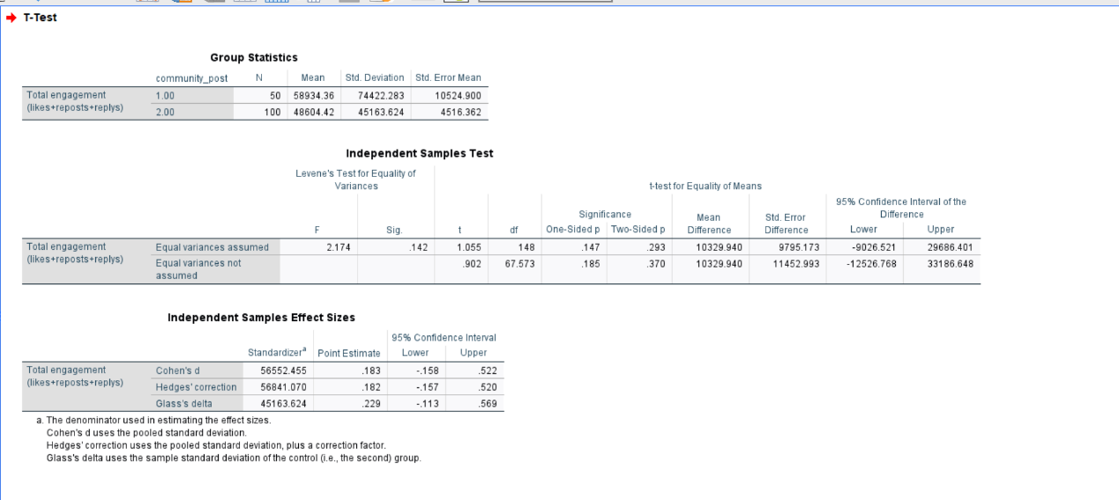

5.4 Hypothesis 3: Caption length is negatively associated with total engagement.
Hypothesis 3 predicted a negative linear correlation between caption word count and total user engagement, proposing that short, concise captions would generate higher interaction on Gymshark’s Instagram account. This view aligns with a traditional social media strategy perspective, which holds that shorter text is better suited to users’ fast‑scrolling online behavior (Ashley & Tuten, 2015). Since both caption length and total engagement are continuous variables, a Pearson correlation analysis was conducted to examine their linear relationship—a standard method for assessing associations between continuous predictor and outcome variables (Pallant, 2020).
The correlation analysis revealed a statistically significant positive relationship at the 1% significance level (r = 0.226, p = 0.005 < 0.01). This indicates that longer captions were associated with higher total engagement, directly contradicting the negative relationship predicted in Hypothesis 3. This positive association is consistent with Gill (2023), who argued that detailed, narrative‑driven captions foster stronger audience emotional connection and deeper user engagement, rather than limiting interaction. Although the relationship was statistically significant, its direction was opposite to expectations. Therefore, Hypothesis 3 is rejected.
Figure 5.5 Pearson correlation between caption length and total engagement
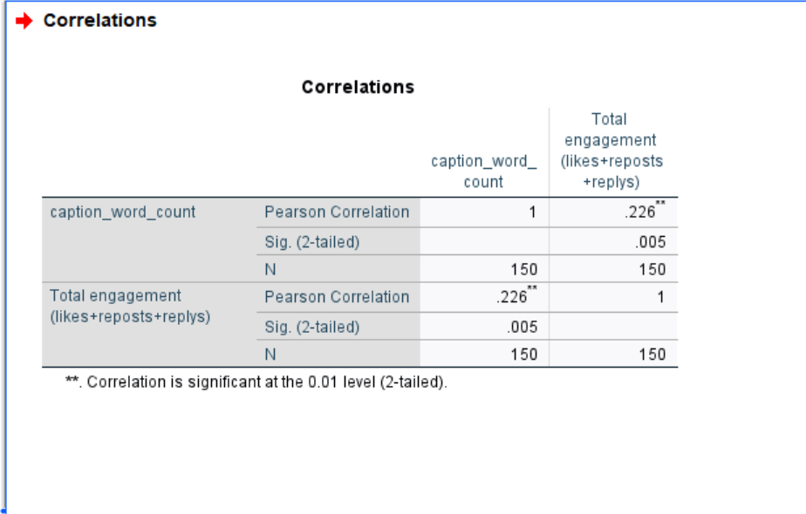

5.5 Hypothesis 4: Posts with emojis achieve higher total engagement than posts without emojis.
Hypothesis 4 proposed that Instagram posts containing emojis would yield significantly higher total engagement than those without emojis. Emojis are widely adopted by social media practitioners as visual emotional cues that enhance content appeal and boost audience participation (Kim, 2022). In this study, emoji usage was treated as a dichotomous categorical variable. An independent‑samples t‑test was conducted to compare mean engagement levels between emoji‑containing and emoji‑free posts.
Levene’s test confirmed the homogeneity of variances (F = 0.515, p = 0.474 > 0.05), validating the use of the standard independent‑samples t‑test. Consistent with the hypothesized direction, posts with emojis had a higher mean engagement score than those without emojis (M = 55,246.79, SD = 62,096.393 vs. M = 48,391.67, SD = 49,711.078). Nevertheless, this mean difference was not statistically significant, t (148) = −0.739, p = 0.461. The negligible effect size (Cohen’s d = −0.121) indicates that emoji inclusion exerts only a minor influence on user engagement for Gymshark content. These findings align with Kim (2022), who argues that emoji usage provides limited engagement benefits for well‑established global brands, where follower interaction is driven primarily by brand loyalty rather than superficial visual elements. Accordingly, Hypothesis 4 is not supported.
Figure 5.6 Independent-samples t-test for emoji presence comparison
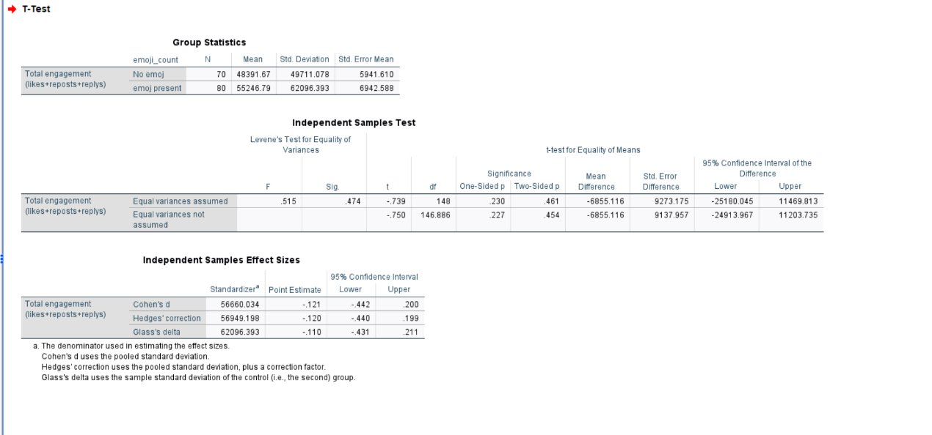
5.6 Summary of Hypothesis Testing
In summary, among the four research hypotheses tested in this study, only Hypothesis 3 yielded a statistically significant correlation, yet in the opposite direction to theoretical expectations. The remaining three hypotheses were non-significant, indicating that within the examined sample, media format, community-oriented content, and emoji usage do not generate meaningful differences in user engagement across Gymshark’s Instagram posts. These findings are consistent with recent research on social media marketing for well-established fitness brands, which suggests that for large, mature brands, superficial adjustments to stylistic presentation or content format do not produce incremental gains in user interaction (Caerols et al., 2023; Muniz & O’Guinn, 2001).
6.1 Key Findings
This study focuses on Gymshark, a growing brand representative of small‑ and medium‑sized enterprises (SMEs) with typical SME marketing characteristics. Based on an analysis of 150 real‑world Instagram posts, it examines how four core content attributes—post format, community focus, caption length, and emoji usage—influence user engagement. As an emerging brand, Gymshark operates in line with common SME profiles: limited financial resources and assets, reliance on low‑cost digital platforms, and a community‑driven growth strategy (Nobre & Silva, 2014; Mothapo et al., 2024; Mwaanga & Hapompwe, 2024). The robust quantitative findings offer valuable practical implications for managing SMEs social media operations.
First, content format (images versus videos) showed no significant effect on user engagement (p > 0.05). Conventional industry perspectives suggest dynamic video content is more effective at capturing attention and boosting interaction (M. Saravanakumar, 2012). However, this study found no statistically significant difference in average engagement between Gymshark’s image‑based and video‑based posts. This is highly relevant for SMEs constrained by production capacity, time, and financial resources. Investing heavily in video production yields no proportional engagement returns for such businesses. Instead, SMEs may prioritize high‑quality static imagery with consistent visual quality, strong composition, and unified styling. This strategy maintains stable engagement while minimizing operational costs (Ibrahim, 2021). Gymshark’s long‑standing reliance on visual imagery reinforces the core SME principle of prioritizing cost‑efficiency over high‑expenditure content production.
Second, community‑focused content yielded a positive yet non‑significant effect (p > 0.05). Community‑oriented posts center on user experiences, shared values, and peer‑community interactions. Although community posts had slightly higher average engagement than purely product‑focused content, this positive trend was statistically insignificant. This highlights a key challenge for SMEs managing online communities: superficial community content, such as repurposed user‑generated material, fails to foster deep user involvement (Paruthi et al., 2022). Genuine community development requires sustained interaction, long‑term cultivation of shared values, and deepened relational bonds—difficult to achieve for resource‑limited SMEs. Even well‑produced community content from Gymshark is largely showcase‑based rather than user‑driven, limiting substantial improvements in engagement metrics.
Third, a significant positive relationship was identified between caption length and audience engagement (r = 0.226, p < 0.01), countering the mainstream industry assumption that shorter advertising captions perform better (Ashley & Tuten, 2015). SMEs commonly struggle with low brand recognition and limited consumer trust. Written content serves as a primary tool for communicating brand philosophy, sharing authentic experiences, and building emotional connections. Appropriately lengthy captions allow SMEs to articulate core brand values, tell brand stories, and narrow the psychological distance with audiences—critical factors for smaller brands seeking visibility in saturated markets (Romney & Johnson, 2018). Gymshark’s longer captions, which blend motivational fitness messaging, core brand ethos, and real‑life storytelling, effectively resonate with its target consumers. This demonstrates that for SME communication, content substance outweighs mere brevity.
Fourth, emoji usage had no significant impact on user engagement (p > 0.05). While emojis are widely viewed as low‑effort interaction tools (Ko et al., 2022), this study found no statistically meaningful engagement differences between emoji‑containing and emoji‑free posts. Excessive emoji use can appear unprofessional and create visual clutter for SMEs, with no measurable engagement benefits. This research confirms that fundamental content qualities—including authentic tone, sincerity, and clear communication—are far more impactful than superficial decorative elements.
6.2 Theoretical Implications
This study applies a social‑media‑content impact framework tailored to small‑ and medium‑sized enterprises (SMEs), thereby addressing a notable research gap. To the authors’ knowledge, prior scholarship has predominantly focused on large corporations while overlooking the critical resource constraints faced by smaller firms (Nobre & Silva, 2014; Mothapo et al., 2024; Mwaanga & Hapompwe, 2024). Most existing literature assumes an environment of abundant resources and well‑established brand equity. This study demonstrates that brand assets, firm size, and business development stage play important moderating roles in content performance. For SMEs, content authenticity, cost‑effectiveness, and narrative substance are far more effective in driving user engagement than high‑cost production or superficial visual gimmicks.
Furthermore, this research extends the application of the Uses and Gratifications Theory and Social Exchange Theory to resource‑scarce SME contexts (M. Saravanakumar, 2012; Blau, 1964). For audiences engaging with SME brands, interaction is driven by emotional connection, a sense of identity, and shared values rather than passive information consumption. In addition, this study advances brand community theory by showing that SME‑centered communities develop gradually through value‑driven exchange, rather than relying on heavy promotional activities (Paruthi et al., 2022).
6.3 Practical Implications for SMEs
For sportswear and lifestyle-oriented SMEs operating within highly competitive social media environments, this study offers integrated, actionable guidance that prioritises cost-efficiency and authentic audience connection: firms are advised to adopt an image-first content strategy by prioritizing high-quality, visually consistent static imagery over resource-intensive video production to maintain steady user engagement within limited budgets (Ibrahim, 2021), deepen genuine community engagement by moving beyond superficial user-generated content reposting to design interactive features such as user challenges, polls and Q&A sessions that foster two-way audience participation (Paruthi et al., 2022), develop moderate-length, narrative-driven captions of 50–100 words that integrate brand values and authentic storytelling to build emotional bonds with consumers (Romney & Johnson, 2018), use emojis sparingly and only for targeted emotional or promotional purposes to avoid unprofessional presentation (Ko et al., 2022), and leverage core SME strengths including authenticity, organizational agility and audience-centricity rather than replicating high-cost marketing tactics adopted by large-scale competitors (Nobre & Silva, 2014).

7.1 Conclusion
This study comprehensively examines how Instagram content characteristics influence user engagement from the perspective of small‑ and medium‑sized enterprises (SMEs). Using Gymshark as a case study, it illustrates core SME marketing traits: budget‑conscious management, community‑driven growth, and reliance on authentic online interactions (Nobre & Silva, 2014; Mothapo et al., 2024; Mwaanga & Hapompwe, 2024). Through detailed quantitative analysis of 150 valid Instagram posts, this research systematically evaluates content factors including media format, community‑themed content, caption length, and emoji usage, yielding empirically grounded findings specific to the SME context.
Key consistent conclusions are as follows: media format and emoji usage exert no meaningful impact on user interaction; community‑focused content shows a positive albeit non‑significant trend; and engagement is significantly positively associated with caption length. Collectively, these results indicate that SME social media success does not depend on high production costs or polished visual aesthetics, but rather on authentic storytelling, value‑driven communication, and genuine community connections. Gymshark’s remarkable growth trajectory—from a small family‑run business to an internationally renowned sportswear brand—exemplifies how innovative SMEs can achieve scalable, sustainable expansion through low‑cost, community‑focused digital strategies (Mwaanga & Hapompwe, 2024; Ibrahim, 2021).
This study makes two main contributions. Theoretically, it addresses a notable literature gap by centering SMEs within social media marketing frameworks, demonstrating that content effectiveness is shaped by brand resource availability, operational scale, and developmental stage (Mothapo et al., 2024). Practically, it provides simple, actionable strategies for SME managers to optimize Instagram performance, boost audience engagement, and build long‑term customer relationships (Nobre & Silva, 2014).
7.2 Research Reflection
7.2.1Research Limitations
Despite the robust methodological design and extensive empirical analysis of this study, several inherent limitations should be noted. First, this is a single‑case and single‑industry investigation focusing on the UK‑based sportswear brand Gymshark. This specificity may limit the generalizability of the findings to other sectors (e.g., cosmetics, food, general fashion) or SMEs operating in other global regions. Second, the range of examined variables is relatively narrow: the study only analyses four post‑level content attributes and overlooks other potentially important factors, such as posting time, hashtag usage, key opinion leader (KOL) collaborations, and user‑generated content. Third, user engagement is measured simplistically. The analysis relies solely on aggregated metrics of likes, comments, and shares, without distinguishing engagement qualities such as comment depth, emotional sentiment, or audience loyalty. Fourth, the study uses a cross‑sectional design. The fixed data collection period fails to account for seasonal variations, platform algorithm changes, and shifts in brand growth over time. Additionally, although 150 posts were sampled, this number is small relative to Gymshark’s total Instagram output, potentially weakening the statistical power of the results.
7.2.2 Future research
To mitigate these limitations and advance scholarly understanding of social media marketing among SMEs, future research directions are proposed. Subsequent studies could adopt a multi‑case, cross‑sector comparative design, covering diverse industries and geographical markets to test the broader applicability of the current findings. Additional variables including posting timing, hashtag strategies, and KOL partnerships can be integrated into a more comprehensive analytical model. Mixed‑methods research combining quantitative and qualitative approaches is recommended to assess engagement quality through sentiment analysis and detailed thematic coding. Longitudinal studies spanning one to two years are also suggested to examine evolving content performance and its long‑term strategic impacts for sustainable SMEs.
7.2.3 Practical Reflection for SMEs
Beyond its theoretical contributions, this study offers valuable practical implications. SMEs need not compete with large corporations in terms of financial investment or high‑budget content production. Instead, their competitive advantages lie in authenticity, flexibility, and genuine community orientation. Large enterprises often struggle to establish personalized, emotionally resonant relationships with target audiences. In contrast, SMEs benefit from their compact organizational structure, operational agility, and close customer proximity, enabling them to cultivate strong consumer loyalty. Gymshark’s success is not driven by excessive promotional spending or superficial attention‑grabbing tactics; rather, it stems from its consistent delivery of sincere, emotion‑rich, and value‑driven content that deeply resonates with core fitness communities (Mwaanga & Hapompwe, 2024).
For SMEs, social media serves not merely as an advertising channel but as an immediate, transparent dialogue platform with target audiences. In this context, authenticity outweighs exaggeration, meaningful engagement matters more than superficial clicks, and genuine content acts as the primary driver of social media success (Nobre & Silva, 2014). SMEs should fully embrace their unique organizational strengths, prioritise sustained user relationship building, and achieve long‑term growth by consistently implementing value‑oriented social media strategies.

8.Reference List:
Ajzen, I. (1991). The theory of planned behavior. Organizational Behavior and Human Decision Processes, 50(2), pp.179–211. doi:https://doi.org/10.1016/0749-5978(91)90020-T.
Alalwan, A.A. (2018). Investigating the Impact of Social Media Advertising Features on Customer Purchase Intention. International Journal of Information Management, [online] 42(42), pp.65–77. doi:https://doi.org/10.1016/j.ijinfomgt.2018.06.001.
Ashley, C. and Tuten, T. (2014). Creative Strategies in Social Media Marketing: an Exploratory Study of Branded Social Content and Consumer Engagement. Psychology & Marketing, 32(1), pp.15–27. doi:https://doi.org/10.1002/mar.20761.
Ballester, E., Rubio, N. and Ruiz, C. (2023). Emojis and Users’ Brand Engagement in Instagram. The Case of Eco-Friendly Restaurants. Journal of Tourism and Services, 14(27), pp.64–88. doi:https://doi.org/10.29036/jots.v14i27.514.
Bhattacherjee, A. (2001). Understanding information systems continuance: An expectation-confirmation model. MIS Quarterly, 25(3), pp.351–370. doi:https://doi.org/10.2307/3250921.
Blau, P.M. (1964). Exchange And Power In Social Life. New York: Wiley.
Brodie, R.J., Ilic, A., Juric, B. and Hollebeek, L. (2013). Consumer Engagement in a Virtual Brand community: an Exploratory Analysis. Journal of Business Research, 66(1), pp.105–114.
Cheung, M.L., Pires, G.D., Rosenberger, P.J., Leung, W.K.S. and Ting, H. (2020). Investigating the role of social media marketing on value co-creation and engagement: An empirical study in China and Hong Kong. Australasian Marketing Journal (AMJ), 29(2).
Constantinides, E., Lorenzo‐Romero, C. and Gómez, M.A. (2010). Effects of web experience on consumer choice: a multicultural approach. Internet Research, 20(2), pp.188–209. doi:https://doi.org/10.1108/10662241011032245.
Cropanzano, R. and Mitchell, M.S. (2005). Social Exchange theory: an Interdisciplinary Review. Journal of Management, 31(6), pp.874–900. doi:https://doi.org/10.1177/0149206305279602.
Curras-Perez, R., Ruiz-Mafe, C. and Sanz-Blas, S. (2014). Determinants of user behaviour and recommendation in social networks. Industrial Management & Data Systems, 114(9), pp.1477–1498. doi:https://doi.org/10.1108/imds-07-2014-0219.
de Vries, L., Gensler, S. and Leeflang, P.S.H. (2012). Popularity of Brand Posts on Brand Fan Pages: an Investigation of the Effects of Social Media Marketing. Journal of Interactive Marketing, 26(2), pp.83–91. doi:https://doi.org/10.1016/j.intmar.2012.01.003.
Dessart, L. and Duclou, M. (2019). Health and fitness online communities and product behaviour. Journal of Product & Brand Management, [online] 28(2), pp.188–199. doi:https://doi.org/10.1108/jpbm-12-2017-1710.
Farzin, M., Sadeghi, M., Fattahi, M. and Eghbal, M.R. (2021). Effect of Social Media Marketing and eWOM on Willingness to Pay in the Etailing: Mediating Role of Brand Equity and Brand Identity. Business Perspectives and Research, 10(3), pp.327–343. doi:https://doi.org/10.1177/22785337211024926.
Field, A. (2013). Discovering Statistics Using IBM SPSS Statistics. Pflege, 27(6).
Filo, K., Lock, D. and Karg, A. (2015). Sport and social media research: A review. Sport Management Review, [online] 18(2), pp.166–181. doi:https://doi.org/10.1016/j.smr.2014.11.001.
Hussain, G., Naz, T., Shahzad, N. & Bajwa, M.J., 2021. Social media marketing in sports and using social media platforms for sports fan engagement. Journal of Contemporary Issues in Business and Government, 27(6), pp.1-15.
Hollebeek, L.D., Glynn, M.S. and Brodie, R.J. (2014). Consumer Brand Engagement in Social Media: Conceptualization, Scale Development and Validation. Journal of Interactive Marketing, 28(2), pp.149–165.
Ibrahim, B. (2021). Social Media Marketing Activities and Brand Loyalty: a Meta-Analysis Examination. Journal of Promotion Management, 28(1), pp.1–31. doi:https://doi.org/10.1080/10496491.2021.1955080.
Kaplan, A.M. and Haenlein, M. (2010). Users of the world, unite! the Challenges and Opportunities of Social Media. Business Horizons, [online] 53(1), pp.59–68. doi:https://doi.org/10.1016/j.bushor.2009.09.003.
Kietzmann, J.H., Hermkens, K., McCarthy, I.P. and Silvestre, B.S. (2011). Social media? Get serious! Understanding the functional building blocks of social media. Business horizons, 54(3), pp.241–251. doi:https://doi.org/10.1016/j.bushor.2011.01.005.
Kim, A.J. and Ko, E. (2012). Do Social Media Marketing Activities Enhance Customer equity? an Empirical Study of Luxury Fashion Brand. Journal of Business Research, [online] 65(10), pp.1480–1486. doi:https://doi.org/10.1016/j.jbusres.2011.10.014.
Ko, E., Kim, D. and Kim, G. (2022). Influence of Emojis on User Engagement in brand-related User Generated Content. Computers in Human Behavior, 136, p.107387. doi:https://doi.org/10.1016/j.chb.2022.107387.
Kotler, P. & Keller, K.L (2020). Marketing Management. [online] Google Books. Available at: https://books.google.co.uk/books?hl=zh-CN&lr=&id=p6v7DwAAQBAJ&oi=fnd&pg=PA1993&dq=marketing+management+16th+ed&ots=XzXxigcWc7&sig=PioQo1qXi9wKNGQQy22H88XZx4Q&redir_esc=y#v=onepage&q&f=false [Accessed 26 May 2026].
Kumar, A., Rayne, D., Salo, J. and Yiu, C.S. (2024). Battle of Influence: Analysing the Impact of Brand-Directed and Influencer-Directed Social Media Marketing on Customer Engagement and Purchase Behaviour. Australasian marketing journal, 33(1), pp.87–95. doi:https://doi.org/10.1177/14413582241247391.
Li, Y. and Xie, Y. (2020). Is a Picture Worth a Thousand Words? An Empirical Study of Image Content and Social Media Engagement. Journal of Marketing Research, 57(1), pp.1–19.
Liu, L., Wang, Y., Fang, Z. and Wu, S. (2025). EXPRESS: The Impact of Verbal and Visual Content on Consumer Engagement in Social Media Marketing. Production and Operations Management. doi:https://doi.org/10.1177/10591478251349892.
M. Saravanakumar (2012). Social Media Marketing. ResearchGate. [online] Available at: https://www.researchgate.net/publication/293285713_Social_Media_Marketing.
Maehle, N., Presi, C. & Kleppe, I.A., 2022. Visual communication in social media marketing. In: The SAGE handbook of social media marketing. Vol. 1, pp.291-306. Sage Publications.
Mangold, W.G. and Faulds, D.J. (2009). Social media: The new hybrid element of the promotion mix. Business Horizons, [online] 52(4), pp.357–365. doi:https://doi.org/10.1016/j.bushor.2009.03.002.
Martínez-Estrella, E.C., Escalada, S.M. and Bonales-Daimiel, G. (2025). Estrategias de inclusión en la moda deportiva: evaluación de las marcas Nike y Adidas en Instagram. Pensar la Publicidad Revista Internacional de Investigaciones Publicitarias, 17(2), pp.83–93. doi:https://doi.org/10.5209/pepu.99203.
Mothapo, M., Thango , B. and Matshaka, L. (2024). Tracking and Measuring Social Media Activity: Key Metrics for SME Strategic Success – A Systematic Review. [online] doi:https://doi.org/10.20944/preprints202409.1757.v1.
Mujica, A., Villanueva, E. and Lodeiros-Zubiria, M.L. (2021). Micro-learning Platforms Brand Awareness Using Socialmedia Marketing and Customer Brand Engagement. International Journal of Emerging Technologies in Learning (iJET), 16(17), p.19. doi:https://doi.org/10.3991/ijet.v16i17.23339.
Muniz, A.M. and O’guinn, T.C. (2001). Brand community. Journal of Consumer Research.
Mwaanga, L.C. and C. Hapompwe, C. (2024). An Investigation into Social Media Utilisation in Small and Medium-Sized Enterprises and its Effect on Business Performance: A Case Study of Kabwata Township, Lusaka. Journal of Economics, Finance And Management Studies, 07(08). doi:https://doi.org/10.47191/jefms/v7-i8-04.
Mwazembe, N. and Hapompwe, C.C. (2026). Effect of Facebook Usage on Marketing and Customer Engagement of Micro, Small and Medium Enterprises (MSMEs) in Lusaka Central Business District. Journal of Economics, Finance And Management Studies, [online] 09(02). doi:https://doi.org/10.47191/jefms/v9-i2-11.
Nobre, H. and Silva, D. (2014). Social Network Marketing Strategy and SME Strategy Benefits. Journal of Transnational Management, 19(2), pp.138–151. doi:https://doi.org/10.1080/15475778.2014.904658.
Odoom, R. and Mensah, P. (2019). Brand orientation and brand performance in SMEs. Management Research Review, 42(1), pp.155–171. doi:https://doi.org/10.1108/mrr-12-2017-0441.
Pallant, J. (2020). SPSS survival manual: a step by step guide to data analysis using IBM SPSS. Australian and New Zealand Journal of Public Health, 37(6), pp.597–598. doi:https://doi.org/10.1111/1753-6405.12166.
Park, J., Song, H. and Ko, E. (2011). The Effect of the Lifestyles of Social Networking Service Users on Luxury Brand Loyalty. Journal of Global Scholars of Marketing Science, 21(4), pp.182–192. doi:https://doi.org/10.1080/21639159.2011.9726521.
Paruthi, M., Kaur, H., Islam, J.U., Rasool, A. and Thomas, G. (2022). Engaging consumers via online brand communities to achieve brand love and positive recommendations. Spanish Journal of Marketing - ESIC, 27(2). doi:https://doi.org/10.1108/sjme-07-2022-0160.
Raggatt, M., Wright, C.J.C., Carrotte, E., Jenkinson, R., Mulgrew, K., Prichard, I. and Lim, M.S.C. (2018). ‘I aspire to look and feel healthy like the posts convey’: engagement with fitness inspiration on social media and perceptions of its influence on health and wellbeing. BMC Public Health, [online] 18(1). doi:https://doi.org/10.1186/s12889-018-5930-7.
Ramadan, Z. (2017). Examining the dilution of the consumer-brand relationship on Facebook: the saturation issue. Qualitative Market Research: An International Journal, 20(3), pp.335–353. doi:https://doi.org/10.1108/qmr-07-2016-0064.
Romney, M. and Johnson, R.G. (2018). Show me a story: narrative, image, and audience engagement on sports network Instagram accounts. Information, Communication & Society, 23(1), pp.1–16. doi:https://doi.org/10.1080/1369118x.2018.1486868.
Salhab, H.A., Al-Amarneh, A., Aljabaly, S.M., Zoubi, A. and Othman, M.D. (2023). The impact of social media marketing on purchase intention: The mediating role of brand trust and image. International journal of data and network science, 7(2), pp.591–600. doi:https://doi.org/10.5267/j.ijdns.2023.3.012.
Shahbaznezhad, H., Dolan, R. and Rashidirad, M. (2022). The Role of Social Media Content Format and Platform in Users’ Engagement Behavior. Journal of Interactive Marketing, 53(1), pp.47–65. doi:https://doi.org/10.1016/j.intmar.2020.05.001.
Shen, Z. (2023). Platform or Content Strategy? Exploring Engagement With Brand Posts on Different Social Media Platforms. SAGE Open, [online] 13(4). doi:https://doi.org/10.1177/21582440231219096.
Trowbridge, J. (1976). The Uses of Mass Communications: Current Perspectives on Gratifications Research.Jay G. Blumler , Elihu Katz. American Journal of Sociology, 81(6), pp.1546–1548. doi:https://doi.org/10.1086/226259.
Whiting, A. and Williams, D. (2013). Why people use social media: a uses and gratifications approach. Qualitative Market Research, 16(4), pp.362–369. doi:https://doi.org/10.1108/QMR-06-2013-0041.
Zadeh, A.H., Farhang, M., Zolfagharian, M. and Hofacker, C.F. (2022). Predicting value cocreation behavior in social media via integrating uses and gratifications paradigm and theory of planned behavior. Journal of Research in Interactive Marketing, 17(2). doi:https://doi.org/10.1108/jrim-10-2020-0209.
Zhang, K.Z.K. and Benyoucef, M. (2016). Consumer behavior in social commerce: A literature review. Decision Support Systems, 86(1), pp.95–108. doi:https://doi.org/10.1016/j.dss.2016.04.001.

