

BA DEVELOPING LEADERSHIP AND MANAGEMENT

Evidence of Learning

E-PORTFOLIO

Mohamed Babeker Osman Ahmed
Student No: 2112126

Changemakers: Creativity Value and Creation

Execution Summary.

This research aims to explore the impact of leadership styles on sustainability within non-profit organisation. challenges of overcoming environmental concerns outgrowing have becomes critical. This research aims to bridge attention on this gap (Taylor and Francis, 2018).
The research intended using abductive reasoning methodology to ‘produces exploratory hypotheses’ (Coghlan and Shani, 2021).
Carried out mixed methods approach which is the combination of ‘quantitative and qualitative method approaches’ (Czernek 2019).
conducted a primary and secondary survey to gather data, through the mixed method approach according to (Strauss and Whitfield 2018), the secondary research has been taken to determine the quality on existent literatures related to effective leadership styles applied on non-profit organisations (Hamlin and et al, 2011).
The sampling size indicated positive correlation the impact of leadership and sustainability efforts within non-profit organisations (Dvoryadkina and Prostova, 2020).

- Table of Contents
cover page 1
1.0 Execution Summary. 2
3.0 Main Findings. 4
3.1 Research Question. 4
3.2 Research Approach. 6
3.3 Data Collection Methods. 7
3.4 Sampling Design Method. 8
4.0 Research Techniques. 9
5.0 Idea of the presentation. 10
6.0 Data Analysis. 11
7.0 Conclusion. 12
8.0 References list. 13

Main Findings.

The role of leadership styles in driving sustainability within non-profit organisations has increased the attention of researchers in recent years (Taylor & Francis). As non-profit organisations face the challenges of overcoming environmental concerns and promote sustainability practices, understanding the impact of leadership on sustainability outgrowth has becomes critical. However, the specific relationship between leadership styles and sustainability within non-profit organizations still unexplored. This research aims to bridge this gap by examining the impact of diverse leadership styles on sustainability efforts and outcomes in non-profit organizations.

Research Question.

The contribution of this research lies in exploring a deeper understanding of how specified leadership styles can effectively drive and influence sustainability practises and initiatives within non-profit organisations. For instance, Non-profit organisations are often created to address social and environmental issues and rely heavily on the leadership of their executives to achieve their mission. There are several leaderships styles including transformational, democratic, autocratic, and laissez-faire. Each has advantages and disadvantages, and the choice of leadership style depends on the specific needs, goals, and mission of the organisation. However, this research focus on main two aspects regarding sustainability within non-profit organisations, which are the ‘impact of leadership’ and the ‘sustainability effort’ employed. According to Curcillo (2022), Transformational leaders motivate and inspire their followers to achieve higher levels of performance and promote innovation and creativity. They also encourage their followers to work towards a shared vision and are likely to empower stakeholder to take part of their work. This explanation of the practices can make transformational leadership style well-suited to non-profit organisations seeking to promote sustainable environmental practices. The second leadership style recommended is a democratic leadership style. In this style, the leader involves others in decision-making processes, which can lead to more innovative solutions and a greater sense of value that focus on the collective good and fundamental rather than profit (Bozeman and Crow, 2021). This can also be effective in promoting sustainable environmental practices among team members in non-profit organisations. In contrast, Autocratic leaders make decisions without input from others and can be resistant to change making it difficult to implement new environmental practices (Chukwusa, 2018). Similarly, a laissez-faire leadership style, in which the leader is hands-off and provides little guidance or direction (Duncan, et al, 2014), which can lead to a lack of focus and accountability. An autocratic leadership style can hinder a non-profit organisation's efforts to promote sustainability. The impact of leadership style on non-profit organisations and their ability to promote sustainability depends on style that has been employed. Clearly, we can identify that transformational and democratic leadership styles are more likely to promote sustainable environment practices within non-profit organisations. However, in this research we will focus only on two leadership styles related effectively to non-profit which are transformational and democratic leadership styles, because they are essential role in leading complex work groups such as non-profit organisations (Megheirkouni, 2017). Therefore, while transformational style is generally associated with positive outcome, but still there could be some potential disadvantages when implemented to the non-profit organisation. For example, relying on the leader’s charisma in setting guidance and direction can be problematic in decision-making, whereas other team members and volunteers’ vision within non-profit organisation could unintentionally force with limitation. Furthermore, democratic leadership style is generally emphasising collective decision-making, the collectiveness requires involvement of large number of participants with complicated discussion and approaches which could result a delay on the decision. This complexity of limitation and time wasted on decision-making is huge problem for the organisation seeking for a balance between effective leadership and monitoring or promote sustainability practices.
This research believes that there are predictable patterns could bring significant values to better understanding of relationships between leadership style and sustainability within non-profit organisations. For example, further investigation could:
- Enhanced knowledge and understanding of the specific mechanisms of leadership styles that impacts sustainability outcomes and dynamic factors that contribute to successful sustainability initiatives in non-profit organisations.
- Provide best practices and guidelines for leaders and mangers to effectively drive sustainability in non-profit organisations.
- Explore the perspectives of various stakeholders, including staff, volunteers, beneficiaries, donors, and community members, regarding the impact of leadership styles on sustainability in non-profit organisations.
The investigation utilised research questions to identify and evaluate the obtained data from the survey (Loucks, 2022). First the impact, to what extent is the correlation between leadership style (transformational, democratic) and implementation of sustainability practices within non-profit organisations? Second sustainability effort, how does the non-profit organisations involve their staff, volunteers, and stakeholder in environmental sustainability efforts?

Research Approach.

The research intention of using abductive reasoning methodology which is ‘produces exploratory hypotheses’ according to Coghlan and Shani, (2021). In this research it could mean that, provide construct through in which we can understand how this study can help to develop in action research. Also help to provide more robust and practical insights that can inform leadership (practices, strategies, and approaches) and enhance sustainability effort in the non-profit sectors (Engelschalt and et al, 2021).

Data Collection Methods.

The research carried out mixed methods approach which are the combination of ‘quantitative and qualitative method approaches’ for collecting the data to gather more ‘comprehensive understanding’ of the topic and to fulfil the gaps identified in the research questions (Zou, et al. 2018). However, Czernek (2019) has mentioned that the mixed methods approach is to help researchers reach a ‘better understanding’ of whether produce a new literature or just to highlight the gaps. Also has conducted a primary survey to gather data, through mixed method approach according to Strauss and Whitfield (2018), is a combination of quantitative and qualitative used to analysing data to identify the pattern from which repercussions respondents. Qualitative approach (closed-ended questions) focuses on gathering numerical data that can be analysed statistically to identify patterns, relationships, and trends (Hall, 2020). In addition, Qualitative approach (open-ended question) seeks to understand representative’s experiences, perceptions, and attitudes, and it can be a valuable approach for investigating complex social phenomena, such as the impact of leadership style on non-profit organizations.
Survey and Responses links provided below.
- https://forms.office.com/pages/designpagev2.aspx?lang=en-GB&origin=OfficeDotCom&route=Start&subpage=design&id=-REPTm4EBUWcuNshUjEeIa2tOxBoIN1CsvSlWBYEVgNUN1FIVEFJTTdOVlhIS1MwV0YwQzM3QVVGMSQlQCN0PWcu&analysis=false
- https://forms.office.com/pages/designpagev2.aspx?lang=en-GB&origin=OfficeDotCom&route=Start&subpage=design&id=-REPTm4EBUWcuNshUjEeIa2tOxBoIN1CsvSlWBYEVgNUN1FIVEFJTTdOVlhIS1MwV0YwQzM3QVVGMSQlQCN0PWcu&analysis=true

Sampling Design Method.

This survey adopted sampling size method with consideration that the specific research design and analysis techniques employed have specific sample size requirements internally within university stakeholders including lecturers and student who could (represent non-profit institutions) as an example for respond to the survey has been conducted. The contribution of representatives group aimed to obtain the data required and understanding the mechanisms of sustainable practices in relation to non-profit organisations activities. Which is important for non-profit organizations to sustain these activities in consistent ways for achieving their mission (Dvoryadkina and Prostova, 2020).

Research Techniques.

Technically, to explore a comprehensive understanding criterion related with effective leadership styles, mechanisms of the sustainability, and the relationship in between, some considerations have been taken such as, the research objectives, resources available, and types of the data need to be collected whether primary or secondary, to determine appropriate technique for the quality research (Carma, 2012) The secondary research has been taken to review evaluate, verify relevance, and reliability of the studies sources used in the research, determining the quality on existent literatures related to effective leadership styles applied on non-profit organisations (Hamlin and et al, 2011), influence sustainability within non-profit and its resistance (Scherrer and et, al,2014), which enabled the analysis of historical data and long-term trends and allowed research to examine changes over time and draw comparisons across different studies. Furthermore, it has provided valuable context and background information on a research topic. It helped research understand the existing theories, frameworks, debates, and prior findings related to their area of interest. The research adopted the techniques depends on the research questionnaire, and type of data needed to address the research problem effectively using of combination research approach has allowed gaining a comprehensive understanding of the topic to achieve our objectives. The evaluating and verifying the quality of the secondary sources used in the research, to clarify factors such as the credibility of the source, the date of publication, the methodology used in the original research. In conclusion, this research seeks to examine and highlight the relationship between leadership styles and sustainability within non-profit organizations.

Idea of the presentation.

Regarding present the idea of the research for the identified stakeholders, video elevator pitch has been created to deliver area of the research, purpose of the research, research approach, and the conclusion to obtain feedback and suggestions they have already received. According to their engagement and participation on watching the content, their feedback can be discredited as.
- Our presentation has demonstrated a deep understanding of the subject matter and effectively conveyed the significance of leadership style in achieving sustainability goals.
- The informative content and clear viability of the design of the video has significant effect on concentration and flow the presentation.
- Including the questions that could identify the pattern and trend has driven the stakeholders to the purpose of the research conversation convincingly.
The video link provided below:
https://www.youtube.com/watch?v=KTlhKBiK8JI&t=38s

Data Analysis.

In this section we have made an academic conference poster the research data analysis, and the original file has been sent for to the module lecture via email.
This is screenshot sample is for the research purpose as evidence of learning outcomes.
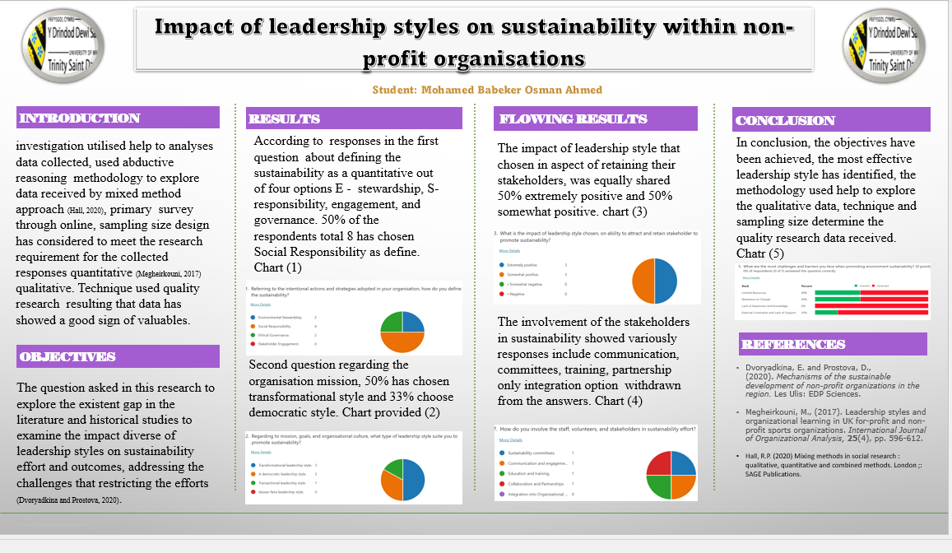

Conclusion.

Ultimately, further investigation could contribute to advancing knowledge, improving practices, and guiding decision-making processes related to leadership and sustainability. Furthermore, increase positive environmental impacts and foster sustainable practices within the non-profit sector. Also, could recommend a combination of different styles and approaches suites non-profit organisations’ specific need and circumstances. Using theories, academic methodology approaches and the representatives’ respondents to investigate how different leadership styles influence sustainability efforts and outcomes, this study aimed to offer valuable insights and practical recommendations for non-profit leaders, practitioners, and stakeholders to enhance promoting sustainable practices in the sector.

References list.

- Aboramadan, M. and Dahleez, K.A. (2020) ‘Leadership styles and employees’ work outcomes in non-profit organizations: the role of work engagement’, The Journal of management development, 39(7/8), pp. 869–893. Available at: https://doi.org/10.1108/JMD-12-2019-0499.

- Anheier, H., Krlev, G. and Mildenberger, G. (2018) Social Innovation : Comparative Perspectives. Milton: Taylor & Francis Group, 11th edition. PP 1-5

- Bozeman, B. and Crow, M.M. (2021) Public values leadership: striving to achieve democratic ideals. Johns Hopkins University Press.

- Chukwusa, J., (2018). Autocratic Leadership Style: Obstacle to Success in Academic Libraries. Library Philosophy and Practice, , pp. 1.
- Coghlan, D. and Shani, A.B. (Rami) (2021) ‘Abductive Reasoning as the Integrating Mechanism between First- Second- and Third-Person Practice in Action Research’, Systemic practice and action research, 34(4), pp. 463–474. Available at: https://doi.org/10.1007/s11213-020-09542-9.

- Curcillo, J., (2022). Find the Glue that Binds Your Team. Non-profit World, 40(4), pp. 22-23.

- Czernek-Marszałek, K. (2019) ‘Applying mixed methods in social network research – The case of cooperation in a Polish tourist destination’, Journal of destination marketing & management, 11, pp. 40–52. Available at: https://doi.org/10.1016/j.jdmm.2018.10.004.

- Daub, C.-H., Scherrer, Y.M. and Verkuil, A.H. (2014) ‘Exploring Reasons for the Resistance to Sustainable Management within Non-Profit Organizations’, Sustainability (Basel, Switzerland), 6(6), pp. 3252–3270. Available at: https://doi.org/10.3390/su6063252.

- Duncan, W.J., LaFrance, K.G. and Ginter, P.M. (2003) ‘Leadership and Decision Making: A Retrospective Application and Assessment’, Journal of leadership & organizational studies, 9(4), pp. 1–20. Available at: https://doi.org/10.1177/107179190300900401.

- Dvoryadkina, E. and Prostova, D., (2020). Mechanisms of the sustainable development of non-profit organizations in the region. Les Ulis: EDP Sciences.

- Hall, R.P. (2020) Mixing methods in social research : qualitative, quantitative and combined methods. London ;: SAGE Publications.

- Loucks, D.P. (2022) Public Systems Modeling: Methods for Identifying and Evaluating Alternative Plans and Policies. Cham: Springer Nature.

- Mathews, M.A. (2019) ‘Betwixt and Between the Board Chair and Executive Director Dyadic Leadership Role Perceptions Within Non-profit Organizations’, Journal of non-profit education and leadership, 9(3), pp. 281–299. Available at: https://doi.org/10.18666/JNEL-2019-V9-I3-8895.

- Megheirkoumi, M., (2017). Leadership styles and organizational learning in UK for-profit and non-profit sports organizations. International Journal of Organizational Analysis, 25(4), pp. 596-612.

- Perceived managerial and leadership effectiveness in a non-profit organization (2011): an exploratory and cross-sector comparative study’, Human resource development international, 14(2), pp. 217–234. Available at: https://doi.org/10.1080/13678868.2011.558318.

- Strauss, G. and Whitfield, K. (2018) Researching the World of Work : Strategies and Methods in Studying Industrial Relations. Edited by G. Strauss and K. Whitfield. Ithaca, NY: Cornell University Press. Available at: https://doi.org/10.7591/9781501717710.

- Toni Bielić, Dalibor Ivanisevic and Ana Gundić (2014) ‘PARTICIPATION BASED MODEL OF SHIP CREW MANAGEMENT’, Promet, 26(5), pp. 437–443. Available at: https://doi.org/10.7307/ptt.v26i5.1502.

- Upmeier zu Belzen, A., Engelschalt, P. and Krüger, D. (2021) ‘Modeling as Scientific Reasoning—The Role of Abductive Reasoning for Modeling Competence’, Education sciences, 11(9), p. 495–. Available at: https://doi.org/10.3390/educsci11090495.

- Using Secondary Data to do Quality Research. . (2012).[Video/DVD] Centre for the Advancement of Research Methods and Analysis (CARMA). Retrieved from. accessed 15/06/2023 https://video.alexanderstreet.com/watch/using-secondary-data-to-do-quality-research.

- Zou, P.X.W. et al. (2018) ‘A mixed methods design for building occupants’ energy Behavior research’, Energy and buildings, 166, pp. 239–249. Available at: https://doi.org/10.1016/j.enbuild.2018.01.068.

