

A Critical Analysis of Marriott International: Organisational Structure, Culture, Strategic Direction, and Change Initiatives
BA International Hotel Management
Management and Organisational Behaviour
BMIH5004
Lecturer Name: Daniel Payne
Student Name: Elena Boboc
Student Id: 2206217

AI declaration:
“I confirm that I have not used any Al tools in the research and creation or this assignment. I confirm that I have not presented any Al generated materials as my own work. I confirm I have copies of my drafts, notes, and other resources I used, which I may be asked to provide in evidence”

Executive Summary
Marriott International is a 1927 established company that has grown into the world’s largest hospitality company with over 31 brands and over 8,500 properties in 139 countries. Marriott is headquartered in Bethesda, Maryland, and its strength is attributable to its global presence, brand recognition, and the Marriott Bonvoy loyalty program, which has 173 million members. This report critically examines the organisational structure, Marriott International’s corporate culture, recent change initiatives, and strategic direction to assess Marriott International’s performance at the corporate and individual hotel levels. Key findings indicate that the matrix structure of Marriott is appropriate due to its ability to balance corporate control and local management of the hotel, as well as to take advantage of the strong culture of employee focus, which leads to better service quality and operational efficiency.
Moreover, work has been done on recent digital transformations, the sustainability efforts under the Serve 360 program, and responses to the pandemic and these have resulted in positive operations but also created challenges in employee engagement and quality control at franchised properties. To retain competitive advantage, recommendations include service quality monitoring for third-party owners that can be enhanced, employee development programs that can be invested, and market penetration into emerging markets. These strategies enhance Marriott’s operational resilience and employee satisfaction and maintain its dominant position in the dynamic global hotel industry.

Table of Contents
1 Introduction 6
2 Organisational Structure, Culture, and Goals 6
2.1 Organisational Structure 6
2.2 Corporate Culture 7
2.3 Organisational Goals 8
3 Recent Change Initiatives 8
3.1 Identification of Change Initiatives 8
3.2 Impact Analysis 9
3.3 Evaluation of Change Management 9
3.4 Lewin’s Change Management Model 10
3.4.1 Unfreeze 11
3.4.2 Change 11
3.5 Refreeze 11
4 Strategic Direction 11
4.1 Examination of Strategic Direction 11
4.2 Strategy Analysis by Using Porter’s Generic Strategies 12
4.3 Ansoff’s Matrix 12
4.3.1 Market Penetration 13
4.3.2 Market Development 13
4.3.3 Product Development 13
4.3.4 Diversification 14
4.4 SWOT Analysis 14
Strengths 14
Weaknesses 14
Opportunities 15
Treats 15
5 Conclusion 15
6 Recommendations 15
References 17

Introduction
Marriott International, founded in 1927 by J. Willard Marriott, has evolved from a small root beer stand into one of the world’s leading hospitality companies. Headquartered in Bethesda, Maryland, Marriott operates over 8,500 properties across 139 countries, employing more than 300,000 people globally. It has been determined in the research of Gjerløv (2023) that the company boasts a diverse portfolio of 31 brands, catering to luxury, premium, and economy segments, and reported a revenue of $23.4 billion in 2022. Notable achievements include the successful acquisition of Starwood Hotels & Resorts in 2016, making Marriott the largest hotel chain worldwide, and its award-winning Marriott Bonvoy loyalty program, which has over 173 million members (Eschenbrenner et al., 2023). This report aims to assess Marriott International’s corporate and individual hotel-level performance critically. The analysis focuses on the company’s organisational structure, culture, and goals, examines recent change initiatives, evaluates strategic direction, and provides recommendations to enhance operational efficiency and competitive advantage.

Organisational Structure, Culture, and Goals

Organisational Structure
Marriott International uses functional and divisional parts of its matrix organisational structure to optimise worldwide efficiency. As of 2023, Marriott runs around 8,500 hotels in 138 countries and territories with this arrangement. Brand management, worldwide marketing, and finance are centralised (Marriott Yi, 2024). However, they have decentralised operational autonomy for the property managers to answer local market needs within the corporate goal. According to Mintzberg, Marriott’s organisation combines divisionalised and professional bureaucracy. Marriott uses The Ritz-Carlton, Sheraton, and Westin to suit its target market niches. As per Zhang et al. (2022) pr, professional bureaucracy shows hotel management and frontline worker’s autonomy in service delivery and client interactions. Marriott’s hybrid strategy gives up flexibility and local creativity and takes a hit to brand consistency but achieves maximal flexibility.
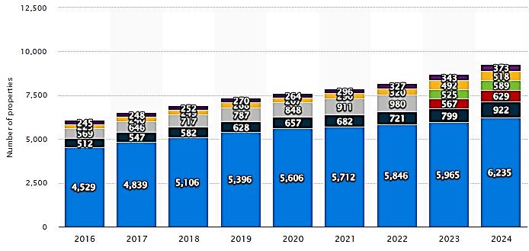
Figure 1 Marriott properties worldwide by region 2023
(Source: Statista, 2024)

Corporate Culture
Marriott's founding principle of “putting people first” has earned them a position on Fortune's “100 Best Companies to Work For” list for over two decades. Wesley et al. (2024) have asserted in this research that Marriott's worldwide workforce has 50% women and 44% people of color in management posts as of 2022, promoting diversity, equality, and inclusion. Using Schein's Organisational Culture Model, Marriott International may analyse its culture in three tiers. Open workplaces, employee appreciation, and Serve 360 environmental activities are artifacts. Leadership development and corporate policies reflect the company's honesty, respect, and service excellence values (Ataman et al., 2024). Marriott's fundamental beliefs emphasise employee well-being as a key to customer pleasure and economic success. This strong culture leads to great staff engagement (85% satisfaction rating) and excellent client experiences.
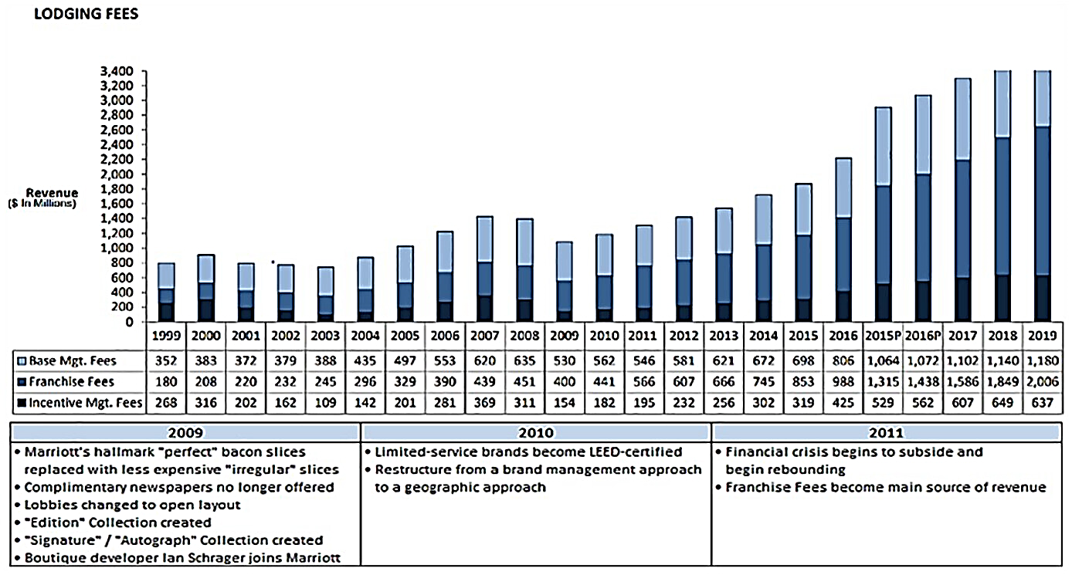
Figure 2 Marriott's Strategy to Survive an Economic Crisis
(Source: Tillery et al., 2023)

Organisational Goals
Marriott's corporate goals revolve around sustainable growth, global expansion, and technological innovation. By 2025, Marriott aims to open 1,400 new properties, targeting emerging markets and established urban centers. Sustainability is another key objective, with ambitious goals to reduce carbon emissions by 30% and achieve 100% renewable energy usage in managed hotels by 2025 (Gössling et al., 2023). At the individual hotel level, goals are tailored to local market conditions, focusing on service excellence, revenue growth, and community engagement. Marriott employs the Management by Objectives (MBO) framework to align corporate and hotel-level goals.

Recent Change Initiatives

Identification of Change Initiatives
Driven by technological advancements, sustainability goals, and external disruptions like the Russia-Ukraine conflict and Brexit, Marriott International has implemented major reform initiatives. Moreover, with Mobile Key technology, Marriott has transformed its digital presence, which lets customers check in, access rooms, and manage stays via cell phones. It has been anticipated in the study of Zhang et al. (2022) that over 4,000 Marriott hotels will use this technology by 2023, improving frictionless, seamless guest experiences. Marriott offers contactless services, including mobile housekeeping requests, digital menus, and automated checkout, boosting consumer convenience and efficiency.

Impact Analysis
These reform activities have had several effects. Contactless technology cut check-in times by 30% and optimised resource allocation throughout Marriott's digital transition. Improved data-driven decision-making lets Marriott customise services to guest preferences—mixed outcomes for employee engagement (Cherenkov et al., 2024). While health and safety precautions and digital training programs boosted staff adaptability and security, pandemic-related layoffs and increasing workloads lowered morale and employee satisfaction by 12% between 2020 and 2021. However, Sanli (2024) has identified in his research those rehabilitation methods, including flexible work arrangements and health programs, increased involvement by 8% in 2023. Marriott's efforts improved customer experience. The Marriott Bonvoy app was used 20% more due to mobile technology, while the “Commitment to Clean” increased cleanliness and safety satisfaction by 15%.

Evaluation of Change Management
Marriott’s change management strategies reveal both successes and challenges. It has been found by Negro (2022) that the company’s proactive adoption of digital technologies positioned it as a leader in contactless hospitality. Strong communication and leadership during the pandemic ensured alignment across global operations. Marriott’s sustainability achievements, including a 28% reduction in carbon intensity by 2022, also demonstrate effective long-term change management. However, Marriott faced challenges such as workforce reductions, which negatively impacted employee morale and public perception (Eschenbrenner et al., 2023). The rapid digital shift created skill gaps, necessitating extensive training. Moreover, implementing consistent changes across diverse global markets required tailored approaches to accommodate varying cultural and regulatory contexts.
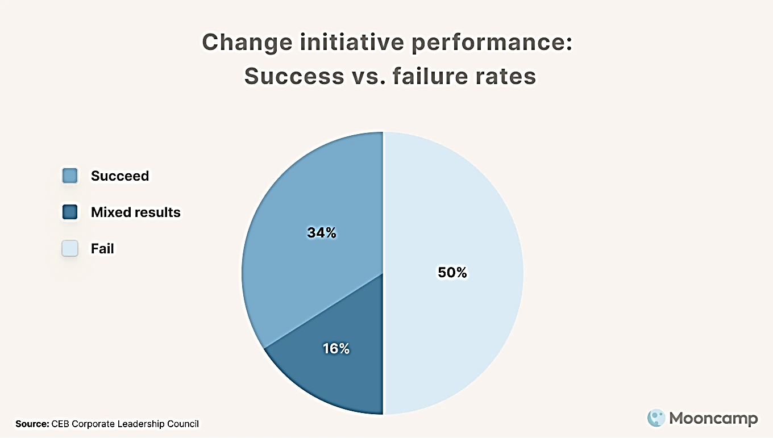
Figure 3 65+ Change Management Statistics for Success in 2025
(Source: Mooncamp, 2024)

Lewin’s Change Management Model
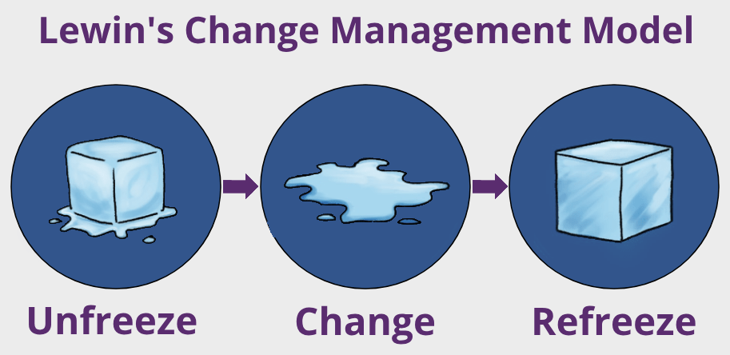
Figure 4 Lewin's Change Management Model
(Source: HRC, 2023)

Unfreeze
Marriott successfully initiated the unfreeze stage by disrupting the status quo, especially during the pandemic. The company communicated the urgency of adopting new health protocols and digital tools, creating a strong case for change (Cannavacciuolo et al., 2023). Leadership buy-in and stakeholder engagement were critical in preparing the organisation for transformation.

Change
Marriott implemented technological innovations, health safety measures, and sustainability programs during the change stage. It has been highlighted in the research of Li and Lin (2025) that employee training, cross-department collaboration, and resource reallocation supported these changes. Despite initial resistance, Marriott’s clear communication and support systems facilitated widespread adoption.

Refreeze
In the refreeze stage, Marriott institutionalised changes by embedding new practices into corporate policies and culture. Continuous performance monitoring, feedback mechanisms, and recognition programs helped solidify these changes, ensuring they became integral to Marriott’s operations (Bardukova, 2023). Although challenges persisted, Marriott’s ability to adapt and anchor these transformations highlights its resilience and strategic agility.

Strategic Direction

Examination of Strategic Direction
Marriott International’s long-term strategy and goal are focused on sustainable development, market leadership, and superior customer experience. On the other hand, it has been argued in the study of Yi, M. (2024) that the firm seeks to be 'the world’s favorite travel company' and aims to' enhance the lives of customers by creating and enabling unsurpassed vacation and leisure experiences.’ Marriott is committed to world expansion, innovation, and service excellence. As of 2023, Marriott is the world’s largest hotel chain, with 8,500 hotels in 139 countries. Marriott is focused on growth, innovation, and market leadership (Cannavacciuolo et al., 2023).
Moreover, in 2025, the business plans to open 1,400 hotels worldwide, particularly in emerging markets like the Middle East and Asia-Pacific. Marriott’s expansion is momentum-driven by its asset-light model, wherein ‒ the company has franchised or managed properties rather than owning them (Ataman et al., 2024). By using this method, Marriott can make 23.4 billion dollars in 2022; it maximises income and minimises capital expenses. According to Yi, M. (2024), Marriott also utilises technology to enhance guest experiences with smartphone cheque-in, the 173 million member Marriott Bonvoy app, and Marriott’s Serve 360 initiative that supports Marriott’s global sustainability goals by reducing carbon emissions, supporting responsible sourcing, and developing communities.

Strategy Analysis by Using Porter’s Generic Strategies
Marriott's competitive posture may be analysed using Porter's Generic Strategies—cost leadership, differentiation, and focus. Marriott's 31 brands include luxury (The Ritz-Carlton, St. Regis), premium (Sheraton, Westin), and economical (Fairfield Inn, Moxy Hotels). It has been analysed in the research of Wesley et al. (2024) that Marriott's brand diversification lets it provide distinct value propositions, including high-quality service, innovative facilities, and loyalty rewards programs for different client categories. Marriott incorporates cost leadership via operational efficiency while focussing on distinctiveness. Marriott achieves economies of scale with the asset-light model's minimal overhead. Systematic systems worldwide save expenses and ensure service consistency (Neves, 2022). This hybrid strategy gives Marriott an edge in some countries by allowing it to deliver luxury experiences at affordable prices.

Ansoff’s Matrix
Marriott’s growth strategies can be further analysed using the Ansoff Matrix, which identifies four key growth strategies: market penetration, market development, product development, and diversification.
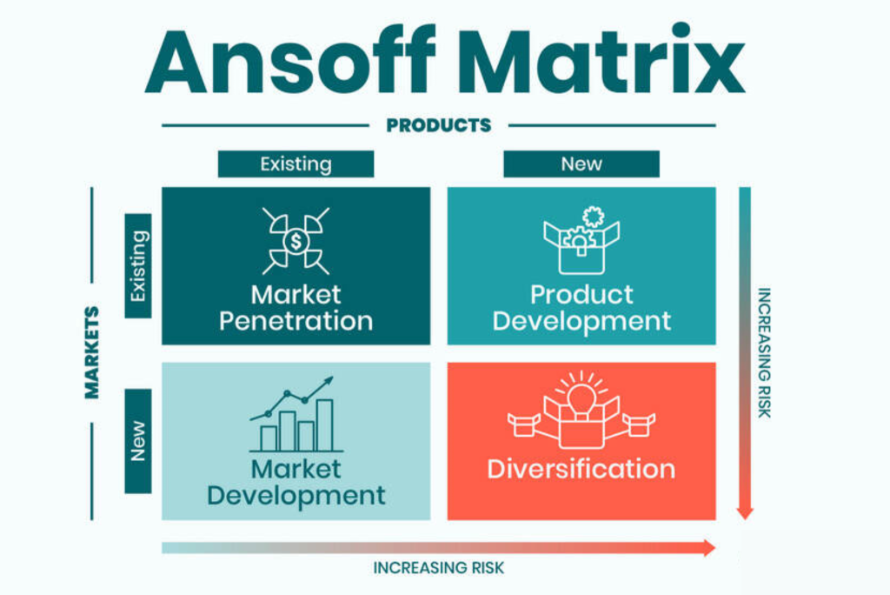
Figure 5 Ansoff - The Market Matrix
(Source: YCC Marketer, 2023)

Market Penetration
Marriott continuously seeks to increase its market share in existing markets through aggressive marketing, loyalty programs, and partnerships (Bardukova, 2023). The Marriott Bonvoy program, with over 173 million members, is crucial in driving customer retention and repeat business.

Market Development
Marriott has expanded into new geographic regions, targeting emerging markets like China, India, and the Middle East. Sanli (2024) has discussed in his study that in 2022, Marriott announced plans to open over 200 hotels in Asia-Pacific, capitalising on growing regional tourism demand.

Product Development
Innovation is at the core of Marriott’s strategy. The company has introduced new hotel concepts, such as Moxy Hotels, designed for younger, budget-conscious travelers seeking vibrant social experiences (Zhang et al., 2022). Marriott also invests in technology, enhancing digital platforms for personalised guest experiences.

Diversification
Although primarily focused on hospitality, Marriott has diversified into related sectors, including vacation ownership through Marriott Vacations Worldwide and luxury residential properties, mitigating risks associated with reliance on traditional hotel operations (Sanli, 2024).

SWOT Analysis
A SWOT Analysis provides a comprehensive view of Marriott’s strategic position.
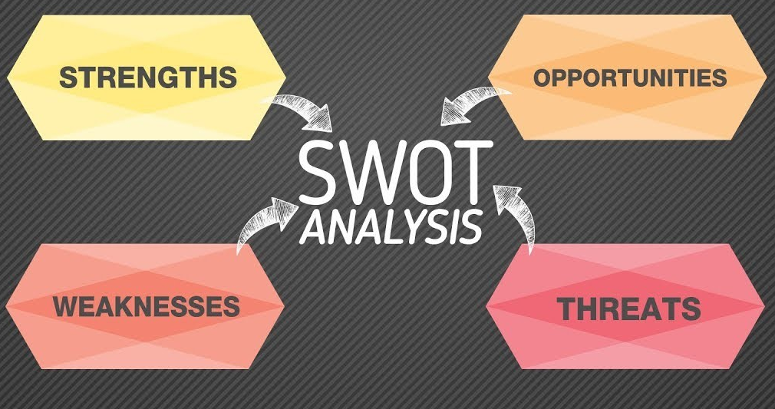
Figure 6 Unveiling the Power of SWOT Analysis in Business
(Source: Eversole, 2023)
Table 1 SWOT Analysis
Strengths | Weaknesses
- Strong global brand presence with over 8,500 properties worldwide.  - Robust Marriott Bonvoy loyalty program with 173 million members. | - Dependence on third-party property owners limits service control.  - Vulnerability to economic downturns affecting global travel demand.
Opportunities | Threats
- Expansion into emerging markets like Africa and Southeast Asia.  - Growing demand for sustainable and eco-friendly travel experiences. | - Intense competition from Hilton, Airbnb, and other hospitality giants.  - Cybersecurity risks are due to the increasing digitalisation of services.

Conclusion
It is concluded that this report critically analysed Marriott International’s organisational structure, culture, strategic direction, and recent change initiatives. The company operates under a matrix structure that balances centralised corporate oversight with decentralised hotel-level management, supported by a strong culture emphasising employee well-being and service excellence. Marriott’s strategic direction focuses on global expansion, digital transformation, and sustainability, with initiatives like the Serve 360 program and mobile technology adoption to enhance operational efficiency and customer satisfaction. Strengths such as a diverse brand portfolio, global presence, and a robust loyalty program have solidified Marriott’s market leadership. However, challenges remain, including reliance on third-party property owners, economic vulnerabilities, and increasing cybersecurity threats. While Marriott has effectively managed change through strong leadership and innovative strategies, continuous improvement in employee engagement, service quality control, and sustainability practices will be crucial to maintaining its competitive edge in the dynamic hospitality industry.

Recommendations
A number of strategic ideas are tried to improve performance and solve major problems at Marriott International. It has been recommended in the study of Negro (2022) that franchisee training and standardised operational audits should assist Marriott in improving the service quality of franchised properties. Hilton could give Marriott its measurements and accountability frameworks for third-party property owners. Organisations should spend after the Brexit on leadership development and mental health to create a resilient workforce and boost employee engagement (Singh et al., 2022).
In addition to this, these reforms will be supervised by corporate and hotel implementation, corporate leadership, regional management, and human resources teams. Before a large worldwide deployment over 12–18 months, a pilot project in high-impact locations is suggested. Marriott will implement measures to ensure uniformity in its corporate offices and hotels (Li and Lin, 2025). In a competitive context, these guidelines focus on service quality, operational efficiency, and employee happiness. To be adaptive in the changing hospitality industry, Marriott will be organised in training, clear communication, and ongoing progress tracking.

References
Ataman, A., Baharun, H., Sanjani, M. A. F., and Safitri, S. D. (2024). Exploring Complementary Leadership Styles in Madrasahs by Aiming at Their Impact on Integrity and Character Development. Business and Applied Management Journal, 1(2), 118-133.
Bardukova, L. (2023). Navigating the Hospitality Horizon: Current Trends and Strategies for Customer Attraction and Retention in the Hotel Industry. Economics and computer science, 2, 88-103.
Cannavacciuolo, L., Capaldo, G., and Ponsiglione, C. (2023). Digital innovation and organizational changes in the healthcare sector: multiple telemedicine project implementation case studies. Technovation, 120, 102550.
Cherenkov, E., Benga, V., Lee, M., Nandwani, N., Raguin, K., Sueur, M. C., and Sun, G. (2024). From Machine Learning Algorithms to Superior Customer Experience: Business Implications of Machine Learning-Driven Data Analytics in the Hospitality Industry. Journal of Smart Tourism, 4(2), 5-14.
Eschenbrenner, B., Zlatic, A., Bechtel, M., Collins, B., Straley, C., and Gubbels, G. (2023). Marriott International: A Managerial Strategic Audit.
Eversole, J. (2023) 'Unveiling the Power of SWOT Analysis: The Business Cornerstone Every Leader Needs'. LinkedIn.
Gjerløv, K. (2023). Value Creation through M&A in the Personal Luxury Goods Industry.
Gössling, S., Balas, M., Mayer, M., and Sun, Y. Y. (2023). A review of tourism and climate change mitigation: The scales, scopes, stakeholders and strategies of carbon management. Tourism Management, 95, 104681.
HRC Online (2023) 'Lewin’s Change Management Model'.
Li, X., and Lin, H. (2025). Platform digitization capability and organizational resilience: examining the roles of resource reconfiguration and environmental munificence. Business Process Management Journal.
Mooncamp (2024) '65+ Change Management Statistics for 2025: Key Trends and Insights'.
Negro, P. (2022). The Smart Hotel: a contactless and digital journey towards sustainability in Malta. The Online Open Access Repository of the Institute of Tourism Studies (Malta).
Neves, D. D. (2022). Marriott International Inc. Equity Research Hotel Giant 's Rcovery (Master's thesis, Universidade NOVA de Lisboa (Portugal)).
Sanli, M. (2024). Digital Transformations in the Hotel Industry (Doctoral dissertation, Long Island University, CW Post Center).
Singh, R., Sihag, P., and Dhoopar, A. (2022). Role of resilient leadership and psychological capital in employee engagement with special reference to COVID-19. International Journal of Organizational Analysis, 31(1), 232-252.
Statista (2024) 'Number of Marriott International properties worldwide from 2016 to 2023, by region'.
Statista (2024) 'Number of Marriott International properties worldwide from 2016 to 2023, by region'.
Tillery, H., Sheppard, S., and Ayoun, B. (2023) 'Marriott's strategy to survive an economic crisis: Invest and ...', SAGE Journals.
Wesley, S., Jackson, K. N., Martínez Ramos, D., Vanbeber, S., and Mujtaba, B. G. (2024). Marriott Hotel's Practices in Mitigating Discrimination Through Inclusionary Employee Resource Groups. Journal of Business Diversity, 24(1).
YCC Marketer (2023) 'Ansoff – The Market Matrix Examples'.
Yi, M. (2024). Sustainable Practices in Luxury Hotels: Case Study of Four Seasons Hotels and Resorts (Doctoral dissertation, Auckland University of Technology).
Zhang, H., Yang, L., Walker, R., and Wang, Y. (2022). How to influence the professional discretion of street-level bureaucrats: transformational leadership, organizational learning, and professionalization strategies in the delivery of social assistance. Public Management Review, 24(2), 208-232.

