

PROGRAMME: BSc CLOUD COMPUTING
Cloud computing Architecture
Module code: ACCA5025
Lecturer: Suneth Fernando
Assignment 1: Essay

Student: Ivo Ivanov/2111853

Contents
Virtualization 4
Benefits of moving to the cloud 6
Azure uses the following concepts to divide resources 8
To provide different levels of service, I would make the following choices 9
Cybersecurity 9
References………………………………………………………………………………………………………………………….10

TASK DESCRIPTION

Explain the terms “virtualisation” and “virtual machine” in the context of cloud computing.
Assume that you are working for a Small or Medium size Enterprise (SME) running an eCommerce website and associated web service. You have been tasked to evaluate the benefits of moving this on premises application to the cloud. There are a number of cloud services such as infrastructure as a service. Explain the differences in these service types and the benefits/drawbacks of moving to each approach. Hint: consider the costs, support provided and expertise required. Now assume that the company has elected to move to an infrastructure as a service model. Furthermore, assume you are also working on two big projects of multiple virtual machines that require high availability. That is, there should be no data loss and services remain available 24/7 with the minimum or no loss of service. Consider two cases where you have: 1. a very high budget with no cost limit 2. a medium budget where some loss of service can be to be tolerated under certain circumstances. Azure divides resources across “locations”, “availability zones” and “resource groups”. (FYI: AWS uses “regions”, “availability zones” and “resource groups”). Explain these concepts then describe the choices you would make to provide these two different levels of service. Given that cyber security is always a concern with any public application, this should always be addressed whenever deploying a public service to the cloud. Outline the differences between authorisation and authentication. Explain the importance of multifactor authentication (MFA), applying the least-privilege permissions, network security groups and Bastions (aka jumpboxes).

Virtualization
Visualisation is a technique used in cloud computing to create a virtual version of a physical resource, such as a server, storage device, or network, by partitioning it into smaller, independent units. This virtualization allows multiple virtual resources to run on a single physical resource, improving resource utilization and cost efficiency.
A virtual machine is a software emulation of a physical computer that behaves like a separate machine with its own operating system, applications, and data. Virtual machines can be created on a virtualization layer provided by the cloud infrastructure. This allows multiple virtual machines to be created on a single physical machine, allowing for better utilization of resources and increased flexibility in managing workloads.

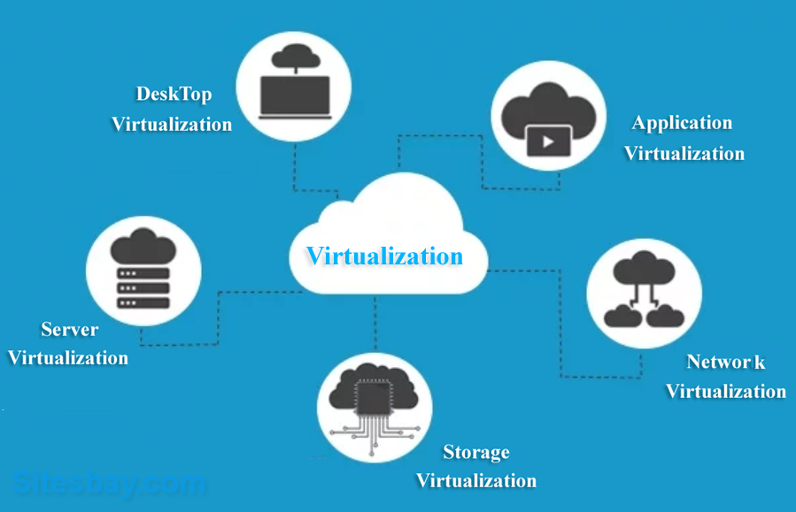
Figure 1: cloud virtualisation

Cloud providers use virtualization technology to create virtual machines for their customers. Users can choose the number of virtual machines they want to create, and each virtual machine can run a different operating system and software applications. Virtual machines are isolated from each other, providing better security and flexibility. Additionally, virtual machines can be easily moved between physical machines, allowing for better scalability and fault tolerance[1].

There are several cloud services available for Small and Medium size Enterprises (SMEs) to host their eCommerce websites and associated web services. These services can be categorized into three main types: Infrastructure as a Service (IaaS), Platform as a Service (PaaS), and Software as a Service (SaaS). Each of these cloud services has its own set of benefits and drawbacks that should be considered when deciding which one to choose for your business.

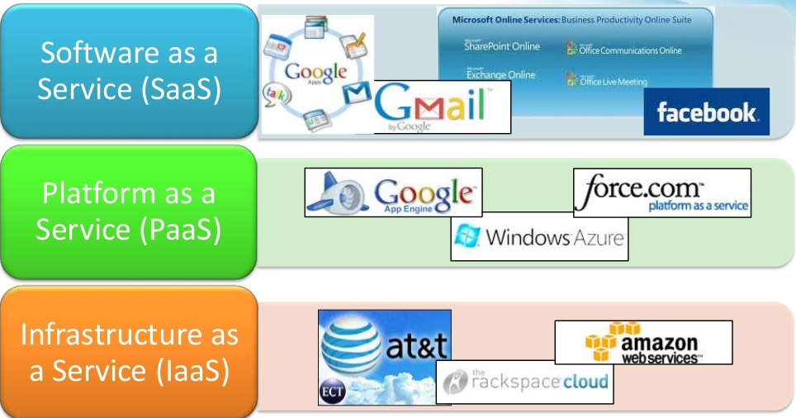

Figure 2: Infrastructure as a Service (IaaS), Platform as a Service (PaaS), and Software as a Service (SaaS).

Infrastructure as a Service (IaaS): IaaS is the most basic form of cloud computing service where the cloud service provider offers virtualized computing resources, such as servers, storage, and networking, to the customers. Customers can then configure and manage these resources to create their own virtual IT infrastructure. The main benefits of IaaS are the flexibility and scalability it offers. SMEs can quickly scale their resources up or down based on demand and only pay for the resources they use. However, IaaS requires SMEs to have a certain level of technical expertise to manage their own infrastructure.
Platform as a Service (PaaS): PaaS provides a complete platform for SMEs to develop, run, and manage their applications without the complexity of building and maintaining the infrastructure. Cloud service providers offer pre-built tools, frameworks, and other services that SMEs can use to develop their applications. PaaS also offers scalability and flexibility but requires less technical expertise than IaaS. However, SMEs may be limited in their choice of tools and frameworks provided by the cloud service provider.
Software as a Service (SaaS): SaaS is a complete software application hosted and managed by a cloud service provider. SMEs can access the application through a web browser without the need for any local installation or maintenance. SaaS offers the highest level of convenience and requires the least technical expertise. However, SMEs may be limited in customizing the application to their specific needs.

Benefits of moving to the cloud

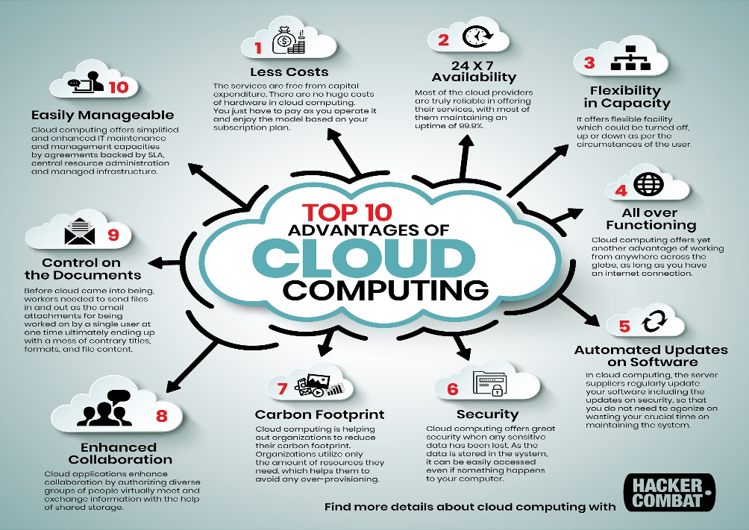

Figure 3: Benefits of moving to the cloud

Cost savings: SMEs can save money by paying only for the resources they use and avoiding upfront costs for hardware and software.

Scalability and flexibility: Cloud services offer SMEs the ability to scale up or down quickly based on demand, without the need to purchase additional hardware.

Access to the latest technology: Cloud service providers are constantly updating their technology, which allows SMEs to stay current without having to invest in new hardware and software.

Disaster recovery: Cloud services provide built-in disaster recovery capabilities that can help SMEs recover quickly from any downtime or data.

Availability 24/7: Most of the cloud providers are truly reliable in offering their services, with most of them maintaining on uptime of 99.9%.

Flexibility and capacity: It offers flexible capacity which could be turned off, up ore down as per circumstances of the user.

All over Functioning: Cloud computing offers yet another advantage of working from anywhere across the globe, as long as you have on internet.

Security: Cloud computing offers great security when only sensitive data has been lost. As the data is stored in the system, it can be easily accessed even if something is happens with your computer.

Carbon Footprint: Cloud computing is helping out of organisations to reduce their carbon footprint. Organisations utilize only the amount of resources they need, which helps them to avoid any over provisioning.

Enhanced Collaboration: Cloud applications enhance collaboration by authorizing diverse groups of people virtuality meet and exchange information with the help of shared storage.
[2]

Now assume that the company has elected to move to an infrastructure as a service model. Furthermore, assume you are also working on two big projects of multiple virtual machines that require high availability. That is, there should be no data loss and services remain available 24/7 with the minimum or no loss of service.

The company can implement a few best practices by Moving to an infrastructure as a service (IaaS) and to ensure high availability.
Use load balancing: Load balancing distributes network traffic across multiple virtual machines to ensure that no single machine becomes overloaded. This helps to improve performance and reduce downtime.

Implement automated failover: Automated failover allows virtual machines to automatically switch to a backup machine if the primary machine fails. This ensures that services remain available 24/7 with minimum or no loss of service.

Regularly backup data: Regular backups of virtual machines and data ensure that data loss is minimized in the event of a system failure or disaster. Backups should be stored off-site or in the cloud to ensure that they are accessible in case of a physical disaster.

Use redundancy: Redundancy can be achieved by creating multiple copies of virtual machines and data in different locations. This ensures that if one virtual machine fails, another copy can take over seamlessly.

Monitor system performance: Regularly monitoring system performance can help identify potential issues before they become critical. This can be achieved by using monitoring tools to track metrics such as CPU usage, memory usage, and disk space.
By implementing these best practices, the company can ensure high availability of their virtual machines and minimize the risk of data loss.[3]

If there is no cost limit, the company can consider implementing a number of additional Measures to further improve availability and minimize the risk of data loss. These measures include:
Use geographically distributed data centers: By using data centers in different regions, the company can ensure that services remain available even in the event of a regional disaster.

Implement real-time data replication: Real-time data replication ensures that data is always up to date and that there is no data loss in the event of a system failure.

Use advanced monitoring tools: Advanced monitoring tools can provide real-time alerts and analytics to help identify potential issues before they become critical.

Use high-availability storage: High-availability storage solutions such as RAID or SAN can ensure that data remains available even in the event of hardware failures.

Use redundant network connections: Redundant network connections ensure that if one network connection fails, there is another connection available to ensure that services remain available.[4]

If there is a medium budget where some loss of service can be tolerated under certain circumstances, the company can consider implementing some of the best practices listed above, but with some limitations. For example, they may choose to implement geographically distributed data centers only in regions where they have a significant user base or implement real-time data replication for only critical applications.
Additionally, the company may need to prioritize their virtual machines and applications, identifying those that require high availability and those that can tolerate some downtime. By doing so, they can allocate their resources more efficiently and minimize costs while still ensuring that critical services remain available.

Azure uses the following concepts to divide resources:
Locations: Azure divides the world into several regions called "locations". A location represents a specific geographic area where Azure deploys its data centers. These locations are used to ensure that customer data remains close to the users, reduces latency, and ensures compliance with regional data sovereignty regulations. For example, some Azure locations include East US, West US, Central US, North Europe, South Africa North, etc.

Availability zones: Azure's availability zones are distinct physical locations within a region that are engineered to be independent of one another with their own power, cooling, and networking. By distributing resources across availability zones, customers can protect their applications and data from datacenter-level failures, while still ensuring high availability. Currently, not all Azure regions have availability zones.

Resource groups: Azure's resource groups are logical containers that hold relatedresources for an application or environment. Resources within a resource group should share the same lifecycle, security requirements, and permissions. They can be used to manage access control, apply tags, and enable role-based access control (RBAC) on a group of resources.[5]

To provide different levels of service, I would make the following choices:
For a high availability service, I would choose an Azure region that supports availability zones and deploy resources across different zones. This would ensure that if one zone experiences a failure, the service can continue to operate from another zone. Additionally, I would distribute resources across multiple resource groups for better organization and management.
For a service that requires low latency and compliance with data sovereignty regulations, I would choose an Azure region that is closest to the users and complies with the regulations. I would deploy resources within a single resource group to ensure that they share the same security requirements and permissions.
In summary, the choice of location, availability zones, and resource groups would depend on the specific requirements of the service, such as availability, compliance, and latency.

Cybersecurity is an essential aspect of deploying any public application to the cloud. Here are some differences between authorization and authentication, and the importance of multi-factor authentication (MFA), least-privilege permissions, network security groups, and Bastions.

Authentication: Authentication is the
process of verifying the identity of a user or a system before allowing access to resources. It ensures that users are who they claim to be by verifying their identity using one or more factors, such as a password, biometric data, or a security token.

Authorization: Authorization is the process of determining what resources a user or a system can access after their identity has been authenticated. It involves setting permissions or access controls that dictate what actions can be performed on specific resources.

Multi-Factor Authentication (MFA): MFA is an authentication method that requires users to provide two or more factors to verify their identity. This can include something the user knows (like a password), something they have (like a security token), or something they are (like biometric data). MFA provides an additional layer of security and helps prevent unauthorized access, even if a user's password is compromised.

Least-Privilege Permissions: Least-privilege permissions involve granting users or systems only the permissions necessary to perform their tasks. This reduces the risk of unauthorized access and minimizes the damage that can be caused by a potential breach.

Network Security Groups (NSGs): NSGs are virtual firewalls that can be used to filter inbound and outbound traffic to and from Azure resources. They allow you to control access to your resources and can be used to enforce network segmentation and restrict access to specific ports and protocols.

(Diogenes, Ozkaya 2019)): A bastion is a dedicated host that acts as a secure gateway between an organization's internal network and the public internet. It is used to remotely access and manage servers in a secure manner by providing a single point of entry for administrators. That model means that the company will be responsible for managing their own virtual machines, operating systems, and applications. This gives the company more control and flexibility, but also increases the responsibility for ensuring high availability and data protection.
Deploying a public application to the cloud requires a thorough approach to cybersecurity. Authentication and authorization, multi-factor authentication, least-privilege permissions, network security groups, and bastions are essential components of a secure cloud infrastructure. By implementing these security measures, you can reduce the risk of unauthorized access, protect your resources, and ensure the confidentiality, integrity, and availability of your data.[6]

References:

[1] (Shaer 2009)
[2] (Bezos 2008)
[3] (Serrano, Gallardo et al. 2015)
(Shaikh, Haider 2011)
[5] (Chaczko, Mahadevan et al. 2011)
[6] (Diogenes, Ozkaya 2019)

