

STUDENT NAME: MAWE ALIX SANDRINE
STUDENT NUMBER:2014838
MODULE CODE: BMHP5015_BIRM
LECTURER NAME: Dr. Tayo Korede

TABLE CONTENT

PART1-WRITTEN ASSIGNMENT

INTRODUCTION...........................................................................................................................3

UNIT1-TOPIC1-AMBITION IS CRITICAL....................................................................................3

. Overview
-Learning point
-My goal set

UNIT2-TOPIC1-NO ONE IS AN ISLAND.....................................................................................4

. Overview
. Learning point
. My employability
-critical evaluation
UNIT 3-TOPIC 2 –IDENTIFYING CAREER OPPORTUNITY............................................................5
. Overview
. Learning point
. Cultivating opportunities
-critical evaluation
UNIT 4- TOPIC 1 FUTURE ME...................................................................................................6
. Overview
. Learning point
-My employability
-Critical evaluation
CONCLUSION............................................................................................................................7
RECOMMENDATIONS..............................................................................................................7
REFERENCES............................................................................................................................8

PART2: PERSONAL DEVELOPMENT PLAN
PDP................................................................................................................................9-10-11

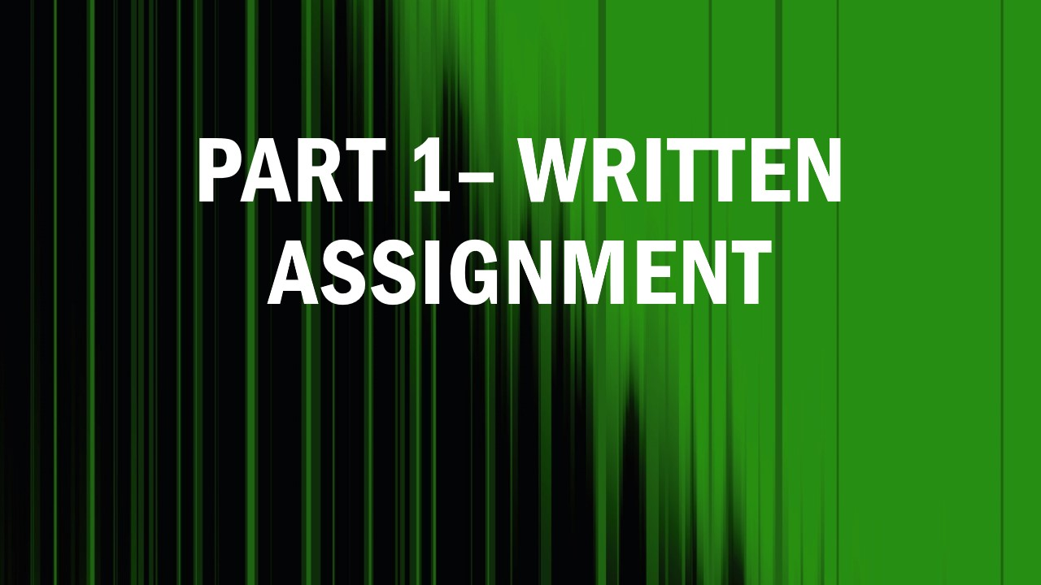

INTRODUCTION
I will write about four topics from the changemakers module (building your brand and sustainable employment). first, I would choose unit 1 and topic 1 which talks about ambition, then I would choose topic 2 of unit 2 which evokes the fact that no one is an island. Next, I would choose topic 2 from unit 3 which explains career and opportunity identification by highlighting career conversations and prioritizing my opportunities. Finally, I would talk about unit 4 subject 1 which is my future, I would explain why what I learned from this unit will be beneficial for my future, and I would talk about my understanding of limiting beliefs. I would do a critical analysis.

UNIT1-TOPIC 1Ambition is critical
OVERVIEW
This unit is made up of four parts, I will use topic 1 which is ambition is critical to explain what I have learned and how I plan to use it in the future.
-Learning point
Ambition is the desire to have something, to set goals, and achieve them (Ambition, 2022). In this unit, I learned that Ambition is something that every human being needs in life. Ambition helps us achieve our goals, even the most difficult ones. Thanks to this unit I learned that Goals are necessary for life, goals must be set in life to achieve the results that we are looking for in a work environment or even in our studies. Some people do not like to hear the word goals. It is important to sit down and make a list of future projects, and objects.
-My goal set
Given the fact that my wish is to be an occupational therapist. After finishing my university studies, I found what I learned in this unit beneficial for my future professional career. The notion of a fixed goal will allow me to improve the lack of confidence I had in myself; I could not believe that my dream of working for the NHS could come true. This unit allowed me to understand that thanks to the authentic notion of choice and freedom I can achieve my professional dreams if I raise my ambitions. for many people, the goals are fixed when they have a deadline to carry out the task, for others it is a source of motivation (Aarts, 2019).
- Critical evaluation
Ambition pushes us to go far, it develops the spirit of creativity and enterprise, and business is changing. Ambition can be positive or negative, in other words, ambition can become a difficulty instead of an advantage (Marques, 2022)

UNIT2-TOPIC 1-no one is an island
OVERVIEW
in this unit, I will use topic 1 which is no one is an island to explain what I have learned about the network and how I am using it to improve and achieve my future.
-LEARNING POINT
the network is a set of lines, and communication channels, which serve the same geographical unit, and which eases exchanges (network, 2022). This unit made me understand that Networking is a crucial form of engagement with the rest of the world. I now know that connecting is the way to make progress that will help us. I learned the fact that communication is key and some professional platforms like LinkedIn supply what we need. I learned that networking is important when trying to target a wider audience. I now know that networking can allow me to connect with many people and spread information.
-My EMPLOYABILITY
With the notion of networking that I learned in this unit, I would be able to evaluate my networking. I learned the usefulness of networking for my future career opportunities. I understood that the world today revolves only around the network.
- CRITICAL EVALUATION
Successful networkers display a sincere interest in their networking contacts and work hard to develop a relationship, set up credibility, and share their information and knowledge. To become a successful networker, I believe in what I need to learn and what I need to gain in knowledge, and what I need to pass on to others. Thanks to the new networks, several activities are flourishing online, and many platforms make it possible to manage a presence on social networks such as Facebook, and Instagram (Ansari, Stahl, Heitmann, and Bremer, 2018)

UNIT 3-TOPIC 2-Identifying career opportunity
OVERVIEW
in this unit I will use topic 2 is about finding career opportunities to explain what I learned and how I am using it to improve and achieve my future.
-LEARNING POINT
In this unit, I understood the importance and well-being of building a career. What I learned is that it is important to cultivate your opportunities and prioritize your targets. The biggest lesson I learned from this part of the course is that knowing how to steer your career has a lot to do with how you find your opportunities.
-CULTIVATING OPPORTUNITIES
What I learned from this module will be important to me in my professional life, I fight to set myself goals, then I work to develop the opportunities I have now and in the future. I keep a critical mind and I take control of my actions. I take the time to define what I hope for. this unit also allowed me to reject distractions that may interfere with my opportunities. I would practice career conversations to focus on my trajectory, the more I meet people and resources that help me better prepare myself to seize opportunities. I have several priority targets soon such as child welfare, behaviours support therapy, occupational therapy, and public health. the knowledge bought in this unit allows me to carry out these projects.
CRITICAL EVALUATION
In the career, everyone has a primary role, but career counselling is done to avoid making a career decision at random, unplanned career events can become learning opportunities (Mitchell, Al Levin, and Krumboltz, 1999)

UNIT4- TOPIC 1 FUTURE ME
OVERVIEW
in this unit4 I will use topic 1 which is based on my future self to explain what I have learned and how I am using it to improve and achieve my future.

-LEARNING POINT
although I am at university, I am limited in many things in daily and professional life. This unit made me believe in my abilities. Vision, that the art of the possible transforms his personal, academic, and professional life. The art of the possible offers a game of creativity in all our facilities. Going to university means ensuring the security of a stable job that meets one's expectations and the possibility of obtaining a higher salary (Martin et al., 2000)
- MY EMPLOYABILITY
What I learned from this unit will be beneficial for my future if I know and understand my limits. In the world of work, I could know my limits, thanks to the art of being a visionary that I benefited know from during this course, I would be able to persevere even to the extent of the impossible to achieve my labor and my university Carrer goals.
CRITICAL EVALUATION
A limiting belief is a mindset or belief about yourself that is holding you back in some way. These beliefs are often false ideas that we have about ourselves, and which can lead to a few harmful consequences for our person (Susaeta, Babinger, and Muñoz, 2020).

CONCLUSION
Overall, this module was beneficial for me. I learned from each of the 4 units concepts that allowed me to understand a certain factor of life that I did not take into consideration, such as the identification of my career., Before starting this module I did not know how to define my opportunities, but I am sure that in the future I will be able to use my degree in health and social care to create new openings. The contexts that I mentioned in this report helped me to understand how important it is to build oneself for a sustainable job.
RECOMMENDATION
In the future, I will use the different skills gained at university, more particularly through this module, to evolve in my professional career. Any success is planned and requires a lot of organization.

REFERENCES

Aarts, H. (2019) Goal setting theory and the mystery of setting goals. Motivation Science, 5(2), pp.106-107.
Ansari, A., Stahl, F., Heitmann, M. and Bremer, L. (2018) Building a Social Network for Success. Journal of Marketing Research, 55(3), pp.321-338.
Dictionary.cambridge.org (2022) ambition. [online] Available at: <https://dictionary.cambridge.org/dictionary/English/ambition> [Accessed 26 July 2022].
Dictionary.cambridge.org. (2022) network. [online] Available at: <https://dictionary.cambridge.org/dictionary/English/network> [Accessed 27 July 2022].
Marques, J. (2022) Leadership and Ambition.
Martin, A., Milne-Home, J., Barrett, J., Spalding, E. and Jones, G. (2000) Graduate Satisfaction with University and Perceived Employment Preparation. Journal of Education and Work, 13(2), pp.199-213.
Mitchell, K., Al Levin, S. and Krumboltz, J. (1999) Planned Happenstance: Constructing Unexpected Career Opportunities. Journal of Counselling &amp; Development, 77(2), pp.115-124.
Susaeta, L., Babinger, F. and Muñoz, N. (2020) Influence of limiting beliefs in soft employability skills. Tourism, 68(2), pp.207-220.

PART 2


SKILL | CURRENT ABILITY | TARGET ABILITY | DEVELOPMENT OPPORTUNITY | CRITERIA TO JUDGE SUCCESS | TIME FRAME | EVIDENCE
Communication skills. I chose communication skills because they reveal the ability to adapt and are useful in many areas and are essential for any sector of activity. I want to develop communication because communication is the basis of everything. Whatever the position one occupies in life, communication is an essential element. | I struggle to be able to communicate effectively with my classmates, my colleagues, and my teachers. First, I have difficulty expressing myself due to a language handicap that I have had since I was young. Secondly, English is my 2nd language. suddenly I must double a lot of effort to be understood. | To improve this communication gap, I socialize from time to time with a community at Smethwick. I have made friends with whom I communicate from time to time to improve my communication skills. | to improve my communication skills, I must use the feedback received from others to progress in my way of communicating. To develop my communication skills, I have taken the resolution to read books regularly, I have created a WhatsApp group that is full of a person with different intellectual abilities with whom I change daily. | My communication skills are a success, 1 year ago I could not present a presentation because I had shortcomings. But today I do it with confidence. Today I am the leader of a WhatsApp group that brings together 10 people to discuss how to improve their communication skills. This is an immense success for me. | In 1 year, I will know a digital communication account. It will allow me to continue learning to be aware of digital media. | Now that I have created a WhatsApp group that allows me to exchange with other people, my communication skills have improved verbally and in writing.
Network stills.  I want to develop network skills because in recent years everything is based on the knowledge of the network. Moreover, without it is impossible to function optimally | I have had a lot of difficulties integrating into networks, even connecting through the network with other people has always been a big challenge for me. | my target for developing a  a professional network is to make friends in my community and to find a network coach who can help me improve my network skills. | Networking will help me develop and improve my skills and keep up to date with the latest trends in my industry and your job market. Networking will also help me advance my career and give me access to more job opportunities. | I have success with the network, I adhere to an event that is held every end of me to discuss the different parameters for the network.  I have an Instagram account that allows me to do my business online. | In 6 months, I will extend my Instagram baseness and I will hire a networking professional to learn new skills with the network, | I am now the owner of a LinkedIn account, now I have 1 million subscribers on my Instagram account.
Decision-making skill  I want to develop decision-making because it is essential to move forward. There is no result without action. | I made efforts to improve my decision-making ability to know how to decide with conviction and without regrets. Making decisions is good, but taking the right ones is better. | my target for developing my decision-making ability is that I have self-confidence. I clearly and simply define the decision I must make; I read and collect the information I gather, and then I put it into practice. | Effective decision-making helps me reduce risks and discover new opportunities that life can offer me. | I no longer experience any difficulty in making complex decisions. For me, it is a sign of success in making decisions. I do it in a logical, methodical, and confident manner. | In 3 months, I would like to track my key decisions using a work management tool. | Now I can handle types of decision-making patterns. I am now able to analyse a final decision and its positive and negative repercussions.

