

Task 1 – Reading Task Template
Upload your photo of your A3 in-class notes here:
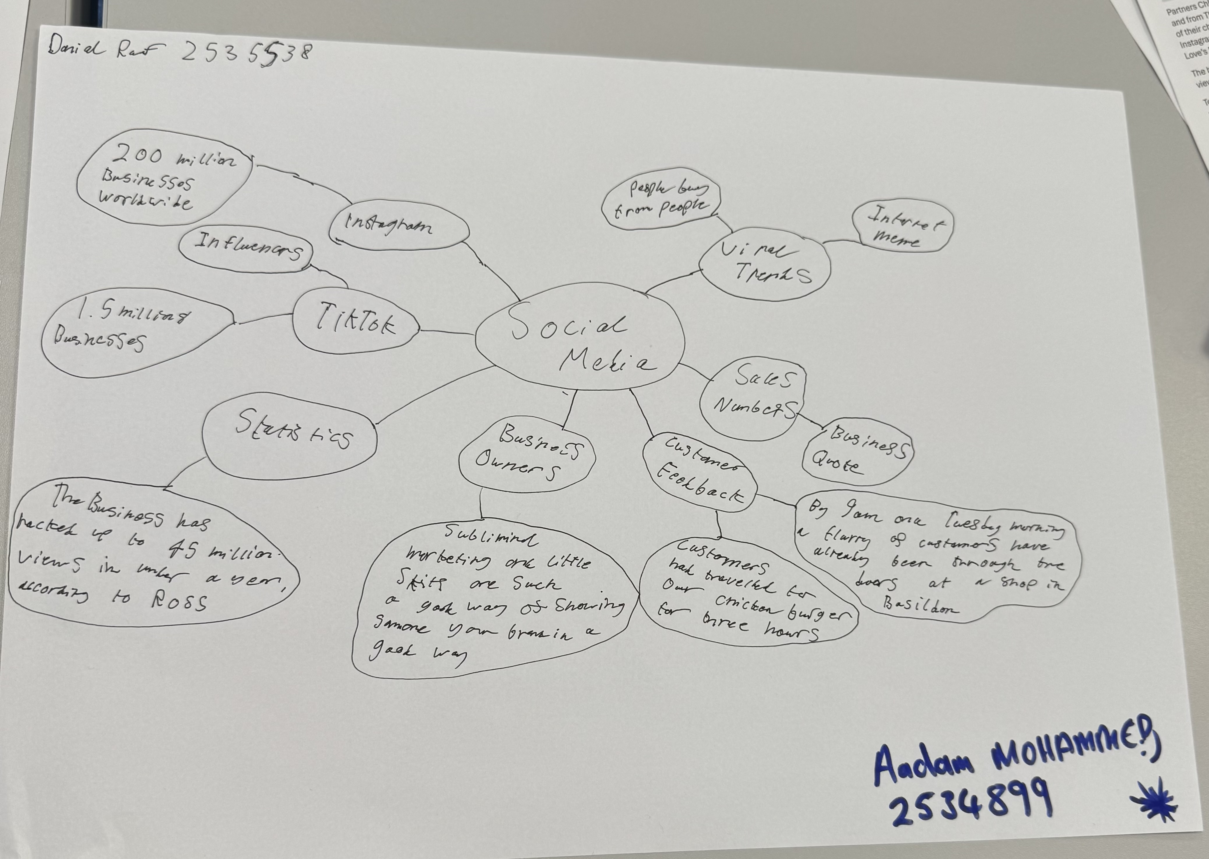

1. Answer these questions using the sentence starters below
a. What is the main idea of the text?
The main idea is that social media can be used to improve sales by making skits and videos.
b. What are two key points?
One key point is that social media is useful for increasing sales for a business.
Another key point is that social media can be used to connect to people from around the world and this can improve sales for a business.
c. What part of the text did you find most important? Why?
The most important part is that social media can make an impact on how it could make a business make huge sales from just creating content on social media.
d. Was anything unclear or difficult to understand?
I was not sure about how a business could make skits or content on social media that could show people that their business is something that they would indulge in.
e. How did your group help you understand the text better?
My group helped me by explaining how some things could be useful like sharing opinions.
3. One sentence reflection
Question: What did you find challenging about this task?
The hardest part was to come up with ideas on how some stuff would be useful for our mind map like sales and numbers or business owners.

