

Task 1 – Reading Task Template
Upload your photo of your A3 in-class notes here:
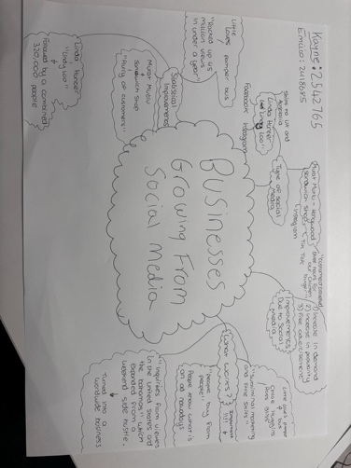

1. Answer these questions using the sentence starters below
a. What is the main idea of the text?
The main idea is that using social media gives businesses a lot more popularity to grow and show off their product/service. This helps businesses stay afloat and sell more as they are advertised to millions of people across the world.
b. What are two key points?
One key point is that businesses have seen a massive increase in popularity and demand due to posting videos online advertising their business.
Another key point is that the most viewed social media increase in views seems to come from Instagram and TikTok. This could be because any video posted on these social media platforms can be shown to any person using the app whereas a social media like Facebook can be limited to people you have as friends.
c. What part of the text did you find most important? Why?
The most important part is that businesses have been able to become popular due to a viral video or many viral videos that are linked to their business. This has allowed them to gain more customers and also reach a wider range of customers who are willing to even travel “3 hours for a chicken burger”. I find this an important thing because, if customers are willing to travel 3 hours to see your business and buy from your business, it shows how much people appreciate your business and even like your business. This gives comfort to the business owner as they can take pride in knowing their customers, and people who see their business advertisements, feel passionate towards their product/service, and also take comfort in knowing that if people have love and a passion for their business, they can surely continue to progress and maintain their business for years to come.

As also seen quoted in my spider diagram, you can see that a specific business believes that “people buy from people,” showing that it is very important in the way you advertise your business. When you advertise, it shouldn’t feel like an advertisement as people online are clearly able to establish the difference between a video that is purposely for advertisement and a video that is published due to passion. This for me, is the most important thing as it can be all the difference between whether you gain customers and whether you do not gain any customers.
d. Was anything unclear or difficult to understand?
To be completely honest, I didn’t really find anything difficult to understand or find anything unclear. This may be due to me doing mind maps/spider diagrams before.
I also find the way I am taught to be quite efficient, and easy to learn from.
e. How did your group help you understand the text better?
My group helped me by giving me different ideas that I may have missed. This allowed me to further develop my understanding of the study and give myself a better chance when it comes to doing my assignment.
3. One sentence reflection
Question: What did you find challenging about this task?
The hardest part in this task for me, was being able to fit everything into one assignment, this is because I feel there is a lot of information and many ways you can go about doing this assignment, whether it be having different opinions or even disagreeing with certain things.

