University of Wales Trinity Saint David
Wales Institute of Science & Art



Risk Assessment Technical Report
Workshop and Practice
ACHA4011

Oliver Nayler
1901161
Date Of Report
Table of Contents
1.0- Introduction……………………………………………………………………………………………………………..1
2.0- Research ………………………………………………………………………………………………………………1-4
3.0- Initial FMEA ………………………………………………………………………………………………………….5- 7
4.0- Amended FMEA……………………………………………………………………………………………………..7-8
Conclusion……………………………………………………………………………………………………………………….8

Introduction
This technical report will cover the risk assessment of an assembly line of a large vehicle manufacturer. The assembly line will be assessed for any weaknesses and areas of potential failure, this will then be backed up with solutions on how these risks could be reduced and employees made aware. It is important for engineers to carry out risk assessments as numerous activities will be undertaken at one time and various equipment is being used which could all pose risks to the engineers in the workplace. The main aim for a risk assessment is to minimise the risk as much as possible and ensure the staff are aware of the risks and hazards within the workplace.

- Research
Risk assessments are a major requirement in the Transportation/ Automotive sector due to the number of hazards it presents. This sector consists of multiple moving assembly and production lines. A moving production line is a manufacturing configuration where there are a series of processing steps, each step sees different components added bringing the product closer to completion. This is all carried out while the product moves slowly onto its next step (spacey, 2017). A moving assembly line is a line of moving parts and components, where a part or component is added at each section moving the product closer to being fully assembled (spacey, 2017).
When completing risk assessments, the level of detail should be comparative to the risk posed. it is also important that that risk assessment is compliant with the laws that are in place.
The Health and Safety Executive (HSE) recommend 5 steps to take when completing a risk assessment, these include;
- Look for hazards
- Decide who might be harmed and how
- Evaluate the risks and decide whether precautions are adequate or more should be done
- Record your findings
- Review your assessment from time to time and revise if necessary
(HSE,1999)
HSE also provide a guide with various questions you should be asking for risks that arise in specific areas of the workplace. The guide then gives information on the standards required by law and the regulation act that you would be breaking if you were to not keep up to these standards. The different areas include;
- General
- The workshop
- Moving and working with articles by hand; loading and unloading; assembly and packing
- Vehicles
- Metal working
- Cleaning and finishing
(HSE, 1999)
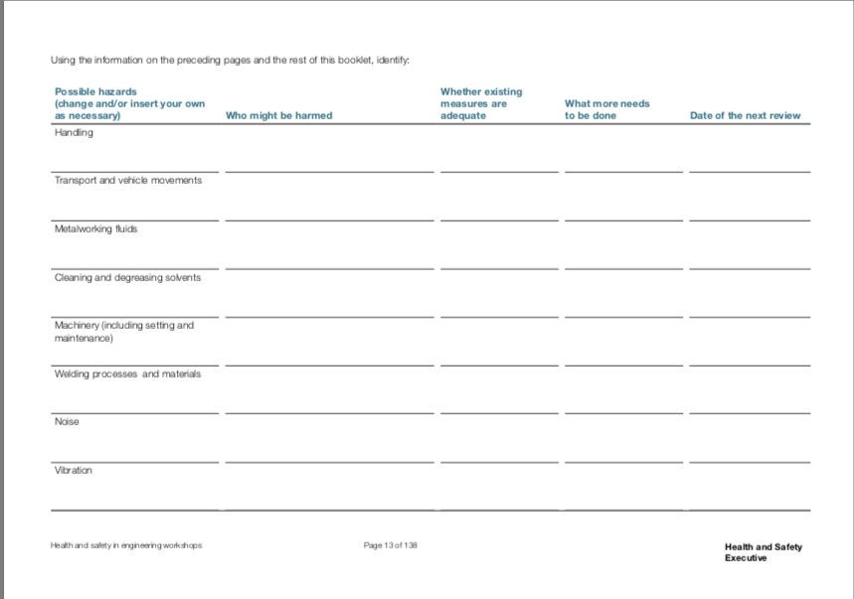
Once you have considered the risks, a table is provided allowing you to keep a record of the risk, existing measures, what needs to be done and date of review. The table is shown below.

(A picture of a risk assessment record sheet) (HSE,1999)
The Institution of Mechanical Engineers (IMechE) also expect all members to follow their code of conduct, this code of conduct is in place to protect members of the public, protect IMechE members and uphold the reputation of the institution and the wider engineering profession. This code of conduct is made up of four principles;
- Practice competently and maintain up-to-date knowledge and skills
- Act with integrity and respect for others
- Promote sustainability
- Exercise engineering leadership
(IMechE, 2021)
Finally, another resource that can be used to mitigate risk is Failure Mode and Effects Analysis (FEMA). FEMA is a step-by-step approach to identify any possible failures in a manufacturing or assembly process (Tague, 2004). FEMA uses a similar process as the HSE risk assessment with the use of a table which has columns including;
- Potential failure mode
- Likelihood of occurrence
- Severity
- Likelihood of detection
- Risk priority number (RPN) (=occurrence* severity*detection)
- Mitigating actions recommended
This is then followed up once action has been taken to ensure there are no more risks.

3.0- Initial FMEA
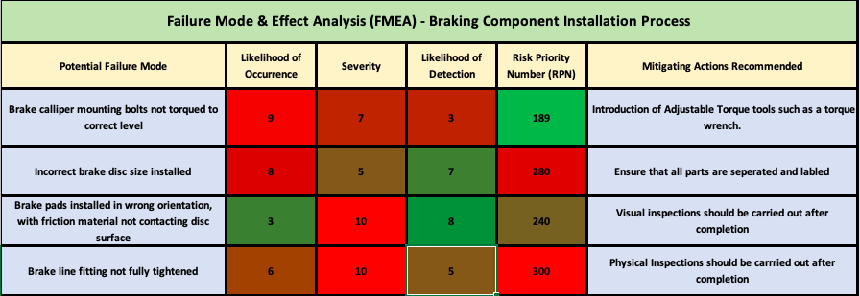
(Table showing the Initial FMEA carried out)

Firstly, when looking at the table above you have to take into account the meaning of the different numbers. The higher the number the more likely the risk is to occur or be more severe, however this does not relate to the likelihood of detection as the higher the number the more likely the risk is to be found before the end of production. The risk priority number is then a multiple of the 3 other numbers.
The first step of carrying out a FMEA is to discover the potential failure modes. In this case the first potential failure mode is ‘brake calliper mounting bolts not torqued to the correct level’. When thinking about the likelihood of occurrence for this failure mode the tools provided had to be taken into account, after this consideration it is believed that no adjustable torque tools were being used which put the likelihood of occurrence high at an 9/10. Following this the severity of this risk was given a 7/10, this is because it poses a risk of brake failure which will put the customer in danger and in turn put the public in danger. However, it is only a 7 as the bolts could be tightened enough that it won’t pose a break failure risk but could still cause problems down the line. For the likelihood of detection, it was ranked at a 3/10 this is because once this section of the production line has been completed and the vehicle has been moved on it is not returned for further checks. This risk had an overall RPN of 189 which is the lowest priority number out of all the risks looked at which means it would be last to be attended to. The mitigating actions required for this risk is to introduce the use of a variety of torque tools such as a adjustable torque wrench which will allow the engineer to set the torque for the variety of different cars that will come through the production line throughout the day.

The next potential failure mode was ‘Incorrect brake disk size installed’. The likelihood of this occurring was given an 8/10, this is because there are multiple different vehicles coming through the production line at a time which have different specifications meaning at some point the wrong disk could be applied to the wrong vehicle. However, the severity of this is only a 5/10 as the brake disk should still work as long as it fits to the calliper that is being applied to vehicle. To back this up when looking at the likelihood of detection it has been given a 7/10 because if a brake disk is too big or small for that specific vehicle the calliper will not be able to fit or the brake pads will be loose, which is easily detectable at the time of install. The RPN for this is shown to be 280 which puts it second in the priority list. In regards to the mitigating actions required it has been advised that all parts should separate into different sections and labelled clearly so that the engineer can see which part they need without any chance of choosing the wrong part.
After that the potential of ‘brake pads installed in wrong orientation, with friction material not contacting disk surface’ was explored. The likelihood of this occurring of this occurring has been ranked low at a 3/10, this is because if this were to happen the calliper should not be able to close however there is still a possibility that this could happen. If this were to happen then the severity of it would be very high as this would mean the brakes would not function at all and will end up putting the customer and public in danger so this has been rated at a 10/10. In regards to the likelihood of detection it has been rated at a 8/10 meaning that it is likely that if this were to happen it would be detected as the callipers should not be able to close with the brake pads in the wrong orientation, however there is still a chance it could happen. The RPN for this potential failure mode is 240 which puts it 3rd in the priority list. To help Mitigate this risk it is suggested that once fully assembled visual checks over the vehicle should be carried out making the likelihood of detection a lot higher.
Finally, the last potential failure mode investigated was ‘brake line fitting not fully tightened’. The likelihood of this happening has been given a 6/10 this could be either because of a lack of equipment such as a torque wrench or it could also be down to worker fatigue as they are completing the same activity multiple times a day. The severity of this was labelled as a 10/10 due to the possibility of the brake line coming loose, which would cause brake failure which will again put the customer and public in danger, this could also cause brake fluid which is corrosive to spill onto other components and can cause more damage. The likelihood of detection was set at a 5/10 as the brake lines will have a slight check again when brake fluid is added, this means that any leaks due to lose brake lines could be detected at that stage of production. The RPN for this risk is 300 which is the highest out of them all and would be main priority to be improved. The mitigating actions recommended for this risk were that physical inspections should be carried out after completion.

4.0- Amended FMEA
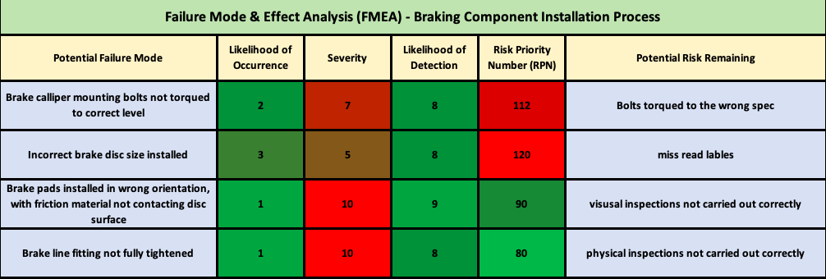
(Table showing the Amended FMEA)
Once all the mitigating actions have been completed from the initial FMEA an amended FMEA was carried out, the aim of this is to investigate further to ensure the risk has been reduced and to see if there is any potential risk remaining. When filling out the amended FMEA table the severity will stay the same because even though action has been taken the consequences of the incident will be just as sever. When looking at the amended FMEA table there is an overall decrease in the likelihood of occurrence and an increase in the likelihood of detection in all four failure modes, this shows that actions taken from the initial FMEA have helped reduce the risks as much as possible. However even though the risk has been reduced there may still be potential risks remaining. When looking at the first potential failure mode the potential risk remaining is shown to be that even though the correct tools have been provided the engineer could tighten the bolts to the incorrect torque as multiple vehicles with different specs will be going through the production line at a time. To improve this, further precautions could be introduced such as a table with the different torque specs for each model of vehicle on the production line each day. The next potential failure mode has a potential risk remaining of the engineers misreading the newly introduced labels on the parts, a possible way of avoiding this could be to have each vehicle and part fitted with a barcode which needs to be scanned together before installing onto the vehicle which will ensure the right parts are fitted, this would also allow the manufacturer to backtrack and ensure all parts on each vehicle are correct before they leave the production stage. For the final two potential failure modes the remaining risks could be solved in a similar way. The remaining risks are that the visual or physical checks are not carried out correctly or parts are missed in inspection. A way to help prevent this from happening is to generate a digital checklist for each vehicle to ensure that all necessary checks have been made on that vehicle.

4.0- Conclusion

To conclude, this technical report has shown that when carrying out risk assessments everything has to be taken into account no matter how small or large the risk, it has also shown that even after action has been taken against the risk there will always be a chance that risk can still occur in the workplace which can be seen in the amended FMEA as there was still remaining risks that could be improved further.
Overall, the process of using FMEA as a risk assessment tool allowed for easy recording of risks and the actions required, I also believe that this method is effective as an amended FMEA needs to be carried out after completion of the initial actions allowing for further risks to be explored, which in turn allows the manufacturer to reduce the risk further. FMEA is also an effective tool as it allows for risks to be recorded and stored effectively which can then be used when doing a future risk assessments/ follow up.
The FMEA tool could be improved by adding a section in the initial FMEA which shows precautions that are already in place to ensure they are not repeating any actions that have already been completed.

References

John Spacey, February 07 2017, Production Line vs Assembly Line, [online], https://simplicable.com/new/production-line-vs-assembly-line

HSE,1999, Health and safety in engineering workshops, [online], https://www.hse.gov.uk/pUbns/priced/hsg129.pdf

IMechE, 2021, Code of Conduct Explained, [online], https://www.imeche.org/about-us/imeche-governance/governance-and-finance-reviews/code-of-conduct-explained

Nancy R. Tague, 2005, The Quality Toolbox, Second Edition, [online], as cited in https://asq.org/quality-resources/fmea

