

Network Operating Systems and Security

Group Name: GROUP 1
Date: 29.08.2020
Author(s): Aleksandar Nedelchev, Aleksandar Andonov, Marin Zaharidov, Modou Pene

Sheet 1 – How to install and use AD*
Task 1: Configure the network and upgrade the server to a Domain Controller
For our task we are going to use Virtual Box. This is an open-source virtual manager used as a network simulator.
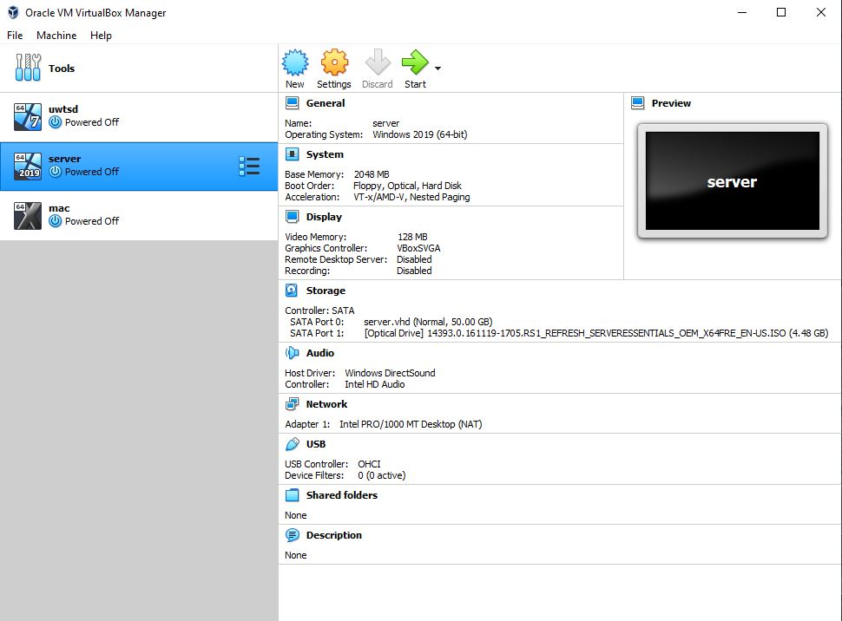
An Active Directory domain is a list of Microsoft Active Directory objects within a network. An object may be a single user or community, or it can be a part of the hardware such as a computer or printer. Every domain has a database containing information about the identity of objects.
It is important for the installation to install the server and the client.
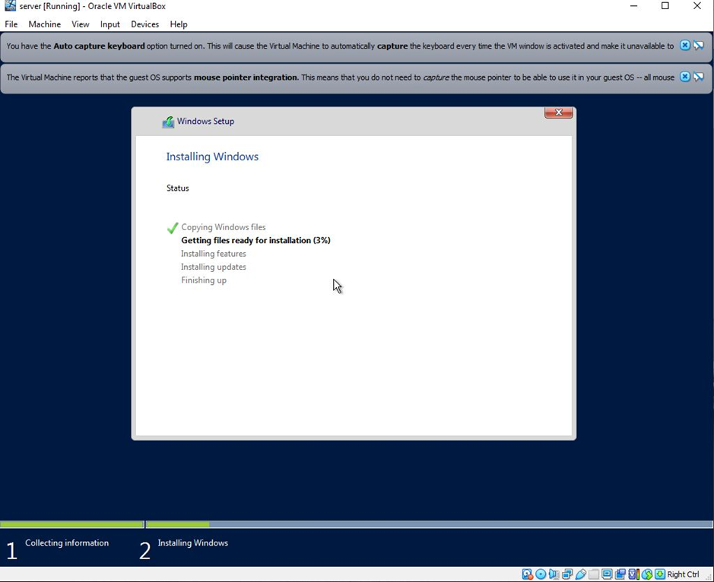
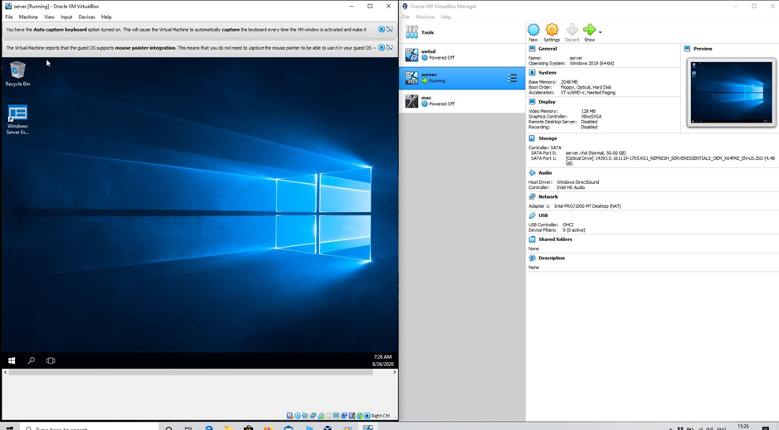
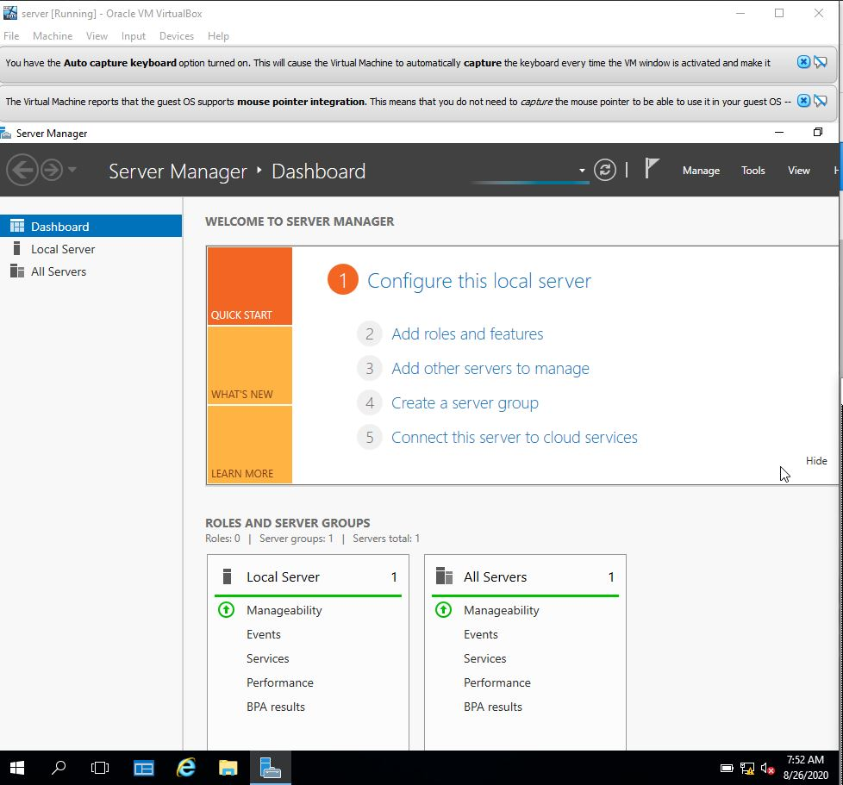

Start Installation of the DNS by adding roles:

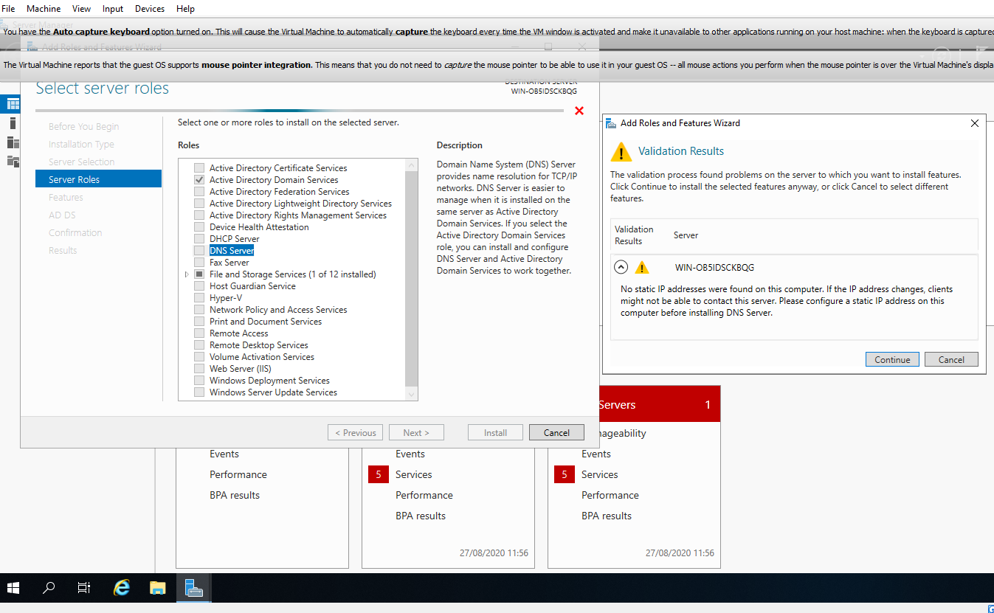
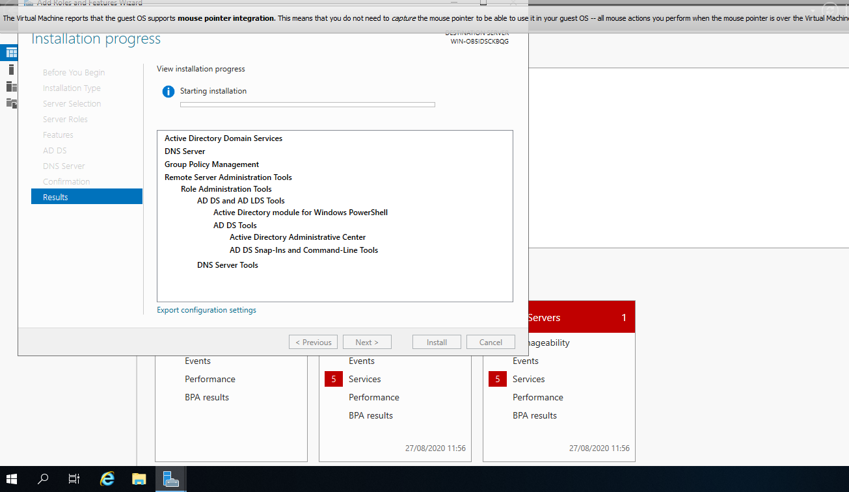

Deployment Configuration
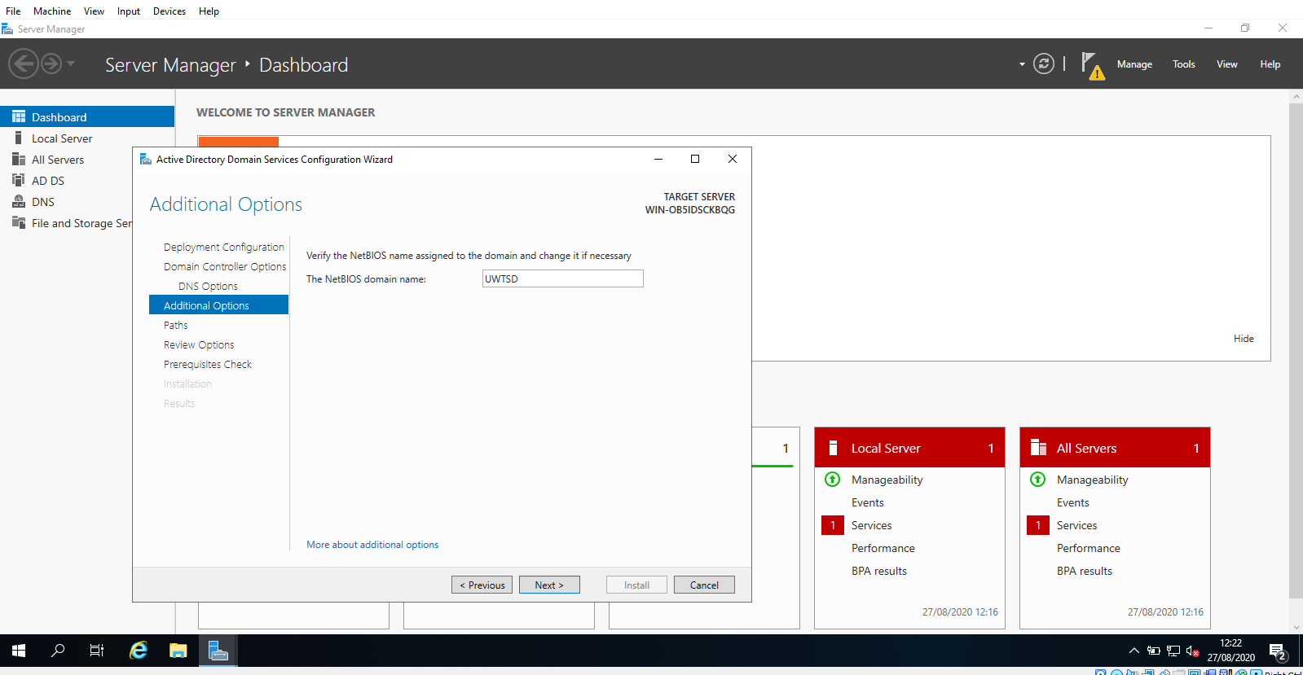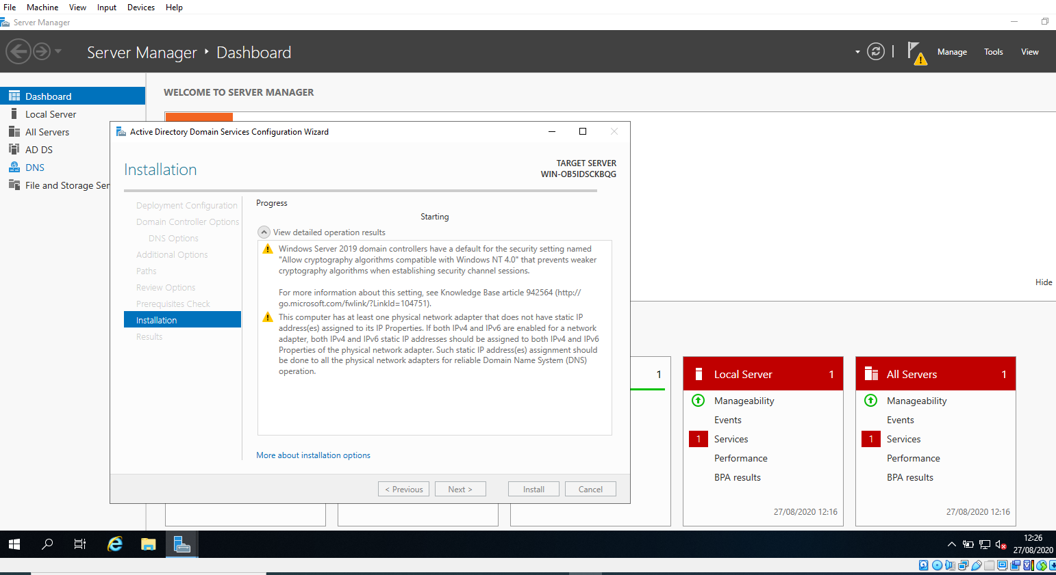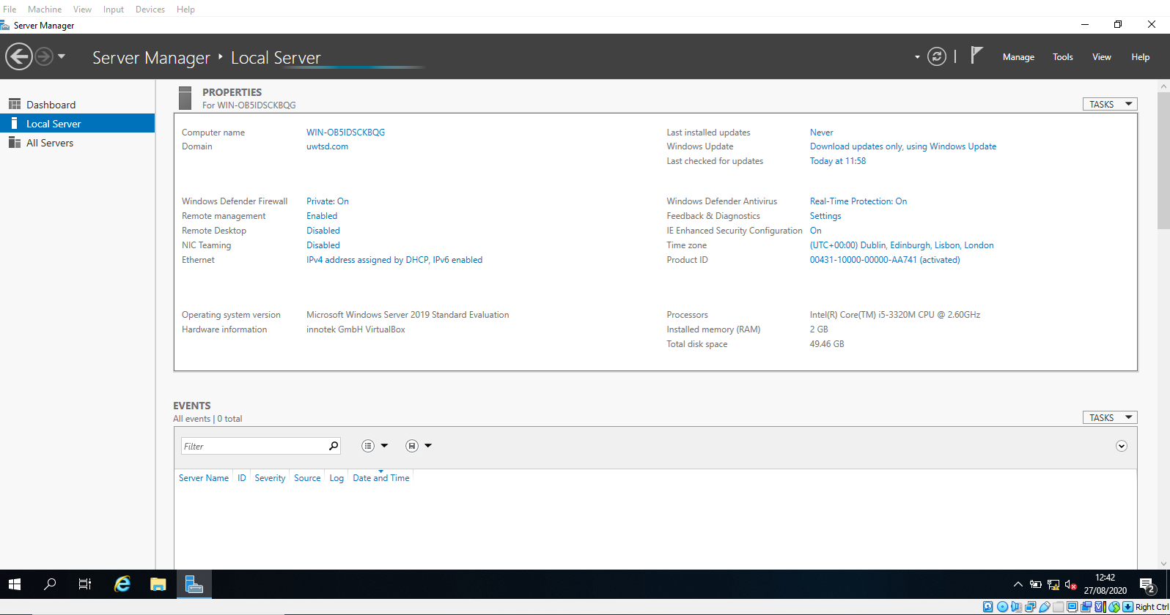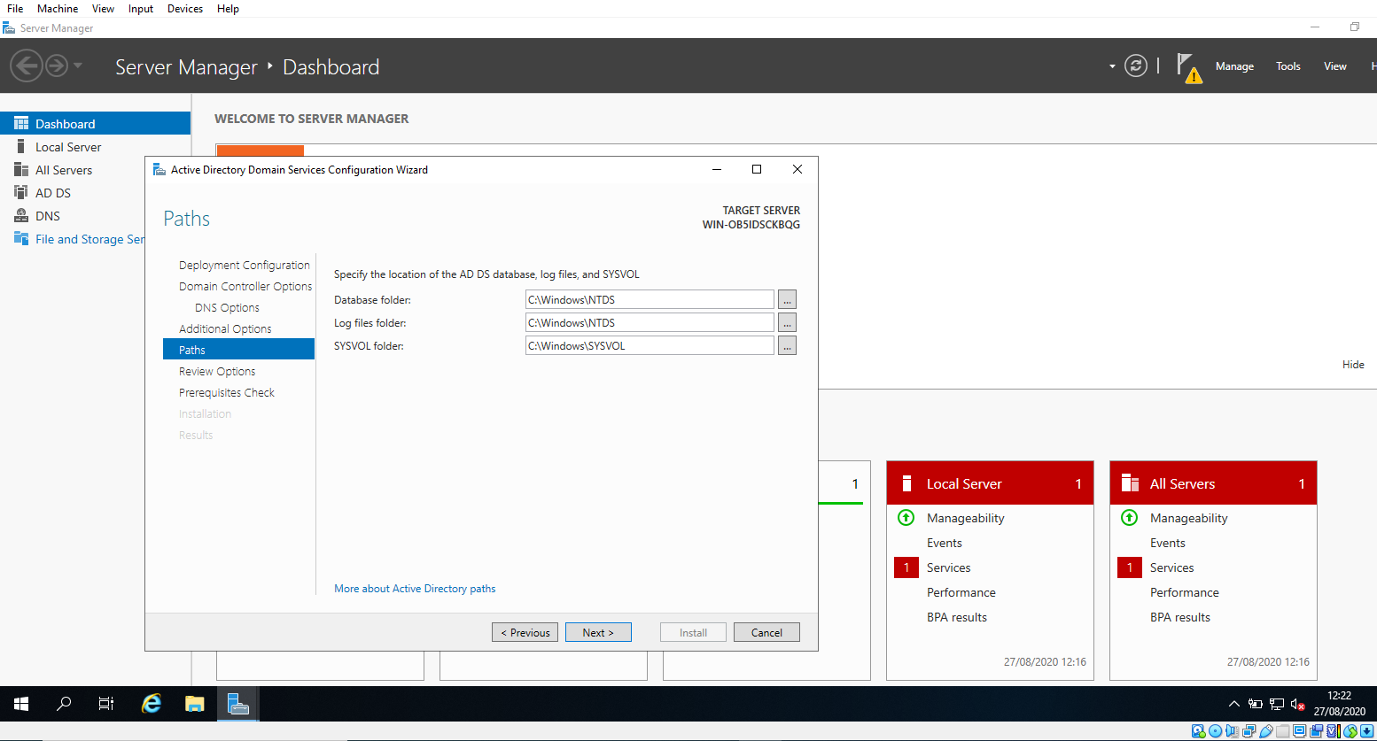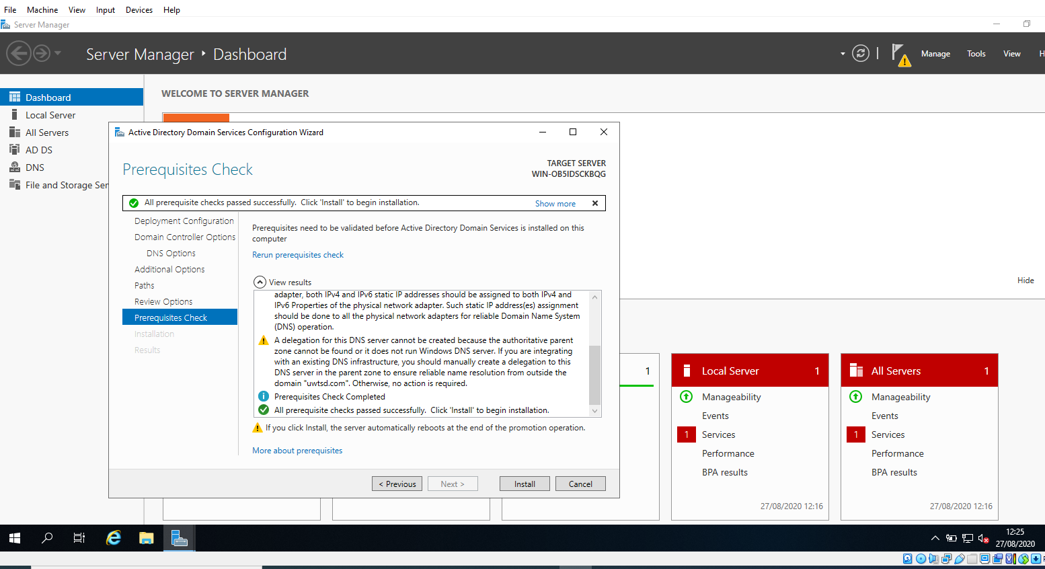
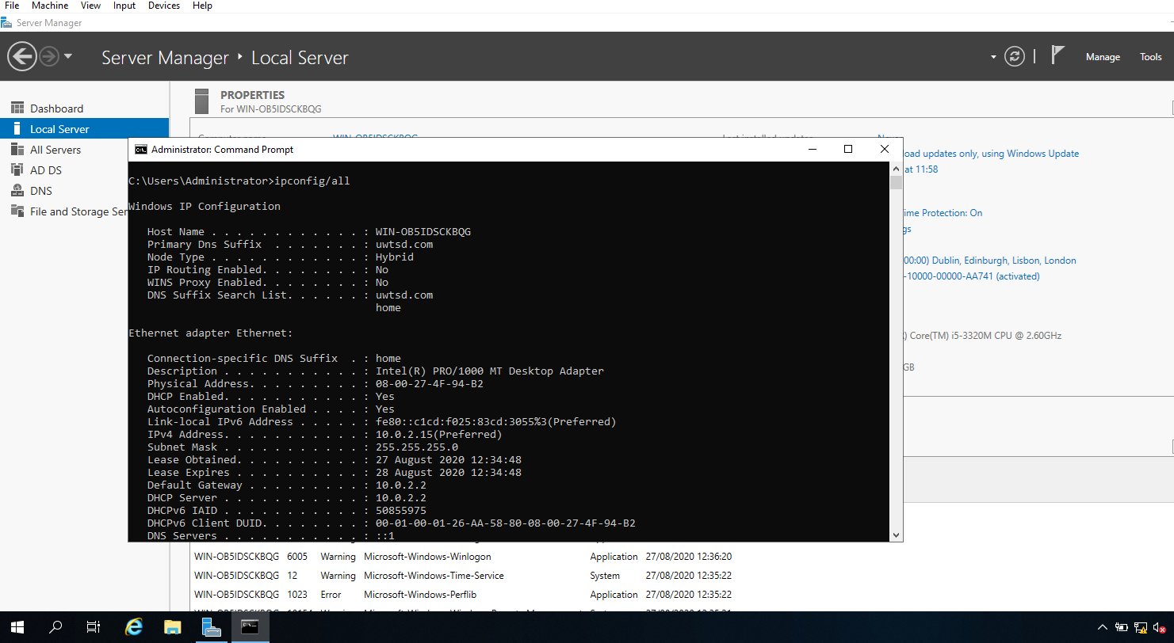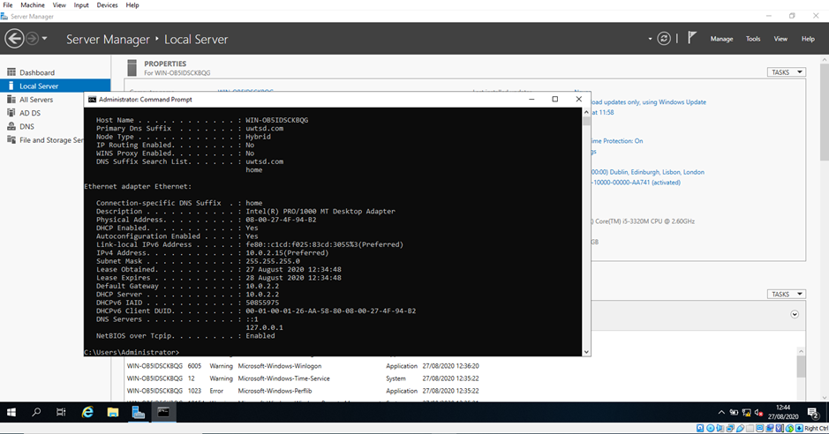

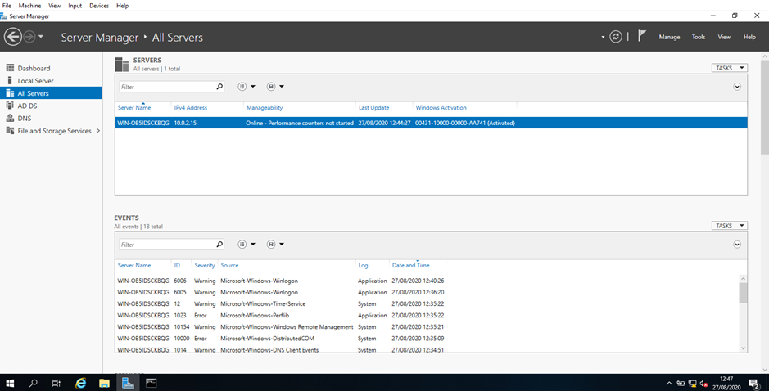

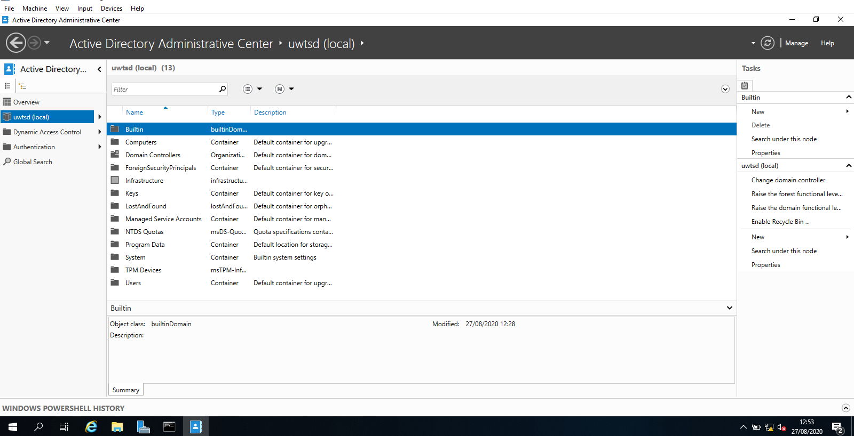
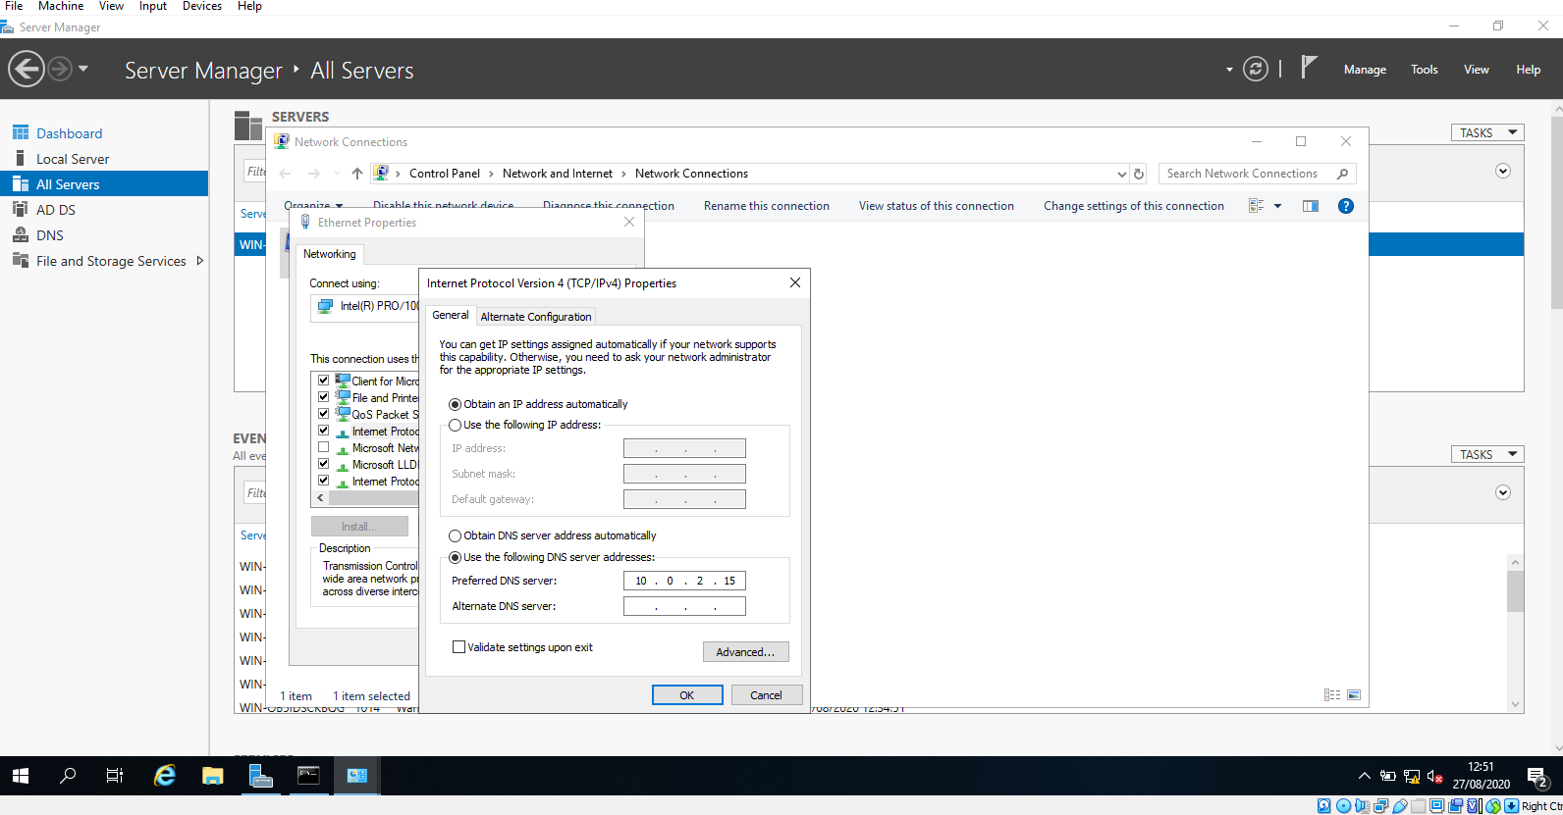

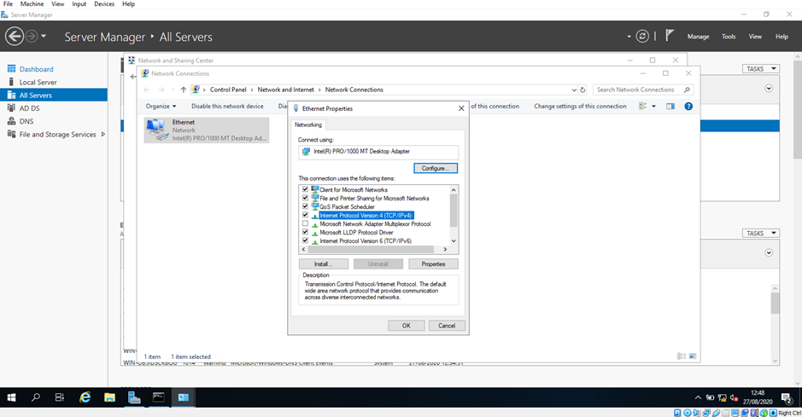
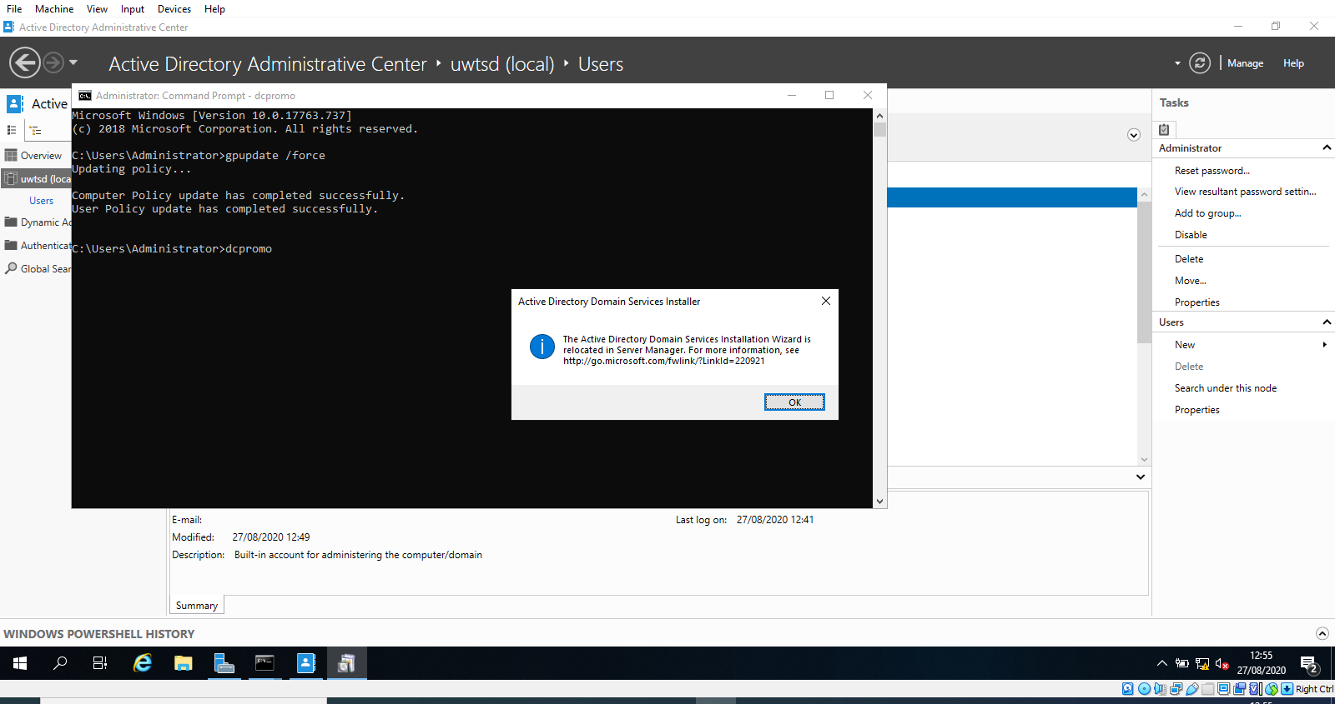
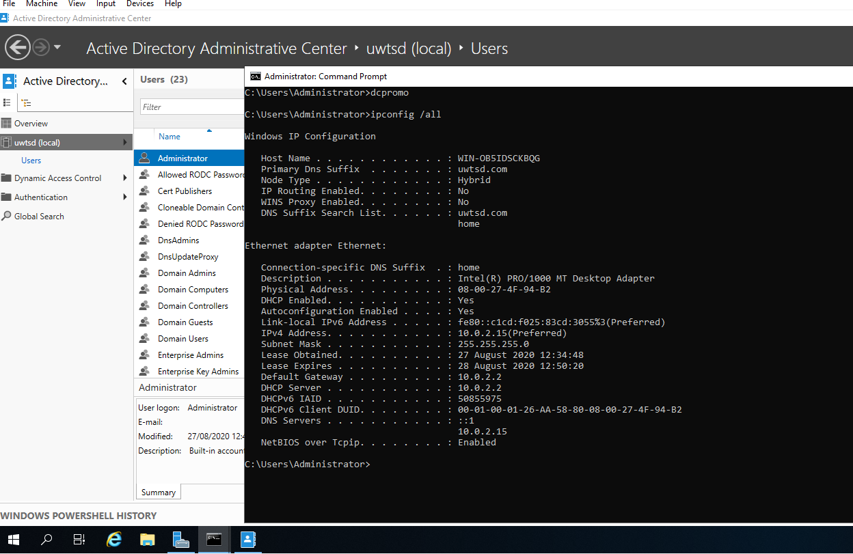

Network Operating Systems and Security Sheet 2: How to manage resources and creating OU

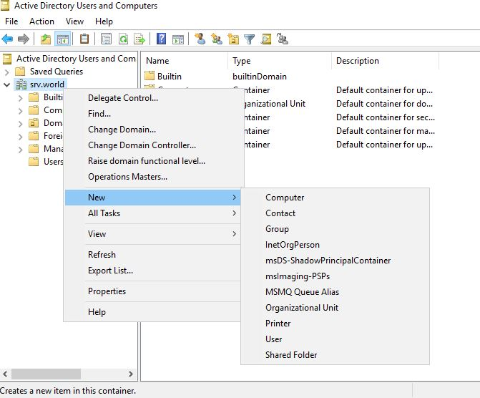

Create and maintain AD* users and accounts.

If there is no Active Directory or LDAP in your system, one or two servers such as an FTP server would need to be added to local users. These will be the accounts that will have the authority / clearance needed to use those services. Take the following basic steps to add a local user to your system:

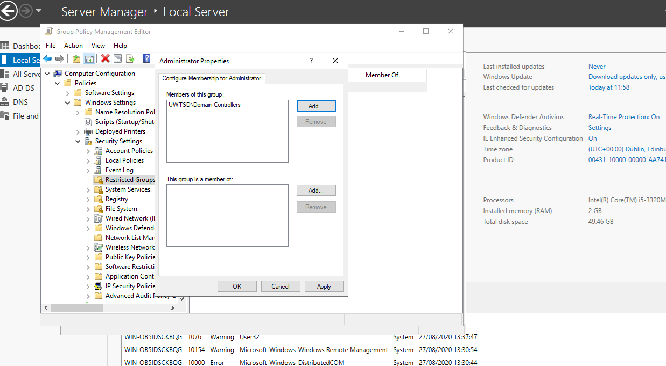
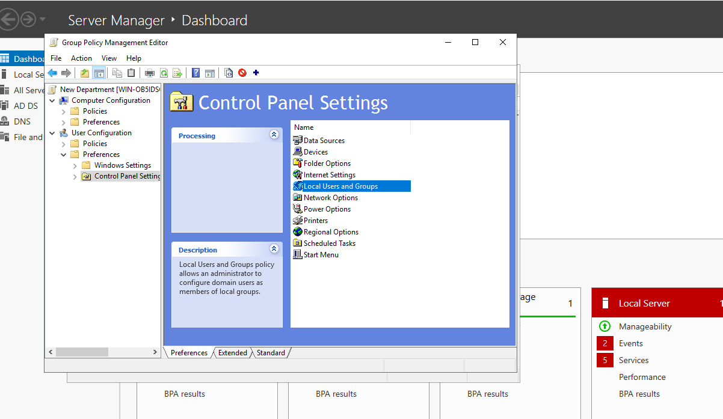
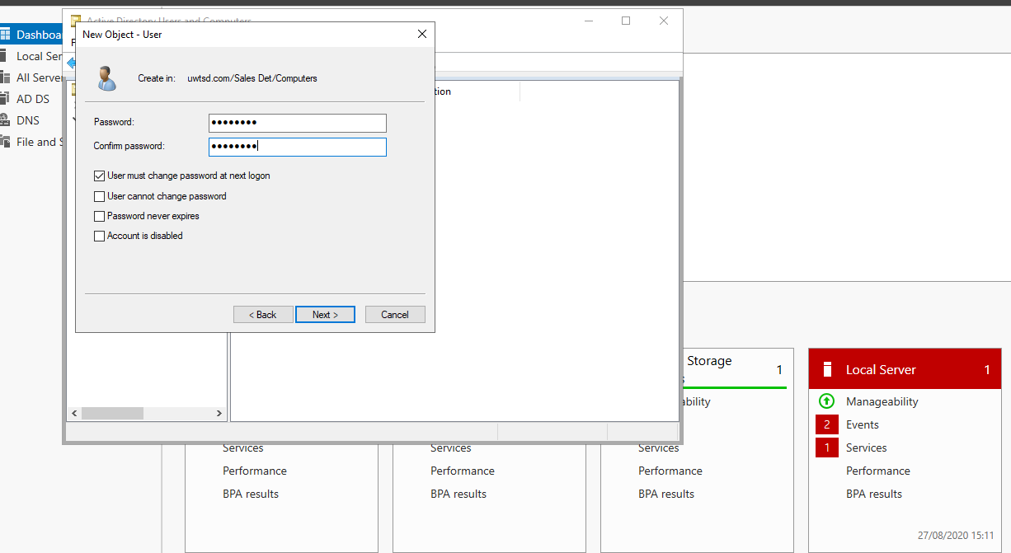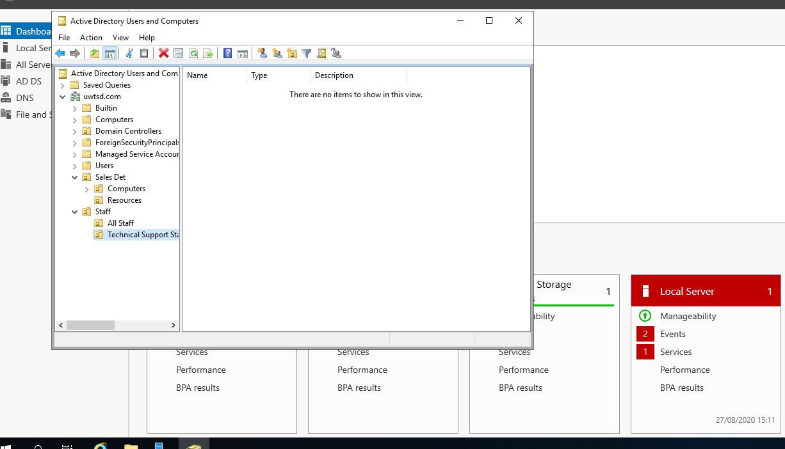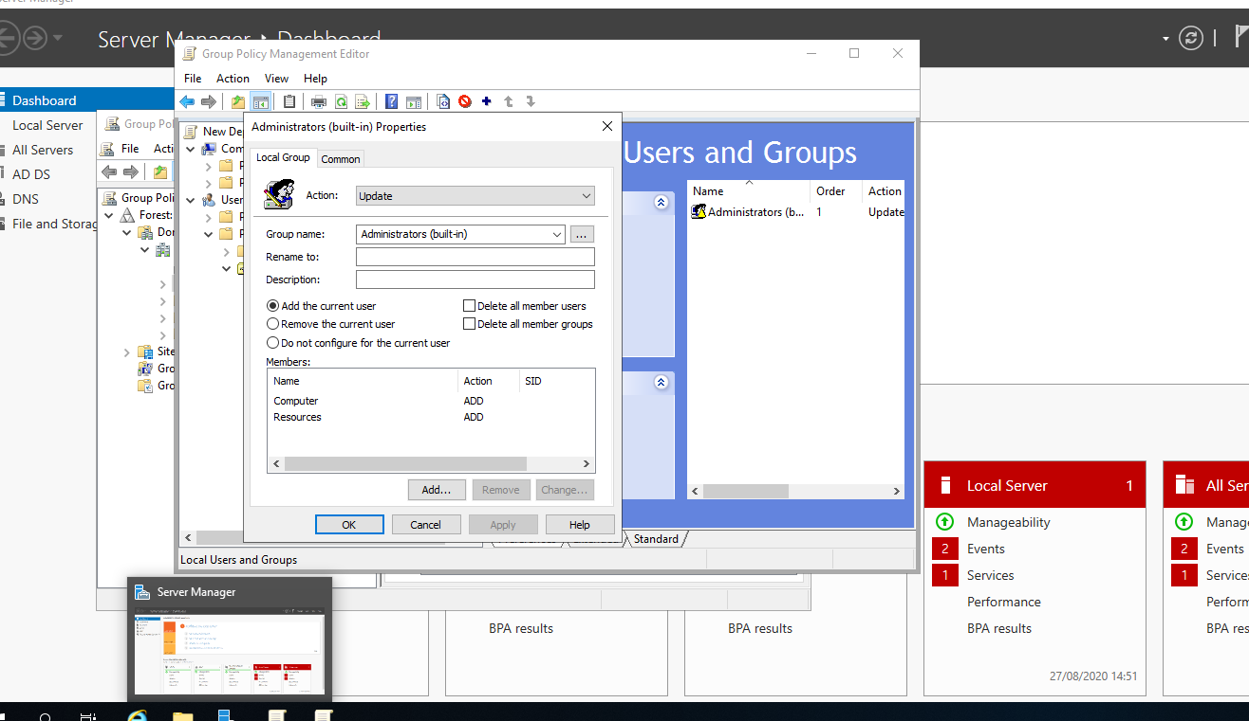
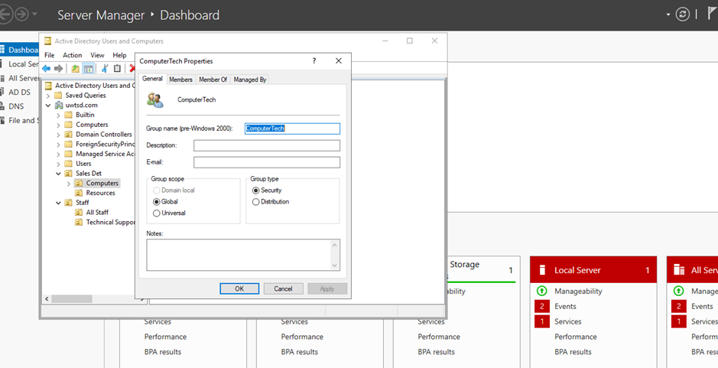

In this part we are going to manage AD* user with password.
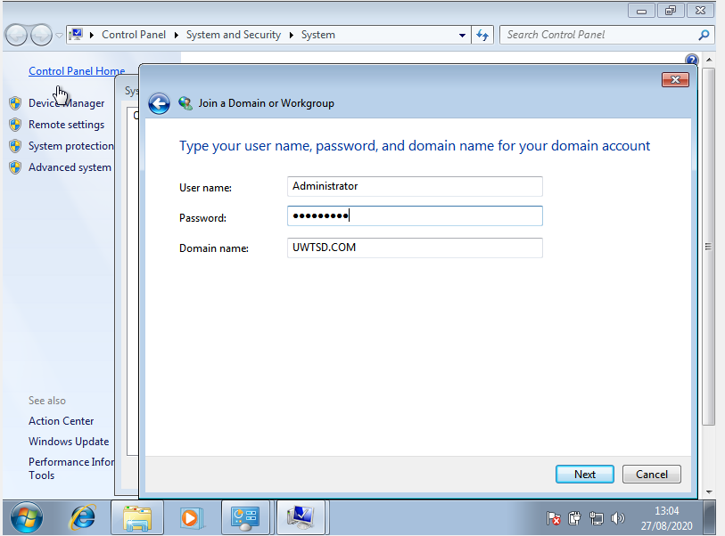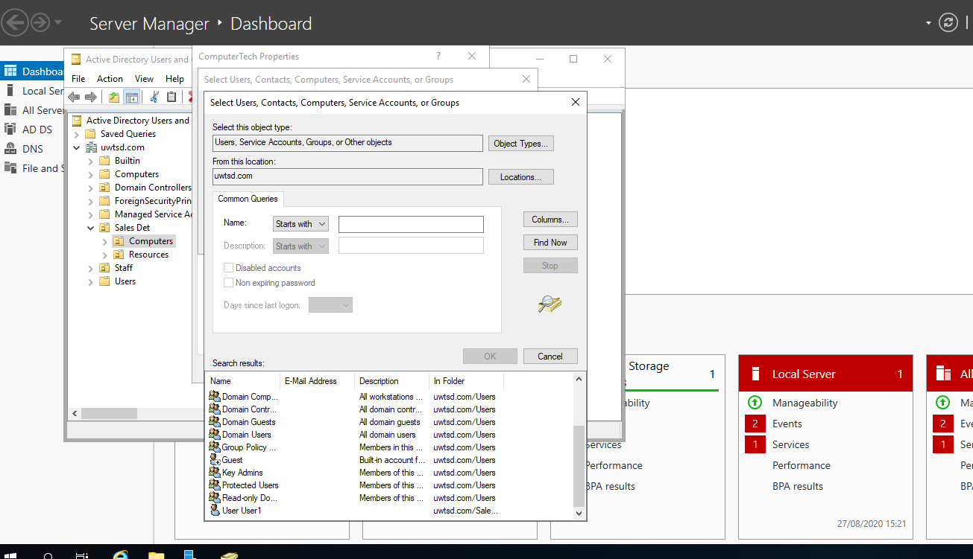

Sheet 3: How to manage files and folders in Domain Environments.
Control and manage access to files and folders using DC*.
We know that Windows Server consists of an arrangement of parts and details that make it unique and special, and what we must bear in mind as directors is that, in any case, we must have a centralized point where customers can perform authoritative activities such as uploading or downloading data , making modern organizers and more, obviously this with the respectively approvals necessary, depending on the user account.

Control of networks access and objects in folders in AD*
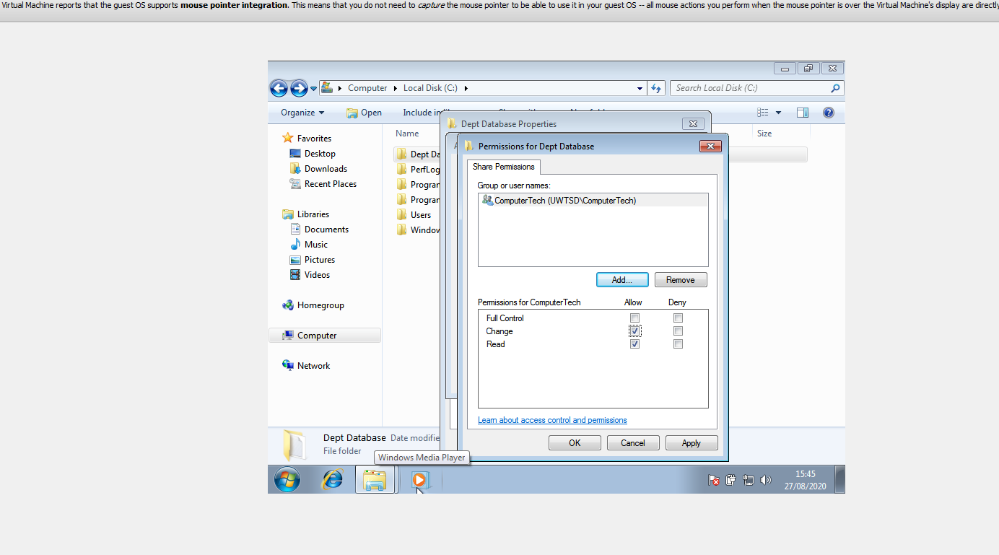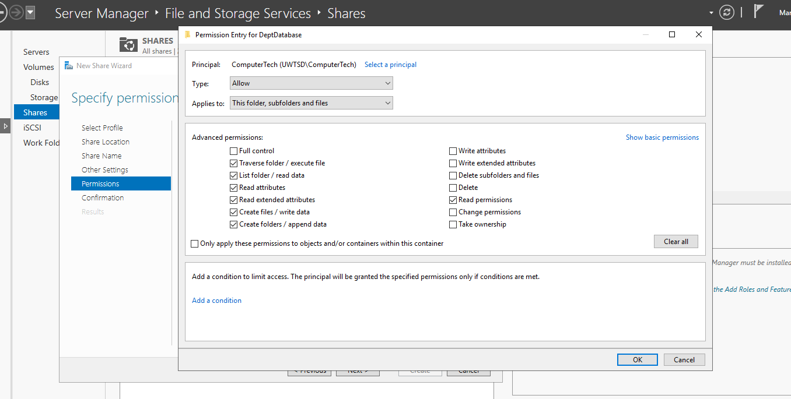
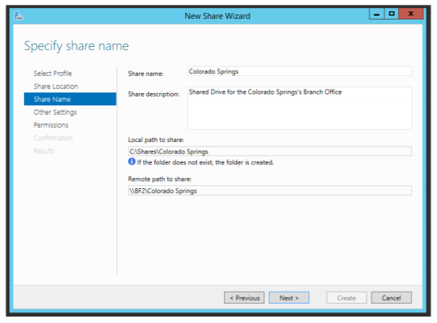
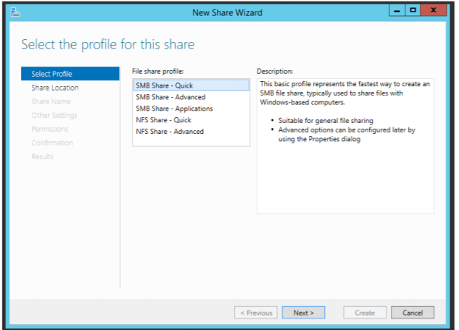
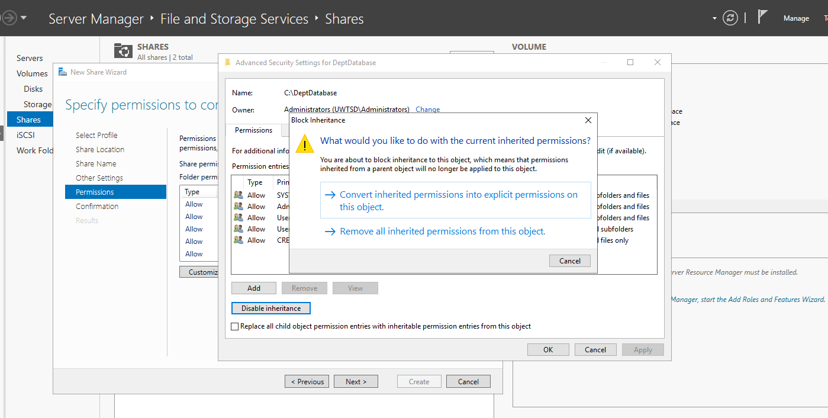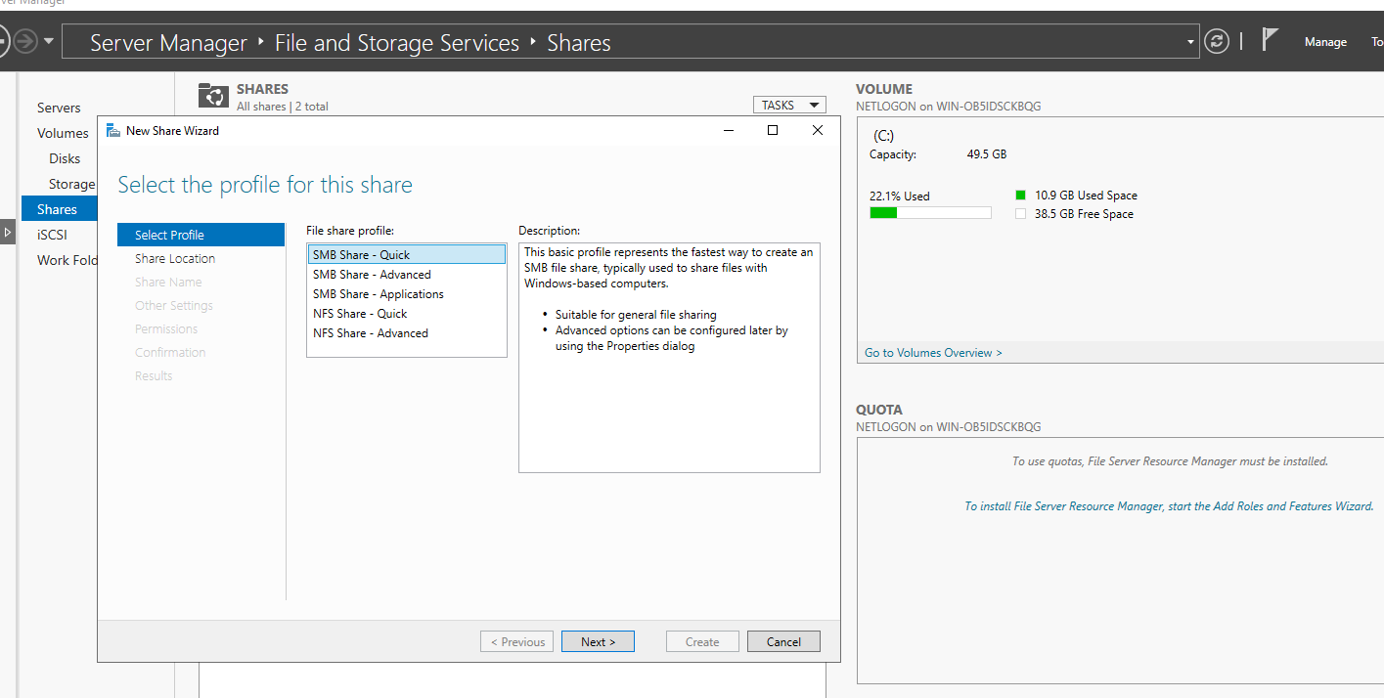
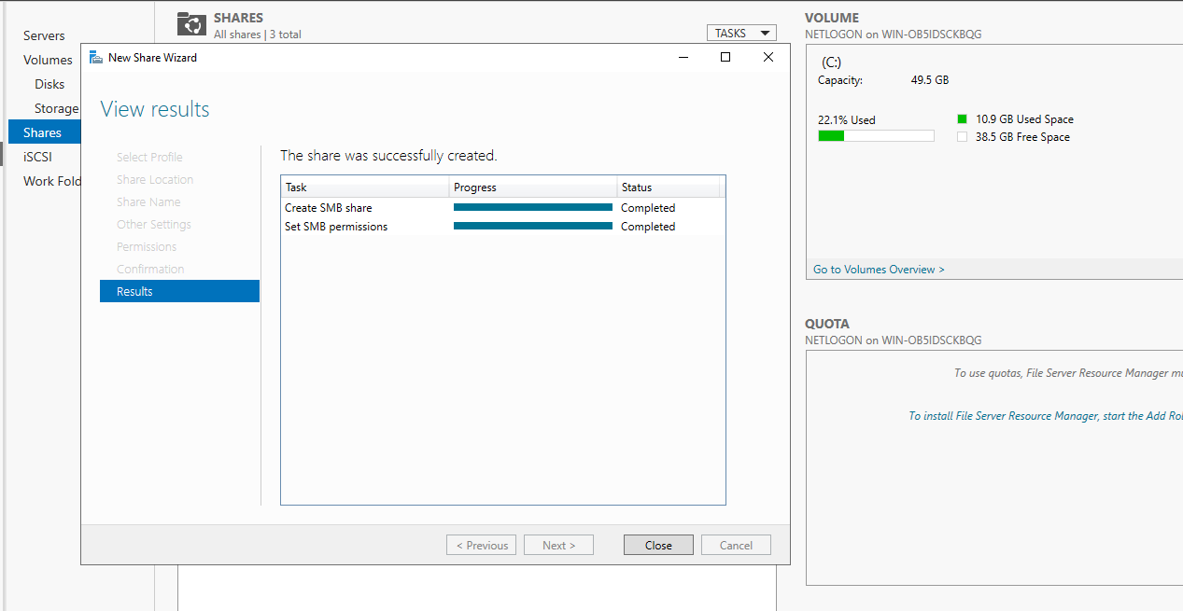
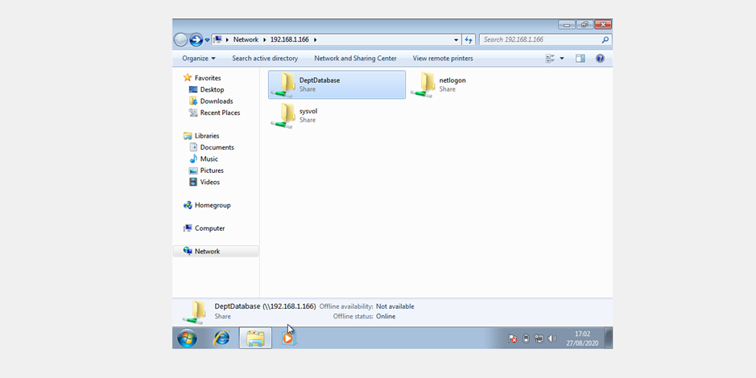
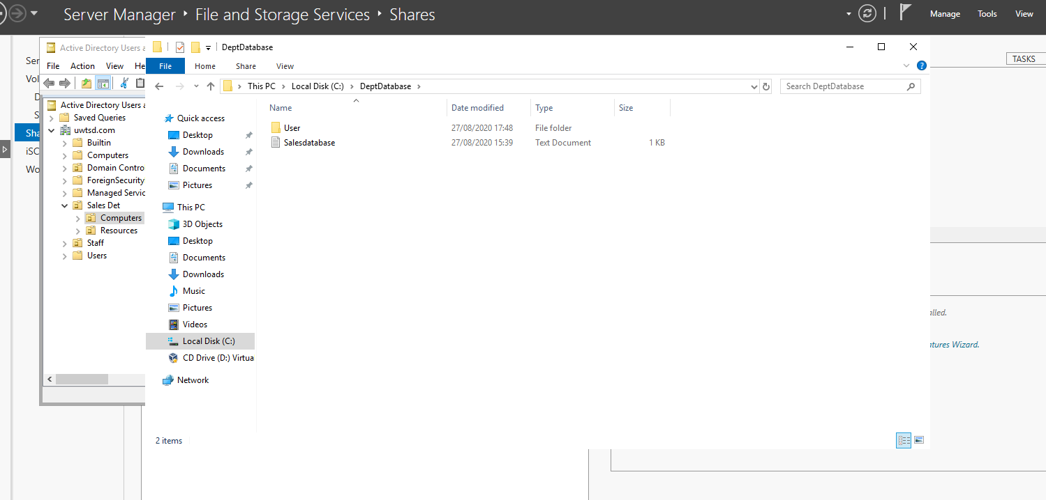
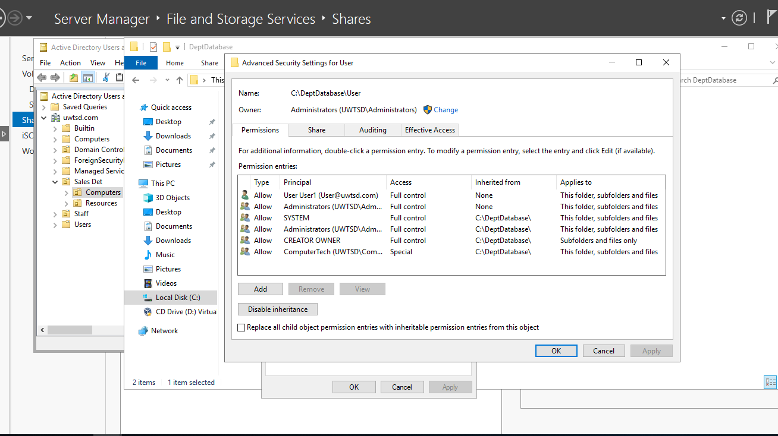

Sheet 4: Network Administration using DHCP

Task 1 : INSTALLTHE DHCP SERVICE.
DHCP is the process where IP addresses are automatically allocated to hosts, and the DNS resolves IP addresses with entirely qualified domain names. If you are a network administrator responsible for maintaining a Microsoft network environment, then you need to have a good understanding of these two communication networks.
Now we are learning how to install , configure and run a DHCP server, and how to deploy DNS. Additionally, explore nomenclature resolution in business networks, including how standard and conditional DNS forwarding can be configured.

Main parts are:
- What is Dynamic Host Configuration Protocol (DHCP)?
- Setting up DHCP
- Securing and troubleshooting DHCP
- Configuring a DHCP relay agent
- Deploying Domain Name System (DNS)
- Creating stub zones and reverse lookup zones
- Testing queries
- DNS security
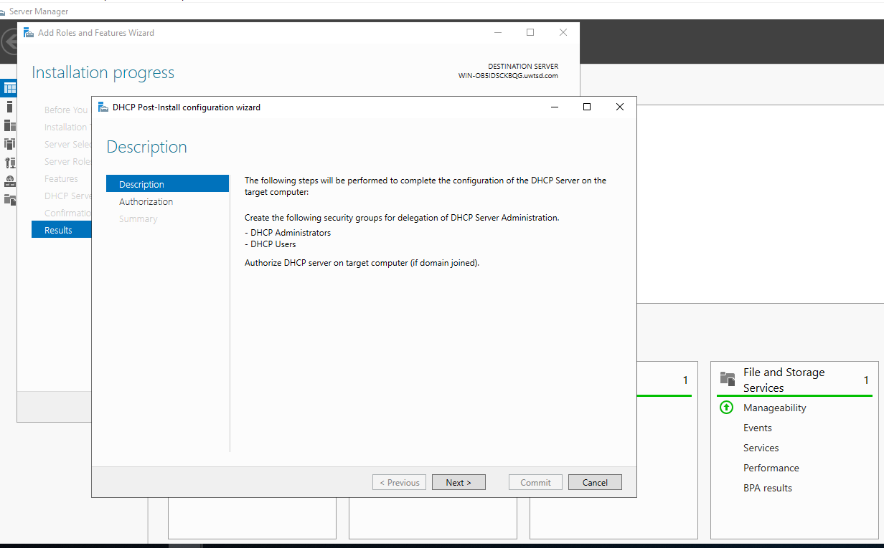
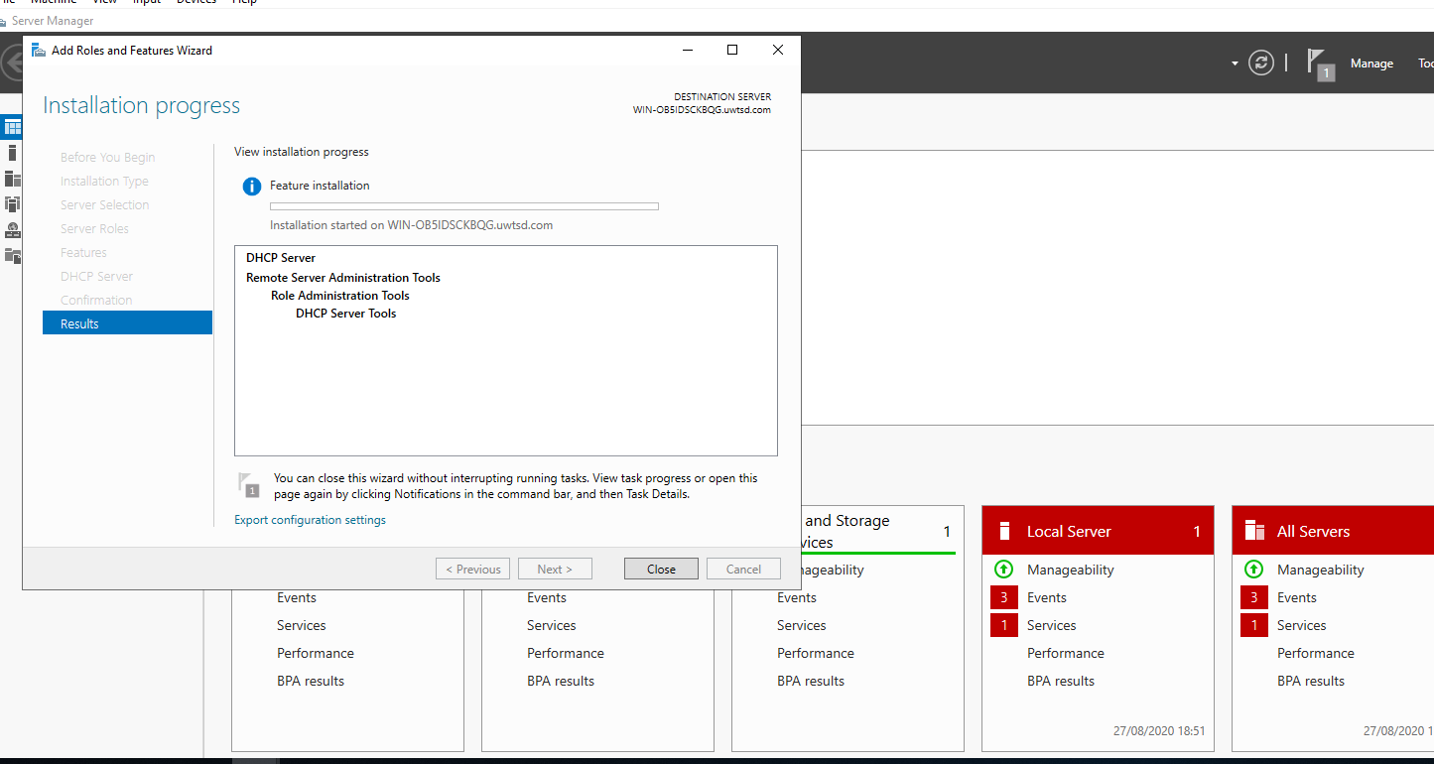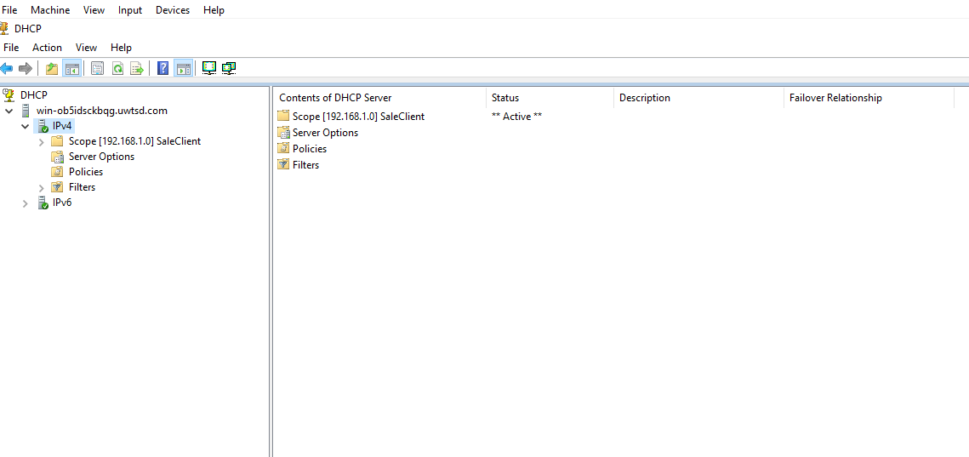

- WE have to use this information to log in to the Client:

Username: Administrator
Password: P@ssw0rd

By using Start – Run – cmd and typing this commands (ipconfig /release , ipconfig /renew (to obtain an IP address from DHCP Server) , ipconfig /all) to verify all the information that we are using.

DHCP options and controls

We start with menu buttons in Start – Administrative Tools – DHCP Console. Then in the console tree - Click Address Leases, verify that the Computer Name displayed is that of the client. This is the way to configure the DHCP.

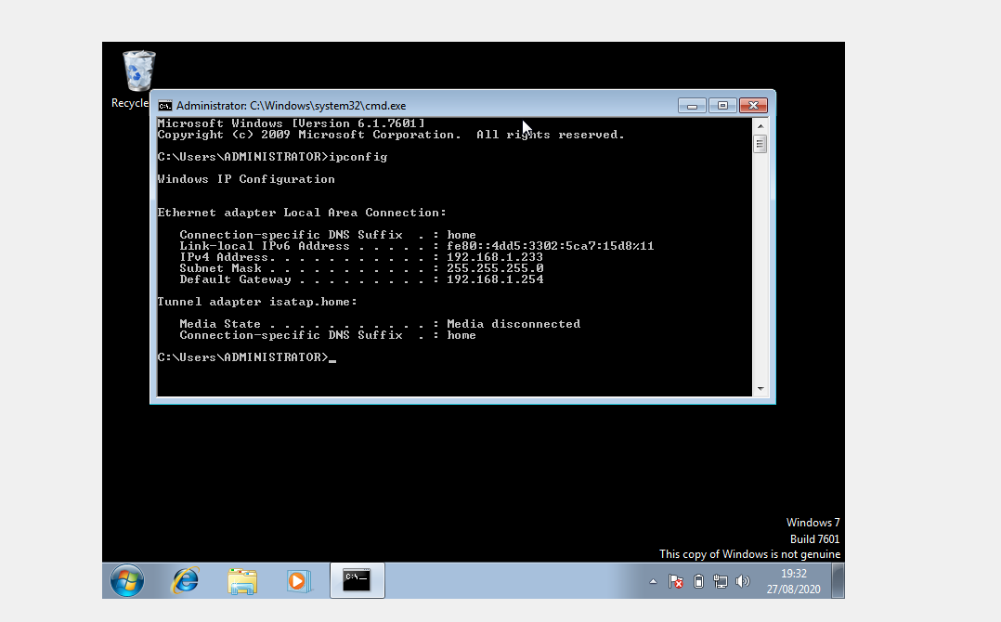
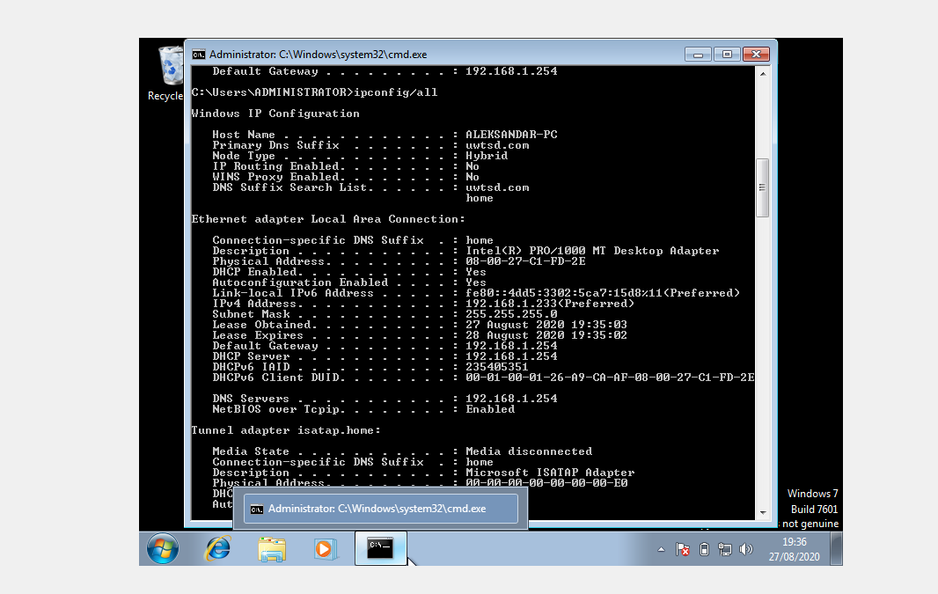

Configuring DHCP Scope Options
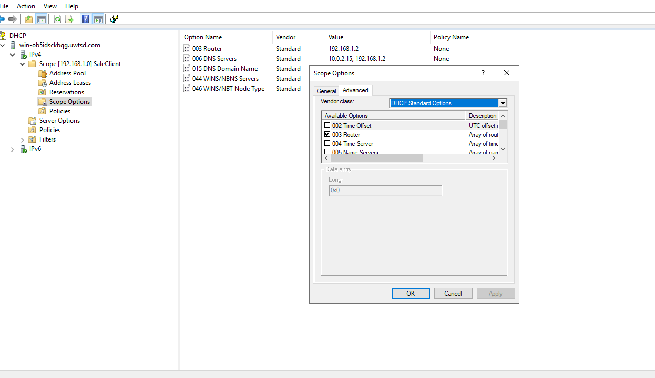

Sheet 5: Infrastructure of DNS and deploying
Task 1: DNS – what we know
DNS is also a very complicated aspect of understanding how websites and servers can be configured. Understanding how DNS functions will help you identify issues with configuring access to your websites and will allow you to expand your understanding of what's happening behind the scenes. A subject related to hosts are subdomains.

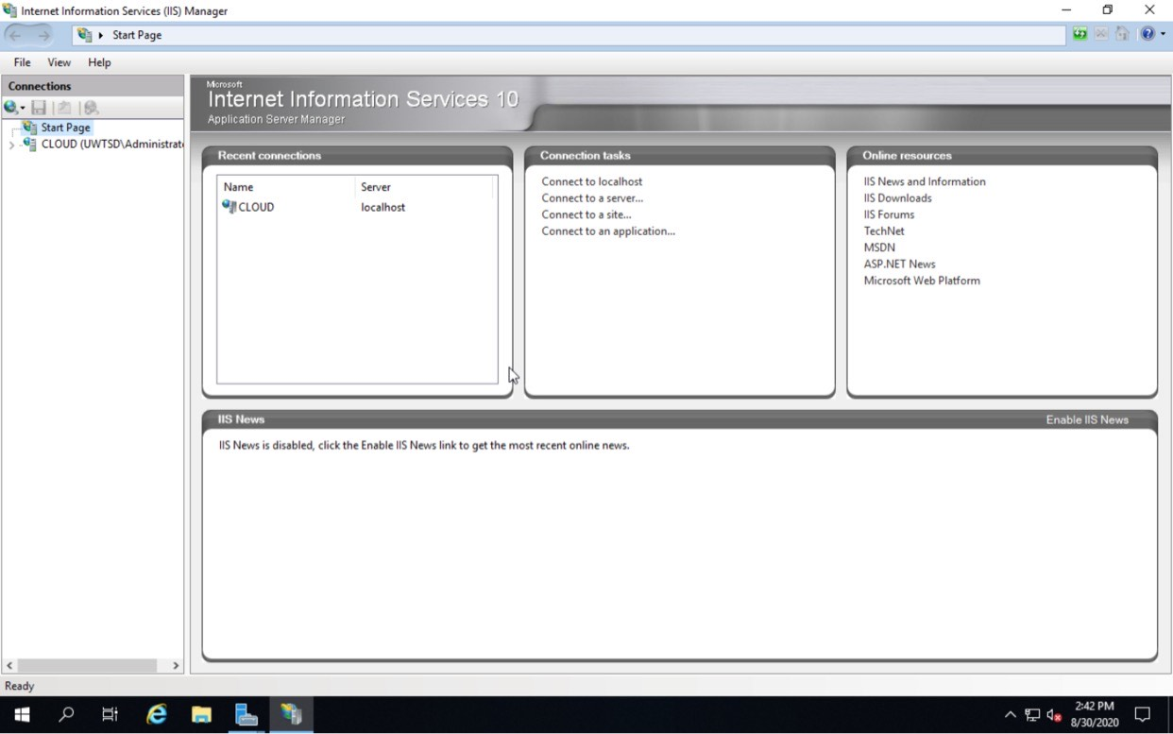
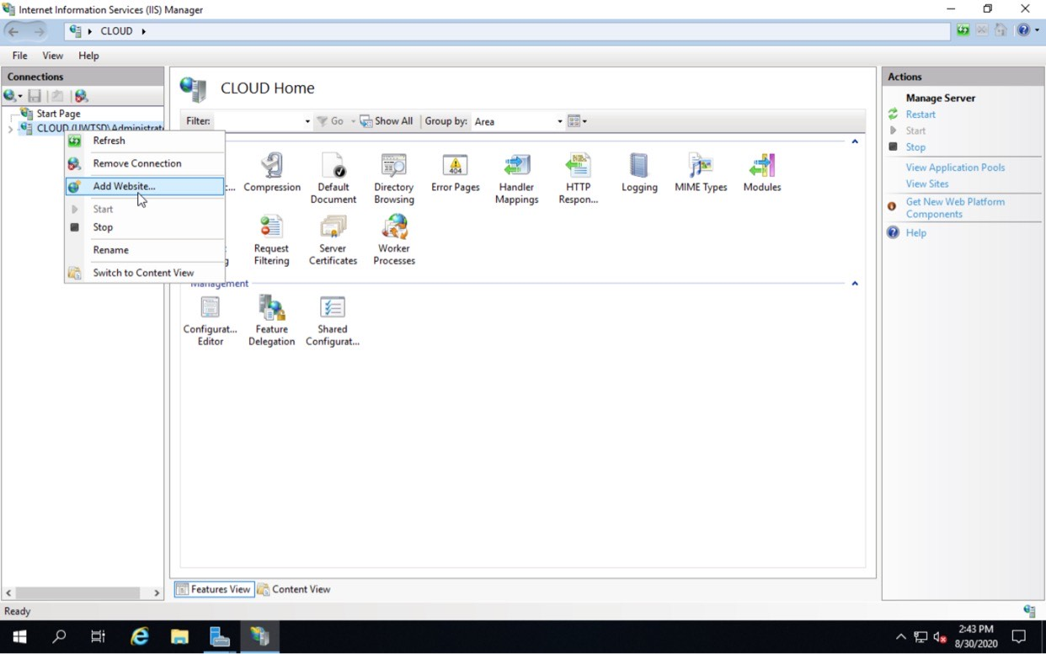
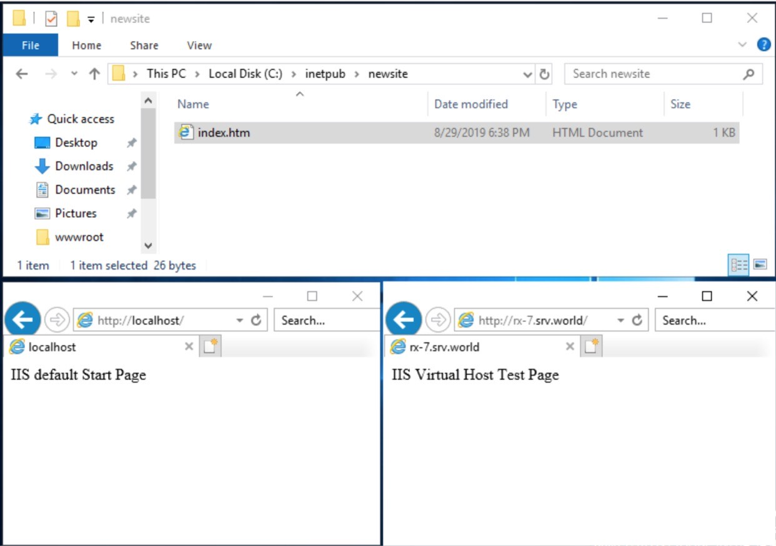
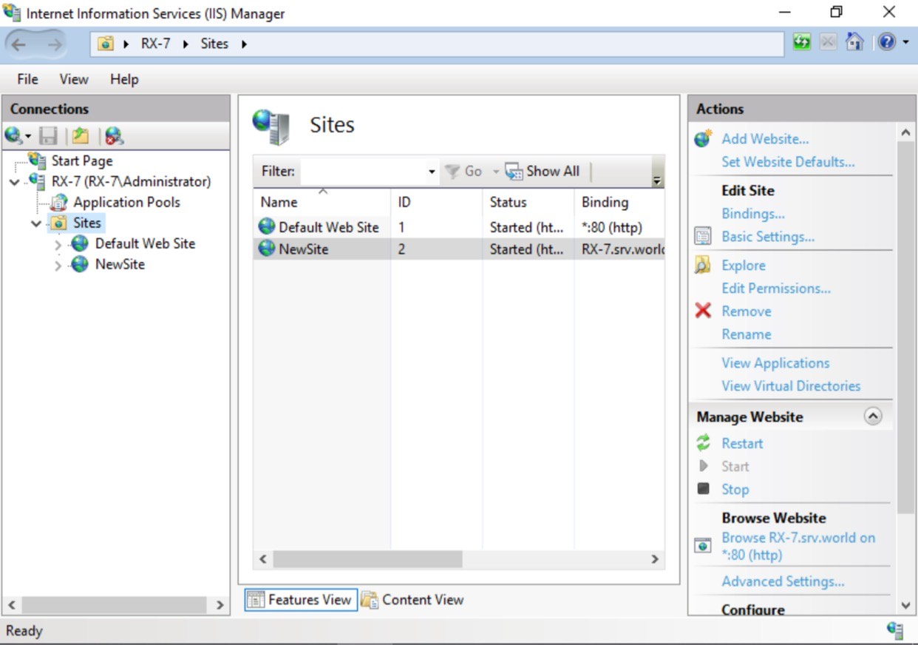

We define :
- A primary DNS server is the first point of contact for a browser, programme or device requiring the transformation of a human-readable hostname into an IP.The primary DNS server keeps a DNS record with the correct IP address for the Hostname. In the absence of the primary DNS server, the device will contact a secondary DNS server which will contain a copy of the same DNS record.
- Changes to DNS data, such as changing the address for a domain name, can only be made
- on a primary server, which could then, for example, change secondary DNS servers often known as slaves.
- DNS servers in one DNS zone can be main and secondary in a separate DNS zone.

- 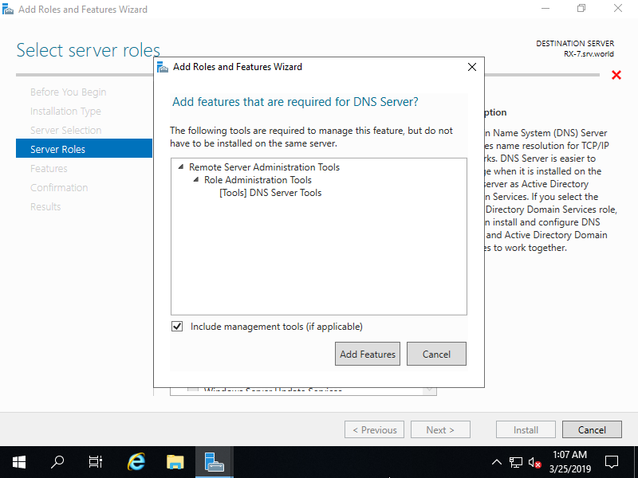

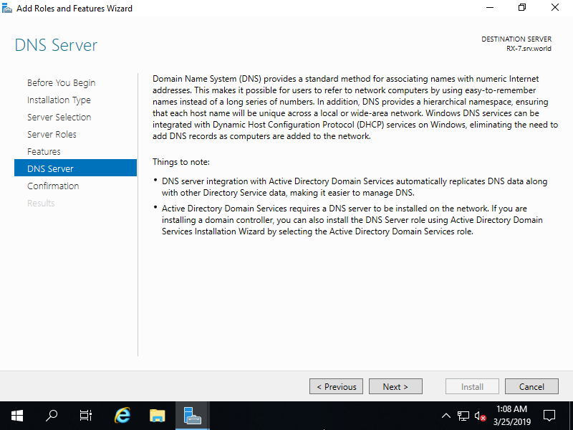

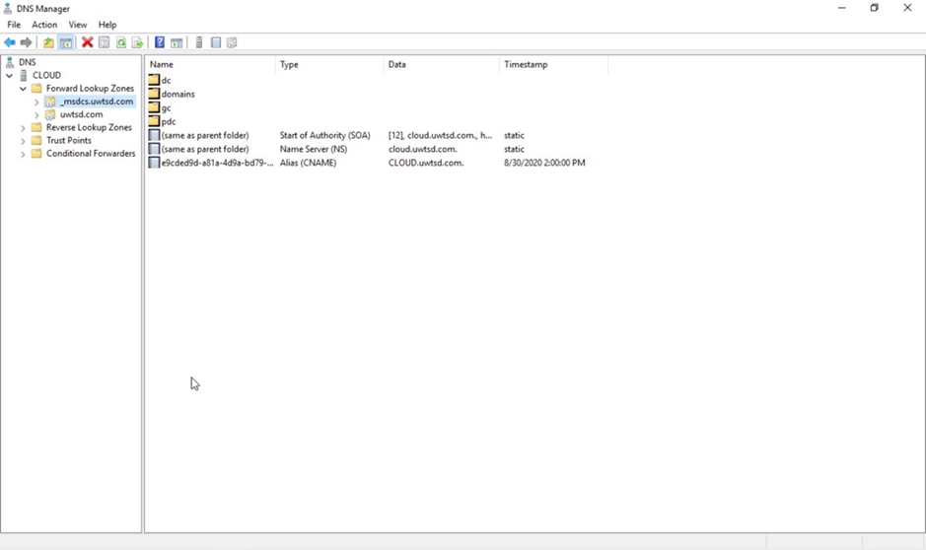

Conclusion

The major distinction with respect to active directory and domain controller is that Active Directory is a directory service designed for Windows domain networks, while Domain controller is a server running on Active Directory Domain Infrastructure. In short, Domain Controller manages Active Directory Domain Service.

