Critical evaluation of non-traditional machining equipment for the manufacturing industry.

Lecturer: Rachel Alexander

Student: Majed Abdallah

P number: 147593

Table of Contents
1. Introduction 2
2. Conventional / traditional machining processes 2
3. Non Traditional Machining Processes(NMT) 2
3.2 Classification of Non traditional machining processes (NMT) 3
3.2.1 Electromechanical process 3
3.2.2 Electro-thermal processes 3
3.2.3 Mechanical Processes 3
3.3 Abrasive Jet Machining (AJM) 3
3.3.1 Equipment 4
3.3.2 AJS machining characteristics and parameters 4
3.3.3 Common use case of Abrasive Jet Machining 5
3.3.4 Limitations 5
3.4 Ultrasonic Machining (USM) 5
3.4.1 Application of ultrasonic machining process 6
3.4.2 Limitations of ultrasonic machining 6
4. Comparative analysis of non traditional machining processes 6
5. Benefits of non traditional machining techniques 8
6. conclusion 9
7. References 9

List of tables
Table 1: input parameters of NTM (El-Hofy, 2005) 6
Table 2: characterization of surface and shapes by of NTM 7
Table 3:Material characterization in respect to various NDT methods 7
Table 4: Material characterization in respect to various NDT methods table 2 7
Table 5: Comparison for non traditional machining processes 8
Table 6: economies of NTM 8

List of figures
Figure 1: fig of chip formed by shearing method of a material 2
Figure 2:Abrasive jet setup (Sarkar & Pandey, 1976) 4
Figure 3:Abrasive jet Machining 4
Figure 4: Ultrasonic machining (El-Hofy, 2005) 6

Non Traditional Machining Processes
Abstract
Engineering advances and strict customer demands have proved to be a challenge to scientists and material engineers. There is a need to develop better manufacturing methods or improve existing techniques to fabricate and process materials at a minimal cost while meeting required quality and dimensional tolerance. This report involves the study of various non traditional machining methods and processes, applications, tooling, initial setting cost, characterization of the surface and shapes of manufactured products, energy needs and their benefits over the conventional machining techniques.

Introduction
Manufacturing processes can be divided into two groups, Non-Traditional manufacturing processes and conventional machining processes. Conventional methods include boring, tunneling, shaping, grinding, slotting among others. Some of the non-traditional methods include electro-discharge machining, Ultrasonic Machining, abrasive water jet among others. This method can be used to used to produce complex geometric shapes at very tight tolerance economically. These methods are suitable for processing modern materials including super alloys, fiber reinforced composites, textile and ceramics spanning across automotive, electronics and aerospace industries.

Conventional / traditional machining processes
The working principle for these method involves application of force on the tool with a sharp wedge shaped edge against the work piece. Applied forces does induce plastic deformation along the shear plane removing material in form of a chip. Usually the tool is made of a harder material that of the work piece under machining conditions.

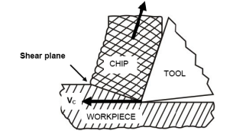
Figure 1: fig of chip formed by shearing method of a material
The major characteristics of conventional/traditional machining include:
- Cutting tool is usually harder than the work piece at the machining and room temperature conditions
- Macroscopic chips are formed during the shearing process
- The material removal is as a result of force applied, hence mechanical energy is dominant.

Non Traditional Machining Processes(NMT)
The non traditional machining methods have the following common characteristics:
- Tool used in the machining or cutting process need not to be harder than the work piece. A good example is a laser jet machine where machining is done by a laser beam, in some cases, physical tool is required, e.g. electrochemical machining.
- Chip size in the NMT process is in micro scale or in other cases no chip is take off the work piece. In electrochemical machining material removal is as a result of electrochemical dissolution.
- Some methods require mechanical energy for material removal while others don’t, for example, electrochemical machining process does not require mechanical energy, the machining process occur using the chemical energy.

3.2 Classification of Non traditional machining processes (NMT)
One of the common classification method of machining is by the energy used in the process of energy removal (Youssef, 2008). The classification is as follows:

3.2.1 Electromechanical process
In this class a combination of chemical dissolution is used together with mechanical energy for the removal of material from the work piece. The processes in this class include:
- Electro Jet Drilling(EJD)
- Electro-chemical grinding (ECG)
- Electro-chemical machining(ECM)

3.2.2 Electro-thermal processes
In this process heat generated from electric source is used in the process of cutting or machining of the work piece. Processes under this class include:
- Laser jet machining (LJM)
- Chemical machining
- Electro-discharge machining(EDM)
- Chemical processes such as chemical (CHM) and photochemical milling (PCM)

3.2.3 Mechanical Processes
In this class, some form of mechanical energy used in the process of machining or cutting. Some of the methods in this class include:
- Ultrasonic Machining (USM)
- Abrasive jet Machining (AJM)
- Abrasive water jet Machining (AWJM)
- Water jet machining (WJM)

3.3 Abrasive Jet Machining (AJM)
In AJM a high velocity fluid carrying abrasive particles strikes the work piece with a very high kinetic energy due to very high velocity, i.e. the principle of erosion. The position and angle of the nozzle in respect to the work piece is adjusted accordingly to maximize the cutting speed as well as improve quality of the cut. Removal of the material is achieved by micro cutting of the material by action of tiny brittle fracture.
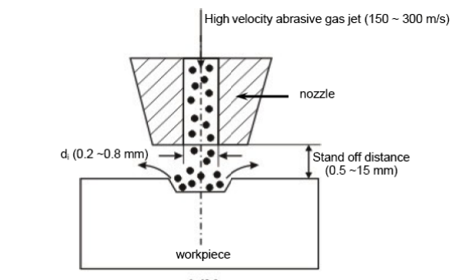
Figure 2:Abrasive jet setup (Sarkar & Pandey, 1976)
A particle size of 50μ impinging the material surface at a speed of 200m/s from a nozzle of radius of about 0.5mm at a stand off distance of about 2mm, removing material as a result of micro cutting or brittle fracture.

3.3.1 Equipment
Compressed air at 5 bar is used as a carrier fluid/gas. Main gases used include N₂ and CO₂ and equipment setup for the AJS is shown in the figure 3 below.

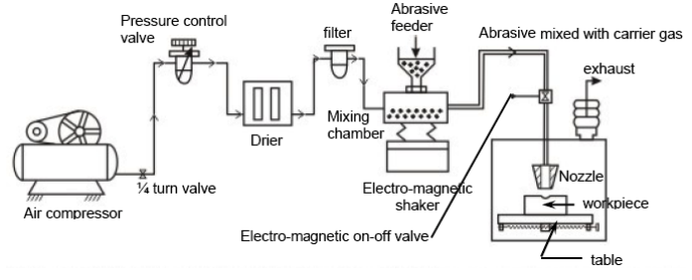
Figure 3:Abrasive jet Machining
In the setup above the carrier gas first passes through pressure regulator to obtain a correct pressure, then to gas drier to remove oil and water vapor, then through series of filters to remove contaminates. In the mixing chamber the clean gas is mixed with the abrasives from the hopper that is vibrated using electromagnetic means (Sarkar & Pandey, 1976).

3.3.2 AJS machining characteristics and parameters
To achieve a quality cut and machined surface, the parameters has to be adjusted accordingly, the abrasive as to be of the right material, free of contaminants, right size and shape. Sarkar and Pandey proposed a model for calculating the material removal rate:

$$MRR=χ{Zd}^{3}v\frac{3}{2}(\frac{ρ}{{12H}_{w}})^{3/4}$$
Equation 1: calculating material removal rate (Sarkar & Pandey, 1976)
Where:
Z = no of particles/unit time
D = mean particle diameter
V = velocity of grains
ρ = density of the abrasive
H₃ = hardness of the work piece
$χ$ = constant

Glass beads, Al₂O₃ and SiC are among the most common abrasive material used with irregular or spherical shape with a size between 10μ and 50μ with a mass flow rate of 2-20 gm/min. The carrier gas also must meet some minimum requirements, such as the composition, a maximum density of 1.3 kg/m³, pressure of 2- 10 bar, a velocity of 500 – 700 m/s and a flow rate of 5-30lpm (Venktesh , Goh, & Wong, 1984 )m.
After the abrasive material and the carrier air have mixed, they form an abrasive jet. For an effective and quality cut, a velocity of 100 – 300 m/s velocity, a standoff distance of 0.5 to 5 mm with an impingement angle of between 60-90º is required for maximized machining. Materials such as sapphire or WC can withstand most of this conditions for a long period of up to 300 hours. In general material removal rate, roughness, machining accuracy and nozzle life can be used to characterize abrasive jet machining.

3.3.3 Common use case of Abrasive Jet Machining
Abrasive Jet Machining is useful for the materials that are hard, brittle, heat sensitive and fragile. Abrasive jet machining can be used in cutting, drilling, etching, debarring and cleaning. Also AJM can be used in macro-machining of very brittle materials.

3.3.4 Limitations
Despite the high quality of machining, AJM is a slow process

3.4 Ultrasonic Machining (USM)
In ultrasonic machining process, a tool of the required shape is vibrated at ultrasonic frequency at an amplitude of 15 to 50 μm over the work piece while a force is applied on the tool to press it downwards. The abrasive slurry is forced between the tool and the work piece. The tool and the work piece are both indented by the abrasive particles, at the same time removing material at the same time. This is achieved by crack initiation, then propagation and finally brittle fracture of the material (Thoea, Aspinwallab, & Wiseb, 1998). USM is suitable for machining brittle material non conductors which cannot the machined using the electro discharge or electrochemical machining methods.
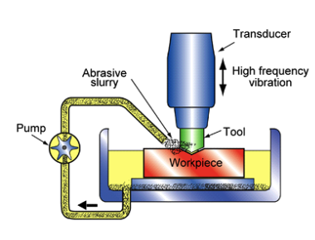
Figure 4: Ultrasonic machining (El-Hofy, 2005)
The process parameters which does govern the ultrasonic machining process include, feed force, feed pressure, abrasive material, flow strength, volume of the slurry, amplitude and frequency of vibration.

3.4.1 Application of ultrasonic machining process
- Machining of brittle and hard semiconductors, glasses, metallic alloys, carbides, ceramics among others
- Punching, wire drawing and other related machining process.
- Machining square, round or irregular shaped holes

3.4.2 Limitations of ultrasonic machining
- It has a lower material removal rate compared to abrasive jet
- high tool ware
- The depth of the machining whole is low compared to other non traditional methods such as abrasive jet machining.

Comparative analysis of non traditional machining processes
A detailed analysis has to be done to pick the most suitable process under specific conditions. The analysis can be based on the following points:
- The physical parameters have an impact on material removal as well as energy consumed during the process of machining. The table below shows the energy used in different non traditional machining processes.
Table 1: input parameters of NTM (El-Hofy, 2005)
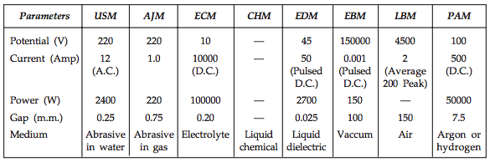
- Shapes that can be machined of the work piece, the operations include, drilling, pocketing, cavity sinking, contouring deep cutting among others.

Table 2: characterization of surface and shapes by of NTM (El-Hofy, 2005)
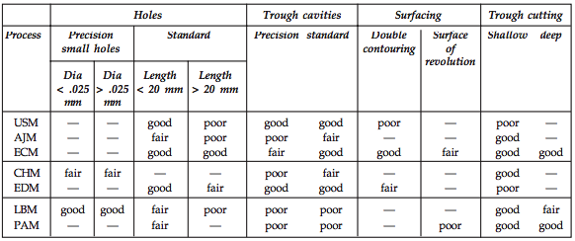
- Material application is another important aspect, materials that are non conductors of electricity cannot be machined using the EDM or ECM, mechanical process can be used in this case. The table below shows methods and suitable materials to be machined.
Table 3:Material characterization in respect to various NDT methods (Sarkar & Pandey, 1976)
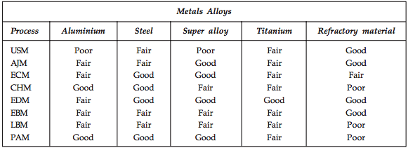
Table 4: Material characterization in respect to various NDT methods table 2
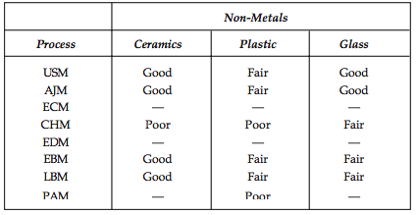
- Machining characteristics is part of the analysis for the non traditional methods, the parameters that can be analyzed include:
- Tolerance to be maintained
- Material removal rate
- Final Surface finish quality
- Energy needed
- Material removal rate (MRR)
The table below shows the comparison summary of non traditional machining processes.
Table 5: Comparison for non traditional machining processes (Youssef, 2008)
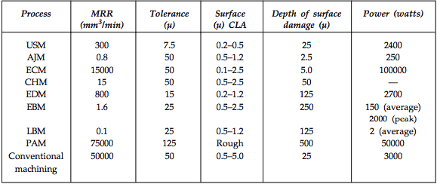

According to the data from table 5 ECM has a high power requirement of 100000 watts, it has a high machining rate of 15,000 compared to other AJMs 0.8 mm³/min, but lower machining rate compared to the conventional machining methods. It has a lower tool wear rate but there is a very high contamination risk and corrosion posed by the electrolyte.
- Economies of the manufacturing process is important factor when choosing a machining process. The following factors can be considered for analysis.
- Tooling cost
- Power costs
- Capital costs
- Tool wear
- Efficiency of material removal

Table 6: economies of NTM (Verma A P, 1984)
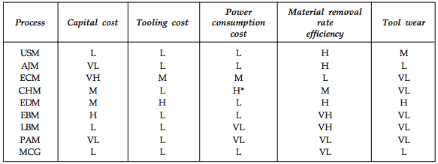

from table 6 above, the capital cost for Ultrasonic machining equipment is relatively higher than that of Abrasive jet machining, however the tool ware for abrasive jet machining is lower.

Benefits of non traditional machining techniques
Non traditional methods of machining have revolutionized the way manufacturing is done. It has brought about several benefits to the automotive sector. Materials that were hard to machine and cut can now be worked on. Parts that were too complex can now be machined with negligible tolerance at a fraction of the cost. Temperature sensitive materials are machined with minimal effect on the internal micro structure. Materials with micro thickness machining is now possible (mech4study).

conclusion
The suitability of a method for a particular machining operation depends on an array of factors which must be considered before picking a particular one. Ultrasonic and abrasive jet machining are the most common methods used. The are relatively similar in many aspects but abrasive jet uses high velocity fluids while ultrasonic machining uses a vibrating tool with abrasive slurry between the tool and work piece.

References
El-Hofy, H. (2005). advanced Machining Process: Nontraditional and Hybrid Machining Process. New York: McGraw-Hill.
mech4study. (n.d.). Non-Traditional Machining Process: Requirements, Types, Advantages and Disadvantages. Retrieved March 14, 2018, from mech4study: http://www.mech4study.com/2017/04/non-traditional-machining-process-requirements-types-advantages-and-disadvantages.html
Sarkar, P. K., & Pandey, P. C. (1976). Some investigations on abrasive jet machining. Institute Engineering , 56.
Thoea, T. B., Aspinwallab, D. K., & Wiseb, M. L. (1998). review on ultrasonic machining. International Journal of machine and manufucture , 38 (4), 239-255.
Venktesh , V. C., Goh, T. N., & Wong, M. J. (1984 ). A emprical study of parameter in abrasive jet for abrasive jet machining. Mecahincal and tool manufucturing , 29 (4), 141.
Verma A P, L. G. (1984). An experimental study of abrasive jet machining. International Journal of Machine Tool Design and Research , 24 (1), 19-29.
Youssef, H. E.-H. (2008). Machining technology machine tools and operations.

