

Module name: Financial Management for the Hotel Industry
Module code: BMIH5007
Assignment Title: Report Case Study: The City Hotel
Student name: Cristina Hondor
Student code: 2246595
Lecture name: Tristan Hawkins
Word count: 2067

AI Acknolegement
I confirm that I did not use any AI tools in the research and creation of this assignment. I confirm that I have not presented any AI generated materials as my own work. I confirm I have copies of my draft, notes, and other resources I used, which I may be asked to provide in evidence.

Executive summaries

A general initiative including the operating performances of the business is relevant for the operating growth support that brings the formulated performance initiative values. According to the basic formulation the application of financial management analysis is mainly structured for the evaluation of present financial positions and performance-initiated structure for the business of The City Hotel with realising the financial performances using ratios. The applications of relevant ratios including the strategic initiative are also formulated for the primary recognition support of the current declining financial approach as well which imposes a certain level of crisis related to accountability. As per the primary identifications the applications of relevant financial measurements and processing also represent the initiated macroeconomic factors involved behind the declining positions and marketing scenario of revenue and profitability in this business that need to be revised by the management in the upcoming for future compatibility. The general initiative related to the applicability of the turnaround strategy for this business is also evaluated in the ending part to identify the general opportunity including the compatibility initiative approach which can be a sustainable attribute for the future growth of this business.

Table of contents

Introduction 4
Discussions 4
1. An accounting evaluation and differentiation analysis for The City Hotel 4
2. General recognition regarding such financial condition in The City Hotel with economic aspects 8
3. Possible developmental initiative with the turnaround strategies in The City Hotel 10
Recommendation 11
Conclusions 11
References 12

Introduction
The city hotel is particularly a restaurant cum bar which is also engaged in event facility support in the urban landscape presently facing a certain level of challenging approach in relation to the position of business revenue and earnings due to circumstantial position. In this report, a detailed analysis related to the position of financial performance of this hotel is evaluated with the support operations so that the compatibility level of the financial trending approach can be identified.

Discussions
1. An accounting evaluation and differentiation analysis for The City Hotel.
The position and performance of every individual business provide systematic guidance to the of earning while considering the market scenario. In other words, favourable market positions with a positive volume of demand and supply provide proper standardised progress in relation to the business revenue and earnings which provide positive market growth and stability with a competitive advantage (Asmundson, 2023). In the present position the application of hospitality business represents a progressive opportunity for the industrial development initiative that brings the optimised opportunity regarding the GDP processing support in individual countries (Walker, 2021). In relation to the position of the present financial structure of The City Hotel, mainly the evaluation of financial position has been evaluated with trending analysis including the ratio processing support that enables the basic understanding approach to stakeholders about the accounting compatibility. Detailed analysis of such financial positions of the business is evaluated.
Revenue: It is defined as an elementary approach that provides a positive level of guidance to the business position of operation with the initiative structure of market positioning. Generally, a positive level of demand imposes a favourable situation for revenue expansions on the quantity of the declining standard of living and insufficient market customers impose a negative impact on business revenue performance (Economic Times, 2024).
“From 5248290 in 2021 to 5307480 in 2022 = 1.12% expansions”
“From 5307480 in 2022 to 2325440 in 2023 = (56.18%) declined”
The initiative of this position indicates around 1.12% of expansion support from 2022 to 2021, while the same approach declined to (56.18%) from 2022 to 2023.
The general insufficient level of market demand with decreasing purchasing capability of the customer mainly imposes this type of negative impact on this business. Additionally, with the enactment of Brexit, the volume of visits from the European Union to the United Kingdom declined from 24.83 million in 2019 to 4.41 million in 2021 and the volume reached 18.96 million in 2022 (Statista, 2023). This fluctuation imposes a significant level of negative impact on the trade position and revenue structure in individual UK hospitality business.
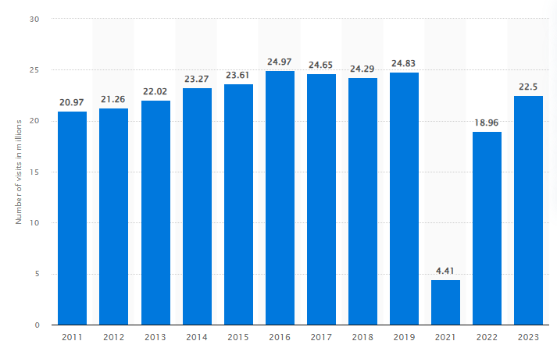
Expenses: To contact the overall operating initiative with the intentions of business earning and going concern support in business performances, a certain level of charges needed to be contributed by the business as a mandatory approach which is defined as business expenses (NetSuite.com, 2024). A detailed trending analysis of the business is provided.
List of expenditures | 2021 | 2022 | Varriance | 2023 | Varriance
Cost of goods sold | 411600 | 401510 | -2% | 176250 | -56%
Employee costs | 1724760 | 1770700 | 3% | 1233160 | -30%
External expenses | 1894720 | 1675410 | -12% | 1071030 | -36%
Taxes and duties | 144070 | 133020 | -8% | 88950 | -33%
Depreciation and expenses | 409190 | 634030 | 55% | 661590 | 4%
Current operating income and expenses | 40520 | 25030 | -38% | 41100 | 64%

The formulation of this approach represents the certain declining initiative related to expenditure structure which mainly initiates the incompetency approach of business operation. In other words, due to the reasons for the declined operating activity and service initiative, the overall operating charges including the areas of expenses are not fruitfully initiated which is also incapable of managing the revenue development properly. Therefore, the insufficient capability of business expenses due to the limited level of cash flow imposes a certain crisis in this business which is not supportive of the profitability and revenue formulation. Under the present position, the application of an activity-based costing structure is relevant for controlling support of costing that is supportively able to decline the level of cost with the allocation processing basis under individual departments on a progressive basis (Drury, 2022).
Profitability: It mainly defines the earning position of the business in proportion to financial element support which is accountable for recognising the business potential profit initiative. It is also applied for formulation support related to profitability in an investment project that provides a general understanding of the support of working capital including the cash flow position as well that manages the monitoring position of the business on a developing basis (Atrill and McLaney, 2018).
Gross profit margin | 2021 | 2022 | 2023
Gross profit | 4836690 | 4905970 | 2149190
Revenue | 5248290 | 5307480 | 2325440
Ratio | 92.16% | 92.44% | 92.425

Operating profit margin | 2021 | 2022 | 2023
Operating profit | 664160 | 674730 | -1218850
Revenue | 5248290 | 5307480 | 2325440
Ratio | 12.65% | 12.71% | -52.41%

The present analysis of gross profit margin indicates the same proportionate results in the business up to 92.42% initiative which represents the overall market demand and supply attribute formulated on an equilibrium basis that does not impose any huge change impact over the service initiated. However, the operating profit declined to the standard of (52.41%) in the current year which means the overall operating charges are not supportively impacted on the business and even the generated revenue capability of the business also imposes a negative impact. In comparison with Whitbread PLC, certain insufficiencies are noticed regarding the level of earnings as the gross profit margin of Whitbread indicates the level of 63.99% and the operating margin indicates 24.83% development initiative with the optimised marketing position support (Investing.com, 2024). The formulation of this financial position mainly represents the required development in the City Hotel in the present marketing standard to gain the optimised operating formulated as the present market position are revised with the progressive expansions of marketing demand related to tourism business.
Liquidity: It has been initiated to measure the cash flow-initiated structure of the business that is accountable for defining the liquidity position in the processing of investment or payment initiatives (gocardless.com, 2024).

Current ratio | 2021 | 2022 | 2023
Current assets | 1891970 | 1965340 | 1285880
Current liabilities | 1957360 | 2107750 | 2014600
Ratio: current assets/current liabilities | 0.967:1 | 0.932:1 | 0.638:1
Quick ratio | 2021 | 2022 | 2023
Current assets- inventory | 1891970-35230 | 1965340-36360 | 1285880-29740
Current liabilities | 1957360 | 2107750 | 2014600
Ratio: current assets-inventory/ current liabilities | 0.949:1 | 0.915:1 | 0.624:1

Formulation of this analysis indicates the current ratio position of the business represents a significant amount of declining approach up to the level of 0.63 times in the current year due to huge expansions of current liability positions compared to the generated capability of current assets. Even the same approach is also noticed regarding quick ratio as well up to 0.62 Times of climbing approach compared to the previous scenario with 0.915 times of development. The low level of inventory initiative including the decreasing standard of operating positions mainly imposes this type of negative approach which also represents the supply chain crisis impact on the business assets.
Solvency: It is initiated to recognise the capital positioning or leverage formulation purpose that is accountable for the market stability and development initiative (Hayes et al., 2020).
Debt to equity ratio | 2021 | 2022 | 2023
Outstanding debt | 87277580 | 11230300 | 12228780
Total equity | 2256180 | 2583030 | 1410580
Ratio | 3.868 | 4.3481 | 8.669

Interest coverage ratio | 2021 | 2022 | 2023
Operating profit | 664160 | 674730 | -1218850
Interest expenses | 40520 | 25030 | 41100
Ratio | 16.39 | 26.96 | -29.66

Debt to assets ratio | 2012 | 2022 | 2023
Total non-current liabilities | 8727580 | 11230300 | 12228780
Total assets | 12941110 | 15921080 | 15653970
Ratio | 0.674 | 0.705 | 0.781

Optimised positions and present initiated capital value of the business indicate is certain expansion approach in relation to the outstanding debt position compared to the generated level of equity capital structure with the expanded support of 8.66 Times of development compared to the previous scenario of 4.34 times. However, in the current year’s general expansions in borrowing capital, the interest coverage represents a huge decline level of up to (29.66) times which imposes the general negative of the present decline profit initiative.
2. General recognition regarding such financial condition in The City Hotel with economic aspects.
Apart from the general internal operating formulation the identification of some of the external factors which are defined as the macroeconomic factor of a business are equally responsible in relation to the positioning approach of finance in individual businesses. In relation to the present market positions, the identification of geo-political consequences can be identified as the relevant approach that imposes a certain level of crisis impact on the UK economy. The initiative of the Brexit referendum imposed a certain level of immigration issues which declined the general level of employee engagement even the tourist formulation properly and ultimately declined the general standard of service initiative in the individual hospitality business in the UK (Restle, 2023). Even the Russia-UK war imposes a certain level of crisis in the form of labour market charges expansion including the supply chain disruption approach that ultimately declines the general standard of development initiative in business. In the present positions, the GDP level of the UK has declined to the standard of 0.1% which represents a huge level of insufficiency positions in relation to the market consequences (Statista, 2024). 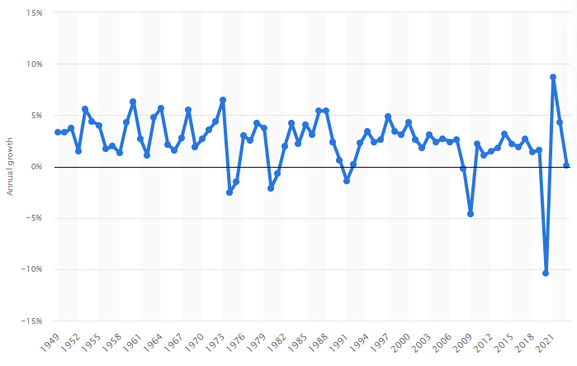
To maintain a proper volume of stability in the market the inflations are generally required to be avoided. However, in the present scenario after the pandemic, the level of inflation negatively impacted the UK economy which reached up to the standard of 11% (Peachey, 2023). These huge expansions of inflation level mainly initiate a certain challenging approach related to the value of service prices and also for the people with decline standard of living position.
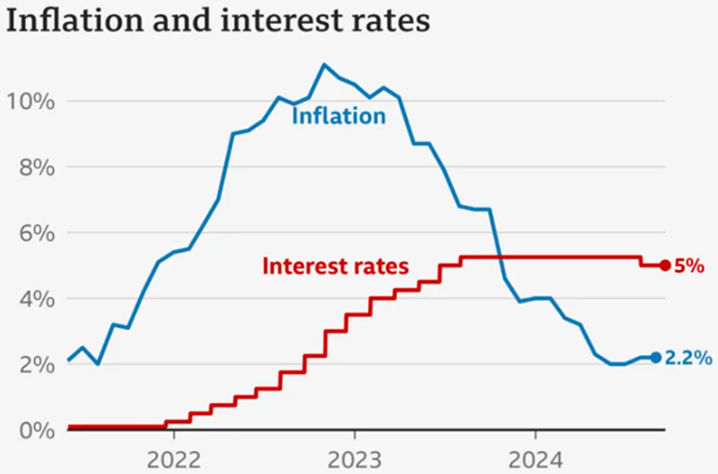
To maintain a proper volume of mitigation support associated with the label of inflations the present government with interventions of BOE revised the fiscal policy and as a result, the expansion of interest charges up to 5.25% is initiated in the UK economy. These huge expansions impose a challenging consequence related to the maintenance of borrowing capital initiatives in individual UK businesses in the period of recession. Since the period of the pandemic, the positive technical advancement provided proper initiatives related to virtual meeting engagement that ultimately initiated the declined position in relation to using hotels for the official meeting initiative. In the last year, the volume of virtual meetings has been more than 13.2 million adults across in the United Kingdom and more than 6000 people in officially purpose uses Zoom virtual meetings, which represents a certain volume of revenue-declining initiatives in that particular aspect on the hospitality business (Zoom, 2023).
The present level of unemployment is expanded up to 4.2% and around 9.30 million people are economically inactive in the present economic standard in the UK which represents around 21.9%. The average wages standard on the other hand expanded by only 1.90% in the last 3 months with the bonus level of 3% only that initiated in the client level of employment initiated standard under individual industries (Powell et al., 2023). Such a negative impact also imposes a systematic crisis related to the hospitality business as well.
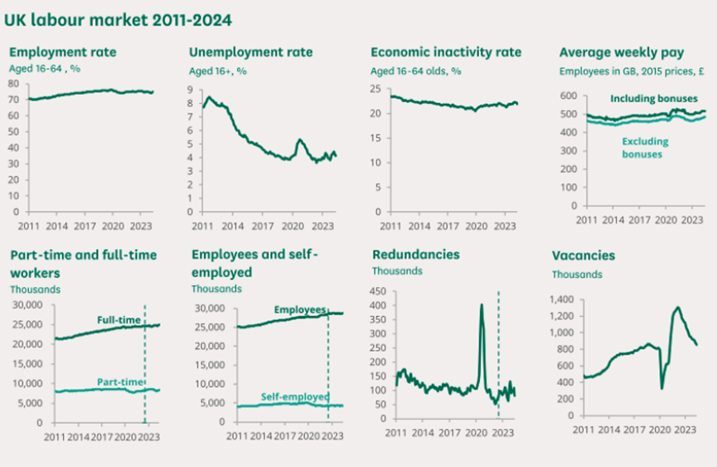
3. Possible developmental initiative with the turnaround strategies in The City Hotel According to Jeyasingh (2023), while a business undergoes the business position of survival- threatening performance, the initiative of proper turnaround strategy can initiate a positive reverse positioning approach for the implementation of stability development while minimising the volume of threats. Under the present situation, implementation of this type of strategic formulation over The City Hotel will be a fruitful initiative to maintain comprehensive development and sustainable profitability progress.
Application of budgetary initiatives in association with the business operation is relevant with the consideration support of management accounting that provides a proper opportunity to identify the variance position of business in a developing order (Seal and Rohde, 2019). It is also optimised for the maintenance of business resources allocation support on a compatibility basis. Under the present market scenario, the implementation of a value-based pricing concept related to productive, or service initiatives will be a sustainable approach for the business to manage and expand the level of revenue formulations on a stable basis (Elphick, 2023).
The implementation Of Cultural initiatives including the inclusion of diversification support in the workplace with positive employee engagement and retention, the business can be able to manage a progressive volume of service development initiatives with expansions of business operating formulations (Lacalle, 2021). Depending on the general operation engagement the applicability of AI-based operation including the initiative of a cloud computing system, development in direct prevention initiative and other operating terminology revisions will be a sustainable attribute for the maintenance of business operating accountability in the upcoming (Cbre.co.uk, 2024).

Recommendation
Under the present scenario, a proper level of strategic partnership initiative in the business will be sustainable to maintain a proper revenue-progressive initiative. With the initiative of collaborating with local attractions, tour operators, and complementary businesses the business can supportively be able to expand its operating engagement. Additionally considering the turnaround strategy’s primary importance to the diversified target marketing including the development of a loyalty program through initiatives of some seasonal discounts the business will be able to manage a positive volume of customer retention approach, which will be able to provide a proper volume of not revenue progress opportunity.

Conclusions
In summary, the primary identifications related to a positive level of significance to the economic factors provide progressive support related to the business positioning approach that is relevant to the values. According to the basic identifications properly applied strategic support associated with the market potential will be sustainable for the business values and stability purpose which will be accountable for the standardised growth and stability attribute support.

References
Asmundson, I. (2023). Supply and Demand: Why Markets Tick. (online) International Monetary Fund. Available at: https://www.imf.org/en/Publications/fandd/issues/Series/Back-to- Basics/Supply-and-Demand (accessed 03 Nov. 2024).
Atrill, P. and McLaney, E.J., (2018). Financial accounting for decision makers. 9 th Ed. Harlow: Pearson Education.
Cbre.co.uk. (2024). Boosting efficiency: The role of AI in the hotel industry. (online) Available at: https://www.cbre.co.uk/insights/articles/boosting-efficiency-the-role-of-ai-in-the-hotel- industry (accessed 03 Nov 2024).
Drury, C. 2022. Management and Cost Accounting. 9th Ed. Cengage Learning.
Economic Times. (2024). What is Revenue? Definition of Revenue, Revenue Meaning. (online) Available at: https://economictimes.indiatimes.com/definition/Revenue (accessed 03 Nov. 2024).
Elphick, D. (2023). What is value added pricing in hotels (online) SiteMinder. Available at: https://www.siteminder.com/r/value-added-pricing/ (accessed 03 Nov. 2024).
gocardless.com. (2024). A Guide to Liquidity in Accounting. (online) Available at: https://gocardless.com/guides/posts/liquidity-in-accounting/ (accessed 03 Nov. 2024).
Hayes, A. (2020). Solvency Definition. (online) Investopedia. Available at: https://www.investopedia.com/terms/s/solvency.asp (accessed 03 Nov. 2024).
Investing.com. (2024). Blocked Page. (online)Available at: https://uk.investing.com/equities/whitbread-ratios/1000 (accessed 10 Nov. 2024).
Jeyasingh, B.B.F., 2023. Factors Determining Turnaround Strategies for Declining, Large, High- tech organizations. Journal of Business and Management Studies, 5(5), pp.180-197. Lacalle, E. (2021). Why is cultural diversity important in the hotel sector? (online)Mews. Available at: https://www.mews.com/en/blog/cultural-diversity-in-hospitality-industry (accessed 03 Nov. 2024).
NetSuite.com (2024). What Are Business Expenses? Examples, Tips and FAQs.(online) Oracle NetSuite. Available at:https://www.netsuite.com/portal/resource/articles/financial- management/business-expenses.shtml (accessed 03 Nov. 2024).
Peachey, K. (2023). Bank of England: What are interest rates? BBC News. (online) 5 Aug. Available at: https://www.bbc.com/news/business-57764601 (accessed 03 Nov. 2024). Powell, A., Francis-Devine, B. and Clark, H. (2023). UK Labour Market Statistics. commonslibrary.parliament.uk, (online) 9366(9366).
Available at: https://commonslibrary.parliament.uk/research-briefings/cbp-9366/ (accessed 03 Nov. 2024).
Restle, B. (2023). How has Brexit affected Britain’s tourist sector? (online) DW.com. Available at: https://www.dw.com/en/how-has-brexit-affected-britains-tourist-sector/a-64515180 (accessed 03 Nov. 2024).
Seal, W.B. and Rohde, C. (2019). Management accounting. London: Mcgraw-Hill Education. Statista. (2023). Inbound visits from the EU to the UK 2011-2019. (online) Available at: https://www.statista.com/statistics/616823/number-of-visits-from-european-union-to-the-united- kingdom-uk/ (accessed 10 Nov. 2024).
Statista. (2024). Average price per night of hotels in big cities UK 2022 (online) Available at: https://www.statista.com/statistics/1371742/average-price-per-night-hotels-in-big-cities-uk/ (accessed 20 Oct. 2024).
Thornhill, J. (2024). Average UK Salary By Age In 2024. (online)Forbes Advisor UK. Available at: https://www.forbes.com/uk/advisor/business/average-uk-salary-by-age/ (accessed 20 Oct. 2024).
Walker, J.R., 2021. Introduction to hospitality. Pearson.
Zoom. (2023). Building Forward with Hybrid Work Models in the UK. (online) Available at: https://www.zoom.com/en/resources/uk-hybrid-work-models-report/ (accessed 20 Oct. 2024).

