

Module name: Managing Food and Beverage Operations
Module Code : BMIH6002
Title: Learning Log
Student name: Monica Clementina Radu
Student number: 2209717
Lecturer’s name: Kathryne Roberts
Word Counted: 1368

Table of Contents

Introduction................................................................................................................3
Section 1: Reflection on Experience and Personal Development.............................3
Description......................................................................................................3
Feelings..........................................................................................................3
Evaluation.......................................................................................................4
Analysis..........................................................................................................5
Conclusion.....................................................................................................5
Action Plan.....................................................................................................6
Section 2: Critical Analaysis of Work -Based Skills and Technical Knowledge.........6
Section 3: Reflection on Organisational Issues........................................................7
Conclusion................................................................................................................8
References...............................................................................................................9

Introduction
This reflective log is based on my 4 week Level 6 hotel placement experience by shadowing a supervisory role in the Food and Beverage Departament of the Delta Marriott Swindon Hotel. Based of these qualitative experiences in my carrer, this log will significantly highlight my leadership, operational efficiency, and guest service excellence skills. This reflective log will use Gibbs' reflective cycle, which consists of six stages, including description, feeling, evaluation, analysis, conclusion, and action plan ( Adeani et al. 2020). This model further will help me explore my qualitative knowledge and operational skills, thereby maintaining higher hospitality standards and productive professional growth.
Section 1: Reflection on Experience and Personal Development
Description
During my time shadowing a supervisory role in the Food and Beverage Departament of Delta Marriott Swindon Hotel, I have developed my experience of guest supervision, ensuring high-quality service and quest satisfaction standards to a greater extent. From setting up the restaurant for dinner to cleaning the tables and supplying the key culteries and dishes, and training the staff,and many others, I have witnessed the relevance of time management, teamwork, task delagation and critical thinking to make more impactful decisions. In week 2 further, I have overseen cleaning the table activities, followed by setting tables for breakfast and dinner at large. Also, I have found the need to inquire about clients' certain food preferences and allergenic chances.
Feelings
In these weeks, I felt excited and challenged. I have faced multiple challenges, including food safety quality standards, contamination risks, regulatory food compliances, and many others. Also, I have felt the issue of language barriers at times, where potential staff training is requaired to deal with overseas clients. However, I have engaged more in the process, thereby becoming more confident in ensuring leadership and teamwork at the workplace.

Evaluation
Positively, I have developed a potential understanding of the core hospitality operations, leading to staff coordination and staff expectation management. However, I have faced the challenge of managing consumer complaints professionally. To this end, i believe that handling these in high-pressure hospitality situations is mandated to avoid communication breakdowns across multiple departaments.

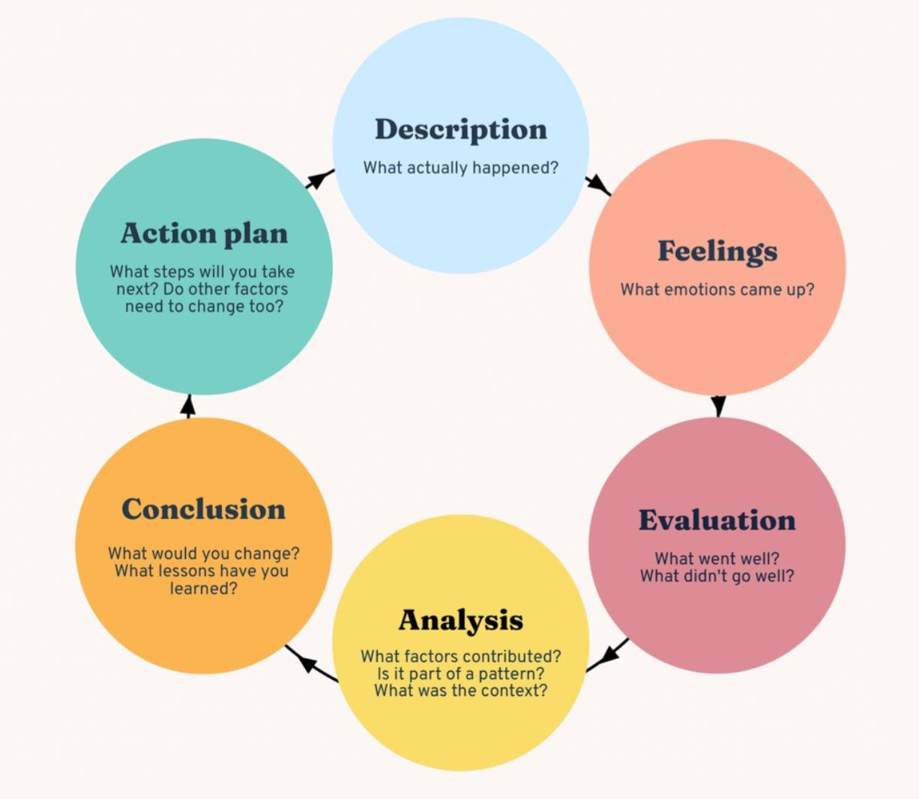
Figure 1: Gibbs Reflective Cycle
Source: ( Adeani et al. 2020)

Analysis
My experience of shadowing the supervisory role in the Food and Beverage Department has highlighted the importance of leadership, adaptability, and communication skills to effectively maintain service standards. According to Hoang et al. (2021), a positive team environment in the restaurant helps the food and beverage supervisor understand the impact of workplace innovation in the future. In a positive working climate, however, employees with highly EI levels can create a highly innovative and supportive contribution to maintain the overall service standards in the industry. Also, Cousin and Weekes (2020) have found that conflict resolution strategies can guide the supervisor to manage overall operations more sustainably eventually. This suggests that better conflict and consumer grievances mitigation stategies can help and F&B supervisor like me to ensure improved consumer satisfaction grades, stronger team dynamics, and enhanced productivity with optimised reputational standards at large. Thus, potential service standards of the hospitality industry can be effectively controlled in the future.

Conclusion
Conclusively, it can be stated that, on the one hand, the shadowing experience of the supervisor has helped me to strengthen my teamwork coordination, and on the other, it has helped me gain problem-solving efficiency over time. Throughout my experience in Delta Marriott Swindon Hotel, I have thus, recognised my grey areas for improvement, thereby managing pressure and conflicting situations more efficiently in the end.

Action Plan
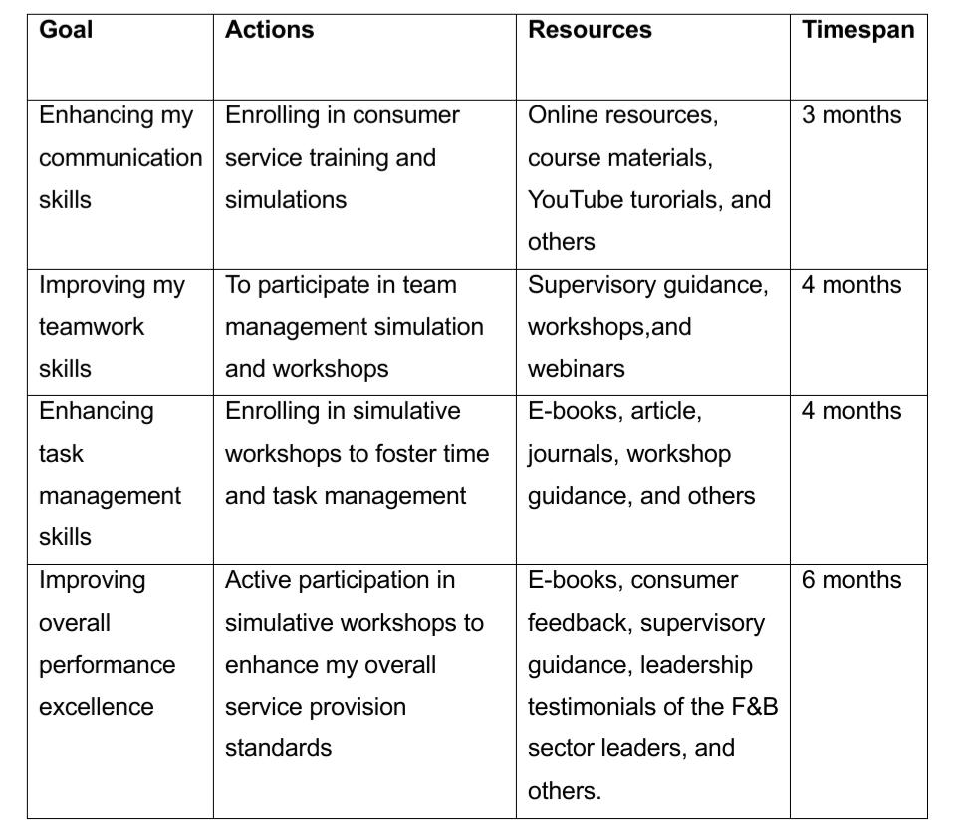

Section 2: Critical Analysis of Work-Based Skills and Tehnical Knowledge
Throughout my shadowing experience in the Food and Beverage industry supervisor, i have observed the relevance of essential work-based skills and technical insights to mainatain high service quality standards and sustainability. To this end, the importance of communication, teamwork, and an initiative-taking mindset with problem-solving and decision-making skills are vivid. These are also highly relevant in fostering operational efficiency and overall productivity standards (Adu et al. 2024). In Delta Marriott Swindon hotel, however, i have found that technical expertise is important to comprehend the relevance of personalised menu items, allergen awareness, and its impact on the overall guest satisfaction standards (Chowdhury et al. 2022). This suggests that proficiency in the technical skills guides the food and beverage supervisor to efficiently manage staff, ensuring operational flexibility, and maximising overall profitability standards of the hotel to a greater extent. To this point, I also have realised the relevance of well-trained staff in addressing the guests' dietary concerns by providing them with a high-end, satisfactory outcome in the end. Apart from this, in the shadowing supervisory role, I have also found the systematic management of the dining table by mainaining proper cleaning and hygiene standards to cater to the clients' tailored expectation levels at large ( Espinosa et al. 2021). I have further noted the technical role of time and task management in the process since it helped the staff to operate efficiently during peak hours with potential teamwork excellence to maintain accuracy and service quality to a significant extent. However, throughout my operational experience, i have understood the importance of emotional intelligence and empathy to understand guests complaints at times (Penco et al. 2021). While serving orders at the table, I was that one of the peers revealed that cold food and delayed deliveries were the actual issues stemming from inadequate staffing and numerous guestes along with many orders coupled with huge product volumes. However, in this situation, the staff directly apologised to the guest by providing another worm dish by following the allergic guidance along providing free drink while waiting( Ali and Aboelmaged, 2020). Thus, the guest satisfaction standard was upscaled, which reinforced the need for client satisfaction standards to a significant extent. Based on my current skills and expertise, there is a need for improved staffing besides order management and organising tasks effectively so that there will be not cold food and delays. Moreover, i also need to upgrade my performance standards as a supervisor in the food and bevarage departament, to optimise my professional growth in the future.
Section 3 : Reflection on Organisational Issues
In my shadowing experience as a food and beverage supervisor in Delta Marriott Swindon Hotel, i have found that the primary problems arises from inadequate staffing together with delayed payment and excessive workloads which result in healthcare worker burnout and operational inefficiency. This results lack of proper communication that escalates staffing problems, time loss, and fatigue, increasing the difficulty of responding to workload problems and producing better outcomes. With this miscommunication amoung staff, the service quality and standards are getting worse, leading to delayed food and room service delivery and frequent servicing errors (Kartini, Adhyatma, and Priliani, 2024). Language barriers also was a prominent issue in dealing with overseas guests, which I have noticed among the staff. According to HBR.org (2023), poor communication in the hospitality industry can disrupt employee coordination to a greater extent, leading to operational bottlenecks and reduced team productivity over time. Therefore, I realised the importance of seamless communication to optimise and maintain the structured communication protocols to a greater extent (Sovacool et al. 2021).
Conclusion
This professional experience in the supervisory F&B role has aided me in gaining valuable, insight into the hospitality industry leadership, teamwork, and guest service excellence to a greater extent. From a supervisory viewpoint, I have also realised the role of the technological expertise of individuals in maintaining overall service quality. Fostering productive guest interaction further has helped me gain long-term sustained connectivity and resilience so that continuous learning and professional development can be fostered. The overall experience can also enable me to work under pressure in the future by mitigating the industry standards. To this end, personal and vocational development are highly impactful to shape my future career goals in the food and beverage industry. While optimising my leadership and teamwork skills can help me master my supervisory roles, it also enhances my capability to manage guests’ expactations as an active listener to their grievances over time. Further, to improve my skills sets, i need to undergo potential customer service training to improve my customer service and communication skills, thereby ensuring my service excellence standards in the future.

References
Adeani, I.S., Febriani, R.B. and Syafryadin, S., 2020. Using GIBBS’ reflective cycle in making reflection of literary analysis. Indonesian EFL Journal, 6(2), pp.139-148.
Adu, I.N., Boakye, K.O., Yeboah, S.and Twumasi, E., 2024. Entrepreneurial leadership and employee performance, the role of innovative work behaviour among employees in the food and bevarage industry. International Hospitality Review.
Ali, I. And Aboelmaged, M.G.S., 2022. Implementation of supply chain 4.0 in the food and beverage industry: perceived drivers and barriers. International Journal of Productivity and Performance Management, 71(4), pp.1426-1443.
Chowdhury, M.T., Sarkar, A., Paul, S.K. and Moktadir, M.A., 2020. A case study on strategies to deal with the impacts of the COVID-19 pandemic in the food and bevarage industry. Operations Management Research, 15(1), pp.166-178.
Cousins, J. And Weekes, S., 2020. Food and bevarage service.Hachette Uk.
Espinosa, R.V., Soto, M., Garcia, M.V and Naranjo, J.E., 2021. Challenges of implementing cleaner production strategies in the food and beverage industry: literature review. Advances and Applications in Computer Science, Electronics, and Industrial Engineering: Proceedings of CSEI 2020, pp.121-133.
HBR.org, 2023. Poor Communication May Be Slowing Down Your Team. Available at: https://hbr.org/2023/10/poor-communication-may-be-slowing-down-your-team [ Accessed on 15th February 2025].
Hoang, G., Wilson-Evered, E., Lockstone-Binney, L. And Luu, T.T., 2021. Empowering leadership in hospitality and tourism management: a systematic literature review. International Journal of Contemporary Hospitality Management, 33(12), pp.4182-4214.
Kartini, L.P., Adhyatma, P. And Priliani, N.L.D., 2024. Enhancing employee performance through strategic training: A study of the food and beverage kitchen department in five-star hotel in Nusa Dua. Journal Syntax Admiration, 5(6), pp.2147-2161.
Penco, L., Serravalle, F., Profumo, G. And Viassone, M., 2021. Mobile augmented reality as an internationalisation tool in the “ Made in Italy” food and beverage industry. Journal of Management and Gouvernance, 25, pp.1179-1209.
Sovacool, B.K., Bazilian, M., Griffiths, S., Kim, J., Foley, A. And Rooney, D., 2021. Decarbonising the food and beverages industry: A critical and systematic review of developments, sociotechnical systems, and policy options. Renewable and Sustainable Energy Reviews, 143, p.110856.
Appendix 1
Action Plan

Goal | Actions | Resources | Timespan
Enhancing my communication skills | Enrolling in consumer service training and simulations | Online resources, course materials, YouTube turorials, and others | 3 months
Improving my teamwork skills | To participate in team management simulation and workshops | Supervisory guidance, workshops,and webinars | 4 months
Enhancing task management skills | Enrolling in simulative workshops to foster time and task management | E-books, article, journals, workshop guidance, and others | 4 months
Improving overall performance excellence | Active participation in simulative workshops to enhance my overall service provision standards | E-books, consumer feedback, supervisory guidance, leadership testimonials of the F&B sector leaders, and others. | 6 months

I confirm that I have not used any AI tools in the research and creation of this assignment. I confirm that I have not presented any AI generated materials as my own work. I confirm I have copies of my drafts, notes, and other resources I used, which I may be asked to provide in evidence.

