Designing a tanker propeller
Structural and fluid analysis
Daniel Edwin Thomas (2114618)
2022
Contents
Task1 2
Task 2 5
Task 3 - 6
Task 4 9
Task 5 11
References 12

Task1
Reynolds number is a ratio of inertial forces and viscous forces. It is dimensionless coefficient of the resistance to flow. Reynolds number is used to determine whether a viscous flow is either laminar or turbulent. The equation for Reynolds number is seen below.
$$Re = \frac{Inertial Forces}{Viscous Forces}$$
If the inertial forces are dominant compared to viscous forces, then the flow can be described as turbulent. If viscous forces are dominant, then the flow can be described as laminar. A low Reynolds number of ranges from 0 – 2000 can be described as laminar flow. Reynolds number of 4000 and greater is described as turbulent. A Reynolds flow of 2000-4000 is described as transitional flow.
Reynolds number describes the flow for both external and internal flow. With internal flow the Reynolds number is affected by the frictional losses due to the pipe roughness. The larger the relative roughness the more energy loses there are and the more turbulent the flow is. The Moody chart is a useful chart to predict the type of flow through pipes depending on the friction factor and relative pipe roughness. Below is an example of the Moody chart.
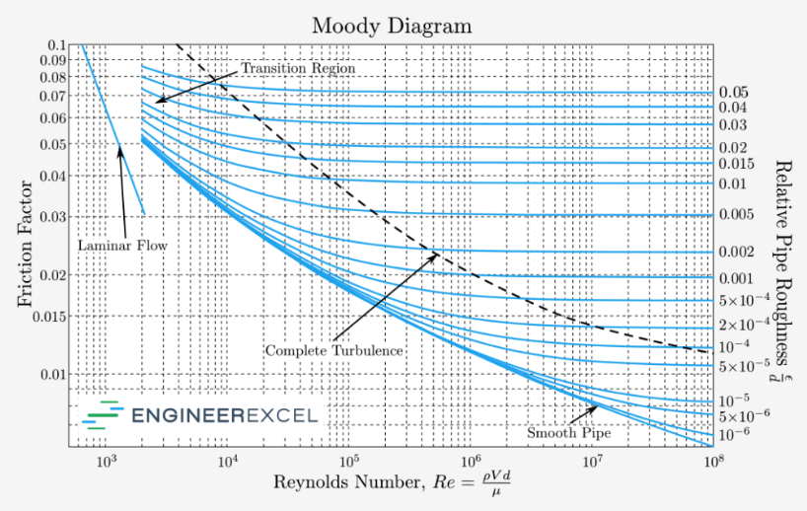
Figure 1

External flow is a flow with no direct boundaries such as a ship’s propeller. Reynolds number describes the flow around a stationary surface where the boundary layer is the area where the velocity of the fluid is zero close to the object and then increases to the same velocity as the average fluid velocity. Below is a diagram that shows the change in flow over a flat plate. The longer the flat plate the more turbulent flow will be seen.
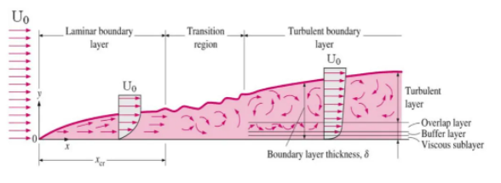
Figure 2
Reynolds number is especially important to consider when designing a component or assembly that needs to be efficient. It helps engineers and designers to analyse the system performance and understand the problems that the different flows will cause.
Different fluid flows around the propeller will affect the performance of the propeller. A laminar flow would be seen near the leading edge of the propeller that then transitions to turbulent towards the back the blade. A more laminar flow around the blades increases the performance and lowers the risk of cavitation. Excess cavitation can cause damage to the propellers, again creating the flow to be more turbulent and the propeller to become less efficient. Due to the size of the ships these days, designers need to make sure the propellers are as efficient as possible to reduce fuel consumption.
The ship's hull also affects the fluid flow, the hull further forward of the propeller creates a wake and causes the flow to be turbulent. This turbulent flow then effects the performance of the propeller, the more the flow is turbulent the less efficient the propeller will be.
From researching Reynolds number and ship propellors, the following equation can be used to estimate the Reynolds number for the propellor.

$Reynolds number = \frac{ρVrL}{μ}$
Where:
$ρ$- Density of the fluid
Vr – local velocity
L – Chord length of 1 blade
$μ$ - Dynamic viscosity of fluid

To calculate the local velocity the following equation is used:
$$Vr =\sqrt{Va^{2}+{\left(LΠnD\right)}^{2}}$$
Where:
Va – Inflow velocity of fluid
L – Chord length of 1 blade
N – Propellor RPM
D – Propellor diameter
From online research the typical rpm for a ship propeller of this size would be a maximum of 300 rpm and minimum of 80 rpm, thus 150 rpm will be used. Also, from research a ship of this size would have a typical velocity of 10.5m/s. Propellor diameter and chord length is given, however there is no dimension for hub diameter. Diameter will be calculated by doubling the radius of 1 blade.
$$Vr = \sqrt{{10.5}^{2}+\left(2.98xΠx{5.96}^{2}\right)}$$
$$Vr = 56.78$$
So,
$$Reynolds Number = \frac{1025×56.78×2.98}{1.1189×{10}^{-3}}$$
$$Reynolds Number = 155004477.6$$
$$Reynolds Number = 155.004 ×{10}^{6}$$
The Reynolds number calculated indicates that the flow of fluid around this propeller is turbulent.

Task 2
Boundary flow is a layer of fluid close to the surface of an object which has zero velocity. Further away from the object and towards the free flow area, the flow steadily increases to the average velocity of the fluid. Below shows the boundary over a curved surface.
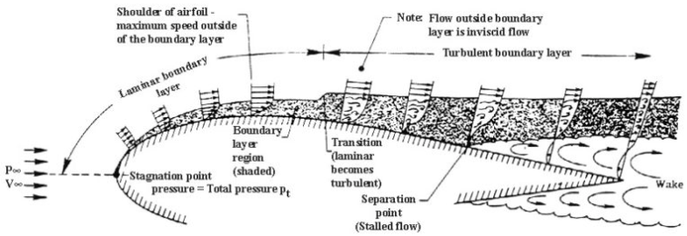
Figure 3
Figure 3 is a cross section of an aerofoil, but ships propellers’ cross section is also very similar and behave in a similar way.
The leading tip of the propeller is the stagnation point. The side closest to the ship’s hull is the low-pressure side. On the low-pressure side, the boundary layer is large and laminar that allows the pressure drop and the fluid is pass over quickly. At the separation point the two pressures of fluid start to combine and cause a turbulent flow. As can be seen above the separation point is where the boundary layer has separated from the object. The separation of the boundary fluid is key to the efficiency of a propeller. The earlier the separation point, the more drag is felt on the propeller and the less lift produced.
Ship propellers are designed in such a way to delay separation as much as possible. This will increase efficiency but also reduce the amount of cavitation experienced. The ships propeller is also twisted the further away it gets from the point of rotation. This is done to make sure that the flow conditions are similar across the radius of the blade.
The curve on the propeller also allows the angle of attack to be reduced. In propeller design the less the angle of attack, the more lift is generated. The curve in the propeller will also delay the separation point and delay the transition of laminar flow to turbulent flow.
The propeller is also designed in a way that there is a very large flat area. This can be seen in figure 7. The large area increases the area of the boundary layer, again increasing lift. As can be seen in figure 7, the large flat area is where the most high- and low-pressure areas can be seen, highlighted in red and blue. The large area allows for a large amount of fluid to be moved.
The image in figure 8 shows the damage that can be sustained due to cavitation. If the curve of the propeller is too sharp towards the tip of the blade this can cause cavitation due to the sudden pressure change.
Propeller design is a compromise between many factors, but delaying the separation point and turbulence will increase the efficiency of the propeller.

Task 3 -
If the ship’s propeller were to be made from carbon fibre reinforced plastic or CFRP, then careful consideration of the design of the propeller would be required. CFRP is a strong, lightweight and corrosion resistant material that has many uses in industries such as aerospace and in the wind turbine industry.
Traditional propellors are made of a corrosion resistant metal such as bronze, aluminium alloys and stainless steel. These are hard wearing and strong but are heavy.
If this propeller were to be made of CFRP then the design would need to compensate for the flexing that would occur. Under load a CFRP propellor will flex and alter the pitch of each blade. The pitch would reduce and decrease the output of the propellor. This could be used in the manufacturers advantage by limiting stress on the propulsion and limiting damage.
The use of CFRP propellers would need the propeller to be a larger diameter than the original. This may be a constraint on some older ships and designs if the CFRP propeller was to be retro fitted. It could be overcome by reducing the size, but then the output and efficiency of the propeller would be compromised.
Other constraints that might affect the use of CFRP is the ISO standards that need to be met. ISO standards 484-2 2015(Shipbuilding, Ship screw propellers) outline the tolerance of key areas of the propellers such as pitch, rake, axial position, blade length etc. With the flexing of the CFRP it might mean that underload the propeller would be a different classification as when it was manufactured. ISO standards may need to be updated to incorporate the characteristics of CFRP propellers.
Key developments have already been made to produce CFRP propellers. A company called Nakashima Propeller Company have been researching and testing these propellers since 2007. In 2014 the company installed a CFRP main propeller to a 499 G/T class ship for real world testing. Below is a table showing the key differences between the original propeller and the one made from CFRP.
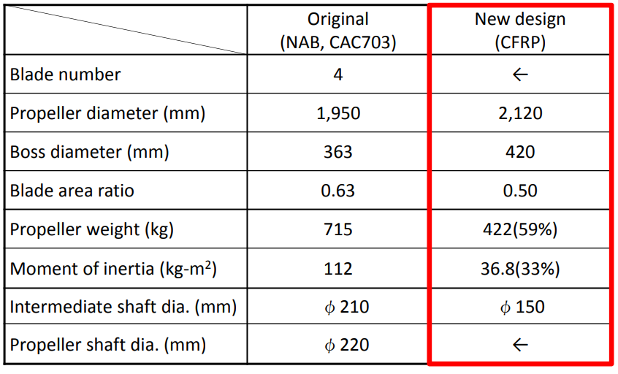
Figure 4
As can be seen here the new propeller is larger in diameters but is 59% lighter. The propeller was fitted, and sea trials carried out, below is the results from the testing period.
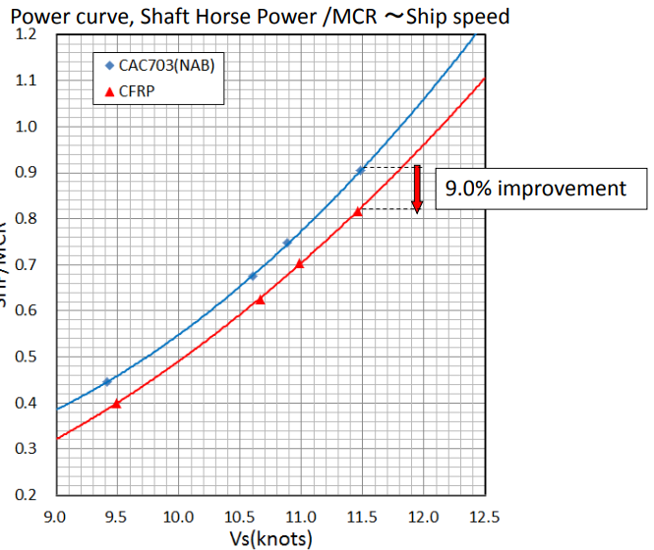
Figure 5
As can be seen here, the new propeller achieved the same speed, 11.5 knots, using 9% less engine power, thus saving on fuel. From the trials it was also noted the propeller was more stable, less vibration and quieter.

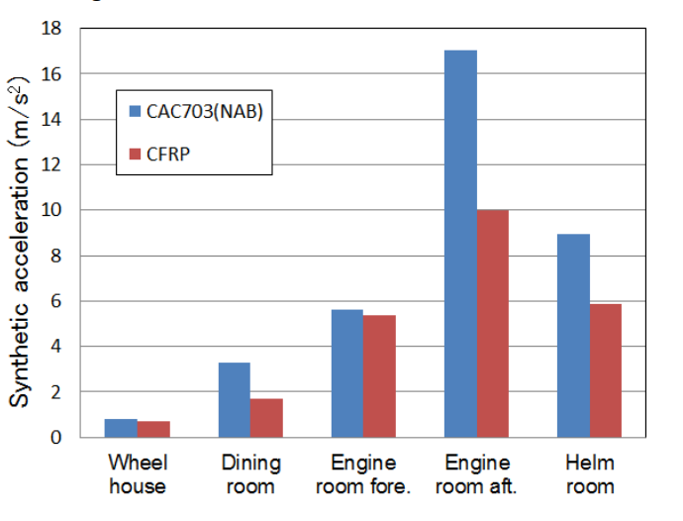
Figure 6
There is currently ongoing research and development into the use of CFRP propellers used for both thrusters and main drive. There are clear advantages to using CFRP over traditional materials. Currently the major drawback to CFRP is the cost of the material and manufacturing of this as it is currently a new process. International standards will also need to be revised to incorporate such developments in propellers.

Task 4
Typically, computation fluid dynamics or CFD, is used to model the fluid flow and performance of a design for a propeller. CFD is a set of programs that is used to simulate fluid flow around any object. The results from CFD can be analysed by engineers to adapt designs until they are happy with the results. CFD on new designs would be carried out first before any real-world modelling.
First, a 3D model of the propeller system would be made using CAD software such as Autodesk Inventor. The 3D model would be made to the exact dimension. Once complete the model would then be set up in the CFD software. In the software a mesh of the components would be created, then boundary conditions would be applied, a solver set up and then the solver ran. Once complete the CFD software would then display the results in any way that the engineers desire. Below is an example of a CFD result for a ship’s propeller.
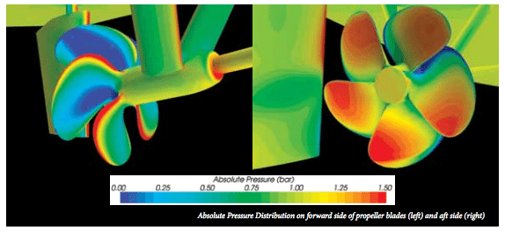
Figure 7
This example shows the low pressure (blue) and high pressure (red) areas on the propeller. This example shows that this design has a flaw that would reduce the performance. The leading edge of the propellor on the left picture shows an area of high pressure on the low-pressure side of the propeller. The same can be seen in the other picture where an area of low pressure is on the tip of the blade on the high-pressure side. This reduces the performance of the propeller.
Using CFD first before manufacturing any test specimens means that any flaws in the design can be adjusted, avoiding costly mistakes. It helps keep the cost of research and development down.
CFD is an accurate software when set up correctly. Figure 8 shows damage sustained by a propeller due to cavitation. Modelling the same propeller in CFD and carrying out the cavitation test, CFD predicted the area where cavitation is to be seen. This shows how accurate the software is and compares well with real world data.
However, CFD is only as accurate as the data it is given to perform the test. If an inexperienced engineer uses CFD and does not set up the software correctly it could mean the results would not be accurate. It could result in resource being spent manufacturing and testing a model that will not perform as well as a the CFD model.
CFD is also an expensive product to implement into an organisation. The software costs are large, and the company would also need to spend money on PC equipment that can run the software efficiently. There are also costs such as hiring experienced CFD engineers to set up and use the software or training for current engineers in the company. The money spent on implementing CFD into a company is large but would be recovered after a few years, with cost savings on time in research and development of products such as a ships propeller.
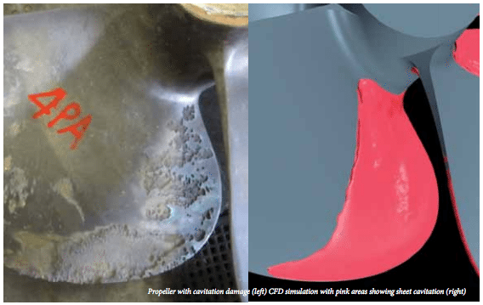
Figure 8
After CFD is complete then the designed propeller can be manufactured in small scale. Scaled tests can then be completed to see if the CFD results match real world testing. The testing is carried out in ship model basins, there are a few around the world. Here tests are completed on ship designs before they are manufactured. They allow designers to refine the design of the ship, and test again without major expense. It is also an opportunity to check that results in CFD compared to small scale tests.
These are expensive to hire out for testing and a company needs to ensure they are well organised before going. Real world events can also hinder development such as COVID19. The impact of COVID 19 meant many companies could not continue development of products, and due to government restrictions, companies could not go to these sites.
Scale testing does not fully represent the results, as in the case of the Reynolds number, if a 2:1 scale is used then the Reynolds number will have been reduced dramatically, to counter act this the speed of fluid flow will need to be doubled.
Once modelled testing is complete then 1:1 scale testing can be completed. The propeller is manufactured to the correct size and material. Tests can be completed on test rigs to ensure the CFD and modelled testing results are similar. After testing on rigs then real-world testing can be completed. A suitable ship is selected, and the new propeller retro fitted to the ship. Sensors in many areas of the ship measure the performance of the new propeller.
Real world testing is the best type when looking at the data results, but it is costly. A full-size propeller manufactured in bronze for a large ship can costs hundreds of thousands. The cost of installing the propeller to the ship is also costly and design companies need to find a shipping company that is willing to install the new propeller to their ships.
Real world data gives the best data as it can be analysed over many months or years. Engine efficiency, noise, vibration, and wear can all be recorded. Testing in real world allows for data to be collected in both turbulent and calm seas and in different density of water around the world.

Task 5
Laboratory testing of the propeller is carried out after CFD simulation to compare the results before going ahead and testing in real world.
I believe that the experiment should be carried out through scaled modelling to compare the results from CFD. The experiment should be carried out in a ship basin test facility where the conditions of the water can be controlled, and the density of the water correctly modelled to real world conditions. The first few tests should be completed as ‘open water’ tests, where the flow of water is uniform.
First, the experiment should be carried out with just the propeller using the ‘paint test’ technique as discussed above. With the correct seal conditions the paint will be used to visually see the flow of fluid around the propeller. Once the test is complete the propeller can be removed from the water and the paint examined. This method, the engineers would be able to see if the high/low pressure of the design correlates to CFD.
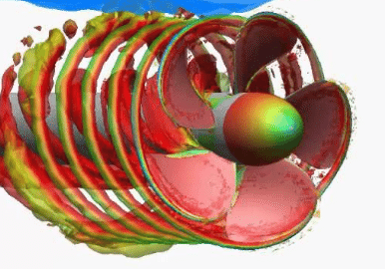
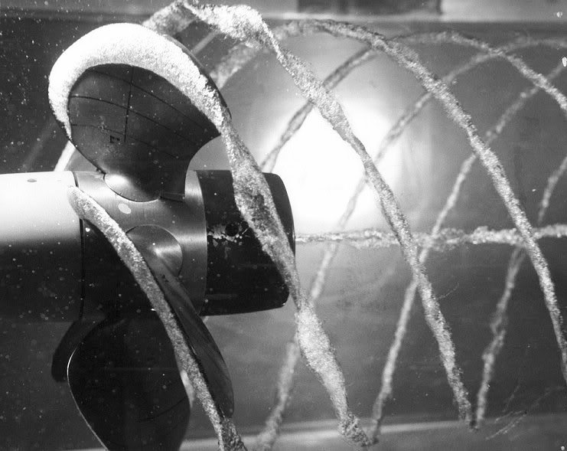
Cavitation should also be tested. This can be done by using a model propeller in a test bath with a camera in locations around the propeller to visually record the wake and cavitation around the blades. With the propeller spinning at designed RPM then the cameras can capture images such as the ones seen below.
Figure 10
Figure 9

These images of cavitation can be compared to CFD analysis, as can be seen above. These results can be visually compared to each other.
The performance of the propeller could also be measured by calculating the thrust the propeller produces at different speeds. This could be done by measuring the linear force the propeller produces on the frame that is holding it in the tank. Load cells can be used to measure this force. This test should be done in different sea conditions and different RPM. The torque of the propeller can be measured and thrust calculated through use of sensors measuring fluid flow and torque.
All these results can be organised graphically to easily be compared with the CFD results.
For testing to be accurate then the model of the propeller should be mounted onto the type of ship it will be used with. Due to the ship's hull creating a wake of turbulent fluid, then the tests will need to be carried out to see the effects of this on the propeller design. The same tests can be carried out as discussed above.

References
Research Gate.2022. [online] Available at: <https://www.researchgate.net/post/Can_you_simulate_in_CFD_flow_around_propeller_with_high_precision> [Accessed 3 June 2022].
Wartsila.2022. [online] Available at: <https://www.wartsila.com/encyclopedia/term/model-tests> [Accessed 2 June 2022].
Classnk.or.jp. 2022. [online] Available at: <https://www.classnk.or.jp/classnk-rd/assets/pdf/katsudou201511_D.pdf> [Accessed 5 June 2022].
Cmst.curtin.edu.au. 2022. [online] Available at: <https://cmst.curtin.edu.au/wp-content/uploads/sites/4/2016/05/colley_eamonn_2012_analysis_of_flow.pdf> [Accessed 1 June 2022].
EngineerExcel. 2022. Moody Chart Calculator - EngineerExcel. [online] Available at: <https://engineerexcel.com/moody-chart-calculator/> [Accessed 1 June 2022].
gCaptain. 2022. Propeller Cavitation Analysis with Computational Fluid Dynamics. [online] Available at: <https://gcaptain.com/propeller-cavitation-analysis/> [Accessed 1 June 2022].
Nuclear Power. 2022. Reynolds Number | Definition, Calculation & Examples | nuclear-power.com. [online] Available at: <https://www.nuclear-power.com/nuclear-engineering/fluid-dynamics/reynolds-number/> [Accessed 1 June 2022].
Ship Technology. 2022. ClassNK and Nakashima install carbon fibre reinforced plastic propeller. [online] Available at: <https://www.ship-technology.com/uncategorised/newsclassnk-and-nakashima-install-carbon-fibre-reinforced-plastic-propeller-4358401/> [Accessed 1 June 2022].
The Shipyard. 2022. Propeller Cavitation Explained | The Shipyard. [online] Available at: <https://www.theshipyardblog.com/propeller-cavitation-explained/> [Accessed 1 June 2022].
Web.mit.edu. 2022. [online] Available at: <http://web.mit.edu/2.016/www/handouts/2005Reading10.pdf> [Accessed 2 June 2022].
Aerospace Engineering Blog. 2022. Boundary Layer Separation and Pressure Drag – Aerospace Engineering Blog. [online] Available at: <https://aerospaceengineeringblog.com/boundary-layer-separation-and-pressure-drag/> [Accessed 1 June 2022].
En.wikipedia.org. 2022. Marine propulsion - Wikipedia. [online] Available at: <https://en.wikipedia.org/wiki/Marine_propulsion#:~:text=Some%20very%20long%20stroke%20engines,the%20range%20300%E2%80%931000%20rpm.> [Accessed 3 June 2022].
2022. A simple method for estimating transition locations on blade surface of model propellers to be used for calculating viscous force. [ebook] Available at: <https://www.sciencedirect.com/science/article/pii/S2092678217301590> [Accessed 1 June 2022].
2022. Propeller RPM. [ebook] Available at: <https://www.sciencedirect.com/topics/engineering/propeller-rpm> [Accessed 1 June 2022].
Li, D., 2022. Open AccessArticle Transitional Flow on Model Propellers and Their Influence on Relative Rotative Efficiency. [ebook] Available at: <https://www.mdpi.com/2077-1312/7/12/427/htm> [Accessed 1 June 2022].

