Dissertation
Dissertation
DissDdiserrrg
Vanya Dragneva Student Number- 2010312

BA (Hons) Business Management
University of Wales Trinity Saint David (London Campus)
Lecturer ‘s Name-Anupam Mazumdar
Modul -LCBB6000

AN EVALUATION OF THE ROLE OF TRAINING AND DEVELOPMENT IN ENHANCING EMPLOYEE RETENTION IN THE WORKPLACE IN THE UK.

Declaration

I, Vanya Dragneva
declare that the work presented is my own and has been generated by me as the result of my own original research of:
An evaluation of the role of training and development in enhancing an employee retention in the workplace the UK.
I confirm that:
1. This Dissertation was done in candidature for the degree at the University of Wales Trinity San David.
2. Where I have quoted from the work of others, the source is always given. Apart from quotations, this is entirely my own work.
3. I have acknowledged all main sources of help.

Signed:

Date: 31/08/2023

Abstract

As a researcher with broad enthusiasm and personal involvement in five-star hotels in London, I conducted this work to examine the importance of the role of training and development in enhancing employee retention in the UK hospitality sector.
This study aims to address, evaluate, and remedy the information gap that has existed over this topic for the past five years in UK hospitality.
The importance of the conducted investigation is to recognise the gap between the existing study in the area before Covid-19 and Brexit, which have had an impact on Hospitality across the UK and after that. Consequently, the research was conducted online as the target population was 90-120 employees contributing in four-and five -stars hotels in London.
The findings strongly follow the existing literature that training and development in UK Hospitality is essential, necessary, and effective for providing not only the best customer experience possible but also for increasing personal career potential and further development as well as decreasing turnover. Further recommendations and suggestions are provided for increasing the research finding process.

Acknowledgements

I would like to express my very great gratitude for this research work to my lecturer, supervisor at the UWTSD and everyone who agreed to take part in the conducted survey.
Without their consistent support, incentive, and guidance I would not have been able to accomplish it and therefore I am deeply thankful to them.

Table of contents
Chapter 1: Introduction
1.1: Introduction ……………………………………………………………………p. 4
1.2: Background of the study………………………………………………….p. 5
1.3: Problem Statement………………………………………………………….p. 7
1.4: Aims, Objectives, Research Questions……………………………..p. 8
1.5: Rationale/Importance of the Research…………………………….p. 8
1.6: Methodology……………………………………………………………………p. 9
1.7: Scope of the Study……………………………………………………………p. 9
1.8: Summary of Chapter 1……………………………………………………..p. 9

Chapter 2: Literature Review
2.1: Introduction……………………………………………………………………..p. 9
2.2: Theoretical Frameworks and Related Research issues….…..p. 10
2.3: Gaps identified to situate own research……………………………p. 16
2.4: Summary of Chapter 2………………………………………………………p. 16

Chapter 3: Research Methods & Methodologies
3.1: Introduction…………………………………………………………………………p. 16
3.2: Philosophical position of the research and why……………………p. 16
3.3: Paradigm position of the research and why………………………….p. 17
3.4: Position of Research Approach and why……………………………...p. 17
3.5: Methodological stance of the Research and why………………….p. 17
3.6: Stance of the Research Strategy and Design and why………..…p. 17
3.7: Research Sample and Population………………………………….……..p. 17
3.8: Data Collection and Data Analysis Tools/Techniques…….……..p. 18
3.9: Ethical Consideration of the Research…………………………….……p. 18
3.10: Summary of Chapter 3…………………………………………….…………p. 18

Chapter 4: Data Analysis and Discussions
4.1: Introduction………………………………………………………………………..p. 19
4.2: Analysis and Discussions of the findings/data……………………..p. 19
4.3: Summary of Chapter 4………………………………………………………..p. 31

Chapter 5: Conclusions, Limitations &Recommendations
5.1: Introduction…………………………………………………………………………p. 31
5.2: Conclusions on each research issue/objectives/proposition
5.3: Conclusions on the research problem………………………………….p. 32
5.4: Limitations of the Research………………………………………………….p. 32
5.5: Recommendations……………………………………………………………….p. 32
5.6: Summary of Chapter 5………………………………………………….………p. 33
6. References………………………………………………………………………………p. 34
7. Appendix…………………………………………………………………………………p. 40

List of Tables

Table 1: Research Method………………………………………………………….p. 16
Table 2:The most effective training received according to participants………………………………………………………………………..……..p. 24

List of Figures

Figure 1: Travel & Tourism Forecast (2020-2032) ……………………….p. 7
Figure 2: United Kingdom hotels & motels industry value (2016-2021)………………………………………………………………………………………….p. 10
Figure 3: Training and Development program's benefits…………….p. 12
Figure 4: Maslow theory representation…………………………………….p. 13
Figure 5: Employee Retention Practises Through Motivation Theories……………………………………………………………………………………..p. 14
Figure 6: Factors Enhancing the Employee Retention……………….p. 15
Figure 7: Participants' age…………………………………………………………..p. 20
Figure8: Nationality of the participants………………………………….…p. 20
Figure 9: Participants' current role………………………………………….….p. 21
Figure 10: Participants' length of service……………………………..….….p. 21
Figure 11: Participants plans for service……………………………………..p. 22
Figure 12: Participants' answers about training programmes……..p. 22
Figure 13: Participants' answers to performance………………………..p. 23
Figure 14: Received training programmes…………………….…………….p. 23
Figure 15: Employee turnover rates 2014-2016 in the UK ….………p. 24
Figure 16: Participant answer on training effectiveness .…………..p. 25
Figure 17: Participants answer about the link training between and development……………………………………………………………………………...p. 25
Figure 18: Participant answers about professional development..p. 26
Figure 19: Employee turnover CIPD…………………………………………….p. 27
Figure 20: Employee turnover in various industries CIPD…………….p. 27
Figure 21: Participant answers over the career goals……………….…p. 28
Figure 22: Participants answer about the rewards……………….….….p. 28
Figure 23: Participant answers about employee retention……..…..p. 29
Figure 24: Participant answers about the impact of Brexit……..…..p. 29
Figure 25: Industries predicted to reopen after the lockdown in the UK……………………………………………………………………………………………...p. 30

Chapter 1: Introduction
1.1: Introduction
In the fast-paced and customer-centric world of the Hospitality sector in the UK, employee retention has emerged as a critical challenge. With a constant influx of competitors and evolving consumer expectations, businesses are recognizing the strategic importance of cultivating a stable and skilled workforce. In this context, the role of training and development has gained prominence as a key factor in enhancing employee retention and fostering long-term loyalty within the sector stated by Agarwal, P.K. & Naidu, Mr. (2021).
The Hospitality industry, encompassing hotels, restaurants, catering services, and leisure facilities, heavily relies on its workforce to deliver exceptional guest experiences. According to GOV UK (2021), the hotel industry consists of 143,000 companies, and around 1.8 million people are employed as it is contributing to the economy with £40.4 billion in 2019, performing a crucial social role, creating occupations, and enhancing the economy. However, the transient nature of the industry can lead to high turnover rates, resulting in increased recruitment and training costs, disruption to service quality, and reduced employee morale. It is here that effective training and development programs have the potential to be transformative.
Training initiatives in the Hospitality industry go beyond simply teaching the necessary skills to perform job tasks. A well-crafted training program also focuses on nurturing a strong service culture, instilling core values, and promoting a sense of belonging among employees. As staff members develop a deep understanding of the company's mission and values, they can feel connected to their roles and the organization as a whole.
Moreover, ongoing professional development opportunities create a sense of growth and progression, incentivizing employees to invest in their careers within the company. By providing avenues for advancement, such as leadership training or cross-functional skill development, organizations can demonstrate a commitment to nurturing internal talent and valuing their employees' potential.
The outcomes of comprehensive training and development extend beyond staff retention and contribute to a positive work environment. Well-trained employees are equipped to handle challenging situations with confidence, resulting in improved service quality and customer satisfaction. A workforce that feels supported and invested in is also more likely to display higher rates of job satisfaction, leading to increased productivity and reduced absenteeism noted by Jaiswal et al., (2021).
This study will explore the multifaceted impact of training and development on employee retention within the UK Hospitality industry. It will delve into, explore and analyse the various training strategies and programs implemented by leading organizations, examining their effectiveness in fostering employee loyalty and sustaining competitive advantages. By shedding light on the significance of investing in employee growth, the researcher seeks to critically evaluate the critical role that training and development play in ensuring the long-term success of the vibrant and dynamic Hospitality sector in the UK.

1.2: Background of the study
The study of training and development to improve employee retention in the UK hospitality industry is motivated by the growing awareness of the sector's particular difficulties and the need to effectively address them. The Hospitality industry, characterized by its dynamic nature and high customer interaction, has long grappled with high turnover rates, creating an urgent demand for effective solutions. The following factors contribute to the significance of studying the role of training and development in improving employee retention in the UK's Hospitality industry:
High Turnover Rates: The Logging industry has historically faced turnover rates significantly higher than other sectors states Narkhede P. (2014). The transient nature of many roles, coupled with long working hours and seasonality, often results in employees seeking opportunities elsewhere. This constant turnover leads to a costly cycle of recruitment, training, and onboarding.
Impact on Service Quality: In a sector where customer satisfaction is paramount, employee turnover can negatively impact service noted by G. Nair (2016). Frequent staff changes can result in inconsistencies in service delivery, leading to customer dissatisfaction and potentially tarnishing the brand's reputation.
Training's Role in Skill Enhancement: Hospitality roles require a diverse range of skills, including customer service, communication, problem-solving, and adaptability. Proper training equips employees with the necessary skills to excel in their roles, boosting their confidence and job satisfaction noted by T. Baum (2002)
Retention as a Competitive Advantage: As the Hospitality industry becomes increasingly competitive, organizations are realizing that retaining skilled and experienced employees can provide a distinct competitive advantage. Loyal employees who understand the company's culture and values contribute to a consistent and high-quality guest experience stated by Ghani et al. (2022).
Changing Employee Expectations: Modern employees, especially younger generations, seek more than just a paycheck from their jobs. They value opportunities for growth, learning, and career advancement noted by S. Brooke (2023). Effective training and development programs align with these expectations, making employees more likely to stay with an organization.
Evolving Workforce Demographics: The UK's Hospitality industry employs a diverse workforce, ranging from entry-level staff to experienced professionals according to Hospitality and Tourism Workforce Landscape (2019). Tailoring training programs to supply
the needs and targets of this diverse demographic can enhance employee engagement and retention.
Industry-Specific Challenges: The nature of the Hospitality industry, which includes unbalanced hours, physically demanding work, and challenging customer interactions, can lead to burnout and dissatisfaction among employees. Proper training can equip employees to handle these challenges effectively, improving their overall job satisfaction. Also, a crucial part of these challenges is the recovery process after COVID-19 when the Hospitality industry was severely hit GOV.UK (2021) and the impact of Brexit.
The study of training and development's impact on employee retention in the UK's Hospitality industry seeks to explore how strategic training initiatives can address these challenges. By examining successful training programs, identifying best practices, and considering the factors that contribute to employee loyalty, researchers aim to provide valuable insights for organizations striving to retain a skilled and motivated workforce. Ultimately, this research contributes to the ongoing efforts to strengthen the industry's human resource practices, elevate service quality, and sustainably enhance employee retention rates in this growing industry.
Figure 1: Travel & Tourism Forecast (2020-2032)
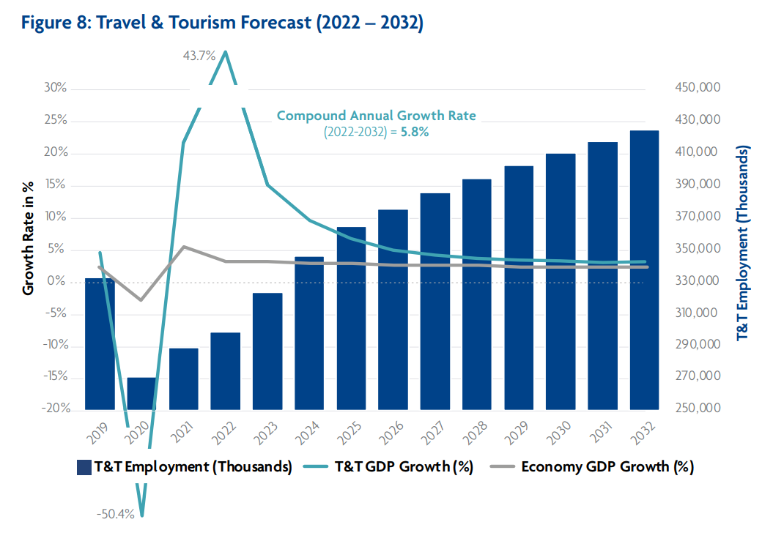Source: World Travel & Tourism Council, Travel & Tourism Economic Impact (2022)
1.3: Problem Statement
The Hospitality industry in the United Kingdom encounters a persistent confrontation of a high turnover rate, posing a significant obstacle to organizational stability and service quality. Despite the industry's detection of the vital role that training and development can play in enhancing employee retention, there remains a gap in understanding how to design and implement effective strategies that address this issue. This gap is evident in the continued prevalence of turnover rates, which disrupt operations, inflate recruitment costs, and hinder the creation of a consistent and skilled workforce.
Despite the availability of training programs, there is a lack of comprehensive investigation that assesses the direct correlation between training and development initiatives and their impact on employee preservation in the UK's Hospitality sector. While organizations invest resources in training, there is often uncertainty about which specific training methods, content, and delivery approaches are most effective in fostering long-term employee loyalty.
Furthermore, the unique characteristics of the Hospitality industry, such as its demanding work environment, seasonality, and diverse workforce demographics, necessitate tailored training solutions. Existing literature falls short in providing industry-specific insights that address these challenges in the context of employee retention noted by The Guardian (2022).
The absence of a clear understanding of how training and development efforts influence employee retention within the UK's Hospitality industry presents a critical problem. Organizations require evidence-based guidance to develop strategic training initiatives that not only enhance employees' skills but also foster a sense of belonging, growth, and alignment with the company's values. Addressing this problem is essential to sustainably improving employee retention rates, elevating service quality, and promoting the overall success of the Hospitality sector in the UK.
By examining the connection between training and development programmes and staff retention in the UK hospitality industry, this study intends to close the knowledge gap currently present in the field. By studying effective case studies, establishing best practices, and comprehending the elements that affect employee loyalty, this research seeks to provide actionable insights that guide organizations toward effective training strategies capable of bolstering retention rates and ensuring a competitive advantage in a challenging industry landscape.
1.4: Aims, Objectives, Research Questions
The purpose of this study is to address, evaluate, and remedy the information gap that has existed over this topic for the past five years in UK hospitality. As a result, The Guardian (2022) noted that the post-Brexit period had a significant impact on the workers in this sector.
The evaluation and comprehension of the scope of training and development's function in the UK hospitality industry is the intended goal of this work.
The following are the proposal's goals:
1) To talk about the function of training programmes in the logging industry
2) Examine the industry's potential for staff growth and training.
3) To investigate the extent and significance of staff retention in the UK hospitality sector
The focus of this study is on the research questions listed below to achieve that goal:
1) What elements influence employee growth and training in the hospitality industry?
2) What are the features and scope of coaching programmes offered in the UK hospitality industry?
1.5: Rationale/Importance of the Research
The importance of the conducted research is to identify the gap between the existing study in the area before Covid-19 and Brexit, which have had an impact on Hospitality across the UK and after that.
1.6: Methodology
The research methodology will be quantitative, conducting a questionnaire with 25 items, whereas the LIKERT scale will be implemented. Will be used also the simple random method as the way of interpreting the data will be descriptive.
1.7: Scope of the Study
The score of this research is limited to the UK, however many of the target groups for conducting the survey are from various nationalities in size of 90-120. The scope includes employees working in four- and five-star hotels in London.
1.8: Summary of Chapter 1
The introduction explores the crucial role of training and development in addressing high turnover rates within the UK's Hospitality industry. Acknowledging the challenges posed by a transient workforce and the impact on service quality, the introduction emphasizes the strategic importance of effective training programs. It highlights that training goes beyond skills acquisition, aiming to instil a strong service culture and sense of belonging among employees. The introduction underscores the benefits of ongoing professional development, emphasizing career progression and increased job satisfaction. By delving into the multifaceted effect of training on employee withholding, the study aims to shed light on the significance of investing in employee growth for the long-term success of Hospitality in the UK.

Chapter 2: Literature Review
2.1: Introduction
In every business, an organization's accomplishment is strongly dependent on its labour force. As a result, the UK hospitality industry should take steps to retain devoted, driven, and skilled workers while also addressing the demands of its workforce and promoting chances for lifelong learning.
A career development plan should be used in conjunction with well-planned and methodically applied approaches to ensure that training and development are effective. Consequently, this study aims to assess how training and development have an impact on employee performance and relative retention in hospitality, which is contributing more than $ 50 billion of economic value in the UK and has a high industry growth.

Figure 2: United Kingdom hotels & motels industry value (2016-2021)
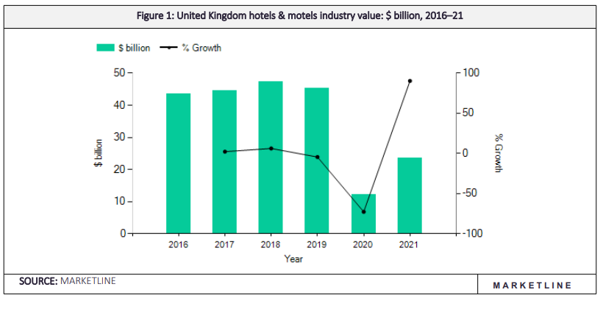
Source: Market Line (2023)
2.2: Theoretical frameworks/models, and related research issues

Training and development
According to Goldstein and Ford (2002) and O'Herron and Simonsen (1995), training is a fitted tactic for learning and development that increases the efficiency of individuals, groups, and organisations. Development refers to the successes that result in the achievement of new knowledge and skills for an employee's personal development. (1999, Garger)
An efficient staff training program, according to Mel Kleiman (2000), is based on the employees' operational skills, managerial competencies, and orientation. These concepts serve as the cornerstone of any program for staff development.
As noted by Janet Kottke (1999), employee development programmes should include vital skills and the right organisational structure to help organisations grow their enterprises.
A training and development programme is a carefully thought-out educational component that uses excellent techniques to share the organisational culture. It moves from teaching job-related abilities to teaching business abilities, while also encouraging managing, innovative solutions, and creativity (Meister, 1998).
Worker improvement is guaranteed by a selection of teaching techniques, schedules, and reassuring learning settings in employee development programmes (Gerbamn 2000, Kottke 1999, Rosenwald 2000).

Training and development are the piloting forces to progress Human Capital within hospitality only if it is identified as an asset rather than a cost (Namasivayan & Denizci, 2006). In addition, hospitality organizations will recognize workers as the most valuable commodity and inspire a philosophy of preparation and learning. This will encourage positive individual and organisational results by developing and enhancing the workforce's knowledge, skills, and abilities (Young et al., 2005). Such findings would also extend to mid-level hospitality workers viewed as non-complex employment, which need lower rates of human resources relative to other industries (Sturman, 2001).

However, the hospitality industry is considered to have low rates of expenditure on human resources, indicating a shortage of preparation learning and growth initiatives (Baum, 2006). According to Yeung (2006) and Huang et al. (2007), one of the key motivations for achieving competitiveness and boosting productivity and adaptation is the changing environment that hotels must adapt to. This environment leads hotels to seek improvements in quality and reputation, efficiency, and the occurrence of innovations. Among other styles of preparation, internal to a company or external, training can take many different forms, including structured off-the-job preparation, recruitment and apprenticeships, informal on-the-job training, and cross-training (Lee-Ross & Pryce, 2010). They also vary in terms of duration, consistency, length, cost and intensity (Chiang et al., 2005, Thacker & Blanchard, 2006).
Employee commitment, involvement, self-perception and affinity with the organisation, enhancement of feelings such as being valued and trusted by the organisation suggests Buckley & Caple (2008) and Nadeem (2010), and increased employee job satisfaction are all outcomes of perceived organisational support (Santos & Stuart, 2003; Washington, Feinstein & Busser, 2003; Young et al., 2005).
Additionally, these elements may have an impact on how employees learn and how their knowledge, abilities, and skills develop suggested by Yaw (2008). Therefore, there must be a suitable learning environment because it can adopt both the level of training incentive and employee engagement in training and development. (Mischkind, Sirota, & Irwin, 2005).

Figure 3: Training and Development program's benefits
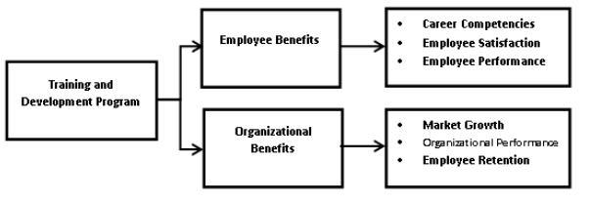
Source: European Journal of Business and Management (2013)
Any organisation that invests in training and development sees two benefits. Investment in training and efficient use of skilled workers advantages both the establishment and the individual worker. These potential benefits can be divided into three categories: employment-related, career-related, and individual benefits. (2008) Buckley and Caple. To increase the effectiveness of training and growth, the transfer from preparation to the workplace environment will be monitored once individuals have obtained the needed skills, talents, and abilities. 2007 (Burke & Hutchins). Additionally, better customer service leads to greater organisational engagement, business expansion, and advanced retention rates (Aggarwal & Bhargana, 2011), as well as higher customer satisfaction (Warech & Tracey, 2004).
According to the study, every person whether it is from the upper, middle, or lower level needs proper training to handle challenges in the business environment (Nicolaides, 2016). As mentioned, the hospitality industry deals in a wide range of operation along with it has great interaction with diverse customers so in the hospitality business every level of management need training.
Employee retention
Employee retention refers to an organization's capability to keep its staff. The Maslow (1943) hierarchy of needs is one of the most well-known management theories concerning retention.
The significance of Maslow's theory in management in retention assumes that satisfied employees perform better and are more loyal to the organisation (Gambrel & Cianci, 2003, p. 158), according to Rodrigues and Rosales (2011, p. 1030).

Figure 4: Maslow theory representation
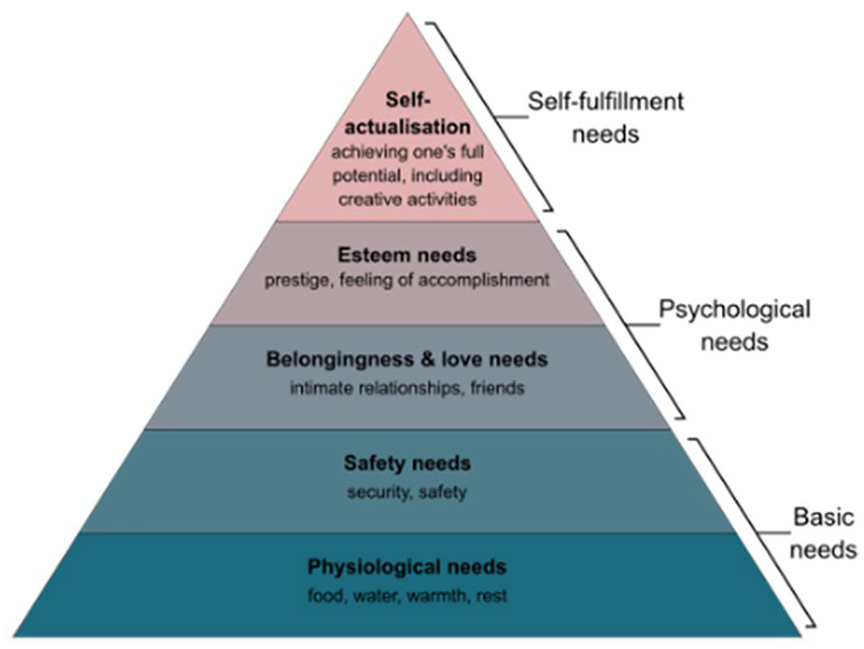
Source: Sage Journals (2022), A Revised Visual Representation of Maslow’s Theory Z

As a model of individual motivation, Alderfer's (1969) theory postulates that there are three categories of fundamental needs: survival, relatedness, and development.
According to Vroom's (1964) description of expectation theory, an employee must feel that the task is reasonable and attainable for them to put out the effort necessary to complete it.

The results are consistent with the notion that Maslow's (1943), Alderfer's (1969), and Vroom's (1964) basic theories are crucial for directing managers in the hospitality business in the formulation of employee retention strategies.

One of the most well-known equity theory theories was settled thanks to the work of J.S. Adams. Adams' hypothesis (Steers, 1983) is most likely the most well-established account of how people assess social transaction ties. In this approach, the two basic elements of discussion interaction are inputs and outcomes. Prior work history, education, on-the-job effort, and training could all be inputs in instances when a person exchanges their services for money.

Figure 5: Employee Retention Practises Through Motivation Theories
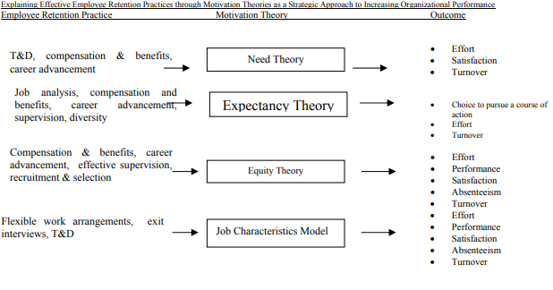 Source: The Journal of American Academy of Business (2004)
Extrinsic and intrinsic motivating factors were used by hospitality managers and their organisations to increase staff retention (Shore, 2013). According to the findings of this study, not all hospitality groups can recruit equally motivated workers or provide comparable retention rates. Effective employee retention tactics might be the consequence of managers' awareness of what motivates or demotivates workers (Caruthers, 2011). It is possible to create a stimulating and fulfilling work environment by being aware of techniques that increase employee retention (Belbin, Erwee, & Wiesner, 2012).
The chapter discussed several retention theories and how they have evolved considering changes in the various aspects that can either improve or decrease an employee's incentive, which is a crucial element in reducing staff resignations. On the other hand, an unmotivated employee may think about quitting (Long, Perumal, & Ajagbe, 2012, p. 63).
Training and Development & Employee retention
Various studies examined the influence of training and development in the hospitality business to more efficiently support the premise that training and development in the hospitality industry can decrease turnover.
Bharwani and Butt (2012) researched the impact of development training on organisation accomplishment and concluded that training and development programmes are crucial for organisations in the hospitality sector for two reasons. These activities, on the one hand, can boost business success by improving service conditions; on the other hand, such programmes can strengthen employee loyalty.
Mitchell et al. (2001) idea is one of those that arose in the 2000s and began to use an alternative perspective on how to preserve individuals. According to the hypothesis, the more embedded an employee is, the less likely he or she is to consider quitting the enterprise because job satisfaction and organisational assurance stay strong in this instance.
Personnel who consider training and development chances as a new chance to obtain skills that can advance their careers are more content with their positions, thus more loyal, and hence less likely to leave the company, according to Costen and Salazar (2011).
Moreover, Hytter (2007) shows that salary, leadership style, career stages, training, and skill development all have a direct impact on retention. According to Arnold (2005), quality training and opportunities to grow and develop promote employee retention.
Small enterprises, according to Jameson (2000), cannot be addressed in the same way, while training and growth are still crucial. However, Kyriakidous and Maroudas (2010) examined the influence of training and development programmes on presentation in hospitality throughout the United Kingdom and determined that “successful 28 organizations adopt an informal approach which is integrated into the culture of the organization, providing a positive training and development environment where employees are more likely to be retained” (p. 32)
Figure 6: Factors Enhancing the Employee Retention
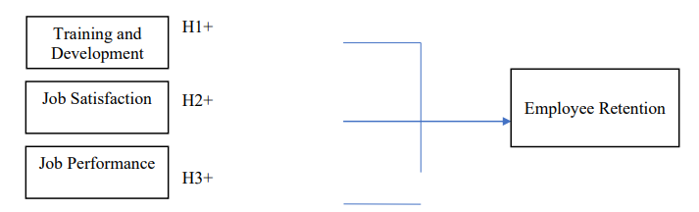
Source: International Journal of Future Generation Communication and Networking (2020)

All these studies suggest the favourable impact of training and development on employee retention, although Poultson (2008) found the opposite. He investigated the influence of ineffective training practices on business execution and staff turnover in the hospitality sector. According to the report, inadequate training practices cause a terrible working climate and anxiety in the company. Furthermore, individuals who receive inadequate training are more likely to depart due to a lack of job fulfilment.
2.3: Gaps identified to situate own research
The gaps that have been identified are as follows:
The influence of Brexit on the UK workforce availability and the effect of the Covid -19 in the Hospitality sector.
According to Statista (2020), Brexit is related to the concern of the lack of labour as the sector is mainly occupied by low-skilled employees and a vast part of them were from EU nations in 2016.
Other findings from Statista (2022) identified the threat of the recovery process in the UK hospitality sector from COVID-19, whereas 85% of the hotels were closed and some of their staff were released.
2.4: Summary of Chapter 2
In the context of UK's hospitality, the literature emphasizes the challenge of turnover. Strategies focusing on motivating employees to increase engagement also positively affect turnover rates. Training and development opportunities enhance motivation and thereby contribute to retention. However, a gap exists between literature and industry practice due to financial limitations, leading to inadequate attention on retention despite its scholarly endorsement.
Chapter 3: Research Methods & Methodologies

3.1: Introduction
This chapter outlines the research philosophy, design, and methods employed. Chapter 3 follows a logical order, beginning with a discussion of constraints faced. It then details research instruments, sample composition, techniques, questionnaire, and analysis type, and concludes with methodological recommendations.
3.2: Philosophical position of the research
This study will undertake an ontology research philosophy as the theme is primarily concerned with an existing problem within the Hospitality industry in the UK. As well as the different questions of the assumptions of how this sector may operate better are committed and held to different points of view such as employer and employee. The implication of Ontological research is to report other perspectives on the findings.
3.3: Paradigm position of the research and Why?
The research pattern implicated in this work is a mix of interpretive and pragmatism. As the researcher in this work has an active part in the Hospitality industry in the UK and is observing by herself how the industry is socially constructed and driven by human interests, the type of Interpretative research is taking place. However, as this work will involve designs that incorporate operational decisions then the pragmatism – will take place to find the answers under investigation.
3.4: Position of Research Approach and Why?
This study will apply a deductive approach as it is concerned with the development of hypotheses already based on existing theories and proven facts in hospitality. Then will be designed a research strategy and a conceptual framework with quantitative measurements from the literature, tested using the data. Through generalisation and the independence of the researcher will be explained the relationships between variables suggested by O’Gorman, K. (2015).

3.5: Methodological stance of the Research and why?
The research methodology as a theory of how research should be undertaken for this work will be quantitative. The reason for implementing this method is that it is concerned with explaining the phenomena within the hospitality sector by collecting numerical data and analysing mathematically as recommended by Saunders, (2019). There will be 25 items in the questionnaire applied to understand the role of the instruction and advancement of the workforce.
3.6: Stance of the Research Strategy and Design and why?

The survey research strategy will be implemented in this work as it allows a collection of quantitative data and analysis and gives the researcher independence. Along with this also action research will take part As said previously the author works in the field of hospitality and promotes changes within the organisation. Another strategy is going to be an archival one as focuses on historical research topics and uses administrative records and papers as the primary sources of data but is bound by the nature of such records and documents.
3.7: Research Sample and Population
The author uses primary, secondary, and quantitative research methodologies to investigate the function of training and development in hospitality in the United Kingdom concerning employee retention in this industry.
Table 1: Research Method
Research | Method | Data Source | Time
Online | Quantitative | Volunteers | August 2023

The sampling method that will be used is simple random as each participant is chosen entirely by chance and everyone has an equal probability of being selected.
Hair, Anderson, Tatham, and Black (1998) suggested a sample size of at least five times the observed variables. The factors researched align with this size recommendation (Comrey, 1973). The study's questionnaire with 25 items implies an estimated test size of n = 5 * 25 = 125.
The scope of the research will be in the UK. The sample size will be 90-125 employees and the sample profile is that they are junior managers and supervisors in the hospitality industry.

3.8: Data Collection and Data Analysis Tools/Techniques
The purpose of carrying out this research indicates that the right tools and methods to be obtained are through observation, existing data such as research journals and surveys, and questionaries as well as reporting- articles and records in hospitality.
A questionnaire with a 5-point Likert scale was employed. For all dependent factors such as effects, rate of growth, performance, and independent variables such as cause and influences, the response categories varied from "1-strongly disagree" to "5-strongly agree." measurement of variables are as follows:
The way of interpreting the data gathered will be descriptive. Will be used Gantt chart for the visualisation of the time prospect of the work too and SPSS.

3.9: Ethical Consideration of the Research
Confidentiality and Data Protection Act and Privacy Rules will be followed in this work.
3.10: Summary of Chapter 3
The study employs quantitative methodology to assess training's impact on employee retention in UK hospitality. Numerical data is gathered, analysed, and interpreted. Limitations like sample bias are addressed, with implications discussed for theory and industry practice. The quantitative approach offers statistically validated insights, enhancing an objective understanding of training's role in retention within UK hospitality.

Chapter 4: Data Analysis and Discussions

4.1: Introduction
The results from the initial data, which was gathered using a quantitative method approach, will be analysed, and interpreted in this section of the study. As stated by Aksu (2005), three things can influence training as following - individual, organisational, and training programme factors.
This chapter's findings related to the proposed model will be illustrated and referred to data analysed supported by a questionnaire distributed online using Google form.
The aim is to assess employee sentiments on existing training and pinpoint enhancement opportunities. Descriptive statistics precede correlation analysis. Attitudes on organizational and management backing for training will be probed, showcasing training benefits. Evaluation of training course experiences and program details will follow to comprehend respondent perceptions.

The correlations between the various dimensions backed by earlier literature studies are depicted in the model below.

4.2: Analysis and Discussions of the findings/data
The researcher received 55 answers from the online questionnaire targeted initially to 90-120 employees working in the Hospitality in the UK. The findings are as follows:
Regarding age, participants were mostly between 35-44 years group, consisting of 32,7% or 18 employees.

Figure 7: Participants' age
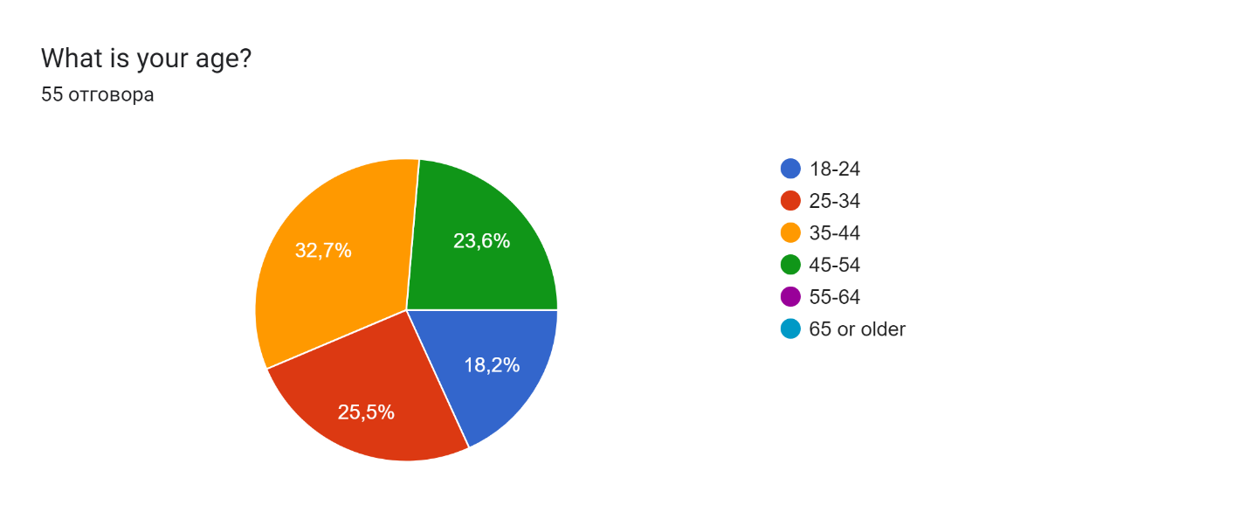
The females are 30 employees- 54,5% and male employees- 45,5% of all.

The nationality is represented in the diagram below where the biggest participants are Bulgarian followed by the Ukrainian workforce as follows:

Figure 8: Nationality of the participants
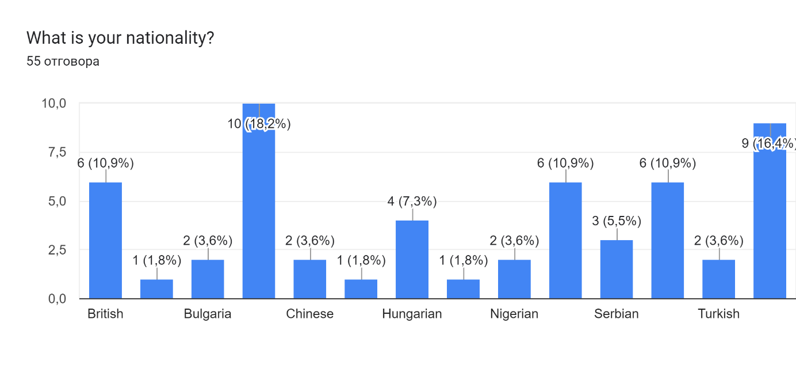
In terms of the current position in Hospitality, the biggest part of the research has the room attendants- 14 (25,5%), followed equally by Coordinators and Supervisory positions.
Figure 9: Participants' current role
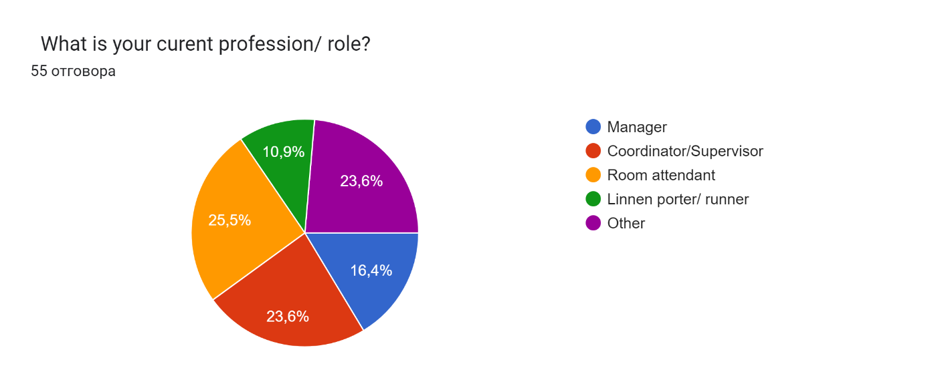

The graphical representation of the length of service is as follows and quite contradictable with the stated intentions of the same participants of their future work in the same company.

Figure 10: Participants' length of service
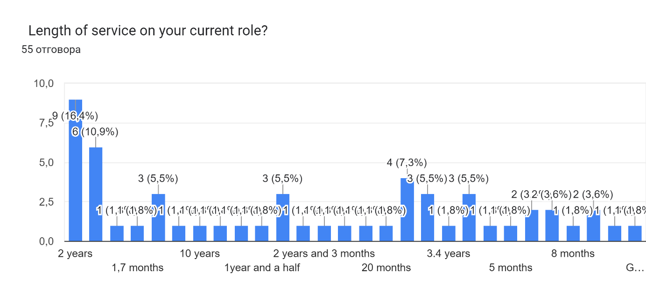
As 32 employees (58,2%) stated that they intend to contribute to the same company for years to come, nevertheless, the real length of service is far different.

Figure 11: Participants' plans for service.
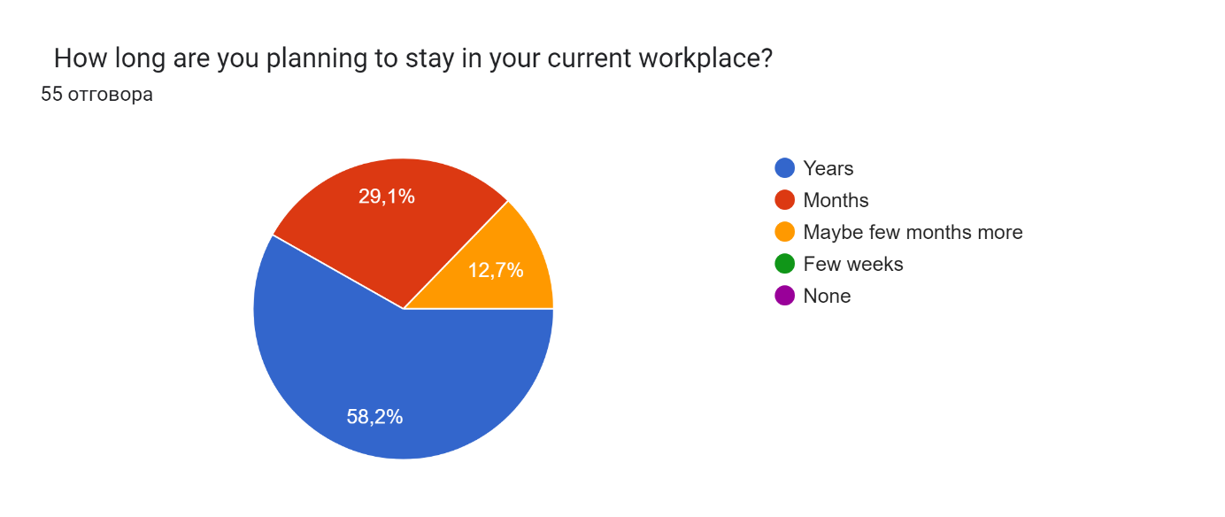
The vast part of the participants -78,2% (43) claimed that they receive training at the current workplace for more than a week, which also contradicts the statement by Baum (2006) that the Hospitality sector has low rates of expenditure in human resource when comes to learning and development initiatives.

Figure 12: Participants' answers about training programmes.
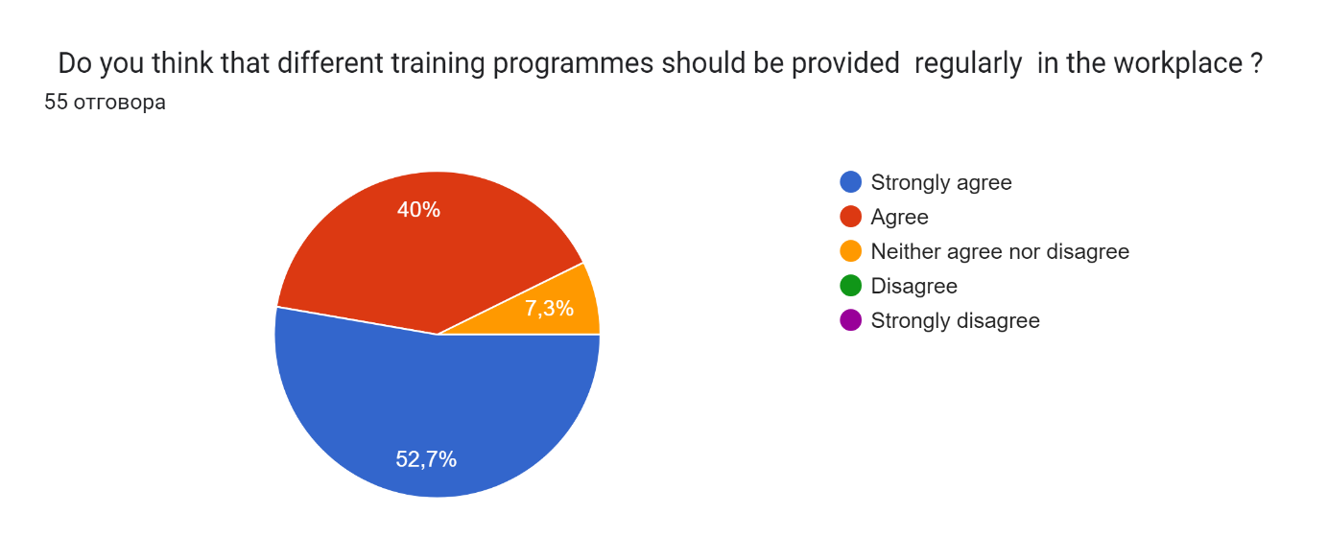

More than half of the employees strongly agree that different training programmes should be provided regularly in the workplace consisting of 29 workers evaluated according to the LIKERT scale. As per Namasivayan & Denizci (2006), viewing training and development as an investment, not an expense, fosters human capital growth in hospitality. This approach cultivates employee capabilities, yielding favourable outcomes for individuals and organizations (Young et al., 2005), supported by research participants, as shown in the diagram.
Figure 13: Participants' answers to performance.
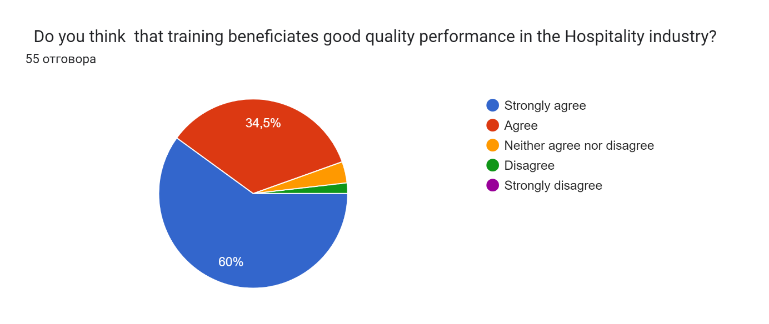
The participants also claimed that they have participated in mostly blended training experiences consisting of online and practical training programmes. Only 10.9% of them got practical training and 16,4% online training separately, moreover they did not participate in seminars.

Figure 14: Received training programmes.
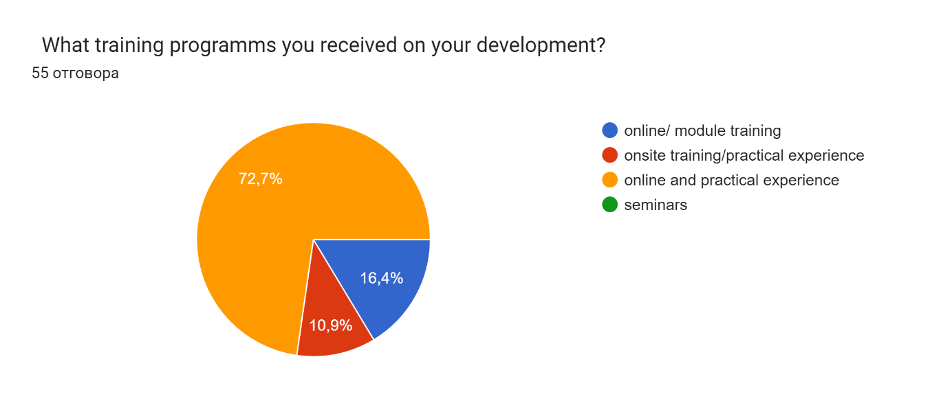Their consideration of the most effective training for them is depicted in the table below as follows:

Table 2: The most effective training received according to participants.
Type of the most effective training | Responses
Online | 3
Practical | 10
Online and practical | 40
N/A | 2

The dominant part of 40 employees claim that blended training is the most effective for them and their further development in the current workplace. However, they are recognising the importance of the technology in the process of effective training as 52,7 % strongly agreed about its important role.
The overall proportion of training supplied in the UK is shown below; however, in contrast to UK businesses supplying any training, Hospitality and Tourism companies in London emerge to deliver more training than the UK.
Figure 15: Employee turnover rates 2014-2016 in the UK
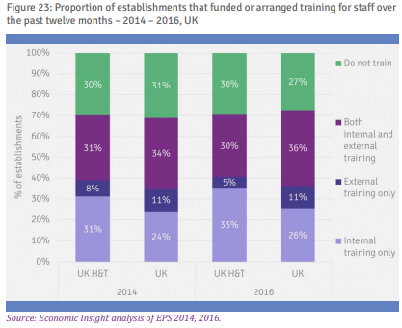
Source: Economic Insight (2019)

Figure 16: Participant answer on training effectiveness
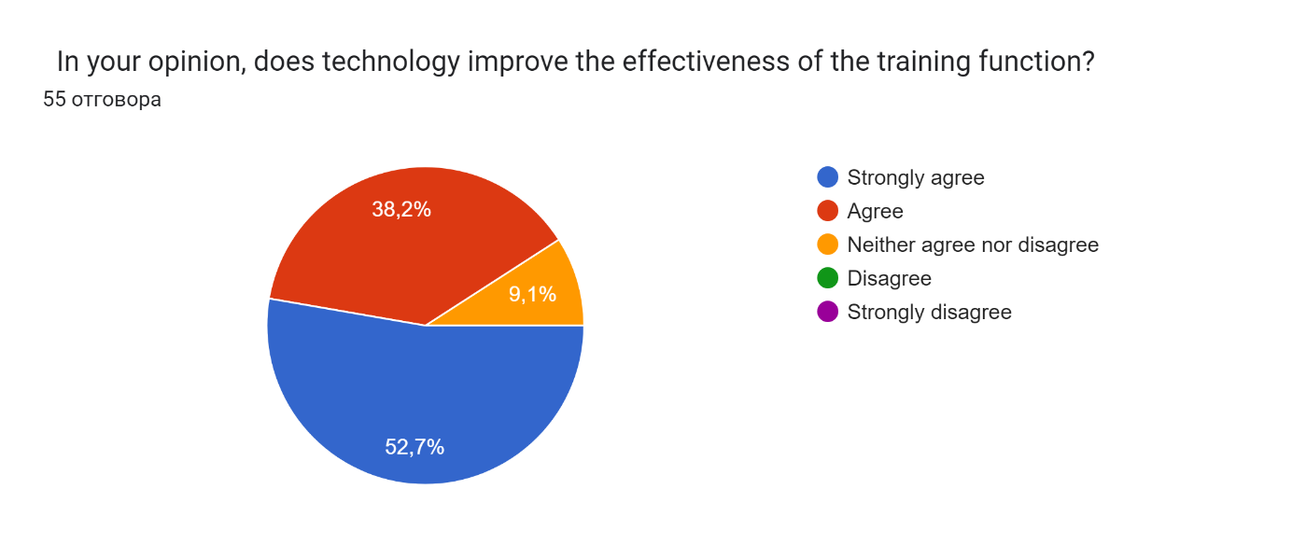

This is a highly important finding in the survey as 50,9% (28) of the participants are sure that training is always related to their development in the company, followed by other majority of 34,5% (19) believe that this correlation is usually the case. Just one of the employees disagrees with this.
Figure 17: Participants answer about the link training between and development.
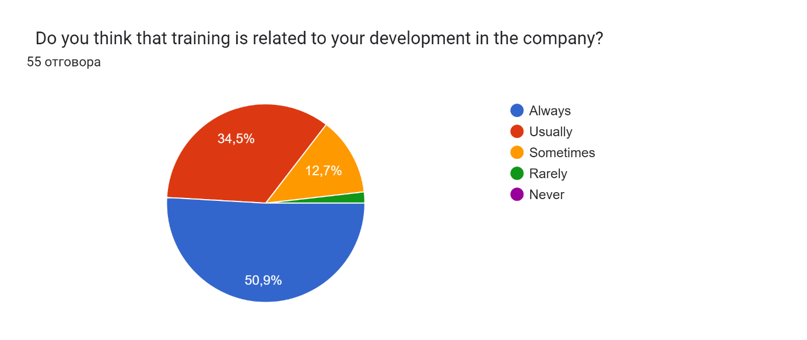

This is also following Burke & Hutchins's (2007) statement that to increase the effectiveness of training and growth, the transfer from preparation to the workplace environment will be monitored once individuals have acquired the necessary skills, talents, and abilities. Also, any organisation that invests in training and development sees two benefits according to Buckley and Caple (2007). Investment in training and efficient use of skilled workers benefits both the organisation and the individual employee. These potential benefits can be divided into three categories: employment-related, career-related, and personal benefits. Additionally, better customer service leads to greater organisational engagement, business expansion, and advanced retention rates (Aggarwal & Bhargana, 2011), as well as higher customer satisfaction (Warech & Tracey, 2004).

A very interesting finding from the survey was the level of extremely interested employees in further development in their current workplace. As the chart below displays 24 (43,6%) employees out of 55 have answered on the highest 5 scale of interest as other 23 (41,8%) stated that they are very interested in this too.
Figure 18: Participant answers about professional development
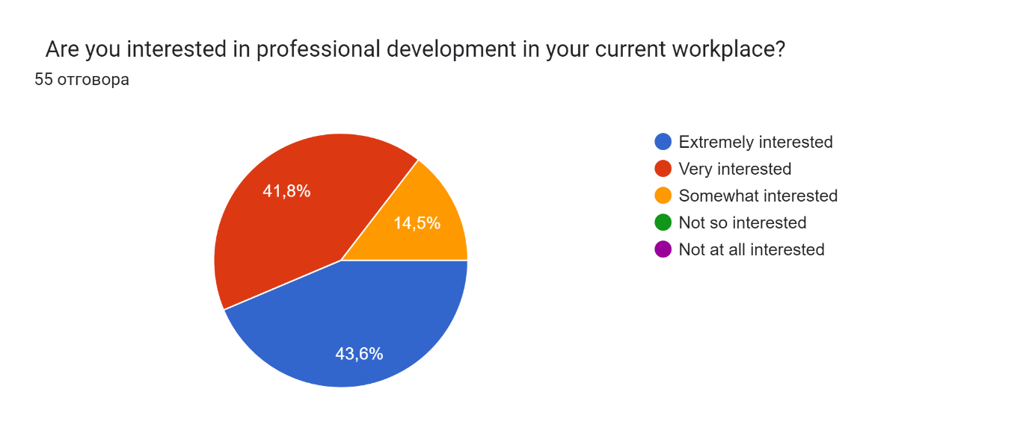

These findings disagree with the stated workforce flow in the UK in the last years where the rate of turnover has increased significantly by 8,7% since 2019 and is predicted to rise by 35,6% in 2023 in the UK according to CIPD (2023). Moreover, a low turnover rate increases the risk of not introducing fresh ideas into the company, whereas a high turnover rate means loss of talent.

Figure 19: Employee turnover CIPD
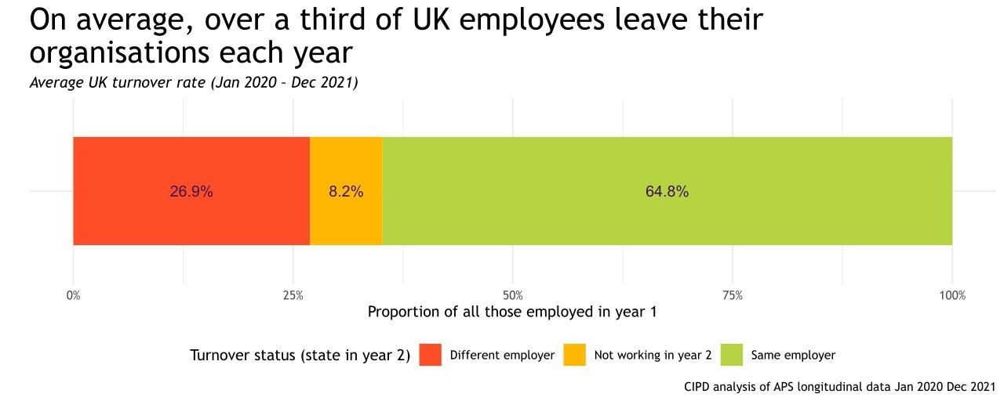
Source: CIPD (2023)
As is shown in the table below, the highest rate is in the Hospitality industry.
Figure 20: Employee turnover in various industries CIPD
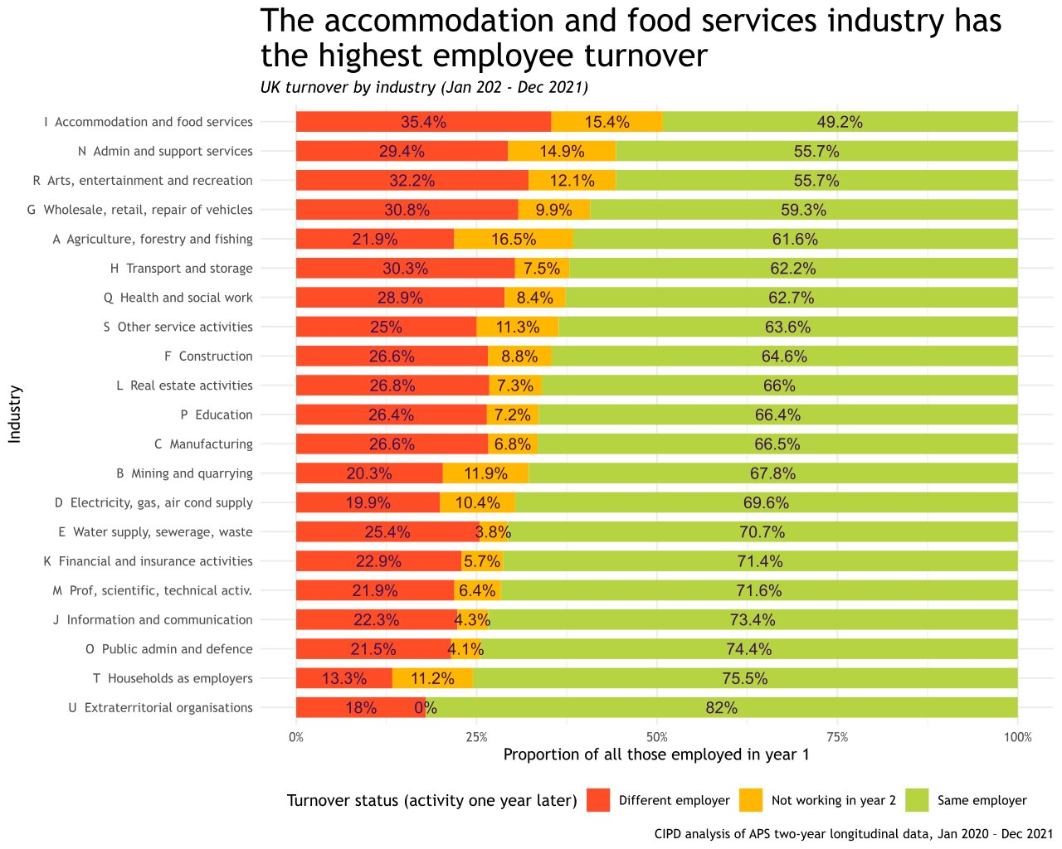

This finding is favoured also by the study of Poultson (2008) who studied how poor training practices affected turnover and corporate success in the hotel segment. According to the report, poor training procedures lead to a hostile work atmosphere and increase workplace conflict. Additionally, in cases of inadequate training, staff members are more likely to quit due to a lack of job satisfaction.
Nevertheless, 54,5 % of the respondents claimed that the current company meets above average their career goals despite the different reasons of motivation given by them.
Figure 21: Participant answers over the career goals
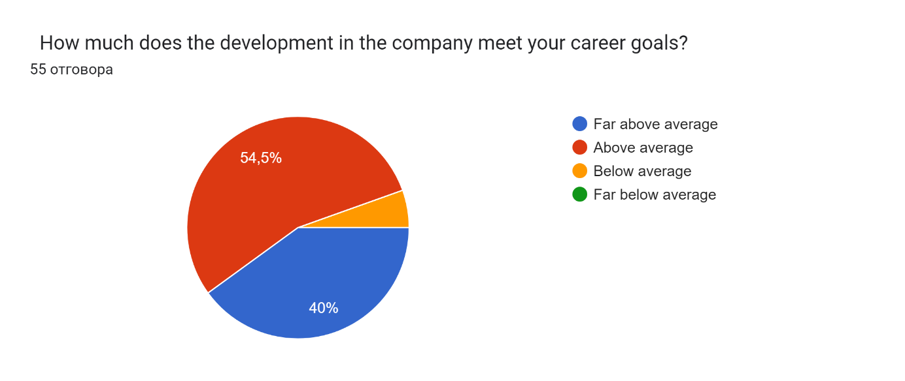

Also, a very high percentage of them noted that they feel fairly rewarded at work- 76,4% (42 employees), while only 1 person feels not rewarded.

Figure 22: Participants answer about the rewards.
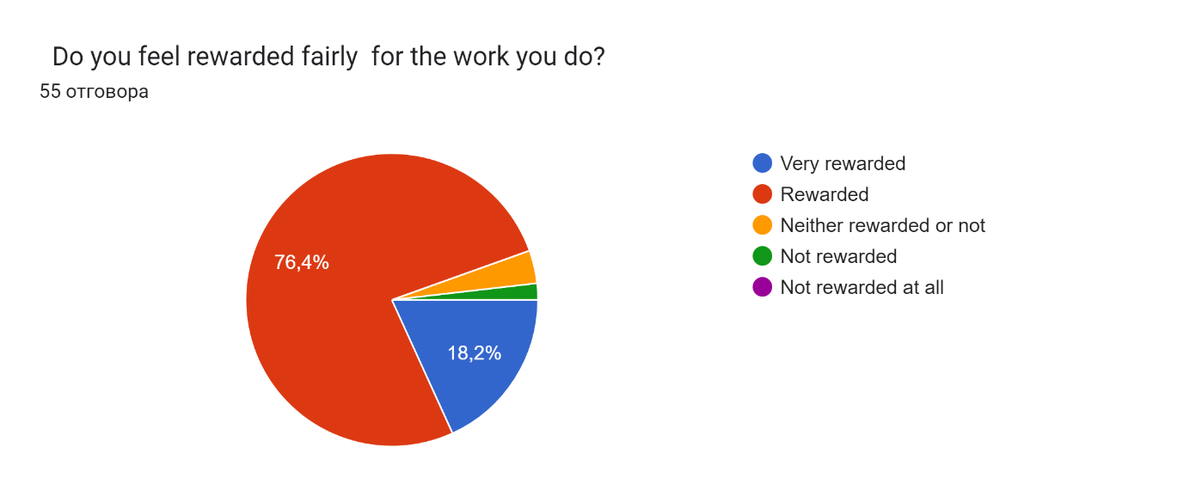
Consequently, it does explain by itself the high turnover in the industry and 50,9% (28) of the employees are considering staying at the same place if a suitable training and development plan is proposed for them. Only 9,1% (5) of the employees would not consider the proposed growth plan for them.

The findings about whatever is a link between the training and development in the company and employee retention are represented below as follows:
Figure 23: Participant answers about employee retention
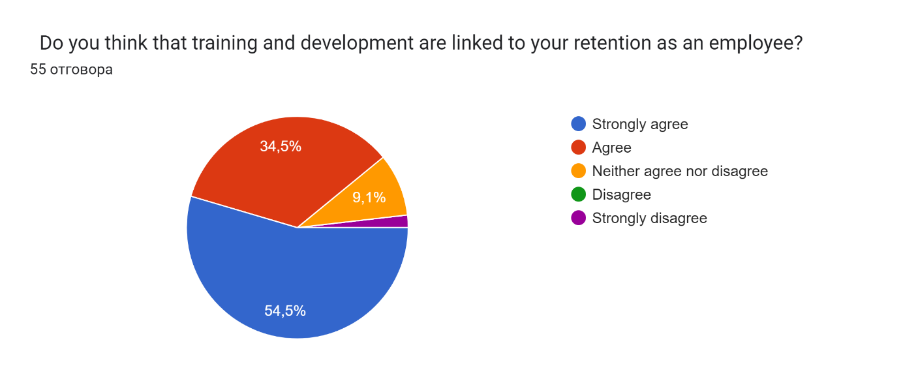
One person strongly disagrees with this statement, while another 30 (54,5%) strongly agree that the link is strong.
Kyriakidous and Maroudas (2010) affirm that an environment fostering learning and growth boosts employee retention. Hytter (2007) demonstrated that factors like pay, leadership, career prospects, and training influence retention. Arnold (2005) likewise highlights how strong training and development correlate with higher employee retention rates.
Figure 24: Participant answers about the impact of Brexit
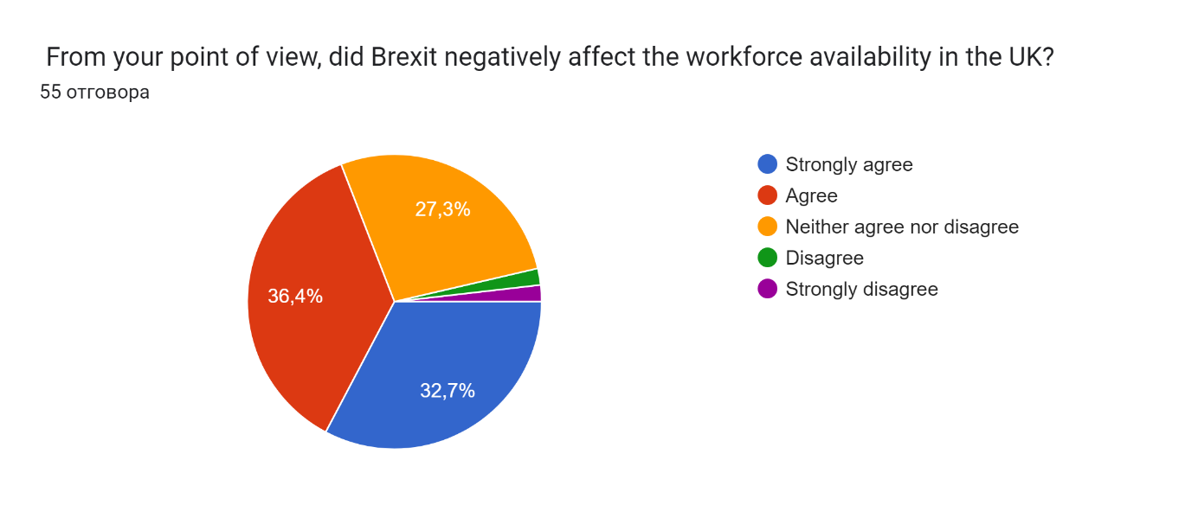
Examining the gap in the studies and works provided so far in the existing literature, the researcher found that according to the questioned workforce, there is a significant correlation between Brexit and labour in the UK now. More than 36 % agree with this, while 32,7% strongly supported the statement.
During Brexit talks, UK enterprises faced concern over EU migrant workers (Statista, 2020). As an EU member, tourism and hospitality accessed a broader labour pool. In 2016, EU nationals constituted a significant portion of hotel employees. Hotels rely heavily on EU citizens to fill skill-scarce roles, addressing labour market gaps, as indicated by respondents' views.
Also, the Hospitality in the UK has been badly hit by Covid-19. The diagram below confirms that more than 85% of the hotels were closed, consequently, the workforce in the same industry has experienced severe difficulties with employment. This has affected the UK Hospitality industry more than ever before findings confirmed.

Figure 25: Industries predicted to reopen after the lockdown in the UK.

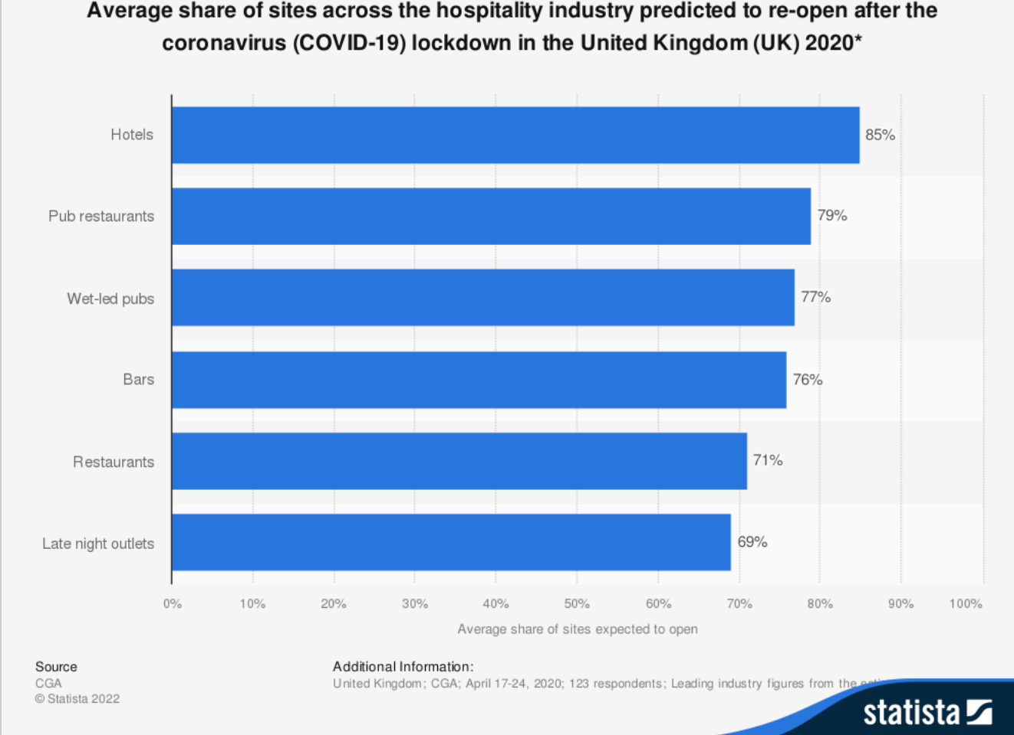
Source: Statista (2022)

4.3: Summary of Chapter 4
The findings in this chapter summarise that indeed the participants and the previous literature reviews agree on how important the training and development of the workforce in the Hospitality segment in the UK is to enhance professionally delivered services, personal growth and employee satisfaction that can be a strong asset for the employee retention in the business. However, the limitations and challenges presented above, cannot constrain the ambition to overcome these obstacles and by introducing new, powerful methods such as technology, the results might be more than satisfactory.

Chapter 5: Conclusions, Limitations &Recommendations

5.1: Introduction
In every company, training and development are crucial. Coworkers who are well-prepared are confident and strong in their work. According to Boella (1996), having a successful training interaction and technique will persuade employees to develop and improve their skills and rewards later. Organisations cannot identify the strengths and weaknesses of their training initiatives to help them improve if they don't even have the slightest concept of how to evaluate their training or what the best method is for doing so.
This was a fantastic opportunity for analysts to test the effectiveness of improvement and training programmes.

5.2: Conclusions on each research issue/objectives/proposition
The conclusions of the findings are as follows:
1. The training and development are highly recommended for the best performance of the company and personal fulfilment and further development of the employees.
2. The link between training and development is very strong and helps enhance personal skills and productivity as well as professional performance in the Hospitality sector.
3. Different training and development programmes are appreciated by the UK workforce and desirable as a step up to better career opportunities.
4. The role of new technology introduced to the L&D process is one of the ways to improve the quality of learning opportunities today.
5. Despite the strong desire for development in the current workplace, many are not motivated in the right way to persist and cause unfavourable outcomes which can make it more difficult for the organisation to prosper, expand, and progress.
6. Brexit and COVID-19 have left a great impact on Hospitality in the UK according to respondents and literature reviews
7. Not always career progression is the main factor for good employee motivation, but the sense of belongingness in the company.
5.3: Conclusions on the research problem
The findings from the conducted investigation are that employee retention rates are relatively low in the Hospitality sector despite the many different training and development programmes introduced and disregarding the good intentions of the participants.

5.4: Limitations of the Research
As the research was overseen by employees working in Hotels in London and mainly in five- and four-star properties, the result cannot be taken as the same for all UK Hospitality. However, in the capital, the concentration of the Hotels, the diversity of the workforce and other factors are much greater than in other parts of the country.
This work used a quantitative method approach which has the limitation for accuracy of the data gathered over the online questionnaire and not everyone in the targeted population has responded to it.

5.5: Recommendations
Find out whether there are any supply-side obstacles keeping training suppliers from providing adaptable training "on-site." This might raise overall training provision even more and produce a workforce that is even more skilled, which might give workers greater options for career advancement.
Examine whether there are any demand-side obstacles inhibiting businesses and employees in the hospitality industry from providing or accepting external training.
Also, analyzing whether changing the vocabulary used to describe specific worker characteristics might improve perceptions of the industry will be helpful.

5.6: Summary of Chapter 5

Good research always leaves room for or encourages additional study. When this study project was initiated, the world was revolving conventionally. By 2023, COVID-19 will have affected the entire world. Out of all the sectors, the hospitality industry is one of the most impacted. The people who were supposed to be providing exceptional customer service were more passive than active. But modern society is already adopting new behaviours.
With a new functional and operational system, the entire firm was launched. Regardless of the state of the economy, the main goal of the hospitality sector is to satisfy customers by providing excellent service. To adjust to the new approach, the pattern of training and development must change.

References:

1. Agarwal, P.K. & Naidu, Mr. (2021). A STUDY ON IMPORTANCE OF TRAINING AND DEVELOPMENT IN HOTEL & TOURISM INDUSTRY IN UTTARAKHAND, Available at:https://www.researchgate.net/publication/353122377_A_STUDY_ON_IMPORTANCE_OF_TRAINING_AND_DEVELOPMENT_IN_HOTEL_TOURISM_INDUSTRY_IN_UTTARAKHAND, Accessed: 3rd May 2023
2. Alderfer C., (1969), An empirical test of a new theory of human needs, Organizational Behavior and Human Performance, Volume 4, Issue 2, P. 142-175, ISSN 0030-5073, Available at: https://doi.org/10.1016/0030-5073(69)90004-X., Accessed: 29th June 2023
3. Arnold, E. (2005), “Managing human resources to improve young employee retention”, The Health Care Manager, Vol. 24 No. 2, pp. 132-40.
4. Aggarwal, U., & Bhargava, S. (2011). Reviewing the relationship between human resource practices and psychological contract and their impact on employee attitude and behaviours: A conceptual model. Journal of European Industrial Training, 33(1), 4- 31.
5. Aksu, A.A. (2005). Defining training needs of five-star hotel personnel: An application in the Antalya Region of Turkey. Managerial Auditing Journal, 20(9), 945-953.
6. Bashir N., (2013), Training and Development Program and Its Benefits to Employee and Organization: An Conceptual Study, European Journal of Business and Management, Available at: https://www.researchgate.net/publication/274703936, Accessed: 29th June 2023
7. Baum, T. (2006). Skills and training for the hospitality sector: A review of issues. Journal of Vocational Education and Training, 54(3), 343-363.
8. Bharwani, S., & Butt, N. (2012). Challenges for the global hospitality industry: an HR perspective. Worldwide Hospitality and Tourism Themes, 4 (2), 150-162
9. Belbin, C., Erwee, R. and Wiesner, R. (2012) “Employee perceptions of workforce retention strategies in a health system,” Journal of Management & Organization. Cambridge University Press, 18(5), pp. 742–760, Available at: Doi: 10.5172/jmo.2012.18.5.742., Accessed: 29th August 2023
10. Boella, M. J. (2000). Human resource management in the hospitality industry, 7th ed.
11. Boella, M., & Goss-Turner, S. (2005). Human resource management in the hospitality industry: An introductory guide. Burlington (MA): Elsevier Butterworth-Heinemann. 333
12. Boston, MA. Available at: https://doi.org/10.1007/978-1-4684-2490-4_4 , Accessed: 6th July 2023
13. Buckley, R., & Caple, J. (2008). The theory and practice of training. (5th ed). London: Kogan Page.
14. Burke, L. A., & Hutchins, H. M. (2007). Training transfer: An integrative literature review. Human Resource Development Review,6(3), 263-296.
15. Caruthers, R. A. (2011). Effective leadership in a 21st-century federal agency. Available from ProQuest Dissertations & Theses database. (UMI No. 3456890)
16. Chiang, C., Back, K., & Canter, D.D. (2005). The impact of employee training on job satisfaction and intention to stay in the hotel industry. Journal of Human Resources in Hospitality and Tourism, 4(2), 99-118
17. CIPD (2023), Available at: https://community.cipd.co.uk/cipd-blogs/b/cipd_voice_on/posts/why-staff-turnover-data-matters, Accessed: 23rd August 2023
18. Comrey, A.L. (1973) A First Course in Factor Analysis. Academic Press, New York, p. 342
19. Costen, W., & Salazar, J. (2011). The Impact of Training and Development on Employee Job Satisfaction, Loyalty, and Intent to Stay in the Lodging Industry. Journal of Human Resources in Hospitality & Tourism, 10 (3), 273-284.
20. International Journal of Future Generation Communication and Networking (2020), The Impact of Training and Development, Job Satisfaction and Job Performance on Young Employee Retention, Vol. 13, No. 3, (2020), pp. 373 - 386
21. Gambrel, P., & Cianci, R. (2003). Maslow's Hierarchy of Needs: Does It Apply In A Collectivist Culture? Journal of Applied Management and Entrepreneurship, 8 (2), 143-161.
22. Garger, E. M. (1999, November). Goodbye training, hello learning. Workforce, 78 (11), 35-42.
23. Gerbman, R. V. (2000) Corporate Universities 101. HR Magazine, 45 (2), 101-106.
24. Girish Nair (2016), Impact of Service Quality on Business Performance in Hospitality Industries: An empirical study, Available at: https://core.ac.uk/download/pdf/234696845.pdf, Accessed: 10th August 2023
25. Gleeson, D., & Keep, E. (2004). Voice without accountability: The changing relationship between employers, the state and education in England. Oxford Review of Education, 30(1), 37-63.
26. Ghani et al. (2022), Challenges and Strategies for Employee Retention in the Hospitality Industry: A Review. Sustainability. , Available at: https://www.researchgate.net/publication/358976415_Challenges_and_Strategies_for_Employee_Retention_in_the_Hospitality_Industry_A_Review , Accessed: 10th August 2023
27. Goldstein IL, Ford JK. (2002). Training in Organizations. Belmont, CA: Wadsworth. 4th ed.
28. Hospitality and Tourism Workforce Landscape (2019), Available at: https://assets.publishing.service.gov.uk/government/uploads/system/uploads/attachment_data/file/827952/Hospitality_and_Tourism_Workforce_Landscape.pdf, Accessed: 10th August 2023
29. Economic Insight (2019), Available at: https://assets.publishing.service.gov.uk/government/uploads/system/uploads/attachment_data/file/827952/Hospitality_and_Tourism_Workforce_Landscape.pdf, Accessed: 23rd August 2023
30. GOV.UK (2021), Hospitality strategy: reopening, recovery, resilience, Available at: https://www.gov.uk/government/publications/hospitality-strategy-reopening-recovery-resilience/hospitality-strategy-reopening-recovery-resilience#executive-summary, Accessed: 10th August 2023
31. Hair, J.F., Black, W.C., Babin, B.J., Anderson, R.E. and Tatham, R.L. (1998) Multivariate Data Analysis. Vol. 5, No. 3, 207-219, Prentice Hall, Upper Saddle River.
32. Hytter, A. (2007), “Retention strategies in France and Sweden”, The Irish Journal of Management, Vol. 28 No. 1, pp. 59-79.
33. Huang, D., Miyoshi, J., La Torre, D., Marshall, A. Peres, P., & Peterson, C. (2007). Exploring the Intellectual, Social and Organisational Capitals at LA’s BEST (CSE Technical Report 714), 1-95., Available at:http://www.cse.ucla.edu/products/reports/r714.pdf , Accessed: 29th June 2023
34. Jaiswal et al., (2021), Rebooting employees: Upskilling for artificial intelligence in multinational corporations (in press). The International Journal of Human Resource Management, Available at: https://www.researchgate.net/publication/349173024_Rebooting_employees_Upskilling_for_artificial_intelligence_in_multinational_corporations_in-press, Accessed: 27th April 2023)
35. Jameson, S. (2000). Recruitment and training in small firms. Journal of European Industrial Training, 24 (1), 43-49
36. Kottke, J. L. (1999). Corporate universities: Lessons in building a world-class workforce. Personnel Psychology, 52, 530-533.320.
37. Kyriakidou, O., & Maroudas, L. (2010). Training and development in British hospitality, tourism, and leisure SMEs. Managing Leisure, 15 (1/2), 32-47.
38. Lee-Ross, D., & Pryce, J. (2010). Human resources and tourism – Skills, culture, and industry. Bristol, UK: Channel View Publications.
39. Long, C., Perumal, P., & Ajagbe, M. (2012). The Impact of Human Resource Management Practices on Employees’ Turnover Intention: A 40. Conceptual Model. Interdisciplinary Journal of Contemporary Research in Business, 4 (2), 629-641.
41. Market Line (2023), Available at: https://advantage-marketline-com.ezproxy.uwtsd.ac.uk/Analysis/ViewasPDF/united-kingdom-hotels-motels-169286, Accessed: 21st June 2023
42. Maslow, A. (1943). A Theory of Human Motivation. Psychological Review, 50, 370-396.
43.Meister, J. C. (1998, November). Ten steps to creating a corporate university. Training and Development, 52 (11), 38-43.
44. Mel Kleiman (2000), What happens if you don’t train them and they stay? Occupational Health and Safety, 69 (1), pp. 18, 70.
45. Michael White & Genevieve Knight (2018) Training, job mobility and employee satisfaction, Journal of Education and Work, 31:5-6, 447-460, DOI: 10.1080/13639080.2018.1513639
46. Mitchell, T., Holtom, B., Lee, T., Sablynski, C., & Erez, M. (2001). Why people stay: using job embeddedness to predict voluntary turnover. Academy of Management Journal, 44, 1102-1122.
47. Namasivayam, K. & Denizci, B. (2006), Human capital in service organizations: identifying value drivers, Journal of Intellectual Capital, 7(3), 381 – 393
48. Narkhede, Parag. (2014), Employee turnover in hospitality industries, A study of service staff, Available at: https://www.researchgate.net/publication/268087499_Employee_turnover_in_hospitality_industries_A_study_of_service_staff, Accessed: 10th August 2023
49. Nicolaides, A. (2016). Spirituality and Cultural Diversity: Serving the Hospitality Industry Workplace.
50. Nunnally, J.C. (1978). An Overview of Psychological Measurement. In: Wolman, B.B. (eds) Clinical Diagnosis of Mental Disorders. Springer,
51. O’Herron, P., and Simonsen, P. (1995), Career development gets a charge at Sears Credit. Personnel Journal, 74 (5), 103-106.
52. O’Gorman, K. (2015), Research methods for business & management: a guide to writing your dissertation. (“The Literature Review — Heriot-Watt Research Portal”) 2nd ed. Oxford, England: Goodfellow Publishers Ltd.
53. Owens, P. L. (2006). One more reason not to cut your training budget: The relationship between training and organisational outcomes. Public Personnel Management, 35(2), 163-172.
54. Peterson, J. F. (1994). Probable Loss. Christianity & Literature, 44(1), 58–58., Available at: https://doi.org/10.1177/014833319404400105 , Accessed: 6th July 2023
55. Poulston, J. (2008). Hospitality workplace problems and poor training: a close relationship. International Journal of Contemporary Hospitality Management, 20 (4), 412-427.
56. Ramlall S., (2004), A Review of Employee Motivation Theories and their Implications for Employee Retention within Organizations, The Journal of American Academy of Business
57. Rodrigues, M., & Rosales, V. (2011). Needs and Wants. In D. Southerton, Encyclopaedia of Consumer Culture (pp. 1030-1034). Thousand Oaks: SAGE Publications
58. Rosenwald, M. (2000), Working class: More companies are creating corporate universities to help employees sharpen skills and learn new ones. Boston Globe, H1.
59. Sage Journals (2022), A Revised Visual Representation of Maslow’s Theory Z, Available at: https://journals.sagepub.com/doi/full/10.1177/00221678221074755, Accessed: 29th June 2023
60. Steers, R., & Porter, L. (1983a). Motivation & Work Behavior (3 ed.). New York: McGraw-Hill Book Company
61. Sirota, D., Misckind, L. A., & Irwin, M. (2005). The enthusiastic employee: How companies profit by giving workers what they want. Upper Saddle River, NJ: Wharton School Publishing.
62. Simon Brooke (2023), How work and employee expectations are changing post-pandemic, Available at: https://www.sage.com/en-gb/blog/work-employee-expectations-changing-post-pandemic/, Accessed: 10th August 2023
63. Sturman, M. C. (2001). The compensation conundrum: Does the hospitality industry shortchange its employees and itself? Cornell Hotel and Restaurant Administration Quarterly, 42(4), 70-76.
64. Shore, B. (2013). Improving employee retention in a South Korean high growth organization: Do Western strategies apply? Journal of Global Business Issues, 7(2), 1-8., Available at: https://www.semanticscholar.org/paper/Improving-Employee-Retention-in-a-South-Korean-High-Shore/e80be574b332f4b8f206785c33db80402263ae3c, Accessed: 29th August 2023
65. Statista (2020), Available at: https://www.statista.com/topics/4895/brexit-and-the-eu-uk-travel-industry/?kw=&crmtag=adwords&gclid=Cj0KCQjw3JanBhCPARIsAJpXTx5PymeD8zjxZ7y886AmbKXIBMWWqAALd0qjqZ5ujH2CIsZpWSpE-bQaAqsnEALw_wcB#topicOverview, Accessed: 23rd August 2023
66. Statista (2021), Available at: https://www.statista.com/statistics/1118834/forecast-uk-hospitality-sector-re-opening-post-covid-19/?kw=&crmtag=adwords&gclid=Cj0KCQjw3JanBhCPARIsAJpXTx5CfUudXOhPuwpBrwORsKoZK2ZqRrFu0rJfcVPOwPtwpyUWdgD52hsaAllvEALw_wcB, Accessed: 23rd August 2023
67. The Guardian (2022), Pubs struggle to retain staff after Brexit and Covid ‘double whammy, Available at: https://www.theguardian.com/uk-news/2022/dec/28/pubs-struggle-to-retain-staff-after-brexit-and-covid-double-whammy, Accessed: 3rd May 2023
68. Tom Baum (2002), Skills and training for the hospitality sector: a review of issues, Journal of Vocational Education and Training, Journal of Vocational Education and Training, Volume 54, Number 3, Available at: https://www.tandfonline.com/doi/pdf/10.1080/13636820200200204, Accessed: 10th august 2023
69. Vroom, V. (2013). Expectancy theory. In E. Kessler (Ed.), Encyclopaedia of management theory (pp. 272-277). Thousand Oaks, CA: Sage. doi:10.4135/9781452276090.n83
70. Warech, M., & Tracey, B. J. (2004). Evaluating the impact of human resources – Identifying what matters. Cornell Hotel and Restaurant Administration Quarterly, 45(4), 376- 387.
71. World Travel & Tourism Council, Travel & Tourism Economic Impact (2022), What is the Hospitality Industry? All your questions answered, Available at: https://hospitalityinsights.ehl.edu/hospitality-industry, Accessed: 10th August 2023
72. Yaw, D. C. (2008). Tools for transfer. Industrial and commercial training. 40(3), 152-155.
73. Yeung, H.W.C. (2006). Change and Continuity in Southeast Asian Ethnic Chinese Business. Asia Pacific J Management, 23, 229-254. 383
74. Young, S. (2005). 10 steps to successful human capital management. Strategic HR Review, 5(1), 24- 27.

Appendix:
The online survey can be accessed on:
https://docs.google.com/forms/d/1EiJ7lIpUPDFK33yjScbFbxk64y7glrlDi9S4h9JZJFA/edit

