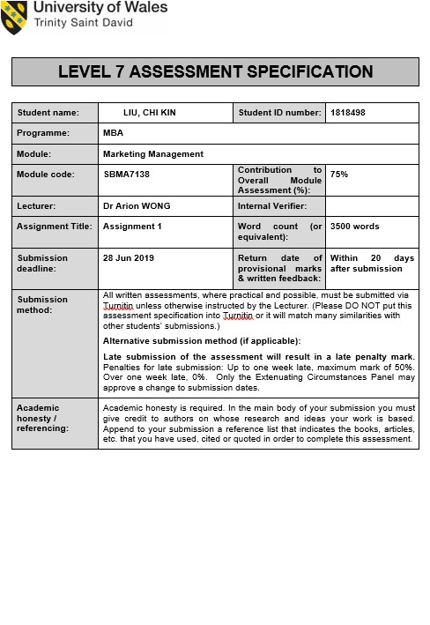

Executive Summary
Grocery retail is a highly competitive market and a major industry in Hong Kong. It is a moderated concentrated segment, and the entrance barrier is very high due to the geographical limitation and capital required.
HKTV mall created a very first eCommerce platform after the failure of application on the free broadcasting license. This horizontal expansion had drawn much attention from the industry. From the beginning of the launch only carried 75,000 SKU expended to over 280,000 SKU in 2019. Top three areas of generating sales are Grocery, Electronic Appliance, Personal Cares and Cosmetic, combined with a total of 70% of the gross merchandise volume.
The global economy surround by uncertainty factors, Trade war between the United States and China Trade war, Brexit, and other movements in Hong Kong generate an unpredictable economy, with all the instability, HKTV mall has to set a clear and yet achievable goal to prepare to face the challenge from the competitor.
Grocery retail falls into the mass market segment and the main objective in this segment is to expand and maintain market share, HKTV mall had layout a breakeven plan according to their latest annual report, expending the customer base, maintain competitive pricing, and drive customer satisfaction are the focus for the group.
Maintaining a low price is another critical componence in the mass market. Rental, wages, and listing fee, accumulate a majority of the retail price structure. In this study will exam these elements and how HKTV mall is capitalizing the advantage and the prediction on the future.
The private label has been proven to be an important profit-generating center around global retailers. By cutting out the middle man, the company can enjoy the full spectrum of transparency and have the ultimate control. The quality perception gap has been narrowed, and the growth rate is double compared to the branded product. Enjoy the technology advancement, HKTV mall is capable of conducting high dimensional data analysis, which able to give a clear direction during selection on product development. On top of widening the market, control the operating cost, and diversify the products, private label development should be an additional tool for the HKTV mall in the next few years.

Table of Contents

Executive Summary i
Table of Contents ii
1. Introduction 1
2. Situation Analysis 3
2.1 Political 3
2.2 Economical 3
2.3 Social 4
2.4 Technology 4
2.5 Online shopping behavior 5
3. Market Strategy 6
3.1 Product 6
3.2 Price 6
3.3 Promotion 7
3.4 Place 7
3.5 Online payment 8
4. Recommendations and Conclusion. 9
4.1 The benefit of developing the private label. 9
4.2 Pricing stregy for private label 9
4.3 Product 10
4.4 Place 10
4.5 Promotion 10
4.6 Conclusion 11
5. References 12

1. Introduction
Retail is one of the major industry in Hong Kong, this sector of trade contributed 4% of the total Hong Kong GDP in 2017 (Census and Statistics Department, 2017a) and employed over twenty-six thousand people (Census and Statistics Department, 2018a).
Hong Kong Consumer Council conducted a study on the grocery retail segment in Hong Kong, and concluded shopping grocery is moderated concentrated in Hong Kong. ParknShop and Wellcome are the top two Supermarket chain in the city together accumulated a majority share of 62.5% (Consumer Council, 2013).
Both ParknShop and Wellcome have a very similar background as both of them are back by a multinational conglomerate. ParknShop is part of the A.S. Watson Group which under CK Hutchison Holding. In 2018, CK Hutchison Holding reported revenue of US$ 35 billion (CK Hutchison Holding, 2018). On the other hand, Wellcome is under Jardine Matheson Holding Limited (Jardines Matheson Holding Limited, 2018), and their preliminary gross revenue in 2018 is US$92 billion (Jardine Matheson Holding Limited, 2019). To illustrate the scale of these companies, Hong Kong GDP in 2018 is just a bit over US$ 364 billion (Census and Statistics Department, 2018b).
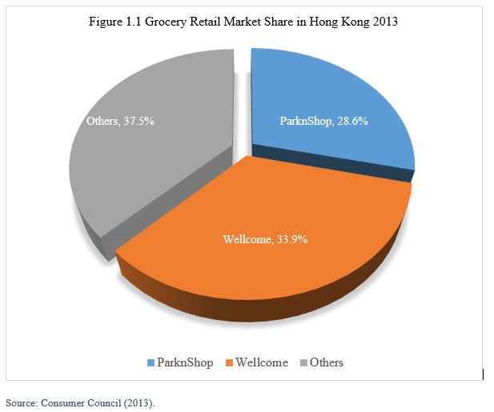
Although, Carrefour, a No. 2 global retailer (Carrfour, 2017) tried to set foot in this small market in the 19 centries but did not succeed. Carrefour's failure has been studied, and the reason is due to the high operating cost, and unable to differentiate from Hong Kong competitors (Ming-Ling et al. 2011, p.445). Carrefour decided to cut their losses and left the Hong Kong market in 2000 (Bastille Post, 2018).
Due to the geography limitation, Hong Kong has named the most expensive place to live (Siscovick, 2018), in turns, the high rental price is always a challenge for Hong Kong retailers. This unique demography phenomenon is a natural and robust barrier preventing competition enter into the market.
Interesting enough, HKTV capitalized the failure of free broadcasting license application, transformed the used to be broadcasting building into an automatic warehouse, created a 100% eCommerce platform, and managed their own delivery feet and became what we knew today as HKTV mall, competing in the retail market in Hong Kong.
Since the launch in 2015, HKTV mall had become a fresh and exciting model in the grocery retail market. With just three years, HKTV mall had one-tenth of Hongkonger age over 18 had shopped with HKTV mall (HKTV Network Limited, 2018) and became the most extensive online shopping platform in Hong Kong (Alexia, 2019). In this study will further look into the current situation impacting HKTV mall, the performance of the company, and suggestion to compete in the market.

2. Situation Analysis
The existing environment illustrates considerable uncertainty domestically and globally, this phenomenal impacting the economy is expected only unclear is the magnitude, with that said, Hong Kong is expected to face some great challenge in the next three years as all indicators point toward recession (SCMP, 2019a).

2.1 Political
In the United States, Donald Trump elected as the President in 2017, his unpredictable moves stir up the world and make the predictable economy unpredictable. Moreover, the United States and China is still in the middle of a trade war. President Trump administration has imposed the tariff three times since 2018 (Wong and Koty, 2019), and yet, the recent announcement by the President stated that he is not ready for a deal (SCMP, 2019c), implies this trade war has yet come to an agreement anytime soon.
In Europe, Brexit remains as a major instability factor in the continent. The Prime Ministry of the United Kingdom, Treacy May, has announced her resignation effective on June 7, 2019 (Prime Minster’s Office, 2019). With only four months, the new Prime Minister of UK has to execute the Brexit, and the EU Parliament is expecting the UK to leave the union by October 31, 2019 (European Parliament, 2019).
The latest move by the government is to put the Fugitive Offenders and Mutual Legal Assistance in Criminal Matters Legislation (Amendment) Ordinance (2019) into Legislation Council; this bill has raised a grave concern by foreign diplomats (SCMP, 2019b), believed passing of this legislation would jeopardizing the Rule of Law in Hong Kong. Despite a vast number of association or countries voice out their concern and a large scale of demonstration (The Guardian, 2019), there is no sign from the government will withdraw or amend the bill (Department of Justice, 2019).

2.2 Economical
The latest forecast from International Monetary Fund has revised the global economic growth from 3.7% down to 3.5%, and whole world advanced economic growth revised from 2.1% to 2.0 % in January 2019 (International Monetary Fund, 2019).
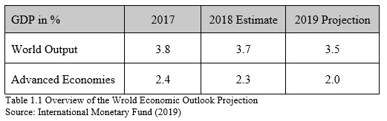

Domestically, Hong Kong GDP in 2018 increases 3.2% (Financial Secretary’s Office, 2018), and the unemployment rate was 3.6% (Census and Statistics Department, 2018c). Entering in 2019, the first quarter of GDP increased slightly by 0.6%, compared to the same quarter of last year, it has been dropped by 4.0% (Census and Statistics Department, 2019). Also, the GDP growth has been decreasing since 2018 Q1, which is a reliable indicator the economy is move toward into a recession.
Hong Kong has a Linked exchange rate with the US Dollar, historically, the interest rate in Hong Kong would follow the United States federal reserve system and revise parallel. In fact, the United States federal reserve system was increasing the Federal fund rate four times in 2018, from 1.5% to 2.5% (Trading Economics, 2019). However, the Hong Kong Monetary Authority did not follow, creating an interest rate gap between Hong Kong Dollars and US dollars. This interest rate gap has to get closer to maintain the stability of the currency and linked exchange system, which indicates that the interest rate will increase in the future.

2.3 Social
High rental cost in Hong Kong is not only affecting businesses but also creates social discontent. Since the handover to China in 1997, the government of Hong Kong put significant efforts on investing in infrastructures, and neglected the funding and demands the for school, hospital, and social services. Gini coefficient from 0.518 in 1996 (Hong Kong Economy, 2006) reaches to a record high of 0.536 in 2016 (Census and Statictic Department, 2017b), it is not hard to understand why Hong Kong is one of the unhappiest places in the world (Gallup, 2017).

2.4 Technology
Hong Kong is a very first city popularized the use of RFID. Octopus card company, a subsidiary of Mass Transit Railway was a massive success since the day launch, Over 99% of Honkonger aged between 15 to 64 holding at least one Octopus card for transportation payment and retailers in the city (Octopus, 2019). However, virtual banking has become popular in neighboring cities, WeChat Pay and Alipay are the major transaction tools in China. E-wallet became a must tool for an online platform which created a significant challenge to VISA and MasterCard, those traditional payment methods.

2.5 Online shopping behavior
Online shoppers are more likely to repeat and extend shopping to more categories (Concumer Council, 2016), in order to maintain customer satisfaction. Comments generate from the Facebook fan page is an excellent tool for gathering information as these are publicly access information. This electronic Word-to-Month (e-WOM) not only crucial to the company reputation (Sharma et al. 2019, p.285), but also able to predict the sale and product movement using various models (Lee, Xu and Lin, 2019, p.68).

3. Market Strategy
Segal and Giacobble (1994) stated grocery retail falls into the mass market segment, and the objective in this segment is to expand and maintain market share, expand the number of potential customers and product, sensitive to the price fluctuation, and build a loyal customer base (Waller and Millins, 2014). HKTV mall has layout a breakeven plan. In the coming years, the company will focus on the operation cost including merchandising, marketing promotion, new customer acquisition and customer services (HKTV Network Limited, 2018), which in line with the objective in the mass market segment.

3.1 Product
Diversity of products and services is a key objective in this market segment. In May 2019, over 290,000 SKU selling from the HKTV mall (HKTV mall, 2019c) and three highest turnover catalogues are grocery, personal care, and electronic compliance (HKTV Network Limited, 2018), as the current model did not have a physical store, after sales service is essential for customer satisfaction. Current Facebook Fan pages mixed with both positive and negative feedbacks, many of those negative feedbacks are related to AI auto-reply when a customer raised a question and unable to solve in a timely matter. This leads to low customer satisfaction, and the company should review their Customer services, staff training to reach a higher customer satisfaction rate.

3.2 Price
Price sensitivity is another key objective in the mass market. There are three major elements that contribute to the price in the Hong Kong retail market, which are rental, wages, and listing fee.
In traditional retails, 24 to 27% of the total cost is rental (HKTV Network Limited, 2016), since HKTV mall is 100% online and not require to have any physical stores, this can help them to reduce the operating cost, and in turns reduce the selling price, or enjoy a better profit margin.
As the minimum wages keep increasing in Hong Kong, the labor cost is another factor that directly correlated with the retail price. By having a centralized warehouse and robotic system, the company can minimize the staff number, even if the labor cost keeps increasing, will still have a softer impact compared to the traditional supermarkets business model.
Listing fee in another significant cost factor in the Hong Kong retail industry. In order to attract more merchants in partner with HKTV mall, the company decided not to acquire listing fee from their merchants, which not only able to keep a low retail price but also creates a diversification on the products.
The current practice of the Consumer Council of Hong Kong is to conduct a weekly price comparison in major grocery items selling in the Market (Consumer Council, 2019), the price is highly transparent which the customer expected now (Carter and Curry, 2010). With technological advancement, price comparison is much easier as it is just “one-click” away. Gathering information from a competitor and adjust the selling price can be program and computerized, providing a better induction for price change in the market (Shi et al. 2015, p.17) Python and R are famously used in the retail industries, track and alert the market movement only require a robust algorithm. In this big data generation, it is much more effective compared to traditional retail stores in providing the most updated information for the customer; for sure, this is an advantage for HKTV mall, in turns, differentiating low price strategy is needed to be more cautious.

3.3 Promotion
Social networks played a major factor in online business; it is an education tool that is transforming into an engagement. (Harris and Rae, 2010). HKTV Mall put significant efforts in an integrated marketing communication plan, including advertising, sales promotion, and public relations. As the company would like to draw strong audience attention, personal selling is not included in their plan.
Website, mobile app, Facebook, Instagram, and Youtube are the leading advertising platform. Compare to the traditional advert; the advantage is that the pacing is much faster. In partnership with Google (HKTV mall, 2018), emphasized three major areas, keyword adverts, graphical promotion, and active reinforce promotion.
Keyword adverts and graphical promotions are based on the inputs in the search and provide the related products and graphical image, fundamental of input-output relation which is a key for increasing sales (Goldfarb and Tucker, 2011, p. 389). Active reinforcing promotion is the engine will reinforce the advertising for that item that has been added into the basket but did not complete the transaction.
HKTV mall is using a mix sales promotion method that includes daily special, periodic promotion, theme promotion. The benefit of sales promotion is to gain full control of the message, and the cost to reach the customer is very low (Walker and Mullins, 2013).

3.4 Place
Traditional retails is limited by the number of stores and its operation hours, but these hurdle does not apply for an online platform. HKTV mall broke the barrier of traditional shopping, a recent study conducted by Go Globe (2014), indicated there are 96% of Hongkonger use their phone to go online every day, and 45% would use it for online shopping, 24-7-365 is a dinting advantage for HKTV mall. In turns, HKTV understood the importance of logistics in the eCommerce, which at the very early stage, ignored all the noise and developed their fleet to counteract of not having physical stores. According to the annual report (HKTV Network Limited, 2018), the fleet is now the longest in Hong Kong, and they will continue to capitalize on the advantage of having the own fleets.
The uniqueness of hiring over 360,000 foreign domestic helpers in Hong Kong (Census and Statistics Department, 2018c) play an essential role for HKTV mall. Domestic workers stay home for most of the time; this creates a flexible for delivery schedule. On the other hand, to cater to those who do not have a domestic worker, the company has offered an evening delivering schedule, from 1800 to 2200. Also, an online-to-offline (O2O) option was available in 2018. 46 O2O locations were set up and targeting to increase up to 120 shops by the end of 2019 (HKTV Network Limited, 2018).

3.5 Online payment
Virtual banking became popular in the neighboring city, the current payment method for HKTV mall is limited to traditional credit card, Payme by HSBC, and octopus card in O2O stores (HKTV mall, 2019a). With the increased popularity of other online payment methods. HKTV mall should consider widening their acceptance to other online payment methods.

4. Recommendations and Conclusion.
Durgee (1984) suggested consumer goods companies should move away from the mass market segment. However, HKTV mall has a short history in the market, and the company is trying to expand the audience and gain their consumer base, if only limited online shoppers, a niche market, which would gain fewer consumer (Toften and Hammervoll, 2009, p.1379), therefore, HKTV should stay in the mass market segment.
HKTV mall has already layout the plan for the next stages, increase the transition volume, get into servicing product, such as insurance or banking. However, using the current model and act as a distributor will lose control and influence on the product, and the competitiveness of the price in the mass market (Thomas, 2007, p.6). Beyond what has already been said in the annual report, developing the private label should be included in the future business development and gain a competitive edge.

4.1 The benefit of developing the private label.
The economic is not promising in Hong Kong, and it remains debatable whether or not it will fall into recession. Le and Nhu (2009) discussed the framework of being competitive during the recession economy. One of the most critical factors is to keep the retail price low. Shama (1981) also indicate that consumer behavior will toward more price sensitive during the recession economy.

4.2 Pricing stregy for private label
Price sensitivity remains the import factory in mass market when trying to increase market shares (Slater and Olson, 2001, p.1056). It has explained the advantage that HKTV mall has, the low operational cost in rental and labor. However, when economy going slow, the unemployment rate will go up, and the rental price will drop, which mean the competitiveness of HKTV mall originally had will be diluted and the gap between the HKTV mall and competitors will get closer. Also, the supplier base in Hong Kong is relatively limited, the current tactic of using parallel import to counteract with the local distributor will face a challenge when competing with other retailers for the same merchandise.
To look deeper into the situation and to learn the experience from global retailers, disintermediation and create the private label is the ultimate way to gain control of the whole supply chain (Bakos, 2001, p.76). In respect to market share growth, private label product within the retail sector is more than double compared to brand product (Mathews-Lefebvre and Valette-Florence, 2014, p.237). On the other hand, private label product is much more profitable compared to selling branded products. As long as the private label can meet the customer expectation, even the price is higher; the customer is still willing to buy private label (Steenkamp, Van Heerde and Gevsken, 2010, p.1011).

4.3 Product
When compared to the branded product, quality perception is the crucial attribute for the customer to choose between branded or private label. Consumer behavior toward grocery shopping has been well analyzing; the perception of quality is the strongest compared to another attribute (Walsh, Shiu and Hassan, 2012). Over the years, the quality perception gap getting closer, and consumer is much more acceptable on private label, which explained that the growth rate of the private label is much faster in the retail sector. Getting sales growth and able to enjoy a higher profit margin, this is the strong reason for HKTV mall to develop its private label.
Involvement vs Importance is well defined in marketing strategy (Robertson, 2018), based on this model, the first stage of developing the private label should focus on the commodities items. The characteristics of commodities sit at low emotion and low importance, the consumer will not spend much time on choosing commodities items which price became an essential factor when competing with branded product in commodities. Quality is signifantly higher for branded products only involvue technological complex categories. (Méndez, Oubiña, and Rubio, 2008, p.144).
To better understand and differentiate from the market leader and to bring benefit to the customer, coping with the Hong Kong lifestyle is important. Average Hong Kong living space is only 15 meter square per person (Wilson, 2014), which in turns limited storage become an essential factor. Smaller packaging size or single pack item will help to differentiate the product and bring benefit to the customer in Hong Kong.

4.4 Place
To better transform the needs from the customer, transaction data will be an essential tool during the development stage. These data can provide a clear direction what is the best selling item in each category, by further investigating the best selling item, it can provide a clear indicator on the price vs quality which is needed for benchmarking in private label development.

4.5 Promotion
Searchability is far most important for an online platform. With all stores trying to gather information to correlate the "keywords" and "intended" purchase, this phenomena can express as Maximum likelihood estimation (Baghfalaki and Ganjali, 2014, p. 341), HKTV mall had its owns database which has a much more competitive edge when it comes to promoting their private label product (Hughes, 2015). Besides, with years of purchasing behavior, HKTV mall has a destine advantage of understanding customer behavior. HKTV mall can achieve two-dimensional cross-selling, providing related items, and suggesting related items.
In-store promotional-based is a well used and understanding practice for the traditional market (Lockshin and Cohen, 2011, p.1236), by physically put the ice cream scope, a utensil item, next to the ice-cream freezer the creat synergy. For the online platform, it just needs to show the picture and making a suggestion. Break the barrier of 2-dimensional selling. The traditional supermarket would like to place the ice-cream scope next to the ice cream to promote cross-category selling. This practice involves operating cost, considerably slow and inefficacy.
In turns, cross-selling is much easier for the online platform. High-dimensional data has already been generating during each transaction, these data in combination with the correct algorithm can help to predict and maximize the sale (Pauleen and Wang, 2017, p.2), HKTV mall should utilize the information in private label development.

4.6 Conclusion
Global and Hong Kong economy is likely to go slow, in the mass market segment, covering a large variety of the audiences with a diversified product range, expending the customer base and maintaining a low price strategy should be the focal point for HKTV mall within the mass market segment.
In order to enhance the competitive edge, developing the private label for commodities items is an excellent expansion. Not only able to capture additional market share, but also generate a higher profit margin compared to become a disturber alone.
Capitalizing the online infrastructure, and maximize the data generate the transaction is essential to enhance the cross-selling and differentiate from the traditional grocery retailer. With the technology advancement, HKTV mall is capable of conducting high dimensional data analysis, which able to give a clear direction during selection on product development, which will be a key of success on private label development.

5. References


