

Master of Business Administration

Financial Management

LCMB7002

Assessment component: Financial performance and management

FINANCIAL PERFORMANCE EVALUATION, WORKING CAPITAL MANAGEMENT, STRATEGIC FINANCIAL RESTRUCTURING, AND INVESTMENT APPRAISAL OF INTERCONTINENTAL HOTELS GROUP (IHG)

Lecturer name: DR shengfeng mei

Student name: Milankumar Manishkumar Upadhyay

Student ID: 2541470

Word count: 4987

Submission date: 12/08/2026

Executive Summary

The financial health of InterContinental Hotels Group (IHG) was analysed for the period 2021-2025, considering its profitability, liquidity, working capital management, financial restructuring, and investment appraisal. After the pandemic recovery, IHG's revenues rose substantially and its net profit improved, in addition to the overall improvement in asset utilisation, the analysis found. However, key reasons given for the lack of liquidity ratios and negative shareholders' equity were the company's asset-light business model and its capital management rather than its operating performance. The report also considered the reasons why the company was utilizing working capital, as well as made some recommendations on how to boost cash flow, aspects of digital innovation and smart financing options. The Net Present Value (NPV) analysis showed that the investment project is financially viable and helps to generate a value adding investment. Finally, the report reiterated the importance of AI in data analysis, explaining that AI is improving the efficiency of the game of numbers, but protocols and systems have to be put in place to ensure the academic rigor and accuracy of the game of numbers.

Table of Contents
1. Introduction 5
2. Financial Health Check 5
2.1 Overview of Financial Performance 5
2.2 Ratio Analysis 6
2.2.1 Net Profit Margin 6
2.2.2 Return on Assets (ROA) 7
2.2.3 Return on Equity (ROE) 8
2.2.4 Liquidity Ratios 9
2.2.5 Inventory Turnover 10
2.3 Trend Analysis 11
2.4 Strengths and Weaknesses 12
3. Working Capital Management Analysis 12
3.1 Cash Operating Cycle 12
3.2 Liquidity Evaluation 13
3.3 Improvement Strategies 13
3.4 Financing Options 14
4. Strategic Financial Restructuring Plan 14
4.1 Need for Restructuring 14
4.2 Proposed Strategies 15
4.3 Impact Analysis 15
4.4 Global & Ethical Considerations 16
5. Investment Appraisal & Capital Budgeting 16
5.1 Project Evaluation Methods 16
5.2 Evaluation of Projects A, B, and C 17
5.3 Project Selection 17
5.4 Capital Rationing Decision 17
5.5 Risk Considerations 17
6. Critical Reflection on AI Usage 18
7. Conclusion 19
References 20
Appendices 23
Appendix 1: Income Statement 23
Appendix 2: Balance Sheet 25
Appendix 3: Ratio Analysis 28
Appendix 4: Investment Appraisal Calculation 29

1. Introduction
InterContinental Hotels Group (IHG) is a worldwide hospitality group with a diverse portfolio of hotel brands and an asset-light business model, including franchising and management contracts. This report is focused on estimating core financial statements of this renowned company with an aim to measure profitability, liquidity, and solvency. Such obtained data are, therefore, predicted to be helpful for the management to spot cash shortages, manage risks, and plan for growth using key financial data. Financial statement analysis, ratio analysis and trend analysis will be used to determine IHG's financial viability in the period 2021 to 2025. It further examines working capital management, liquidity and financing strategies before proposing a strategic financial restructuring plan. Three investment projects are appraised using investment appraisal techniques, and then a critical reflection on the role of Artificial Intelligence in the preparation of this report is made.

2. Financial Health Check

2.1 Overview of Financial Performance
In spite of the uncertainty faced by hotels all over the world, InterContinental Hotels Group (IHG) recovered well over the last 5 years, spanning from 2021 to 2025. Revenue is set to rise from US$2,318 million in 2021 to US$5,189 million in 2025 as occupancy increases, reflecting a rebound in leisure and business travel demand, as well as an expanding franchised hotel and management fee revenue (Annual Report, 2021). As a result of the company's asset-light business model, its recurring revenue portfolio continued to improve and capital investment needs were lower (Annual Report, 2025). Net income also showed a dramatic increase in value, from US$266M to US$758M, despite some inflationary pressures, in relation to a pricing and operations strategy that has proven effective. Over the three years, total assets had risen from US$2,066 million during 2021 and 2022 to US$1,678 million, primarily due to investment activities and lease accounting adjustments (Annual Report 2023). Shareholders' equity still continued to be negative (now at –US$2,736 million) [Refer to Appendix 1, 2]. It is so because the company interpreted it as the result of share repurchases and dividend distributions, yet not because of financial hangovers. (Annual Report, 2022). According to Sharma et al. (2021), innovation seems to provide resilience to the hotel during disruption. Altogether, IHG's financial results illustrate that the company is successfully managing its operations and expanding its presence in the business world with an asset-light approach.

2.2 Ratio Analysis

2.2.1 Net Profit Margin
Figure 1: Analysis of Net Profit Margin
(Source: Excel)
Net Profit Margin indicates the percentage of revenue that a company retains after covering its operating and finance costs and taxation, thus making it a good measure of operational efficiency and profitability. Despite temporarily peaking in 2023 at 16.2%, IHG's Net Profit Margin was robust over the 5 years, from 11.5% in 2021 to 14.6% in 2025 (Annual Report, 2025). The overall improvement suggests that the company managed its operating costs appropriately while enjoying improved room demand, improved pricing and growth in its asset-light franchise and management business. This drop following 2023 is primarily due to cost pressures on the business post-2023, cost of labour and investments in digital technologies and global expansion will be the cause [Refer to Appendix 3]. As stated by Tong-On et al. (2021), the use of Business Intelligence and Data Analytics contributes to better hotel profitability by supporting Revenue Management, forecasting accuracy and operational decision-making. Likewise, Amoako et al. (2023) revealed that digital innovation can boost customer satisfaction and stimulate rebooking, which contributes to improved long-term financial results. From an overall perspective, IHG's closing of the Net Profit Margin is a positive development, driven by robust cost management, operational agility and execution of their asset-light approach. The trend of rising profitability indicates that the company has good potential to sustain earnings despite the challenges from the outside, including inflation and economic uncertainty (IHG, 2026).

2.2.2 Return on Assets (ROA)
Figure 2: Analysis of ROA
(Source: Excel)
The Return on Assets ratio reflects a company's efficiency with all its assets in creating net profit, and it is therefore important as an indicator of efficiency. The ROA rose significantly from 12.9% (2021) to 37.0% (2025), with a highest peak of 42.7% in 202,3 and settled moderately in the next 2 years (Annual Report, 2025). The general rise illustrates the company's capacity to produce significantly larger profits while also maintaining a fairly stable level of assets [Refer to Appendix 3]. Much of this was the result of IHG's asset-light strategy of increasing value by operating through franchises and hotel management contracts rather than making a large capital-intensive investment in building properties and, in some instances, owning them. The slight decline goes beyond the impact of the operational decline, as it is mainly driven by investments in the digital transformation, technology enhancements and global growth strategies. Mariani and Borghi (2021) stated that AI and digital technologies improve operational efficiency, service quality and organisational performance in the hospitality sector. Overall, IHG's ROA is consistently robust, reflecting the asset-light strategy, the implementation of the marketing concept, strong asset utilisation and wise financial management.

2.2.3 Return on Equity (ROE)
Figure 3: Analysis of ROE
(Source: Excel)
Return on Equity (ROE) is a measure of return on investment by equity holders and is commonly used to evaluate the performance of a manager in generating value for equity investors. However, this should not be interpreted as ROE for IHG because the net profits of IHG were all positive, but the ROE was negative due to the negative shareholders' equity present throughout the review period. Despite facing dividend distributions and capital management decisions compared to the amount of significant share repurchases, shareholders' equity reduced due to operational losses from -US$1,474 million in 2021 to -US$2,736 million in 2025 (Annual Report, 2024). Thus, IHG has financed poorly, rather than performed poorly, and the result is that the negative ROE is attributable to its financing policy and its capital structure. Lusiana et al (2021) argued that only financial performance can be assessed from several financial indicators instead of one accounting ratio. Thus, the financial performance of IHG can be better evaluated by profitability ratios like Net Profit Margin and Return on Assets, which reflect the company's potential to achieve sustainable earnings and make efficient use of its resources.

2.2.4 Liquidity Ratios
Figure 4: Analysis of Current Ratio
(Source: Excel)
Figure 5: Analysis of Quick Ratio
(Source: Excel)
As inspired by the ideas of Gunawan (2023), liquidity ratios reflect a company's current resourcing of its short-term debt obligations with current assets. IHG's liquidity position remained relatively stable throughout the five years, although both the Current Ratio and Quick Ratio were consistently below the conventional benchmark of 1.0 [Refer to Appendix 3]. The current ratio range was between 0.76 and 0.98, with the value being 0.80 in 2025, meaning that the current liabilities were running higher than the current assets (Annual report 2025). The Quick Ratio also mirrored the same trend, as the Hotel businesses have a relatively small ratio of inventory to total current assets. These ratios indicate a relatively comfortable short-term liquidity situation, but are not uncommon for an asset-light hospitality business that earns predictable operating cash inflow through a stable mix of hotel management contracts and franchising. These companies typically have less working capital than value-intensive companies. Crespí-Cladera et al. (2021) have underlined the importance of maintaining proper liquidity as a critical success factor for the hospitality industry in the period following the pandemic. Overall, the liquidity ratios of IHG are not particularly high, but the company's solid cash-generation capabilities and the regular fee income suggest that it may be in an advantageous position to fulfil short-term payments and sustain future growth efforts.

2.2.5 Inventory Turnover
Figure 6: Analysis of Inventory Turnover Ratio
(Source: Excel)
Consists of how quickly a company can get an item out of its warehouse (or stockroom) into its customers' hands. Food, drinks and operating supplies are hotel properties' greatest asset, as IHG is a large hotel services company, and does not own any hotels, earning the majority of the company's income from franchising and hotel management contracts (IHG, 2025). As estimated in Appendix 3, inventory turnover of this company increased from 320.25 to 390.5 in 2022 and again reduced to 357.8 the next year (2023). It, however , reached its peak in last 5 years in 2024 with a value of 479. This means that inventories are not as big as a percentage of total assets and are lower than companies that carry more inventories like the hospitality sector. IHG's stocks turnover was maintained at the same level throughout the period, with stocks being managed effectively and the level of capital invested in stocks being low (Annual Report, 2025).
Having control over inventory will assist in avoiding unnecessary wastage and spoilage, reduce the load on storage space and or handling fees and will ensure that IHG managed and IHG owned hotels are supplied with the critical inventory they require on time. This results in more efficient day-to-day business operations, enhanced customer service and good cash flow controls. Moreover, having an ideal level of inventory reduces the requirement for extra working capital and boosts business efficiencies. Norris et al. (2021) proposed that businesses might consider using a flexible inventory management system as a way to ensure their operations remain resilient in the event of market disruptions while also supporting their business continuity plans. IHG's asset-light business model complements their good inventory management, which helps enhance working capital efficiency, while support in delivering their service level and good sustainable financial performance across its hotel network globally.

2.3 Trend Analysis
IHG's financial trends show the company has recovered its position after being affected by the Covid-19 pandemic throughout the last five years. Global travel demand was recovering well, and the hotel portfolio was growing, as reflected by the revenue growth from US$2,318 million in 2021 to US$5,189 million in 2025 (Annual Report, 2021; Annual Report, 2025). Likewise, the net profit jumped from US$266 million to US$758 million during the same period, due to better operational and pricing strategies. Profitability ratios even had positive numbers too. Net Profit Margin grew from 11.5% to 14.6%, and Return on Assets came up from 12.9% to 37.0,% reflecting greater efficiency in the use of assets. Consequently, although this reduced IHG's ROE due to the company's negative shareholders' equity, it was a consequence of capital management rather than a sign of poor operating results. Current liquidity position ratios continued to be lower than usual, indicating the reliance on solid operating cash flows to cover the current short-term debt requirements. As illustrated in the financial table, IHG has been able to enhance its earnings whilst maintaining minimal levels of asset investment due to its asset-light business model. Studies by Sharma et al. (2021) have revealed that innovation or adaptability to operations improves the financial resilience of the hospitality industry under uncertainty. Overall, IHG's financial performance signals continued recovery and enhanced profitability and operational efficiency, with liquidity management to be kept in check.

2.4 Strengths and Weaknesses
IHG shows strong financial attributes which benefit its competitiveness for the long-term. This asset-light business model coupled with its global brands certainly helped drive its strong revenue growth and continued high profitability for the last 5 years. Their capital needs were abated because their franchise fee revenue was good and their cash flow was steady. Other investments in digital and operational innovations have also strengthened their experience and business results. Amoako et al. (2022) highlighted the need for stakeholder collaboration to build the long-term sustainability and competitiveness of organisations and sustainable tourism. Despite these strengths, however, there are a number of financial shortcomings. Hence, liquidity ratios are less than 1.0 would indicate relatively low short-term financial flexibility, and if the negative shareholder's equity is largely due to capital management strategies it could result in an unfavourable investor impression. That may lead to higher operating costs caused by inflation, the inability to find the necessary workforce, geopolitical uncertainty and it could be a threat to profitability in the future. In addition, climate risks and sustainability expectations are still having an impact on investment decisions in the hospitality industry. Zhou et al. (2023) noted that financial risks stemming from climate change are becoming more influential for corporate financing and the long-term performance of investments. As a result, IHG will continue to need to be financially resilient with effective liquidity management and sustainable growth strategies in the future.

3. Working Capital Management Analysis

3.1 Cash Operating Cycle
The Cash Operating Cycle (COC) is the time that a company takes from spending cash in its operations to receiving cash payments from its customers. An asset-light operating model, IHG generates a significant volume of revenue through franchise and management contracts, with a cash operating cycle that is much shorter compared to businesses with extensive inventories or long credit terms with large customer bases. Low stock levels have been maintained, and receivables are kept under control by fixed contractual agreements with franchisees and business customers. Meanwhile, the business has favourable trade payable terms with suppliers, allowing it to fund part of the business using trade payables. The characteristics of the company helped it to invest in core working capital to be available for operations every day and improve cash flow efficiency (Annual Report, 2025). González-Torres et al. (2021) suggested that during disruptions, supply chain coordination and stakeholder relationships play a role in increasing operational resilience and better cash flow management. IHG's relatively efficient cash operating cycle will enable liquidity, improve operational flexibility and complement its asset-light business model by minimising the need for significant investment in working capital.

3.2 Liquidity Evaluation
The assessment of the company's liquidity mirrors its ability to meet the current obligations and its ability to operate the business efficiently day-to-day. IHG's liquidity was not high during the review period as the Current Ratio remained less than 1.0 and is as low as 0.80 in 2025 which shows that current assets were less than current assets (Annual report, 2025). The ratios can seem a sign of the company's liquidity liability initially, but most often are noted by asset light hospitality businesses with consistent cash flow, rather than substantial working capital balances. IHG's franchise and management fees generate cash revenues in the business, thus reducing the need for carrying inventories and trade receivables. This is the kind of business where despite its small size, it can operate efficiently due to its lower level of liquidity ratios. However, though not for these reasons alone, a proper cash reserve is still necessary because unexpected economic slowdowns, inflation or the disruption of world tourism may affect the cash generation for a while, but adequate cash reserves can make up for those hurdles. Jafari et al. (2023) stated that when faced with an environment of uncertainty, financial resilience and effective liquidity management has emerged as an important area of interest for hospitalities organisations. To sum up, the liquidity of IHG is satisfactory, however continued actions are going to play a vital function in the short-term and in its near-term commitments as the key to sustainable growth and expansion.

3.3 Improvement Strategies
While IHG's asset-light approach is conducive to effective use of working capital, there are still a number of nodes that can be strengthened to give IHG further liquidity strength. Implementing a sophisticated Business Intelligence (BI) system can make business cash flow planning more effective and meet the funding needs of the company. If digital payment solution and automation of the work on receivables will be implemented, the collection processes, both from customers at the franchisee's level and from corporate customers, would be shortened. Further, being better able to negotiate terms of payment with the supplier that would be more favourable, but still while maintaining good business relations, would improve cash flow flexibility. Food and beverage operations could benefit from having better inventory control, which will lower the holding costs and minimise waste. Further, the implementation of Artificial Intelligence and predictive analytics would also help to improve accuracy of forecasts, pricing and planning. Mariani and Borghi (2024) argue that AI facilitates more rapid and accurate decision-making processes, which helps enhance service operations and organisational resilience. These will help build liquidity as well as increase efficiency and sustainability for IHG's long-term growth.

3.4 Financing Options
Contingent on IHG's liquidity requirements, it can partner with financing methods such as short-term or long-term financing in accordance with their strategic targets. These are temporary financing, which are in the short-term nature, e.g. bank overdrafts, use of trade credit or the placement of revolving credit facilities, and can help to arrange and deal with the seasonal demand for working capital, but may not be suitable for long-term growth as there is a risk of refinancing and fluctuating interest rates. The long term financing are debt finance, corporate bond, and bank loan and equity finance is used for sources of finance that involve strategic investments and expansion abroad. Cost containment and flexibility over a long period of time might be suitable for IHG in order to utilise their capabilities of a bond issue for future growth. According to Sadiq et al. (2022), sustainable finance allows organisations to harmonise their financial and environmental and social efforts. Therefore, a sustainable financing model must be accepted that ensures a financially balanced capital structure, growth in expansion, digital innovation and environmental sustainability for IHG.

4. Strategic Financial Restructuring Plan

4.1 Need for Restructuring
While IHG has proven to have good revenue growth and improving financial performance, strategic financial restructuring is now essential in order to be more resilient in the future. In 2025, the firm's net share repurchases coupled with dividend payments brought the negative shareholders' equity of –US$2,736 million, notwithstanding its robust operating performance (Annual Report, 2025). Besides, the relatively low level of liquidity ratios and the uncertainties in the world economy also point to the continued need for solid financial flexibility. Future operating costs and investments may also be impacted by rising inflation and increased borrowing rates as well as geopolitical tensions. The constant changes in customers' expectations, digital transformation, and sustainability are creating pressures on the hospitality business and the need for ongoing financial restructuring. According to Crespí-Cladera et al. (2021), financial pressure faced by hospitality firms should be resolved by building up their capital structure and increasing their financial flexibility so that they can achieve their long-term resilience. IHG needs to regularly reassess its financial policies, allocate capital and investment priorities appropriately to have an adequate amount of capital resources for future growth and provide a stable return to its shareholders.

4.2 Proposed Strategies
IHG needs to implement several financial restructuring measures as an aid to sustainable growth and to build a secure long-term financial position. Firstly, the company will need to maintain its asset-light strategy and continue to grow its franchise and management fees, rather than making substantial investments in hotel ownership. This approach could lower the up-front cost of the project and provide steady, consistent revenue while running the business. Secondly, gradually correct capital structure by reducing the scale of shares repurchased in the future and retaining a larger percentage of profits to enhance shareholders' equity and financial strength. Debt refinancing must also be considered when the interest rate is more favourable, helping to optimise the financing costs and also cash flow effectiveness. IHG should continue to invest in digital transformation and give greater emphasis on developing AI functionalities, data analytics, and customer relationship management systems, for increased operational efficiency and greater guest satisfaction. Furthermore, the enhanced commitment to environmental, social and governance (ESG) initiatives would boost the company's reputation and aid in delivering long-term value creation. Farooq et al. (2022) found that by promoting environmentally sustainable practices, HRM for green organisations positively impacts innovation and organisational performance in luxury hotels. Therefore, expanding sustainability programmes in parallel with digital innovations would enhance the financial situation and, overall, the competitive position. All these restructuring measures would have a positive effect on profitability, operational efficiency and financial stability, and would assist IHG's strategy for the foreseeable future.

4.3 Impact Analysis
The restructuring plans detailed will provide IHG with good financial and operating results. The asset-light model will generate lower capital investment costs and more recurring income stream from management and franchise fees, resulting in more profits and cash generated for the organisation. The more it does, the more the power of the company would definitely get strengthened in the long run for which retention of earnings shows. The power of the company would certainly get only strengthened with every earnings being retained. The finance costs might also be lowered and the financing process would offer financial flexibility by refinancing the loans if it is identified that the Finance Rates are favourable. Additionally, an enhanced digital boost in investment would lead to more productive working efficiency and a greater revenue management and customer satisfaction, it is likely to produce better long-term growth performance and lead to better revenues. Besides this, AI could also be leveraged to enhance resilient service operations regarding decision-making, service operating performance and optimising the creation of customer value (Mariani and Borghi, 2024). As part of IHG's rebalance in its overall financial stability, the restructuring plan is expected to create a positive impact on IHG's shareholder value and improve IHG's ability to respond to market dynamics. All this would help the company to remain competitive and profit out of the world of tourism.

4.4 Global & Ethical Considerations
A multinational hotel firm like IHG needs to take into account international financial risks and ethical obligations in the pursuance of financial restructuring. The flow of revenues, operating costs and investment returns from foreign sources may be subject to substantial fluctuations due to exchange rate changes, inflation and foreign policy risks. Therefore, proper foreign exchange risk management and spreading business around the world are still critical factors to keep financial stability even. Furthermore, environmental sustainability and corporate governance are additional factors which have reflected in investors' confidence and sustainable competitiveness to a larger extent. Implementing ESG strategies, lower carbon footprints and doing good business is both a trend gaining momentum and a way to enhance corporate image and sustainable financial outcomes. Kılıç et al. (2021) reported that by adopting sustainability governance, organisational performance is also improved, leading to sustainable long-term competitiveness in the hospitality industry. Additionally, ethical decision-making, transparent financial reporting, and responsible stakeholder relationships will foster investor trust and compliance with regulations in global markets. IHG will equip itself with better satisfaction of current customers, increase its financial performance and build longer-term shareholder value. Financial discipline and sustainability, and ethical governance policies, hand-in-hand, will improve IHG's global reputation.

5. Investment Appraisal & Capital Budgeting

5.1 Project Evaluation Methods
InterContinental Hotels Group (IHG) was considering a five-year digital transformation project; the financial viability of the project was assessed through investment appraisal. The project was given a US$80M start-up to upgrade hotel management systems and create digital hospitality technology to enhance operational efficiency, customer experience, and franchise performance. The investment was estimated to be fully depleted after 5 years and with no residual value, and the investment risk was estimated to be 12% of the cost of capital [Refer to Appendix 4]. The Net Present Value (NPV) is the main investment appraisal technique chosen as it takes the time value of money into account and identifies if the discounted future cash flow is greater than the investment made. According to Sadiq et al. (2022), Sustainable investment appraisal is important for supporting the value of the organisations in the long-term by linking the financial returns of investment with long-term strategic goals.

5.2 Evaluation of Projects A, B, and C
Payback Period, Accounting Rate of Return (ARR), Internal Rate of Return (IRR), Net Present Value (NPV) and Profitability Index (PI) are used to evaluate Projects A, B and C. The analysis revealed that Project B would have the most positive NPV, the highest IRR and the best Profitability Index, and it would pay back the original investment within a reasonable time period. Project A generated returns, but IQ was less than that of Project B; Project C was overall poorly performing but positive. Project B has a positive NPV as the present value of future cash flows is greater than the initial cash flow, making it the most attractive option. Mariani and Borghi (2024) suggest that the use of artificial intelligence and digital technologies supports hospitality businesses to be more efficient and resilient.

5.3 Project Selection
The findings from the investment appraisal of the projects showed that Project B offers the highest financial return and aligns with the long-term objective of digital transformation and operational excellence of IHG. The project will be achieved through revenue management, in terms of Customer experience and franchise performance, and to build a stronger Competitive advantage in the international market. Tong-On et al. (2021) discovered that usage of business intelligence and data analytics can improve decision-making, operational effectiveness and long-term competitiveness in the hospitality industry. The other aim is to maximise shareholder wealth, which is achieved when the project with maximum NPV is chosen.

5.4 Capital Rationing Decision
IHG should focus on Project B when investing funds are scarce, for it yields the highest NPV and maximises the shareholders' value. Capital rationing involves organisations choosing projects that have the highest financial return when they do not have enough financial resources to fund all of their projects. If a fund becomes available, Project A could be considered, and in the event that no additional funding becomes available, Project C may be funded at the lowest priority due to the relatively weak investment performance. Sadiq et al. (2022) gave special attention to the importance of effectively allocating investment so that long-term organisational performance will increase by allocating resources for value creation projects.

5.5 Risk Considerations
While Project B may be a good payoff, other potential risks exist, such as slower adoption of the technology, threats to cybersecurity, inflation, shifting consumer tastes, and global economic uncertainty. Projected cash inflows could be decreased, or the implementation costs could be increased by these factors. According to Mariani and Borghi (2024), digital transformation is a journey that necessitates organisational flexibility and employee adaptability, as well as effective implementation. Moreover, regular review of the project, monitoring of risks and contingency planning will enhance the outcome of the investment and reduce the risks occurring in the implementation process. In conclusion, while there are some uncertainties, the overall benefit of Project B is the long-term strategic and financial value that it brings, making it the preferred investment.

6. Critical Reflection on AI Usage
The Artificial Intelligence (AI) has been used for assistance in preparing this financial management report to aid research, data organization, interpretation of the data and academic writing. A tool that required AI was used to find academic articles and structure the often complicated financial data and information into a logical report structure. They also helped them in their financial statement analysis, accounting ratio analysis and comparison of financial performance of InterContinental Hotels Group (IHG) for 5 years. Automation of tasks such as literature search, summarisation of data and smoothing of language allowed for more efficient and shorter report writing. It refined the report to make it clearer, more coherent and academically sound and increased the financial analysis and evidence-based recommendations. Though AI provides many advantages, it also has its shortcomings. Information obtained from AI may be inaccurate, subjective or unreliable in terms of interpretation of information or the references. Financial data always evolves in the course of time and detached verification is essential. All financial data, ratio calculations and academic references used in this report have, therefore, been checked against the last 5 years Annual Reports of IHG. These have been published and peer reviewed and have been used to incorporate such data as part of the analysis used in this report. In addition, AI is incapable of mimicking professional skills, critical thinking and judgment skills of humans.
Financial analysis is not just a number crunching. As per the ideas of Fridson and Alvarez (2022), it has to incorporate appreciation of business strategy, the business that you are in and management decisions. Hence, there had to be the ability to interpret the financial performance and to make recommendations; therefore, the need also existed for independent analyses and criticism. There are ethical challenges and concerns with the use of AI tools in educational environments, including integrity issues and the responsible use of AI. AI should be used as an aid, not a replacement FOR, nor independent thought, nor independent analysis. AI was only used as a research and writing tool during this report, and all the conclusions and recommendations in the report were developed in isolation. Overall, the implementation of AI technologies enhanced the effectiveness and quality of report work while simultaneously adding an element of risk, the need for verification, and a need to incorporate independent judgement to ensure academic integrity and to sufficiently support robust financial analysis.

7. Conclusion
The study and assessment of Financial Performance, Working Capital Management, Strategic Financial Restructuring and Investment Appraisal of InterContinental Hotels Group (IHG) is covered in the annual reports of 2021-2025. Overall, the results are calculated to be positive and representative of the effectiveness of the company in implementing their asset light business model as reflected in the model's revenues. This, in turn, showed positive growth, alongside asset utilisation and profitability being improved. The liquidity ratios were not as good as normal ratios and the negative share equity was particularly associated with the process of capital usage, rather than with bad operations. Further investment in digital transformation, sustainable investment, and good capital management have the potential to further enhance the power of finance in the future; the case of Financial Restructuring options and positive investment appraisal is just such an example. Consequently, IHG will continue its path to profitable growth, sustain an improvement of shareholder value and will be a major player in the hospitality industry worldwide.

References
Amoako, G.K., Doe, J.K. and Neequaye, E.K., 2023. Online innovation and repurchase intentions in hotels: the mediating effect of customer experience. International Hospitality Review, 37(1), pp.28-47. https://www.emerald.com/ihr/article/37/1/28/112773
Amoako, G.K., Obuobisa-Darko, T. and Ohene Marfo, S., 2022. Stakeholder role in tourism sustainability: The case of Kwame Nkrumah Mausoleum and centre for art and culture in Ghana. International Hospitality Review, 36(1), pp.25-44. https://www.emerald.com/ihr/article/36/1/25/107192
Annual Report, 2021. IHG Annual Report 2021. Available at: https://www.annualreports.com/HostedData/AnnualReportArchive/i/NYSE_IHG_2021.pdf [Accessed on 28.07.2026].
Annual Report, 2022. IHG Annual Report 2022. Available at: https://www.annualreports.com/HostedData/AnnualReportArchive/i/NYSE_IHG_2022.pdf [Accessed on 29.07.2026].
Annual Report, 2023. IHG Annual Report 2023. Available at: https://www.annualreports.com/HostedData/AnnualReportArchive/i/NYSE_IHG_2023.pdf [Accessed on 28.07.2026].
Annual Report, 2024. IHG Annual Report 2024. Available at: https://www.annualreports.com/HostedData/AnnualReports/PDF/NYSE_IHG_2024.pdf [Accessed on 27.07.2026].
Annual Report, 2025. IHG Annual Report 2025. Available at: https://www.ihgplc.com/~/media/Files/I/Ihg-Plc/investors/annual-report/2025/ihg-ar25-interactive.pdf [Accessed on 28.07.2026].
Crespí-Cladera, R., Martín-Oliver, A. and Pascual-Fuster, B., 2021. Financial distress in the hospitality industry during the Covid-19 disaster. Tourism Management, 85, p.104301. https://www.sciencedirect.com/science/article/pii/S0261517721000200
Fridson, M.S. and Alvarez, F., 2022. Financial statement analysis: a practitioner’s guide. John Wiley & Sons. https://books.google.com/books?hl=en&lr=&id=wn5qEAAAQBAJ&oi=fnd&pg=PA25&dq=Financial+analysis+is+helpful+for+business+&ots=BvXDKKvaN-&sig=PU39v7cmRaH61_ATsRyMXdigUls
Farooq, R., Zhang, Z., Talwar, S. and Dhir, A., 2022. Do green human resource management and self-efficacy facilitate green creativity? A study of luxury hotels and resorts. Journal of Sustainable Tourism, 30(4), pp.824-845. https://www.tandfonline.com/doi/abs/10.1080/09669582.2021.1891239
Gunawan, E., 2023. Liquidity Ratio Analysis in Financing Short Term Liabilities. International Journal of Health, Economics, and Social Sciences (IJHESS), 5(2), pp.157-162. https://jurnal.unismuhpalu.ac.id/index.php/IJHESS/article/view/3611
González-Torres, T., Rodríguez-Sánchez, J.L. and Pelechano-Barahona, E., 2021. Managing relationships in the Tourism Supply Chain to overcome epidemic outbreaks: The case of COVID-19 and the hospitality industry in Spain. International journal of hospitality management, 92, p.102733. https://www.sciencedirect.com/science/article/pii/S0278431920302851
IHG, 2026. About Us. Available at: https://www.ihgplc.com/about-us [Accessed on 24.07.2026].
Jafari, K., Özduran, A. and Saydam, M.B., 2023. Hospitality and tourism industry amid COVID-19 pandemic: voices from small Mediterranean town. International Hospitality Review, 37(2), pp.243-264. https://www.emerald.com/ihr/article/37/2/243/106539
Kılıç, M., Uyar, A., Kuzey, C. and Karaman, A., 2021. Drivers and consequences of sustainability committee existence? Evidence from the hospitality and tourism industry. International Journal of Hospitality Management, 92. https://avesis.samsun.edu.tr/yayin/2506d47f-c297-4a0d-905e-90cb42f3ad67/drivers-and-consequences-of-sustainability-committee-existence-evidence-from-the-hospitality-and-tourism-industry
Lusiana, M., Haat, M.H.C., Saputra, J., Yusliza, M.Y., Muhammad, Z. and Bon, A.T., 2021, March. A review of green accounting, corporate social responsibility disclosure, financial performance and firm value literature. In Proceedings of the International Conference on Industrial Engineering and Operations Management (Vol. 7, No. 2, pp. 5622-5640). https://www.researchgate.net/profile/Jumadil-Saputra/publication/375513115_A_Review_of_Green_Accounting_Corporate_Social_Responsibility_Disclosure_Financial_Performance_and_Firm_Value_Literature/links/682eecc5026fee1034fa12c3/A-Review-of-Green-Accounting-Corporate-Social-Responsibility-Disclosure-Financial-Performance-and-Firm-Value-Literature.pdf
Mariani, M. and Borghi, M., 2021. Customers’ evaluation of mechanical artificial intelligence in hospitality services: a study using online reviews analytics. International Journal of Contemporary Hospitality Management, 33(11), pp.3956-3976. https://www.emerald.com/ijchm/article/33/11/3956/126269
Mariani, M.M. and Borghi, M., 2024. Artificial intelligence in service industries: customers’ assessment of service production and resilient service operations. International Journal of Production Research, 62(15), pp.5400-5416. https://www.tandfonline.com/doi/abs/10.1080/00207543.2022.2160027
Norris, C.L., Taylor Jr, S. and Taylor, D.C., 2021. Pivot! How the restaurant industry adapted during COVID-19 restrictions. International Hospitality Review, 35(2), pp.132-155. https://www.emerald.com/ihr/article/35/2/132/111049
Sadiq, M., Nonthapot, S., Mohamad, S., Chee Keong, O., Ehsanullah, S. and Iqbal, N., 2022. Does green finance matter for sustainable entrepreneurship and environmental corporate social responsibility during COVID-19?. China Finance Review International, 12(2), pp.317-333. https://www.emerald.com/cfri/article/12/2/317/110794
Sharma, A., Shin, H., Santa-María, M.J. and Nicolau, J.L., 2021. Hotels' COVID-19 innovation and performance. Annals of Tourism Research, 88, p.103180. https://www.sciencedirect.com/science/article/pii/S0160738321000426
Tong-On, P., Siripipatthanakul, S. and Phayaphrom, B., 2021. The implementation of business intelligence using data analytics and its effects towards on performance in the hotel industry in Thailand. International Journal of Behavioral Analytics, 1(2). https://papers.ssrn.com/sol3/papers.cfm?abstract_id=3944077
Zhou, F., Endendijk, T. and Botzen, W.W., 2023. A review of the financial sector impacts of risks associated with climate change. Annual Review of Resource Economics, 15(1), pp.233-256. https://www.annualreviews.org/content/journals/10.1146/annurev-resource-101822-105702

Appendices

Appendix 1: Income Statement
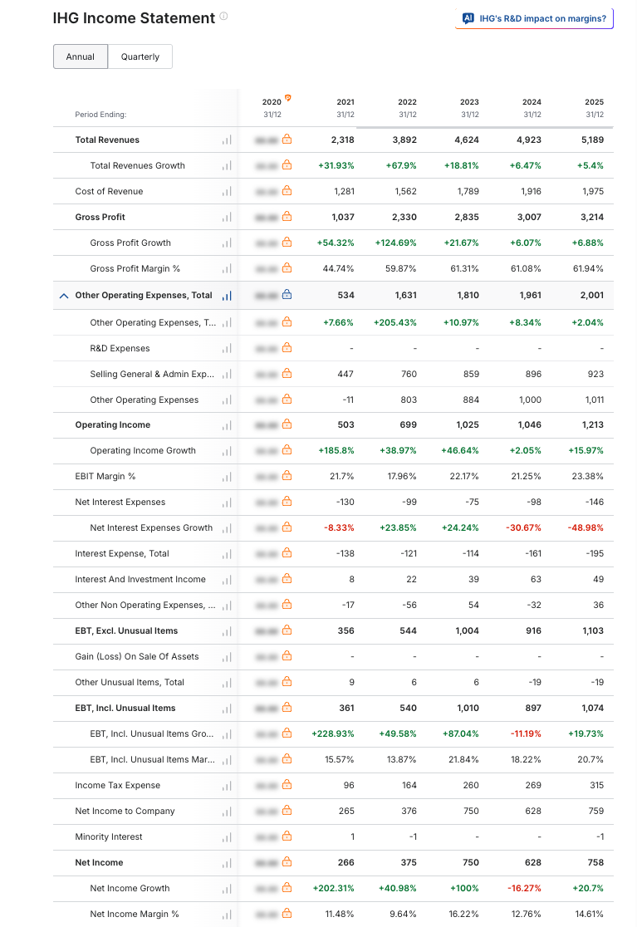
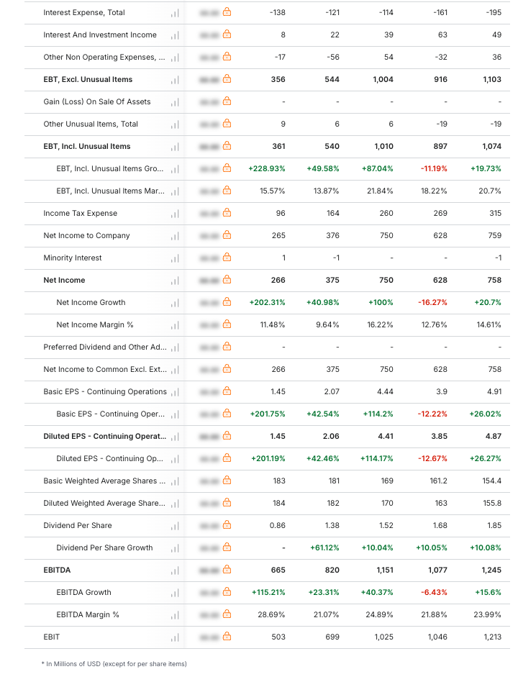
(Source: https://in.investing.com/equities/intercontinental-hotels-group-income-statement)

Appendix 2: Balance Sheet
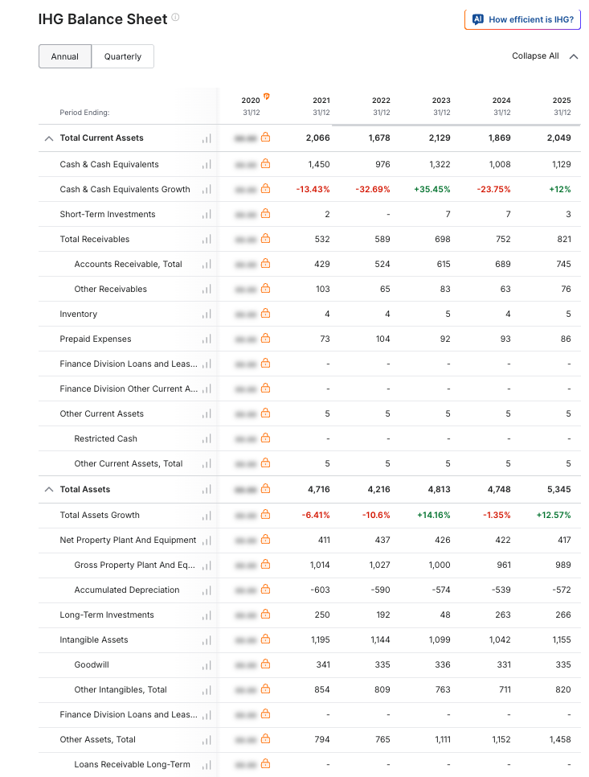
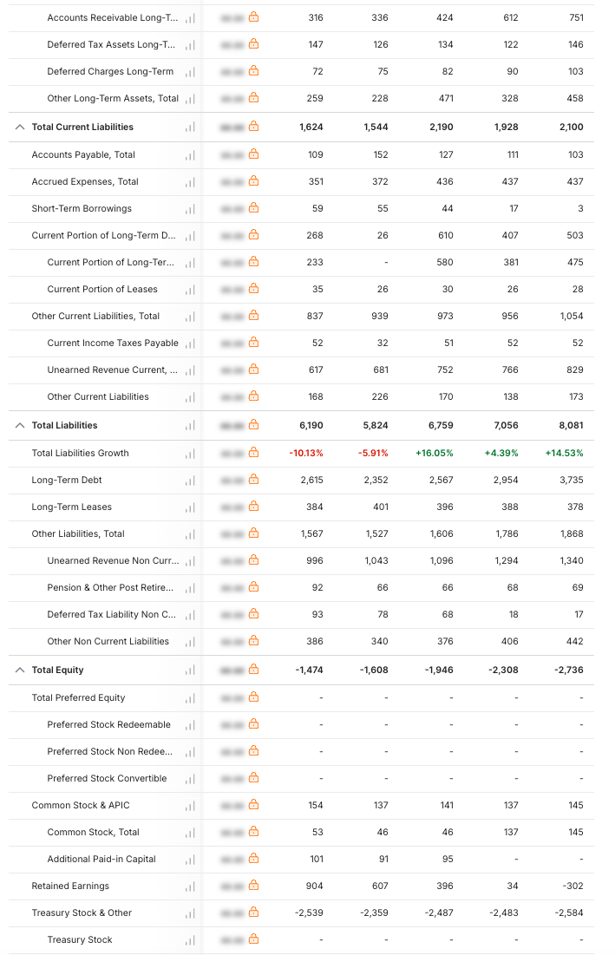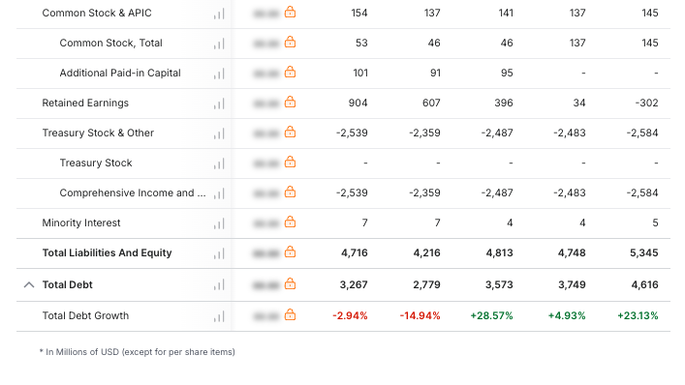
(Source: https://in.investing.com/equities/intercontinental-hotels-group-balance-sheet)

Appendix 3: Ratio Analysis

Appendix 4: Investment Appraisal Calculation

