

Student name:Emilia Dunguiongue
Student ID:2328855

Module name: independent project
Module code:BMHP6020
Supervisor’s name:jolly Nwankwo

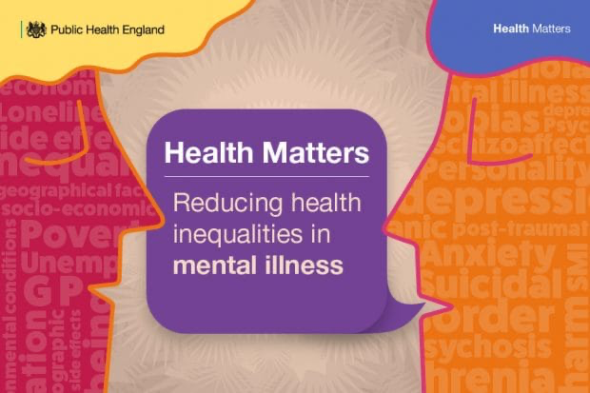 |  | Aim  The aim of this research is to explore how social isolation affects the mental health and emotional wellbeing of older people in the United Kingdom, focusing on implications for health and social care services. The study will examine links between limited social interaction, loneliness, depressive symptoms, anxiety and reduced quality of life. It will also consider how person-centred care, community support and social prescribing may improve older adults’ wellbeing.  Social isolation and loneliness are related but different concepts. Social isolation concerns limited social contact, whereas loneliness describes the distress experienced when relationships do not meet an individual's emotional needs (Age UK, 2024). |  | 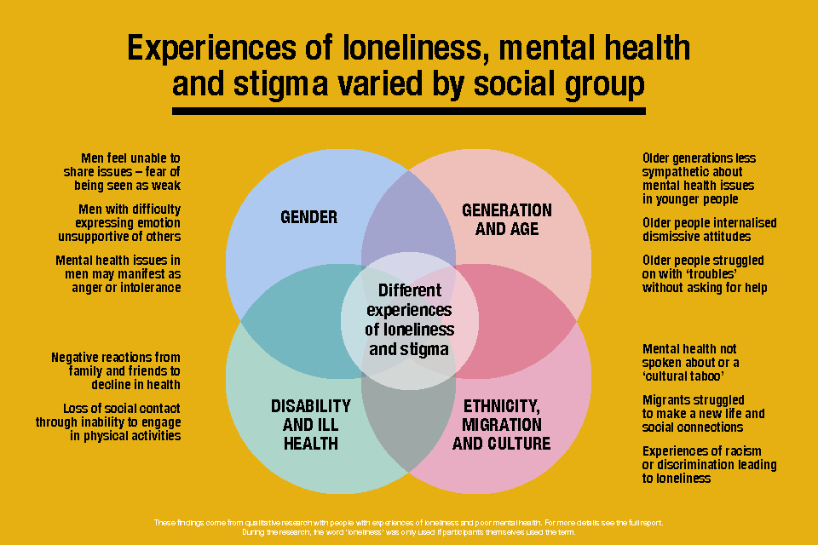
Figure 1 |  |  |  | Figure 2
Methodology  This project will use a qualitative secondary research design to explore existing evidence rather than recruit participants or conduct interviews. A qualitative approach is suitable because it supports an in-depth understanding of older people's experiences, social circumstances and barriers to accessing support.  The study will examine UK-focused publications produced between 2016 and 2026.Sources will include peer-reviewed journal articles, government reports, NHS publications and research available through PubMed and Google Scholar. A structured literature review will enable comparison of evidence concerning mental health outcomes, community participation and social care provision.  The Department for Culture, Media and Sport's evidence review identifies continuing gaps in knowledge about loneliness and the effectiveness of interventions, supporting the need for critical examination of existing |  |  |  | Data Analysis Methods  The selected literature will be analysed using thematic analysis. The researcher will read each source carefully, identify meaningful findings, develop initial codes and organise related codes into broader themes. Potential themes include depressive symptoms, bereavement, reduced independence, barriers to community participation and the effectiveness of social support.  Findings will be compared across community settings, residential care and health services. The analysis will consider differences between authors' conclusions and assess research quality, credibility and relevance to UK practice.  Li et al. (2024) found that local-authority anti-loneliness strategies had no significant overall effect on loneliness or depressive symptoms, indicating that interventions require careful evaluation rather than assumptions of effectiveness.  The findings will inform recommendations for integrated care, early identification of emotional distress and collaborative working between social workers, nurses, general practitioners and voluntary organisations.  Ethical Considerations  The researcher will represent older people's experiences respectfully, avoiding ageist assumptions that loneliness is inevitable in later life. Naughton-Doe et al. (2024) discuss ethical challenges associated with researching loneliness, including stigma and emotional vulnerability, reinforcing the importance of sensitive interpretation.  Confidentiality will be respected when discussing published personal accounts, and copyright requirements will be observed. The review will report contradictory findings honestly and acknowledge limitations, including publication bias, restricted access to full-text articles and limited transferability between UK regions.  Finally, the research will consider equality, dignity, safeguarding and person-centred care. The UK Government's loneliness strategy emphasises collaboration across public services and communities to strengthen social connections (DCMS, 2018).

Data Collection Methods
Inclusion criteria will comprise English-language publications dated 2016–2026 that examine older adults' mental health, social relationships or support services in the UK, alongside irrelevant publications and sources lacking sufficient methodological detail.
A search log will record databases, keywords, eligibility decisions and reasons for exclusion. Particular attention will be given to qualitative interviews and peer-reviewed studies. Kharicha et al. (2017) explored older people's views of primary care and community interventions, providing useful evidence about acceptable support for people experiencing loneliness.
Neves, Sanders and Kokanović (2019) also examined loneliness among older people living in care homes, highlighting the importance of considering residents' relationships and experiences when planning social care.

References

Age UK (2024) You are not alone in feeling lonely: Parliamentary briefing on loneliness in later life. Available at: https://www.ageuk.org.uk/siteassets/documents/reports-and-publications/reports-and-briefings/loneliness/you-are-not-alone-in-feeling-lonely---parliamentary-briefing-.pdf (Accessed: 12 October 2026).

Department for Culture, Media and Sport (DCMS) (2018) A connected society: A strategy for tackling loneliness. Available at: https://www.gov.uk/government/publications/a-connected-society-a-strategy-for-tackling-loneliness (Accessed: 12 October 2026).

Department for Culture, Media and Sport (DCMS) (2023) Tackling loneliness evidence review: Main report. Available at: https://www.gov.uk/government/publications/tackling-loneliness-evidence-review/tackling-loneliness-evidence-review-full-report (Accessed: 12 October 2026).

Kharicha, K. et al. (2017) ‘What do older people experiencing loneliness think about primary care or community based interventions to reduce loneliness? A qualitative study in England’, Health & Social Care in the Community, 25(6), pp. 1733–1742. Available at: https://doi.org/10.1111/hsc.12438.
Li, L. et al. (2024) ‘Has the UK Campaign to End Loneliness Reduced Loneliness and Improved Mental Health in Older Age? A Difference-in-Differences Design’, The American Journal of Geriatric Psychiatry, 32(3), pp. 358–372. Available at: https://doi.org/10.1016/j.jagp.2023.10.007.
Naughton-Doe, R. et al. (2024) ‘Ethical issues when interviewing older people about loneliness: reflections and recommendations for an effective methodological approach’, Ageing & Society, 44(7), pp. 1681–1699. Available at: https://doi.org/10.1017/S0144686X2200099X.
Neves, B.B., Sanders, A. and Kokanović, R. (2019) ‘“It's the worst bloody feeling in the world”: Experiences of loneliness and social isolation among older people living in care homes’, Journal of Aging Studies, 49, pp. 74–84. Available at: https://doi.org/10.1016/j.jaging.2019.100785.

