BA (HONS) LEADERSHIP AND MANAGEMENT SKILLS FOR THE WORKPLACE

MODULE: emergent leadership skills
MODULE CODE: BMSW6101
LECTURER: rebecca stewart
STUDENT NAME: TONI TREVIS
STUDENT NUMBER:2016781

Table of content

Introduction....................................................................................................................... 3
Leadership styles............................................................................................................. 4-6
Leadership Skills...............................................................................................................7
Challenges to Leadership in uncertain times .................................................................8-9
Ethical Leadership.............................................................................................................10
Conclusion........................................................................................................................ 11
Reference list.................................................................................................................. 12-13

2

Introduction

This report delves into leadership within the NHS and the qualities needed to lead effectively. Looking at positive and negative attributes that may excel or harbour the organisations level of effectiveness within each sector. Critically assessing theories and leadership styles to gather information on leadership qualities and invaluable leadership traits. Leaders must not be confused with managers. Leaders create a vision, motivate, inspire and Seak to bring about change, delegating tasks whereas managers stick to the status quo with structured functions and following processes (Bertocci, 2009). In this Report we delve into Leadership within the National Health Service. In current years, the NHS have fallen under extreme pressure with financial downfalls, staffing issues and lack of funding, Amanda Prichard (Chief Executive of the NHS) has come into her new role at a time of great challenge within the NHS with the pressures of the past 18 months. An overworked workforce and a budget that is not sustaining operations adds to the pressures she faces to provide better services and care.
The NHS are faced with a great burden of stretching resources and utilising limited staff (linkedin, n.d). it is crucial for the NHS to have strong resilient leadership to help tackle the immense amount of pressure. Leadership carries the role of setting boundaries, inspiring, motivating and encouraging change and growth within organisations giving rules and instructions to piers whilst looking for ways to improve current conditions (Schein, 2017). Managers tend to stick to the rules sustaining operations and following processes with structured functions (Chase, n.d). In today’s article we concentrate on leadership within the NHS and aims to critically evaluate leadership within the NHS looking at leadership styles and traits to help highlight negative and positive aspects within the NHS.

3

Leadership styles
Within the NHS there are various roles that require leadership to control operations with specific leadership styles to best handle situations and decision. Some situations may require a flexible leader that can look at things with a democratic approach, considering the thoughts and opinions on others whereas roles that demand structure and consistency will require an autocratic leader, autocratic leaders have may better manage a larger scale organisation with strict rules and set guidelines ensuring compliance to workplace standards and clear fluent communication and orders.
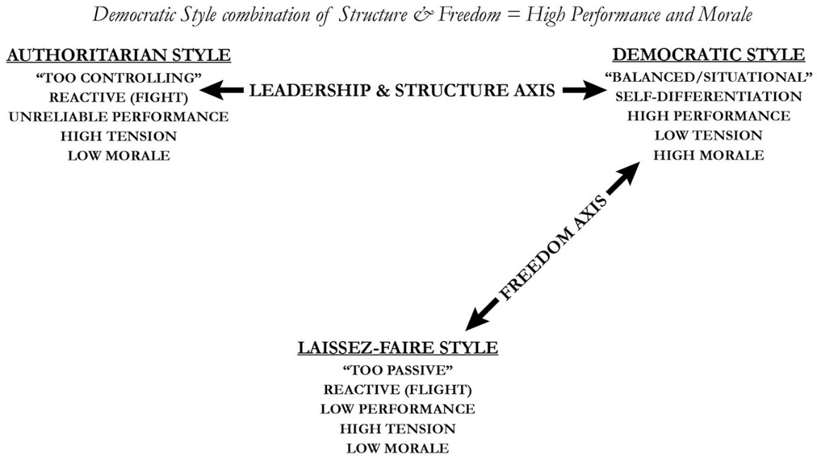
Figure 1: (Crosby, 2020).
Autocratic leadership
Autocratic leaders are known to adopt a direct approach to leadership, a more task-orientated style...................... give direct orders, structured tasks. Autocratic leaders hold full responsibility for the decisions they make leaving no room for employee input. Within the NHS there are several reasons an autocratic leadership style may be vital to ensure clear communication and ethical practices within the organisation. With the lives of many at the mercy of care staff within the NHS it is vital leaders get it right the first time to ensure safe conditions, fair conduct, and a quality health service.

. 4

Leaders may need to adopt an autocratic approach when addressing staffing issues, planning, and preparing to increase available training and bring in experienced staff to help tackle the backlogs and help the existing workforce cope with the huge demand on the public health sector. There is a huge need for extra funding and support throughout the NHS to stabilise operations and ensure sufficient ethical practice.
Democratic leadership
Democratic leaders encourage everyone to participate and have an input, although they retain the power of decision-making. Democratic leaders tend to be more relationship orientated than an autocratic leader, they analyse the environment and listen to the views of others to help make a final decision. Within the NHS there are various leadership roles that may adapt a democratic leadership style for example Xray specialists may consult one another to ensure the best treatment plan and procedures are put into practice. Strikes are currently taking place across the UK (United Kingdom) with ambulance and NHS staff appealing to the government for more to be done to support national health services, their staff, and patients this shows individuals are unhappy and feeling let down by Leaders, feeling unheard and overturned may have also added to the issue regarding strikes and an unhappy workforce. Leaders may need to listen to the voice of the people and look at what can be done to address the issues and ensure satisfactory services.
Laisse-faire leadership
Laissez-faire leaders allow the power to fall into the hands of their most skilled and experienced employees, with less need for guidance and support skilled subordinates are left to handle tasks and decision-making processes with full support and trust from leadership for example skilled surgeons and biologists are trusted to carry out tasks and make decisions based on their findings and best judgement. In the case of the arising issues within the NHS and the current challenges a laisse-faire approach to leadership may not be the best approach when trying to stabilise operations and improve services. Adopting a more autocratic or democratic style may better suit the current issues at hand for example addressing staffing issues and setting rules may require an autocratic leader whereas understanding the internal issues and reasons staff are on strike with a democratic mindset may also help make better sense and judgement of the current crisis.
5

Effective Leadership Styles
Leaders have struggled to adapt to the current climate as the covid-19 pandemic swept the nation the NHS came under intense pressure stretching resources and pushing the system and the workforce to the brink. It is a huge task to deal with the current climate and overcome the problems that arose at such a fast pace so it is important for leaders to be vigilant and can handle tough situations to find best suited solutions (Chima & Gutman, 2020). According to The Lancet “Pritchard is respected and seemingly well liked.” Pritchard states she is “optimistic but also realistic” (The Lancet 2021) this shows Amanda Prichard can clearly see she has a great deal of work ahead of her and her Leadership and ability to lead is vital to her success and the success of bettering operations. Amanda having a respected reputation may indeed help her reach better results due to her power and the level of trust individuals have in her abilities. It is vital for leadership to remain focused and leadership styles help shape a leader's way of thinking and how he or she handles and addresses situations via strategic planning and logical problem-solving skills. Effective leadership skills can help motivate and encourage subordinates, bring about positive change and shift dynamics within the workplace and its culture. Adopting a more Autocratic Leadership style to tackle staffing issues, delegate tasks and Handle budgeting issues may help the NHS tackle issues in a more controlled manor retaining power and authority whilst retaining power and final decision-making processes to ensure correct responses to current and arising issues.
However, the issue regarding strikes and unhappy workers may require leaders to adapt a more democratic or transformational approach to help understand the current issues among workers and try come to a healthy agreement that is viable and meets the needs of employees and Patients whilst being practical and within reach for the NHS.

6

Effective leadership core skills

Leadership skills are skills that can be developed. Helping to better a leaderships effectiveness and overall success. Leadership skills can be broken down into three parts.
- Administrative skills
Leaders can manage people, resources, and technical compliances these skills help leaders ensure correct people resources set in roles to best suit their abilities, recourses and finances are being allocated effectively and ensuring effective operations. In the context of the NHS their seems to be a lack in administrative skills when it comes to funding and allocating resources throughout the sector. It is vital leaders ensure their administrative leadership skills are improved to better the conditions within the service and ensure resources are allocated efficiently where they are needed most. It is Clear in the case of the NHS the Core administrative skills are lagging, funding exhausted and a stretched workforce leading to huge backlogs shows a lack of care when managing people and resources and the devastating effects it can have not only on the organisation but the patients being admitted, and the staff employed to run operations.
- Interpersonal skills
Interpersonal skills include emotional intelligence, social perception and interpersonal conflict. Within the NHS there is a transparent need for reform and change, Health workers are being pushed to their limits, on stretched budgets and tight shift patterns employees are battling to give patients the care they require whilst being overworked due to the staffing shortfall. Leadership may better manage the issues regarding strikes if they can come to a mutual agreement regarding pay, funding, and the workplace environment.
Being able to manage and deal with people issues will help understand the internal issues for workers and ensure a safe, ethical working environment with adequate reasoning and the ability to emphasis as well as delegate Leaders may be able to settle deputes with the unhappy workforce.

7

- Conceptual skills
Conceptual leadership skills are, creating visions, strategic planning, and problem-solving skills all of which are vital to help the NHS through this difficult faze. With problematic issues arising and an expediential waiting list that may affect around 13 million patients this year it is crucial to plan and prepare for how to best handle the arising issues and backlogs. Creating a vision, motivating, and encouraging employees to share the same vision and views whilst rewarding their hard work may also help with the issues regarding strikes and an unhappy workforce.
Challenges to leadership in uncertain times
Leading a large organisation such as the public health sector is an immense task and requires a highly skilled, resilient, capable leader. Uncertain times can be defined as situations or periods of time where Leadership cannot predict or control the future or future outcomes (Robbins, 2021). External issues such as the covid-19 pandemic or cost of living crisis challenges leadership's ability to maintain smooth operations and can prove to have huge knock-on effects within the organisation negatively impacting sustainability and human health. The cost-of-living crisis adds yet another pressure to the already burdened national health service and their extremely stretched budget, with inflation across the country there is no wonder employees are disheartened and crying out for more financial support. Leadership needs to ensure spending within the sector is sufficient to maintain effective operations and ensure staffing levels are increased to help tackle the shortfall and reduce stress and pressure to exhausted people resources within the organisation.
Throughout the NHS it is visible to see leadership are struggling to cope with the current economic climate. The devastating impacts of the covid-19 pandemic has added furthermore pressure on the national health service. With a steady decline in ability to handle and cope with the demand, an already exhausted workforce is struggling to maintain effective operations. It is clear to see there is a staffing issue and more needs to be done to ensure the national health service is running effectively. A steady decline in funding is having a huge negative effect within the NHS and as a result poor health care outcome are being seen showing a decline in the ability to provide a high standard of care that is vital to the health of the nation (The Economist, n.d). These issues cannot be overlooked or overturned as they could potentially have catastrophic effects and may potentially worsen health or endanger lives.
8

Throughout the NHS there have been strikes regarding fair pay and better treatment with NHS workers and Ambulance services taking a stand to make their appeal for help visible and call for more to be done to support the NHS. Not only are the NHS struggling to deliver a service that meets the current demand of the nation, but workers are unhappy too. (NHS England, n.d) Those working all hours to keep the nation fit and healthy are under immense pressure with little financial support, limited services, and a lack of staff to deal with steadily increasing backlogs of patients waiting to be seen. The article suggests Pritchard directs implementation with a response that can sustain operations long-term, progressively evolving the vision for the NHS and strengthens clinical research within the organisation tending to staff shortfalls and backlogs. Pritchard clearly has her work cut out and it is vital she makes the right decisions when tackling the current crisis within the health sector. Having good strong leadership qualities and the ability to negotiate and influence is vital when faced with such an overwhelming workload. A lot is riding on the Chanceller's autumn spending review and if the NHS receives vital funding to help lighten the burden (Spending Review, 2019).
‌

9

Ethical leadership
Ethics are defined by Gosh Hospital as “Rules and principles which distinguish between right and wrong” (Gosh Hospital, n.d). Not everyone shares the same Ethics or moral beliefs which can sometimes lead to problems regarding individuals sharing a vision or having faith in leaderships decisions. Not all Ethics are legally binding although there are laws relating to medical negligence and equality some ethics such as the way organisations or leaders conduct themselves are more of a moral obligation than mandatory procedure. For Leaders to retain power and influence others they must be seen to be trustworthy and demonstrate ethical leadership with actions that align with their visions and the ethical views they claim to have for example, during covid-19 when the country was faced with uncertainty Boris Johnson the former prime minister introduced strict guidelines to stay indoors or social distance. During this period, the Prime minister was seen to be having a social gathering with colleagues at number 10 downing street (BBC, 2022). This caused up raw in the press and across the country due to his lack of consistency and transparency causing the public to lose faith in his abilities, showing Leaders actions hinder their abilities to retain authority leaders have a moral obligation to defend and deliver what they value and view to be morally right. Ethical Leadership is defined by Moore, B. 2021 as the Art of making good decisions-based things such as fairness, values, respect, and equality (Moore, 2021).

10

Conclusion

Throughout the NHS there are clear calls for reforms, with workers exhausted, strikes taking place and a system that is struggling to cope with the current economic pressures. There is a need for leadership intervention and a strong capable leader who possesses all the qualities to improve current conditions. With a huge task ahead and an already stretched budget it is clear the NHS need additional financial support and an increase in skilled workers to cope with the growing workload. Amanda Pritchard is faced with huge responsibilities and to ensure the success of improvements, leadership interventions need to be had to coordinate processes and improve the Quality of services provided to staff and patients. Furthermore, the skills possessed, and leadership style adapted may just determine the outcome. Vital funding is needed to help the National Health Service cope with the crisis and whilst awaiting the chancellors budget decision Leaders must ensure an ethical, strong-willed nature and have the vital core skills and correct leadership style to address and handle situations. Adopting a Transformational leadership style and having all the vital core skills to lead effectively will help Leaders within the NHS handle situations and address them via their ability to make valid and ethical decisions to better the organization.

11

Reference List

Bertocci, D.I., 2009. Leadership in organizations: There is a difference between leaders and managers. University Press of America.
Chima, A. and Gutman, R. (2020). What It Takes to Lead Through an Era of Exponential Change. [online] Harvard Business Review. Available at: https://hbr.org/2020/10/what-it-takes-to-lead-through-an-era-of-exponential-change.
Chase, K. (n.d.). Leader vs. Manager: Understanding the Difference Between These Two Key Roles. [online] TopResume. Available at: https://www.topresume.com/career-advice/leader-vs-manager-understanding-the-difference-between-these-two-key-roles.
Crosby, G. (2020). Lewin’s Democratic Style of Situational Leadership: A Fresh Look at a Powerful OD Model. The Journal of Applied Behavioral Science, [online] 57(3), p.002188632097981. Available at: https://journals.sagepub.com/doi/abs/10.1177/0021886320979810.
‌GOSH Hospital site. (n.d.). About the Clinical Ethics Service. [online] Available at: https://www.gosh.nhs.uk/wards-and-departments/departments/clinical-specialties/clinical-ethics-service-information-health-professionals/about-clinical-ethics-service/#:~:text=Ethics%20refers%20to%20the%20rules%20and%20principles%20which [Accessed 17 Mar. 2023].
Moore, B. (2021). What is Ethical Leadership? Principles & Examples. [online] Great Work Life. Available at: https://www.greatworklife.com/what-is-ethical-leadership-decision-framework/.
Partygate: A timeline of the lockdown gatherings. (2022). BBC News. [online] 19 Apr. Available at: https://www.bbc.com/news/uk-politics-59952395.
The Economist. (n.d.). Britain’s NHS faces huge challenges in 2023. [online] Available at: https://www.economist.com/the-world-ahead/2022/11/18/britains-nhs-faces-huge-challenges-in-2023.
The Lancet (2021). The NHS: the many challenges for leadership. The Lancet, 398(10300), p.559.
Schein, & Schein, P. (2017). Organizational culture and leadership (Fifth edition.). John Wiley & Sons, Inc.
Spending Review: What is it and how does it affect me? (2019). BBC News. [online] 3 Sep. Available at: https://www.bbc.co.uk/news/business-49549350#:~:text=Chancellor%20Rishi%20Sunak%20has%20announced%20how%20much%20money [Accessed 17 Mar. 2023].

12

tonyrobbins.com. (2021). 9 top strategies for dealing with uncertainty | Tony Robbins. [online] Available at: https://www.tonyrobbins.com/mind-meaning/certainty-uncertain-times/ [Accessed 17 Mar. 2023].
www.england.nhs.uk. (n.d.). NHS England» NHS briefing: Industrial action winter 2023. [online] Available at: https://www.england.nhs.uk/briefing-industrial-action-winter/.
www.linkedin.com. (n.d.). Technology challenges facing the NHS in 2023 and beyond. [online] Available at: https://www.linkedin.com/pulse/technology-challenges-facing-nhs-2023-beyond-adam-britton [Accessed 15 Mar. 2023].

13

Reflective Report
During the Emergent Leadership Skills for the workplace module, I have learned key leadership qualities and it has enabled me to identify my own strengths and weaknesses as a leader, helping to highlight my strong areas and areas of improvement. Looking at William Ouchi's Taylorism and theory x, y, and z, and how theory x people believe that individuals do not want to work and have a need for structure appose to theory y’s view of self-motivated individuals who Seak responsibilities this philosophy aligned with myself and underlines me as a theory y individual (Ouchi & Barney,2004). This module has helped me gain key information on vital core skills, leadership styles and how to identify each style and enabled me to assess myself as a leader. When doing a task and relationship questionnaire it helped identify my leadership behaviour and identified that I am more task orientated showing I give more time and attention to completion of tasks and less time on people related matters within the workplace. This is a positive and negative attribute as in some situations I may need to adapt a more relationship empathies approach and when handling internal or employee related issues. However, having a Task orientated approach may also be highly effective in areas that need structure and strict processes such as situations that require an autocratic approach. During this module I delved into Bass’s Transformational Leadership Theory and gained a great deal of knowledge about transformational leadership which I strongly aligned with (Bass & Riggio, 2006). Bass’s Transformational theory identifies the Characters of transformational leadership and I gained a lot of knowledge regarding leadership styles, traits and skills required to lead effectively. Overall, the Learning in this module has been beneficial and I personally think I have learned a lot about effective leadership and my own abilities and character as a leader.
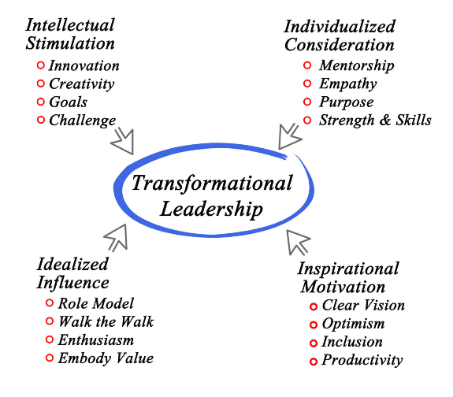
(Changing minds, n.d)

14

Reference list
Bass, B.M. and Riggio, R.E. (2006). Transformational Leadership. [online] Google Books. Psychology Press. Available at: https://books.google.co.uk/books/about/Transformational_Leadership.html?id=2WsJSw6wa6cC&redir_esc=y.
Bass, B.M. and Riggio, R.E. (2006) Transformational leadership. Second edition. Mahwah, New Jersey ;: Lawrence Erlbaum Associates. Available at: https://doi.org/10.4324/9781410617095.
changingminds.org. (n.d.). Bass’ Transformational Leadership Theory. [online] Available at: https://changingminds.org/disciplines/leadership/theories/bass_transformational.htm#:~:text=Bass%20defined%20transformational%20leadership%20in%20terms%20of%20how [Accessed 17 Mar. 2023].
‌courses.lumenlearning.com. (n.d.). Theory X, Theory Y, and Theory Z | Introduction to Business. [online] Available at: https://courses.lumenlearning.com/suny-hccc-introbusiness/chapter/reading-douglas-mcgregors-theory-x-and-theory-y-2/.
Ouchi, W. and Barney, J.B. (2004) ‘An Interview with William Ouchi’, Academy of Management perspectives, 18(4), pp. 108–116. Available at: https://doi.org/10.5465/AME.2004.15268706.
Ugochukwu, C. (n.d.). Transformational Leadership Theory - Simply Psychology. [online] simplypsychology.org. Available at: https://simplypsychology.org/what-is-transformational-leadership.html.

15

