Title – Global warming and environmental issues.
Name – Rosie M Fox
P Number - 150541
Submitted in partial fulfilment of the requirements for the degree of BA (Hons) University of Trinity Saint David, Swansea, and the date of presentation (i.e. 12th December 2018).
Word count (excluding bibliography) - 4319
Global warming and Environmental issues.
Ecologically and in terms of global warming and the environment, what impact is humanity and consumerism having on the planet. In more detail, what is or can be done to combat this effect. If people are already making changes, is it having a positive effect? How?
Introduction
During this investigation I want to look briefly at the impact we, as inhabitants of the earth are having on the planet in terms of global warming and the environment and in more detail, what could be done to alleviate the situation, what is being done already and if these interventions are having a positive impact. When talking to people about what I wanted to write about some told me about what they do in their lives to make a change, there are people making small changes in their lives such as cutting down the amount of plastics they buy, not consuming anything with palm oil in it and using eco-friendly toothbrushes made from bamboo, but I want to research to see if making these personal differences will make an ecological difference or if it’s going unnoticed.
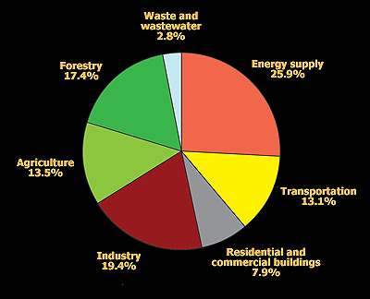
Global warming can be put down to seven main causes, Forestry (deforestation), Agriculture, Industry, Residential and Commercial Buildings, Transportation, Energy Supply and Waste and Water waste. The supply of energy being the biggest contributor of all. The pie chart on the right shows clearly the sections causing global warming, this chart was recorded in 2004 (Windows to the Universe, 2009) and an article quoted on the same website “there is no time to lose” published in 2007 (Windows to the Universe, 2009). So why, eleven years down the line, are we still facing the consequences of these actions instead of changing them.
Figure 1
Global warming is self-explanatory, it is the acceleration in the global temperature. This acceleration, although not noticeable at first, is having an adverse effect on the environment we live in. According to Amanda MacMillan, “Over the past 50 years, the average global temperature has increased at the fastest rate in recorded history.” (MacMillan, 2016) This is due to the increase of CO² and other pollutants in the atmosphere, these chemicals act as a blanket around the earth trapping in the heat and warming up the planet, causing a wide range of changes that might not be reversable.
Already the raise in temperature has bleached the majority of the coral reef. Measured in 2016, the coral showed a 93% loss of life on the Great Barrier Reef off the shore of Australia, (Kahn, 2016) a reef that spans the area larger than Italy and brings tourism and thousands of jobs to Australia every year. If the temperature of the water stays the same or rises then the chance of the coral reviving is very little, P.Weber said in an article in 1993 that “Coral's ability to adjust is limited.” (Weber, 1993) Not only that, the bleaching of the reef means no algae living off the coral (which gives its bright colours) which then means no fish living off the algae which in turn affect their predators and so on. Killing a whole ecosystem of life. Which many rely on. (Weber, 1993)
As well as the coral bleaching the rise in temperature means that our summers are longer which gives us longer droughts, heavier downpours of rain, floods, and more hurricanes (MacMillan, 2016). This then also means that breakouts of infectious diseases, allergy reactions and asthma attacks will become more common due to the conditions being more favourable to insects (like mosquitos) which spread diseases, ragweed which produces large amounts of pollen and the increase of air pollution.
It’s no secret that there is a current crisis of global warming and the message we are told is clear, that we cannot continue the torment on the planet we live on as it is killing it, like a parasite kills its host. (Nordqvist, 2018) The feeling among the public when I have spoken to people is that the threat is too far into the future to care about. In a documentary called “Years of Living Dangerously” (The Years Project, 2018) a town in Texas, America, known for droughts, is on the brink of extinction due to the lack of farm land and the lack of cattle which meant the local meat packing factory had to close, loosing the majority of the town their livelihoods. The little community left now have no income and instead of doing research into the crisis, it being a largely religious based community, they’ve decided to put their faith in their god and trust that he will provide the answers.
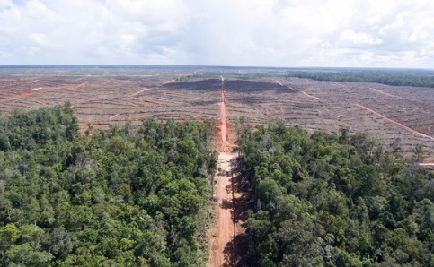
Also shown in the same documentary (The Years Project, 2018), one of the scary contributors of the emissions into the atmosphere are the burning of forest sites in Asia, America and Africa to make way for palm oil plantations and other monocultures, the existing life is demolished or burnt releasing all of the CO² collected into the atmosphere then oil palms are planted and cut again in 25 years and again burnt releasing more emissions into the air. The ground in these previously vast forests wasn’t just made up of soil but was covered in the debris and mulch of the fallen trees and plant life that grew and died throughout the years to make way for new life, this mulch is full of the carbon collected by the life grown and once cleared or burnt to make way for palm it is all released into the air, undoing thousands and thousands of years of free air filtration a process called “carbon sequestration” (Selin, 2011). This is what happens during photosynthesis when the plant takes in carbon and doesn’t release it back into the air, the plant then acts as a “sink” and the carbon gets stored into the ground when the plant dies where it has little effect on the planet. (Bloch, n.d.) Few people know that “palm oil-based biofuels actually have three times the climate impact of traditional fossil fuels” (Rainforest-rescue.org, n.d.) and that consuming palm oil in the many products on the store shelves can lead “to damage(d) DNA and (can) cause cancer” (Rainforest-rescue.org, n.d.). Not only does it have the impact on us and the environment it is causing several endangered animals to become scarcer as their habitats are being destroyed. But the supply and demand of palm oil is ever increasing because of its high yield and product diversity make it a cheap and useful product for many companies. (Rainforest-rescue.org, n.d.)
Figure 2
I am now going to be looking at case studies to see what individuals are doing to rectify the impact we have on the planet and its environment. Having looked at the problems we face today, I have chosen four studies that have made drastic contributions to the world they live in.
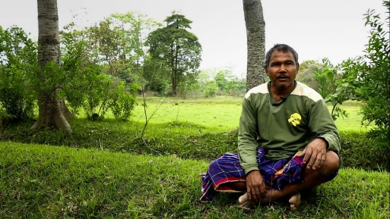
First Case Study
The first person of interest making a difference in the world is a man called Jadav Payeng, also known as the “forest man of India” (Burman, 2015) for his personal mission to replant an entire forest singlehandedly. It started when a young boy born on the river island Majuli, returned to find that severe flooding had washed up snakes onto the land and due to the lack of greenery, they died in the hot sun. Jadav, who was said to be heartbroken (Burman, 2015), went to look for help but found none at the authorities, the villagers however urged him to plant trees to save the snakes. A number of them donated seeds and bamboo saplings, at age 15 he planted what he could and “Thirty-six years later, he has reaped a forest.” (Burman, 2015) The forest now stretches a space larger than Central Park in New York (Kalita, 2013). Several species of animals, many of them endangered, now call this forest home and a herd consisting of over 100 elephants now visit several times a year for three to four months at a time. This one man, with a little help from villagers, managed to plant a whole forest on his own, saving a massive ecosystem.
Figure 3
Jadav said in his documentary (Kalita, 2013) that after he planted the forest and the trees grew, he found it difficult to protect it, not from animals but from “man”, who wanted to destroy it for “economic gain”. Payeng says the Tigers that now call the forest home have actually feasted on 85 of Jadav’s cows, 95 buffalo and 10 pigs. As he is a farmer relying on his livestock to pay bills and feed his family, you’d have thought this would be devastating but he simply says “They (the tigers) do not know farming, you see.” (Payeng, 2012)
He has now been recognised and awarded for his amazing work although rewards don’t have much meaning to the man who reaps achievement of this magnitude, he says -
“The Padma Shri is an award for encouragement, but my aim has always been to do good for the country. Even the President of India has to do something for the earth; otherwise, there will be nobody left, nothing.” (Payeng, 2012)
This is a man who understands what it takes to make a difference in the world we live in and makes it his daily objective. He also suggests that environmental sciences become part of the education of young children, as he was taught by his parents when he was young also. “If every schoolchild is given the responsibility to grow two trees, it will surely lead to a Green India,” (Payeng, 2012) a sentiment the rest of the world should take note of.
Deforestation is one of the many problems in the current days, “We’re losing 18.7 million acres of forests annually, equivalent to 27 soccer fields every minute.” (Cesareo and Walker, n.d.) According to the WWF website, our worldwide land area is 31% forest land, those trees are constantly growing and taking in carbon from the air and replacing it with oxygen, as well as providing habitats for thousands of different animals and insects, many of which are endangered. The website also explains how many people live off and rely on the forest land, benefiting on “what forests offer, including food, fresh water, clothing, traditional medicine and shelter.” (Cesareo and Walker, n.d.). In fact, the WWE has been working and contributing to help stop reckless deforestation for more than 50 years, helping people just like Jadav Payeng-
“With a focus on protected areas management and sustainable forestry, WWF works with governments, companies, communities and other stakeholders to promote certification for responsible forest management practices, combat illegal logging, reform trade policies and protect forested areas.” (Cesareo and Walker, n.d.). Supporting a cause like this helps to support people like Jadav Payeng and helps promote a greener world.
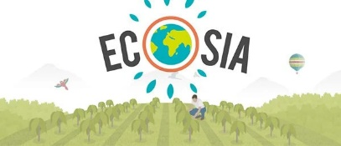
There is also now a company called “Ecosia”, it is a search engine just like “google” but it uses its profits to plant trees in the countries that need it more than ever. (Ecosia.org, n.d.) Helping the people, local economy and environment. They posted on a social media website that “If Ecosia was as big as Google, we could plant enough trees to offset global deforestation” (Facebook.com, 2018). By using Ecosia instead of your current search engine, with every click, you effectively plant a tree.
Figure 4
Second Case Study
Another person, or people making a difference are the Kumar family in California with their company “Brush with Bamboo”. They claim that their originally grassy lawn garden, now tropical oasis, was their inspiration for the idea of brushing with a toothbrush made from bamboo. They turned their plain garden into a haven called a “permaculture garden” (Kumar. Rishi, 2015) that produces around 5000 lbs of food a year and started a small piece of farm land near their home to grow and teach others how to grow to harvest to move toward a “sustainable zero-waste lifestyle.” (Kumar, n.d.)
Manju Kumar (Co-founder) said in their website video that “It was through our experience with soil and farming that we realised, plastic never decomposes, it never returns to the soil. That’s why we started ‘Brush with Bamboo’” (Kumar, 2015) It was their aspiration to not only help their community with the farming they do and teach but to help with world they live in also.
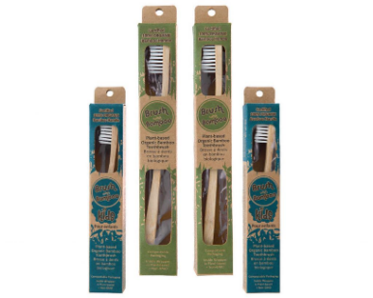
“All the plastic toothbrushes created since their invention in the 1930’s still exists” (Kumar, 2015). It doesn’t biodegrade, and more plastic is used to make the same product, plastic is also harmful for your health, as seen on “Blue Planet 2” (Blue Planet 2, 2018) there is now so much plastic in the ocean that particles from the plastic separate and are digested by the marine life and often kill it. If not killing it then the ecosystem is damaged and we as hunters catch the fish and consume the plastic particles ingested by the fish with have the potential to be toxic (Johnston, 2017).
Figure 5
So the Kumar family immediately started looking into making toothbrushes out of a more sustainable material and landed on a -“Bamboo handle, bristles made from vegetable oil and paper packaging that folds together without the use of glue or tape, making the entire product plant based and biodegradable.” (Kumar, 2015) the brushes themselves can be reused in several ways after they’ve finished being used as a toothbrush, such as name tags in the garden or learning projects for children, they also have a range of other products like children’s sizes and tongue scrapers.
This product is incredibly sustainable, the bamboo they use is organic and wild and because the plant itself creates its own antimicrobial agents, it has no need for fertilisers or pesticides and means it grows quickly. When they cut up a stalk for their toothbrushes, it only takes two years to grow another stalk in its place rather than the amount of time it takes to grow a tree. (Kumar, n.d.)
What the Kumar family have created is relatively a small company, but the effect they have is large as they spread the idea around the world. For every person that switches to a bamboo toothbrush means less plastic toothbrushes in production and furthermore, on landfills and in oceans.

Third Case Story
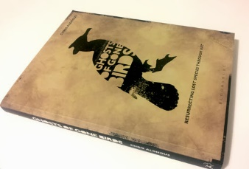
There is a book published called ‘Ghosts of gone birds’ (Aldhous, 2013) based on an art project to inform and highlight the story of birds that have gone extinct. The book explains the process of inspiration to realisaton and actualisation. The project’s final work culminated by large exhibitions in Brighton, Liverpool, London and Swansea and a wide range on new contacts, including artists, writers and musicians. (GoneBirds, n.d.)
Figure 6
The work started with a list of recently extinct birds being writen with a brief bio on each, explaining the birds individually and details of their extinction including an aproximate date and a hypothesised reason as to why. (Aldhous, 2013) Tearing down the familiar barrier between art and science, the book brings beautiful, detailed and colourful illustrations of over 180 artists along with scientific facts to send a thought provoking message.
“It reminds us that birds are not just the property of birdwatchers and scientists. In reality, they are part of a wider artistic and cultural heritage whose fuller expression may yet represent the best way of ensuring their survival.” (Stoddart, 2014)
The authors of the book also have a website in which they explain the book, reasoning and any news connecting to their cause. You can also buy prints of the art in which a percentage of profit and royalties goes towards conservation projects to help save the birds we do have and that are under threat. (GoneBirds, n.d.)
The question here, however, is why the collaborators of the project felt that it was necessary for its inception in the first place. In the world of today with so many ecosystems being destroyed, the increased use of pesticides and the pollution of plastics in our oceans – the bird population is on a decrease, “Bird numbers across France have declined by a third in the past 15 years” (Gabbatiss, 2018). So perhaps they were simply trying to show how much of an impact the people of the earth have on the other inhabitants that reside on this planet, or maybe they were heartbroken by the birds that were lost when, using today’s technology, it can be prevented.
Fourth Case Study
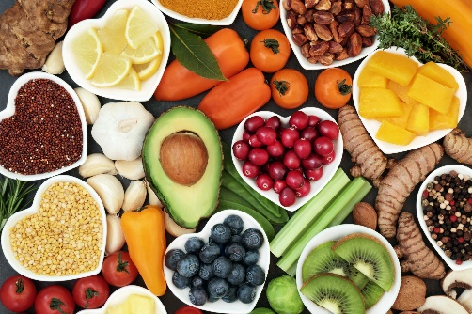
Across the world there are thousands of people changing their diet to one that is vegan, “Veganism has skyrocketed in recent years, with more people than ever before choosing to enjoy a plant-based life.” (Petter, 2018) With over three and a half million British citizens now identifying as a vegan since 2016, according to a survey led by comparethemarket.com, the survey also showed even more converting to vegetarianism and a large percentage of people reducing the amount of meat products they eat each week. (Moss, 2018) According to a website called “Peta”, there are many reasons why people turn to veganism, including wanting a healthier diet and lifestyle, for moral reasons or to cut down on the impact they have on the environment (PETA, n.d.) Studies show that -
“From farm to fork and beyond, food accounts for about 20% of all of our greenhouse gas emissions. Estimates suggest that if all of our meat eaters switched to a vegan diet, it would roughly halve total greenhouse gas emissions associated with food,” (Moss quoting Professor Carolyn Roberts, 2018)
Figure 7
In a devastating video on “YouTube” a man called Phillip Wollen is shown giving a speech to a hall of people. (YouTube, 2015) In the speech, among other horrific factual statements he says, “CO², Methane and Nitrous oxide from the livestock industry are killing our oceans with acidic, toxic dead zones.” and that “the oceans are dying in our time, by 2048 all our fisheries will be dead”. One figure he states which would come as a shock is that “Cornell and Harvard say that the optimum amount of meat in a healthy human diet in precisely 0%”, but also states that “eliminating mean (from diet) will end starvation forever” and goes on to tell of the health and financial benefits that would domino from not consuming animal products.
The environmental benefits of going vegan, as stated before, include reducing greenhouse emissions, but also help to preserve habitats and species “Producing meat requires large amounts of land to raise animals on. Every second, an area of rainforest equivalent to a football field is cleared to rear and graze animal” (Veganuary.com, 2018) and one could argue that the same land could easily be used for growing crops but “It’s estimated that eating meat requires three times more land than is needed for a vegan diet”. (The Vegan Society, 2018) Also previously stated, the waste products from poorly managed disposals often end up in our water systems and oceans creating ‘dead zones’ as a result of the toxic chemical build up from the waste and killing a wide range of life (Veganuary.com, 2018). A third benefit of veganism is reducing the impact on the water shortage in the world, as livestock need water to drink, wash and so on. They become an influence on the impact. “A study comparing the water footprint of different foods found that whilst a soy burger has a water footprint of 158 litres, a beef burger has a water footprint of 2,350 litres, which is over 14 times as big” (Veganuary.com, 2018). Showing that if the world’s population became vegan or at least lowered the amount of meat products consumed a week, the environmental and ecological problems faced today would have a substantial consequence.

Compare
Each of the stories looked at here have their own advantages and disadvantages, Jadav Payeng for example had little help in his personal endeavour, it makes you think what he could have accomplished with support from more powerful parties. The other stories admittedly do have support from others and because of this they are well on their way to changing the worlds perception of their cause. The Kumar family had themselves to help each other after all they turned their family business into a blooming toothbrush business, but they also help other by teaching what they know so that people can grow their own food, then spreading the mission to others like a chain reaction.
The story about the Ghosts of Gone birds is very emotive and inspirational but unfortunately seems to have been abandoned. The illustrations, collages and paintings were however eye opening and they make you feel personally responsible for the loss of these exotic birds. The website and social media connected to the cause seem to be outdated and no longer operational, but the book is still popular amongst artists and bird lovers which means that it is still a source of inspiration to the right reader, someone willing to make a change. Chris Aldhous created an army of artists and creative people willing to support the cause.
The last case study talks about a large number of people making a change to their diet for a number of varied reasons as well as for climate change or environmental reasons, this was included in the case studies as it shows that many people can work together to support the same thing, just like the Ghosts of gone birds team and the Kumar family’s customers.
Conclusion
Although, none of the stories investigated directly concern global warming or environmental issues, the information is valuable as they portray ways of making a change. In each instance the stories tell of one man or many people’s contribution to working towards making a difference in their own worlds, whether it’s planting trees, brushing your teeth with an alternative material or painting extinct birds. They seem like unconventional ways of getting the desired result but with devotion, the result seems more accomplishable than ever before.
Jadav Payeng managed to singlehandedly plant a whole forest and save an ecosystem when his original goal was to save reptiles that had died in the hot sun. The Kumar family are trying to reduce their ecological footprint and live a low waste life by brushing with toothbrushes made from bamboo and are then spreading their idea all over the world creating a chain reaction and the GoneBirds group are trying to save our remaining bird species by bringing attention to the tragic loss of birds that have already gone extinct by way of painting. All three have proved extremely effective in their fields, which gives hope that when people see a problem that they find important, if they think about it and dedicate time to it than they can make a difference.
These are not large companies in anyway, Jadav is one person, a livestock farmer with low resources, if he can do it than surely if the large corporations and the leaders of the world with the funding and resources tried, they could solve our current crisis and create a healthy, sustainable world for generations to come. The solution seems simple when you look at it this way.
The truth is that our world is in dire need of help and it takes people like the one’s in this investigation to make a difference, sometimes it’s down to the individuals to make a change. If you and everyone you know stop buying biscuits with palm oil in them the sales of the company start to go down, and they lose profit and are then forced to find an alternative. In my experience it’s sometimes, and unfortunately often, only when you threaten money that they do anything. As seen on “Years of Living Dangerously” (The Years Project, 2018), many of the forests that are being demolished to make room for palm oil plantations are supposedly on protected ground and a forbidden from being destroyed and yet they still are, the governments in these countries are so corrupt it happens anyway.
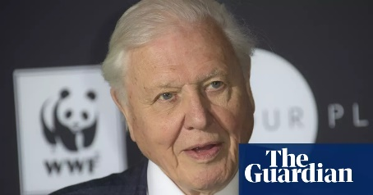
Sir David Attenborough made a speech to the UN climate change summit in Poland, in which he said “the worlds people have spoken, their message is clear: time is running out. They want you, the decision-makers, to act now. Leaders of the world, you must lead. The continuation of our civilisations and the natural world upon which we depend, is in your hands” (The Guardian, 2018) and posted a video after the broadcast of “Blue Planet 2” in which he said “The actions of any just one of us seem to be trivial and have no effect, but the knowledge that there are thousands, hundreds of thousands of people who are doing the same thing, that really does have an effect.” (Attenborough, 2018) With emphasis on individuals making a change, it’s clear that when everyone does the same thing, great things can come of it. Sometimes those changes can be as simple as buying a bamboo toothbrush, planting a tree in your garden or eating less meat a week at yet collaboratively, they have an immense impact.
Figure 8
It seems clear that not much comes from published scientific data, the information we know today has been known for years, and yet nothing has been done to rectify them. However, when someone takes an initiative and makes a change in their life and tells their friends, this seems to have a bigger affect. It’s clear from this investigation that it’s the individual stories that make the difference. It feels like these stories connect with people on an emotional, personal level and makes them think of what they can do to help. Individuals like Jadav Payeng, those switching to a vegan diet or brushing with a bamboo toothbrush, even a lowly birdwatcher, those are the people who change the world we live in. For the better. Perhaps the individuals can make enough of an impact to get the large businesses on boards.

Bibliography

Quotations and information
- The Years Project (2018). Years of Living Dangerously. [video] Available at: https://www.youtube.com/watch?v=brvhCnYvxQQ [Accessed 28 Nov. 2018].
- MacMillan, A. (2016). Global Warming 101. [online] NRDC. Available at: https://www.nrdc.org/stories/global-warming-101 [Accessed 28 Nov. 2018].
- Oceanservice.noaa.gov. (2018). What is coral bleaching?. [online] Available at: https://oceanservice.noaa.gov/facts/coral_bleach.html [Accessed 28 Nov. 2018].
- Kahn, B. (2016). Bleaching Hits 93 Percent of the Great Barrier Reef. [online] Scientific American. Available at: https://www.scientificamerican.com/article/bleaching-hits-93-percent-of-the-great-barrier-reef/ [Accessed 28 Nov. 2018].
- Rainforest-rescue.org. (n.d.). Palm oil – deforestation for everyday products - Rainforest Rescue. [online] Available at: https://www.rainforest-rescue.org/topics/palm-oil#start [Accessed 29 Nov. 2018].
- Selin, N. (2011). Carbon sequestration. [online] Encyclopedia Britannica. Available at: https://www.britannica.com/technology/carbon-sequestration [Accessed 29 Nov. 2018].
- Nordqvist, C. (2018). Parasites: Types, in humans, worms, and ectoparasites. [online] Medical News Today. Available at: https://www.medicalnewstoday.com/articles/220302.php [Accessed 30 Nov. 2018].
- Weber, P. (1993). Reviving Coral Reefs. In: In: State of the world 1993. New York: W.W.Norton, p.Abstract.
- Gupta, A. and Kalita, J. (2014). Watch: Forest Man, a short film on the Man who Made a Forest – India's Endangered. [online] Indiasendangered.com. Available at: http://indiasendangered.com/watch-forest-man-a-short-film-on-the-man-who-made-a-forest/ [Accessed 4 Dec. 2018].
- Kumar, M. (n.d.). Our Story – Brush with Bamboo. [online] Brushwithbamboo.com. Available at: https://www.brushwithbamboo.com/story/ [Accessed 5 Dec. 2018].
- BBC (2018). Sir David Attenborough's plastic message - BBC. [video] Available at: https://www.youtube.com/watch?v=IW3jEIYBFzg [Accessed 5 Dec. 2018].
- Blue Planet 2, (2018). [TV programme] One: BBC, David Attenborough.
- Fuller, E. (n.d.). The Lost Birds of Paradise. 1st ed. Swan Hill Press.
- Aldhous, C. (2013). Ghosts of gone birds. Bloomsbury Publishing.
- Stoddart, A. (2014). Book Review: Ghosts of Gone Birds just £19.99 quoteRBA33. [online] Rarebirdalert.co.uk. Available at: http://www.rarebirdalert.co.uk/v2/Content/Book_Review_Ghosts_of_Gone_Birds.aspx?s_id=991190186 [Accessed 6 Dec. 2018].
- GoneBirds (n.d.). Art Project | GHOSTS OF GONE BIRDS. [online] Ghostsofgonebirds.com. Available at: http://www.ghostsofgonebirds.com/?page_id=53 [Accessed 6 Dec. 2018].
- Cesareo, K. and Walker, L. (n.d.). Deforestation | Threats | WWF. [online] World Wildlife Fund. Available at: https://www.worldwildlife.org/threats/deforestation [Accessed 6 Dec. 2018].
- Facebook.com. (2018). Ecosia. [online] Available at: https://www.facebook.com/ecosia [Accessed 7 Dec. 2018].
- Kumar, M. (n.d.). About the brush – Brush with Bamboo. [online] Brushwithbamboo.com. Available at: https://www.brushwithbamboo.com/about-the-brush/ [Accessed 7 Dec. 2018].
- Gabbatiss, J. (2018). ‘Shocking’ decline in birds across Europe due to pesticide use, say scientists. [online] The Independent. Available at: https://www.independent.co.uk/environment/europe-bird-population-countryside-reduced-pesticides-france-wildlife-cnrs-a8267246.html [Accessed 7 Dec. 2018].
- Petter, O. (2018). The number of vegans in the UK has soared to 3.5 million, according to a survey. [online] The Independent. Available at: https://www.independent.co.uk/life-style/food-and-drink/vegans-uk-rise-popularity-plant-based-diets-veganism-figures-survey-compare-the-market-a8286471.html [Accessed 10 Dec. 2018].
- Moss, R. (2018). '3.5 Million People In The UK Are Now Vegan'. [online] HuffPost UK. Available at: https://www.huffingtonpost.co.uk/entry/35-million-people-in-the-uk-are-now-vegan_uk_5ac49b5ee4b093a1eb2087cb?guccounter=1&guce_referrer_us=aHR0cHM6Ly93d3cuZ29vZ2xlLmNvLnVrLw&guce_referrer_cs=rwulOGjGUCZtvyB4ouIFDA [Accessed 10 Dec. 2018].
- PETA. (n.d.). Top 10 Reasons to Go Vegan in the New Year (Updated for 2019) | PETA. [online] Available at: https://www.peta.org/living/food/top-10-reasons-go-vegan-new-year/ [Accessed 10 Dec. 2018].
- Youtube (2015). Watch this and GO VEGAN! Amazing speech on saving the planet. [video] Available at: https://www.youtube.com/watch?v=x1r7fYioLGU [Accessed 10 Dec. 2018].
- Veganuary.com. (2018). You’ll save wildlife. [online] Available at: https://veganuary.com/why/environment/youll-save-wildlife/ [Accessed 10 Dec. 2018].
- The Vegan Society. (2018). Food security. [online] Available at: https://www.vegansociety.com/resources/environment/food-security [Accessed 10 Dec. 2018].
- Veganuary.com. (2018). You’ll reduce pollution. [online] Available at: https://veganuary.com/why/environment/youll-reduce-pollution/ [Accessed 10 Dec. 2018].
- Veganuary.com. (2018). You’ll save water. [online] Available at: https://veganuary.com/why/environment/youll-save-water/ [Accessed 10 Dec. 2018]
- Bloch, M. (n.d.). Artificial vs natural carbon dioxide sequestration. [online] Carbonify.com. Available at: http://www.carbonify.com/articles/carbon-sequestration.htm [Accessed 10 Dec. 2018].

Images
- Figure 1 - Windows to the Universe (2004). Pie chart showing cause of global warming. [image] Available at: https://www.windows2universe.org/earth/climate/mitigation_intro.html [Accessed 29 Nov. 2018].
- Figure 2 - Holder, M. (2016). Palm oil firm accused of systematic illegal deforestation in Indonesia. [online] Businessgreen. Available at: https://www.businessgreen.com/bg/analysis/2469457/palm-oil-firm-accused-of-systematic-illegal-deforestation-in-indonesia [Accessed 11 Dec. 2018].
- Figure 3 - Kalamfanclub.com. (2017). Jadav Payeng – The Man Who Single Handedly Converted A Barren Land Into A Forest – Abdul Kalam Fan Club. [online] Available at: http://kalamfanclub.com/jadav-payeng-the-man-who-single-handedly-converted-a-barren-land-into-a-forest/ [Accessed 11 Dec. 2018].
- Figure 4 - Good Energies Alliance Ireland. (2017). Ecosia – An eco search engine. [online] Available at: https://goodenergiesalliance.com/2017/09/01/ecosia-an-eco-search-engine/ [Accessed 11 Dec. 2018].
- Figure 5 - Kumar, M. (n.d.). About the Brush – Brush with Bamboo. [online] Brushwithbamboo.com. Available at: https://www.brushwithbamboo.com/about-the-brush/ [Accessed 5 Dec. 2018].
- Figure 6 - Ramsden, R. (n.d.). Ghosts of Gone Birds (book).. [online] Robertramsden.blogspot.com. Available at: http://robertramsden.blogspot.com/2014/01/ghosts-of-gone-birds-book.html [Accessed 11 Dec. 2018].
- Figure 7 - Mance, H. (2018). The Vegan Boom and My Month on an Animal-Free Diet – Financial Times – Medium. [online] Medium Financial Times. Available at: https://medium.com/financial-times/the-vegan-boom-and-my-month-on-an-animal-free-diet-5d81f5fe7bd2 [Accessed 11 Dec. 2018].
- Figure 8 - the Guardian. (2018). Sir David Attenborough to speak for the people at UN climate summit. [online] Available at: https://www.theguardian.com/environment/2018/nov/21/sir-david-attenborough-to-speak-for-the-people-at-un-climate-summit [Accessed 11 Dec. 2018].

Unused research
“Plastics” - https://www.globalcitizen.org/en/content/uk-tackling-plastic-pollution-waste-plan/
https://www.globalcitizen.org/en/content/alternatives-to-plastic-straws-eco-friendly/

