Business Report -Comparison of Two Hospitality Organizations

Student name: Anat Dranciuc-Georgescu
Student Id: 2125394
Module: Financial Management for the Hotel Industry (BMIH5007)
Lecturer name: Tristan Hawkins
Word Count: 2214

Executive summary

Corinthia Hotels, founded in 1962, and Ibis Hotels, established in 1974, have each created unique spaces within the hospitality sector. This analysis explores their financial strategies, considering factors such as market positioning, revenue streams, growth prospects, and commitments to Corporate Social Responsibility (CSR), drawing from industry trends and the operational models of each brand.
Corinthia is associated with luxury, generating revenue from premium services and real estate, and catering to a wealthy demographic. Its financial performance demonstrates the resilience of the luxury segment to economic fluctuations, albeit susceptible to global economic changes. On the other hand, Ibis, a prominent player in the economy lodging sector, generates revenue through a combination of direct operations and franchising, prioritising accessibility, and consistent service, aligning with current market preferences for affordability and convenience. Both brands exhibit strong growth trajectories. Corinthia is augmenting its luxury positioning by expanding into emerging markets with a focus on lavish experiences. Ibis is expanding its footprint through strategic franchising and a focus on digital and sustainable practices, catering to a wider, price-sensitive customer base.
CSR initiatives are fundamental to both brands, with Corinthia’s reputation benefiting from enhanced brand loyalty through its commitments, and Ibis utilising Accor’s Planet 21 program to strengthen its sustainability credentials.
Considering this analysis, recommendations for Corinthia include offering additional luxury options to its clients, such as installing solar panel roads within their parking spaces. This would not only attract more customers but also contribute to energy savings and carbon footprint reduction. For Ibis, a suggestion would be to install plant beds on their rooftops to support and sustain the environment while reducing food waste and producing their own supplies, aiding bees in the process and attracting more customers with their sustainable options.
In conclusion, the divergent yet successful financial strategies of Corinthia and Ibis underscore the importance of strategic brand positioning in the hospitality industry. The continued success of each brand depends on their ability to adapt to evolving market and consumer trends.
Contents

Executive summary 1
Introduction 5
Main Body 6
Corinthia 6
Ibis 7
Marketing position 8
Development and CSR 9
Conclusion 11
Recommendations 11
Reference List 12
Appendix 19
Figure 1: Annual Report & Financial Statements 31 December 2022. 19
Figure 2: Full-Year 2023 Results 19
Figure 3: UK Hotel Market Trading Performance 20
Figure 4: Website Analysis; Domain traffic (Similar Web, 2023) 20
Figure 5: Global, Country and Industry rank (Similar Web, 2023) 20
Figure 6: Corinthia London. 21
Figure 8: London Marriott Hotel County Hall. 22
Figure 9: LONDON MARRIOTT HOTEL COUNTY HALL 22
Figure 11: Premier Inn Hotel London Prices 23
Figure 12: Premier Inn Hotel Prices Over 30 days. 24
Figure 15: TOP COUNTRIES: IBIS, PREMIER INN, TRAVELODGE. 25

Introduction
This report will conduct an in-depth analysis and comparison of two outstanding types of hotels within the hospitality industry. The objective of this report is to evaluate their respective approaches to financial management, considering various critical areas that impact their financial performance and sustainability and critically evaluate Corinthia Hotels and Ibis Hotels in terms of their financial management strategies and practices.
Corinthia Hotels, established by the Pisani family in Malta 60 years ago, has grown from a local family business into a distinguished luxury hotel brand with properties worldwide. Maintaining its familial values and commitment to excellence, the brand started with the Corinthia Palace, a transformed restaurant, and now boasts iconic locations across major cities while preserving its Mediterranean heritage. Corinthia Hotels are known for their unique blend of luxury and personal touch, offering features that set them apart: luxurious accommodations, gourmet dining, award-winning spas, prime locations, personalized services, and cultural immersion Corinthia Hotels (2024). These features, along with their commitment to excellence and rich history, make Corinthia Hotels stand out in the global luxury hospitality market.
On the opposite side Ibis Hotels, a subsidiary of the esteemed French multinational corporation Accor (2019) established in 1974, has strategically established itself as a dominant entity within the economy lodging sector. Renowned for providing accommodations that are both comfortable and economically viable, Ibis has cultivated an expansive global network, boasting over 1,100 hotels across 67 nations. This formidable presence serves various clientele, incorporating both the budget-conscious tourist and the recognised business traveller. The extensive reach of Ibis Hotels is a testament to the brand’s commitment to ensuring accessibility and delivering uniform service excellence in a multitude of markets.
As, both Corinthia and Ibis have placed their mark deep within the hospitality industry offering high-quality services on both markets equally, luxury and economic class.

Main Body
In this day and age, trends have a major impact on guests' decisions for holidays and travel, Lacalle (2022) points out that: customising marketing emails, in-room experiences, and guest interactions to create a tailored experience, prioritising eco-friendly practices, such as using sustainable cleaning products and conserving water, collaborating with local merchants, sourcing locally for food to enhance your brand, catering to digital nomads by providing strong Wi-Fi, technology integration, health focus, investing in extra cleaning staff, UV disinfection, and safety measures to reassure guests, mixing concepts to attract diverse audiences; all this shape the future of hotels and help meet the evolving needs of guests.

Corinthia
In its firm progression Corinthia Group (2024b), points out that the company sustains its foundational principles, ‘The Spirit of Corinthia’, fostering a deep sense of companionship among employees. The COVID pandemic has only strengthened their resolve to assist and uplift lives. Their culture, the essence of their existence, sets them apart from competitors by offering memorable experiences. Their success over the decades is attributed to their people, culture, and purpose, rather than just their physical properties. They passionately strive to uplift the lives of their guests and each other, embodying a clear aspiration and spirit (Figure 1).
Focusing their attention on their employees and maintaining a family-like relationship with their customers, Corinthia Hotels became one of the world's top luxury companies.
Corinthia is constantly advancing, with a well-defined agenda, supported by a robust commitment and a distinct business focus. Sustainability is a pivotal element in this context and serves as a significant method for long-term operational and financial evolution. All three pillars of Sustainability - Environmental, Social, and Governance - will be addressed, thereby Corinthia is concentrating its efforts on integrating sustainability in a strategic and structured manner across its diverse property and operations portfolio.

Ibis
As per Accor’s 2022 financial report, Accor — Finance (2024) points out that, Ibis Hotels, prominent for its economy lodging services, primarily generates revenue from room sales. Being part of the Accor group, Ibis influences a robust business model that combines direct hotel operations with franchising, facilitating rapid expansion and market penetration with minimal capital investment. Supplementary services such as food and beverage offerings, meeting and conference facilities, and other guest services further enhance revenue. The brand’s strategic positioning in urban centres and transport hubs, coupled with digital innovations and a commitment to sustainability, have reinforced its appeal and revenue growth. Its adaptability to market shifts and consumer trends, particularly the rising demand for affordable yet quality accommodations, continues to drive Ibis Hotels’ financial performance (Figure 2).
While both Corinthia and Ibis function within the same industry, their opposite approaches to revenue generation reflect their distinctive brand positioning and market strategies in their unrelated categories, Corinthia is a luxury brand while Ibis is an economic brand.
Kotler (et al. 2019, p5) point out that corporations harbour a shared enthusiasm for fulfilling customer requirements within specific allocated target markets. They inspire every individual within the organisation to contribute towards the cultivation of enduring customer relationships predicated on the creation of value. In the contemporary landscape, customer relationships and value have assumed vital importance. Confronted with significant technological advancements and profound economic, social, and environmental challenges, contemporary customers are re-evaluating their choices. Developments in digital, mobile, and social media have activated a transformation in consumer shopping and interaction behaviours, in this manner changing marketing strategies and tactics was imperative.
Corinthia culture sets them apart from competitors by offering memorable experiences. Their success over the decades is attributed to their employees, business culture, and purpose, rather than just their physical properties. They passionately strive to uplift the lives of their guests and each other, threw a luxurious and impeccable experience for their employees and guests alike.
SINGH (2024) points out that, in 2024, the hospitality industry, having endured the COVID-19 pandemic and the surge of technological innovation, stands at a critical crossroads. This era has tested global hoteliers’ resilience and triggered a significant shift in operational and guest service concepts. The intersection of technology and hospitality enhances guest experiences. By adopting technologies, smart systems, and data-driven personalization, hoteliers can surpass guest expectations. Prompt implementation of these strategies is vital for success in the digital age, enabling hoteliers to lead the competition by offering memorable, experiences.
Corinthia Hotels emphasises this idea by offering their clients high-quality services, luxury rooms and easy and accessible access to technology.
The Regional UK hotel market experienced a favourable first quarter of the year, marked by commendable RevPAR growth due to increased occupancy and average daily rate. This growth was driven by heightened demand for meetings, events, and a surge in corporate and negotiated rates. Golf & Spa hotels, along with full-service Upscale and Upper-Upscale, surpassed the regional market in revenue growth and profitability (Goldstein, 2024) (Figure 3).

Marketing position
In Corinthia’s case, the number of customers accessing its websites is constant and with predominant popularity within the United Kingdom (Figure 5) on another note Corinthia’s main competitive hotels seem to be Marriot and Hilton both with a vast number of clients overall (Figure 4).
After carefully analysing Expedia (2024), and Trip Advisor (2024), Corinthia Hotel in London may have high prices for its rooms but that suggests a high demand for luxury and professional locations within the area for the competition in London is Marriot, they have a lower price range of rooms even as a deluxe option (Figure’s 6-9).
Ibis, a key player in the economy lodging sector, enjoys a strong geographic reach and high traffic volume. Catering to a diverse clientele including budget business travellers, young tourists, and families, it positions itself as an affordable, reliable, and accessible brand. This strategy, targeting a wider, price-sensitive market, results in a unique financial dynamic. While Ibis benefits from high occupancy rates due to its affordability and presence, its per-customer revenue is lower than luxury brands. However, its financial performance is resilient to economic downturns due to sustained demand for budget accommodations (Taylor, 2022).
Ibis hotels have a certain appeal to them, economically, friendly, fun, creative, it target a vast number of customers and at an affordable price.
After carefully analysing several websites such as Travelodge (2024), Booking.com (2024), IBIS(2024), ibis(2024), PREMIER INN(2024), Premier Inn Rest Easy (2024), it is quite clear that Ibis Hotels has quite affordable prices when it comes to its rooms and what they have to offer, however, its main competitors would possibly be Premier Inn(Figure’s 10-15), from those results it is obvious that at least for United Kingdom the main hotel brand accessed is Premier Inn( Similar Web, 2024b).

Development and CSR
Corinthia Hotels’ approach involves the transformation of landmark structures into high-end accommodations, enriching their distinctive portfolio and enhancing their reputation for luxury and exclusivity (IHI, 2023). Their growth strategy encompasses strategic alliances and property investments. The inaugural hotel among seven new establishments is in New York (CPP Luxury, 2021), with imminent openings planned in economically and strategically viable tourist-centric cities.
Notable examples include Grand Hotel Royal, Budapest: Originally opened in the 1890s, it underwent a €100 million renovation and reopened in 2003 (Global Home, 2024). The Metropole Hotel, London: Established in 1885, it was extensively renovated to become Corinthia London in 2012 (Mourby, 2024). Corinthia Hotel Bucharest: A Class A Monument of Culture, it is currently being refurbished into a luxury hotel with 50 suites, multiple dining options, a ballroom, boutique meeting spaces, and leisure amenities (QPML, 2024). The Surrey, New York: Acquired by Reuben Brothers in 2020, it is set to reopen as a Corinthia Hotel in early 2023, marking Corinthia’s debut in the United States THOMAS (2024).
These transformations enrich Corinthia’s unique portfolio and strengthen its image of luxury and exclusivity.

The Group worldwide have long been dedicated to sustainable development, with notable CSR practices in several countries, serving as inspiration for their network. The Group has been deeply committed to environmental sustainability, eliminating single-use plastics by 2022 and aiming for carbon neutrality by 2050.
For instance, ibis Wien Mariahilf has implemented measures to protect the planet, including hosting beehives on its roof and eliminating single-use plastics. Sofitel Guarujá Jequitimar has established a circular economy system for water reuse. ibis Barcelona Montmelo Granollers supports the REIR Foundation. Pullman London St Pancras has implemented a smart building management control system to save energy and cooperates with local food banks to limit food waste. Mercure Porto Centro Aliados has implemented energy-saving measures and uses solar panels for heating Accor (2021).
These initiatives not only reduce environmental impact but also inspire other hotels within the network.
Reckmann (2023) underscores the significance of Corporate Social Responsibility (CSR) for both society and global businesses. CSR encompasses environmental conservation, achieved by companies through pollution reduction, recycling, natural resource replenishment, and the development of CSR-compliant products. It also involves equitable and ethical conduct, including fair treatment of customers, competitive employee compensation, transparent business transactions, philanthropy, fiscal responsibility, and volunteering, as well as sustainability.
IHI, Corinthia’s autonomous public holding company, is dedicated to ‘Uplifting Lives’. Recognizing the significance of sustainability in fortifying its mission, IHI views itself as a conduit for promoting stakeholder interests. The company aims to lead in fostering global, regional, and national sustainability awareness, forming strategic alliances, and adopting best practices. Corinthia’s Corporate Sustainability Policy rests on four pillars: outstanding guest experience, nurturing colleagues, the environment, and uplifting communities. By backing these initiatives in alignment with these pillars at internal, regional, and national levels, they contribute to achieving the Sustainable Development Goals, guided by their values of authenticity, understanding, passion, and precision (Corinthia Hotels ,2024).
Accor, a pioneer in sustainable hospitality, is accelerating its global transformation to contribute more than it takes, embedding sustainability across all activities with a focus on people and nature. The company recognises the high stakes of sustainable transformation, with climate change, biodiversity loss, and social challenges increasingly impacting business and growth. Its strategic vision is clear: to drive transformation across the Group, work closely with hotel owners, partners, and all stakeholders, and lead change across the hospitality industry. The key objective is to make a positive impact on People and Nature, the core fundamentals of the sector and activity Accor (2024).
Accor’s hotels are deeply rooted in their local ecosystems, communities, and economies. The company strives to actively protect the local environment and cultural heritage of the destinations around its hotels and create opportunities and meaningful connections with the local communities.

Conclusion
Even though both Corinthia and Ibis work in the same hospitality field and have different marketing strategies and positions, Corinthia been a luxury brand and Ibis been a economic one, both of this hotel brands have one thing in common and that is sustainability and respecting the CSR rules and regulations, both of them focusing on trying to make the world a better place for everyone from their employees to their guests and the community that they operate in.

Recommendations
Corinthia could benefit from an extra luxury option to offer to its clients and that would be solar panel roads placed within their parking spaces, this would not only attract more customers, but it would help with energy savings and reduce carbon footprint, GARDINER (2024).
As for Ibis, with sustainability in mind, they could follow the idea of planting plant beds on top of their rooftops to support and sustain the environment while reducing food waste and producing their own supplies, helping bees in the process, and attracting more customers with their sustainable options Terence Baker (2024).

Reference List
Accor (2019) ALL - Accor Live Limitless. [Online] accor.com. Available at: https://all.accor.com/united-kingdom/index.en.shtml [Accessed on 27 May 2024].
Accor (2021) Our hotels – ambassadors of sustainable development. [Online] Available at: https://group.accor.com/en/Actualites/2021/04/csr-hotels-initiatives (Accessed: 30 May 2024).
Accor — Finance (2024) Full-Year 2023 Results: Record EBITDA of more than €1 billion | Accor – Newsroom. [Online] Available at: https://press.accor.com/full-year-2023-results-record-ebitda-of-more-than-eur1-billion/?lang=en (Accessed: 29 May 2024).
Accor (2024) Commitment. [Online] Available at: https://group.accor.com/en/commitment (Accessed: 30 May 2024).
Adrian Mourby (2024). The most famous hotels in the world. The library of hospitality. [Online] Available at: https://famoushotels.org/news/the-corinthia-london-the-metropole (Accessed: 30 May 2024).
Booking.com (2024) ibis London Earls Court (Hotel) (UK) deals. [Online] Available at: https://www.booking.com/hotel/gb/paragon-hotel.en-gb.html?aid=397594&label=gog235jc-1FCAEoggI46AdIM1gDaFCIAQGYAQm4ARfIAQzYAQHoAQH4AQyIAgGoAgO4Aqrl4bIGwAIB0gIkYmQyZmVlYzEtMGIwNy00YzBlLWJmMTEtODRlMzc5MzJmY2Qw2AIG4AIB&sid=95a91a3b0ceb9153e65998be9265e941&all_sr_blocks=11143310_376291306_2_42_0;checkin=2024-06-03;checkout=2024-06-04;dest_id=-2601889;dest_type=city;dist=0;group_adults=2;group_children=0;hapos=1;highlighted_blocks=11143310_376291306_2_42_0;hpos=1;matching_block_id=11143310_376291306_2_42_0;no_rooms=1;req_adults=2;req_children=0;room1=A%2CA;sb_price_type=total;sr_order=popularity;sr_pri_blocks=11143310_376291306_2_42_0__12900;srepoch=1717072869;srpvid=7ed9592ead64006a;type=total;ucfs=1&#hotelTmpl (Accessed: 30 May 2024).
Corinthia Hotels (2024) Discover Corinthia. [Online] Available at: https://www.corinthia.com/en-gb/discover-corinthia/ (Accessed: 27 May 2024).
Corinthia Hotels (2024b) Sustainability Policy. [Online] Available at: https://www.corinthia.com/globalassets/corinthia-global/documents/sustainability/ch_booklet-sustainabilitypolicy-a5p-28324.pdf (Accessed: 30 May 2024).
Corinthia Group (2024)2022 ANNUAL REPORT & Financial Statements. [Online] Available at: https://docs.publicnow.com/viewDoc?hash_primary=C4D9AB244C114C34DEF1AA5FDEE4E60E79ABD16B (Accessed: 29 May 2024).
Corinthia Group (2024b)2022 ANNUAL REPORT & Financial Statements. [Online] Available at: https://www.corinthiagroup.com/wp-content/uploads/2023/06/37547-CORINTHIA-ANNUAL-REPORT-2022_WEB-min.pdf (Accessed: 29 May 2024).
CPP Luxury (2021) Corinthia Hotels opens in New York first hotel in the U.S. [Online] CPP Luxury. Available at: https://cpp-luxury.com/corinthia-hotels-opens-in-new-york-first-hotel-in-the-u-s/ (Accessed on 29 May 2024).
BEN THOMAS (2024) Corinthia Hotels to take over The Surrey. [ONLINE] Available at: https://www.sleepermagazine.com/stories/projects/corinthia-hotels-to-take-over-the-surrey-nyc/ (Accessed: 30 May 2024).
Expedia (2024) Corinthia London. [Online] Available at: https://www.expedia.co.uk/London-Hotels-Corinthia-London.h3849185.Hotel-Information?chkin=2024-05-30&chkout=2024-05-31&x_pwa=1&rfrr=HSR&pwa_ts=1717010945106&referrerUrl=aHR0cHM6Ly93d3cuZXhwZWRpYS5jby51ay9Ib3RlbC1TZWFyY2g%3D&useRewards=false&rm1=a2&regionId=2114&destination=London%2C+England%2C+United+Kingdom&destType=MARKET&neighborhoodId=179536&selected=3849185&latLong=51.50746%2C-0.127673&hotelName=Corinthia+London&sort=RECOMMENDED&top_dp=985&top_cur=GBP&userIntent=&selectedRoomType=324570081&selectedRatePlan=394947449&searchId=c81c553c-221f-4f11-9b99-5b2759b2a08c&propertyName=Corinthia+London (Accessed: 29 May 2024).
Expedia (2024b) London Marriott Hotel County Hall. [Online] Available at: https://www.expedia.co.uk/London-Hotels-London-Marriott-Hotel-County-Hall.h19058.Hotel-Information?chkin=2024-05-30&chkout=2024-05-31&x_pwa=1&rfrr=HSR&pwa_ts=1717010677997&referrerUrl=aHR0cHM6Ly93d3cuZXhwZWRpYS5jby51ay9Ib3RlbC1TZWFyY2g%3D&useRewards=false&rm1=a2&regionId=6195474&destination=London+City+Centre%2C+London%2C+England%2C+United+Kingdom&destType=MARKET&neighborhoodId=6195474&selected=4481&latLong=51.508362%2C-0.129026&hotelName=London+Marriott+Hotel+Regents+Park&guestRating=45&sort=PROPERTY_CLASS&top_dp=545&top_cur=GBP&userIntent=&selectedRoomType=87781&selectedRatePlan=203890663&searchId=183d73c8-91ed-46fb-9b62-256718323500&propertyName=London+Marriott+Hotel+County+Hall (Accessed: 29 May 2024).
Global Home (2024) The History of the Hotel. [Online] Available at: https://www.corinthia.com/en-gb/budapest/history-of-the-hotel/ (Accessed: 30 May 2024).
IBIS (2024) LONDON EARLS COURT - Updated 2024 Reviews, Photos & Prices. [Online] Available at: https://www.tripadvisor.co.uk/Hotel_Review-g186338-d192139-Reviews-Ibis_London_Earls_Court-London_England.html (Accessed: 30 May 2024).
ibis (2024) London Earls Court. [Online] Available at: https://www.expedia.co.uk/London-Hotels-Ibis-London-Earls-Court.h14264.Hotel-Information?chkin=2024-06-09&chkout=2024-06-10&x_pwa=1&rfrr=HSR&pwa_ts=1717073680664&referrerUrl=aHR0cHM6Ly93d3cuZXhwZWRpYS5jby51ay9Ib3RlbC1TZWFyY2g%3D&useRewards=false&rm1=a2&regionId=2114&destination=London%2C+England%2C+United+Kingdom&destType=MARKET&neighborhoodId=553248635976381483&selected=14264&latLong=53.5336%2C-1.1046&sort=RECOMMENDED&top_dp=132&top_cur=GBP&icmcid=Meta.tripa.Expedia_UK-DM&icmdtl=htl.14264.taid.192139...testslice..clickid.0fdf5166-be02-4440-a02c-8ce58b381a0d_2024-06-09_2024-06-10_1717073678362.AUDID..defdate.1.bucket.BMP_custom_marketing_text___unlock_expedia_member_perks_1677162634_bucket_not_found&mctc=9&userIntent=&selectedRoomType=321758445&selectedRatePlan=389471863&searchId=75dc1e27-1ac1-49ad-b46e-c4c96a8214b7 (Accessed: 30 May 2024).
IHI PLC (2022). Financial Report Corinthia hotels. [Online] Corinthiagroup.com. Available at: https://www.corinthiagroup.com/wp-content/uploads/2023/04/ihi.html (Accessed on 29 May 2024).
International Hotel Investments p.l.c. (2024) Annual Report & Financial Statements 31 December 2022. [Online] Available at: https://www.corinthiagroup.com/wp-content/uploads/2023/04/ihi.html (Accessed: 28 May 2024).
Kotler, Phil T., et al. (2019) Principles of Marketing, Pearson Education Limited,. ProQuest Ebook Central [Online]. Available at: https://ebookcentral.proquest.com/lib/trinity/reader.action?docID=5978379&ppg=30 (Accessed: 29 May 2024).
Lacalle, E. (2022). Hotel trends you’ll see in 2023 in the hospitality industry. [Online] Available at: https://www.mews.com/en/blog/hotel-trends-hospitality-industry (Accessed 27 May 2024).
Nadia Reckmann (2023) What Is Corporate Social Responsibility? [Online] Available at: https://www.businessnewsdaily.com/4679-corporate-social-responsibility.html (Accessed: 29 May 2024).
NIKKIE RANDHAWA-SINGH (2024). Luxury Hotels 5 Tech Strategies for Success 2024 Luxury Hotel Guide: Top 5 Strategies for Future Success. [Online]Available at: https://insights.shijigroup.com/2024-luxury-hotel-guide-top-5-strategies-for-future-success/ (Accessed: 29 May 2024).
Philippa Goldstein (2024). London’s hotel market shows resilience with Q1-24 profits up, despite a softening in the ADR. [Online] Available at: https://www.knightfrank.com/research/article/2024-05-08-londons-hotel-market-shows-resilience-with-q124-profits-up-despite-a-softening-in-the-adr- (Accessed: 29 May 2024).
PREMIER INN (2024) LONDON COUNTY HALL HOTEL - Updated 2024 Reviews, Photos & Prices. [Online] Available at: https://www.tripadvisor.co.uk/Hotel_Review-g186338-d210361-Reviews-Premier_Inn_London_County_Hall_Hotel-London_England.html (Accessed: 30 May 2024).
Premier Inn Rest Easy (2024) London County Hall Hotel. [ Online] Available at: https://www.premierinn.com/gb/en/hotels/england/greater-london/london/london-county-hall.html?ARRdd=09&ARRmm=06&ARRyyyy=2024&NIGHTS=1&ROOMS=1&CHILD1=0&COT1=0&ADULT1=2&INTTYP1=DB&SMO1=NON&CID=TRA_UK_META_DESKTOP_LONCOU&refid=5b1d099d-efb2-489c-befd-f871094eb5f2 (Accessed: 30 May 2024).
QPML (2024) Corinthia Hotel Bucharest, Grand Hotel du Boulevard is brought back to its timeless elegance and sophistication. [Online] Available at: https://qpml.com/project/corinthia-hotel-bucharest/ (Accessed: 30 May 2024).
RICHARD BURDETT-GARDINER (2024). China Moves to Solar Powered Roads. [Online] Available at: https://www.renewableenergyhub.co.uk/blog/china-moves-to-solar-powered-roads (Accessed: 30 May 2024).
Similar Web (2024) Similar Web Identity. [Online] Available at: https://pro.similarweb.com/#/digitalsuite/websiteanalysis/overview/website-performance/*/999/3m?webSource=Total&key=corinthia.com,hilton.com,marriott.com (Accessed: 29 May 2024).
Similar Web(2024b) Website Performance. [Online] Available at: https://pro.similarweb.com/#/digitalsuite/websiteanalysis/overview/website-performance/*/999/3m?webSource=Total&key=ibis.accor.com,premierinn.com,travelodge.co.uk (Accessed: 30 May 2024).
Taylor, M. (2022). How a Global Recession Might Impact Travelers and the Travel Industry. [Online] Available at: https://www.travelpulse.com/News/Features/How-a-Global-Recession-Might-Impact-Travelers-and-the-Travel-Industry (Accessed: 29 May 2024).
Terence Baker (2024). News | Hotel Rooftop Gardens Blossom as Source of Savings, Inspiration, Sustenance. [Online] Available at: https://www.costar.com/article/1963976400/hotel-rooftop-gardens-blossom-as-source-of-savings-inspiration-sustenance (Accessed: 30 May 2024).
Travelodge (2024) London Covent Garden Hotel - Book Now. [Online] Available at: https://www.travelodge.co.uk/hotels/318/London-Central-Covent-Garden-hotel?checkIn=02%2F06%2F2024&checkOut=03%2F06%2F2024&rooms%5B0%5D%5Badults%5D=2&rooms%5B0%5D%5Bchildren%5D=0 (Accessed: 30 May 2024).
Trip Advisor (2024) CORINTHIA LONDON - Updated 2024 Prices & Hotel Reviews (England). [Online] Available at: https://www.tripadvisor.com/Hotel_Review-g186338-d1845678-Reviews-Corinthia_London-London_England.html (Accessed: 29 May 2024).
Trip Advisor (2024b) LONDON MARRIOTT HOTEL COUNTY HALL - Updated 2024 Prices & Reviews (England). [Online] Available at: https://www.tripadvisor.com/Hotel_Review-g186338-d195225-Reviews-London_Marriott_Hotel_County_Hall-London_England.html (Accessed: 29 May 2024).

Appendix

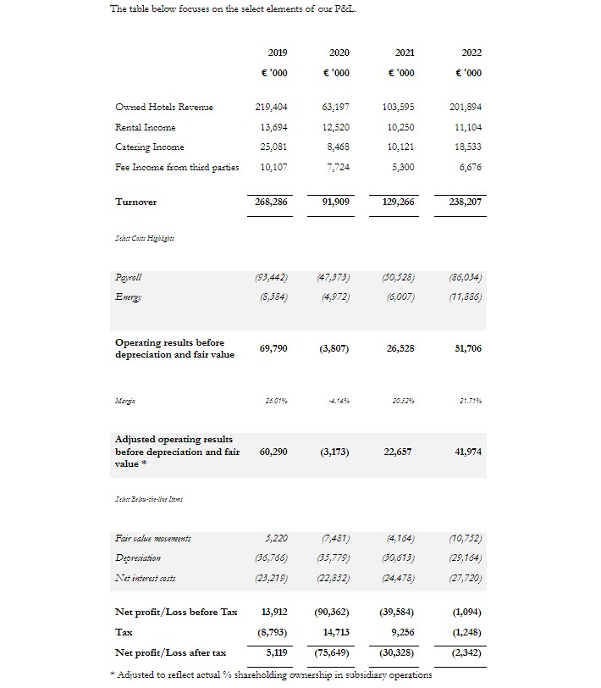 Figure 1: Annual Report & Financial Statements 31 December 2022.
(International Hotel Investments p.l.c. ,2024)
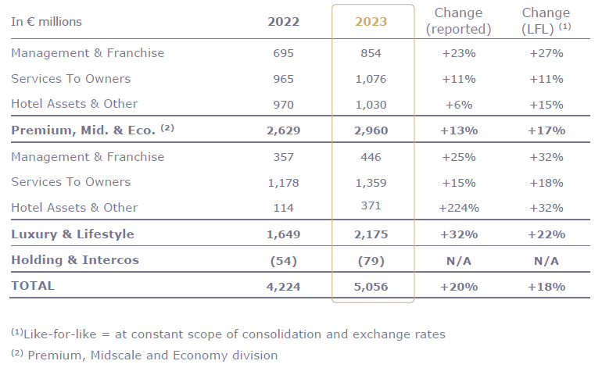Figure 2: Full-Year 2023 Results Accor — Finance (2024)
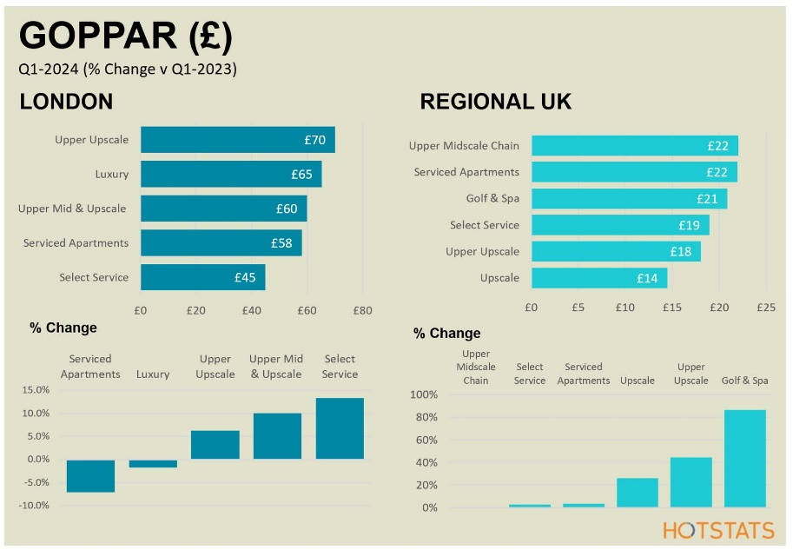Figure 3: UK Hotel Market Trading Performance Goldstein (2024)

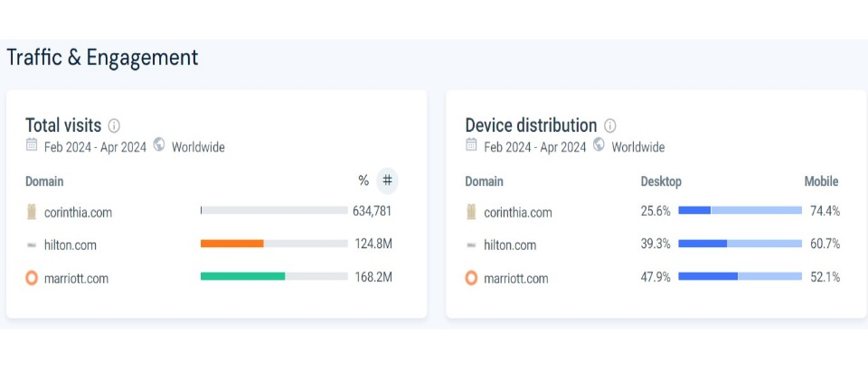Figure 4: Website Analysis; Domain traffic (Similar Web, 2023)

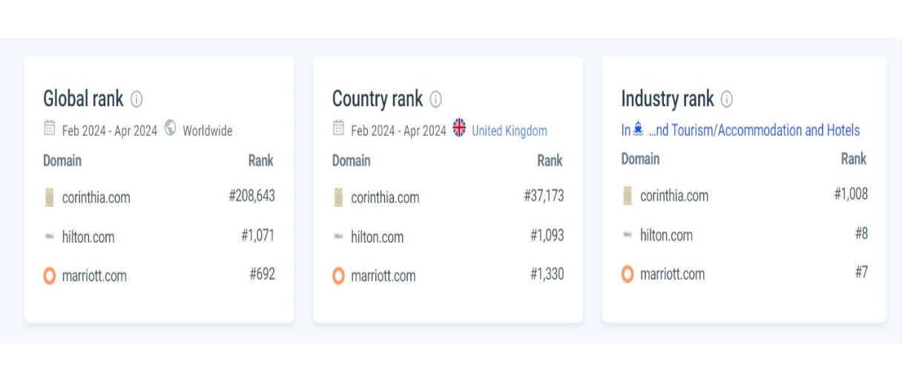Figure 5: Global, Country and Industry rank (Similar Web, 2023)

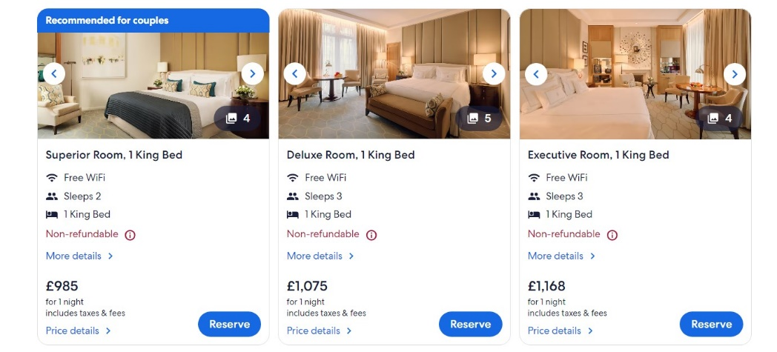
Figure 6: Corinthia London. (Expedia, 2024)
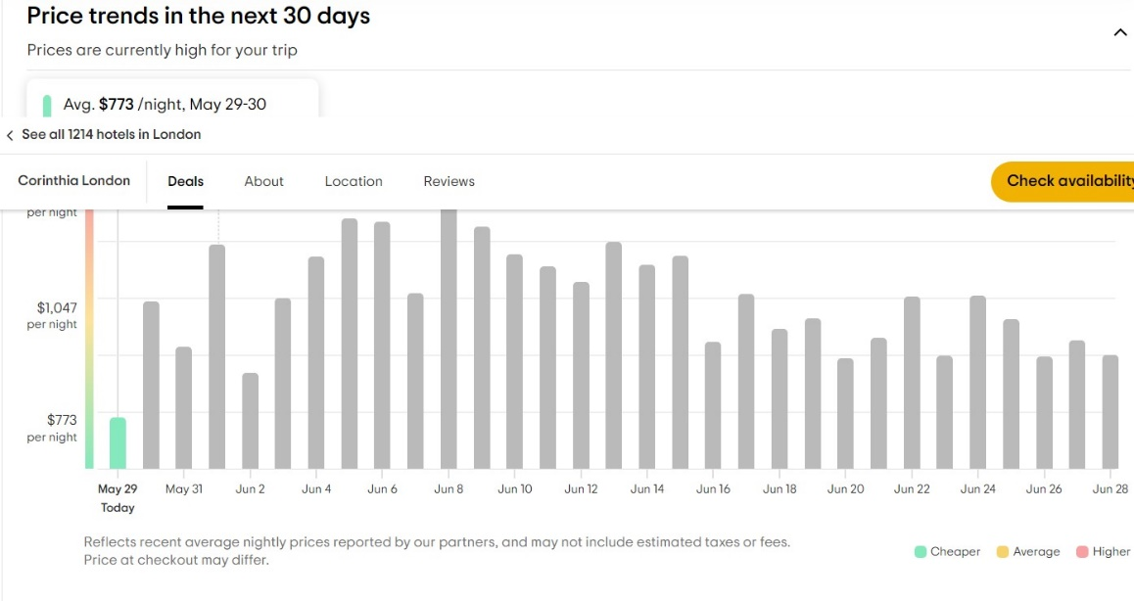 Figure 7: CORINTHIA LONDON - Updated 2024 Prices. (Trip Advisor, 2024)

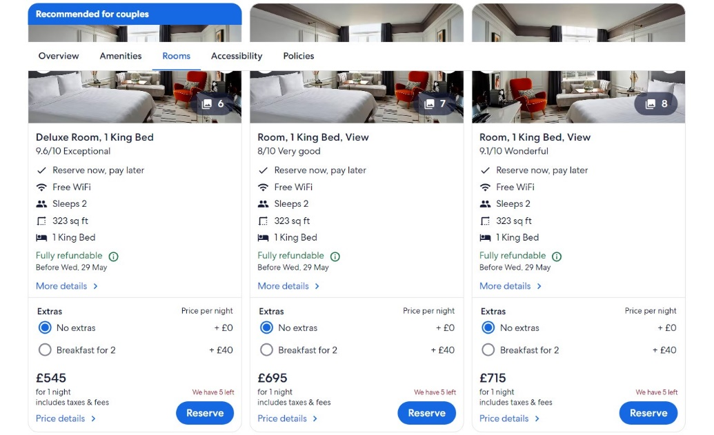
Figure 8: London Marriott Hotel County Hall. (Expedia, 2024b)
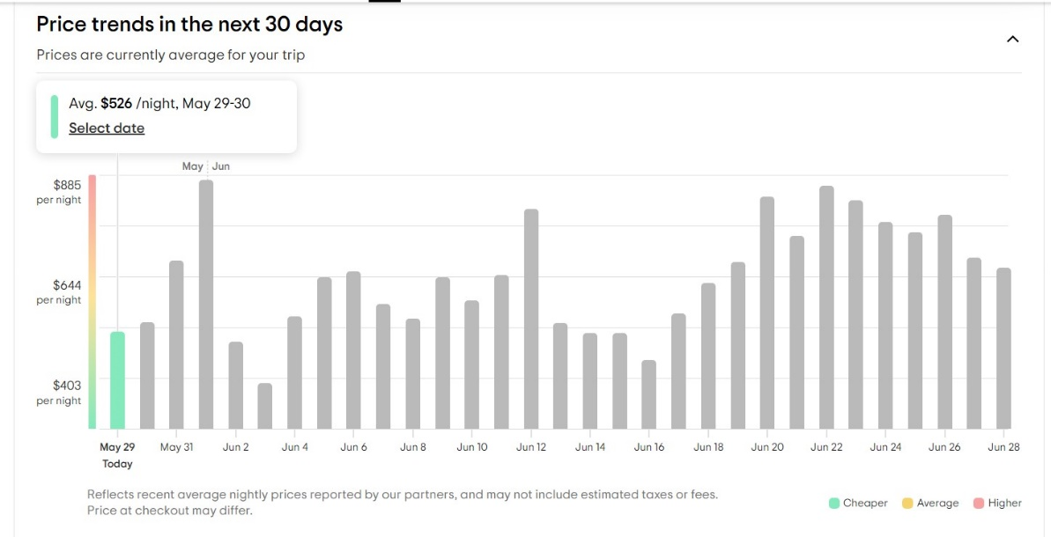
Figure 9: LONDON MARRIOTT HOTEL COUNTY HALL (Trip Advisor, 2024b)
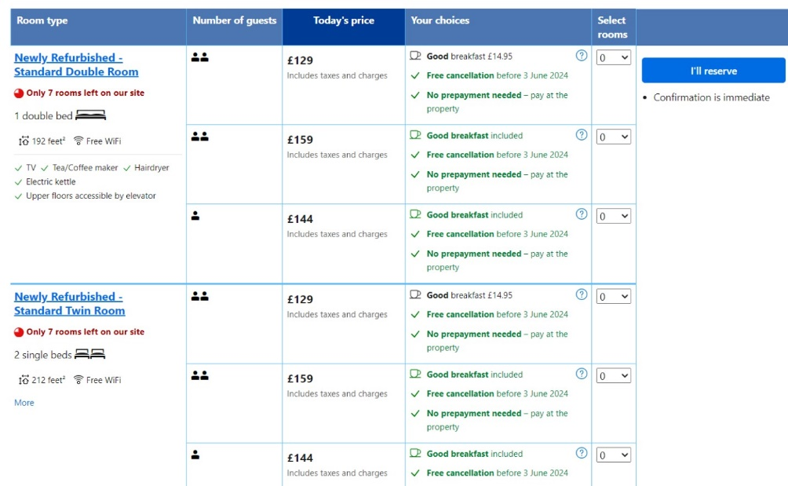 Figure 10: Ibis Hotel London Room prices (Booking.com, 2024)
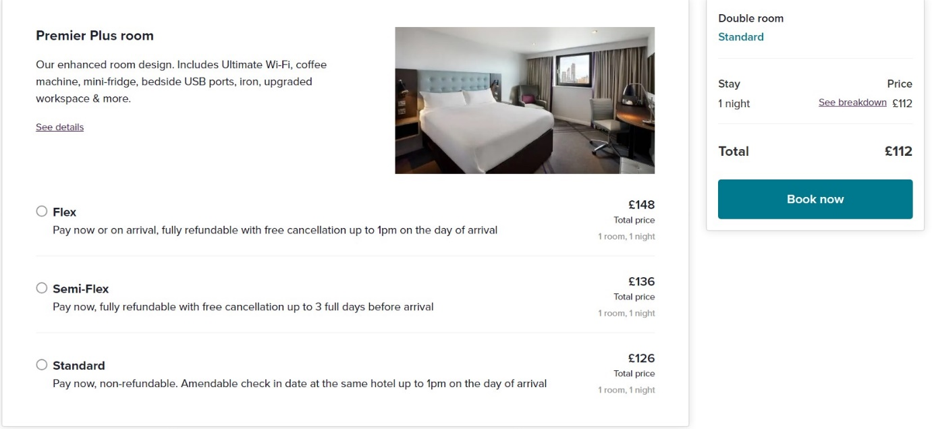
Figure 11: Premier Inn Hotel London Prices (Premier Inn Rest Easy, 2024)
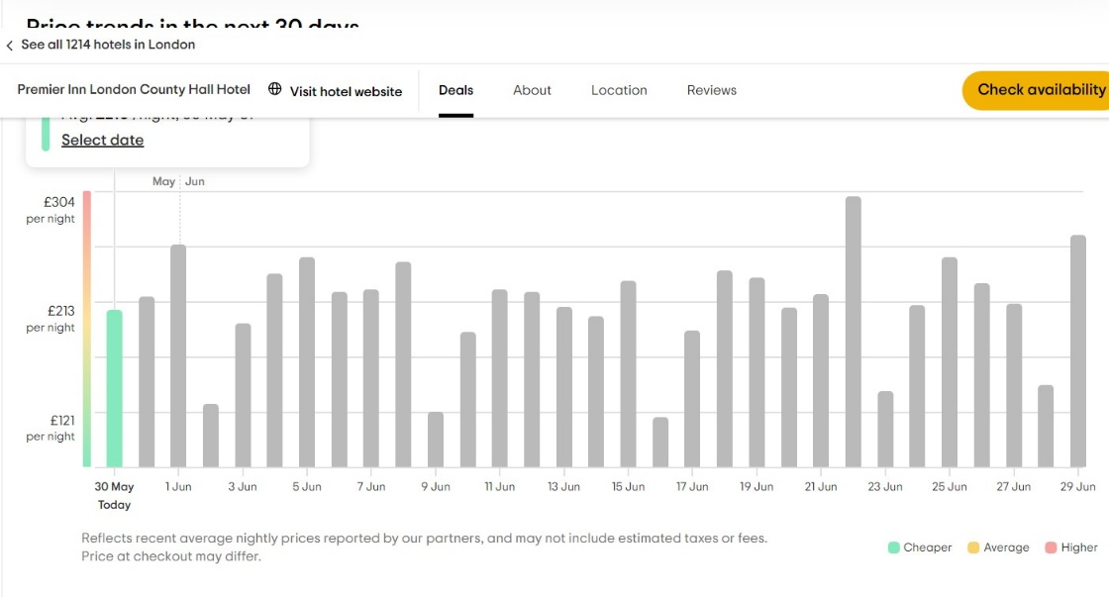

Figure 12: Premier Inn Hotel Prices Over 30 days. (Trip Advisor, 2024)
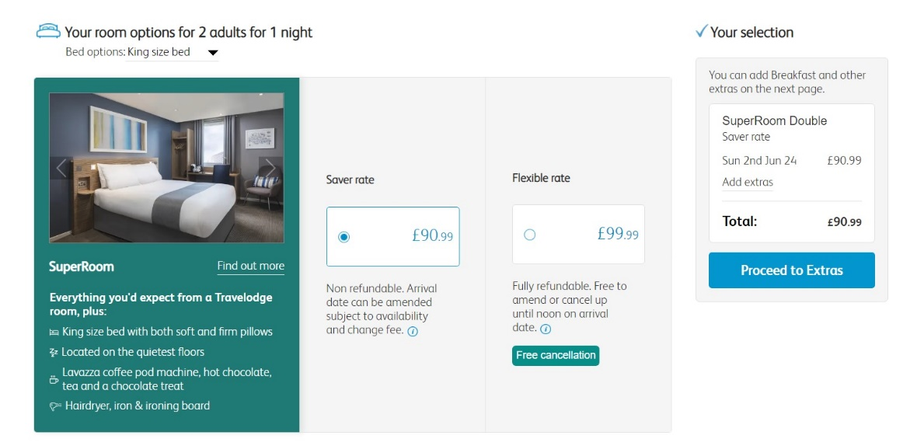Figure 13: Travelodge London Covent Garden Room Prices. (Travelodge, 2024)

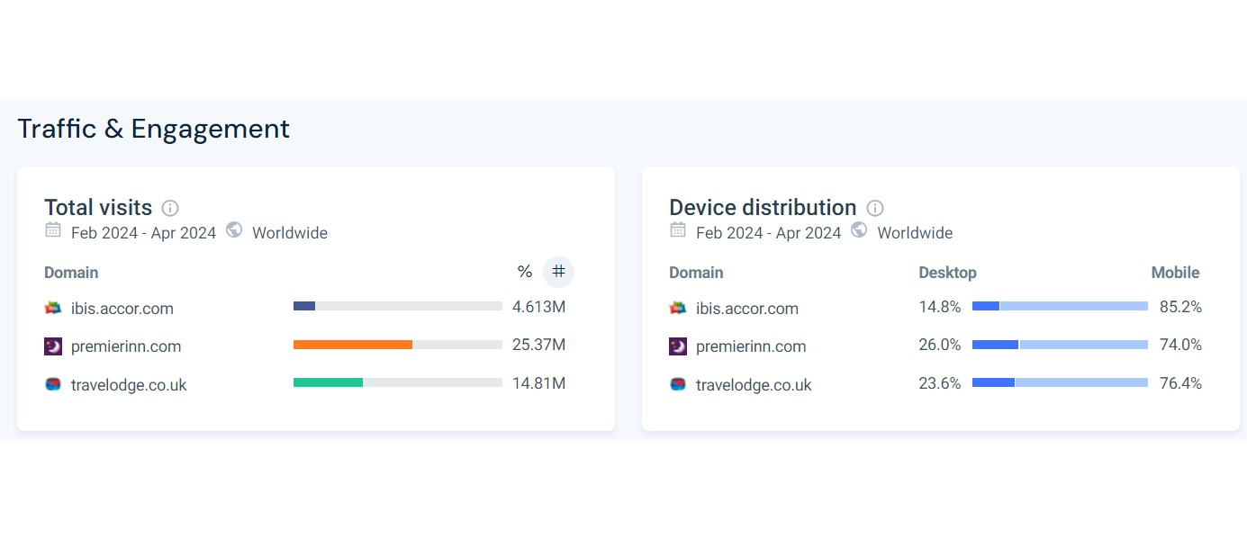Figure 14: traffic engagement IBIS, PREMIER INN, TRAVELODGE. (Similar web,2024b)
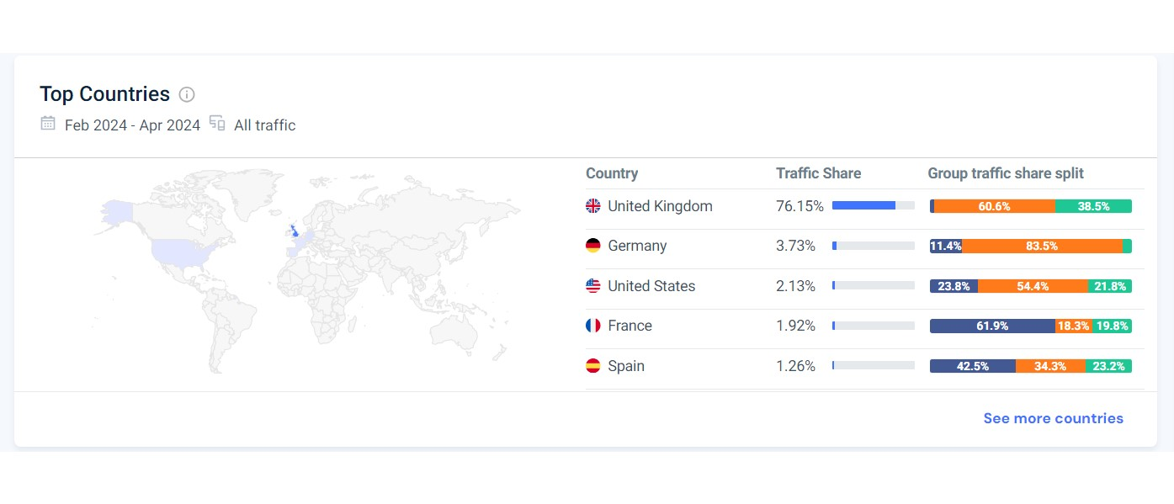
Figure 15: TOP COUNTRIES: IBIS, PREMIER INN, TRAVELODGE. (Similar web,2024b)

