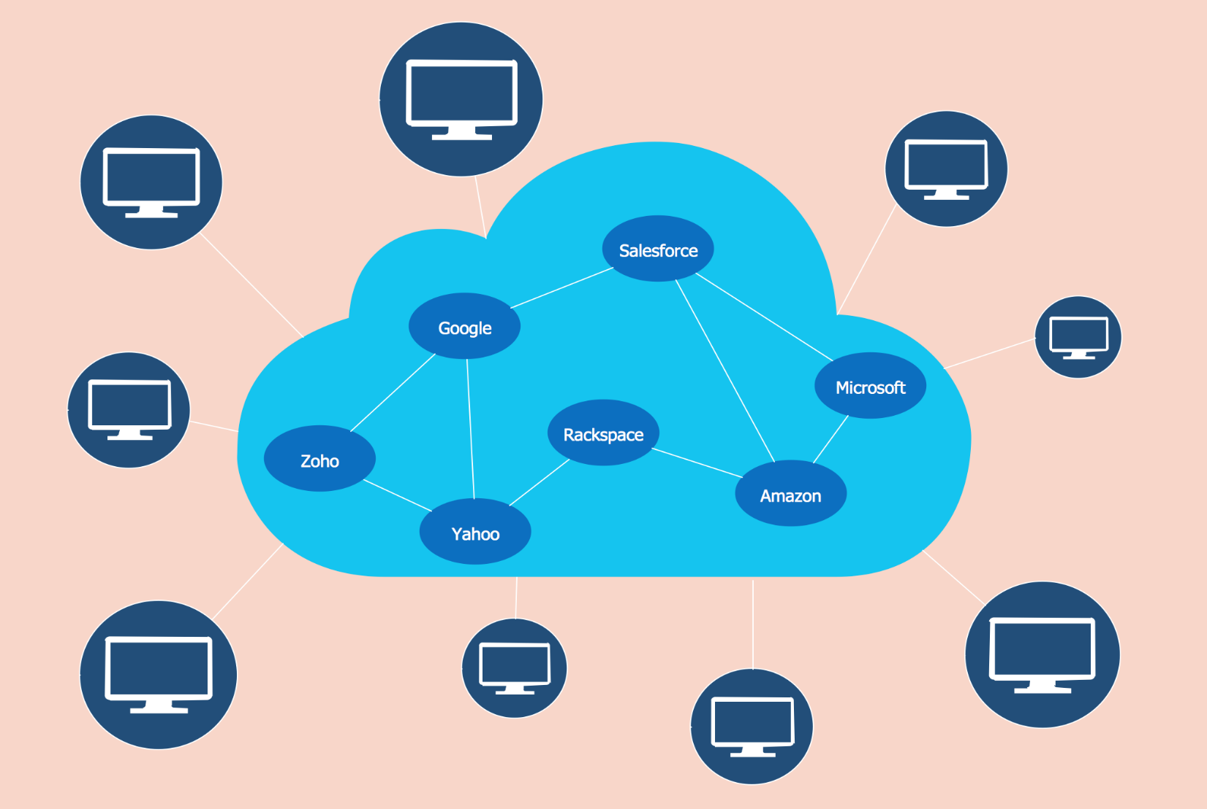

Module name: Cloud Computing Architecture
Module code: ACCA5025
Assignment 1: Essay

Teacher name : Suneth Fernando
Student name: Stefania-Loredana Galbau
Student ID: 2114954
Date of submision: 06/04/2023

Table of Contents
Task I 3
The term "virtualization" refers to what? 3
What exactly are virtual computers, also known as VMs? 3
Task II 3
About IaaS ("infrastructure as a service.") 3
Diferences between IaaS and PaaS 3
Advantages and Disadvantages of Using IaaS 4
Cost, support provided and exertise required 4
Unlimited budget 5
Moderate budget 5
Task III 6
Azure location, availability zones, resourse groups 6
Task IV 6
Authorisation and Authentication. The difference between 6
Importance of multifactor authentication(MFA) 6
Network security groups (NSGs) 7
References 8

Task I

The term "virtualization" refers to what?

Virtualization refers to a set of practises that underpin cloud computing and allow for more efficient use of physical computer hardware. The word "virtual machine" is used to describe an intermediate layer between the hardware and the operating system.Therefore, it follows that virtualization enables a larger yield on the investment in physical computer hardware and provides for more efficient usage of such hardware. Virtualization is widely used in today's corporate IT systems [1]. The technology is also what makes cloud computing so lucrative.In the cloud, users can scale up their processing power as their workloads increase without incurring additional costs beyond what they initially invested. Cloud service providers can support customers using the customers' existing hardware [2]. The advent of virtualization allows for this.
In general, virtualization is a powerful technology that can help you improve the efficacy, adaptability, and availability of your infrastructure while simultaneously lowering your expenses and increasing your mobility.

What exactly are virtual computers, also known as VMs?

A virtual machine, or "machine," is an abstract representation of a real computer. They are often termed a guest, while the physical machine they run on is known as a host. Thanks to virtualization, multiple virtual computers can be created on a single real computer, each with its own OS and set of software apps.A VM can't talk to a real computer because there's no physical connection between them. Instead, it needs a lightweight software layer called a hypervisor to translate between itself and the underlying hardware.
The hypervisor allots hardware resources like CPUs, RAM, and hard drives to each virtual machine (VM) separately.It ensures that each VM continues to function independently of the others. Although this technology goes by many names, including "virtual server," "virtual server instance," and "virtual private server," we'll just call them "virtual computers" from here on out [3].
In other words, virtual machines offer businesses an adaptable and extensible method of running numerous operating systems and applications on a single physical computer. As a result, businesses are able to improve their operational efficacy, lower their operating costs, and increase their degree of adaptability.

Task II

About IaaS ("infrastructure as a service.")

Infrastructure as a Service, or IaaS, is a subset of cloud computing in which customers are given access to shared processing resources like virtual computers, storage, and networking [4]. Without having to purchase or perform routine maintenance on the base hardware, users can supply and control these resources on demand.
With Infrastructure as a Service, users can quickly launch and expand their apps without making costly infrastructure expenditures. Costs can be kept to a minimum by having customers pay only for the resources they actually use.Amazon Web Services (AWS), Microsoft Azure, and Google Cloud Platform are all instances of infrastructure as a service (IaaS) companies.
Among the many services available from these vendors are virtual machine hosting, data storing, network connectivity, and database management.
In conclusion, Infrastructure as a Service (IaaS) is a potent resource for businesses that want to take advantage of cloud computing to cut expenses, increase agility, and quickly expand their infrastructure.

Diferences between IaaS and PaaS

While both Infrastructure as a Service and Platform as a Service are examples of cloud computing, there are important distinctions between them.
- Users can access automated infrastructure resources like virtual computers, storage, and networking thanks to IaaS's high level of abstraction. In comparison, Platform as a Service (PaaS) allows developers to focus on making their apps work rather than on managing the core technology on which those applications run.
- Users of Infrastructure as a Service (IaaS) are responsible for administering the underlying virtual infrastructure, including the OS, protocols, and apps [5]. By outsourcing these tasks, PaaS frees up developers to concentrate on creating and releasing apps.
- IaaS customers have more leeway to tailor their technology to their specific requirements, which is a major benefit. However, in order to keep the platform uniform for all users, PaaS may have restrictions on what can be customised.
- Given that the supplier has already set up and is responsible for managing the core technology, PaaS can provide a shorter time to launch. Users of IaaS must first invest time customising their system in preparation for application deployment.Heroku, Google App Engine, and Microsoft Azure App Service are all examples of companies who offer a PaaS.
The final decision between Infrastructure as a Service and Platform as a Service should be made based on each company's individual requirements. IaaS is a good fit for businesses that need precise management of their infrastructure and want to tailor their setting to their needs, while PaaS is a better option for companies that value rapid application release and want to concentrate on programme development.

Advantages and Disadvantages of Using IaaS

The benefits of IaaS are:
First, businesses can save money by using IaaS because it eliminates the need for costly hardware and its upkeep.
Second, IaaS makes it simple for businesses to expand or contract their infrastructure on the fly, without purchasing expensive new equipment.
Thirdly, IaaS is adaptable, as it allows businesses to tailor their systems to their unique requirements.
Fourthly, IaaS companies usually provide high availability and resilience, so system resources can be accessed whenever they are required.
For improved efficiency and catastrophe recovery, businesses can spread their infrastructure and apps across various areas thanks to the IaaS provider's global network of data centres.

IaaS's Drawbacks
IaaS has a high learning slope for those who are unfamiliar with cloud computing or automated system management.
Organizations are still liable for protecting their own apps and data, even though IaaS companies offer security features and regulatory licences [6].
Third, IaaS companies usually pool real resources like computers and storage for the benefit of all their customers. If one user's activity has an effect on the resources available to other users, this could degrade efficiency.

Cost, support provided and exertise required

- Cost: The price of infrastructure as a service (IaaS) differs from one supplier to another and from one service to another. Infrastructure as a service companies typically bill customers according to how much they make use of the service's underlying components.
- Support provided roviders of infrastructure as a service (IaaS) usually have multiple channels of customer service available, including email, newsgroups, and phone [7]. In addition to the standard methods of customer service, some vendors provide premium choices like round-the-clock tech assistance, personal account managers, and even on-site technicians.

- Expertise required: Provider- and service-specific considerations determine the depth of customer care.
Even though IaaS companies handle much of the infrastructure administration, users are still responsible for setting up and maintaining their own virtual computers, apps, and other resources. This requires a certain level of knowledge and expertise [8]. To make the most of IaaS, therefore, businesses need a certain degree of technological knowledge. Skills in operating systems, networks, and safety are required. Managed services, which are offered by some suppliers, can lessen the burden of technical knowledge on customers.
Overall, the expense, assistance, and knowledge needed will change based on the chosen IaaS supplier and the chosen service tier. Before implementing IaaS, businesses should give serious thought to these issues, ensuring they will be able to reap the advantages of this cloud computing service.

Unlimited budget

The following strategies could be implemented to improve your cloud server performance if money were no object:
First, take advantage of premium or high-performance services: If you have a sizable budget, you can select from options like Azure Premium Storage, Azure Ultra Disk, and Azure SQL Database Premium. These services are more efficient and scalable than the norm because of this.
Use Azure Site Recovery, Azure Backup, or Azure ExpressRoute to set up a reliable catastrophe recovery and business continuity strategy at no additional expense. In the event of a catastrophe or power failure, these services can help keep your data and programmes operational.
Third, add resilience with Azure Availability Zones, which replicate your data and apps across various datacenters to provide extra failure tolerance [9]. In the case of a widespread power failure, this can help keep your services operational.
Overall, you can ensure the safety, dependability, and scalability of your cloud infrastructure by allocating a sizable budget without worrying about going over budget.

Moderate budget

The following choices can help you optimise your cloud architecture if you have a moderate budget and can live with intermittent service outages.
First, select for standard or base services rather than their more expensive luxury versions if you're working with a moderate budget. Although the efficacy of these services may not be as good as that of paid services, they may still be sufficient for many applications.
Second, make use of fault tolerance by deploying tools like the Azure Availability Sets and the Azure Load Balancer to keep your services online even if there is a hardware or programme malfunction [10]. This can aid in keeping your services available to clients and reducing the amount of time you're down.
Third, prioritise your most important services so that they receive the time, money, and care they need to run smoothly and without interruptions for your clients. Automatic backup and prioritising resource allocation to mission-critical services are two possible solutions.
Overall, you can optimise your cloud infrastructure to provide sufficient speed, availability, and dependability while minimising costs with a medium budget and a readiness to endure some loss of service under certain conditions.

Task III

Azure location, availability zones, resourse groups

With Microsoft Azure, you can take advantage of IaaS, PaaS, and SaaS, three of the most popular service models in the cloud computing industry. (SaaS). Concepts central to understanding Azure's architecture are outlined below.
Azure's data centres are situated in "regions," which are defined as geographical locations that each host one or more data centres. Organizations can tailor their resource deployment to meet their unique requirements by deciding where in the world to place their operations. An organisation might prioritise efficiency by selecting an area physically near to its customers.
Second, in certain Azure areas, Microsoft provides Availability Zones, which are like different data centres but still part of the same region. High availability and resilience for mission-critical apps and services are the primary goals of Availability Zones. By spreading their resources across several Availability Zones, businesses can lessen their vulnerability to outages caused by a single point of failure.
In Azure, resources are categorised and managed in what are called "resource groups." Virtual computers, data store accounts, and network nodes are all examples of resources that can be grouped together. Groups of resources allow for more targeted management and policy implementation [11]. To facilitate the management and tracking of resources for a given project or division, an organisation may, for instance, establish dedicated resource groups.
In sum, Azure's many available infrastructure choices (such as regions, Availability Zones, and resource groups) allow businesses to tailor their cloud computing experience to their unique requirements. Organizations can more fully take advantage of Azure's capabilities for developing and deploying apps and services by mastering these principles.

Task IV

Authorisation and Authentication. The difference between

While they share some similarities, authentication and permission in the cloud have separate goals.To authenticate is to check a person's or computer's credentials. Verifying a user's identity, such as their login and password, or using additional verification factors, such as multi-factor authentication, is what authentication is all about [12]. To restrict access to restricted tools or services, identification is required.In contrast, authorization refers to the process of deciding whether or not to give a person or computer system access to a set of privileges. Finding out what a person can and can't do with a given resource depends on their assigned position or rights. Authorization's purpose is to restrict use to only those areas and activities for which a user has been granted permission.
Authorization refers to deciding what a person or system is permitted to do after their identification has been confirmed through the verification procedure [13].
To ensure that only authorised users can gain access to resources and take actions in the cloud, identification and permission are crucial parts of cloud security. Strong identification and permission rules help businesses lower their vulnerability to hacking and other forms of data loss.

Importance of multifactor authentication(MFA)

With multifactor authentication (MFA), users are prompted for a one-time code or fingerprint proof in addition to their usual login and password. Multi-factor authentication (MFA) is crucial in cloud computing because it adds an additional security component that can prevent unauthorised entry and data leaks.
Some of the most compelling reasons to employ multifactor verification when working in the cloud include the following:
One, it's more difficult for adversaries to gain access to resources or data because multi-factor authentication (MFA) adds another degree of security beyond just a login and password.
The second benefit of MFA is a lower probability of data leaks, as it prevents unauthorised entry even if an intruder obtains a user's passcode.
Third, multi-factor authentication (MFA) is often mandated by safety laws and standards like PCI-DSS, HIPAA, and GDPR.
In conclusion, it is impossible to exaggerate the significance of multifactor security in cloud computing. The danger of unauthorised access and data leaks can be greatly reduced by adopting MFA, allowing businesses to better protect their cloud-based resources.

Network security groups (NSGs)

In Azure, sentinel servers and network security groups (NSGs) are two crucial parts of cloud security:
- Organizations for Network Safety: Traffic to and from Azure virtual machines (VMs) and subnets is managed by network security groups, which function as virtual firewalls. You can use NSGs to manage the flow of data to and from the resources in a virtual network in accordance with the policies you establish. You can add another degree of protection to your virtual network by blocking connections to particular ports or protocols.
- Hosts in Bastion: In Azure, a bastion server is a specialised virtual computer (VM) used for safe, off-site access to other VMs. Bastion servers connect your private network on-premises or the internet to your public Azure virtual network [14]. Using a fortress server allows you to keep your virtual computers isolated from the wider internet, protecting them from potential threats.
To ensure that only authorised users can access the network, bastion servers are usually installed in a distinct region within the virtual network and outfitted with NSGs. Users can then access the virtual computers within the virtual network by connecting to the base server via Remote Desktop Protocol (RDP) or Secure Shell (SSH).When it comes to Azure cloud security, NSGs and sentinel servers are two crucial components that let you manage who can access your virtual network and keep your data safe. Using these capabilities, you can strengthen the safety and dependability of your cloud-based setup.

References

[1] | "S. A. Babu, M. J. Hareesh, J. P. Martin, S. Cherian and Y. Sastri, "System Performance Evaluation of Para Virtualization, Container Virtualization, and Full Virtualization Using Xen, OpenVZ, and XenServer," 2014 Fourth International Conference on Advances".
[2] | "A. Abuabdo and Z. A. Al-Sharif, "Virtualization vs. Containerization: Towards a Multithreaded Performance Evaluation Approach," 2019 IEEE/ACS 16th International Conference on Computer Systems and Applications (AICCSA), Abu Dhabi, United Arab Emirates, 201".
[3] | "M. Ku, D. Min and E. Choi, "Analysis of virtual machine creation characteristics on virtualized computing environment," The 7th International Conference on Networked Computing and Advanced Information Management, Gyeongju, Korea (South), 2011, pp. 1-6.".
[4] | "A. K. Bansal, V. Gupta and H. Kaur, "An implementation of private cloud's service model (IaaS) using lightweight virtualization," 2016 International Conference on Electrical, Electronics, and Optimization Techniques (ICEEOT), Chennai, India, 2016, pp. 950".
[5] | "E. Salbaroli, E. Benetti and G. Mazzini, "Open source IAAS and PAAS services in a public administration datacenter," 2015 IEEE International Black Sea Conference on Communications and Networking (BlackSeaCom), Constanta, Romania, 2015, pp. 122-126, doi: 1".
[6] | "A. Celesti, F. Tusa, M. Villari and A. Puliafito, "An Approach to Enable Cloud Service Providers to Arrange IaaS, PaaS, and Saas Using External Virtualization Infrastructures," 2011 IEEE World Congress on Services, Washington, DC, USA, 2011, pp. 607-611,".
[7] | "N. Junath and G. Shanmugarathinam, "A Cloud service and conceptual modeling of IAAS," IET Chennai 3rd International on Sustainable Energy and Intelligent Systems (SEISCON 2012), Tiruchengode, 2012, pp. 1-4, doi: 10.1049/cp.2012.2193.".
[8] | "M. Kozlovszky, M. Törőcsik, T. Schubert and V. Póserné, "IaaS type Cloud infrastructure assessment and monitoring," 2013 36th International Convention on Information and Communication Technology, Electronics and Microelectronics (MIPRO), Opatija, Croatia,".
[9] | "X. Li, B. Gu, C. Zhang, K. Yamori and Y. Tanaka, "Price competition in a duopoly IaaS cloud market," The 16th Asia-Pacific Network Operations and Management Symposium, Hsinchu, Taiwan, 2014, pp. 1-4, doi: 10.1109/APNOMS.2014.6996552.".
[10] | "T. Wang, X. Chang and B. Liu, "Performability Analysis for IaaS Cloud Data Center," 2016 17th International Conference on Parallel and Distributed Computing, Applications and Technologies (PDCAT), Guangzhou, China, 2016, pp. 91-94, doi: 10.1109/PDCAT.2016".
[11] | "Timothy L. Warner, "Deploying Platform Resources to Microsoft Azure," in Microsoft Azure For Dummies , Wiley, 2020, pp.137-138.".
[12] | ""IEEE Draft Standard for Discovery, Authentication, and Authorization in Host Attachments of Storage Devices," in IEEE P1667/D03, October 2017 , vol., no., pp.1-286, 20 Oct. 2017.".
[13] | "A. Tolnai and S. von Solms, "Managing Some Security Risks Related to the Deployment of Multifarious Authentication and Authorization in a Virtualized Environment," 2010 International Conference on Broadband, Wireless Computing, Communication and Applicati".
[14] | "Man Young Rhee, "Internet Firewalls for Trusted Systems," in Wireless Mobile Internet Security , Wiley, 2013, pp.387-414, doi: 10.1002/9781118512920.ch11.".

