

Research on Real-Time Lane Detection Algorithm Based on Deep Learning
by
Bowen Chen

Supervisor: Gorden Dickers
Second Marker: None

Project submitted as part of the requirements for the award of MSc Data science and Artificial Intelligence

September 2023

DECLARATION

I, Bowen Chen, declare that I am the sole author of this Project; that all references cited have been consulted; that I have conducted all work of which this is a record, and that the finished work lies within the prescribed word limits.

This work has not previously been accepted as part of any other degree submission.

Signed : ....

Date : ..............Sep 10th, 2023................................

FORM OF CONSENT

I ,Bowen Chen , hereby consent that my Project, submitted in candidature for the M.Sc. Applied Computing degree, if successful, may be made available for inter-library loan or photocopying (subject to the law of copyright), and that the title and abstract may be made available to outside organisations.

Signed : .

Date : ........ Sep 10th, 2023..................

Abstract
The development and proliferation of emerging technologies such as Artificial Intelligence, Edge Computing, 5G, and Cloud Computing are shaping the world of interconnected intelligence. Among these, the automotive industry is considered the cornerstone of most future industries, serving as a primary platform for technological research and practical implementation. Lane detection is a fundamental problem in applying computer vision to autonomous driving or driver assistance, representing a pivotal research focus within the field of autonomous vehicles. Early lane detection tasks primarily relied on traditional image processing methods. However, real-world scenarios often feature complex road conditions, including significant occlusions, ambiguous lane markings, and poor lighting conditions, which posed substantial challenges for conventional image processing approaches. In comparison, segmentation methods based on deep learning offer enhanced semantic representation capabilities, enabling higher-level semantic analysis of lanes, and have consequently become mainstream. Unfortunately, while these convolutional neural network-based methods excel in scene understanding, they still struggle with lane detection in cases involving long structural regions or potential occlusions. Moreover, as a foundational module within intelligent vehicle environment perception systems, lane detection typically operates with limited hardware resources, necessitating a focus on maximizing detection speed. This paper presents a real-time lane detection method based on deep learning, offering faster detection speeds and efficient performance compared to most state-of-the-art methods. The proposed approach introduces a lane detection model based on per-row grid unit classification and an attention mechanism. Specifically, it adopts a grid unit classification approach, merging a channel attention mechanism with spatial attention to aggregate global information. It employs ResNet-18 as the backbone network with the embedded attention mechanism. Additionally, pixel-level semantic segmentation serves as an auxiliary branch to enhance training outcomes, with the auxiliary branch excluded from inference to boost testing speed. The paper conducts experiments on two major publicly available datasets, Tusimple and Culane , and compares the proposed method with various state-of-the-art methods. The method achieves an accuracy of 0.9579 on the Tusimple dataset and an F1-measure of 0.6978 on the challenging Culane dataset. By redefining the lane detection task as a classification problem based on per-row grid units, the reduction in the number of grid units compared to pixels results in a simpler and lightweight network architecture, ensuring real-time detection. To better address scenarios lacking visual cues and further enhance detection efficiency, the paper combines spatial and channel domain attention mechanisms, integrating a lightweight attention mechanism to aggregate global features and fuse global and local features, which may have potential utility for related detection tasks in other domains. The algorithm comprehensively considers detection accuracy and speed, yielding excellent results on both datasets, demonstrating the feasibility and practicality of this approach.
Key words：ResNet; Attention; Lane line detection; Tusimple dataset; Culane dataset;

Content
Abstract 3
Chapter 1 Introduction 7
Chapter 2 LITERATURE REVIEW 8
2.1 Lane Detection Based on Traditional Image Processing 8
2.2 Lane Detection Based on Deep Learning 9
2.3 Development History of Convolutional Neural Networks 10
2.4 Summary and thoughts 15
Chapter 3 Methodology 16
3.1 The method based on row-wise grid classification 16
3.2 Creating Labels for Image Data 17
3.3 Lane Detection Combined with Attention 17
3.4 Backbone-----ResNet-18 with CBAM 21
3.4.1 How to combine CBAM with ResNet-18’s Basic Block 21
3.4.2 The backbone network’s architecture 22
3.5 Overall network architecture 23
3.6 Loss Function 24
3.7 Summary of this chapter 25
Chapter 4 Design and Implementation 26
4.1 Data Preprocessing 26
4.2 Dataloader 27
4.3.1 CBAM basic block 29
4.3.2 Channel Attention Module 30
4.3.3 Spatial Attention Module 31
4.4 Dynamic learning rate adjustment 32
4.5 Summary for this chapter 33
Chapter 5 Experiment and Analysis 33
5.1 Datasets to be used 33
5.2 Evaluation criteria for lane detection 34
5.3 Training environment 37
5.4 Experiment on Culane dataset 37
5.5 Experiment on Tusimple dataset 42
5.6 Knockdown Experiment 45
5.7 Summary of this chapter 46
Chapter 6 Conclusions and Recommendations 46
Chapter 7 Reflection 48
References 49

Chapter 1 Introduction
The development and proliferation of emerging technologies such as Artificial Intelligence, Edge Computing, 5G, and Cloud Computing are shaping the world of interconnected intelligence. Among these, the automotive industry is considered the cornerstone of most future industries, serving as a primary platform for technological research and practical implementation. Therefore, the development of intelligent, electric, and connected vehicles is a prevailing trend. These intelligent vehicles are often referred to as Intelligent Connected Vehicles (ICVs).
For different levels of ICVs, various concepts have been introduced, including "Intelligent Assistance," "Shared Autonomy," and "Self-driving Automobiles." Self-driving can be further subdivided into perception, decision-making, and execution modules. The environmental perception module typically relies on onboard cameras and other sensors to acquire information about the vehicle's surroundings, providing the vehicle with a certain level of perception capability.
Within the framework of a comprehensive ICV environment perception system, the core foundation lies in the lane detection function module. Lane detection, in fact, presents a highly challenging task. Firstly, lane detection operates in the real-world scenario of moving vehicles on the road, necessitating swift detection capabilities within the ICV's environmental perception system. Therefore, the detection speed of lane detection is a critical issue requiring special attention. Furthermore, real-world vehicles navigate through a variety of complex road conditions. For instance, lanes on congested roads are often partially or completely obscured by other vehicles. Additionally, adverse weather conditions such as rain, snow, intense or dim lighting, uneven terrain, and wear and tear on lane markings present a series of challenges, introducing visual ambiguity. All these factors collectively pose significant challenges to lane detection tasks.
Hence, the design of a lane detection method that can operate at high speed while maintaining accuracy is a highly challenging and immensely valuable research topic, with profound implications for the future of intelligent vehicles.

Chapter 2 LITERATURE REVIEW
Lane detection is a fundamental problem in applying computer vision to autonomous driving or driver assistance, with a long research history. Lane detection has traditionally relied on sensors such as radar, GPS, or cameras. Therefore, relevant studies have been primarily based on GPS-based lane recognition, laser radar-based lane recognition, and vision sensor-based lane recognition.
The basic requirement for laser radar-based lane recognition is that the detected lane lines themselves must have high-quality, standardized paint intensity. This method heavily relies on lane line reflection characteristics, leading to poor performance in scenarios with worn-out or obstructed lane lines [1]. GPS-based lane recognition methods often utilize GPS positioning systems combined with high-precision maps to handle lane recognition tasks, but they are susceptible to electromagnetic interference and external environmental factors. Lane recognition based on vision sensors uses cameras on vehicles as a foundation and detects vehicle trajectories based on designed detection models [2]. Compared to the first two methods, onboard cameras have lower cost and greater convenience. Additionally, vision sensors have a perception similar to human vision and provide richer interaction information [3]. Considering these factors, lane recognition methods based on vision sensors have gradually gained recognition among researchers and have become the most commonly used methods in the industry. Therefore, to make this study more engineering-oriented and practical, the lane detection algorithm in this paper is also developed based on vision sensors.
In lane detection tasks, based on visual perception techniques, two categories can be identified: one is traditional lane detection based on image processing, and the other is lane detection based on deep learning. Detailed introductions to these two categories are provided below.

2.1 Lane Detection Based on Traditional Image Processing
In traditional methods, lane detection can be further categorized into feature-based lane detection and model-based lane detection. For lane markings, there are distinct differences between their inherent characteristics and those of the road surface, such as unique color [4], shape [5], edges [6], and texture. Feature-based lane detection methods leverage these inherent differences to detect lane markings. Sun et al. [7] proposed the HIS color model, which transforms the RGB image into the HIS color space and then applies intensity-based pixel filtering. Batavia et al. [8], on the other hand, utilize lane texture features in image processing and subsequently combine lane shape characteristics with edge detection for lane detection. Feature-based algorithms often require high-quality lane image characteristics, but in real-world scenarios, they are often vulnerable to external environmental interference, leading to low robustness.
Model-based lane detection methods are built on existing road information and the geometric properties of lane markings. This involves creating a geometric model of lane markings and calculating and solving various model parameters to achieve lane detection. Commonly used methods include least squares [9], Hough transform [10], and Random Sample Consensus (RANSAC) algorithm [11]. Phueakjeen et al. [12] proposed using a linear model for the proximal end of lane markings and a parabolic model for heavily curved lane markings. Xu et al. [13], by partitioning each channel, employed the RANSAC algorithm for lane detection. However, model-based lane detection algorithms require a trade-off in the complexity of the model. Low-complexity models struggle to handle various lane scenarios, while high-complexity models lead to significant increases in computational workload, imposing limitations on such methods.

2.2 Lane Detection Based on Deep Learning
In the rapidly advancing landscape of deep learning, utilizing Deep Neural Networks (DNNs) for lane detection has demonstrated its remarkable advantages. Building upon this foundation, approaches based on deep segmentation and row classification have been proposed. The deep segmentation approach operates on each pixel of the input image, aiming to classify each pixel as either a lane or background. After generating a segmentation map, post-processing steps are needed to decode it into a set of lanes. SCNN [14] extends the traditional convolutional neural network's layer-wise convolution to a per-patch convolution in feature map mappings, enabling pixel signal transmission between rows and columns. This is particularly suitable for continuously shaped and elongated lane structures, showing significant performance in lane detection tasks. However, this recursive neural network-like approach leads to slow processing speeds, making it challenging to meet the real-time requirement of practical applications. Generally, complex backbone networks contribute to slow processing, prompting efforts to find real-time lightweight methods. SAD [15] introduces a self-attention distillation module based on knowledge distillation to aggregate contextual information, allowing the use of lighter backbone networks, significantly enhancing the real-time efficiency of lane detection while maintaining high performance. Lane-Net [16] represents pixels using vectors and combines semantic segmentation to form a multitask model, finally utilizing Mean-Shift to cluster lane pixel points to achieve instance segmentation of lanes. The row classification method is a simple grid-based road recognition algorithm. For each divided grid row, the model selects the grid with the highest likelihood of containing a portion of lane markings. Since only one most likely grid unit is chosen per row, this process is repeated for each lane marking in the image. Finally, a post-processing step is employed to construct a collection of lane markings. E2E-LMD [17] first adopts a row-based lane detection method in lane detection tasks, viewing the task as distinguishing the specific position of each lane marking in each row, achieving 74% accuracy on the challenging CULane dataset. However, its network structure is relatively complex, and the code has not been open-sourced, making reproduction challenging. Ultra Fast LaneNet [18] similarly employs a row-based lane detection method, treating the lane detection problem as row-based griding cells position selection and classification based on global image features. The network structure is more streamlined and achieves high detection accuracy and relatively fast inference rates on the CULane dataset. Overall, the advantages of deep learning-based lane detection techniques over other detection techniques lie in their strong autonomous learning capabilities. However, a technical limitation for most algorithms remains how to accurately detect lane markings in scenarios involving inherent lane defects and various external environmental factors that result in the absence of visual clues. Additionally, deep learning-based lane detection methods require hardware capable of handling substantial computation. How to quickly detect lane markings within limited computational costs is also a current focus of related work. Therefore, there is a pressing need for further improvements in lane detection algorithms.

2.3 Development History of Convolutional Neural Networks
In 1998 Proposed by Yann LeCun and his team[19], it is one of the pioneers of CNNs and was used for handwritten digit recognition. It introduced the concepts of convolutional layers and pooling layers, laying the foundation for CNNs in the early stages.Due to insufficient computational power of hardware, LeNet-5 did not immediately catch the attention of the academic community after its proposal. As a result, convolutional neural networks entered a prolonged period of stagnation. Finally, in the past few years, there has been a substantial improvement in the quality of computational hardware. Convolutional neural networks have experienced a resurgence and have rapidly developed into a state of explosive growth. Subsequently, a detailed exposition will be provided regarding representative convolutional neural networks from recent years.
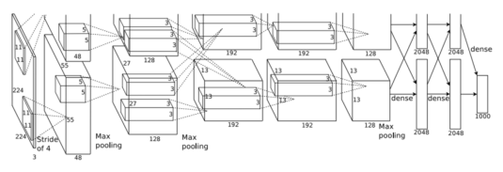
After a prolonged period of stagnation, the commencement of a new wave of development for convolutional neural networks occurred in the ImageNet competition of 2012. Alex Krizhevsky et al. introduced AlexNet [20], which claimed victory with a performance significantly surpassing that of the runner-up. The network architecture of AlexNet is depicted in Figure 2.7, with the fundamental concept still being convolution followed by fully connected layers, though much more intricate in detail compared to LeNet. The most prominent innovations of AlexNet include the utilization of ReLU activation functions to address the gradient vanishing issue of Sigmoid in deep networks, employing repeated Max Pooling to enhance feature richness, implementing Dropout to randomly neglect certain neurons to mitigate overfitting, proposing Local Response Normalization to enhance the model's generalization ability, and pioneering the use of GPU acceleration for training.
Fig 2.1 The network architecture of AlexNet [20]

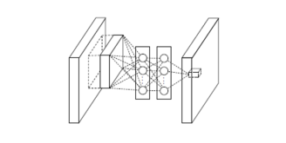
The drawback of AlexNet is evident, namely its substantial parameter count. In 2014, Lin et al. introduced "Network in Network" [26], a network architecture that achieved comparable performance to AlexNet with only 29M parameters, a significant reduction from AlexNet's 230M parameters. The influence of "Network in Network" has been far-reaching, with echoes of its concepts appearing in numerous subsequent papers. In essence, "Network in Network" proposes two key innovations: MLP Convolution Layers and Global Average Pooling. Figure 2.8 illustrates the structure of MLP Convolution Layers. These layers incorporate several 1x1 convolutions following regular convolutions, effectively linearly combining feature maps as if multiple neural units were intertwined. The MLP convolution layers leverage 1x1 convolutions to abstract and fuse features, thereby enhancing abstract feature expression. Global Average Pooling is employed as a substitute for fully connected layers. In the preceding paragraph, the use of Dropout in AlexNet to enhance generalization was mentioned; however, the computational load of fully connected layers remained unaddressed. NIN suggests replacing fully connected layers with global average pooling to mitigate this issue. After applying average pooling to the final layer's feature map, the result is directly passed to the softmax layer. This classification task directly associates feature maps, and because global average pooling does not introduce additional parameters, the computational load is markedly reduced compared to fully connected layers.
Fig 2.2 MLP Convolution Layers Structure
In the same year, the Visual Geometry Group at the University of Oxford introduced VGGNet [21], which secured the runner-up position in the ImageNet competition. VGGNet is a deep variant of AlexNet, both composed of convolutional and fully connected layers, but VGGNet has a simpler structure and fewer parameters. VGGNet innovatively builds upon AlexNet, using the same 3x3 convolution kernel size and 2x2 max pooling size throughout the entire network, in contrast to AlexNet's 7x7 convolution kernel. Additionally, while each convolutional layer in AlexNet contains a single convolution operation, VGGNet incorporates two to four convolution operations per layer. This approach allows VGGNet to reduce parameters and increase non-linear mappings, thereby enhancing the network's adaptability. VGGNet's most significant contribution was demonstrating the vital impact of increasing network depth on performance.
GoogLeNet [22], developed by a team at Google, is a deep neural network model based on Inception modules. It won the championship in the 2014 ImageNet competition and has been continually refined over the next two years. Various versions have emerged, such as InceptionV2, InceptionV3, InceptionV4, and more. Extending networks in the depth and width directions is the most effective way to enhance neural network capabilities. However, this expansion comes with challenges like excessive parameters, overfitting due to limited training data, high computational complexity from large networks and parameter counts, and the issue of gradient vanishing in deep networks. Hence, the approach aims to reduce the parameter count while increasing the network's depth and width. Substituting fully connected layers with sparse connections can decrease some parameters. Nevertheless, most hardware is designed for dense matrix operations, which doesn't lead to efficient computation even with small data. To address this, Google's network adopted the modular architecture of Inception. Inception essentially combines multiple convolutional or pooling operations into a network component, constructing the network architecture in a modular fashion.
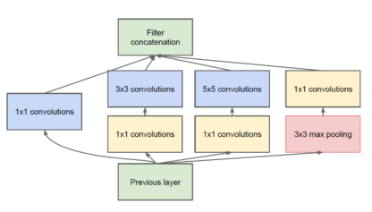
Inception V1's detailed structure is depicted in Figure 2.3. It fuses features of different scales by concatenating convolutions with various kernel sizes and embedding pooling operations. However, 5x5 convolutions still entail high computational costs as layer count increases. To alleviate this, like VGGNet, GoogLeNet also incorporated the idea of 1x1 convolutions from Network in Network. After three different-sized convolutions and max pooling, 1x1 convolutions were added to form the complete structure of Inception V1.In subsequent versions, V2 introduced Batch Normalization on the foundation of V1 and replaced a 5x5 convolution with two 3x3 convolutions, along with using 1xN and Nx1 convolutions instead of NxN convolutions. This significantly reduced parameter count without affecting the network's expressive power. V3, building on V2, employed Label Smoothing and introduced the RMSProp optimizer. The latest V4 version integrated ResNet's residual blocks.
Fig 2.3 Inception V1 Structure

In 2016, Kaiming He introduced the deep residual network, ResNet [23], marking another significant advancement in convolutional neural networks. As mentioned earlier, the depth of a network significantly impacts its performance. Deeper networks extract richer, more abstract, and semantically meaningful features. Consequently, deeper neural networks are theoretically expected to yield better results. However, through extensive experimentation, researchers have theoretically and empirically shown that as a network grows deeper, its accuracy saturates or even decreases. It has been observed that as the network's structure becomes more complex with increasing depth, the stochastic gradient descent strategy used in training tends to converge to local optima instead of the global optimum. This phenomenon is referred to as degradation.The ideal solution to the degradation problem is how to retain the benefits of deep networks while avoiding the degradation issue inherent to complex structures. Thus, a key insight emerged: by transforming the stacked layers beyond a certain depth into identity mappings ℎ(x) = x, the model essentially becomes a shallower network.
ResNet introduces residual learning, where the output of one or more layers is added back to the input, allowing the network to learn the residual mapping. This approach eases the training process, as the network can learn to adjust the input rather than reconstruct the whole transformation. The use of shortcut connections, also known as skip connections or identity mappings, helps propagate gradients more effectively during training. These connections allow for direct access to earlier layers' information and help mitigate the vanishing gradient issue.
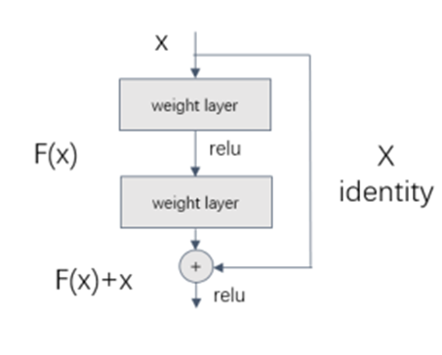
ResNet's architecture has shown strong generalization capabilities, making it adaptable to various tasks beyond image classification, such as object detection, segmentation, and more. Over time, ResNet has seen various architectural variants, like ResNetV2, which further refined the original design by introducing techniques like batch normalization before activation and changing the placement of the activation function.
Fig 2.4 Residual Structure

2.4 Summary and thoughts
This chapter provides a summary and introduction to the current research status of lane detection, and the development of CNNs. Despite the numerous solutions proposed for the lane detection task, there remain several challenges that have not been adequately addressed:

(1) Most of the existing lane detection algorithms are primarily designed for structured roads with complete and standardized lane markings. There is a need for more profound research to achieve accurate lane detection on unstructured roads.
(2) In the face of complex and variable road conditions such as changing lighting, adverse weather like rain, snow, and fog, occlusions caused by congested traffic, road surface irregularities, or building shadows, lane detection encounters significant difficulties. Achieving lane detection in various complex road scenarios is a formidable task.
(3) Traditional image processing methods often require extensive manual parameter tuning, and their algorithm complexity and detection cost are relatively high.
(4) Autonomous driving systems demand exceptionally high real-time performance, particularly when vehicles are traveling at high speeds. Stringent speed requirements for lane detection are present. However, the computational power of hardware integrated into vehicles is inevitably constrained. Therefore, achieving real-time detection speed with minimal resource utilization while maintaining detection accuracy is a research topic of practical significance.

Chapter 3 Methodology
In response to the aforementioned issues, this paper introduces a lane detection method based on image row-wise grid classification method. Compared to per-pixel segmentation methods, this approach enhances detection speed while incorporating an attention mechanism to further improve accuracy and efficiency. This method allows the utilization of the lightweight convolutional neural network ResNet-18 as the backbone model. It effectively addresses challenges such as lane wear, occlusions, and the lack of visual cues caused by various external environmental factors. The algorithm's performance is evaluated through training and testing on the Tusimple dataset and the challenging lane dataset Culane. Opting for PyTorch as the framework for deep learning

3.1 The method based on row-wise grid classification
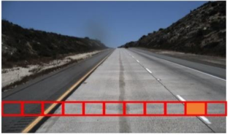
The method based on row-wise grid classification is primarily proposed to address the real-time nature of lane detection and the issue of missing visual cues. In general, this approach involves identifying the correct lane positions within each predefined row by combining global image features. Firstly, the entire image is gridded into appropriately sized units, facilitating the creation of dataset labels. Subsequently, a series of pre-defined rows, known as row anchors, are established within the grid. Each row anchor contains or corresponds to cells that encompass lanes. These cells indicate the correct lane positions on the respective row anchor. Ultimately, the task of lane detection is represented as the selection of specific cells within the predefined series of row anchors. In contrast to deep segmentation methods that involve per-pixel channel-wise selection, the row-wise grid classification approach is much faster in testing and have a better performance in real-time aspect.
Fig 3.1 Image grid segmentation on a specific row

During data preprocessing, the images are divided into Y * X grids. Here, Y represents the number of rows, and X represents the number of grids per row. It's important to note that the divisions are not tightly packed in each row. Based on the global visual characteristics of lane images from different datasets and guided by prior knowledge, the value of Y, determining the number of rows, is determined. At the same time, the pixel-level positions of each row on the image are also established. The value of X, representing the number of grids per row, serves as a hyperparameter. I utilizes the Tusimple dataset as well as the Culane dataset, where the value of X varies between different datasets.

3.2 Creating Labels for Image Data
During training, the data has dimensions of [B, X+1, Y, N], where B represents the batch size, X denotes the number of grids per row in the image, the X+1 dimension indicates the absence of a certain lane on that row, Y represents the number of rows, and N stands for the lane count, usually needs to observe up to four lanes. The network's prediction output corresponds to the probability of a certain grid on a specific row of an image belonging to one of the four lanes. The final output result is obtained by selecting the maximum predicted probability, representing the position of the corresponding grid within the lane. Obviously, the position of the lane in the grid on each image serves as the data label.

3.3 Lane Detection Combined with Attention
In recent years, attention mechanisms derived from the field of biological neuroscience have been widely applied to various machine learning tasks. They have demonstrated remarkable performance in both natural language processing and visual tasks. Rooted in the human cognitive process, attention mechanisms essentially allocate weights to information resources.In a sentence or an image, the "amount of information" carried by different locations and scales of target objects is clearly distinct. Similar to how the human brain operates, more important and directly inferable information receives greater attention, amplifying its influence on the final outcome. Conversely, less significant information, such as modifiers in sentences or most of the background in images, is selectively ignored to expedite reading or comprehension. This principle holds even truer in computing systems with limited resources. To enable machines to possess this selective disregard and contextual integration ability, researchers have devised various methods to design machine attention mechanisms in different domains based on data and network computation. Just as humans comprehend visual information, visual tasks can assign different weights to pixels in different positions or regions, imbuing the outcome with "bias." Regions given higher weights contribute more substantially to the overall understanding of the content. Introducing attention mechanisms into visual tasks yields several beneficial impacts: structurally selecting input data, reducing computation of high-density meaningless data. Guiding tasks towards more relevant directions, disregarding unimportant information, and shielding against interfering noise to enhance system performance. Attention mechanisms allocate weights between computational resources and input information, aiding feature extractors in filtering, processing different regions, channels, pixels, semantic content, and learning relationships.

Convolutional Block Attention Module (CBAM)
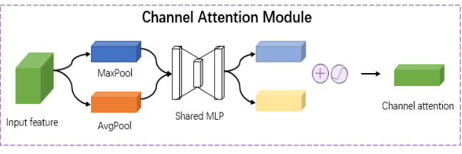
Here I utilize the CBAM (Convolutional Block Attention Module) [27] attention module to generate attention maps from both channel and spatial perspectives. Channel attention guides the network to focus on "what" is in the image. Figure 3.2 illustrates the structure of channel attention. Initially, the outputs obtained from the backbone network are separately subjected to MaxPool and AvgPool operations in the channel domain, resulting in two one-dimensional vectors. These vectors are then fed into a shared multi-layer perceptron (MLP) fully connected layer for corresponding calculations, and their results are added. This process produces a one-dimensional channel attention, which is broadcast along the channel dimension and then multiplied element-wise with the original input elements to generate a new feature map adjusted by channel attention.

Fig 3.2 Channel Attention Module

Continuing, the network can further emphasize the spatial positions of objects within the image by concatenating a spatial attention module. Figure 3.3 illustrates the structure of the spatial attention. The new feature map obtained from the channel attention serves as the input for the spatial attention module. Initially, in the spatial domain, MaxPool and AvgPool operations are applied to generate two-dimensional vectors. These vectors are then concatenated and subjected to convolution, resulting in a two-dimensional spatial attention. Similarly, this spatial attention is broadcast along the spatial dimension and multiplied element-wise with the original input elements to produce the final feature map. In this way, the model acquires feature maps with richer global information. This enriched feature map is subsequently inputted into the classification network to better utilize global information for lane position classification predictions, thereby achieving an improvement in accuracy to some extent.
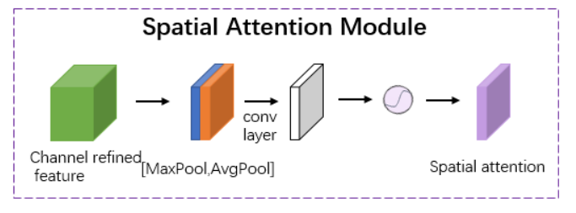

Fig 3.3 Spatial Attention Module

Assuming the original input feature map is . The channel attention module is
.The special attention module is , so the process of attention generation can be expressed as shown in Equations 3.1 and 3.2.
represents the output feature map from the channel attention, represents the output feature map from the spatial attention, which is the final output feature map. The symbol ⊗ indicates element-wise multiplication operation.

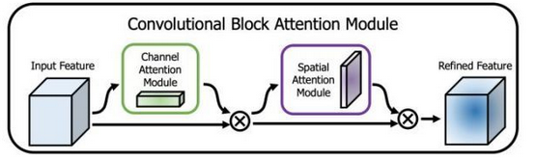
Fig 3.4 Convolutional Block Attention Module

The CBAM module [27], which begins by enhancing channel features through Channel Attention and then strengthening spatial features through Spatial Attention. This stacking of attention mechanisms aids the network in capturing crucial features within the image, consequently enhancing model performance.
This approach of first enhancing channel features through Channel Attention and then strengthening spatial features through Spatial Attention aims to address different aspects of feature learning within the network. Channel Attention focuses on capturing interdependencies among different channels, allowing the model to emphasize more relevant channels and suppress less relevant ones. This is particularly useful for recognizing abstract features and patterns that might be distributed across various channels.
On the other hand, Spatial Attention emphasizes relationships among spatial locations, enabling the model to focus on relevant regions of the feature map while attenuating irrelevant ones. This is beneficial for highlighting the spatial regions that contain essential details and information.
By combining both types of attention mechanisms, the network becomes more capable of capturing both detailed spatial information and high-level semantic information from different channels. This dual attention mechanism ensures that the model can effectively recognize crucial features at various scales and levels of abstraction. Consequently, this combined attention approach contributes to enhancing the model's overall feature representation and understanding, ultimately leading to improved performance in tasks like image classification.

3.4 Backbone-----ResNet-18 with CBAM
The CBAM module, as a lightweight attention mechanism, focuses on spatial and channel attention. It can be embedded into the feature extraction part of the backbone network. By integrating the CBAM module into a residual network, ResNet-18, it assists in distributing attention across channels and spatial information, thus enhancing the accuracy of the network.
I selected ResNet-18 as the backbone network for feature extraction. Considering the dataset size and GPU performance constraints, compared to deeper residual networks like ResNet-34, the decrease in accuracy is minimal. ResNet-18 offers faster model training and inference speed, which better meets the real-time requirements of lane detection.

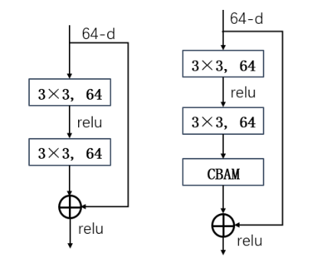
3.4.1 How to combine CBAM with ResNet-18’s Basic Block
Fig 3.5 Basic bloack of ResNet with CBAM

Based on the aforementioned, improvements were made to the basic modules of the residual network. Employing the approach depicted in Figure 3.4, the CBAM module was integrated into the design of the residual network.
Within the Basic Block, the CBAM module is integrated behind the convolutional layers. Specifically, the following steps are taken: After passing through the first 3x3 convolutional layer, the feature map undergoes Batch Normalization and ReLU activation. Subsequently, the feature map enters the second 3x3 convolutional layer. However, before entering this layer, as shown in Fig 3.4, it first undergoes channel attention enhancement through the Channel Attention module, followed by spatial attention enhancement through the Spatial Attention module .Ultimately, the feature map produced by the convolutional layer is multiplied by the feature map that has undergone the attention modules, thereby highlighting crucial feature information. This process is repeated within each BasicBlock to enhance the expressive capability of the feature map.

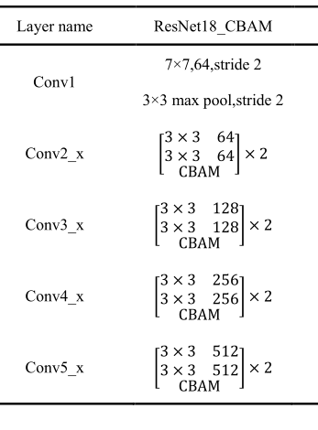
3.4.2 The backbone network’s architecture
Fig 3.6 Backbone network’s architecture
Fig 3.6 presents the diagram of the modified feature extraction backbone network architecture of ResNet-18, excluding the fully connected layers. Each layer consists of multiple convolutional pooling segments, yielding feature maps of varying sizes across different stages.
Each stage comprises a sequence of convolutional and pooling layers, designed for feature extraction and dimension reduction [23].
(1) Conv1: This is the initial convolutional layer of the network, which takes the original image as input. It typically includes a 7x7 convolutional kernel, a convolution operation with a stride of 2, and a 3x3 pooling operation. These components are used for preliminary feature extraction and dimension reduction on the input image.
(2) Conv2: This constitutes the second stage of the network and encompasses multiple BasicBlocks (or Bottleneck Blocks). It serves to further extract features from the image. This stage usually involves multiple 3x3 convolutional operations and pooling operations, along with a stride-2 operation for dimension reduction.
(3) Conv3, Conv4, Conv5: These represent the third, fourth, and fifth stages of the network, respectively. Each stage comprises multiple BasicBlocks (or Bottleneck Blocks). As the number of layers increases, these stages progressively extract higher-level features for more intricate image recognition tasks.

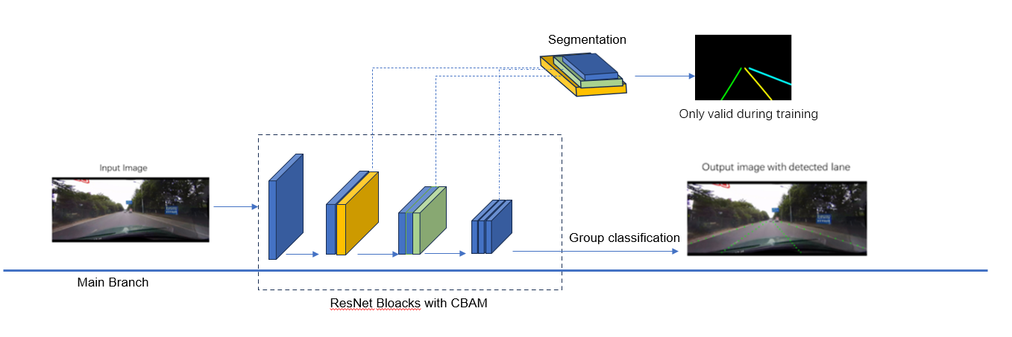
3.5 Overall network architecture
Fig 3.7 Network architecture

The entire lane detection network is divided into a backbone network and a branch network. In the backbone network, the image input undergoes pixel transformation and image enhancement. ResNet-18 combined with CBAM is used to extract features of different dimensions from the image. These features are then fed into the branch network for pixel-wise segmentation. It's worth noting that the branch part is only effective during the training process. As mentioned earlier, pixel-wise segmentation can lead to slower model inference speeds and affect real-time performance. The introduction of the segmentation part during training aims to better facilitate the network's learning of image feature extraction. The underlying principle is that improved feature extraction leads to better classification results in model predictions. In the backbone network, the final steps involve pooling layers and fully connected layers to output classification results.
Regarding the format of data labels during training, please refer to the description in section 3.2. In the main branch, after features are extracted by ResNet, the features are input into a prediction module that performs row-by-row grid classification. The definition of lane prediction here is shown in Equation 3.3.
Whererepresents the probability of selecting each grid on the i-th row anchor of the 𝑗-th lane where there is a line. x represents the global feature of the image. N represents the number of lanes which needs to be identified. Y denotes the number of rows defined.
As mentioned in section 3.2, during training, the data has dimensions of [B, X+1, Y, N], where B represents the batch size, X denotes the number of grids per row in the image, the X+1 dimension indicates the absence of a certain lane on that row. The network's prediction output corresponds to the probability of a certain grid on a specific row of an image belonging to one of the four lanes. The final output result is obtained by selecting the maximum predicted probability, representing the position of the corresponding grid within the lane.

3.6 Loss Function
The classification loss function is as follows.
Where N represents the number of lanes which needs to be identified. Y denotes the number of rows defined. represents the right location of a certain lane with one-hot label. represents the softmax focal loss function.
The Softmax Focal Loss assigns higher weights to hard-to-classify examples, effectively reducing the contribution of easy examples during training. This helps the model focus more on the challenging examples and can improve performance on minority classes, which are often overshadowed by majority classes in traditional cross-entropy loss.
Besides the classification loss, lane structural loss [18] is also implemented to improve the lane detection accuracy on structured road. We will utilize this loss function on the Tusimple dataset, as the Tusimple dataset primarily consists of well-structured roads. However, for the Culane dataset, where road lane markings are highly irregular, the weight value of this loss function will be set to 0 during training on Culane

is the lane structural loss. The author of [27] came out with this idea. As mentioned above, the network outputs the probability values of each cell belonging to a certain lane. The position corresponding to the highest probability value is the final predicted lane position. For two adjacent units on a lane, their variation is extremely gradual, implying that the predicted values from the network should be close to each other. In simple terms, when predicting a certain lane, we expect to obtain a single cell that corresponds to the shape of the lane. Therefore, each neighboring cell positioned along this lane should have network output probabilities that are approximately similar. Since this is not pixel-wise segmentation, this loss function cannot be used on complex urban road datasets such as Culane.
The overall loss function is defined as shown in Equation 3.6. In this equation, represents the pixel-level segmentation loss function. As mentioned in the previous section, during training, the branch network calculates the loss for pixel-level segmentation of images. This step is performed only during training and is not carried out during the testing phase to ensure real-time performance in lane detection.

3.7 Summary of this chapter
Traditional image processing methods often encounter the problem of missing visual cues in lane detection tasks, especially when lane markings are present in complex scenes, resulting in suboptimal detection performance. On the other hand, deep segmentation-based approaches often involve pixel-wise predictions, leading to increased computational load and slower detection efficiency. Therefore, this chapter adopts a row-anchor-based method, which significantly enhances detection speed through grid division and classifying tasks using predefined row anchors. Additionally, this chapter introduces an attention mechanism to aggregate global information after feature extraction by the backbone network, followed by input to the classification network. This improves the detection performance of lightweight networks. Compared to pixel-wise segmentation methods, this approach enables the network to better learn global features, effectively addressing issues caused by lane wear, occlusion, and various external environmental factors that lead to the absence of visible cues for lane detection.

Chapter 4 Design and Implementation

4.1 Data Preprocessing
In the task of lane detection, data preprocessing and augmentation are crucial steps to enhance model performance and robustness. To enable deep learning models to better comprehend diverse road scenarios, we employ a series of data transformation techniques, including geometric transformations, brightness adjustments, noise injection, and simulated occlusions and deformations.
Primarily, I preprocess the target labels, where target_transform and segment_transform constitute two pivotal data transformation operations. Their primary objective is to convert the target labels into a format acceptable by the model. target_transform achieves this by employing customized scaling operations to adjust the labels to fixed dimensions (288x800 and 36x100), subsequently converting them into tensor form for use during model training. This facilitates improved model understanding of lane line shapes and positions.
Subsequently, the img_transform data preprocessing operation is applied to handle image data. This encompasses resizing images to a consistent size (288x800), converting images into tensors, and performing normalization. The normalization process ensures that pixel values in the images are confined within a smaller range, making it easier for the model to learn features and enhance training stability.
Lastly, data augmentation strategy is executed through simu_transform. This sequence includes randomized operations such as rotation, vertical and horizontal offsets. Through these operations, we simulate variations in lane lines under different angles, lighting conditions, and road scenarios. This enhances the model's robustness, enabling accurate lane detection across a spectrum of real-world road conditions.
Data preprocessing and augmentation represent pivotal stages in the lane detection task, contributing to improved model performance, generalization capabilities, and robustness. By employing a diverse set of data transformations, I facilitate more effective model training, ensuring its proficiency in accurately detecting lane lines across a spectrum of real-world road conditions.

4.2 Dataloader
During training, the data has dimensions of [B, X+1, Y, N], where B represents the batch size, X denotes the number of grids per row in the image, the X+1 dimension indicates the absence of a certain lane on that row, Y represents the number of rows which the image is divided, and N stands for the lane count, usually needs to observe up to four lanes. As is mentioned before, the network's prediction output corresponds to the probability of a certain grid on a specific row of an image belonging to one of the four lanes. The final output result is obtained by selecting the maximum predicted probability, representing the position of the corresponding grid within the lane. Obviously, the position of the lane in the grid on each image serves as the data label.
 | Tusimple | Culane
Number of lanes | 4 | 4
Number of rows per image defined | 57 | 18
Number of grids per row divided | 100 | 200
Table 4.1 Image Grid Partitioning
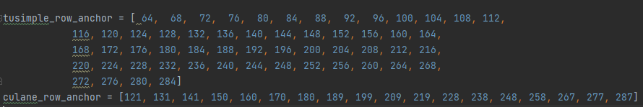
The input image in both the datasets are resized to the same height 288, In these 288 pixel values, specific rows are selected as the ones of interest. The division of these rows is shown in the figure below. Taking into account the characteristics of the two datasets' images, these values were chosen.
Fig 4.1 Rows defined and chosen

For the division of each row grid in the image, a uniform partitioning method was applied based on the predefined number of grids.

4.3 ResNet-18 with CBAM
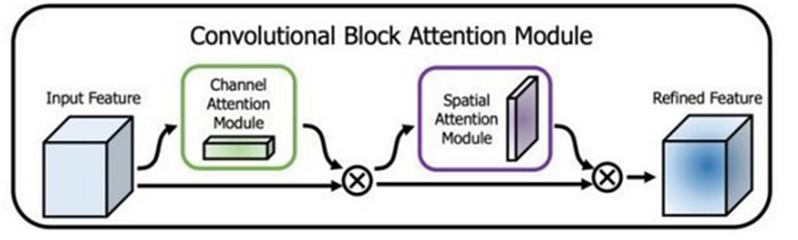

Fig4.2 Convolutional Block Attention Module

CBAM combines two mechanisms: Channel Attention and Spatial Attention. The reason CBAM chooses to concatenate these two attention mechanisms is because they focus on different levels of feature information, and by combining them, it can capture image features more comprehensively.Specifically, the Channel Attention Module is used to learn the weights between different channels, highlighting important channel features while suppressing unimportant ones. This helps the model better focus on information from different feature channels, improving the quality of feature representation. Channel attention can be seen as an attention operation in the channel dimension.
On the other hand, the Spatial Attention Module is used to learn the weights between different spatial positions, emphasizing important spatial locations while suppressing unimportant ones. This helps the model better focus on different regions of the image, improving the efficiency of utilizing spatial information. Spatial attention can be seen as an attention operation in the spatial dimension.
The benefit of concatenating these two attention mechanisms is that they complement each other. Channel attention enhances the quality of feature representation by improving the understanding of different feature channels, while spatial attention enhances the utilization of positional information, enabling better understanding of different regions of the image. By combining them, the CBAM module can comprehensively capture image features, thereby improving the model's performance.
For each residual block in ResNet-18, including both BasicBlocks and Bottlenecks, the Concatenated CBAM is embedded. This is achieved by appending the CBAM module at the end of each residual block. The final feature representation is obtained by adding the features processed through channel attention and spatial attention operations to the original output of the residual block.

4.3.1 CBAM basic block
The CBAM basic block consists of the following key components:
(1) Convolution Layer 1 and Convolution Layer 2: Convolution Layer 1 and Convolution Layer 2 are responsible for extracting features at different scales from the input feature map. They employ 3x3 convolution kernels to capture both local and global features.
(2) Batch Normalization Layer 1 and Batch Normalization Layer 2: These two layers are used to normalize the output of the convolution layers, aiding in speeding up the training process and enhancing the model's generalization performance.
(3) ReLU Activation Function: The ReLU activation function introduces non-linearity, thereby increasing the model's expressive power.
(4) Channel Attention Module: The Channel Attention module is employed to enhance feature correlations among different channels. It achieves this by learning the weights for each channel, allowing the network to better capture inter-channel relationships.
(5) Spatial Attention Module: The Spatial Attention module is used to enhance spatial relationships within the feature map. It accomplishes this by learning the weights for each pixel, enabling the network to focus more on important regions within the image.

These components above collectively contribute to the CBAM basic block's ability to improve feature representation and are instrumental in various computer vision tasks.

4.3.2 Channel Attention Module
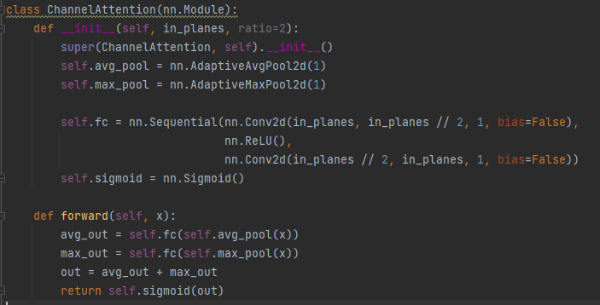
In the Channel Attention module, it begins with the use of Adaptive Average Pooling and Adaptive Max Pooling layers. These layers are employed to pool the input feature map into a 1x1-sized feature map, thereby capturing global features. Following the pooling layers are two convolutional layers. The first convolutional layer is a 1x1 convolutional layer designed to reduce the number of channels in the input feature map by a factor of "ratio," effectively reducing computational complexity. Subsequently, a ReLU activation function is applied to introduce non-linearity. The second convolutional layer is also a 1x1 convolutional layer, which serves to restore the channel dimension to its original state. The module concludes with a Sigmoid activation function, which constrains the output of the Channel Attention module to a range between 0 and 1. This ensures that the attention weights for each channel, derived from the fused feature map, are limited to the range of 0 to 1, forming the final channel attention weights.
Fig 4.3 Channal Attention module code

In this context, there exists a hyperparameter called "ratio," which represents the scaling factor. When the contribution of individual channels within the input feature map to the task is relatively consistent, it is advisable to set the ratio to a smaller value. This encourages the module to treat each channel more evenly. For tasks such as lane detection in input images, which are typically grayscale or RGB images, the differences in information across channels are relatively small. They all contain information related to brightness, color, and other characteristics associated with lane markings. In such cases, employing a smaller ratio value ensures that no single channel is overly emphasized, thereby better capturing the distinctive features of lane markings.Hence, for this specific task, a ratio value of 2 has been chosen to strike a balance between channel compression and the preservation of valuable information, ultimately enhancing the effectiveness of the Channel Attention module.

4.3.3 Spatial Attention Module
First, there is a convolutional layer that takes the input feature map and reduces the number of input channels from 2 to 1. This is because subsequent operations involve calculating the average and maximum values, which are used to capture the overall characteristics of the feature map. Therefore, the number of channels in the feature map is reduced here.
Next, there is a Sigmoid activation function that maps the output of the convolutional layer to the range [0, 1] to generate attention weights. The kernel_size parameter determines the size of the convolutional kernel used to generate the spatial attention map. Typically, smaller convolutional kernels are used to capture local spatial relationships, while larger kernels consider a broader contextual information. This parameter determines the receptive field size of the convolutional layer, which determines how the module captures relationships between features in the spatial dimension. Typically, in the dataset of lane line images, where lane lines are relatively narrow, smaller kernel sizes may be more suitable for capturing fine features and edge information. Therefore, here I set the kernel size to 3.
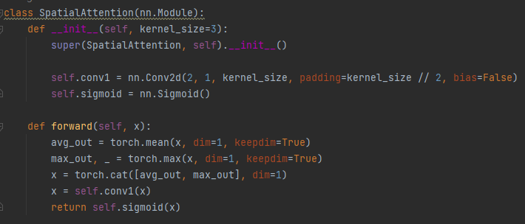

Fig 4.4 Spatial Attention Module code

4.4 Dynamic learning rate adjustment
A suitable learning rate can help the model converge to the optimum solution more quickly, but improper learning rate settings can lead to highly unstable training, and the model may even fail to converge. The Cosine Annealing algorithm [29] is a strategy used to dynamically adjust the learning rate. It adjusts the learning rate following the shape of a cosine function and is typically used for training on a very large scale and when there is periodic learning rate variation. Since the dataset used in this study is extremely large, the learning rate needs to be dynamically adjusted during training.

The formula above is the equation for the variation of the learning rate with respect to epochs in the Cosine Annealing algorithm. "eta_min" is the lower limit of the learning rate, which I have set to 0 in this case. "lr_init" is set as the initial learning rate, which is typically assigned a relatively large initial value. In this case, I have set it to 0.1. "iters" represents the current training iteration step, while "T_max" denotes the total number of cycles for cosine annealing.
One of the advantages of cosine annealing is that it helps the model gradually converge towards a better local minimum. This is achieved by having a smaller learning rate in the later stages of training, allowing the model parameters to fine-tune closer to the loss function. Additionally, cosine annealing can reduce oscillations during the training process, leading to more stable training.

4.5 Summary for this chapter
First, resize the images to a consistent size. Apply data augmentation to the images, including random operations such as rotation, vertical, and horizontal offsets. Through these operations, we simulate variations in lane lines under different angles, lighting conditions, and road scenarios. We partition the images into grids as defined and create the dataloader for the dataset. For the pre-defined grids, based on pixel-level labels from the dataset, we assign labels to the grids we have divided for subsequent training and testing. Finally, we build the backbone network by combining ResNet-18 with CBAM and connect it to fully connected layers for the final output.

Chapter 5 Experiment and Analysis

5.1 Datasets to be used
In this study, I conducted experiments using the challenging CULane dataset and the classic Tusimple dataset. The CULane dataset is widely used in lane detection research and consists of nine different scenarios: Normal, Crowded, Night, No-line, Shadow, Arrow, Dazzlelight, Curve, and Crossroad. The Tusimple dataset does not classify different lane scenes and comprises data collected under relatively stable highway lighting conditions. However, the dataset contains a sufficient variety of multi-lane, occlusion, high curvature bend, uphill, and downhill scenarios, which pose significant challenges for lane line fitting.

Dataset | Tusimple | CULane
abundant | 6408 | 153235
Train set | 3268 | 88880
Test set | 2782 | 34680
Validation set | 358 | 9675
image resolution | 1280*720 | 1640*590
Max number of lanes | 4 | 4
environment | Highways | Urban roads and highways
Table 5.1 Information of the two datasets

They both played pivotal roles in the comprehensive evaluation of our lane detection methods. The CULane dataset, with its diverse scenarios encompassing different lighting conditions and road complexities, allowed us to assess the robustness and adaptability of our approach in various real-world situations. On the other hand, the Tusimple dataset, although focused on relatively stable highway lighting conditions, proved invaluable in testing the generalizability of our model. Its inclusion of multi-lane scenarios, occlusions, high curvature bends, as well as uphill and downhill segments, presented formidable challenges that helped us gauge the algorithm's ability to handle extreme road configurations. By leveraging these two datasets with distinct characteristics, we were able to conduct a thorough and rigorous evaluation of our lane detection system's performance, ensuring its reliability in a wide range of practical scenarios.

5.2 Evaluation criteria for lane detection
So far, the majority of lane detection work, along with related research achievements, have not been open-sourced. Many companies have invested significant financial and human resources in developing high-performance autonomous driving systems. As a result, there are few publicly available lane dataset resources. However, open-source datasets often come with variations in data collection equipment, placement, different lane scene types, variations in lane markings' shapes, and differences in lane data annotation methods. Therefore, there is currently no "officially certified" dataset for lane detection, nor are there "officially certified" evaluation metrics. This situation makes it challenging to make precise comparisons between different algorithms. Here, several common criteria used in road traffic are introduced:
- Detection Line-to-Ground Truth Line Gap: In this context, the gap generally refers to the straight-line distance between two lines. A successful detection has a gap smaller than a specified threshold. In some work, the gap refers to the mean distance of detection line points to the ground truth line, and a successful detection has a mean gap smaller than a certain threshold.
- Lane Line Coordinate Values: In the context of detecting lane line equations, by substituting the ground truth line's x-coordinate values into the detection line equation, you obtain the detection line's y-coordinate values. The difference between this value and the ground truth line's y-coordinate value is averaged. A successful detection is when the result value is less than a defined threshold.
- Reference the Intersection over Union (IoU) commonly used in semantic segmentation tasks. Consider the lane lines as having a certain width and calculate the ratio of intersection between the detected lane line shape and the actual lane line shape. If it exceeds a certain threshold, it is considered a successful detection.

The evaluation method for the CULane dataset falls into the third category. An IOU threshold of 0.5 is chosen, where if the IOU between the predicted lane lines and the ground truth lane lines is greater than 0.5, it is considered a correct prediction; otherwise, it is considered an incorrect prediction.
The F1-measure, also known as the F1-score in some contexts, is a commonly used metric for evaluating the performance of classification algorithms. The F1-measure is actually a specific form of the F-measure, where the F-measure was originally designed to combine Precision and Recall. Let's denote Precision as P and Recall as R. In the context of lane detection, P represents how accurate the detected lane markings are, while R indicates how many of the actual accurate lane markings were detected.Precision and Recall are often associated with common concepts such as True Positive (TP), True Negative (TN), False Positive (FP), and False Negative (FN). Table 4.2 describes the relationship between TP, FP, TN, and FN.

 | Relevant | NonRelevant
Detected | True Positives (TP) | False Positives (FP)
Not Detected | False Negatives (FN) | True Negatives (TN)
Table 5.2 The relationship between four indicators

Based on the relationships indicated in the table, we can derive the calculation formulas for Precision and Recall as shown in Equations 5.1 and 5.2, respectively.
For the values of P and R, the expectation is that higher values of both Precision (P) and Recall (R) are desirable. However, in reality, these two metrics can be conflicting in some situations. For example, in an extreme case where only one result is detected, and it is correct, then P would be 100%, but the value of R would be very low. On the other hand, if all results are returned, R will inevitably be 100%, but the value of P would be very low. Therefore, in many cases, researchers need to carefully consider and balance P and R, often using the method of plotting Precision-Recall curves to assist in the analysis.
As described in the preceding section, the P and R metrics can sometimes be contradictory, and therefore, there is a desire to have a method to consider them together. To address this, the F-measure metric was introduced. The F-measure metric is essentially a weighted harmonic mean of Precision and Recall, as shown in Equation 5.3.
When the parameter 𝑏 = 1, it corresponds to the most common form of F1-measure. The F1-measure combines the results of Precision (P) and Recall (R), as shown in the equation below:
When the F1-measure is higher, it indicates that the experimental method is closer to an ideal state. Therefore, in this chapter, we use the F1-measure as the performance evaluation metric for CULane dataset, as it provides a relatively comprehensive assessment of the model's performance level.

5.3 Training environment
The model is trained on a remote server. The training software environment for the deep convolutional neural network model constructed in this article is as follows: a Linux system, PyTorch 1.8.1 deep learning framework. The hardware environment for model training includes an RTX3090 graphics card with a VRAM size of 24GB. The training is conducted on a remote paid server.

5.4 Experiment on Culane dataset
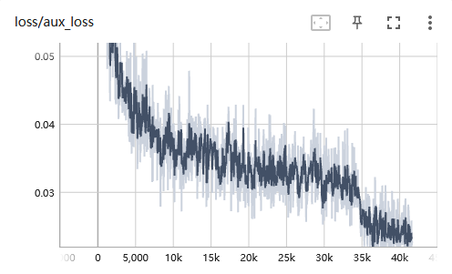
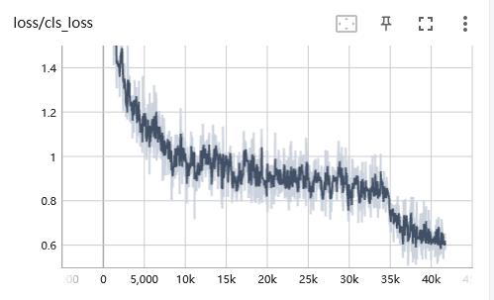
In the first part, we evaluate the algorithm's performance on the Culane dataset. For the images in this dataset, its height is 288 after size conversion. Then we select the row anchors ranging from 120 to 288 with a step nearly as 9. The number of row anchors is 18. The training epoch is 30, optimizer is “adam”, learning rate is 0.1, momentum is 0.9, and using L2 regularization with a weight_decay of 1e-4. For the loss function, the is set to 0, which means we only consider classification loss and segmentation loss when train in this dataset.
Fig 5.1 classification loss Fig 5.2 Segmentation loss

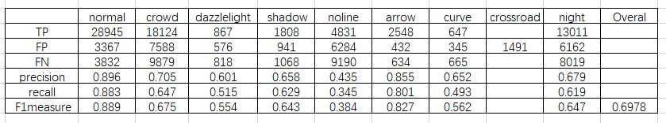
During the training process, when we reached around 40,000 iterations, the losses of both branches of the network had already decreased to relatively low values and continued to show a little decreasing trend. Considering the vast size of the dataset and the cost of renting server resources, training to this extent was deemed sufficient. The binary classification branch had achieved a low loss value of approximately 0.6 around the 40,000th iteration, while the pixel segmentation branch had a loss value close to 0.02 at a similar iteration count. Both had stabilized and reached low levels, indicating that the neural network model, combining attention with ResNet-18 as designed in this paper, had been trained to produce desirable results. The accuracy of lane detection on the test set was measured by an F1-measure value of 0.6978. This is a commendable result for a challenging dataset like Culane, which is divided into 9 different sub-scenes, each of which presents its own set of challenges. Detailed test results for each sub-scene are shown in the following figure.
Fig 5.3 Test result on 9 categories scenes of the Culane dataset
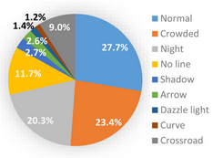
- Crowded: This sub-scene simulates highly congested road conditions, typically encountered in urban traffic jams.
- Curve: This scenario includes curved sections of the road, used to test the algorithm's ability to detect lane lines on curved roads.
- Dazzle light: There are intense or glaring light sources that can affect the image quality. Algorithms need to be able to handle lane line detection under different lighting conditions. Night: Nighttime driving scenario, challenging the ability to detect lane lines in low-light conditions.
- No line: In certain situations, there may be no visible lane markings on the road. This sub-scene simulates such cases, requiring the detection algorithm to identify lanes without clear markings.
- Shadow: Shadow effects caused by lighting conditions or the surrounding environment. This scenario demands the algorithm to accurately detect lane lines in the presence of shadows.
- Arrow: Arrow signs on the road, which are typically used to indicate the direction of vehicle travel.
- Crossroad: Crossroads, which are the locations where roads intersect, typically involving multiple roadways converging. These images can be used to evaluate the performance of lane line detection algorithms in complex intersection scenarios.
(8): Normal: Representing a typical driving scenario, without special signs, intersections, or other complex factors.
(9): Night: Road images captured in a nighttime environment.

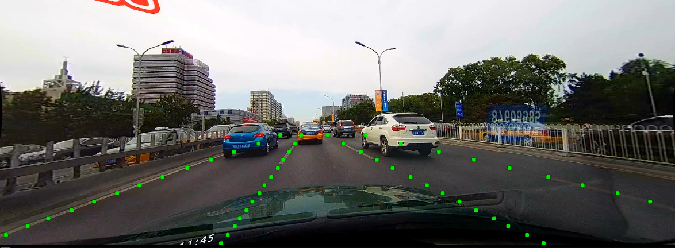
Fig 5.4 Test performance on normal category

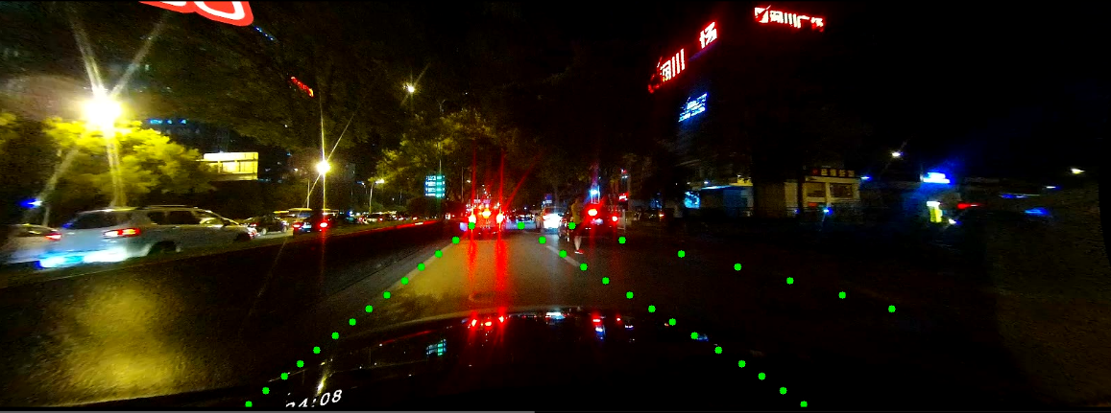
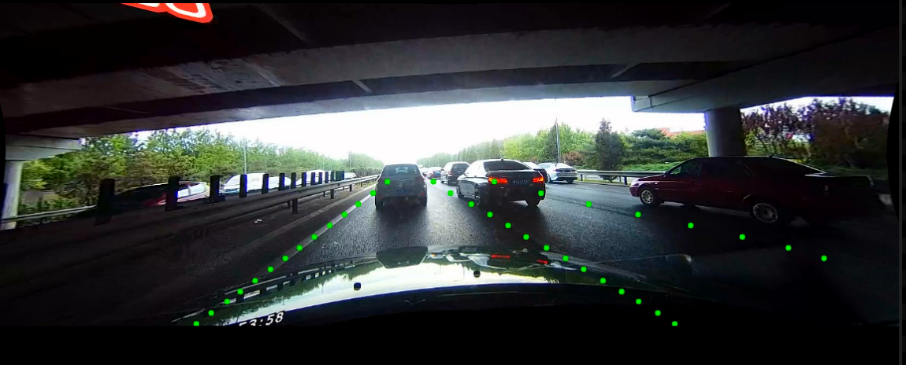
Fig 5.5 Test performance on shadow category
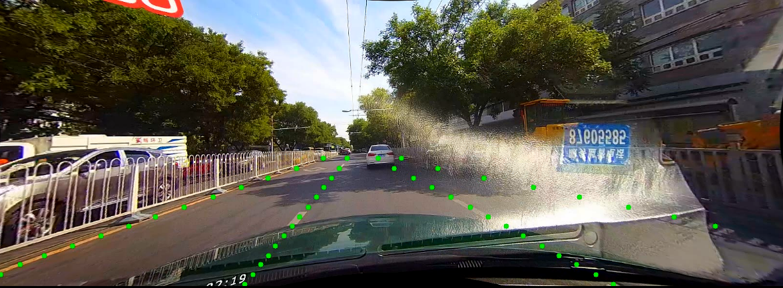
Fig 5.6 Test performance on night category
Fig 5.7 Test performance on Dazzle light category
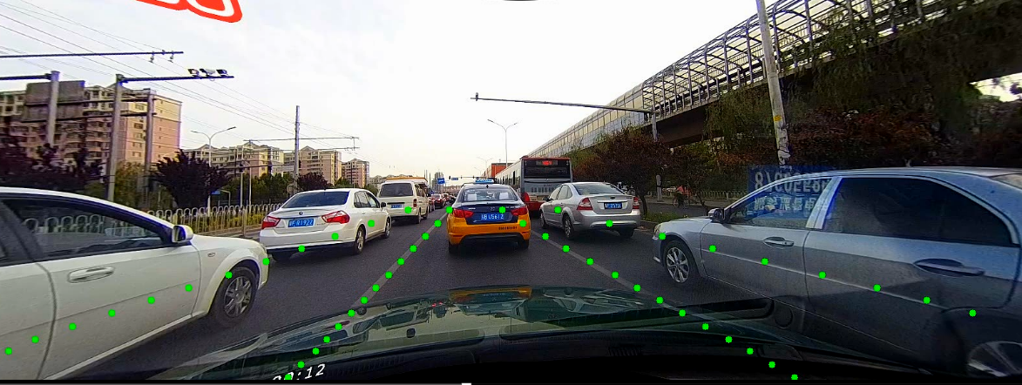
Fig 5.8 Test performance on crowd category

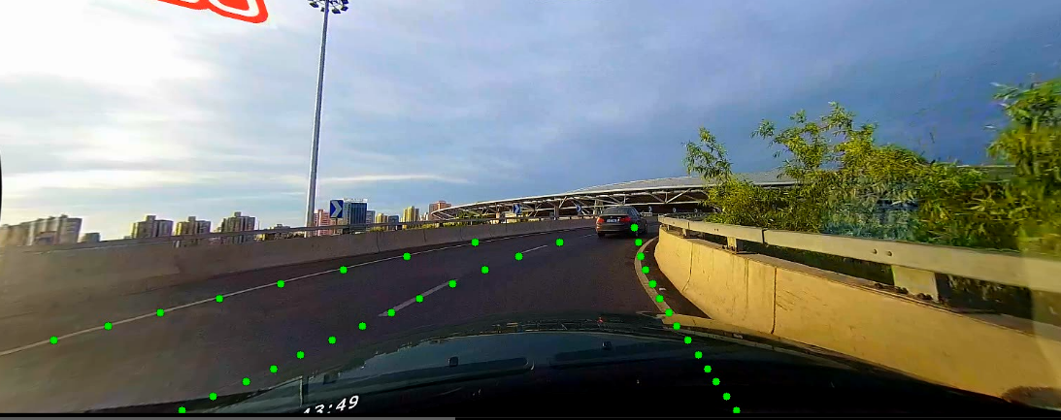
Fig 5.8 Test performance on curve category
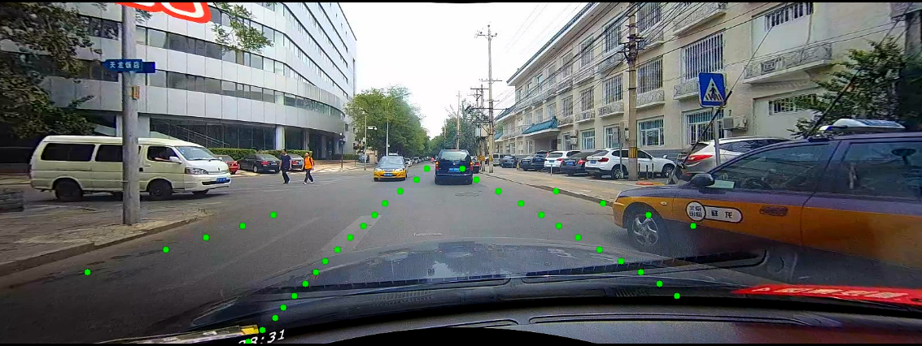
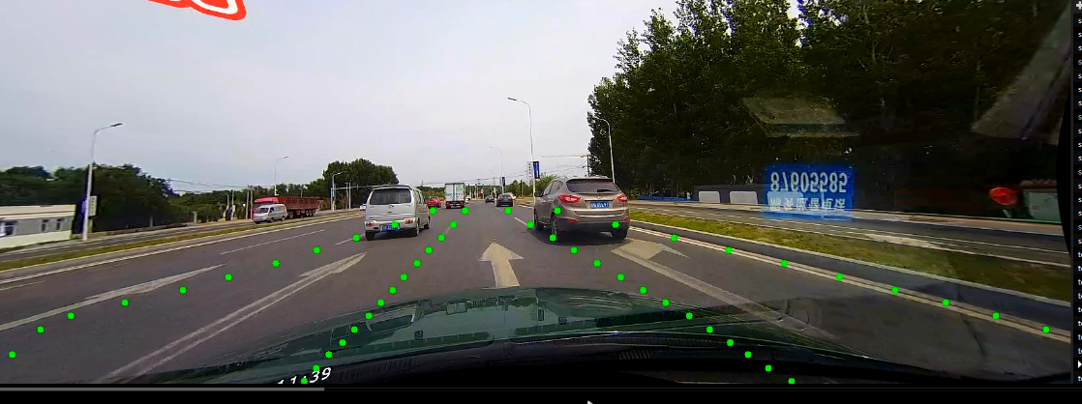
Fig 5.9 Test performance on arrow category
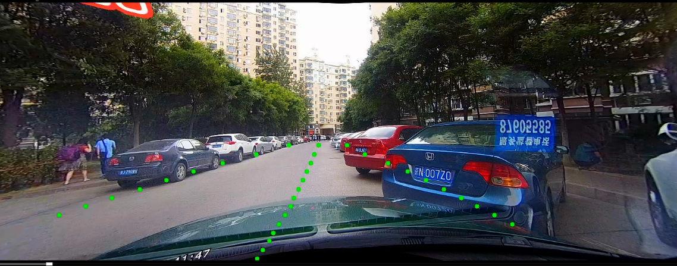
Fig 5.10 Test performance on cross road category
Fig 5.11 Test performance on no line category

The nine images above showcase the performance of the algorithm presented in this paper for lane line detection across different scenarios. Fig 5.3 illustrates various metrics for the algorithm in nine different scenarios. In the "crossroad" scenario, only false positives were counted.
The "Normal" scenario is the simplest, with an impressive F1-measure of 0.889 in the tests. This high F1-measure indicates that the algorithm achieves a high level of accuracy in lane line detection during regular driving scenarios.
For the "crowd" scenario, the in-car camera fails to capture the complete lane lines, as they are obscured by other obstacles. Consequently, the accuracy of such determinations is generally lower. In this case, the paper employs a row anchor-based classification network. This network selects columns belonging to lane lines in different rows, reducing the complexity associated with traditional semantic segmentation at the pixel level. Additionally, global features are used to increase the network's receptive field, improving its inference capabilities when vehicles obstruct the view. The algorithm still achieves an F1-measure of 0.675 in congested scenarios.
In the cases of "Dazzle light," "no line," and "night" scenarios, the algorithm still demonstrates certain levels of effectiveness. Strong light sources can lead to image overexposure or reflections, blurring the lane line contours and making detection more challenging. Reduced lighting at night may decrease the contrast of lane lines, making them harder to detect. Certain roads may lack distinct lane lines or have poor-quality lines due to severe wear or blurriness, impacting the performance of the detection algorithm.
In summary, the overall F1-measure of the algorithm on the Culane dataset reaches 0.6978. While the predictive performance of individual subclasses may be suboptimal, considering the challenges posed by this dataset, the algorithm's test results are at a high level. For instance, a segmentation method based on ResNet-50 [28] achieves 0.667 on the Culane dataset, while SCNN [14] achieves 0.716. Although the algorithm presented in this paper falls slightly short of SCNN in terms of performance, it features a simpler network structure and is significantly faster than per-pixel segmentation methods.

5.5 Experiment on Tusimple dataset
In the second part, we evaluate the algorithm's performance on the Tusimple dataset. For the images in this dataset, its height is 288 after size conversion. Then we select the row anchors ranging from 64 to 284 with a step nearly as 4. The number of row anchors is 50. The training epoch is 100, optimizer is “adam”, learning rate is 4e-4, momentum is 0.9, and using L2 regularization with a weight_decay of 1e-4. For the loss function, the is set to 1, which means we not only consider classification loss and segmentation loss ,but also the similarity loss which we mentioned in chapter 3.
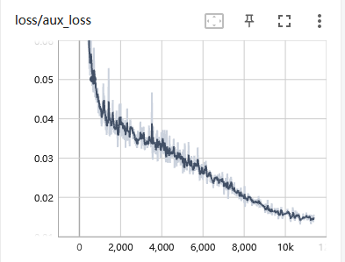
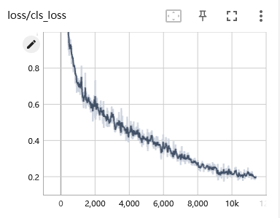
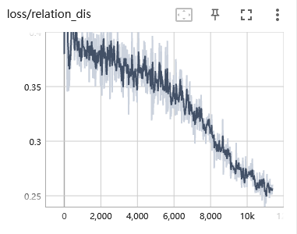
Fig 5.12 Classification loss Fig 5.13 Segmentation loss
Fig 5.14 relation loss
During the training process, when we reached approximately 100,000 iterations, the losses of the three branches of the network had already decreased to relatively low values and continued to show a slight decreasing trend. Considering the vast size of the dataset and the cost of renting server resources, I deemed training to this extent to be sufficient. At around the 100,000th iteration, the loss value for the grid cell classification branch had decreased to approximately 0.2, while the loss value for the pixel segmentation branch at a similar iteration count was close to 0.015. Both had stabilized and reached low levels, indicating that the neural network model designed in this paper, combining attention with ResNet-18, had achieved satisfactory results after training. At this point, the F1-measure value for lane detection on the test set reached 0.9579. The majority of the images in the Tusimple dataset were collected on highways and regular urban roads, without complex lighting conditions or high-frequency occlusion phenomena. Training and testing the network on this dataset was relatively simpler compared to the Culane dataset. Therefore, the accuracy we achieved in testing demonstrates the effectiveness of the algorithm presented in this paper, which is sufficient for performing lane line detection tasks in typical urban road scenarios.
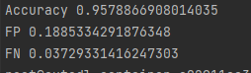

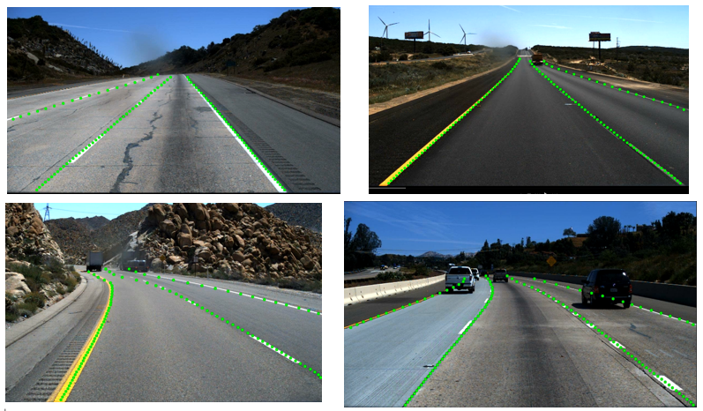
Fig 5.15 Test performance on Tusimple dataset

The specific test results can be seen in the images above. The loss function of the algorithm in this paper incorporates similarity loss between adjacent grid cells, resulting in near-perfect detection of straight lane lines. However, there is a bias in detecting lane lines at longer distances. Considering that the algorithm in this paper offers fast testing speeds and a higher frame rate compared to per-pixel segmentation methods, the slight deviation in detecting very distant targets does not affect the current operation of the autonomous driving system. LaneNet [16] achieved an accuracy of 96.38% on the Tusimple dataset, employing a per-pixel segmentation-based approach. In contrast, our method is based on per-row grid cell classification, significantly accelerating the detection speed. While improving speed, our accuracy is comparable. Additionally, we utilize an attention mechanism network based on ResNet-18, which results in a simpler network structure. There is potential to achieve higher accuracy by using a more complex backbone network like ResNet-34. However, due to constraints related to GPU prices and dataset size, I opted for the simpler backbone network structure.

Backbone | Tusimple | Culane
ResNet-18 with CBAM | 0.9579 | 0.6978
ResNet-18 | 0.9487 | 0.6795

5.6 Knockdown Experiment

Table 5.3 Knockdown experiment result

By training and testing with both ResNet-18 and ResNet-18 combined with the CBAM module on two datasets while keeping other parameters constant, we obtained the results mentioned above. It can be observed that the introduction of the attention mechanism has improved the accuracy of the algorithm.
In the field of deep learning for lane line detection tasks, designing lightweight detection methods has been a critical and long-standing research topic. Convolutional neural networks (CNNs) focus on extracting regional features, which is one of the three main characteristics of convolutions - the representation of local receptive fields. However, for complex road scenarios, solving the problem of missing lane line clues is difficult when relying solely on learning local features. Fully connected layers can utilize global receptive fields in classification problems, but stacking too many fully connected layers can lead to a dramatic increase in the number of parameters.
In lane line detection algorithms based on per-row grid cell classification, CNNs are used for feature extraction, followed by fully connected layers for classification. Introducing an attention mechanism into this process can effectively aggregate global information and incorporate it into local features. Moreover, attention modules themselves can be lightweight and do not significantly increase computational costs. Additionally, considering the lane line detection task itself, lane lines occupy only a small portion of the entire road scene image. Treating all pixels equally would introduce significant redundancy in terms of efficiency. Therefore, attention modules can also enhance the efficiency of the detection algorithm.
In summary, based on the results of knockdown experiments, the application of attention to lane line detection demonstrates improvements in both accuracy and efficiency.

5.7 Summary of this chapter
In this chapter, we introduce two datasets used in our experiments, as well as the evaluation metrics for lane line testing. We explain some of the training parameters that were set. Three loss functions defined in this paper show a stable decrease in loss values during training iterations without significant oscillations, gradually converging. This indicates the effectiveness of the network training, with performance improving over time. The algorithm proposed in this paper achieved an F1-measure of 0.6978 on the Culane dataset and an accuracy of 0.9579 on Tusimple. Compared to other mainstream algorithms, our algorithm performs similarly, but it significantly improves the detection speed compared to segmentation-based methods, making it more suitable for real-time lane line detection in automated systems. Through ablation experiments, a comparison reveals the performance improvement brought by the combination of the CBAM module with ResNet-18. A series of experiments demonstrates that the attention fusion approach used in this paper better aggregates global information in lane scenes, enhancing the model's detection performance.

Chapter 6 Conclusions and Recommendations
Traditional image processing methods often require extensive manual parameter tuning, and their algorithm complexity and detection cost are relatively high. In the face of complex and variable road conditions such as changing lighting, adverse weather like rain, snow, and fog, occlusions caused by congested traffic, road surface irregularities, or building shadows, lane detection encounters significant difficulties. Achieving lane detection in various complex road scenarios is a formidable task. Autonomous driving systems demand exceptionally high real-time performance, particularly when vehicles are traveling at high speeds. Stringent speed requirements for lane detection are present. However, the computational power of hardware integrated into vehicles is inevitably constrained. Therefore, achieving real-time detection speed with minimal resource utilization while maintaining detection accuracy is a research topic of practical significance.
Segmentation-based methods typically involve pixel-level predictions, which increase computational load and reduce detection efficiency. This paper adopts a grid-based classification approach, which significantly improves detection speed by dividing the image into grids and performing classification tasks using predefined row anchors. Additionally, this paper introduces the CBAM attention mechanism, which aggregates global information after feature extraction by the ResNet-18 backbone network and then inputs it into the classification network, enhancing the detection performance of lightweight networks. Compared to pixel-wise segmentation methods, this approach enables the network to better learn global features, effectively addressing issues caused by lane wear, occlusion, and various external environmental factors that result in a lack of visible visual cues for lane detection.
When comes to implementation, first, resize the images to a consistent size. Apply data augmentation to the images, including random operations such as rotation, vertical, and horizontal offsets. Through these operations, we simulate variations in lane lines under different angles, lighting conditions, and road scenarios. We partition the images into grids as defined and create the dataloader for the dataset. For the pre-defined grids, based on pixel-level labels from the dataset, we assign labels to the grids we have divided for subsequent training and testing. Finally, we build the backbone network by combining ResNet-18 with CBAM and connect it to fully connected layers for the final classification output.
In the experimental section, we first introduce the two datasets used in our experiments and the evaluation metrics for lane line testing. We explain some of the training parameter settings. Three loss functions defined in this paper show a stable decrease in loss values during the training process without significant oscillations, gradually converging. This indicates the effectiveness of the network training, with performance improving. The algorithm proposed in this paper achieved an F1-measure of 0.6978 on the Culane dataset and an accuracy of 0.9579 on Tusimple. Compared to other mainstream algorithms, our algorithm performs similarly, but it significantly improves detection speed compared to segmentation-based methods, making it more suitable for real-time lane line detection in automated systems. Through ablation experiments, a comparison reveals the performance improvement brought by the combination of the CBAM module with ResNet-18. A series of experiments demonstrates that the attention fusion approach used in this paper better aggregates global information in lane scenes, enhancing the model's detection performance.
Due to hardware resource limitations and the vastness of the dataset, I opted for a lightweight network, ResNet-18, to achieve faster training results. While lightweight networks have demonstrated good predictive performance, there is no doubt that more complex networks, such as ResNet-34 or ResNet-50, have the potential to improve performance significantly. This paper does not involve the fitting of lane lines between individual points but calculates accuracy based on separate coordinate points. To better integrate into the entire autonomous driving system, in practice, the lane detection module may need to detect a complete lane rather than individual points. Therefore, a possible avenue for future research is to add a lane line fitting component to address this requirement.

Chapter 7 Reflection
After completing my graduation thesis on lane line detection, I have come to deeply appreciate the importance of reflection. Reflection is the process of looking back at something that has happened to show what we have learned from it. Through reflection, I had the opportunity to integrate theoretical knowledge with practical experience, gaining a better understanding of the work I have done and providing guidance for future research. In this section, I will review my research journey, discuss the achievements I have made, the challenges I have faced, and areas for improvement.
First and foremost, I want to emphasize that in the lane line detection project, I gained valuable experience in the fields of deep learning and computer vision. Through studying existing literature and hands-on experimentation, I delved into the application of deep learning models in the context of autonomous driving environment perception. I learned how to construct and train convolutional neural networks under the PyTorch framework to detect lane lines from images. This process deepened my understanding of the principles and applications of deep learning technology.
Secondly, I encountered some challenges, especially when dealing with complex road scenarios. Lane line detection tasks are not always straightforward, as there can be various complexities on the road, such as occlusions, unclear lane markings, and adverse lighting conditions. In the early stages of experimentation, I faced difficulties, particularly when testing on the challenging Culane dataset where the results were not as high as desired. Insufficient GPU computing power and the size of the dataset had an impact on my experiments.
Another crucial aspect of reflection pertains to experimental design and dataset selection. For my research, I chose to conduct experiments using the Tusimple and Culane datasets, both of which are widely applied in the field of lane line detection. However, these datasets still have certain limitations and cannot fully cover all possible road scenarios. In future research, I believe there is room to explore more diverse datasets to comprehensively evaluate model performance.
In summary, through this project, I not only deepened my understanding of the knowledge I acquired over the past year but also improved my problem-solving abilities and the capacity to explore uncharted territories. I have come to realize that reflection is a key step in enhancing the quality of work and can help me perform better in future research endeavors. I look forward to applying these experiences to my future career.

References
1. Chang, L. L. (2019). Research on Lane Detection Method Based on Laser Radar [Master's thesis, Chongqing University of Posts and Telecommunications].
2. Wang, Z., Wang, B. Y., Hu, H. C., et al. (2019). Lane Detection Method and Implementation in Mobile Robot Navigation System. Computer Measurement & Control, 27(9), 42-46.
3. Liu, G. Y. (2015). Research on Vision-Based Lane Detection and Vehicle Recognition Technology [Master's thesis, Beijing University of Technology].
4. Lu K, Xia S, Chen D, et al. Unstructured road detection from a single image[C]//2015 10th Asian Control Conference (ASCC). IEEE, 2015: 1-6.
5. Wu P C, Chang C Y, Lin C H. Lane-mark extraction for automobiles under complex conditions[J]. Pattern Recognition, 2014, 47(8): 2756-2767.
6. Ozgunalp U, Dahnoun N. Lane detection based on improved feature map and efficient region of interest extraction[C]//2015 IEEE Global Conference on Signal and Information Processing (GlobalSIP). IEEE, 2015: 923-927.
7. Sun T Y, Tsai S J, Chan V. HSI color model based lane-marking detection[C]//2006 ieee intelligent transportation systems conference. IEEE, 2006:1168-1172.
8. Batavia P H, Pomerleau D A, Thorpe C E. Predicting lane position for roadway departure prevention[C]//Proceedings of the IEEE intelligent vehicles symposium.1998, 98.
9. Lim K H, Seng K P, Ang L M, et al. Lane detection and Kalman-based linear parabolic lane tracking[C]//2009 International Conference on Intelligent Human Machine Systems and Cybernetics. IEEE, 2009, 2: 351-354.
10. Mammeri A, Boukerche A, Lu G. Lane detection and tracking system based on the MSER algorithm, hough transform and kalman filter[C]//Proceedings of the 17th ACM international conference on Modeling, analysis and simulation of wireless and mobile systems. 2014: 259-266.
11. Deng J, Han Y. A real-time system of lane detection and tracking based on optimized RANSAC B-spline fitting[M]//Proceedings of the 2013 research in adaptive and convergent systems. 2013: 157-164.
12. Phueakjeen W, Jindapetch N, Kuburat L, et al. A study of the edge detection for road lane[C]//The 8th Electrical Engineering/Electronics, Computer, Telecommunications and Information Technology (ECTI) Association of Thailand-Conference 2011. IEEE, 2011: 995-998.
13. Xu S, Ye P, Han S, et al. Road lane modeling based on RANSAC algorithm and hyperbolic model[C]//2016 3rd international conference on systems and informatics (ICSAI). IEEE, 2016: 97-101.
14. Pan X, Shi J, Luo P, et al. Spatial as deep: Spatial cnn for traffic scene understanding[C]//Proceedings of the AAAI Conference on Artificial Intelligence. 2018, 32(1).
15. Hou Y, Ma Z, Liu C, et al. Learning lightweight lane detection cnns by self-attention distillation[C]//Proceedings of the IEEE/CVF international conference on computer vision. 2019: 1013-1021.
16. Neven D, De Brabandere B, Georgoulis S, et al. Towards end-to-end lane detection: an instance segmentation approach[C]//2018 IEEE intelligent vehicles symposium (IV). IEEE, 2018: 286-291.
17. Yoo S, Lee H S, Myeong H, et al. End-to-end lane marker detection via row-wise classification[C]//Proceedings of the IEEE/CVF Conference on Computer Vision and Pattern Recognition Workshops. 2020: 1006-1007.
18. Qin Z, Wang H, Li X. Ultra fast structure-aware deep lane detection[C]//European Conference on Computer Vision. Springer, Cham, 2020: 276-291.
19. LeCun, Y., Bottou, L., Bengio, Y., & Haffner, P. (1998). Gradient-based learning applied to document recognition. Proceedings of the IEEE, 86(11), 2278-2324.
20. Krizhevsky, A., Sutskever, I., & Hinton, G. E. (2012). Imagenet classification with deep convolutional neural networks. Advances in neural information processing systems, 25, 1097-1105.
21. Simonyan, K., & Zisserman, A. (2014). Very deep convolutional networks for large-scale image recognition. arXiv preprint arXiv:1409.1556.
22. Szegedy, C., Liu, W., Jia, Y., Sermanet, P., Reed, S., Anguelov, D., ... & Rabinovich, A. (2015). Going deeper with convolutions. In Proceedings of the IEEE conference on computer vision and pattern recognition (CVPR) (pp. 1-9).
23. He, K., Zhang, X., Ren, S., & Sun, J. (2016). Deep residual learning for image recognition. In Proceedings of the IEEE conference on computer vision and pattern recognition (CVPR) (pp. 770-778).
24. Howard, A. G., Zhu, M., Chen, B., Kalenichenko, D., Wang, W., Weyand, T., ... & Adam, H. (2017). Mobilenets: Efficient convolutional neural networks for mobile vision applications. arXiv preprint arXiv:1704.04861.
25. Tan, M., & Le, Q. V. (2019). EfficientNet: Rethinking model scaling for convolutional neural networks. International Conference on Machine Learning (ICML).
26. Lin M, Chen Q, Yan S. Network in network[J]. arXiv preprint arXiv:1312.4400, 2013.
27. Sanghyun Woo, Jongchan Park, Joon-Young Lee, In So Kweon. "CBAM: Convolutional Block Attention Module." In Proceedings of the European Conference on Computer Vision (ECCV), 2018.
28. Chen, L.C., Papandreou, G., Kokkinos, I., Murphy, K., Yuille, A.L.: Deeplab: Semantic im-
age segmentation with deep convolutional nets, atrous convolution, and fully connected crfs.
IEEE Transactions on Pattern Analysis and Machine Intelligence 40(4), 834–848 (2017)
29. Loshchilov, I., & Hutter, F. (2016). "SGDR: Stochastic Gradient Descent with Warm Restarts." In Proceedings of the International Conference on Learning Representations (ICLR).

