

11/18/2025
v 11/18/20
Assessment 1
25-11-2025
Certificate in Higher Education
In Computing Skills for Workplace

Module Name: Introduction to Web and
Database Concepts
Module Code: ACCA 4023
Student Name: Ma. Crystal Pearl Grajewski
Student ID: 2442405
Group: 1
Lecturer’s Name: Suneth Fernando



University of Wales Trinity Saint David
LONDON CAMPUS
Table of Contents
Introduction 3
Task 1: Implementation Guide: 4
Scenario Analysis 4
Entity-Relationship Diagram (ERD) 5
Data structure Development 6
Normalization Compliance 7
Sample Data Population 11
Query Development 15
Validation and Testing 16
Conclusion 16
References 17
Appendices 17
Appendix 1: Draft work 17

Introduction

The first assessment in Introduction to Web and Database Concepts is all about database, the basic knowledge and fundamental information that gives us idea on how to create and design our own database pursuing this course in the future, it gives us clearly what is ahead. In this task, we are given a scenario of an Eco Bike business, assuming I am a developer and given the task to design a simple database for this business. To make this successful and efficient, it should be meticulously done and followed the standard and step by step process to ensure and achieve functional data. This include creating a proper EDR diagram to create a picture of what your database will look like, connecting data by pointing relationship and its constraints. Ensuring data integrity and using normalisation form to avoid anomaly and other issues creating the database and finally testing its validity and functionality.

Scenario:
EcoRide – An Electric Bike Rental Scheme
The local authority has recently launched a green transport initiative called Eco_Ride - an electric bike rental service available across several public locations like parks, train stations, and university campuses. The aim is to make commuting greener and healthier. Riders can scan their ID at a rental point, take a bike, and return it to any Eco_Ride station nearby. While the service is growing in popularity, the management team is facing challenges in handling operations due to its current reliance on paper forms and basic spreadsheets. Rider details and rental transactions are recorded manually, while bike maintenance needs are tracked informally. This results in limited visibility of which bikes are available, currently in use, or undergoing repairs. Consequently, the system experiences occasional double-bookings and unreturned bikes, making it difficult to produce accurate summaries or analyse overall service usage effectively.
You have been approached to design and implement a structured database solution that can streamline the operations of this scheme. The solution should enable the team to:
• Register riders by storing essential details such as their name, contact information, and ID numbers.
• Maintain records of all electric bikes, including their type, condition, location, maintenance history and other related details.
• Record bike rental transactions, including rental and return dates, duration, cost and any other related details.
• Track staff involvement, including who serviced or inspected each bike
Design a database system that meets the functional requirements which includes the design and modelling of system components, implementation of core features, and demonstration of its practical use with sample data.

Task 1: Implementation Guide:

Scenario Analysis
- Riders-attributes like their name, address and contact information, user of the bike
- Bikes- type, condition, location and status, the product use
- Stations- location, rider and bike where the business happen
- Rentals- cost, duration, where the ride start and ends
- Maintenance Logs- sample of relationship is check up or repair, it involves the staff or management and maintenance
- Staff- tracking the service, the prodcuct (bike) and maintenance of the product.

Entity-Relationship Diagram (ERD)
Entity Relationship Diagram is a structural Diagram used in web design. It contains different symbols, objects and connectors to visualize relationship between values.
Entity picture as a person, object, concept, event or a noun.
Attribute is the description of the entity.
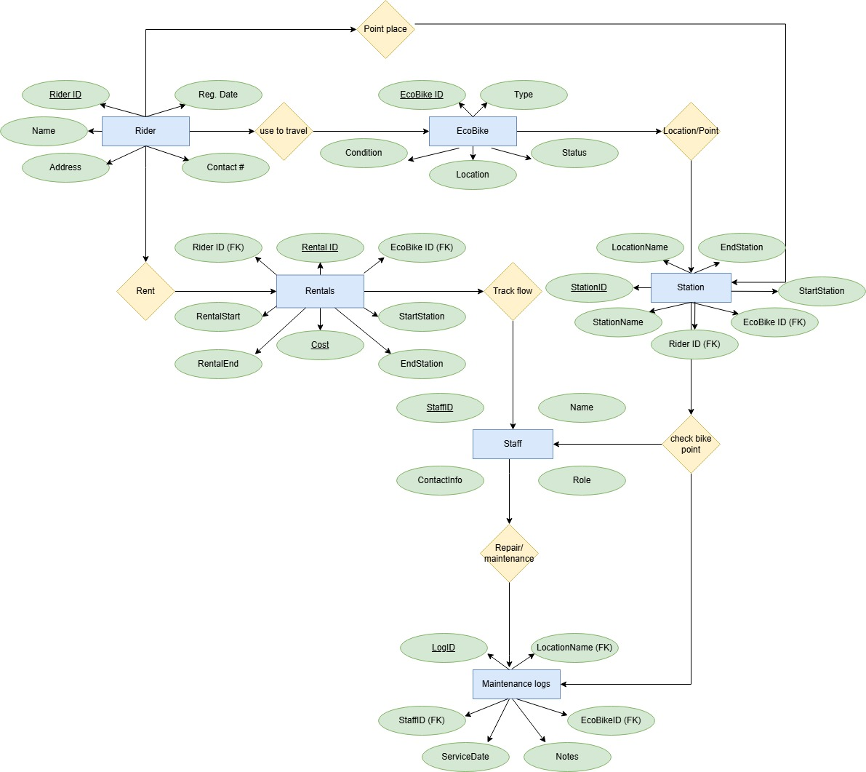
Relationship is the connection between two or more entities[1]

Figure 1 Sample ERD image showing Chen ERD Model
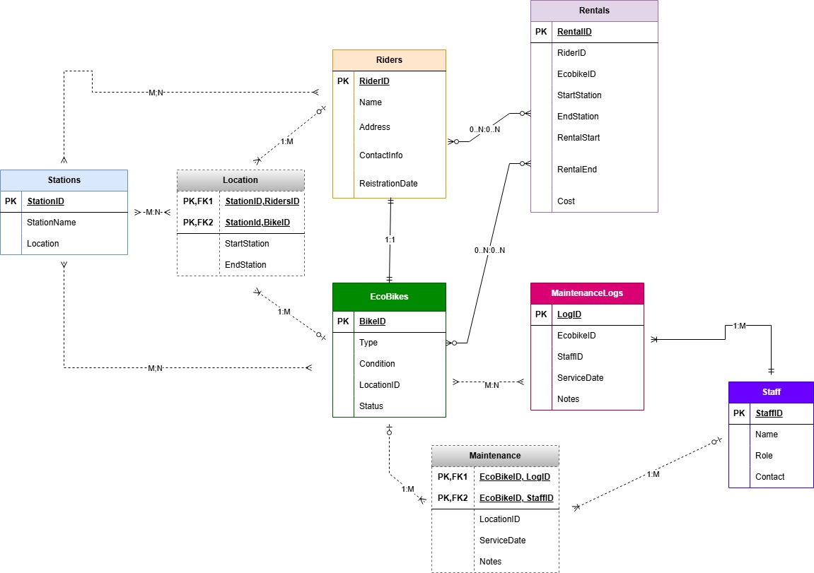
Figure 2 Sample image showing IE Model

There are three major methods that is use today, Chen Model named after Dr. Peter Chen who is the origin of this technique, where the use of shapes rectangle (entity), oval (attribute) and diamond (relationship is known. Information Engineering (IE or crows feet) it is known for relationship connection and constraint whether it is one to one, one to many and many to many relationship and Unified Modelling language (UML) which is more subject-oriented. Whether or whatever model is use is actually not that important as long as the concept is there and it is able to tell you the idea how you will create your database[2]

Data structure Development
Constructing and designing data requires organization of all data including ensuring entity, attribute and relation between them. With appropriate constraints to make sure the data integrity is protected. With everything sorted, all information is clear and easy to retrieve. Having organize data structure makes it easy, fast and reliable information, reduces errors and inconsistencies.
To be able to construct design in a database, we use Entity-Relationship Diagrams[2]

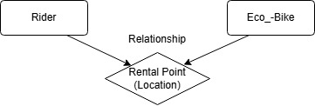
With the scenario given, and with ER model guide to use in constructing a design defining and establishing relationships with appropriate constraints to ensure data integrity.

Figure 3 Sample ERD establishing relationship between the Rider and the bike.

Constrains in database are fundamental to maintain data integrity, accuracy and consistency and preventing invalid data, constrains like primary key, foreign key, unique, not null is crucial when making a database design. With this business management can enhance productivity, track the business flow easily and accurately [3]

Normalization Compliance
To achieve an accurate representation of data, their relationships or connection and constraints, developer use normalisation method.
Normalization method is looking for functional dependencies between attributes, the purpose of this technique is to identify the correct set of relations interconnecting the entity and attributes supporting the required data needed in your database. In short Normalization technique is to check validation between structures of relation [4]
For the data to be stored nicely and sufficiently, and to avoid encountering any problem at all, securing data integrity, no redundancy and obtain best performance in your database, this method is use.
Here is a sample data to give a picture using normalisation form.
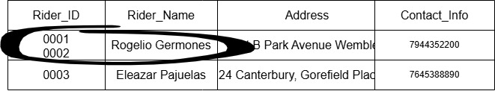
Figure 4 Sample image of 0NF or Unnormalized Form
We call the data unnormalized form if the table have more than one value and contains redundant data (Figure 4), with this we have to put normalisation method, there are 6 types of normalisation , the 1st Normalisation form (1NF), 2nd Normalization, 3rd Normalisation Form, Boyce-Codd Normal Form and so on, these are levels of increasing strictness to ensure data integrity and functionality.
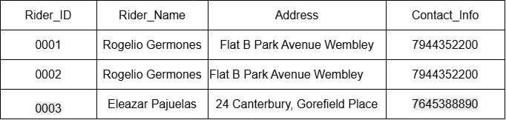
Figure 5 Sample image of First Normal Form (1NF)

Figure 5 is a sample of First Normal Form where no redundant or double values in a table.

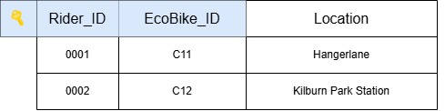
Figure 6 Sampe of Second Normal Form (2NF)
Second normal form is to prevent deletion anomaly, update anomaly and insertion anomaly [5]
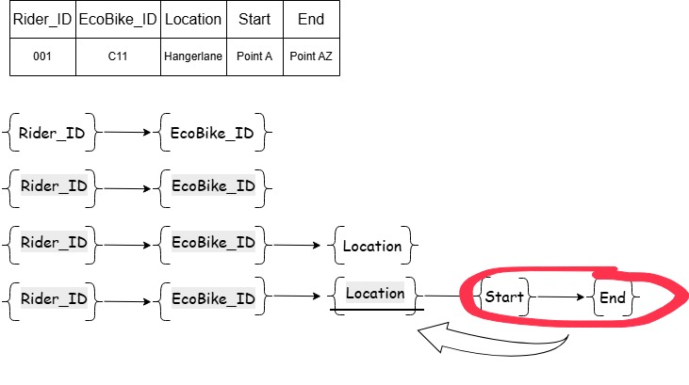
In this form we remove partial dependency and attribute is dependent to the key. The sample data tells that Rider_ID and Ecobike_ID is a composite key, and location is non key attribute and dependant to Rider and Ecobike key. (See Figure 6)
Figure 7 Image shown additional attrubutes to work out 3NF

The Third Normalization rule is all depend to the key and nothing but the key. Supposed in our sample, Riders and Eco bike and location, Rider and EcoBike made up the composite key and non-key attribute is location, we achieve this in 2NF but what if we add data assuming our scenario business, the product (bike) are moving (Figure 7), so we need to add location where it starts and where it ends, now location itself does not known if it depend on Rider or the Ecobike. If we talk about the points where the Ecobike is to place then its dependent to the primary key EcoBike, but if the rider leave it to where he/she stops then that is dependent to our Rider Primary Key, in this case adding where travel starts and ends will be depended to our location, it depends with the rider and bike through the location, on what we called transitive dependencies, so we have to solve this kinds of dependency in third normal form. We would have need more tables to each entity but assuming we need the location where the rider start to use the EcoBike and the end location where he stop using it, then we can make another table for location, as an entity and non-key attribute when the ride starts and end destination (see figure 8).Now we achieve the third normal form where we eliminate transitive dependencies and all attribute is relying in primary key and nothing but the key. So here in Third Normal Form we add another table for location.
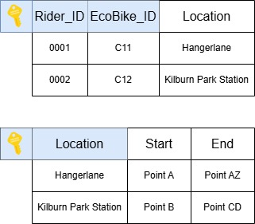

Figure 8 Sample image in Third normal Form (3NF)
This is only simple data to picture how we use normalization technique to give us clearer data functionality, in our scenario, we should add more table for example, adding aside from Rider, bike and location, we should have also table for maintenance logs, rentals and staff who manage the product (bike) and also who tracks rentals. Also, we must think the static and moving data. For example, we have location Point A, B,C, that’s the static point of the EcoBike, but how about when moving, outside the points (Rider stop location), address, also you need to think of cost, is it per hour? Does the cost depend on what bike type? Does the cost depend how far the ride is or is it fix hourly? Also, the staff allocation and position and the services of bike to maintain its usage and more to add to think and consider to build a good database design for client.

Sample Data Population

Sample data of 6 main Entities in our scenario.
Buils a sample data and populate using MS Access.
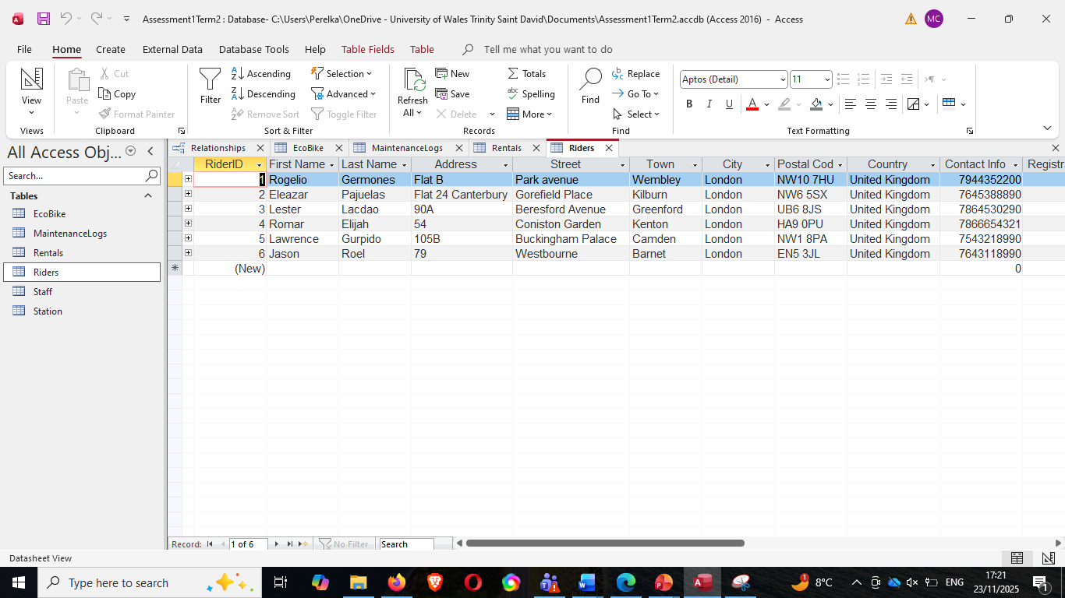
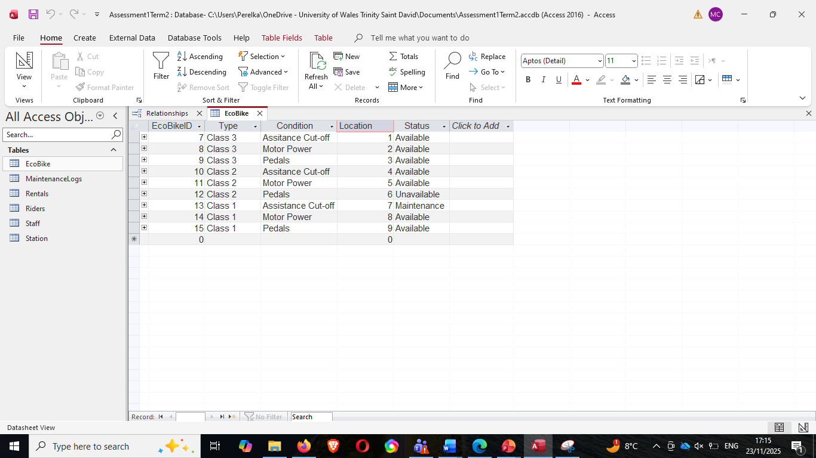
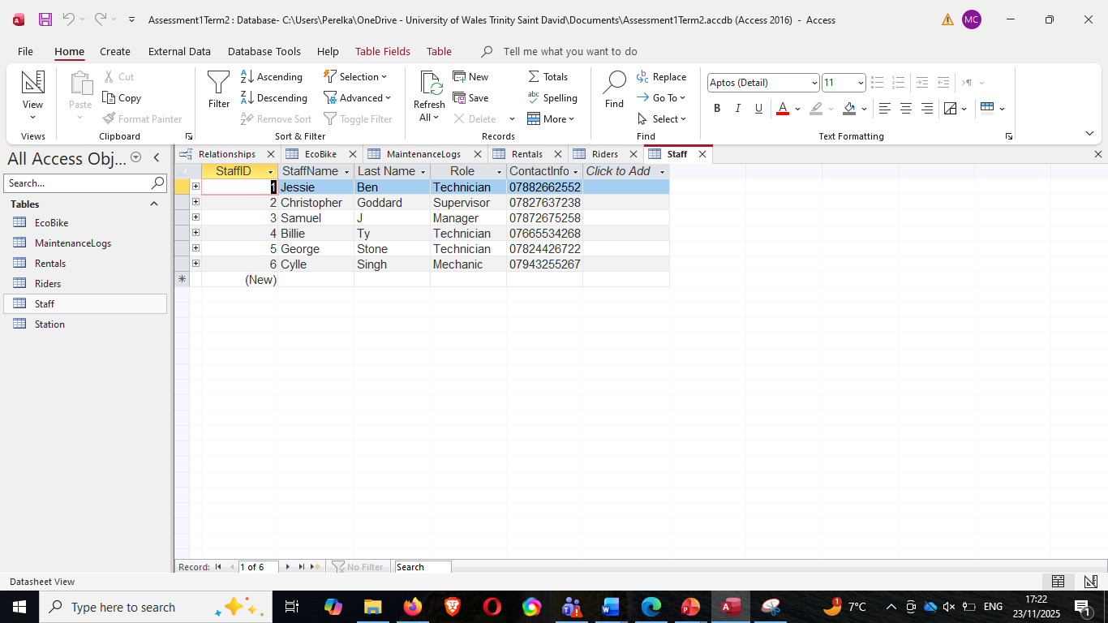
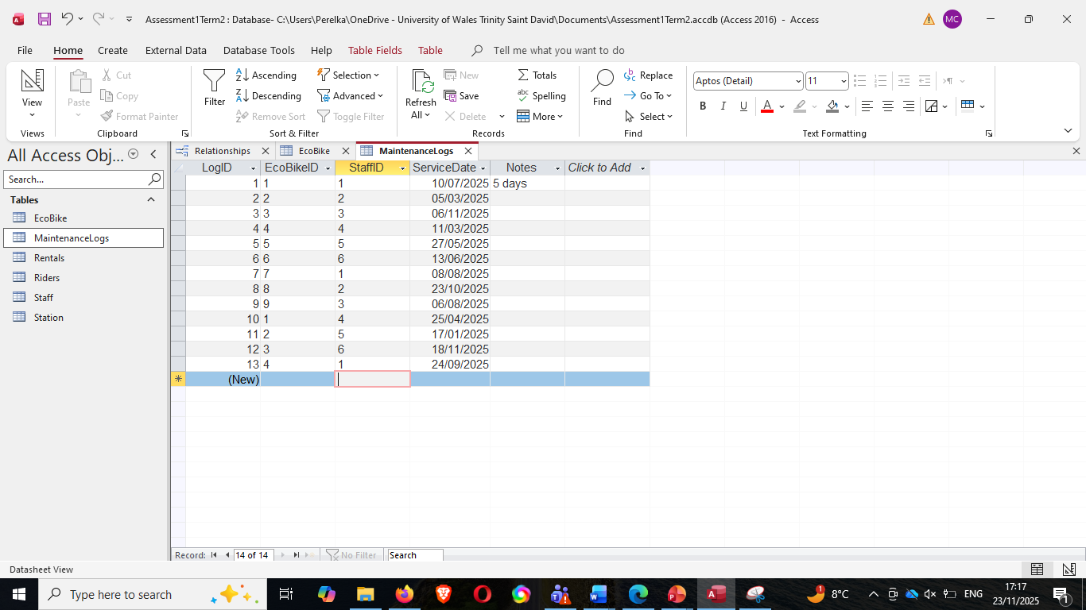

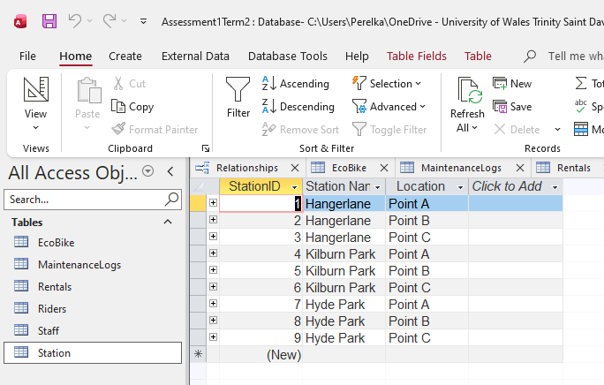
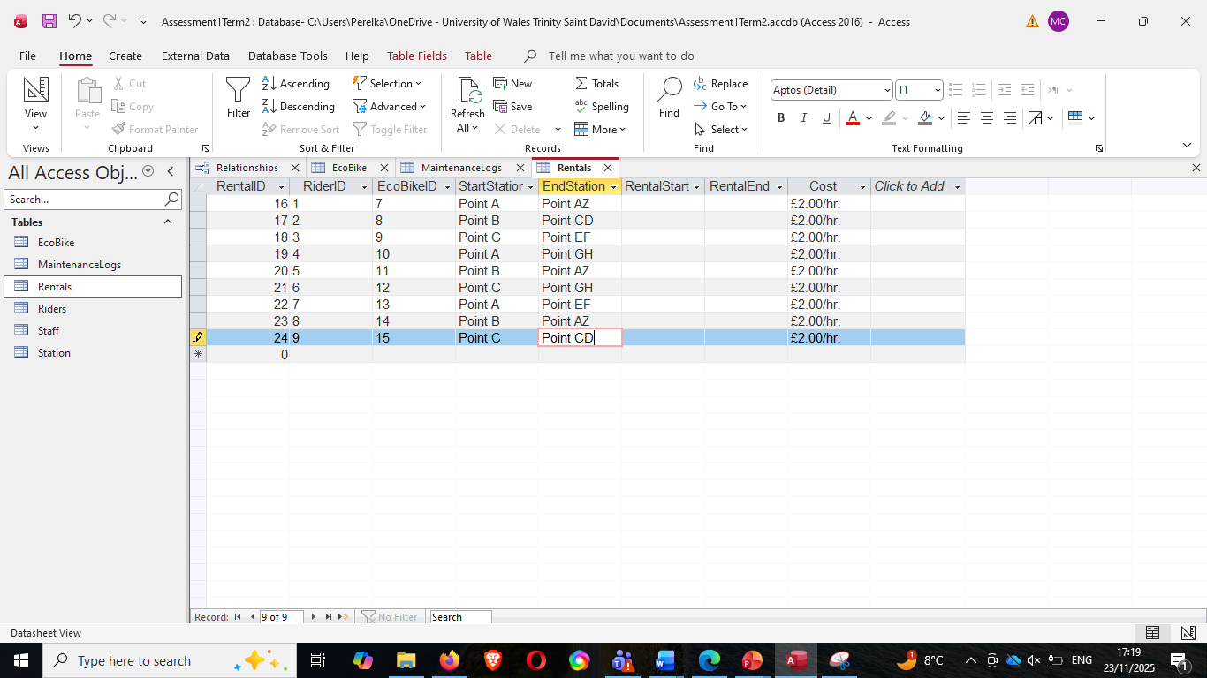

Query Development
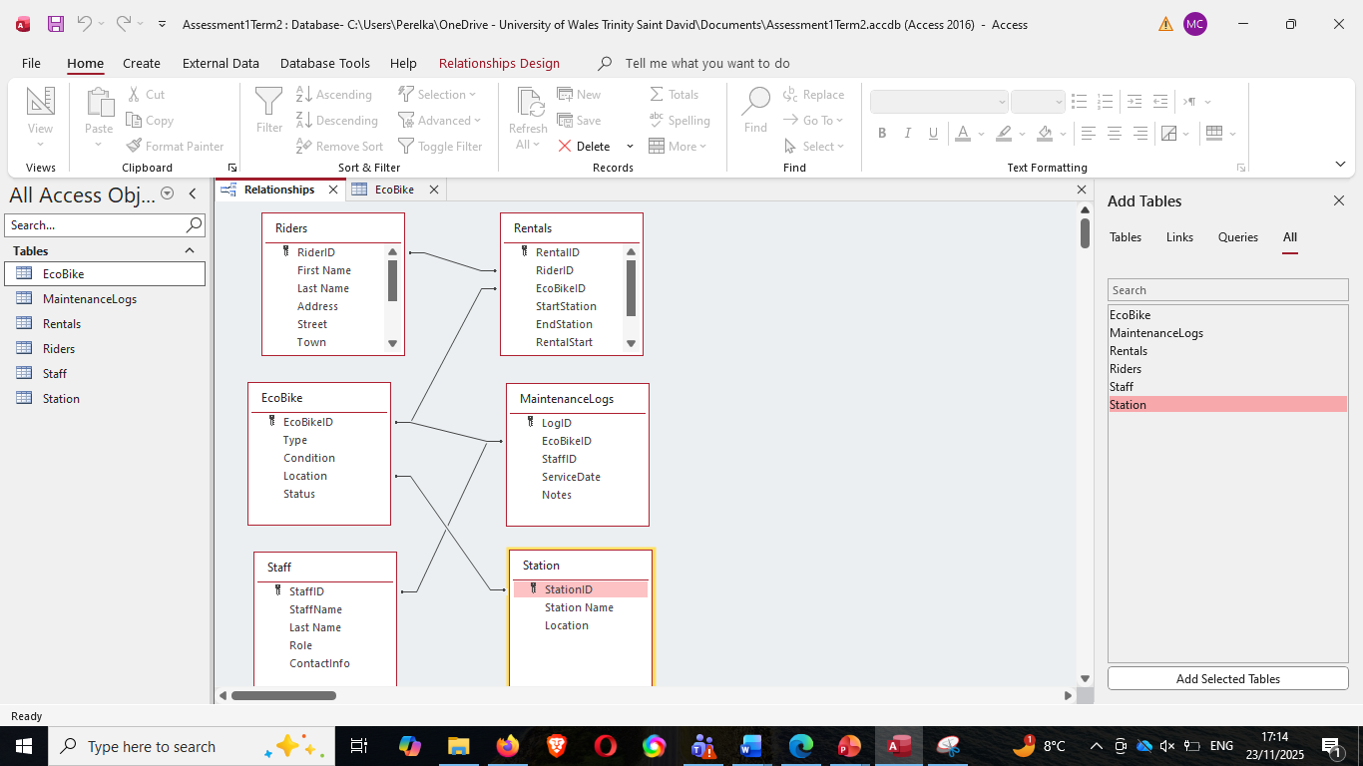
Database practical test, shown in Figure 9 where you showed relationship and putting it in test with sample Query. In second image (Figure 10), shows sample query for Bike and station, ensuring its relationship and dependencies and successfully carrying out query in Figure 11.

Figure 9 Sample image showing relationship

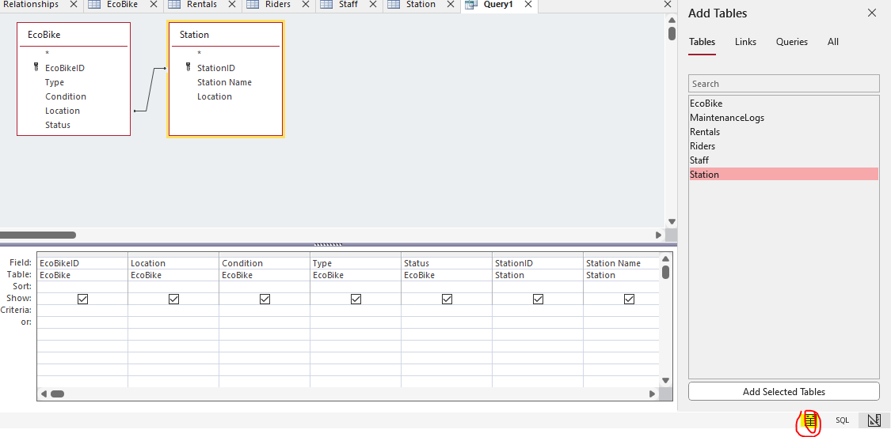
FIGURE 10 Sample image showing simple Query
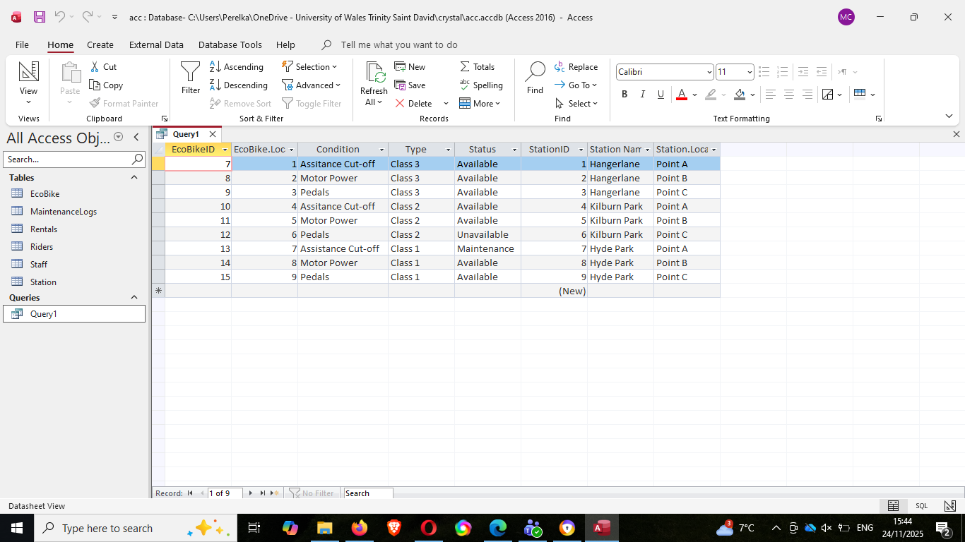
Figure 11Simple Query outcome

Validation and Testing
The database I made needs to work out and to be think more to implement data functionality it needs more input/data to consider, also relationship between entity needs to be worked out, I manage to get a proper relationship between bike and the location and it successfully given me sample query which means all data must be in proper functional way to carry out good performance and avoid problem. As the scenario apply, assuming I am a developer and even this task to manage the database of said business, I need to think my database if it is user-friendly and allow management functionality, this way I can assure the full optimization of performance of my database.

Conclusion
I therefore conclude that to have a successful database design, I need to apply the structured process, such as creating ERD to model all your data before creating your database. Using Normalization to achieve data integrity and to avoid redundant and anomaly in all data and implementing the importance of key to ensure relationship and dependencies between entity and attributes, with this realization I can make a functional database where integrity, consistency and optimal performance has met and effectively used. Also to bear in mind when creating a database, that a table without a primary key is useless and it’s violating the normal form, always think of normalization after having your ERD design to prevent, deletion, update and insertion anomaly in your data and lastly, each values in the table must depend in the key, and nothing but the key.

References
References
[1] "What is Entity Relationship Diagram (ERD)?" Visual Paradigm. https://www.visual-paradigm.com/guide/data-modeling/what-is-entity-relationship-diagram/
[2] J. L. Harrington, Relational database design and implementation, Morgan Kaufmann, 2016.
[3] TiDB Team. "Understanding Different Types of Database Constraints." TiDB. https://www.pingcap.com
[4] T. Connolly, Database System: A Practical Approach to Design, Implementation, and Management, Pearson Education, 2015.
[5] Decoplexify, “Learn Database Normalization”, 2021
https://www.youtube.com/watch?v=GFQaEYEc8_8

Appendices

Appendix 1: Draft work

